2014 Gag Update Summary

The SEDAR 10 gag assessment was updated in 2014 with data through 2012. The methodologies and historical data between the two assessments remained mostly consistent, with a few exceptions. These changes to the data and methods (which will be discussed below in detail), along with the added years of data, have led to some noticeable differences in the output trends between SEDAR 10 and the 2014 Update (Table 1, Figures 1-3). The trend in F follows SEDAR 10 fairly closely until 1992 (Figure 1). At this point, the SEDAR 10 F trend continues on a downward trajectory while the 2014 update shows a steep increase in F until 1995 before the trend starts to decrease again. The level of SSB from the 2014 Update is higher than that from SEDAR 10 for almost every year of the overlapping time series (Figure 2). Age-1 recruitment is very similar between the two assessments, except for the beginning period (1962-1977, Figure 3). This discrepancy is due directly to a methodology change from SEDAR 10 to the 2014 Update, which will be discussed below. Other noticeable differences are that the values of steepness (h), SSBMSY, MSST, and MSY are all significantly lower in the 2014 Update than they were in SEDAR 10 (Table 1).

During any update, certain data sets must necessarily change due to the nature of the data sets themselves. For example, all the indices were changed because they are standardized using a modeling approach. So, when new years are added to the data series, the model will update the estimated parameters and the time series will change. Several other methods were also updated using more modern standard practices rather than what was used in SEDAR 10. For example, the number of trips is used as the effective sample size rather than the number of fish. Also, dome-shaped selectivity curves were estimated by fitting a logistic curve to the ascending limb and then estimating the descending limb separately with a negative exponential function. SEDAR 10 used a double logistic to estimate the dome-shaped selectivity curves. Another method update was that the mixed Monte Carlo/Bootstrap approach was used to characterize uncertainty rather than simply bootstrapping and refitting the spawner-recruit relationship.

The big method update affecting all species is the conversion from MRFSS to MRIP for all general recreational landings. Depending on the magnitude of the difference, this could potentially have ramifications on stock productivity, biomass estimates, and fishing mortality estimates. However, a quick comparison between the two series of landings shows very little difference overall (Figure 4). The biggest differences are in the peek landings seen in 1983-1984, but the trend remains unchanged and the difference in other years is minimal.

According to the analytical team, there were a few issues with updating some of the data series though the terminal year. These issues were related to certain restrictive management measures and affected the indices of abundance. Due to closures, the commercial handline index could only be run through 2011 and only included May-Dec of 2011 (due to the spawning season closure and a regulatory closure in Oct 2012). The general recreational index was not extended or changed in any way from SEDAR 10 due to limitations in human resources. Therefore this index ended in 2004. However, the analysts did mention that due to the high CVs associated with this data set, it would receive a much lower weight than all the others, since these indices are weighted based on their CVs. The headboat index is the only one that was able to be extended to the terminal year, excluding Jan-Apr for 2011-2012.

There were also several methodological changes made in the 2014 Update. The first is that the 2014 update used a different set of ages for the age composition data than SEDAR 10. The Update used ages 1 to 12+ for the age composition data whereas SEDAR 10 used ages 0 to 20+. The reasoning given is that very few fish were observed at age 0 and above age 12 and many zeroes are problematic when using multinomial likelihoods. It is unclear if and how this change would have affected model outputs as compared to SEDAR 10.

The second major change in the Update is that steepness (h) was not estimated, but input into the model. The value input for h in the Update was 0.84. The estimated value from the SEDAR 10 base run was 0.95. This value has ramifications on the stock-recruitment relationship and the productivity of the stock. This is standard practice now, and there were some problems estimating h during SEDAR 10 when it was originally done. That’s what led to the decision to input h rather than try to estimate it. Sensitivity runs were done looking at different values of h (Figure 5, Table 2). According to the sensitivity run results, having an h closer to the SEDAR 10 value results in higher estimates of SSBMSY and MSY and a lower estimate of FMSY (Table 2, S3 and S4). However, the trends in and values of F/FMSY and SSB/MSST do not change very much (Figure 5).

The final major change is related to how recruitment is handled in the early part of the time series. The earliest landings composition data are length comps from 1972. Therefore, as is consistently done in recent assessments, the spawner-recruit curve is estimate with data from 1972 to the terminal year and the years prior to 1972 are assumed to fall exactly on the spawner-recruit curve. All the other years have recruitment deviations estimated that deviate recruitment from the spawner-recruit curve based on length or age comps from that year. In SEDAR 10, recruitment deviations were estimated for every year, including those prior to 1972. However, the spawner –recruit curve was estimated using only data from 1972 onward. A sensitivity run was done exploring the effect of this decision on model estimates. The results of this sensitivity run show that there is quite a substantial influence of this decision on model estimates and the trend in SSB/MSST (Figure 6, Table 2). Estimating the recruitment deviations in the early time period results in much higher estimates of SSBMSY and MSY as compared to the base run (Table 2, S9). Also, the trend in SSB/MSST looks very similar to the one from SEDAR 10 for this sensitivity run (Figure 6).

The one difference that cannot be directly accounted for is the difference in the F/FMSY trend (Figure 1). The divergence that happens in 1992 is not explained by any of the sensitivity runs. This could simply be a product of adding the new years of data or a combination of all the changes discussed here. A retrospective analysis may have been useful in looking at this difference, but one was not conducted for the 2014 Update. A much more in depth analysis is required to further explore this discrepancy between the current Update and SEDAR 10. However, this shift in the values of F and the shift in the values of SSB have potentially changed the baseline that gag are being evaluated by. This makes it very difficult to compare the results of the Update to SEDAR 10. Catch limits back in 2009 were set based on the results of SEDAR 10, which estimated MSY at around 1,200,000 lbs. The current Update is saying that MSY is really closer to 900,000 lbs. That’s 300,000 lbs. lower than the SEDAR 10 estimate. Even if the management measures implemented in 2006 were very successful in keeping gag landings below the SEDAR 10 MSY (which is OFL), that would still result in overfishing when evaluated by the 2014 Update level of MSY. Another confounding factor is that management measures from SEDAR 10 were not implemented until June 29, 2009 (final rule publishes for Amendment 16). The terminal year of data from SEDAR 10 was 2004. The fishery continued to produce landings well above the eventual ACL for those 4 years, which may have driven the stock down to levels where the newly implemented ACL in 2009 was still too high to prevent overfishing (Table 3).

|  |  |  |  |
| --- | --- | --- | --- |
| **Quantity** | **Units** | **SEDAR 10** | **Update** |
| M | per year | 0.14 | 0.14 |
| h | - | 0.95 | 0.84 |
| FMSY | per year | 0.21 | 0.29 |
| SSBMSY | 1000 lbs ww | 7,925 | 4,038 |
| MSST (M) | 1000 lbs ww | 6,816 | 3,473 |
| MSST (75%) | 1000 lbs ww | 5,944 | 3,029 |
| MSY | 1000 lbs gw | 1,238 | 938 |
| Y at 75%FMSY | 1000 lbs gw | 1,217 | 921 |
| SSB/SSBMSY | - | 0.94 | 0.97 |
| SSB/MSST (M) | - | 1.09 | 1.13 |
| SSB/MSST (75%) | - | 1.26 | 1.29 |
| F/FMSY | - | 1.48 | 1.23 |

Table 1. Estimated parameters from SEDAR 10 and the 2014 Update. Data from the 2014 Update report and the SEDAR 10 report.

|  |  |  |  |  |  |  |  |  |
| --- | --- | --- | --- | --- | --- | --- | --- | --- |
| **Run** | **Description** | **FMSY** | **SSBMSY**  **(1000 lbs ww)** | **MSY**  **(1000 lbs gw)** | **Fcurrent /FMSY** | **SSB2012 /MSST** | **steep** | **R0**  **(1000 fish)** |
| Base | — | 0.286 | 4,039 | 938 | 1.23 | 1.13 | 0.84 | 229 |
| S1 | M=0.1 | 0.226 | 3,314 | 695 | 2.44 | 1.22 | 0.84 | 111 |
| S2 | M=0.18 | 0.357 | 4,059 | 993 | 0.94 | 1.28 | 0.84 | 308 |
| S3 | h=0.74 | 0.259 | 4,094 | 901 | 1.34 | 1.11 | 0.74 | 230 |
| S4 | h=0.94 | 0.257 | 4,134 | 960 | 1.42 | 1.1 | 0.94 | 209 |
| S5 | Finit=0.015 | 0.285 | 3,988 | 923 | 1.23 | 1.14 | 0.84 | 227 |
| S6 | Finit=0.045 | 0.287 | 4,072 | 949 | 1.23 | 1.12 | 0.84 | 231 |
| S7 | Dmort=0.15 | 0.35 | 3,812 | 982 | 1.01 | 1.18 | 0.84 | 220 |
| S8 | Dmort=0.35 | 0.247 | 4,094 | 877 | 1.45 | 1.11 | 0.84 | 232 |
| S9 | Flexible IC | 0.287 | 4,495 | 1,095 | 1.28 | 1.05 | 0.84 | 235 |
| S10 | Iter reweight | 0.325 | 4,112 | 1,001 | 1.88 | 0.74 | 0.84 | 235 |

Table 2. Results of the sensitivity runs from the 2014 Update. Fcurrent is the geometric mean of the F values from the last 3 assessment years. Data are from the 2014 Update report.

|  |  |  |  |  |  |  |
| --- | --- | --- | --- | --- | --- | --- |
| **Year** | **Comm** | **Comm ACL** | **Rec** | **Rec ACL** | **Total** | **Total ACL** |
| 2005 | 555,539 | - | 505,419 | - | 1,060,958 | - |
| 2006 | 511,435 | - | 588,928 | - | 1,100,363 | - |
| 2007 | 601,712 | - | 505,660 | - | 1,107,371 | - |
| 2008 | 470,161 | - | 691,300 | - | 1,161,461 | - |
| 2009 | 432,274 | 352,940 | 420,375 | 340,060 | 852,650 | 694,000 |
| 2010 | 411,632 | 352,940 | 171,841 | 340,060 | 583,473 | 694,000 |
| 2011 | 412,675 | 352,940 | 169,854 | 340,060 | 582,529 | 694,000 |
| 2012 | 352,096 | 352,940 | 177,097 | 340,060 | 529,193 | 694,000 |
| 2013 | 327,306 | 326,722 | 63,595 | 340,060 | 390,901 | 694,000 |

Table 3. Gag commercial and recreational landings and ACLs in lbs. gw. Data from the SERO ACL monitoring website and the SEFSC SAFE data.

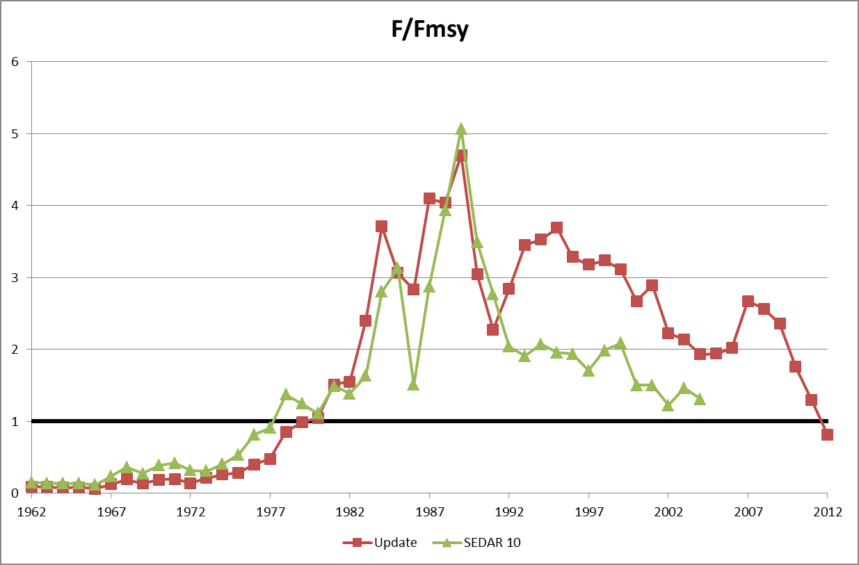

Figure 1. Time series of F/FMSY from the 2014 Update and SEDAR 10 with a 1:1 line for reference. Data from the 2014 Update report and the SEDAR 10 report.

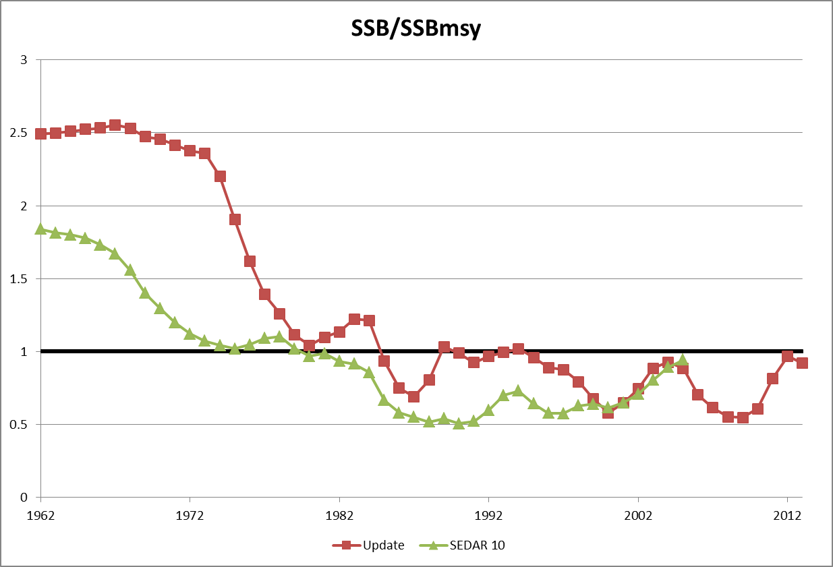

Figure 2. Time series of SSB/SSBMSY from the 2014 Update and SEDAR 10 with a 1:1 line for reference. Data from the 2014 Update report and the SEDAR 10 report.

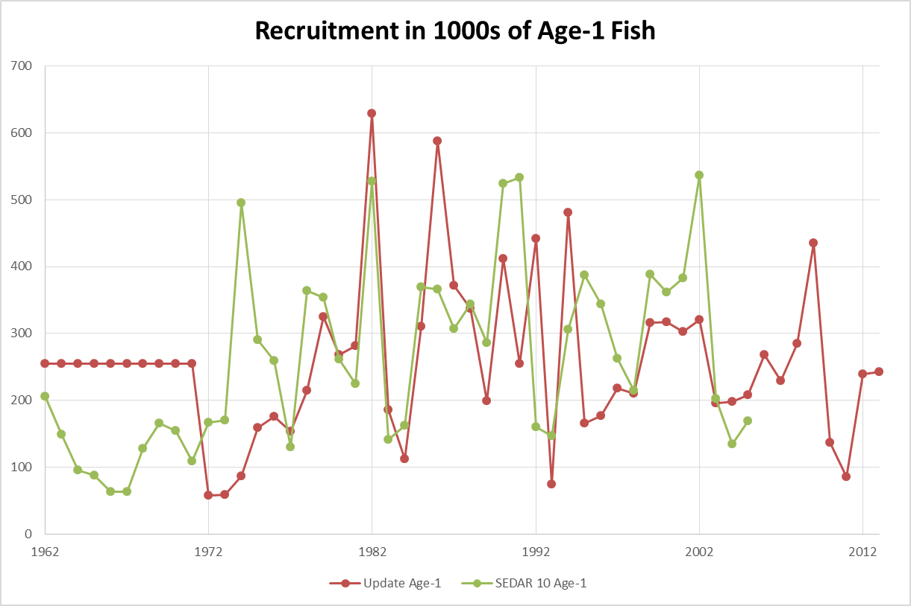

Figure 3. Time series of Recreuitment from the 2014 Update and SEDAR 10 in numbers of age-1 fish. Data from the 2014 Update report and the SEDAR 10 report.

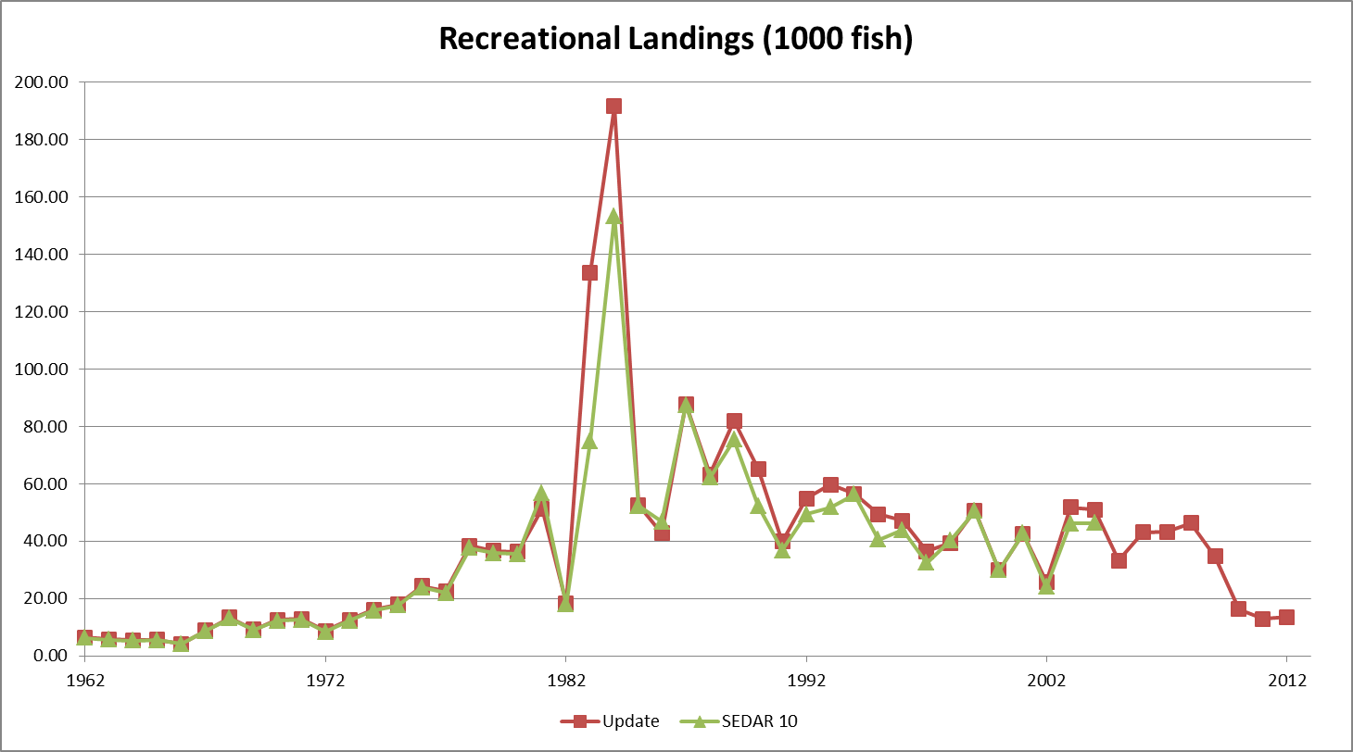

Figure 4. Time series of General Recreational Landings from the 2014 Update and SEDAR 10 in 1000s of fish. Data from the 2014 Update report and the SEDAR 10 report.

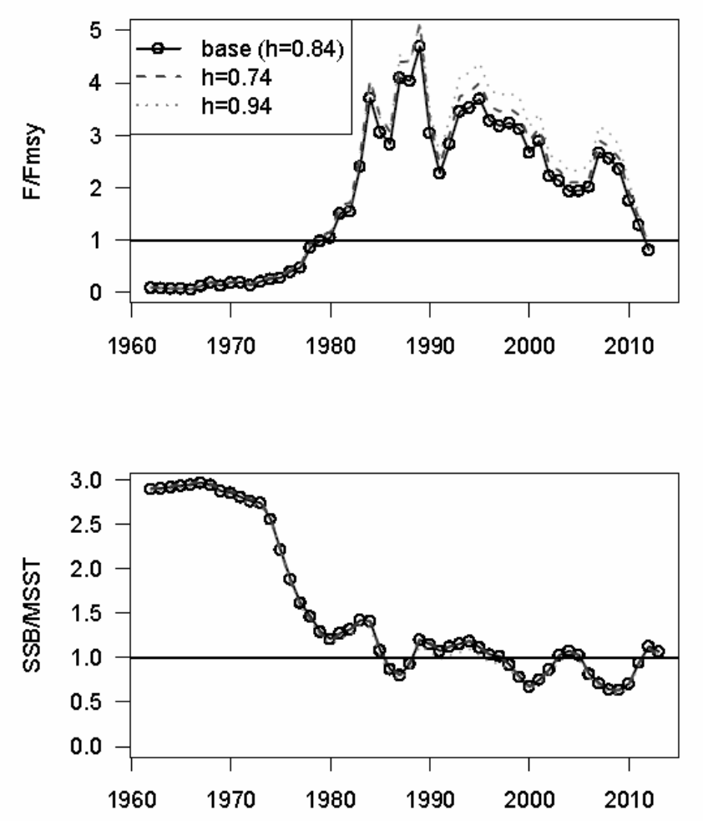

Figure 5. Results of sensitivity runs S3 and S4 (h=0.74, h=0.94). The top figure shows the time series of F/FMSY and the bottom figure shows the time series of SSB/MSST. Data are from the 2014 Update.

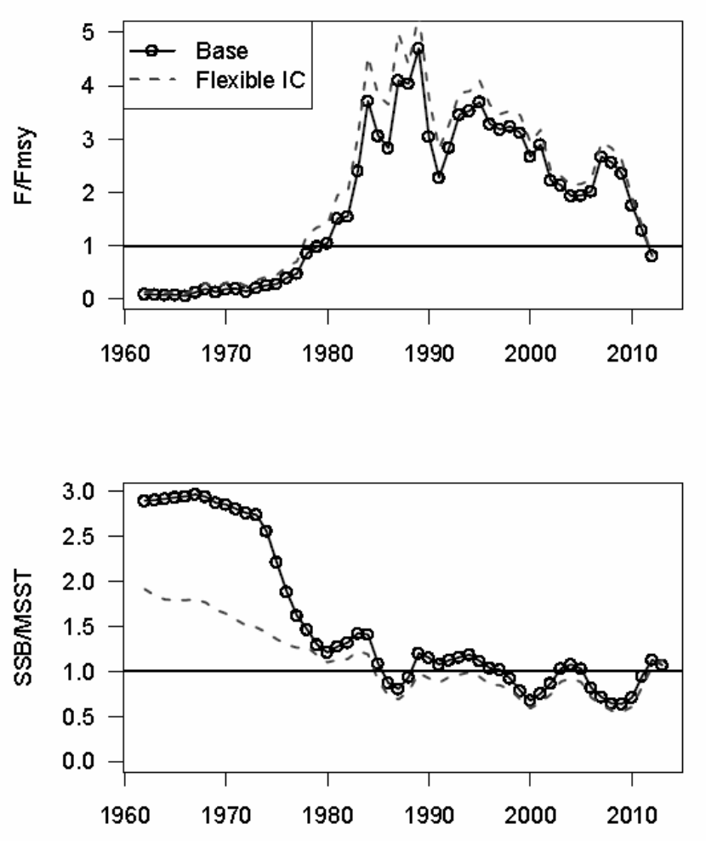

Figure 6. Results of sensitivity run S9 (recruitment devs 1962-1971). The top figure shows the time series of F/FMSY and the bottom figure shows the time series of SSB/MSST. Data are from the 2014 Update.