A Brief History of the Golden Tilefish Fishery
My public comments, concerning golden tilefish (Amendment 1 to the Snapper/Grouper Fishery Management Plan, Regulatory Impact Review, and Final Environmental Impact Statement for the Snapper-Grouper Fishery of the South Atlantic Region, March 1983) serve as a frame of reference for this discussion. They are captured, verbatim, below:
8.4.7.5 (pg. 53) The large increase in tilefish landings, recently, is due to increased consumer acceptance=increased demand=increased ex-vessel price=more fishermen fishing for tilefish=longline efficiency=low skill high return fishery=less tilefish in a very few years due to slow growth rate and overfishing. Only here, you can make a difference before gross overfishing occurs. Catch rates have already decreased in the longline fleet in 3 years. One Ft Pierce fisherman, one of the first to start longlining tilefish, caught 3 pounds/hook in 1979, in 1982, ¾ pound/hook.
9.4 (pg.39). If the fishing power of a longline is 2x that of power snapper reels and the northern longliners w/tubtrawls are 10x more efficient than regular longlines, and automatic longliners are 2x more efficient than tubtrawls, then the automatic longline is 40x more efficient than power snapper reels. I guess you can kiss the tilefish goodbye!
It was not long after this commentary that the long line fishery removed the biomass necessary to support the hook and line fishery. Hook and line production peaked in 1982 at 597,000 pounds; this was also the largest year of long line landings at 2.774 million pounds (table,5.2; figure 1). By 1987 hook and line landings declined to about 25,000 pounds (table, 5.2) and it became economically unfeasible for most bandit fishermen to continue targeting golden tilefish. This is an important consideration for golden tilefish management as the inefficiencies of bandit gear depend upon a much higher biomass, in a given area, for that gear to be productive.
Early golden tilefish stock assessments were chasing a declining biomass, similar to other snapper/grouper stocks, and were unable to prevent significant stock declines. Long line catches declined by an order of magnitude, from the peak landings (2.774 m/lbs.) in 1982 to 247,000 pounds in 1987 (table, 5.2; figure1). A number of longline vessels, especially off South Carolina, shifted effort to other species as the stock declined (Low et al., 1983). The long line fishery stabilized from 1988-1994 with catches averaging around 721,000 pounds. A 1.5 m/lb. quota was approved in 1994 which was stepped down to just over 1 million pounds by 1996. Unfortunately, the decline in landings renewed to around 300,000 pounds by the late 1990s and to around 200,000 pounds by the mid-2000s (table 5.2). By the early 2000s, the law of diminishing returns, created an economic environment in which many of the remaining long line vessels, left the fishery or were sold due to low golden tilefish abundance and regulatory impacts in the shark fishery (Kathy Hedges, Inlet Seafood, pers. com). The few remaining golden tilefish long line fishermen were averaging around 300 pounds per day (Joe Klosterman, pers. com.). During this time (late 1990s early 2000s), several large year classes were produced, which would not be fully recruited to the commercial fishery until about age 7 (2004-2007). In 2006 a realistic stock assessment was completed which identified overfishing occurring and a rebuilding plan was approved by the council. The increase in recruitment was unknown in this assessment due to the gear selectively issue. The low quota was further reduced in Amendment 17B, due to ACL implementation (282,819 lbs.). For the first time in management history, the council was chasing an increasing biomass instead of a declining one and the fishery was primed for significant rebuilding and this was identified in SEDAR 25.
After the rebuilding plan was implemented it was important to consider a means to limit the number of longline vessels in the golden tilefish fishery. The time was right, as the current number of longliners remaining in the fishery (11) was at the lowest level since the mid- 1980s. The council appointed a tilefish workgroup in October, 2008 to discuss methodologies to limit effort in the golden tilefish fisheries. Both longline (5) and hook and line fishermen (1) participated. The members of the workgroup accounted for approximately 70% of the golden tilefish quota, at that time. They approved endorsement criteria for both longline and hook and line fisheries. The council was bogged down with the arbitrary timelines concerning The Comprehensive ACL Amendment and had to put tilefish endorsements on hold. The workgroup saw the interest remerging in the tilefish fishery as other vessels were starting to gear up with longline gear. They felt strongly enough that they asked for the endorsements to be approved through Emergency Action. Unfortunately, here we are 4 years later with 20 longline vessels landing golden tilefish in 2010.

In the early 1990s, in my first term as a council member, I introduced the concept of prohibiting long lines from St Lucie Inlet to the Southern SAFMC’s jurisdictional boundary. The vision was to prohibit long line gear in an area that was easily accessible to recreational and commercial hook and line fishermen, rebuild golden tilefish populations, in that area, to levels of abundance that would produce eggs and larvae that could aid in rebuilding areas to the north, and restore biomass levels to those necessary to restore a viable bandit and recreational fishery.
Over time, that vision has come to fruition, and currently both the bandit and recreational fisheries are producing catches of size and abundance that rival the historical fishery. Figure 2 (Nominal CPUE) indicates changes in my commercial catches in this area since 1990. The current 300 pound average catch (figure 2) is very similar to average historical catches that occurred in the same area in 1976 (Bob Preston, Tilefish Workgroup,2008).
Any serious consideration of allocation between bandit and long line gears needs to recognize the historical contribution of each respective gear type (Table 5.2). It is unfortunate that we have to return to the late 1970s and early 1980s for these considerations to be realistic. Once long line became the dominant gear, the bandit fishery was never able to reproduce its historic catch contribution and even most of the long line effort dwindled due to significant overfishing and low stock size by the early 2000s. Table 5.2 and Figure 1 indicate the historical landings by gear type (SEDAR 25 DW Report). Some of the most recent landings are omitted due to confidentiality concerns. There are problems with the SEFSC’s decisions in attributing historical catch to gear types. In the 1962-1976 timeframe there was a decision made to allocate the gear types 86% long line, 14% handline (table 5.2). Low et al. (1983) noted that in the South Atlantic Bight, landings of golden tilefish were small prior to 1980 and were primarily caught in a small area of southeastern Florida (the area that I fish). Prior to August, 1981, virtually all golden tilefish landings off South Carolina, were by snapper reel boats (Low et al. 1983). Long line gear for tilefish was introduced, in the South-Central Florida area, in 1979. In northern Florida, Rusty Hudson was one of the first bandit fishermen to convert to bottom long line to target tilefish in February, 1981. Prior to 1979, bandit gear accounted for all of the golden tilefish landings. From 1979 to 1981 hook and line gear was responsible for most of the landings. Longline catches dominated the landings after 1981. Table 4-9 (pg. 102) of the amendment shows the historical landings by gear from the NMFS ALS data base. These results corroborate the conclusions that I made previously.
The SAFMC has tried to preserve some semblance of the bandit fishery in tile fish regulations over time. Amendment 6 (1994), contained a provision for a 65,000 pound incidental catch which was deducted from the quota as a set- aside. This would equate to 23% of the current quota. The set-aside provision was to be landed under a 300 pound trip limit. Amendment 13C (2006) included a 4000 pound trip limit that reverts to 300 pounds when 75% of the quota is landed. When this regulation was approved it was the council’s expectation that the remaining 25% would be caught with bandit gear, extending the length of the season in the process. Unfortunately, the long line fishery has also dominated production in the 300 pound trip limit period, significantly reducing the hook and line components landings in the process. A long line vessel is about 8 to 10 times more productive, on a given day, than a bandit vessel. This is based on comparing my daily landings with several other long line vessels. This is also corroborated by the recent landings percent contribution by gear types (Table, 5.2). Regardless of the length of the season, the bandit fishery lands about 10% of the quota. The golden tile fish season has been progressively shorter since implementation of the rebuilding plan. In 2006, the quota was caught by 10/23, the nine and one half week 2011 season closed on 3/10.
Some of the hook and line fishermen that were displaced by long line gear in the mid- 1980s, are still fishing today and have had a modest opportunity to share in the catches resulting from the current stock rebuilding. It was bad enough when the long liners started targeting tilefish during the 300 pound trip limit, adding insult to injury, the 300 pound trip limit has not existed for the past two seasons due to the inability of the SEFSC to monitor the quota accurately during the 4000 pound trip limit. The long line prohibited area provides an area of increased golden tile fish biomass where bandit trips are viable again on a day trip basis. The hook and line endorsement is important in that it sets the stage for a management option that could be used for other species in the near future. As the trip limits increase for snowy grouper do we open up the fishery to every snapper/grouper permit holder? Or, do we use historical landings, before the rebuilding plan went into effect, to identify the permit holders with snowy landings and initiate an endorsement program for that fishery. An important consideration for golden tile and snowy grouper is that the universe of permit holders that target these species is relatively small compared to the number of fishermen who fish for the major species in the complex. Red snapper will be another candidate for endorsements when we are able to reopen that fishery. Again, historical participants could be included in an endorsement system with an accompanying bycatch allowance for fishermen who are not included in an endorsement program. At the last meeting, a hook and line endorsement for black sea bass was discussed but the amendment was too far along to include that option. Since the majority of our fishermen have not embraced the catch share management philosophy we are going to need other options to try and address the reduced productivity that is evident in many species in the snapper/grouper complex.
Moving Forward:
1) Approve options for Public Hearings that include hook and line and longline endorsements.
2) Divide the quota 75% longline 25% hook and line which meets the intent of previous council decisions in Amendments 6 (1994) and 13C (2006).
3) Preferred Alternative for hook and line endorsement merges option 2b and 2l. At least 500 pounds (gw) when the best 3 of 5 years, 2001-2005, are aggregated and at least 500 pounds (gw) when the best 3 of 5 years, 2006-2009 are aggregated.
4) Preferred Alternative for longline endorsement remains 2a. At least 2000 pounds gw when landings from 2006-2008 are aggregated (Sub-alt from GT LAP WG).
Sincerely, Ben Hartig

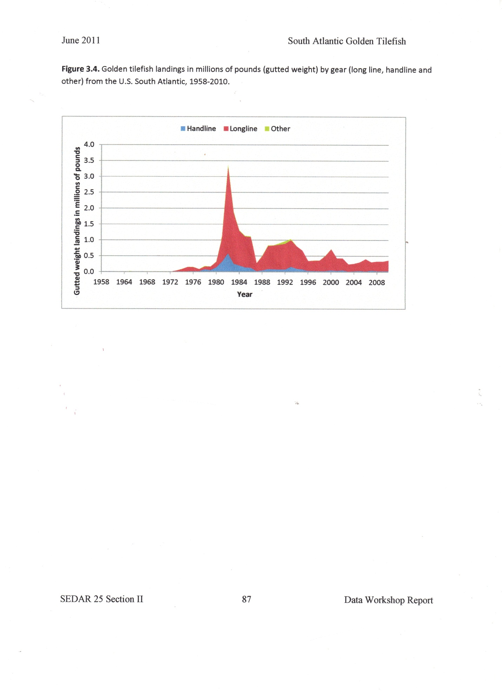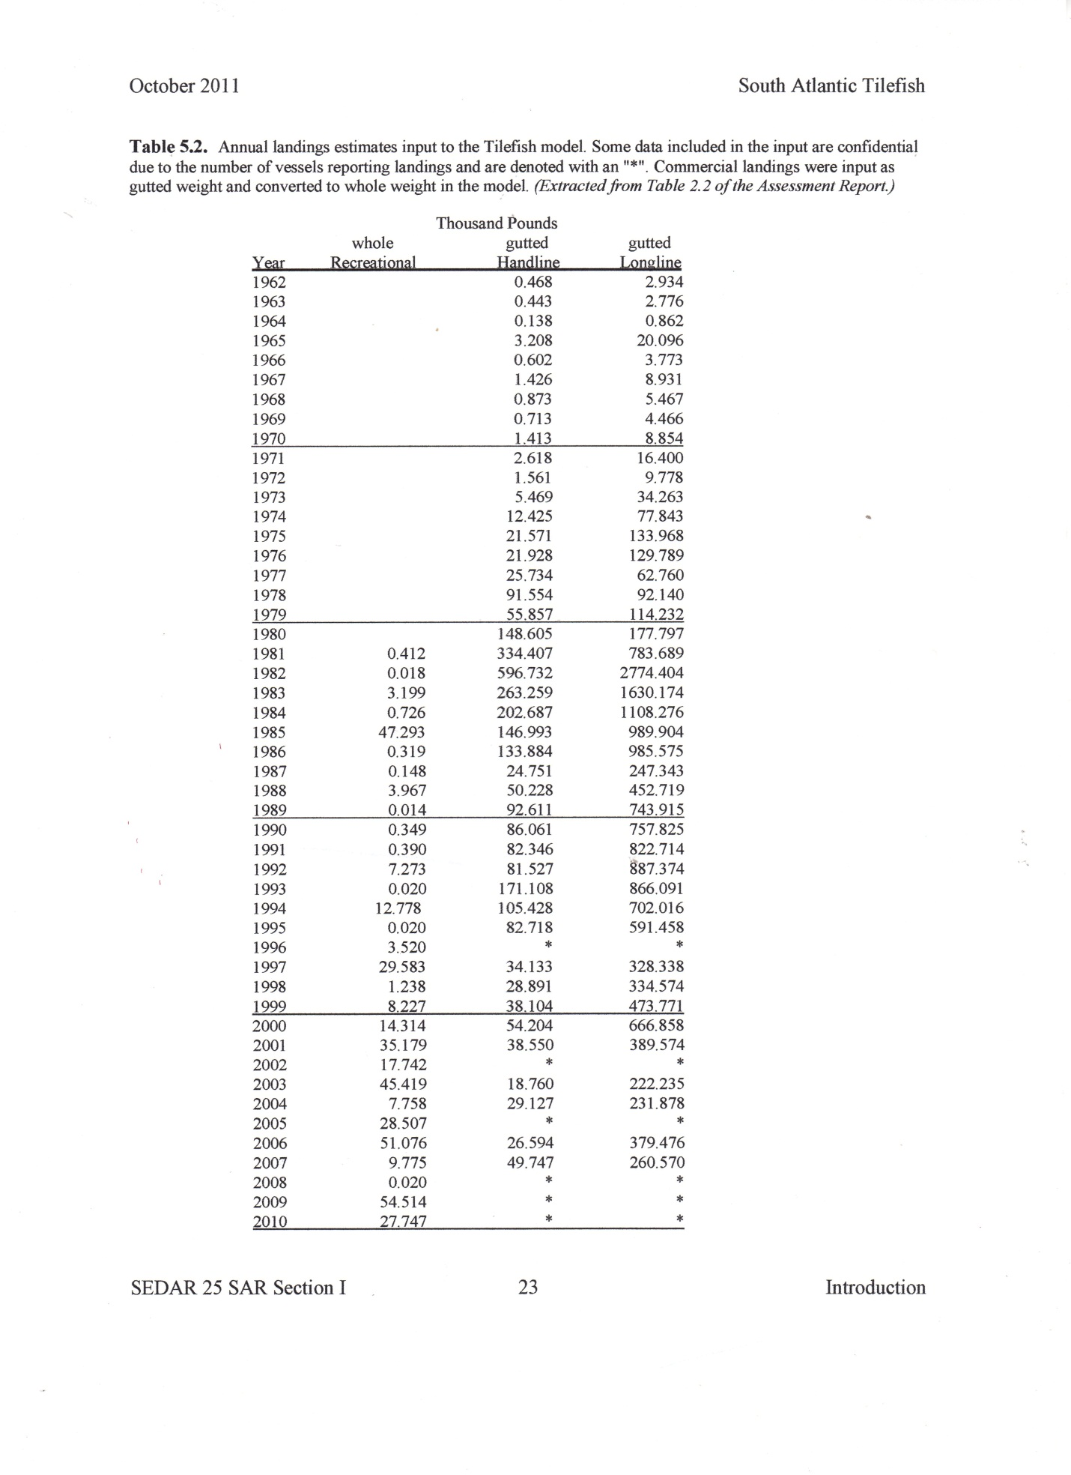
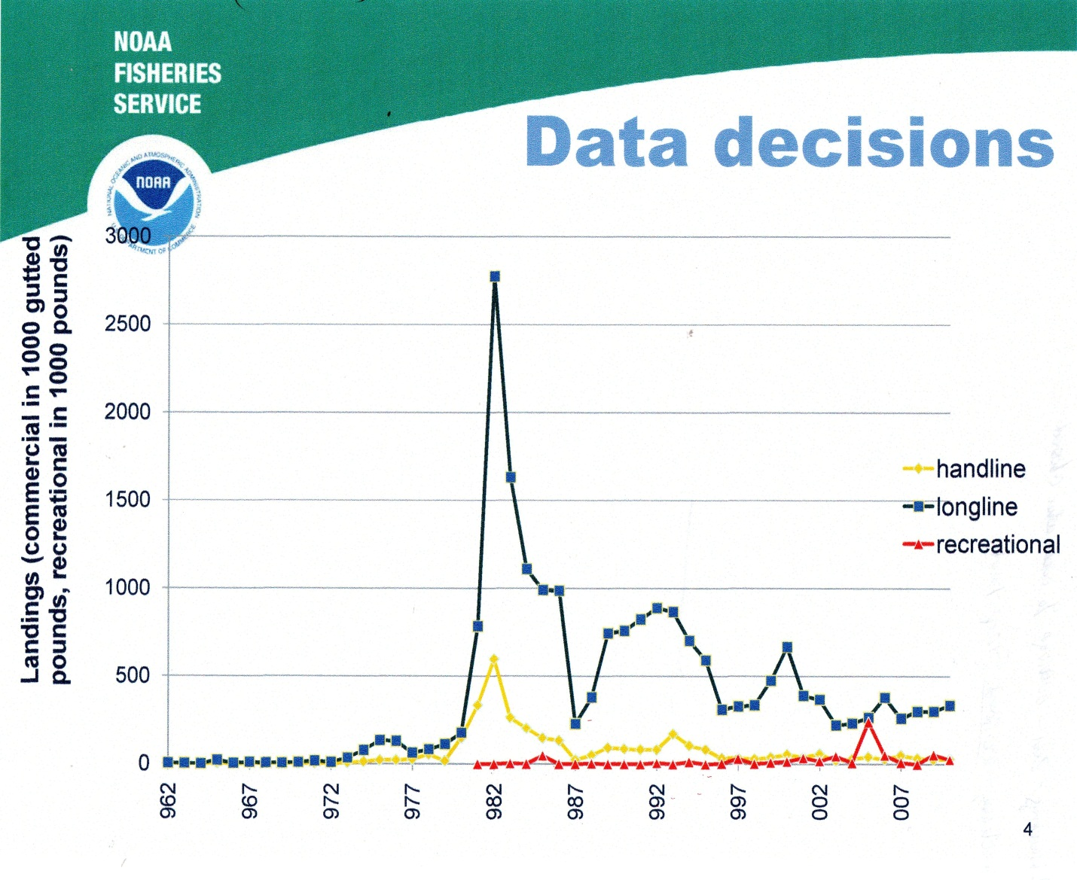
Table 5.2. Annual landings estimates input to the Tilefish model. Some data included in the input are confidential
due to the number of vessels reporting landings and are denoted with an "*". Commercial landings were input as
gutted weight and converted to whole weight in the model. (Extracted from Table 2.2 of the Assessment Report.)
Thousand | Pounds
 | whole | gutted | gutted | Total | % | %
Year | Recreational | Handline | Longline | Commercial | Handline | Longline
1962 |  | 0.468 | 2.934 | 3.402 | 14% | 86%
1963 |  | 0.443 | 2.776 | 3.219 | 14% | 86%
1964 |  | 0.138 | 0.862 | 1 | 14% | 86%
1965 |  | 3.208 | 20.096 | 23.304 | 14% | 86%
1966 |  | 0.602 | 3.773 | 4.375 | 14% | 86%
1967 |  | 1.426 | 8.931 | 10.357 | 14% | 86%
1968 |  | 0.873 | 5.467 | 6.34 | 14% | 86%
1969 |  | 0.713 | 4.466 | 5.179 | 14% | 86%
1970 |  | 1.413 | 8.854 | 10.267 | 14% | 86%
1971 |  | 2.618 | 16.4 | 19.018 | 14% | 86%
1972 |  | 1.561 | 9.778 | 11.339 | 14% | 86%
1973 |  | 5.469 | 34.263 | 39.732 | 14% | 86%
1974 |  | 12.425 | 77.843 | 90.268 | 14% | 86%
1975 |  | 21.571 | 133.968 | 155.539 | 14% | 86%
1976 |  | 21.928 | 129.789 | 151.717 | 14% | 86%
1977 |  | 25.734 | 62.76 | 88.494 | 29% | 71%
1978 |  | 91.554 | 92.14 | 183.694 | 50% | 50%
1979 |  | 55.857 | 114.232 | 170.089 | 33% | 67%
1980 |  | 148.605 | 177.797 | 326.402 | 46% | 54%
1981 | 0.412 | 334.407 | 783.689 | 1118.096 | 30% | 70%
1982 | 0.018 | 596.732 | 2774.404 | 3371.136 | 18% | 82%
1983 | 3.199 | 263.259 | 1630.174 | 1893.433 | 14% | 86%
1984 | 0.726 | 202.687 | 1108.276 | 1310.963 | 15% | 85%
1985 | 47.293 | 146.993 | 989.904 | 1136.897 | 13% | 87%
1986 | 0.319 | 133.884 | 985.575 | 1119.459 | 12% | 88%
1987 | 0.148 | 24.751 | 247.343 | 272.094 | 9% | 91%
1988 | 3.967 | 50.228 | 452.719 | 502.947 | 10% | 90%
1989 | 0.014 | 92.611 | 743.915 | 836.526 | 11% | 89%
1990 | 0.349 | 86.061 | 757.825 | 843.886 | 10% | 90%
1991 | 0.39 | 82.346 | 822.714 | 905.06 | 9% | 91%
1992 | 7.273 | 81.527 | 887.374 | 968.901 | 8% | 92%
1993 | 0.02 | 171.108 | 866.091 | 1037.199 | 16% | 84%
1994 | 12.778 | 105.428 | 702.016 | 807.444 | 13% | 87%
1995 | 0.02 | 82.718 | 591.458 | 674.176 | 12% | 88%
1996 | 3.52 | * | * | * | * | *
1997 | 29.583 | 34.133 | 328.338 | 362.471 | 9% | 91%
1998 | 1.238 | 28.891 | 334.574 | 363.465 | 8% | 92%
1999 | 8.227 | 38.104 | 473.771 | 511.875 | 7% | 93%
2000 | 14.314 | 54.204 | 666.858 | 721.062 | 8% | 92%
2001 | 35.179 | 38.55 | 389.574 | 428.124 | 9% | 91%
2002 | 17.742 | * | * | * | * | *
2003 | 45.419 | 18.76 | 222.235 | 240.995 | 8% | 92%
2004 | 7.758 | 29.127 | 231.878 | 261.005 | 11% | 89%
2005 | 28.507 | * | * | * | * | *
2006 | 51.076 | 26.594 | 379.476 | 406.07 | 7% | 93%
2007 | 9.775 | 49.747 | 260.57 | 310.317 | 16% | 84%
2008 | 0.02 | * | * | * | * | *
2009 | 54.514 | * | * | * | * | *
2010 | 27.747 | * | * | * | * | *
