Data tables for DW 10-SG 44

The SAFMC has been interested in seeing how longline landings of dolphin break down by permit types. Tables 1-3 below show longline landings only by area and years (2010 – 2014) by permit type (Atlantic Dolphin Wahoo only or Atlantic Dolphin Wahoo + HMS). To calculate these by permit type, trips that used longline gear and landed dolphin were analyzed to see what other species were caught on the same trip. If any HMS species were included in the landings, it was assumed the vessel had an HMS permit. If no HMS species were landed, the trip was assumed to be by a vessel that had only the Atlantic Dolphin Wahoo permit.

Limitations of the analysis include the possibility that an HMS fish was landed without a permit, or a vessel with an HMS permit could have landed just dolphin. However, this analysis is considered a workably good approximation of landings by permit type.

Table 1. Number of pounds of dolphin landed by longline and area and permit type (2010-2014).
Pounds of Dolphin Landed by LL
Year | Permit | Mid & North Atl¹ |  | NC |  | SC |  | GA-EFL²
2010 | Dolphin Only | 2,607 | 8% | 53,564 | 32% | 15,832 | 30% | 114,059 | 59%
 | HMS | 30,875 | 92% | 114,083 | 68% | 36,413 | 70% | 80,486 | 41%
2011 | Dolphin Only | 8,325 | 29% | 30,202 | 64% | 44,878 | 32% | 133,140 | 74%
 | HMS | 20,111 | 71% | 17,312 | 36% | 96,774 | 68% | 47,661 | 26%
2012 | Dolphin Only | * |  | 87,103 | 56% | 4,438 | 28% | 52,884 | 39%
 | HMS | 63,847 |  | 69,163 | 44% | 11,442 | 72% | 81,749 | 61%
2013 | Dolphin Only | 170 | 0% | 36,533 | 26% | * |  | 52,777 | 37%
 | HMS | 46,328 | 100% | 102,289 | 74% | 22,740 |  | 89,863 | 63%
2014 | Dolphin Only | 847 | 1% | 70,296 | 20% | 61,968 | 41% | 117,638 | 44%
 | HMS | 65,828 | 99% | 275,598 | 80% | 89,619 | 59% | 149,499 | 56%
Table 2. Number of vessel participants landing dolphin by longline and area & permit type (2010-2014).
Number of Participants in the Dolphin LL Fishery
Year | Permit | Mid & North Atl¹ |  | NC |  | SC |  | GA-EFL²
2010 | Dolphin Only | 5 | 11% | 21 | 47% | 4 | 14% | 14 | 29%
 | HMS | 40 | 89% | 24 | 53% | 25 | 86% | 35 | 71%
2011 | Dolphin Only | 3 | 7% | 18 | 39% | 7 | 35% | 13 | 27%
 | HMS | 39 | 93% | 28 | 61% | 13 | 65% | 35 | 73%
2012 | Dolphin Only | * |  | 19 | 40% | 6 | 25% | 31 | 41%
 | HMS | 42 |  | 29 | 60% | 18 | 75% | 45 | 59%
2013 | Dolphin Only | 4 | 6% | 20 | 33% | * |  | 20 | 35%
 | HMS | 68 | 94% | 41 | 67% | 10 |  | 37 | 65%
2014 | Dolphin Only | 7 | 11% | 15 | 27% | 11 | 38% | 29 | 39%
 | HMS | 58 | 89% | 40 | 73% | 18 | 62% | 45 | 61%
Table 3. Number of commercial trips landing dolphin by longline and area by permit type (2010-2014).
Number of trips landing doNumber of Trips That landed Dolphin by LL
Year | Permit | Mid & North Atl¹ |  | NC |  | SC |  | GA-EFL²
2010 | Dolphin Only | 12 | 9% | 94 | 44% | 6 | 8% | 22 | 10%
 | HMS | 128 | 91% | 119 | 56% | 73 | 92% | 195 | 90%
2011 | Dolphin Only | 3 | 2% | 47 | 31% | 11 | 15% | 28 | 13%
 | HMS | 120 | 98% | 107 | 69% | 64 | 85% | 184 | 87%
2012 | Dolphin Only | * |  | 49 | 24% | 12 | 23% | 44 | 15%
 | HMS | 137 |  | 159 | 76% | 41 | 77% | 249 | 85%
2013 | Dolphin Only | 7 | 4% | 71 | 20% | * |  | 35 | 12%
 | HMS | 171 | 96% | 279 | 80% | 37 |  | 265 | 88%
2014 | Dolphin Only | 10 | 5% | 31 | 12% | 20 | 27% | 49 | 16%
 | HMS | 183 | 95% | 219 | 88% | 55 | 73% | 252 | 84%
* Data are confidential due to there being less than 3 participants.
1. The Mid-Atl and North Atl regions were combined due to issues with confidentiality for trips with only Dolphin permits.
2. GA and E. FL were combined due to confidentiality issues with the GA data.
EFL does not include landings from Monroe County, Florida

Table 4 shows the pounds landed (ww) of dolphin by longline and hook and line gear types from 2005 through 2014 by month. In that 10-year period, when there were no closures, 62% of commercially landed dolphin was by longlines and 48% by hook and line. Only in May and June do longline landings have a much larger percent of the landings compared to hook and line-caught fish. The longline landings volume in May and June tend to be very large, whereas the hook and line landings are more evenly distributed throughout the fishing year.

Table 4. Dolphin landings by month/year for the commercial sector by gear type
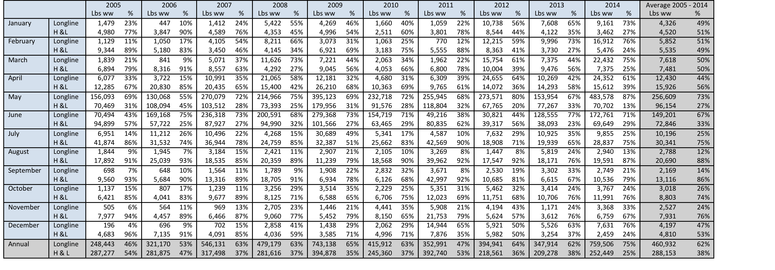

Table 5 is similar to Table 4 except that it combines all commercial landings of dolphin and compares them to recreational landings by month for the years 2005 through 2014. The 2005 – 2014 10% commercial/90% recreational allocations matches the revised allocation put in place in Dolphin Wahoo FMP Amendment 8.

Table 5. Dolphin landings by month/year by commercial and recreational sectors
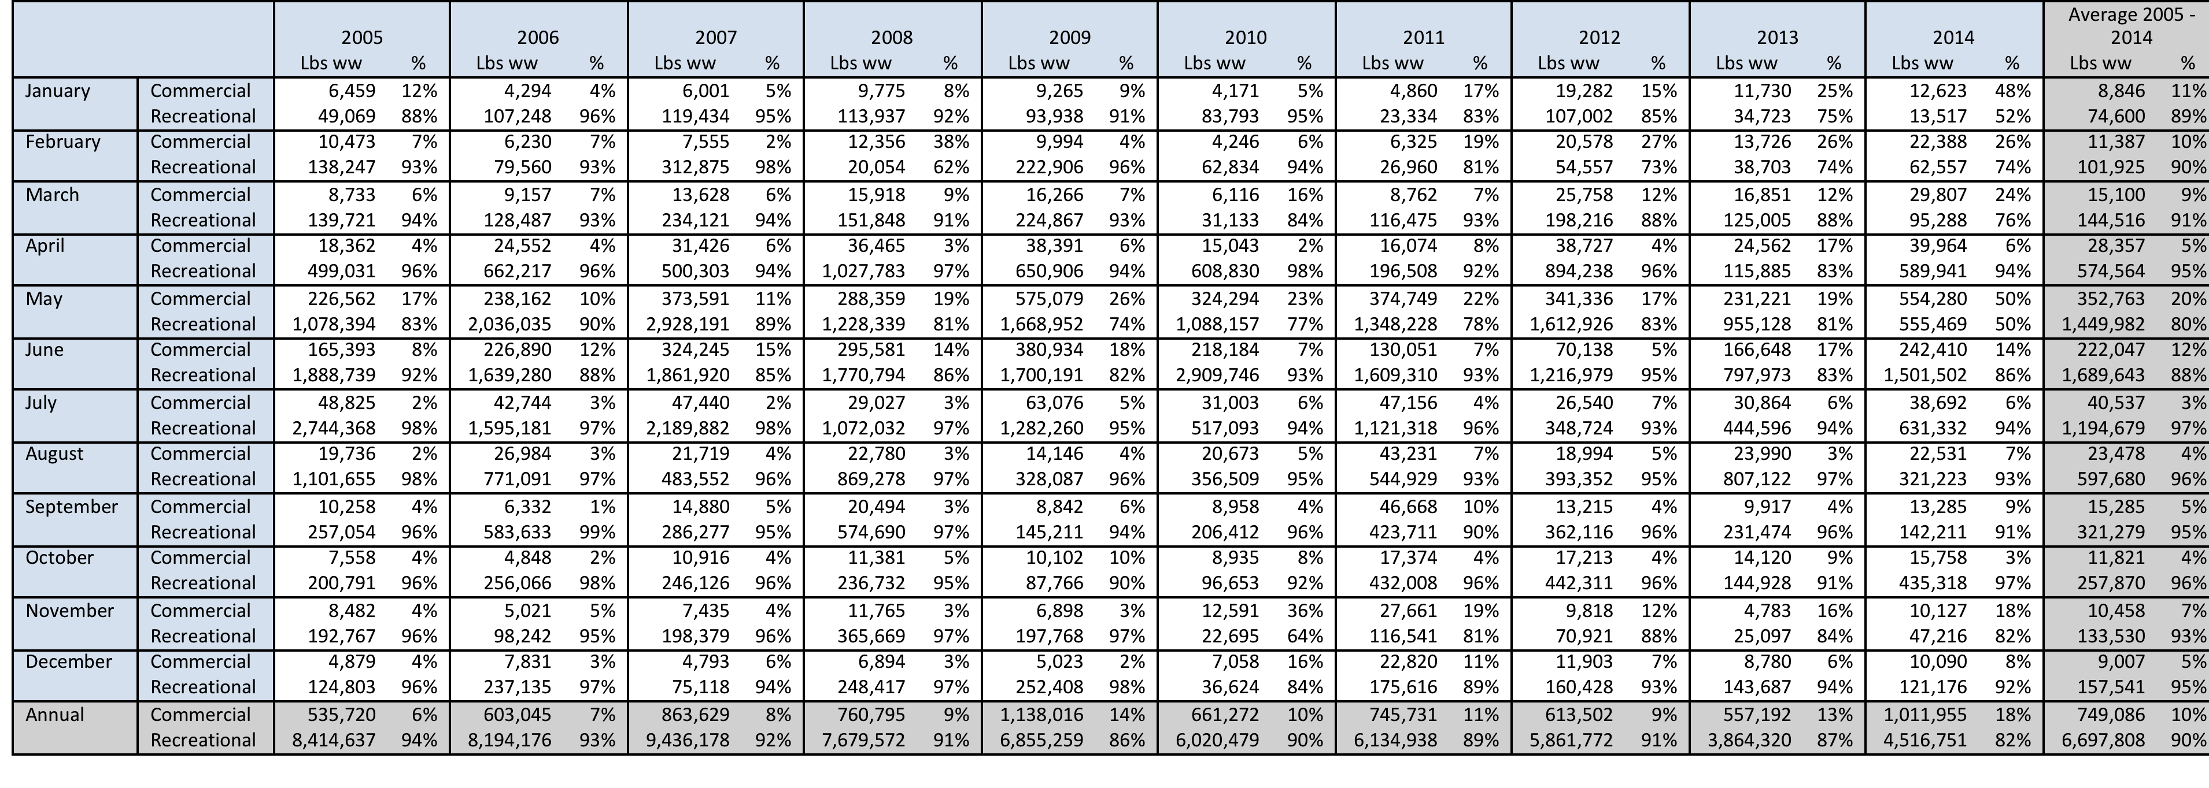

Table 6 is similar to Table 5 except that it compares commercial landings of yellowtail snapper with recreational landings by month for the years 2005 through 2014. The current allocations for yellowtail snapper are 52.56% commercial and 47.44% recreational. The commercial sector was closed for yellowtail snapper on 10/31/2015, it was not closed during the 2005 – 2014 time series used in Table 6. The recreational sector has not been closed for yellowtail snapper.

Table 3. Yellowtail snapper landings by month/year by commercial and recreational sectors
