Vision Blueprint Commercial Regulatory Amendment 27

Decision Document

Background
The Vision Blueprint COMMERCIAL Regulatory Amendment 27 to the Fishery Management Plan for the Snapper Grouper Fishery of the South Atlantic Region would address specific action items in the 2016-2020 Vision Blueprint for the Snapper Grouper Fishery (Vision Blueprint). The Vision Blueprint identifies the goals, objectives, strategies, and actions that support the vision for the snapper grouper fishery and centers around four goal areas - Science, Management, Communication, and Governance. During 2015, the Council prioritized action items that would be addressed through amendments to the Snapper Grouper Fishery Management Plan over the next five years. The Council chose to focus on actions that would address “seasonality” and “retention” in the fishery and began development of two amendments to address the commercial and recreational sectors, respectively. Vision Blueprint Regulatory Amendment 27 includes actions that would address commercial management measures.

Actions in this amendment
NOTE: Actions reflect guidance from the Council from June 2017:
- Action 1: Establish a commercial split season and modify the commercial trip limit for blueline tilefish
- Action 2: Establish a commercial split season for snowy grouper
- Action 3: Establish a commercial split season and modify commercial trip limit for greater amberjack
- Action 4: Establish a commercial split season and modify commercial trip limit for red porgy
- Action 5: Modify the commercial trip limit for vermilion snapper in the second season
- Action 6: Implement a commercial trip limit for the Other Jacks Complex
- Action 7: Modify the seasonal prohibition on commercial harvest and possession of shallow-water groupers
- Action 8: Remove the commercial minimum size limits for certain deep-water species
- Action 9: Reduce the commercial minimum size limit for gray triggerfish in the Exclusive Economic Zone off East Florida
- Action 10: Remove the commercial prohibition on the use of powerheads in the Exclusive Economic Zone off South Carolina

Objectives for this meeting
- Consider suggested changes to Purpose and Need and approve
- Consider suggested changes to actions and alternatives and approve or make modifications, as appropriate
- Provide rationale for inclusion or removal of actions/alternatives, as appropriate
- Approve timing of amendment development

Expected amendment timing

June 2017 Council reviewed actions and alternatives and preliminary analyses and provided guidance to staff. The Council did not approve the amendment for public hearings.

September 2017 Council reviews actions and alternatives and makes final changes. Council reviews, modifies as appropriate, and approves Purpose and Need.

December 2017 Council reviews analyses, selects preferred alternatives as appropriate, and approves for public hearings in January/February 2018

March 2018 Council reviews public comment, modifies the amendment as appropriate, and approves all actions.

June 2018 Council reviews and approves for formal review.

Purpose and need statement
From June 2017:
Purpose
The purpose of this amendment is to modify commercial regulations such as fishing seasons, trip limits, seasonal closures, and minimum size limits for species in the snapper grouper fishery.

Need
The need for this amendment is to lengthen commercial fishing seasons, improve access, minimize discard mortality, to improve compliance with the regulations, and aid in enforcement of regulations in the South Atlantic region.

IPT Recommendation:
Purpose
The purpose of this amendment is to increase commercial access to the snapper grouper fishery, minimize discards, and simplify regulations.

Need
The need for this amendment is to achieve optimum yield from the commercial component of the snapper grouper fishery and improve regulatory compliance and consistency to aid enforcement.

Committee Action:
MOTION:
ACCEPT IPT’S SUGGESTED EDITS AND APPROVE
APPROVED BY COMMITTEE

- DO NOT APPROVE THE IPT’S SUGGESTED EDITS
- COMMITTEE MAKES MODIFICATIONS TO PURPOSE AND NEED
- OTHERS?

Proposed Actions and Alternatives

Action 1. Establish a commercial split season and modify the commercial trip limit for blueline tilefish

Discussion:
In June 2017, the Committee discussed commercial split seasons for blueline tilefish and snowy grouper in conjunction since the two species co-occur and it is desirable to have their seasons aligned. In general, blueline tilefish and snowy grouper are important in the beginning of the year when shallow-water groupers are not available due to the 4-month seasonal closure. The Committee agreed that examining the historical distribution of commercial landings for these species by state would be very informative to select an appropriate range of alternatives for analysis. The Committee requested average commercial landings by state for 2006-2016 for blueline tilefish. Figure 1 presents the distribution of landings by state from 2004 through 2013. Figure 2 presents the percentage of blueline tilefish landings by state in the South Atlantic region from 2002 through 2016 (see Attachment 3b for more details).

On the issue of whether it would be best to delay changes in management for blueline tilefish until after the completion of SEDAR 50, some members thought that regional differences in accessibility would remain regardless of the result of the stock assessment and the Council should consider taking action now. The Council is scheduled to receive the results of the stock assessment in December 2017. In June, the Committee also discussed possibly modifying trip limits and/or implementing step-down(s) once a certain percentage of the ACL has been met. The Committee did not provide specific guidance pending further exploration of the landings distribution in the region. However, the Council chair contacted staff after the June meeting to suggest specific changes that the Committee could discuss in September (presented under Alternative 4). Table 1 presents predicted closure dates using two methodologies (details in Attachment 3b) for each of the alternatives.

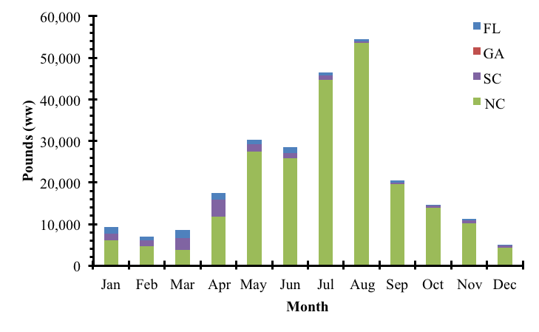
Figure 1. The average monthly South Atlantic blueline tilefish commercial landings by state from 2004-2013 in pounds whole weight. The years 2014-2016 were excluded due to closures.
Source: SERO with data from Southeast Fisheries Science Center commercial (5/2/2017) ACL dataset.

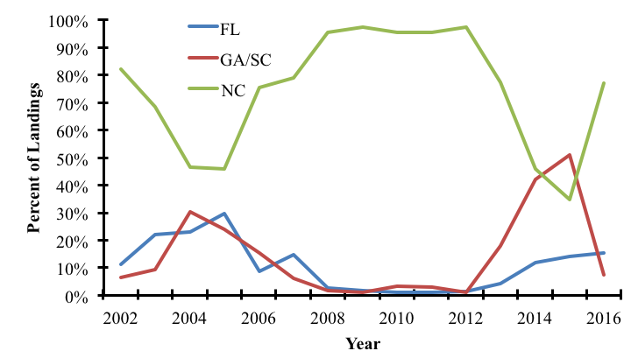
Figure 2. The percentage of annual South Atlantic blueline tilefish commercial landings by state from 2002-2016. Georgia and South Carolina were combined due to confidentiality concerns.
Source: SERO with data from Southeast Fisheries Science Center commercial (5/2/2017) ACL dataset.

Table 1. Projected mean and 95% lower and upper (L95, U95) confidence limits on projected commercial closure dates for blueline tilefish under different alternatives proposed for Action 1. Gray shading denotes alternatives that were not evaluated due to missing details in the proposed action.
 |  | Mean 2014-2016 |  |  | SARIMA
Alternative | Season | L95 | MEAN | U95 | L95 | MEAN | U95
Alt 1 | Jan-Dec |  | 7-Jul | 22-Apr |  | 13-Jul | 2-May
Alt 2a | Jan-June |  | No closure | 18-May |  | No closure | 16-May
 | July-Dec |  | 8-Aug | 18-Jul |  | 8-Aug | 20-Jul
Alt 2b | Jan-June |  | 10-May | 19-Mar |  | 23-May | 19-Mar
 | July-Dec |  | 24-Aug | 4-Aug |  | 27-Aug | 12-Aug
Alt 2c | Jan-June
 | July-Dec
Alt 3 | Jan-Dec
Alt 4a | Jan-Dec |  | 30-Jul | 16-Jun |  | 27-Jul | 14-Jun
Alt 4b | Jan-Dec |  | 24-Jul | 4-Jun |  | 23-Jul | 30-May
Alt 4c | Jan-Dec |  | 20-Jul | 9-Jun |  | 18-Jul | 5-Jun

Action Alternatives:
As discussed in June 2017:

Action 1. Establish a commercial split season for blueline tilefish

Alternative 1 (No Action). The commercial fishing year for blueline tilefish in the South Atlantic EEZ is from January 1 to December 31.

Alternative 2. Specify two commercial fishing seasons for blueline tilefish. Allocate the blueline tilefish commercial ACL into two quotas: XX% to the period January 1 through June 30 and YY% to the period July 1 through December 31. Any remaining quota from Season 1 would transfer to Season 2. Any remaining quota from Season 2 would not be carried forward.

Alternative 3. Specify two commercial fishing seasons for blueline tilefish. Allocate the blueline tilefish commercial ACL into two quotas: XX% to the period January 1 through ______ and YY% to the period ____ through December 31. Any remaining quota from Season 1 would transfer to Season 2. Any remaining quota from Season 2 would not be carried forward.

Snapper Grouper AP Recommendations:
- Commercial harvest of blueline and snowy need to be kept in line, especially important for fishery off the Carolinas after vermilion and gray triggerfish close. However, fishermen are also targeting blueline and snowy early in the year.
- Concern about ongoing assessment. Possibly wait to take action until after assessment results?
- MOTION: AP RECOMMENDS ALTERNATIVE 1, NO ACTION, ON SPLITTING THE COMMERCIAL SEASON FOR BLUELINE TILEFISH
APPROVED (UNANIMOUSLY)
- MOTION: CONSIDER A TRIP LIMIT STEP-DOWN/REDUCTION IN THE SNOWY AND BLUELINE TRIP LIMITS TO COINCIDE WITH OPENING OF SHALLOW-WATER GROUPER ON MAY 1. CONSIDER OTHER OPTIONS TO LENGTHEN SEASON (INCLUDING STEP-DOWN WHEN A CERTAIN PERCENTAGE OF THE ACL IS MET).
APPROVED (UNANIMOUSLY)

IPT Recommendations:
Action 1. Establish a commercial split season and modify the commercial trip limit for blueline tilefish

Alternative 1 (No Action). The commercial fishing year for blueline tilefish in the South Atlantic Exclusive Economic Zone is from January 1 to December 31. The commercial trip limit is 300 pounds gutted weight (lbs gw).

Alternative 2. Specify two commercial fishing seasons for blueline tilefish. Allocate the blueline tilefish commercial ACL into two quotas: 60% to the period January 1 through June 30 and 40% to the period July 1 through December 31. Any remaining quota from Season One would transfer to Season Two. Any remaining quota from Season Two would not be carried forward.
Sub-alternative 2a. Season 1 trip limit = 100 lbs gw, Season 2 trip limit = 300 lbs gw.
Sub-alternative 2b. Season 1 trip limit = 300 lbs gw, Season 2 trip limit = 100 lbs gw.
Sub-alternative 2c. Season 1 trip limit = XX lbs gw, Season 2 trip limit = XX lbs gw.

Alternative 3. Specify two commercial fishing seasons for blueline tilefish. Allocate the blueline tilefish commercial ACL into two quotas: XX% to the period January 1 through ______ and YY% to the period ____ through December 31. Any remaining quota from Season One would transfer to Season Two. Any remaining quota from Season Two would not be carried forward.

Alternative 4. Modify the commercial trip for blueline tilefish:
Sub-alternative 4a. 100 lbs gw from January 1 through April 30 and 300 lbs gw from May 1 through December 31
Sub-alternative 4b. 150 lbs gw from January 1 through April 30 and 300 lbs gw from May 1 through December 31
Sub-alternative 4c. 100 lbs gw from January 1 through April 30 and 400 lbs gw from May 1 through December 31

- There was some confusion as to whether sub-alternative 2b is adequate. The IPT requests clarification.
- Does the Committee wish to retain Alternative 3 for analysis and fill in percentages?

Committee Action:
- ACCEPT THE IPT’S SUGGESTED EDITS TO THE ACTION AND ALTERNATIVES
- DO NOT ACCEPT THE IPT’S SUGGESTED EDITS
- COMMITTEE MAKES MODIFICATIONS TO ACTION AND ALTERNATIVES
- PROVIDE CLARIFICATION AS REQUESTED BY THE IPT
- OTHERS?

DRAFT MOTION: CHANGE ALTERNATIVE 2 ACL PERCENTAGES TO 40%/60% AND REMOVE SUB-ALTERNATIVE 2B AND MODIFY Sub-alternative 2c. Season 1 trip limit = 150 lbs gw, Season 2 trip limit = 300 lbs gw
APPROVED BY COMMITTEE

MOTION: MOVE ALTERNATIVE 3 TO CONSIDERED BUT REJECTED APPENDIX
Alternative 3. Specify two commercial fishing seasons for blueline tilefish. Allocate the blueline tilefish commercial ACL into two quotas: XX% to the period January 1 through _____ and YY% to the period ____ through December 31. Any remaining quota from Season One would transfer to Season Two. Any remaining quota from Season Two would not be carried forward.
APPROVED BY COMMITTEE

MOTION: ADD SUB-ALTERNATIVE TO ALTERNATIVE 4 TO CONSIDER 100 POUNDS JAN-JUNE AND 300 POUNDS JULY-DEC
APPROVED BY COMMITEE

Action 2. Establish a commercial split season for snowy grouper

Discussion:
In June 2017, the action was presented to the Committee as Action 3. The Committee requested it be re-numbered as Action 2. Remarks under the discussion for Action 1 above are applicable here. The Committee should consider modifying alternatives for snowy grouper based on their modifications to alternatives for blueline tilefish under Action 1.

In June 2017, the Committee requested average commercial landings by state for 2006-2016 for snowy grouper. However, there was concern that the effect of regulatory changes in 2006 would be excluded unless a longer time-series were examined (Amendment 13C implemented snowy grouper trip limit of 275 lbs in 2006, 175 lbs in 2007 and 100 lbs in 2008). Hence, Figure 3 below presents average monthly landings of snowy grouper by state from 2002 through 2016. The years 2006 and 2012-2016 were excluded due to closures, however. Figure 4 presents the percentage of snowy grouper landings by state for the same time period (refer to Attachment 3b for additional details). Table 2 shows predicted closures for commercial snowy grouper harvest based on two methodologies (refer to Attachment 3b for details). To further inform the distribution of commercial landings, Figure 5 presents the number of vessels reporting landings of snowy grouper by state and year from 2006 through 2016.

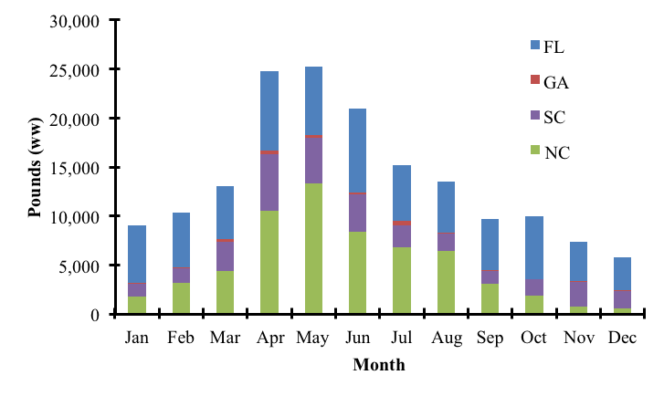
Figure 3. The average monthly commercial South Atlantic snowy grouper landings by state from 2002-2005 and 2007-2011 in pounds whole weight. The years 2006 and 2012-2016 were excluded due to closures. Source: SERO with data from Southeast Fisheries Science Center commercial (5/2/2017) ACL dataset.

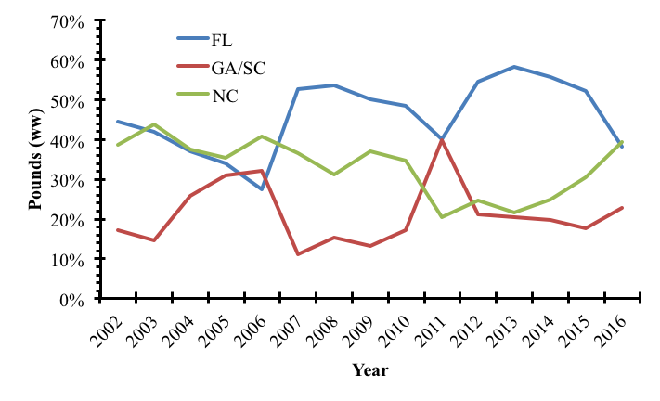
Figure 4. The percentage of annual South Atlantic snowy grouper commercial landings by state from 2002-2016. Georgia and South Carolina were combined due to confidentiality concerns.
Source: SERO with data from Southeast Fisheries Science Center commercial (5/2/2017) ACL dataset.

Table 2. Projected mean and 95% lower and upper (L95, U95) confidence limits on quota closure dates for snowy grouper under different alternatives proposed for Action 2. Gray shading denotes alternatives that were not evaluated due to missing details in the proposed action.
Alternative | Season | L95 | MEAN | U95 | L95 | MEAN | U95
Alt 1 | Jan-Dec | No closure | 21-Sep | 1-Jul | 8-Nov | 19-Mar | 14-Feb
Alt 2 | Jan-June | No closure | 21-Jun | 8-May | No closure | 18-Feb | 27-Jan
 | July-Dec | No closure | 26-Sep | 27-Sep | 8-Nov | 28-Jul | 15-Jul
Alt 3 | Jan-?
 | ?-Dec
Source: SERO

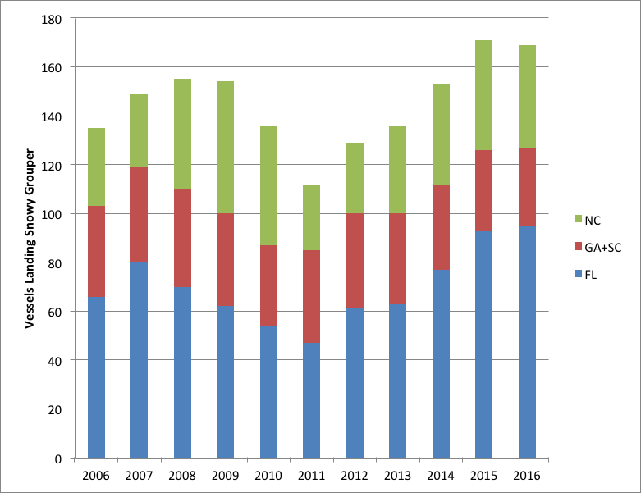
Figure 5. Number of vessels reporting landings of snowy grouper, by state and year. Note that Georgia and South Carolina have been aggregated to protect confidentiality.
Source: SERO

Action Alternatives:
As discussed in June 2017:

Action 3. Establish a commercial split season for snowy grouper

Alternative 1 (No Action). The commercial fishing year for snowy grouper in the South Atlantic federal waters is from January 1 to December 31.

Alternative 2. Specify two commercial fishing seasons for snowy grouper. Allocate the snowy grouper commercial ACL into two quotas: XX% to the period January 1 through June 30 and YY% to the period July 1 through December 31. Any remaining quota from Season 1 would transfer to Season 2. Any remaining quota from Season 2 would not be carried forward.

Alternative 3. Specify two commercial fishing seasons for snowy grouper. Allocate the snowy grouper commercial ACL into two quotas: XX% to the period January 1 through ______ and YY% to the period ____ through December 31. Any remaining quota from Season 1 would transfer to Season 2. Any remaining quota from Season 2 would not be carried forward.

Snapper Grouper AP Recommendations:
- AP reiterates that snowy and blueline seasons, if implemented, should be in line.
- MOTION: CONSIDER A TRIP LIMIT STEP-DOWN/REDUCTION IN THE SNOWY AND BLUELINE TRIP LIMITS TO COINCIDE WITH OPENING OF SHALLOW-WATER GROUPER ON MAY 1. CONSIDER OTHER OPTIONS TO LENGTHEN SEASON (INCLUDING STEP-DOWN WHEN A CERTAIN PERCENTAGE OF THE ACL IS MET).
APPROVED (UNANIMOUSLY)

IPT Recommendations:
Action 2. Establish a commercial split season for snowy grouper

Alternative 1 (No Action). The commercial fishing year for snowy grouper in the South Atlantic federal waters Exclusive Economic Zone is from January 1 to December 31.

Alternative 2. Specify two commercial fishing seasons for snowy grouper. Allocate the snowy grouper commercial ACL into two quotas: 60% to the period January 1 through June 30 and 40% to the period July 1 through December 31. Any remaining quota from Season One would transfer to Season Two. Any remaining quota from Season Two would not be carried forward.

Alternative 3. Specify two commercial fishing seasons for snowy grouper. Allocate the snowy grouper commercial ACL into two quotas: XX% to the period January 1 through ______ and YY% to the period ____ through December 31. Any remaining quota from Season One would transfer to Season Two. Any remaining quota from Season Two would not be carried forward.

- Consider changes to Action 1 for blueline tilefish when considering changes to range of alternatives under Action 2.
- Wish to consider 60/40 split season Jan-April and May-December to match blueline trip limit alternatives?

Committee Action:
- ACCEPT THE IPT’S SUGGESTED EDITS TO THE ACTION AND ALTERNATIVES
- DO NOT ACCEPT THE IPT’S SUGGESTED EDITS
- COMMITTEE MAKES MODIFICATIONS TO ACTION AND ALTERNATIVES
- OTHERS?

MOTION: MODIFY ALTERNATIVE 3 AS FOLLOWS:
Alternative 3. Specify two commercial fishing seasons for snowy grouper. Allocate the snowy grouper commercial ACL into two quotas: 70% to the period January 1 through JUNE 30 and 30% to the period JULY 1 through December 31. Any remaining quota from Season 1 would transfer to Season 2. Any remaining quota from Season 2 would not be carried forward.
APPROVED BY COMMITTEE

Action 3. Establish a commercial split season and modify commercial trip limit for greater amberjack

Discussion:
The Committee requested the action be re-numbered as Action 3 and requested information on the distribution of commercial landings by state, similar to blueline tilefish and snowy grouper (pending data from SEFSC as of 8/14/17). The Committee requested to add an alternative to reduce the trip limit to 1,000 lbs and implement a step-down (750-500 lbs) when 75% of the commercial ACL is met or is projected to be met. Include options for timeframe(s) after which the step-down would not apply.

Action Alternatives:
As discussed in June 2017:

Action 4. Establish a commercial split season for greater amberjack

Alternative 1 (No Action). The commercial fishing year for greater amberjack in the South Atlantic federal waters is from March 1 to the end of February. During April, commercial harvest is limited to one per person per day or one per person per trip, whichever is more restrictive.

Alternative 2. Specify two commercial fishing seasons for greater amberjack. Allocate the commercial ACL for greater amberjack into two quotas: XX% to the period March 1 through August 31 and YY% to the period September 1 through the end of February. Any remaining quota from Season 1 would transfer to Season 2. Any remaining quota from Season 2 would not be carried forward. Commercial harvest would still be prohibited annually in April.

Alternative 3. Specify two commercial fishing seasons for greater amberjack. Allocate the commercial ACL for greater amberjack into two quotas: XX% to the period March 1 through ______ and YY% to the period ______ through the end of February. Any remaining quota from Season 1 would transfer to Season 2. Any remaining quota from Season 2 would not be carried forward. Commercial harvest would still be prohibited annually in April.

Snapper Grouper AP Recommendations:
- AP supports exploring use of commercial split season to lengthen amberjack harvest.
- Consider trip limit reduction or step-down to achieve objective of lengthening season and improving access.

IPT Recommendations:
Action 3. Establish a commercial split season and modify commercial trip limit for greater amberjack

Alternative 1 (No Action). The commercial fishing year for greater amberjack in the South Atlantic Exclusive Economic Zone is from March 1 to the end of February. During April, commercial harvest is limited to one per person per day or one per person per trip, whichever is more restrictive. The commercial trip limit is 1,200 pounds whole weight (lbs ww).

Alternative 2. Specify two commercial fishing seasons for greater amberjack. Allocate the commercial ACL for greater amberjack into two quotas: XX% to the period March 1 through August 31 and XX% to the period September 1 through the end of February. Any remaining quota from Season One would transfer to Season Two. Any remaining quota from Season Two would not be carried forward.
Sub-alternative 2a. Season 1 trip limit = 1,200 lbs ww, Season 2 trip limit = 1,000 lbs ww. Season 2 would include a trip limit step-down to 750 lbs ww when 75% of the ACL is met or projected to be met.
Sub-alternative 2b. Season 1 trip limit = 1,200 lbs ww, Season 2 trip limit = 1,000 lbs ww. Season 2 would include a trip limit step-down to 500 lbs ww when 75% of the ACL is met or projected to be met.
Sub-alternative 2c. Season 1 trip limit = XX lbs ww, Season 2 trip limit = XX lbs ww.

Alternative 3. Specify two commercial fishing seasons for greater amberjack. Allocate the commercial ACL for greater amberjack into two quotas: XX% to the period March 1 through ______ and YY% to the period ______ through the end of February. Any remaining quota from Season 1 would transfer to Season 2. Any remaining quota from Season 2 would not be carried forward. Commercial harvest would still be prohibited annually in April.

- Clarification on range of alternatives under Alternative 2. Does the Committee also want to consider modifications of trip limit without splitting the season?
- Please clarify whether the intent is to retain the harvest restrictions in the month of April.

Committee Action:
- ACCEPT THE IPT’S SUGGESTED EDITS TO THE ACTION AND ALTERNATIVES
- DO NOT ACCEPT THE IPT’S SUGGESTED EDITS
- COMMITTEE MAKES MODIFICATIONS TO ACTION AND ALTERNATIVES
- PROVIDE CLARIFICATION AS REQUESTED BY THE IPT
- OTHERS?

MOTION: MODIFY SUB-ALTERNATIVE 2C TO INCLUDE A 1,000 TRIP LIMIT IN BOTH SEASONS WITH A STEP-DOWN TO 500 POUNDS WHEN 75% OF THE COMMERCIAL ACL HAS BEEN MET IN EACH SEASON
APPROVED BY COMMITTEE

INCLUDE LANGUAGE IN SUB-ALTERNATIVES THAT WOULD SPECIFY A STEP DOWN WOULD NOT OCCUR IF …(LOOK AT MACKEREL)

MOTION: ALLOCATE THE COMMERCIAL ACL 50/50 TO EACH SEASON UNDER ALTERNATIVE 2.
APPROVED BY COMMITTEE

MOTION: ADD ALTERNATIVE 3 TO CONSIDER A 60/40 SPLIT OF THE COMMERCIAL ACL BETWEEN SEASONS WITH THE SAME SUB-ALTERNATIVES AS UNDER ALTERNATIVE 2
APPROVED BY COMMITTEE

Action 4. Establish a commercial split season and modify commercial trip limit for red porgy

Discussion:
Guidance from June 2017 was to re-number the action as Action 4, include an alternative that would split the commercial ACL 50/50 during two seasons (January through April and May through December) with rollover of uncaught ACL from first to second season and a range of alternatives up to 60 fish in season one and 120 fish in season two. Analyses for proposed Alternative 3 are underway but could not be completed in time for the September Briefing Book. The Committee also requested average commercial landings by state from 2006 through 2016. Figure 6 shows average monthly landings of red porgy by state from 2005 through 2012 and 2014 through 2016 (2013 was excluded due to closure). Figure 7 presents percentage of red porgy commercial landings by state from 2002 through 2016.

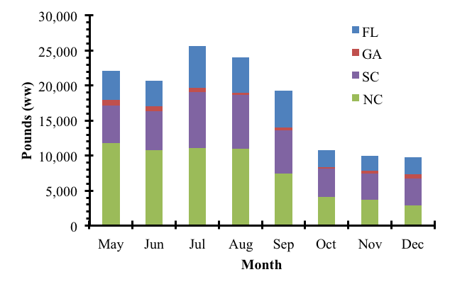
Figure 6. The average monthly South Atlantic red porgy commercial landings by state from 2005-2012 and 2014-2016 in pounds whole weight. The year 2013 was excluded due to a closure. Data from the months of January to April were not available due to the seasonal closure in place since 2000.
Source: SERO with data from Southeast Fisheries Science Center commercial (5/2/2017) ACL dataset.

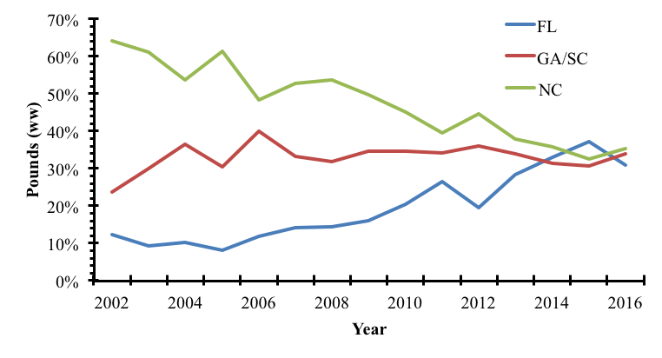
Figure 7. The percentage of annual South Atlantic red porgy commercial landings by state from 2002-2016. Georgia and South Carolina were combined due to confidentiality concerns.
Source: SERO with data from Southeast Fisheries Science Center commercial (5/2/2017) ACL dataset.

Action Alternatives:
As discussed in June 2017:

Action 2. Establish a commercial split season for red porgy and modify commercial retention limit

Alternative 1 (No Action). The commercial fishing year for red porgy in the South Atlantic federal waters is from January 1 to December 31. During January, February, March, and April, the seasonal harvest limit of red porgy in or from South Atlantic federal waters is three per person per day or three per person per trip, whichever is more restrictive. From May 1 through December 31, the trip limit is 120 fish.

Alternative 2. Maintain the annual January 1 to April 30 seasonal harvest limit for red porgy.
Sub-Alternative 2a. Allocate the directed commercial red porgy ACL into two quotas: 50% to the period January 1 through June 30 and 50% to the period July 1 through December 31. Any remaining quota from Season 1 would transfer to Season 2. Any remaining quota from Season 2 would not be carried forward.
Sub-alternative 2b. Allocate the directed commercial red porgy ACL into two quotas: XX% to the period January 1 through ______ and YY% to the period ____ through December 31. Any remaining quota from Season 1 would transfer to Season 2. Any remaining quota from Season 2 would not be carried forward.

Alternative 3. Remove the annual January 1 to April 30 seasonal harvest limit for red porgy.
Sub-Alternative 3a. Allocate the directed commercial red porgy ACL into two quotas: 50% to the period January 1 through June 30 and 50% to the period July 1 through December 31. Any remaining quota from Season 1 would transfer to Season 2. Any remaining quota from Season 2 would not be carried forward.
Sub-Alternative 3b. Allocate the directed commercial red porgy ACL into two quotas: XX% to the period January 1 through ______ and YY% to the period ____ through December 31. Any remaining quota from Season 1 would transfer to Season 2. Any remaining quota from Season 2 would not be carried forward.

Snapper Grouper AP Recommendations:
- Discard issue exists but there is also a market issue. Red porgy is important for the market when vermilion snapper and gray triggerfish close.
- Concern about moving forward with management changes ahead of the stock assessment.
- Consider trip limit modification to address discards and still consider split season. Consider a low trip limit (bycatch allowance) when vermilion and triggerfish are still open.
- MOTION: CONSIDER TRIP LIMIT MODIFICATION TO ADDRESS DISCARDS AND STILL CONSIDER SPLIT SEASON. ANALYZE A RANGE OF TRIP LIMIT OPTIONS: 30 FISH TO 60 FISH IN SEASON 1 (DURING THE MONTHS OF THE SPAWNING CLOSURE).
APPROVED (UNANIMOUSLY)

IPT Recommendations:
Action 4. Establish a commercial split season and modify commercial trip limit for red porgy

Alternative 1 (No Action). The commercial fishing year for red porgy in the South Atlantic Exclusive Economic Zone is from January 1 to December 31. During January through April each year, the seasonal harvest limit of red porgy in or from South Atlantic Exclusive Economic Zone is three per person per day or three per person per trip, whichever is more restrictive. From May 1 through December 31, the trip limit is 120 fish.

Alternative 2. Maintain the annual January 1 to April 30 seasonal harvest limit for red porgy.
Sub-Alternative 2a. Allocate the directed commercial red porgy ACL into two quotas: 50% to the period January 1 through June 30 and 50% to the period July 1 through December 31. Any remaining quota from Season One would transfer to Season Two. Any remaining quota from Season Two would not be carried forward.
Sub-alternative 2b. Allocate the directed commercial red porgy ACL into two quotas: XX% to the period January 1 through ______ and YY% to the period ____ through December 31. Any remaining quota from Season One would transfer to Season Two. Any remaining quota from Season Two would not be carried forward.

Alternative 3. Remove the annual January 1 to April 30 seasonal harvest limit for red porgy.
Sub-Alternative 3a. Allocate the directed commercial red porgy ACL into two quotas: 50% to the period January 1 through June 30 and 50% to the period July 1 through December 31. Any remaining quota from Season 1 would transfer to Season 2. Any remaining quota from Season 2 would not be carried forward.
Sub-Alternative 3b. Allocate the directed commercial red porgy ACL into two quotas: XX% to the period January 1 through ______ and YY% to the period ____ through December 31. Any remaining quota from Season 1 would transfer to Season 2. Any remaining quota from Season 2 would not be carried forward.
Alternative 3. Specify two commercial fishing seasons for red porgy. Allocate the commercial red porgy ACL into two quotas: 50% to the period January 1 through April 30 and 50% to the period May 1 through December 31. Any remaining quota from Season One would transfer to Season Two. Any remaining quota from Season Two would not be carried forward. Modify the annual January 1 to April 30 seasonal harvest limit for red porgy.
Sub-alternative 3a. 30 fish
Sub-alternative 3b. 40 fish
Sub-alternative 3c. 50 fish
Sub-alternative 3d. 60 fish

- Please clarify whether sub-alternatives are needed for Alternative 2.
- Please clarify whether Alternative 3 should be removed and structured as presented and whether it captures the intent or requires modification.

Committee Action:
- ACCEPT THE IPT’S SUGGESTED EDITS TO THE ACTION AND ALTERNATIVES
- DO NOT ACCEPT THE IPT’S SUGGESTED EDITS
- COMMITTEE MAKES MODIFICATIONS TO ACTION AND ALTERNATIVES
- PROVIDE CLARIFICATION AS REQUESTED BY THE IPT
- OTHERS?

MOTION: MOVE ALTERNATIVE 2 UNDER ACTION 4 TO THE CONSIDERED BUT REJECTED APPENDIX
APPROVED BY COMMITTEE

MOTION: MODIFY ALTERNATIVE 3 AS FOLLOWS:
Alternative 3. Specify two commercial fishing seasons for red porgy. Allocate the commercial red porgy ACL into two quotas: 50% 30% to the period January 1 through April 30 and 50% 70% to the period May 1 through December 31. Any remaining quota from Season One would transfer to Season Two. Any remaining quota from Season Two would not be carried forward. Modify the annual January 1 to April 30 seasonal harvest limit for red porgy.
Sub-alternative 3a. 30 fish
Sub-alternative 3b. 45 fish
Sub-alternative 3c. 50 fish
Sub-alternative 3d. 60 fish
APPROVED BY COMMITTEE

MOTION: ADD ALTERANTIVE TO SPLIT COMMERCIAL ACL 50/50 JAN-APRIL AND MAY-DEC AND ADD SUB-ALTERNATIVES OF 30, 60, AND 120 FISH FOR JAN-APRIL.
APPROVED BY COMMITTEE (3 OPPOSED)

Action 5. Modify the commercial trip limit for vermilion snapper in the second season

Discussion:
In June 2017, the Committee requested that an additional alternative be analyzed that would implement a 750-pound trip limit for both seasons without a step-down. This is reflected in Alternative 4 under “ITP Recommendations”. Table 3 below presents projected season closure dates under the various alternatives (refer to Attachment 3b for detailed methodology)

Table 3. Projected mean and 95% lower and upper (L95, U95) confidence limits trip limit reduction and projected quota closure dates for vermilion snapper under different alternatives proposed for Action 5.
 | TRIP LIMIT REDUCED
 | Last 3 Years |  |  |  | SARIMA
Alternative | L95_Last3 | Last3 | U95_Last3 |  | L95_SARIMA |  | SARIMA |  | U95_SARIMA
1 | 18-Sep | 25-Aug | 13-Aug |  | 4-Oct |  | 22-Aug |  | 4-Aug
2 | 28-Sep | 1-Sep | 18-Aug |  | 18-Oct |  | 30-Aug |  | 9-Aug
3 | n/a
4 | n/a
 | FISHERY CLOSED
 | Last 3 Years |  |  |  |  | SARIMA
Alternative | L95_Last3 | Last3 |  | U95_Last3 |  | L95_SARIMA |  | SARIMA |  | U95_SARIMA
1 | 25-Oct | 16-Sep |  | 30-Aug |  |  |  | 15-Sep |  | 23-Aug
2 | 8-Nov | 23-Sep |  | 4-Sep |  |  |  | 23-Sep |  | 28-Aug
3 | 12-Dec | 11-Oct |  | 17-Sep |  |  |  | 10-Oct |  | 9-Sep
4 | 29-Oct | 18-Sep |  | 31-Aug |  |  |  | 17-Sep |  | 23-Aug
Source: SERO

Action Alternatives:
As discussed in June 2017:

Alternative 1 (No Action). The commercial trip limit for vermilion snapper in the South Atlantic federal waters is 1,000 pounds gutted weight (lbs gw) and the commercial ACL is split equally between two six-month seasons. For both seasons, when 75% of the vermilion snapper seasonal quota is met or is projected to be met, the trip limit is reduced to 500 lbs gw. Any remaining quota from Season 1 transfers to Season 2. Any remaining quota from Season 2 is not carried forward.

Alternative 2. Implement a 750 lbs gw vermilion snapper commercial trip limit for the second season (July 1 through December 31). The commercial trip limit is reduced to 500 lbs gw when 75% of the second season quota is met or is projected to be met.

Alternative 3. Remove the step-down to 500 lbs gw when 75% of the seasonal quota is met or projected to be met, and implement a 500 lbs gw vermilion snapper commercial trip limit for the second season (July 1 through December 31).

Snapper Grouper AP Recommendations:
- AP supports exploring alternatives as presented.
- Perhaps also consider trip limit reduction in first season as well (although some AP members stated concern about weather being a factor in some areas that would disadvantage some fishermen at a lower trip limit than the current one. Also there are not that many species available for market during first season).
- MOTION: AP RECOMMENDS ALTERNATIVE 2
Alternative 2. Implement a 750 lbs gw vermilion snapper commercial trip limit for the second season (July 1 through December 31). The commercial trip limit is reduced to 500 lbs gw when 75% of the second season quota is met or is projected to be met.
APPROVED (2 ABSTENTIONS)

IPT Recommendations:
Alternative 1 (No Action). The commercial trip limit for vermilion snapper in the South Atlantic Exclusive Economic Zone is 1,000 pounds gutted weight (lbs gw) and the commercial annual catch limit is split equally between two 6-month seasons. For both seasons, when 75% of the vermilion snapper seasonal quota is met or is projected to be met, the trip limit is reduced to 500 lbs gw. Any remaining quota from Season One transfers to Season Two. Any remaining quota from Season Two is not carried forward.

Alternative 2. Implement a 750 lbs gw vermilion snapper commercial trip limit for the second season (July 1 through December 31). The commercial trip limit is reduced to 500 lbs gw when 75% of the second season quota is met or is projected to be met. Retain the management measures in the first season (January 1 through June 30). For the second season (July 1 through December 31), change the commercial trip limit to 750 lbs gw and retain the trip limit step down to 500 lbs gw when 75% of the second season quota is met or projected to be met.

Alternative 3. Remove the step-down to 500 lbs gw when 75% of the seasonal quota is met or projected to be met, and implement a 500 lbs gw vermilion snapper commercial trip limit for the second season (July 1 through December 31). Retain the management measures in the first season (January 1 through June 30). For the second season (July 1 through December 31), change the commercial trip limit to 500 lbs gw and remove the trip limit step down to 500 lbs gw when 75% of the seasonal quota is met or projected to be met.

Alternative 4. Change the commercial trip limits for both seasons (January 1 through June 30; July 1 through December 31) to 750 lbs gw and remove the Season Two trip limit step-down when 75% of the seasonal quota is met or projected to be met.

Committee Action:
MOTION: ACCEPT THE IPT’S SUGGESTED EDITS TO THE ALTERNATIVES UNDER ACTION 5
APPROVED BY COMMITTEE

- DO NOT ACCEPT THE IPT’S SUGGESTED EDITS
- COMMITTEE MAKES MODIFICATIONS TO ALTERNATIVES
- OTHERS?

Action 6. Implement a commercial trip limit for the Other Jacks Complex

Discussion:
In June 2017 the Committee requested revising the alternatives to denote gutted weight instead of whole weight.

Action Alternatives:
As discussed in June 2017:

Alternative 1 (No Action). There is no commercial trip limit for the Other Jacks Complex (lesser amberjack, almaco jack, and banded rudderfish).

Alternative 2. Establish a commercial trip limit for the Other Jacks Complex.
Sub-alternative 2a. 500 pounds whole weight (lbs ww)
Sub-alternative 2b. 400 lbs ww
Sub-alternative 2c. 300 lbs ww

Alternative 3. Establish a commercial trip limit for almaco jack.
Sub-alternative 3a. 500 lbs ww
Sub-alternative 3b. 400 lbs ww
Sub-alternative 3c. 300 lbs ww

Snapper Grouper AP Recommendations:
- AP reiterates concern over almaco Jack. AP had previously recommended removing almaco from the Complex and implementing a trip limit on that species.
- Analysis should include season length under no trip limit and under proposed trip limits.
- If possible, break down landings by species to determine whether a single species is driving the harvest.

IPT Recommendations:
Alternative 1 (No Action). There is no commercial trip limit for the Other Jacks Complex (lesser amberjack, almaco jack, and banded rudderfish).

Alternative 2. Establish a commercial trip limit for the Other Jacks Complex.
Sub-alternative 2a. 500 pounds gutted weight
Sub-alternative 2b. 400 pounds gutted weight
Sub-alternative 2c. 300 pounds gutted weight

Alternative 3. Establish a commercial trip limit for almaco jack only.
Sub-alternative 3a. 500 pounds gutted weight
Sub-alternative 3b. 400 pounds gutted weight
Sub-alternative 3c. 300 pounds gutted weight
- There can be identification issues with Jacks species. Removing almaco jack (~80% of landings) would require a plan amendment.

Committee Action:

MOTION: ACCEPT THE IPT’S SUGGESTED EDITS TO THE ALTERNATIVES UNDER ACTION 6
APPROVED BY COMMITTEE

- DO NOT ACCEPT THE IPT’S SUGGESTED EDITS
- COMMITTEE MAKES MODIFICATIONS TO ALTERNATIVES
- OTHERS?

MOTION: UNDER EACH SUB-ALTERNATIVE OF ALTERANTIVE 2 INCLUDE A TRIP LIMIT STEP DOWN TO 50% OF THE TRIP LIMIT ONCE 75% OF THE ACL HAS BEEN MET
APPROVED BY COMMITTEE

MOTION: MOVE ALTERNATIVE 3 TO THE CONSIDERED BUT REJECTED APPENDIX
APPROVED BY COMMITTEE

DRAFT MOTION: ADD AN ACTION TO IMPLEMENT A MINIMUM SIZE LIMIT FOR ALMACO JACK. INCLUDE RANGE OF 20-26 INCHES FORK LENGTH
APPROVED BY COMMITEE
***GUIDANCE FOR IPT TO ASSIST WITH RANGE***

Action 7. Modify the seasonal prohibition on commercial harvest and possession of shallow-water groupers

Discussion:
In June 2017 the Committee requested the same modifications to this action as in Vision Blueprint Regulatory Amendment 26:
- Move Alternative 2 and its sub-alternatives to Appendix A (Prohibit recreational harvest and possession of shallow-water grouper species seasonally by area)
- Retain Alternative 4 (prohibit recreational harvest of black grouper) but specify area south of 28 degrees
- Modify Alternative 5 as presented below.
In addition, the Committee wanted to explore a trip limit for gag (100-300 lbs) during the month of April as an additional sub-alternative to Alternative 2.

Action Alternatives:

As discussed in June 2017:

Alternative 1 (No Action). Commercial harvest and possession of shallow-water groupers (gag, black grouper, scamp, red grouper, yellowfin grouper, yellowmouth grouper, red hind, rock hind, graysby, and coney) is prohibited annually in the South Atlantic federal waters from January 1 through April 30.

Alternative 2. Prohibit commercial harvest and possession of shallow-water grouper species annually by area:
Sub-alternative 2a. In federal waters off East Florida from the Georgia/Florida state boundary south to the end of the SAFMC’s jurisdiction), the closure applies (month) to (month).
Sub-alternative 2b. In federal waters off Georgia and the Carolinas from the Georgia/South Carolina border north to the North Carolina/Virginia border, the closure applies (month) to (month)

Alternative 3. Prohibit commercial harvest and possession of shallow-water grouper species (excluding black grouper) south of 28° North latitude (approximately off Palm Bay, Florida):
Sub-alternative 3a. January – March (3 months)
Sub-alternative 3b. February – March (2 months)
Sub-alternative 3c. February – April (3 months)
Sub-alternative 3d. February – May (4 months)

Alternative 4. Prohibit commercial harvest and possession of black grouper in federal waters off (specify area based on Alternative 2a above?)
Sub-alternative 4a. January – March (3 months)
Sub-alternative 4b. January
Sub-alternative 4c. February
Sub-alternative 4d. March

Alternative 5. Prohibit commercial harvest and possession of red grouper in federal waters off (specify area based on Alternative 2b above?)
Sub-alternative 5a. January – May (5 months)
Sub-alternative 5b. February – May (4 months)
Sub-alternative 5c. March – June (4 months)

Snapper Grouper AP Recommendations:
MOTION: AP RECOMENDS ALTERNATIVE 1, NO ACTION, FOR MODIFYING THE SHALLOW WATER GROUPER CLOSURE FOR THE COMMERCIAL SECTOR
APPROVED (UNANIMOUSLY)

IPT Recommendations:
Alternative 1 (No Action). Commercial harvest and possession of shallow-water groupers (gag, black grouper, scamp, red grouper, yellowfin grouper, yellowmouth grouper, red hind, rock hind, graysby, and coney) is prohibited annually in the South Atlantic federal waters Exclusive Economic Zone from January 1 through April 30.

Alternative 2. Maintain seasonal prohibition on commercial harvest of shallow-water groupers annually from January 1 to April 30 north of 28 degrees North latitude. Prohibit commercial harvest and possession of shallow-water grouper species (gag, scamp, red grouper, yellowfin grouper, yellowmouth grouper, red hind, rock hind, graysby, and coney) (excluding black grouper) south of 28° North latitude (approximately off Palm Bay, Florida):
Sub-alternative 2a. January – March (three months)
Sub-alternative 2b. February – March (two months)
Sub-alternative 2c. February – April (three months)
Sub-alternative 2d. February – May (four months)

Alternative 3. Maintain seasonal prohibition on commercial harvest of shallow-water groupers (excluding gag) annually from January 1 through April 30. Commercial harvest of gag is prohibited from January 1 through April 30 MARCH 31 each year. Specify a trip limit for gag during April.
Sub-alternative 3a. 100 pounds gutted weight
Sub-alternative 3b. 200 pounds gutted weight
Sub-alternative 3c. 300 pounds gutted weight

Alternative 4. Maintain seasonal prohibition on commercial harvest of shallow-water groupers annually from January 1 to April 30 north of 28 degrees North latitude. Prohibit commercial harvest and possession of black grouper in federal waters the Exclusive Economic Zone south of 28 degrees North Latitude:
Sub-alternative 4a. January – March (three months)
Sub-alternative 4b. January
Sub-alternative 4c. February
Sub-alternative 4d. March

Alternative 5. Maintain seasonal prohibition on recreational harvest of shallow-water groupers annually from January 1 to April 30 in the Exclusive Economic Zone off Georgia and east Florida. Prohibit COMMERCIAL harvest and possession of red grouper in federal waters the Exclusive Economic Zone off North Carolina and South Carolina
Sub-alternative 5a. January – May (five months)
Sub-alternative 5b. February – May (four months)
Sub-alternative 5c. March – June (four months)

- Suggest structuring trip limit alternatives for gag during April as separate alternative as shown above instead of sub-alternative to Alternative 2 as Committee requested.
- Gag trip limit in gutted weight or whole weight?
- Provide rationale for significance of 28 degrees North latitude (existing regulatory boundary for circle hook requirement?).

Committee Action:
- ACCEPT THE IPT’S SUGGESTED EDITS TO THE ALTERNATIVES
- DO NOT ACCEPT THE IPT’S SUGGESTED EDITS
- COMMITTEE MAKES MODIFICATIONS TO THE ALTERNATIVES
- PROVIDE CLARIFICATION AS REQUESTED BY THE IPT
- OTHERS?

MOTION: MODIFY ALTERNATIVE 3 AS FOLLOWS:
Alternative 3. Maintain seasonal prohibition on commercial harvest of shallow-water groupers (excluding gag) annually from January 1 through April 30. Commercial harvest of gag is prohibited from January 1 through April 30 MARCH 31 each year. Specify a trip limit for gag during April in the South Atlantic Exclusive Economic Zone south of 28 degrees North Latitude:
Sub-alternative 3a. 100 pounds gutted weight
Sub-alternative 3b. 200 pounds gutted weight
Sub-alternative 3c. 300 pounds gutted weight
APPROVED BY COMMITTEE

GUIDANCE TO CHANGE ORDER OF ALTERANTIVES (ALT 2 & 4 TOGETHER). ADD MAP TO SHOW 28 DEG.

Action 8. Remove the commercial minimum size limits for certain deep-water species

Discussion:
The Committee made no changes to this action at the June 2017 meeting. There were no changes to the analyses presented in June.

Action Alternatives:
Alternative 1 (No Action). The commercial minimum size limit for queen snapper, silk snapper, and blackfin snapper in South Atlantic federal waters is 12 inches total length (TL).

Alternative 2. Remove the 12-inch TL commercial minimum size limit for queen snapper, silk snapper, and blackfin snapper in South Atlantic federal waters.

Snapper Grouper AP Recommendations:
MOTION: RECOMMEND REMOVAL OF MINIMUM SIZE LIMIT FOR DEEP-WATER SPECIES
APPROVED (UNANIMOUSLY)

IPT Recommendations:
Alternative 1 (No Action). The commercial minimum size limit for queen snapper, silk snapper, and blackfin snapper in the South Atlantic federal waters Exclusive Economic Zone is 12 inches (TL) total length.

Alternative 2. Remove the 12-inch (TL) total length commercial minimum size limit for queen snapper, silk snapper, and blackfin snapper in the South Atlantic federal waters Exclusive Economic Zone.

Committee Action:
MOTION: ACCEPT THE IPT’S SUGGESTED EDITS TO THE ALTERNATIVES UNDER ACTION 8
APPROVED BY COMMITTEE

- DO NOT ACCEPT THE IPT’S SUGGESTED EDITS
- COMMITTEE MAKES MODIFICATIONS TO THE ALTERNATIVES
- OTHERS?

Action 9. Decrease Reduce the commercial minimum size limit for gray triggerfish in federal waters the Exclusive Economic Zone off the east coast of Florida

Discussion:
In June 2017 the Council selected Alternative 2 as Preferred (reduce the recreational minimum size limit of gray triggerfish in federal waters off east Florida to 12 inches Fork length).

Action Alternatives:

As discussed in June 2017:

Alternative 1 (No Action). The commercial minimum size limit for gray triggerfish in the South Atlantic federal waters off the east coast of Florida is 14 inches fork length (FL). The commercial minimum size limit for gray triggerfish in the federal waters off Georgia, South Carolina, and North Carolina is 12 inches FL.

Alternative 2. Decrease the commercial minimum size limit for gray triggerfish in the federal waters off the east coast of Florida to 12 inches FL.

Snapper Grouper AP Recommendations:
MOTION: AP RECOMMENDS ALTERNATIVE 2, REDUCING THE MSL FOR GRAY TRIGGERFISH OFF EAST FLORIDA TO 12 INCHES
APPROVED BY AP (1 ABSTENTION)

IPT Recommendations:
Alternative 1 (No Action). The commercial minimum size limit for gray triggerfish in South Atlantic federal waters off the east coast of Florida is 14 inches fork length. The recreational minimum size limit for gray triggerfish in federal waters the Exclusive Economic Zone off Georgia, South Carolina, and North Carolina is 12 inches FL fork length.

Preferred Alternative 2. Reduce the COMMERCIAL minimum size limit for gray triggerfish in federal waters the Exclusive Economic Zone off the east coast of Florida to 12 inches FL fork length.

Committee Action:
MOTION: ACCEPT THE IPT’S SUGGESTED EDITS TO ACTION 9 AND ITS ALTERNATIVES
APPROVED BY COMMITTEE

- DO NOT ACCEPT THE IPT’S SUGGESTED EDITS
- COMMITTEE MAKES MODIFICATIONS TO THE ACTION AND ALTERNATIVES
- OTHERS?

Action 10. Remove the commercial prohibition on the use of powerheads in the Exclusive Economic Zone off South Carolina

Discussion:
This action was added based on guidance at June 2017 Council meeting. Rationale is that powerhead use is not restricted elsewhere besides off South Carolina (and in SMZs).

Action Alternatives:

Alternative 1 (No Action). A powerhead may not be used to harvest South Atlantic snapper grouper in the Exclusive Economic Zone off South Carolina.

Alternative 2. Allow the use of powerheads for commercial harvest of South Atlantic snapper grouper species in the Exclusive Economic Zone off South Carolina.

Snapper Grouper AP Recommendations:
There are no recommendations on this action as it was added to the amendment in June 2017, after the spring 2017 AP meeting.

IPT Recommendations:
- It is not clear how this action addresses Visioning priorities related to seasonality and retention. However, it would address the Council’s intent to simplify regulations. Committee should provide rationale for inclusion in this amendment.

Committee Action:
- MAKE MODIFICATION TO THE ACTION AND/OR ALTERNATIVES
- DO NOT MAKE MODIFICATIONS TO ACTION/ALTERNATIVES
- OTHERS?

MOTION: REMOVE ACTION 10 FROM THE VISION BLUEPRINT REGULATORY AMENDEMNET 27 AND MOVE TO AMENDMENT 46
APPROVED BY COMMITTEE

MOTION: APPROVE THE SAME TIMING FOR VB REG 27 AS THAT FOR VB REG 26 (FINAL APPROVAL IN SEPTEMBER 2018)
APPROVED BY COMMITTEE

