Action 1: Limit Spiny Lobster Fishing in Certain Areas in the EEZ off Florida to Protect Threatened Staghorn (Acropora cervicornis) and Elkhorn Corals (Acropora palmata)

Alternative 1: No Action – do not limit spiny lobster fishing in certain areas in the EEZ off Florida to address ESA concerns for Acropora spp.

Alternative 2: Close all known hardbottom in the EEZ off Florida in water depths less than 30 meters.
Option a. In the closed areas, spiny lobster trapping would be prohibited.
Option b. In the closed areas, all spiny lobster fishing would be prohibited.

Alternative 3: Create new closed areas in the EEZ off Florida consisting of identified Acropora colonies with straight line boundaries as shown in Figure 2.1.
Option a. In the closed areas, spiny lobster trapping would be prohibited.
Option b. In the closed areas, all spiny lobster fishing would be prohibited.

Alternative 4: Create new closed areas in the EEZ off Florida consisting of identified Acropora colonies with a 500 ft. buffer surrounding each set of colonies as shown in Figure 2.2.
Option a. In the closed areas, spiny lobster trapping would be prohibited.
Option b. In the closed areas, all spiny lobster fishing would be prohibited.

Note: Transit would be allowed for vessels traveling through a closed area. The term "transit" is defined as on a direct and continuous course through a closed area.

Action 2: Require Gear Markings for Spiny Lobster Trap Lines in the EEZ off Florida

Alternative 1: No Action – do not require markings for spiny lobster trap lines.

Alternative 2: Require all spiny lobster trap lines in the EEZ off Florida to have a white marking along its entire length, such as an all white line or a white tracer throughout the line. The marking must be visible at all times when traps are in use. All gear must comply with marking requirements no later than August 6, 2017.

Alternative 3: Require all spiny lobster trap lines in the EEZ off Florida to have a permanently affixed white marking at least 4-inch wide spaced at least every 15 ft along the trap line, or at the midpoint if the line is less than 15 ft. The marking must be visible at all times when traps are in use. All gear must comply with marking requirements no later than August 6, 2017.

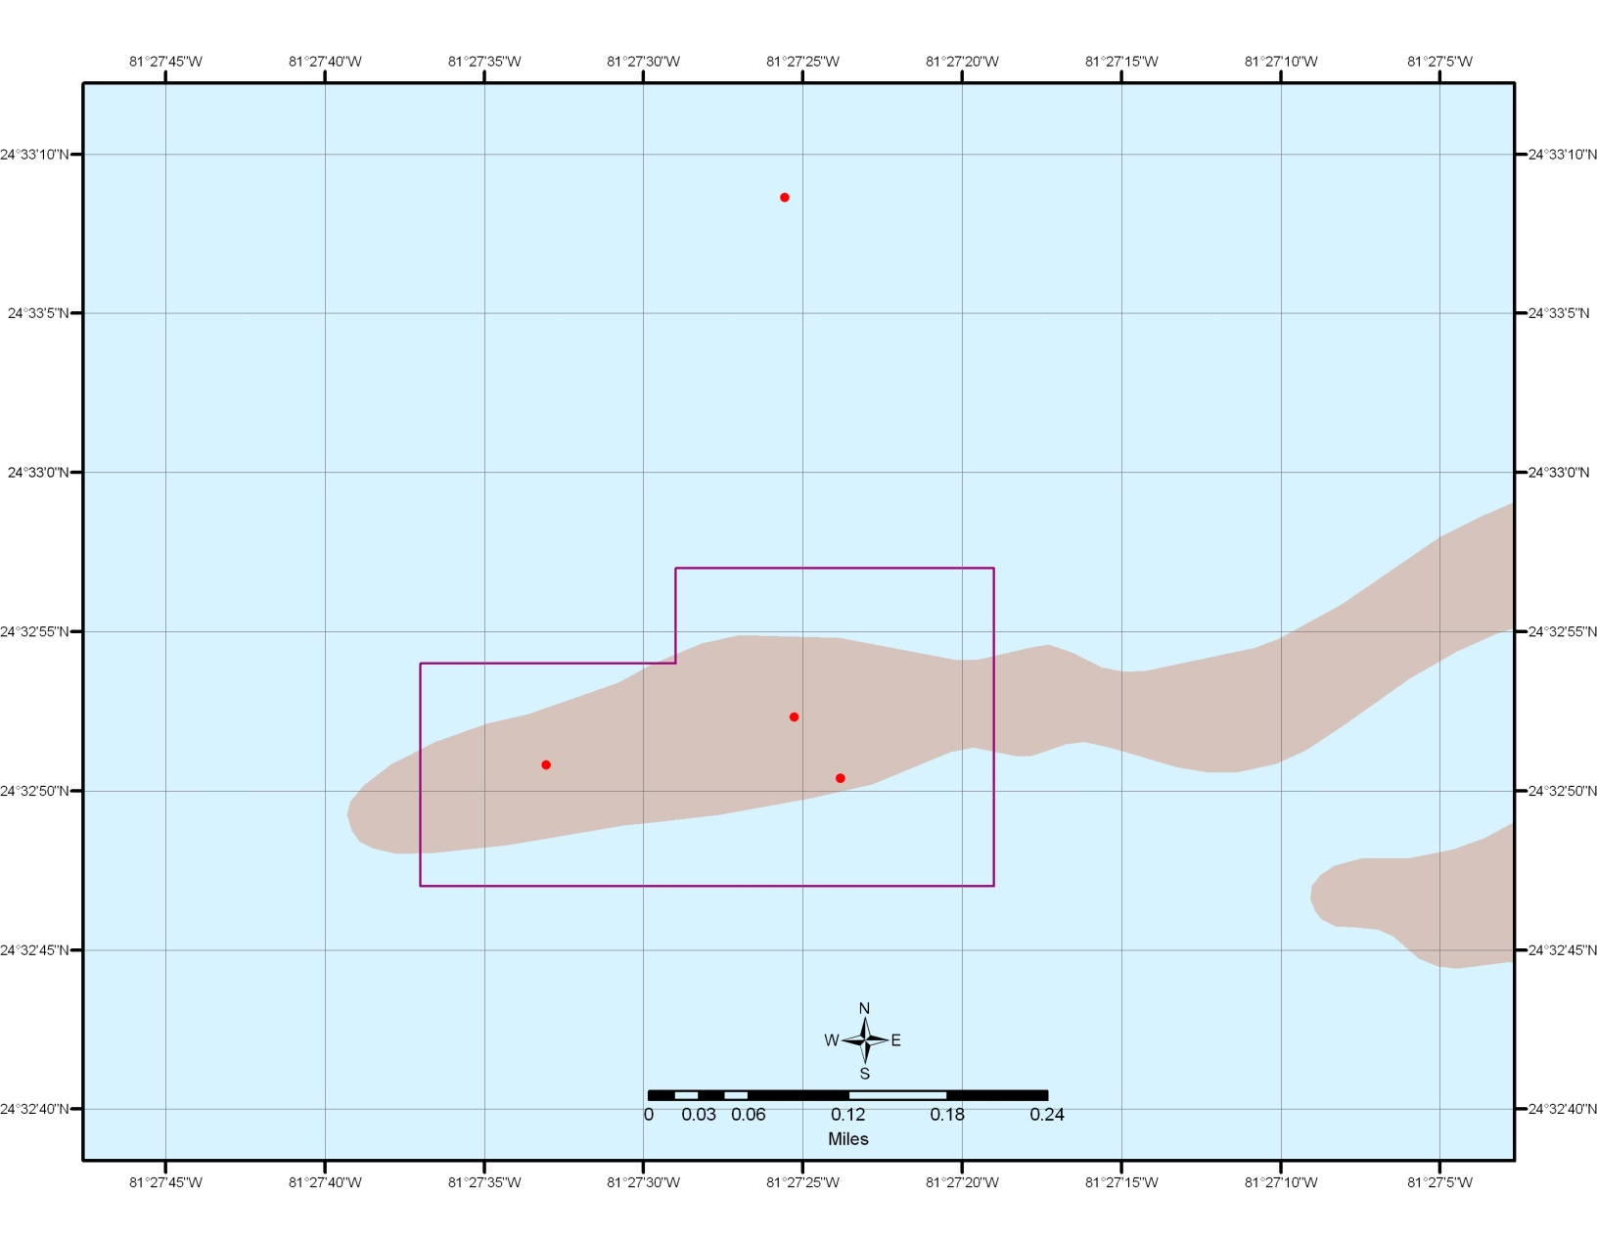
Figure 2.1 Example of a proposed straight line boundary closed areas

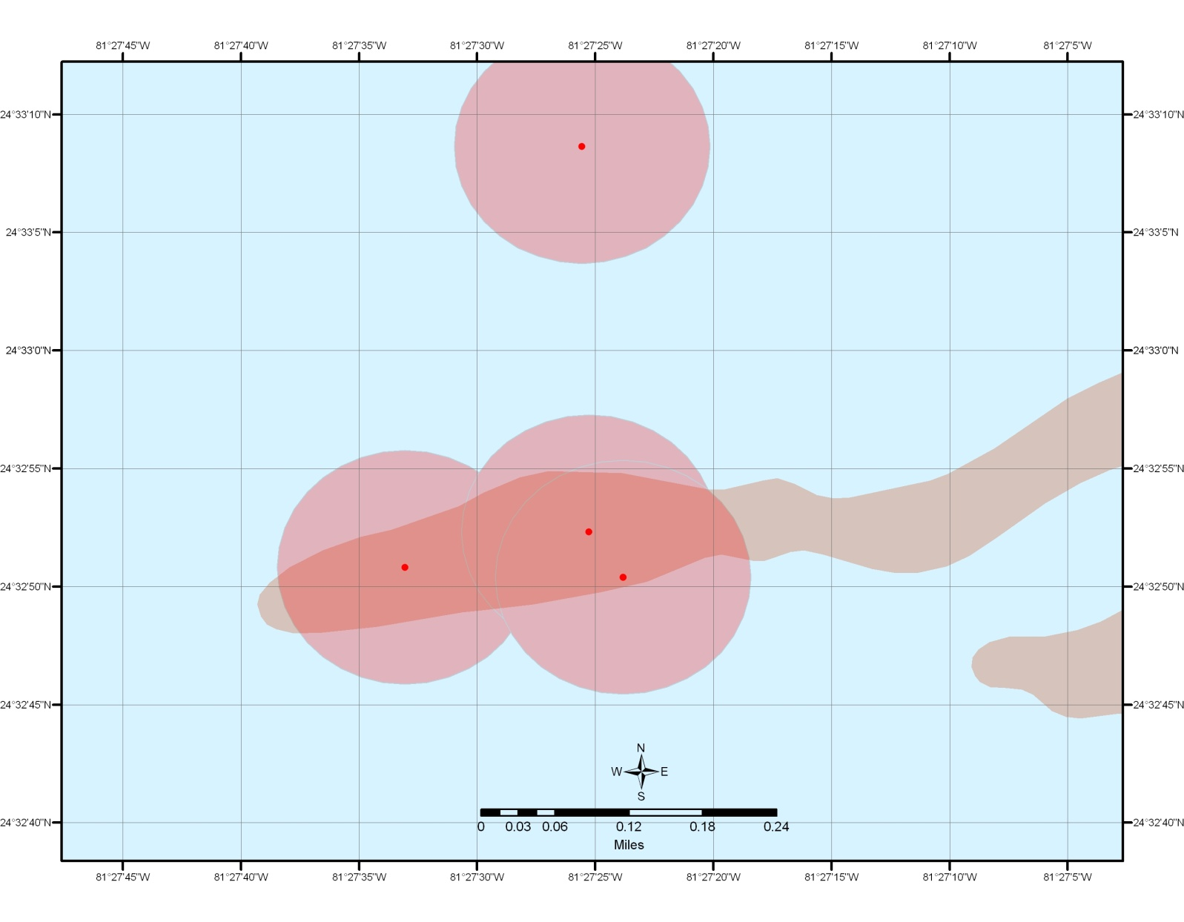
Figure 2.2 Example of a proposed 500 ft. buffer surrounding colonies

