INTRODUCTION SYSTEM MANAGEMENT PLAN FOR THE AMENDMENT 14 MPAs

The South Atlantic Fishery Management Council is preparing a System Management Plan (SMP) for the Marine Protected Areas (MPAs) established through Snapper Grouper Amendment 14 in January 2009. A review of the impacts of implementing the MPAs was presented to the Council during the December 2013 meeting. Lack of adequate funding to conduct the required enforcement, monitoring, and evaluations left the Council in the position of not being able to clearly demonstrate the benefits of the MPAs. The Council determined that to ensure the necessary enforcement, research/monitoring, outreach, and evaluation were possible, a concerted effort to identify specific projects and funding would be necessary. The Council is committed to using community outreach networks, citizen science and traditional fishery independent surveys to conduct this work. The Council will actively search for the necessary funding for this work.

The System Management Plan will be the vehicle to identify the outreach, enforcement, and research/monitoring necessary for the Council to conduct a successful evaluation of the MPAs. The Council’s current timing is as follows: Final Timing 2015:
a. Contract work on items to develop an outline – 2014/15
b. √IPT meeting – 12/10/14
c. √IPT works on items in the outline – January 2015 through March 2015 d. √Council reviews draft SMP and provides guidance – March 2015
e. √IPT revise document as necessary – March-May 2015
f. √Snapper Grouper AP input/overview – April 13-14, 2015 g. √SSC & SEP will provide initial comments in April 2015
h. A sub-group of the I & E AP will provide initial commends prior to June 2015 i. Council reviews/approves Draft SMP – June 2015
j. √IPT revise document as necessary – June/July 2015
k. √ Public input – July/August/September 2015
l. √Council reviews comments/document and provides guidance – September 2015
m. √IPT revise document as necessary – September/October
n. √ SSC review – October 2015
o. √Snapper Grouper AP and I and E input – October 2015
p. Council reviews input and approves Final SMP – December 2015

A draft SMP was available at the September 2015 meeting. In addition, a draft SMP chapter was included with the Amendment 36 document used for the 2nd round of public hearings in August 2015.

System Management Plan Outline for the SAFMC Amendment 14 MPAs

Executive Summary

A framework is in development for a System Management Plan (SMP) for the eight SAFMC Snapper-Grouper Amendment 14 MPAs and to provide a foundation for potential future SAFMC MPA management plans in the southeast U.S. This document is currently serving as a starting point to expand the development of adaptive- and effectiveness-based management of the SAFMC’s array of protected areas.

This SMP draft is intended to increase the dialogue among the SAFMC and NOAA, commercial and recreational fishers, other members of affected communities, scientists, and additional agencies and stakeholders to achieve common goals to effectively monitor and protect the resources intended by the Amendment 14 MPAs. Once the primary working structure is established, the component sections of the SMP will be populated and vetted through the SAFMC’s public process.

The final SMP will contain the proposed management action items and background details for the eight MPAs established by Amendment 14 in January of 2009:
- Snowy Grouper Wreck MPA
- Northern South Carolina MPA
- Edisto MPA
- Charleston Deep Artificial Reef MPA
- Georgia MPA
- North Florida MPA
- St. Lucie Hump MPA
- East Hump MPA

To provide a foundation for the SMP, four steps for management actions are proposed: resource protection, research and monitoring, outreach and education, and administrative. Additionally, management effectiveness evaluations are recommended as a fundamental component that the final SMP contain to determine the status and utility of the MPAs in achieving the intentions set by Amendment 14 (Appendix II). The final SMP expects to support the requirements of the reauthorized Magnuson-Stevens Fishery Conservation and Management Act (U.S. Public Law 109-479 2007) and adapt management of the MPAs in the southeast to protect and assess target resource populations and associated habitats.

Amendment 14 Overview

Overview
Amendment 14 states that “the primary purpose of these actions is to employ a collaborative approach to identify sites for Type 2 marine protected areas (MPAs) with the potential to protect a portion of the population (including spawning aggregations) and habitat of long-lived, slow growing, deepwater snapper grouper species (speckled hind, snowy grouper, warsaw grouper, yellowedge grouper, misty grouper, golden tilefish, and blueline tilefish) from directed fishing pressure to achieve a more natural sex ratio, age, and size structure within the proposed MPAs, while minimizing adverse social and economic effects. MPAs are the most effective fishery management tool that allows deepwater snapper grouper species to reach their natural size and age, protect spawning locations, and provide a refuge for early developmental stages of fish species” (2007).

Legislative Authority
The authority to create MPAs comes from the Magnuson-Stevens Act and enables NMFS to enact area-based management. Area-based management is required to be based on science, include criteria to assess benefit, timetable for review, and based on benefit/impact analysis. Amendment 14 was reviewed and found to meet the requirements for area-based management. The placement of the deepwater MPAs was developed through a series of meeting with stakeholders and scientist in order to reduce bycatch and discards of deepwater species. This SMP will provide additional guidance on the timetable for review.

The authority to enforce MPA regulations comes from the Magnuson-Stevens Act and is granted to the USCG and NMFS (Table 2.2.1). State agencies can enforce federal law through Joint Enforcement Agreements (JEAs). Currently North Carolina is the only state in the southeast without a JEA. Although North Carolina does not have a JEA, they can enforce MPA regulations if a North Carolina licensed vessel is found in violation of the federal regulations.

Table 2.2.1. Natural resource enforcement agency’s role and authority for enforcement of regulations for the deepwater MPAs in the South Atlantic.
Agency |  | Agency Role and Authority
U.S. Coast Guard | The U.S. Coast Guard District Seven and District Five have a primary role in protecting natural resources under the Magnuson-Stevens Act Managed Areas Act (Deepwater Marine Protected Area Network 50 CFR 622.35i, Deepwater Coral Habitat Areas of Particular Concern 50 CFR 622.35n and Bottom Line Prohibition Zone 50 CFR 622.25b), National Marine Sanctuaries Act, and Endangered Species Act. They also provide support to state and federal fisheries enforcement.
NOAA Fisheries | NOAA Fisheries has a primary role in protecting natural resources under the Magnuson-Stevens Act Managed Areas Act and has Joint Enforcement Agreements with state agencies to assist in the enforcement of federal regulations in nearshore ocean state waters, federal offshore waters, and inshore waters.
FWC | FWC has a Joint Enforcement Agreement with NOAA Fisheries which provides funding to the state to enforce federal regulations. FWC re-organized their fleet in 2014 to better enforce the deepwater MPAs.
GADNR | GADNR has a Joint Enforcement Agreement with NOAA Fisheries which provides funding to the state to enforce federal regulations. However GADNR does not have any patrol assets capable of enforcing deepwater MPA regulations.
SCDNR | SCDNR has a Joint Enforcement Agreement with NOAA Fisheries which provides funding to the state to enforce federal regulations. However SCDNR does not have any patrol assets capable of enforcing deepwater MPA regulations.
NCDENR | North Carolina does not have a Joint Enforcement Agreement with NOAA Fisheries. The state currently has one vessel that could patrol the deepwater MPA off North Carolina but funding for the vessel is uncertain.

Regulations
The deepwater MPAs are Type 2 MPA which means some fishing is allowed in the area but the closure is throughout the year. In the deepwater MPAs, fishing for and possession of snapper-grouper species is prohibited and shark bottom longline is prohibited. Trolling for pelagic species such as dolphin, mackerel, marlin, tuna, and wahoo is allowed. A transit provision allows fishermen with snapper grouper species onboard their vessel to traverse the MPA if their fishing gear is stowed according to regulations. Properly stowed means:
- Terminal gear must be disconnected and stowed separately from automatic reel, bandit gear, buoy gear, hand-line, or rod and reel. Rod and reel must be removed from the rod holder and stowed securely on or below deck
- Longline may be left on the drum if all gangions and hooks are disconnected and stowed below deck. Hooks cannot be baited. All buoys must be disconnected from the gear: however, buoys can remain on deck.
- A trawl or try net may remain on deck, but trawl doors must be disconnected from the net and must be secured. Note: This regulation may vary among MPAs and habitat areas of particular concern.
- A gill net, stab net, or trammel net must be left on the drum. Any additional such nets not attached to the drum must be stowed below deck.
- A crustacean trap, golden crab trap, or sea bass pot cannot be baited. All buoys must be disconnected from the gear; however, buoys can remain on deck.

System Management Plan

Goals and Objectives
The goals and objectives, which were used to choose the specific MPA, sites are modified from Amendment 14 (2007) (details in Appendix III). The goals and objectives will be reviewed by the SMP AP to determine if the goals and objectives should be modified to meet management needs. The recommendations from the SMP AP will be reviewed by stakeholders, other APs, and the Council. The Council will make final selection of the goals and objectives of the SMP. The numbers in parentheses correspond to goals listed in How Is Your MPA Doing? (Pomeroy et al. 2004). G=Governance, BI= Biophysical, SE=Socioeconomic.

- Adopt and utilize an effective process to evaluate and refine management of deepwater MPAs
- Input from scientists, fishermen, advisory panels, and the public utilized to evaluate and refine management of deepwater MPAs. (Matches G 1F)
- Ensure a management system that is efficient and representative of fishery stakeholders. (G 3A)

- Biological benefits of the MPA maximized
- Populations of speckled hind, snowy grouper, Warsaw grouper, yellowedge grouper, misty grouper, golden tilefish, and blueline tilefish restored to or maintained at sustainable levels. (BI 1A, 3A)
- Over-exploitation of deepwater species minimized, prevented, or prohibited entirely. (BI 1D)
- Populations of deepwater species are protected from harvest in some nursery areas and habitats protected from fishing/human impacts inside MPAs. (BI 1C, 2D, 2E, 3C, 4C)
- Replenishment rate of fishery stocks increased or sustained. (BI 1F)

- Adverse social and economic effects minimized
- Economic impact to stakeholders targeting species other than snapper-grouper species minimized. (SE 2A)
- Respect for understanding of local knowledge enhanced. (SE 6A)
- Boater safety was not compromised due to the placement of and regulations in the closed areas.

- Enforceability and compliance within MPA is enhanced
- Consider the seven criteria from the Law Enforcement AP’s report when determining suitable MPA sites
- Enforceability of arrangements ensured (G 2E)
- Surveillance and monitoring of coastal areas improved (G 4A)
- Application of law and regulations maintained or improved (4E)
- User participation in surveillance, monitoring, and enforcement increased (G 4D)

- Research and monitoring capabilities maximized
- Fishery-independent and fishery-dependent data utilized to increase scientific knowledge and understanding (SE 6C, 6D).
- Citizen science to provide additional information on the biological, social, and economic metrics for the SMP is enhanced (SE 6A, 6B, 6C, 6D and G 4A, 4D).

- Research and monitor impact of invasive species enhanced (new goal added by IPT)
- Program to reduce or eliminate invasive lionfish enhanced or maintained
- Scientific knowledge on lionfish and ecosystem impacts increased

- Environmental awareness and knowledge about the Deepwater MPAs improved
- Level of knowledge about the purpose, importance of and regulations in Spawning SMZs held by the public increased. (SE 6C)
- Stakeholder participation strengthened and enhanced. (G 3C)
- Existence value of Spawning SMZs enhanced or maintained. (SE 3B)

Connectivity Within and Among MPAs

The Amendment 14 MPAs are connected by oceanographic features, that can facilitate larval dispersal within and among S-G spawning sites in or outside of these MPAs (Sedberry et al. 2006, Lesher 2008). Additionally, satellite-tracked drifters can assist in the identification of oceanographic features that can connect settlement and nursery habitats to the Amendment 14 MPAs and spawning sites (M.S.T. Meadows and G.R. Sedberry unpublished). Protecting essential fish habitat (e.g., spawning and nursery habitats) through the use of MPAs facilitates the potential for both the advection and retention of larval S-G species to settlement sites associated with the MPAs (Lindeman et al. 2000, Burke et al. 2003, Paris et al. 2005, Hare and Walsh 2007). Post-settlement recruitment is important for replenishment of reef fish populations at multiple regional scales in the southeast U.S.

Existing Knowledge Gaps

Target Resource
Many of the target species for Amendment 14 lack a complete description of their life history traits including when and where they spawn, whether they aggregate to spawn, home range, migration patterns, and nursery habitats. Spawning season and spawning location(s) are two key pieces of data that are needed to improve the siting and timing of potential closed areas. Further life history research could assist in better placement or refinement of closed area boundaries. Information on movement (e.g., home range size) and migration patterns during and outside of spawning season is also needed to determine if the size of the MPA is adequate to protect focal species.

Habitat
The habitat and general geomorphological characteristics for focal species has not been described in thorough detail for the South Atlantic. To be added.

Use of MPAs
Traditionally, a comparison of the benefits and costs associated with each proposed Type 2 MPA would have been evaluated quantitatively. However, empirical data typically used to conduct empirical analyses was at a coarser spatial scale than that of the Type 2 MPA sites in Amendment 14. Thus, it was not possible to produce the robust quantitative analysis. As a result, a Delphi approach was adopted to provide a semiquantitative analysis of the social and economic consequences associated with implementation of Type 2 MPAs in deepwater regions of the south Atlantic snapper grouper fishery. More detailed landings data are needed for area-specific management.

Compliance with the regulations of the MPAs remains a concern. Florida FWC has rearranged their assets to better patrol the Deepwater MPAs off Florida but Georgia, North Carolina, and South Carolina have limited assets available to monitor the MPAs. The USCG is the primary agency that monitors the Deepwater MPAs from Georgia through North Carolina. Information on the non-compliance is needed to determine if illegal fishing is preventing or delaying the recovery of the focal species in the managed areas.

Management Action Items

The final SMP will detail the strategies to achieve the proposed management action items. The purpose and needs detailed in Amendment 14 sections (2007, Appendix IV) will be revisited along with identifying additional needs and strategies through a participatory process with affected users. The following information under the four categories of proposed action items includes brief summaries and examples.

Resource Protection Action Items

NOTE: This document is for information purposes only; nothing in this document commits agencies to supply any specific resources or creates any financial obligations. This document does not change any statutory authority or create any new responsibilities.

Enforcement of MPAs is one of the most controversial and concerning aspects of this type of area-based management. The Council has been advised throughout the entire process of developing MPAs by its Law Enforcement Advisory Panel (LEAP) and has been given a list of recommendations (SAFMC 2005) by this group. The Council followed those recommendations as closely as possible while balancing the biological, social, and economic objectives and impacts of MPAs. Because the Council chose to allow some fishing (Type 2 MPAs) and transit through the MPAs, enforcement continues to be very challenging.

Law enforcement partners were requested to update information on the enforceability of the MPAs and available assets that could be used to monitor the MPAs. Enforceability ratings were given by state agencies and USCG for each of the deepwater MPAs. Two very large obstacles continue to limit enforcement of some deepwater MPAs: (1) distance from shore of the majority of MPAs and (2) Type 2 designation, which allows certain fishing activities to take place. Consequently, occasional flyovers by enforcement aircraft, drone, or satellite are not effective for enforcing regulations; therefore, an on-site enforcement presence is necessary in order to determine whether the fishing activity is lawful or not.

In 2015, the FWC revised the enforceability rating of the MPAs off Florida from a Low rating (in Amendment 14) to a High rating. This is due to the shift in enforcement assets that FWC performed in 2014 to better service offshore closed areas along Florida’s east coast. Off North Carolina, the Snowy Grouper Wreck MPA was rated as Moderate by the USCG. The USCG did not provide enforceability ratings for the deepwater MPAs in Amendment 14 but they provide rating in the SMP, which are included in Table 3.4.1. The remaining MPAs continue to have a Low enforceability rating as originally considered in Amendment 14. The current ratings were based on the same criteria as in Amendment 14:

A “HIGH” rating means that the area is easily accessible with the assets and personnel already in place. Such an area may already be patrolled and would not require additional assets. Additional funding may be required to maintain adequate enforcement patrols.

A “MODERATE” rating indicates that with some additional assets, or the relocation of existing assets, patrols could be conducted from time to time and during targeted details. Additional funding will likely be required to increase the ability rating to “HIGH”.

A “LOW” rating means that patrols of the area would only occur during an organized enforcement detail with Federal partners such as NMFS or USCG. The States do not have the assets or personnel with the proper training to patrol the area. Additional funding will be essential to increase the ability rating.

Table 3.4.1. The enforceability rating of the deepwater MPAs in the South Atlantic. State ratings were developed by state enforcement agency in the closest state.
MPA | Closest State | Amendment 14 Rating | State Rating (2015) | USCG Rating (2015)
North Florida | Florida | Low | High | Low
St. Lucie Hump | Florida | Moderate | High | Low
East Hump | Florida | Moderate | High | Low
Georgia | Georgia | Low | Low | Low
Northern South Carolina | South Carolina | Low | Low | Low
Edisto | South Carolina | Low | Low | Low
Charleston Deep Artificial Reef | South Carolina | Low | Low | Low
Snowy Grouper Wreck | North Carolina | Low | Low | Moderate

The available assets to monitor the deepwater MPAs vary by state and agency. GADNR does not a have vessel capable of traveling 60 miles offshore to the Georgia MPA or other nearby MPAs. NCDENR currently has one vessel capable of traveling to the Snowy Wreck MPA; however funding for that vessel is currently under review. FWC increased the size of the offshore fleet to a total of five high speed offshore vessels on the East Coast and has aircraft. The vessels range in size from 33’ to 40’ in length. The newer vessels allow FWC to cover more distance with lower cost and less down time than previously experienced. The newer vessels also have soft collars, which allow crews to conduct a higher number of inspections in various sea states. A 40’ Brunswick Impact Patrol vessel has been moved to New Smyrna. A 33’ Brunswick Impact has been moved to Jupiter. NOAA OLE has a 24’ Rigid Hull Inflatable Boat (RHIB) for available surge operations. The USCG has several types of vessels available (Table 3.4.2).

Table 3.4.2. USCG enforcement assets available for monitoring the deepwater MPAs.

Coastal Patrol Boats (CPB)
Fast Response Cutters (FRC)
Helicopters (HH-60)
Aircrafts (C-130)
Medium Endurance Cutters (MEC)
High Endurance Cutters (HEC)

Three Notices of Violation and Assessments have been issued for violating regulations established for the deepwater MPAs. The cases were either settled out of court or uncontested. In the uncontested case, the Administrative Law Judge used several pieces of evidence to support the default judgement that the fishermen violated the MSA including: the vessel was anchored inside an MPA, the fishing gear was not properly stowed, the fisherman was in possession of snapper-grouper species while inside a MPA, and the fishermen was liable for violating fishing regulations under the MSA. If more NOVAs are issued for the deepwater MPAs, the regulations established for the deepwater might be challenged and changes to the regulations may be needed to improve adjudication in favor of the enforcement agencies.

The resource protection action items aim to address the following goals and objectives of the System Management plan:

Goal 4 Enforceability and compliance within MPA is enhanced
- Consider the seven criteria from the Law Enforcement AP’s report when determining suitable MPA sites
- Enforceability of arrangements ensured
- Surveillance and monitoring of coastal areas improved
- Application of law and regulations maintained or improved
- User participation in surveillance, monitoring, and enforcement increased

The following action items would be initiated by either Council staff and/or by potential partners:

Action Item 1: Develop cooperative enforcement via intelligence and asset sharing, meetings, and training to encourage coordination of MPA patrols and investigations.
Tasks:
- Schedule MPA enforcement activities and challenges to be reported at LEAP annual meeting to coordinate MPA patrols and investigations.
Justification: Coordination among enforcement agencies can help to minimize duplicative effort and provide better coverage with limited resources.
Deliverables: Oral Report at LEAP Meeting
Schedule: Yearly in March
Budget: OLE Partners Time, Meeting cost done in conjunction with yearly LEAP Meeting
Potential Partners/roles: NMFS, Law Enforcement Partners

Tasks:
- Continue to have officers train at the USCG Southeast Regional Fisheries Training Center
Justification: The Southeast Regional Fisheries Training Center has been a valuable asset for training officers in enforcement of fisheries regulations, including those pertaining to MPAs.
Deliverables: Trained Officers
Schedule: Annually
Budget:
Potential Partners/roles: USCG, NOAA OLE, FWC, GADNR, NCDENR, SCDNR

Tasks:
- Develop a patrol/sortie reporting form and database for determining compliance in MPAs
- Develop centralized database for information access
Justification: A standardized reporting form developed by the law enforcement partners would help collect data to improve frequency and effectiveness of enforcement patrols. A centralized database would assist in reporting of data to requesting agencies such as NMFS or SAFMC.
Deliverables: Form and database to calculate compliance
Schedule:
Budget:
Potential Partners/roles: NMFS, Law Enforcement Partners

Action Item 2: Maintain the “high” enforceability rating for the Florida MPAs and increase the enforceability rating to at least “moderate” for the other MPAs.
Tasks:
- Purchase and maintain vessels capable of conducting offshore patrols
- Increase enforcement capacity to monitor the deepwater MPAs
Justification: Protection of the deepwater MPAs is crucial to their success. Fishing incursions into MPAs could remove individuals from the population and prevent maintenance of a natural sex ratio, age structure, and size structure. Having enforcement assets to monitor the deepwater MPAs is critical for preventing incursions into the area. If new vessels are needed for enforcement of the deepwater MPAs off each of the states, a vessel costs approximately $150,000 for a large center console vessel with two outboard engines. Some states may require more than one vessel.
Deliverables: Vessels available for offshore patrol
Schedule: Med/Long-term (with funding)
Budget: $200,000/ year
Potential Partners/roles: Law Enforcement Partners

Action Item 3: Patrol MPAs with aerial and at-sea assets.
Tasks:
- Provide a deterrent presence within the MPA through routine aerial and at-sea patrols
- Schedule and conduct dedicated surge operations.
Justification: A deterrent presence is needed in the deepwater MPAs to reduce incursions into the areas. Fishing incursions may prevent attaining the stated biological goals of the MPAs. To monitor the Deepwater MPAs, it was estimated to have three patrol officers per trip. The trip would last approximately 12 hours. The cost per officer was approximately $40 per hour and includes all fringe values. The vessel operating cost is approximately $100 per hour. This adds up to approximately $2,600 per monitoring event. The budget is estimated assuming five monitoring events per MPA and 8 MPAs.
Deliverables: Patrols are conducted in the MPAs
Schedule: Long-term (dependent on Action Item 2)
Budget: $105,000
Potential Partners/roles: Law Enforcement Partners

Action Item 4: Initiate a remote monitoring program for the deepwater MPAs.
Tasks:
- Review methods for remote monitoring in offshore areas.
Justification: Patrols in the deepwater MPA are expensive and can occupy an entire day for officers involved in the patrol. Frequently when patrols occur in the MPAs, no vessels are sighted. Remote monitoring methods can be used to detect incursions at times when they are likely to occur.
Deliverables: Report on remote monitoring methods
Schedule: Report- Short/Med-term
Budget: Staff Time
Potential Partners/roles: NMFS MPA Center, NMFS SEFSC, SECOORA, NOS, SAFMC Staff

Tasks:
- Apply to possible funding sources for remotely monitoring offshore sites and implement program.
Justification: Funding is limited in the SE for remote monitoring offshore areas. Additional funding will be required if a remote monitoring program is to be developed. The cost estimate is based on ten monitoring events for the eight deepwater MPAs at an estimated cost of $2,000 per event.
Deliverables: Grant/Funding requests for monitoring offshore areas.
Schedule: Long-term
Budget: $160,000
Potential Partners/roles: NMFS, SAFMC Staff

Action Item 5: Develop a citizen science/research science program and database for reporting effort in MPAs.
Tasks:
- Identify potential partners (federal and state resource agencies, NGOs, academic institutions) to seek funding for a cooperative research/citizen science program focusing on MPA compliance
Justification: Cooperative research/citizen science programs would promote buy-in from the public and contribute to voluntary compliance over the long-term. Such programs also enhance education and outreach opportunities and promote resource stewardship.
Deliverables: Research existing cooperative research/citizen science programs.
Develop list of possible partners and contact information.
Schedule: Short-term
Budget:
Potential Partners/roles: SAFMC, NMFS SEFIS, FWC, GADNR, NCDNR, SCDNR

Action Item 6: Report enforcement and compliance activities to the South Atlantic Fishery Management Council.
Tasks:
- Report quarterly/semi-annually/annually on enforcement and compliance activities at the South Atlantic Fishery Management Council Meetings
Justification: Reporting on enforcement activities enables the enforcement agencies to review the patrolling of the MPAs to determine if sufficient patrols have been conducted and keeps management agencies informed of law enforcement activities.
Deliverables: Quarterly/semi-annual/annual enforcement reports (at Council meetings)
Schedule: Short-term
Budget: Law Enforcement Partners staff time
Potential Partners/roles: Law Enforcement Partners

Action Item 7: Provide compliance assistance to user groups through outreach and education.
Tasks:
- Communicate to the public about the deepwater MPAs while on patrol in the deepwater MPA and outreach and education events.
Justification: Communication by patrol officers can help to educate and increase the public’s understanding of the importance of the Deepwater MPAs and regulations to protect them.
Deliverables: Increased public awareness
Schedule: Ongoing
Budget: Law Enforcement Partners staff time
Potential Partners/roles: Law Enforcement Partners

Action Item 8: Encourage North Carolina to commit to a JEA with NOAA.
Tasks:
- Have SAFMC Chair send a letter encouraging North Carolina to commit to the JEA with NOAA.
Justification: Currently North Carolina is the only state in the South Atlantic Region without a JEA. This limits their ability to enforce the federal regulations for all vessels in federal waters. The JEA could also provide funds for purchasing assets or maintaining current assets for patrols in federal waters.
Deliverables: Letter sent to North Carolina DENR
Schedule: Short-term
Budget: $0
Potential Partners: SAFMC

Action Item 9: Monitor/Improve adjudication of MPA regulations.
Tasks:
- Monitor court decisions and orders to track adjudication of Notices of Violation and Assessment in the deepwater MPAs and, if needed, recommend modifications to regulations or other actions to improve adjudication in favor of enforcement agencies.
Justification: Regulations must be enforceable, and monitoring enforcement decisions and orders provides an opportunity to determine if the current regulations should be altered or if other actions by the Council are needed.
Deliverables: Annual oral updates at LEAP meeting
Schedule: Short-term
Budget: Staff time
Potential Partners/roles: SAFMC, Law Enforcement Partners, NOAA General Counsel Enforcement Section

Research and Monitoring Action Items

Scientific research and stakeholder collaboration was heavily incorporated into the decision making process of selecting the eight MPAs created by Amendment 14 (SAFMC 2007). This research, along with new research and monitoring, will continue to inform decision-­‐makers during consideration of the existing and potential new protected areas (MPA Expert Workgroup 2012, 2013), and Special Management Zones (Amendment 36).
The purpose of the Research and Monitoring Action Plan is to provide a guide for data collection and research activities inside the MPAs, and throughout the region, that will improve management and preservation of the protected areas. Strategies will be detailed to achieve anticipated goals and objectives through proposed natural resource and socioeconomic research and monitoring action items.
The Research and Monitoring Action Plan includes several components under the general headings of monitoring, assessment, and mapping. Considerable efforts were made to balance the benefits of each component against its cost and feasibility. As a result several items were deleted from the plan. This is not to imply these items do not have merit and would provide a benefit to management, however their costs and/or feasibility impractical. Examples of items intentionally left off this Plan include mapping of nursery and settlement habitats, trophodynamics in habitats in and adjacent to MPAs and environmental stressors in habitats in and adjacent to MPAs. There are finite resources available to execute the Research and Monitoring Plan; the best returns for both scientific and financial considerations are included below.

Resource Monitoring

The main objective is to determine and monitor the effect of MPAs on deepwater snapper grouper species’ distribution and status. The most significant benefit of MPAs is to enhance fisheries through recovery of populations as a result of protection of adults at spawning aggregation sites and spillover into adjacent fishing grounds. A variety of approaches are needed to assess fish populations synoptically in and outside the MPAs with the first step being collection of baseline data to compare to subsequent assessments.

The following goals would be achieved by completing the action items for resource monitoring.

Goal 2: Biological benefits of the MPA maximized
Obj. C: Populations of speckled hind, snowy grouper, Warsaw grouper, yellowedge grouper, misty grouper, golden tilefish, and blueline tilefish restored to or maintained at sustainable levels.
Obj. D: Over-exploitation of deepwater species minimized, prevented, or prohibited entirely.
Obj. E: Populations of deepwater species are protected from harvest in some nursery areas and habitats protected from fishing/human impacts inside MPAs.
Obj. F: Replenishment rate of fishery stocks increased or sustained.

Goal 6: Research and monitor impact of invasive species enhanced (new goal added by IPT)
Obj. P: Program to reduce or eliminate invasive lionfish enhanced or maintained
Obj. Q: Scientific knowledge on lionfish and ecosystem impacts increased

There are twelve actions items for the resource monitoring section.

Action Item 1: Identify fish population demographics (e.g. size and age structure, sex ratio, etc.) within and adjacent to the MPAs.
Priority Ranking: 1
Justification: A major objective of the MPAs is to provide areas where fish population demographics can recover to levels that are capable of providing a reproductive haven and contribute to recruitment outside the protected areas. Evaluation of size and age structure of fishery species inside vs. outside the MPAs provides an indication of whether or not the MPA is protecting reproductively active individuals, particularly larger and older fish that are the most productive spawners.
Projects Completed or Underway:
• Marine Resources Monitoring, Assessment, and Prediction (MARMAP) have been collecting size, age and reproductive data from trap surveys inside and outside several of the MPAs since 1987 including: Snowy Wreck, Northern South Carolina, Edisto, Georgia, North Florida, and St. Lucie Hump.
• NOAA Southeast Fishery-­‐Independent Survey (SEFIS) has been collecting size, age and reproductive data from trap surveys inside and outside several of the MPAs since 2010 including: Snowy Wreck, Northern South Carolina, Edisto, Georgia, and North Florida (Bacheler et al, 2013).
Deliverables: Demographic data on fishery species.
Schedule: Ongoing
Budget:
Potential Partners: NMFS, MARMAP
Potential Methods: Fish size can be measured underwater with stereo cameras or lasers attached to submersibles and ROVs. Age must be determined from captured fish using either otoliths or spines and rays. Sex ratios can be determined from gonad biopsies unless the species has sexually dimorphic characteristics.

Action Item 2: Maintain an annual monitoring program to collect data inside and outside the MPAs. Data collected should include: distribution, abundance, size and age structure, and sex ratios of dominant harvested species in and outside the MPAs.
Priority Ranking: 2
Justification: Ensuring an annual monitoring program continues to be funded for several years is the only way to collect the data necessary to assess the effectiveness of the MPAs. The deepwater grouper, snapper, and tilefish that are protected by these MPAs are long lived species with a late onset of maturity. Couple that with many of the species being uncommon to rare means that it may take a long time to see changes.
Projects Completed or Underway:
• NOAA Fisheries, Southeast Fisheries Science Center, Panama City Lab has been collecting data on distribution and abundance of all fish species from ROV surveys inside and outside several of the MPAs including: Snowy Wreck, Northern South Carolina, Edisto, Georgia, North Florida, and East Hump.
• Southeast Reef Fish Survey (SERFS), which is a collaboration of SEFIS and MARMAP, have been collecting distribution, abundance, size and age structure, and sex ratio data from trap and stationary camera surveys inside and outside several of the MPAs including: Snowy Wreck, Northern South Carolina, Edisto, Georgia, North Florida, and St. Lucie Hump.
Deliverables: Distribution, abundance, and demographic data on key fishery species with which spatial and temporal changes inside and outside the MPAs can be determined.
Schedule: Ongoing
Budget:
Potential Partners: NMFS, MARMAP

Action Item 3: Determine pre-closure distribution and abundance of dominant harvested species inside and outside the MPAs, in order to provide historical context for subsequent assessments.
Priority Ranking: Medium
Justification: In order to differentiate changes in key resources that occur naturally from those which are caused by human influence, a baseline set of criteria must be established and monitored over subsequent years. Once these data have been gathered and analyzed, scientists and managers can determine more precisely what variability is naturally inherent in the system and what changes may be the result of anthropogenic influences.
Projects Completed or Underway:
• A collaborative NOAA project (Southeast Fisheries Science Centers of Panama City and Beaufort and Gray’s Reef National Marine Sanctuary) titled, “Assessing the efficacy of South Atlantic deepwater MPAs’ includes density and distribution data for all fish species from 1985-­‐2014.
• NOAA Fisheries, Southeast Fisheries Science Center, Panama City Lab has been collecting data on distribution and abundance of all fish species from ROV surveys inside and outside several of the MPAs since 2004 including: Snowy Wreck, Northern South Carolina, Edisto, Georgia, North Florida, and East Hump.
• Marine Resources Monitoring, Assessment, and Prediction (MARMAP) have been collecting data on distribution and abundance from trap surveys inside and outside several of the MPAs since 1987 including: Snowy Wreck, Northern South Carolina, Edisto, Georgia, North Florida, and St. Lucie Hump.
• NOAA Ocean Exploration conducted video surveys of fish species composition from submersible dives on shelf edge reefs at North Florida MPA and Northern South Carolina MPA from 2001-­‐2003 (Schobernd and Sedberry, 2009; Fraser and Sedberry, 2008).
• North Carolina Sea Grant conducted acoustic surveys to measure reef fish relative abundance at Snowy Wreck MPA between 2007 and 2008 (Rudershausen et al., 2010).
Deliverables: Baseline density and distribution data for key fishery species with which to compare future data against.
Schedule: Short-term
Budget: Staff-time
Potential Partners: NMFS, MARMAP, SAFMC

Action Item 4: Locate spawning aggregations of deepwater snapper and grouper species.
Priority Ranking: Medium
Justification: Spawning aggregations are valuable sources of recruits to populations. Protecting these sources of larvae is important for sustaining fisheries and building resilience into marine reserve networks. In order to maintain fish stocks at proper levels for a healthy, profitable fishery, spawning aggregations need to be protected from exploitation.
Projects Completed or Underway:
• LGL Ecological Research Associates, Inc. (Will Heyman) has been conducting a study using geomorphology to predict spawning aggregation sites since 2014.
• NOAA Fisheries, Southeast Regional Office, Southeast Fisheries Science Center has produced a geographic distribution model which includes potential spawning habitats of snapper grouper species (SAFMC MPA Expert Workgroup, 2012 & 2013).
Deliverables: Locations of target fishery species spawning aggregations.
Schedule: Ongoing for NMFS and MARMAP
Budget: $50,000 per site per year – Independent Researchers
Potential Partners: NMFS, MARMAP, Citizen Science Program, Independent Researchers
Potential Methods: A variety of gear types could be used to locate spawning aggregations including manned submersibles, ROVs, and drop cameras. Unless gamete release is observed, spawning condition of the fish needs to be verified via histology.

Action Item 5: Develop and apply coupled biological and physical models to locate potential nursery sites.
Priority Ranking: Low
Justification: Locating potential nursery sites for increased recruitment from increased spawning activity.
Projects Completed or Underway:
• NOAA Fisheries, Southeast Regional Office, Southeast Fisheries Science Center has produced a geographic distribution model for speckled hind and Warsaw grouper which incorporates a hydrographic model to evaluate the relative utility and benefits of the MPAs for fisheries management (SAFMC MPA Expert Workgroup, 2012 & 2013).
• North Carolina State University (Ruoying He) has produced a Coastal Circulation and Ecosystem Nowcast/Forecast System for the South Atlantic Bight and Gulf of Mexico. See: http://omgsrv1.meas.ncsu.edu:8080/ocean-­‐circulation/
• NOAA, Southeast Fishery Science Center has a proposal titled “Use of a biophysical modeling framework to develop a recruitment index for inclusion in stock assessment in the Gulf of Mexico and South Atlantic”.
• Other sources of models to predict nursery sites include ROMS, Ichthyop, and HYCOM.
Deliverables: Physical Models
Schedule: Long-term
Budget:
Potential Partners:

Action Item 6: Track movement of adult fish.
Priority Ranking: Low
Justification: Having knowledge of the temporal and spatial movements of key fishery species makes it easier to protect them. In order to provide complete protection, MPAs must be large enough to encompass the home range of targeted species. If fish readily move in and out of the closed areas, recovery of fish populations will not occur as fish will be lost to fishing in the portion of their range that are not protected.
Projects Completed or Underway:
• McGovern et al, 2005. This was a tag and recapture study of gag grouper in the south Atlantic completed during 1995-­‐1999.
Priority: Low. This information would be extremely useful. It is only ranked low in priority because it will be difficult and expensive to obtain. Many of the species being protected (i.e. grouper species like speckled hind and Warsaw) are too rare to be able to tag or track enough of them to decipher movement patterns.
Deliverables: Migration patterns of adult fish within and adjacent to the MPAs.
Schedule: Long-term
Budget: Telemetry >$2,500,000/ Tag and Recapture >$1,000,000
Potential Partners: State Agencies, NMFS, Independent Researchers, Citizen Science Program
Potential methods: Telemetry or tag and recapture.

Assessment Needs
The purpose of monitoring is to establish a baseline of information on natural resources and other components of the ecosystem so that changes over time can be detected and assessed. As monitoring studies gather data, they have the potential to detect significant changes in natural resources that result from management actions or from other causes. The finding of research projects must also help mangers and scientists identify cause and effect relationships that generate ecological patterns and trends, and stressors, and other factors that threaten the health of the reef ecosystem.

Action Item 7: Characterize deepwater snapper grouper species within the MPAs compared to reference sites. This includes: distribution and abundance patterns, size and age distribution, spawning aggregation presence, and sex ratios.
Priority Ranking: 3 (Ongiong)
Justification: Comparison of these parameters for deepwater snapper grouper species inside vs. outside the MPAs provides a means to evaluate the efficacy of the protected areas. Ideally, a higher abundance of key fishery species would be observed inside the MPAs given enough time following implementation of fishing restrictions. Evaluation of size and age structure of fishery species inside vs. outside the MPAs provides an indication of whether or not the MPA is protecting reproductively active individuals, particularly larger and older fish that are the most productive spawners. The size/age structure of fished populations should remain fairly constant over time, whereas it should increase within the MPAs if fishing mortality is eliminated (or significantly reduced) and the MPAs are large enough to encompass the home range of the fish.
Projects Completed or Underway:
• A collaborative NOAA project (Southeast Fisheries Science Centers of Panama City and Beaufort and Gray’s Reef National Marine Sanctuary) titled, “Assessing the efficacy of South Atlantic deepwater MPAs” includes density and distribution data for all fish species from 1985-­‐2014.
• Marine Resources Monitoring, Assessment, and Prediction (MARMAP) have been collecting distribution, abundance, size, age and reproductive data from trap surveys inside and outside several of the MPAs since 1987 including: Snowy Wreck, Northern South Carolina, Edisto, Georgia, North Florida, and St. Lucie Hump.
• NOAA Southeast Fishery-­‐Independent Survey (SEFIS) has been collecting distribution, abundance, size, age and reproductive data from trap surveys inside and outside several of the MPAs since 2010 including: Snowy Wreck, Northern South Carolina, Edisto, Georgia, and North Florida.
• NOAA Fisheries, Southeast Fisheries Science Center, Panama City Lab has been collecting data on distribution and abundance of all fish species from ROV surveys inside and outside several of the MPAs since 2004 including: Snowy Wreck, Northern South Carolina, Edisto, Georgia, North Florida, and East Hump.
• NOAA’s SE-­‐DSCTP project collected data on distribution and abundance of all fish species from ROV dives conducted in 2011 inside and around the North Florida and East Hump MPAs (Reed et al., 2014).
Deliverables: Comparison of variables such as distribution, densities, size and age distribution, and sex ratios for snapper grouper species inside the MPAs vs. reference areas outside the MPAs.
Schedule: Ongoing
Budget:
Potential Partners: MARMAP, NMFS
Potential Methods: Since there have been surveys conducted prior to implementation of the MPAs, a BACI (before/after, control/impact) sampling design should be used when examining MPA effectiveness.

Action Item 8: Characterize fish communities, inside and out of the MPAs, including habitat utilization patterns, trophic interactions, ontogenetic changes, and predator prey relationships.
Priority Ranking: Medium
Justification: Detailed characterization of fish communities allows a much greater understanding of the dynamics of the ecosystem. This information significantly increases the confidence of predictive exercises when forecasting how changes in one part of the system will affect other parts. The different components which parameterize this characterization process vary tremendously in the cost, difficulty, and time to complete. However synergism with other ongoing field collections and laboratory analyses allow many of the components to be evaluated in a cost effective manner.
Projects Completed or Underway:
• A collaborative NOAA project (Southeast Fisheries Science Centers of Panama City and Beaufort and Gray’s Reef National Marine Sanctuary) titled, “Assessing the efficacy of South Atlantic deepwater MPAs” includes density and distribution data for all fish species from 1985-­‐2014.
• NOAA Fisheries, Southeast Fisheries Science Center, Panama City Lab has been collecting data on habitat utilization patterns of all fish species from ROV surveys inside and outside several of the MPAs since 2004 including: Snowy Wreck, Northern South Carolina, Edisto, Georgia, North Florida, and East Hump.
• Marine Resources Monitoring, Assessment, and Prediction (MARMAP) have been collecting information on habitat utilization patterns from trap surveys inside and outside several of the MPAs since 1987 including: Snowy Wreck, Northern South Carolina, Edisto, Georgia, North Florida, and St. Lucie Hump.
• NOAA Southeast Fishery-­‐Independent Survey (SEFIS) has been collecting information on habitat utilization patterns from trap surveys inside and outside several of the MPAs since 2010 including: Snowy Wreck, Northern South Carolina, Edisto, Georgia, and North Florida.
• NOAA’s SE-­‐DSCTP project collected data on habitat utilization patterns of all fish species from ROV dives conducted in 2011 inside and around the North Florida and East Hump MPAs (Reed et al., 2014).
Deliverables: Comparison of fish communities inside the MPAs to reference areas outside the MPAs.
Schedule: Ongoing
Budget:
Potential Partners: NMFS, MARMAP
Potential Methods: Since there have been surveys conducted prior to implementation of the MPAs, a BACI (before/after, control/impact) sampling design should be used when examining MPA effectiveness.

Habitat Monitoring

Action Item 9: Complete multibeam surveys of the MPAs.
Priority Ranking: 4 (Ongoing)
Justification: Comprehensive, high-­‐resolution bathymetry surveys are a priority to determine the extent of biological and geological habitat and emergent features which may serve as essential fish habitat inside the MPAs.
Projects Completed or Underway:
• NOAA Fisheries Southeast Fisheries Science Center (SEFSC), Panama City Lab has been collecting multibeam data inside several of the MPAs since 2004 including: Snowy Wreck, Northern South Carolina, Edisto, Georgia, North Florida, and East Hump.
• NOAA Fisheries SEFSC Southeast Fishery-­‐Independent Survey (SEFIS) group has collected multibeam data inside the North Florida MPA since 2010.
• NOAA Ocean Exploration (Sedberry) conducted sonar surveys between 2001 and 2003 in the North Florida and Northern South Carolina MPAs (Schobernd and Sedberry, 2009; Fraser and Sedberry, 2008).
• The US Navy contracted for a large multibeam survey off NE Florida in 2010. The areas covered encompass the entire North Florida MPA. These areas are used for anti-­‐submarine warfare training and encompass areas containing EFH and deep reefs.
• NOAA’s SE-­‐DSCTP project completed mapping in 2011 at the North Florida and East Hump MPAs (Reed et al., 2014).
• Note: Low resolution mapping has been completed for the majority of the MPAs.
Deliverables: High resolution GeoTIFFs included in Site Characterization (Section 4).
Schedule: Ongoing
Budget:
Potential Partners: NMFS, Independent Researchers

Action Item 10: Complete multibeam surveys of areas adjacent to, but outside the MPAs (within a 5 nautical mile radius of the MPAs).
Priority Ranking: Medium
Justification: Comprehensive, high-­‐resolution bathymetry surveys are a priority to determine the extent of biological and geological habitat and emergent features which may serve as essential fish habitat adjacent to the MPAs. Mapping these areas will support comparisons inside vs. outside the MPAs.
Projects Completed or Underway:
• NOAA Fisheries, Southeast Fisheries Science Center, Panama City Lab has been collecting multibeam data adjacent to several of the MPAs since 2004 including: Snowy Wreck, Northern South Carolina, Edisto, Georgia, North Florida, and East Hump.
• NOAA Southeast Fishery-­‐Independent Survey (SEFIS) has been collecting multibeam data outside several of the MPAs since 2010 including: Snowy Wreck, Northern South Carolina, Edisto, Georgia, and North Florida.
• NOAA Ocean Exploration (Sedberry) conducted sonar surveys between 2001 and 2003 adjacent to the North Florida and Northern South Carolina MPAs (Schobernd and Sedberry, 2009; Fraser and Sedberry, 2008).
• The US Navy contracted for a large multibeam survey off NE Florida in 2010. The locations mapped include surrounding areas north and south of the North Florida MPA. These areas are used for anti-­‐submarine warfare training and encompass areas containing EFH and deep reefs.
• NOAA’s SE-­‐DSCTP project completed mapping in 2011 outside the North Florida and East Hump MPAs (Reed et al., 2014).
Deliverables: High resolution GeoTIFFs
Schedule: Ongoing
Budget:
Potential Partners: NMFS, Independent Researchers

Action Item 11: Ground-­‐truth bathymetric data for habitat classification.
Priority Ranking: Medium
Justification: Acoustic bathymetry and backscatter data is useful for detecting features which may provide habitat for targeted reef fish, however visual data is required to confirm habitat suitability. Ground truthing using ROVs or AUVs provides a cost-­‐ effective method for collecting visual data of representative features showing similar bathymetric profiles and backscatter reflectance patterns.
Projects Completed or Underway:
• NOAA Fisheries, Southeast Fisheries Science Center, Panama City Lab has been collecting multibeam data with ROV groundtruthing inside and outside several of the MPAs since 2004 including: Snowy Wreck, Northern South Carolina, Edisto, Georgia, North Florida, and East Hump.
• Southeast Reef Fish Survey (SERFS), which is a collaboration of SEFIS and MARMAP, have been collecting multibeam data with trap and stationary camera groundtruthing inside and outside several of the MPAs since 2010 including: Snowy Wreck, Northern South Carolina, Edisto, Georgia, North Florida, and St. Lucie Hump.
• NOAA Ocean Exploration (Sedberry) conducted sonar surveys with submersible groundtruthing between 2001 and 2003 in and around North Florida and Northern South Carolina MPAs (Schobernd and Sedberry, 2009; Fraser and Sedberry, 2008).
• The US Navy contracted for a large multibeam survey off NE Florida in 2010. The areas covered are the USWTR and the CC Box which encompass the entire North Florida MPA and includes surrounding areas north and south of the MPA. Both areas are used for anti-­‐submarine warfare training and encompass areas containing EFH and deep reefs. They also conducted ROV ground truthing throughout the mapped area.
- NOAA’s SE-­‐DSCTP project completed mapping in 2011 inside and around the North Florida and East Hump MPAs (Reed et al., 2014).
Deliverables: High resolution video and digital stills from ROV, AUV, or submersible surveys depicting habitat type (rugosity, relief, geomorphology, and substrate).
Schedule: Long-term
Budget:
Potential Partners: NMFS, Independent Researchers

Action Item 12: Generate habitat classification maps.
Priority Ranking: Low
Justification: Habitat classification maps are the penultimate goal of most mapping programs. This process allows tremendous predictive capabilities over very large areas, once the areas have been acoustically mapped and ground truthing of representative areas has been completed. This procedure does not require field work, yet it requires skilled technicians to yield high quality results. Habitat classification is relatively low cost, but it does require inputs of acoustic and visual data which themselves are acquired at relatively high cost.
Projects Completed or Underway: None
Deliverables: GIS map displaying the distribution of habitat types for all areas where multibeam surveys have been conducted.
Priority: Low
Schedule: Long-term
Budget:
Potential Partners: NMFS, State Agencies, Independent Researchers

Socioeconomic monitoring
The purpose of socioeconomic monitoring is to better understand the social and economic impacts of the MPAs and monitor stakeholder knowledge and perception about MPAs. As monitoring studies gather data, they have the potential to detect significant changes in stakeholder perceptions and knowledge about MPAs. The finding of research projects can help mangers and scientists improve or adapt management. The priority rankings for the socioeconomic monitoring are separate from resource monitoring, assessment, and habitat mapping rankings.

Action Item 13: Collect baseline social and economic data on resource users groups in different areas to understand the social and economic effects of prohibiting access to the MPAs.
Priority Ranking: 1
Justification: Understanding the social and economic effects of area closures can help managers compare the biological benefits to social and economic costs of establishing closed areas. Additionally, detailed information on different user groups in different areas will allow analysis of cumulative effects on fishermen and communities when a closed area is implemented. Collection of baseline data will allow for comparison of future data to better understand how fishing behavior changed, and how fishing businesses and recreational anglers adapted to restricted access.
Projects Completed or Underway:
• Helies, F.C., J.L. Jamison, and A. Lasseter. 2011. Assessment of the Impacts of the Oculina Bank Marine Protected Area and In-Depth Ethnographic Profile of the Fort Pierce, Florida Fishing Community. Gulf and South Atlantic Fisheries Foundation. Saltonstall-Kennedy Grant #NA09NMF4270086 . Available online: http://www.gulfsouthfoundation.org/uploads/110_final_revised.pdf
Deliverables: Report
Priority: Medium
Schedule: Long-term
Budget: $300,000
Potential Partners: NMFS and Academic Scientist

Action Item 14: Stakeholders are engaged in a citizen science program to collect data to evaluate the performance of the Deepwater MPAs.
Priority Ranking: 2
Justification: Due to a limited budget, a citizen science program is needed to gather data to assist in the evaluation of the Deepwater MPAs to determine if the area is protecting focal species from harvest, a spawning area for snapper grouper species, or a nursery area for focal species. Additionally, cooperative research and involvement of resource users in data collection will increase buy-in for MPAs as a management tool, and better understanding of the purpose of MPAs.
Projects Completed or Underway:
• SAFMC is developing a citizen science program
Deliverables: Information to be included in the Deepwater MPA Evaluation Report
Priority: Medium
Schedule: Short-term
Budget:
Potential Partners: NMFS, Council Staff, Fishermen, and Academic Scientist

Action Item 15: Develop techniques to track stakeholder knowledge about the purpose, importance of and regulations in the Deepwater MPAs.
Priority Ranking: 3
Justification: Data are needed to evaluate stakeholders’ knowledge and perception of Deepwater MPAs. The data could be collected via online survey to evaluate communication and outreach strategies.
Projects Completed or Underway:
• N/A
Deliverables: Report
Priority: Medium
Schedule: Long-term
Budget: $10,000
Potential Partners: NMFS, Council Staff, and Academic Scientist

Action Item 16: Monitor stakeholder perception of MPAs as a management tool.
Priority Ranking: 4
Justification: Data are needed to evaluate stakeholder’s knowledge and perception of MPAs. Data could be collected via online survey, or during public meetings. The outcomes could be used to evaluate communication and outreach strategies.
Projects Completed or Underway:
• N/A
Deliverables: Report
Priority: Medium
Schedule: Long-term
Budget: $10,000
Potential Partners: NMFS, Council Staff, and Academic Scientist

Outreach and Education Action Items

Outreach is an essential component of effective ongoing fisheries and spatial management. Outreach activities within the community and with stakeholders helps to inform the public of the purpose and associated laws and regulations of the protected areas, and achieves a level of awareness and understanding while promoting public participation, ownership, and compliance. The desired outreach action items in this section are listed as projects and are modified from the outreach component of the Amendment 14 to the SG FMP (SAFMC 2007) and the Council’s Oculina Experimental Closed Area (OECA) Evaluation Plan (SAFMC 2005).

“The Council will solicit input from its Information and Education Advisory Panel and the Information and Education Committee in reviewing these needs and possibly developing further recommendations. As with the outreach component of the Oculina Experimental Closed Area Evaluation Plan, the Council acknowledges the need to work closely through partnerships to achieve these outreach needs. Possible partners in outreach efforts include, but are not limited to: Sea Grant, NOAA Fisheries, NOAA National Undersea Research Center at the University of North Carolina – Wilmington (NURC/UNCW), NOAA Office for Law Enforcement, individual state marine resources and law enforcement agencies, NOAA National Marine Sanctuary Program, Harbor Branch Oceanographic Institution, Centers for Ocean Sciences Education Excellence (COSEE) in South Carolina and Florida, Project Oceanica, and others” (SAFMC 2007).

As of 2015, the SAFMC in collaboration with project partners produced the following outreach items:
• Deepwater MPA Regulation brochures with updated Type 2 MPA content, in collaboration with the S.C. Sea Grant Extension Program (SAFMC 2009).
• Information about MPAs and Deepwater MPAs on the SAFMC website (http://www.safmc.net/managed-areas/marine-protected-areas).

The outreach action items aim to address the following goals and objectives of the System Management plan:

Goal 1. Adopt and utilize an effective process to evaluate and refine management of Deepwater MPAs.
Objective A. Input from scientists, fishermen, advisory panels, and the public utilized to evaluate and refine management of deepwater MPAs.
Objective B. Ensure a management system that is efficient and representative of fishery stakeholders.

Goal 7. Environmental awareness and knowledge about the Deepwater MPAs improved.
Objective R. Level of knowledge about the purpose, importance of, and regulations in Deepwater MPAs held by the public increased.
Objective S. Stakeholder participation strengthened or enhanced.
Objective T. Existence value of Deepwater MPAs enhanced or maintained.

The management plan will be enhanced through effective communication developed during outreach efforts. Specific communications targets for outreach include:
- Communication products accessible to the public in various formats.
- Management plan development delivered through transparent and open process.
- Compliance with the management plan is fostered through targeted communication.

The following ten outreach action items would be initiated by either Council staff and/or by potential partners and are organized in rank order:

Action Item 1: Work with fishing chart manufacturers (both printed and electronic) and/or vendors to improve available information for the Deepwater Type 2 MPAs.
Tasks: Identify manufacturers of more commonly used fishing charts in South Atlantic, contact manufacturers and coordinate methods to update products.
Justification: fishermen have expressed concerns that charts commonly used do not currently portray the coordinates and restrictions for new Type 2 MPAs.
Deliverables: add information to electronic and printed charts, possible labels to apply to existing printed charts available at retail outlets.
Schedule: Year 1, identify manufacturers and assess best method to modify information currently available. Year 2, work with cooperating manufacturers to modify electronic data for products. Due to publishing constraints, outcomes of this project may not be immediately evident but will have long-reaching effects.
Budget: Staff time is the primary expected cost for working with electronic chart manufacturers; dependent upon the number of printed fishing charts currently available (including those in storage), cost of creating and printing additional labels for existing printed charts.
Potential Partners/Roles: Council staff will work with NOAA’s Marine Charting Division to investigate if OECA, HAPC, and MPA boundaries and regulations can be included in a new proposed digital overlay of marine protection boundaries.

Action Item 2: Develop files for managed area boundaries that can downloaded onto a SD card from the website for various GPS units and have directions on how to use the file.
Tasks: Create files that have boundaries with regulations for managed areas in the South Atlantic. Identify manufacturers of commonly used fishing charts in South Atlantic, contact manufacturers and coordinate methods to update products.
Justification: Fishermen have requested to have the boundaries of the Deepwater MPAs available for download onto SD cards for use in their GPS units.
Deliverables: Files available on the website.
Schedule: Year 1, identify manufacturers and file types for use in GPS units. Year 2, have files available for download on the website.
Budget: Staff time is the primary expected cost for working with electronic chart manufacturers; dependent upon the number of printed fishing charts currently available (including those in storage), cost of creating and printing additional labels for existing printed charts.
Potential Partners/Roles: Council staff will work with GPS manufacturers to investigate if MPA boundaries and regulations can be included in a new proposed digital overlay of marine protection boundaries.

Action Item 3: Develop video presentations and power point presentations about the deepwater Type 2 MPAs; distribute on CD, post on the Web site, and disseminate to fishing clubs, environmental groups, state Sea Grant programs, local governments, etc.
Tasks: design and create video and PowerPoint presentations using existing photos, video, maps, and other information to highlight Type 2 MPAs, history of management, research and monitoring activities, law enforcement, etc.
Justification: provides a quick method to distribute information for use by various audiences that can be readily updated.
Deliverables: Video and PowerPoint presentations on CD and Web site.
Schedule: Year 1, produce and distribute presentations; Years 2-5, update as necessary with current news and information on research and monitoring.
Budget: Years 1-5, staff time.
Potential Partners/roles: Council outreach staff; NOAA Fisheries Southeast Fisheries Science Center; Florida Fish and Wildlife Commission; Sea Grant; and National Undersea Research Center.

Action Item 4: Expand the Council’s existing MPA web pages to provide comprehensive education and outreach products (e.g., regulations, publications, research and monitoring information, law enforcement activities, news releases, high-resolution video and photographs, maps, etc.). Publicize availability of information by having links posted on other fishing/Non-Governmental Organizations/tourism related web sites.
Tasks: enhance the Council’s MPA web pages and integrate materials, including links to other relevant sites. Publicize the availability of web-based information.
Justification: The Web site is the best media for maintaining comprehensive, dynamic content and imagery. The availability of this information can be publicized from other existing high profile Web sites.
Deliverables: Web site and promotion.
Schedule: Year 1, develop expanded content with feedback from the Council’s I&E AP and program partners; Years 2-5, implement expanded web pages, promote availability, and update quarterly.
Budget: Year 1, staff time; Years 2-5, dependent on expansion of web page content and use of multi-media.
Potential Partners/roles: National Undersea Research Center; NOAA Fisheries’ Southeast Fisheries Science Center (SEFSC); Florida Fish and Wildlife Commission; Florida Fish and Wildlife Research Institute (FWRI); US Geological Service; and NOAA Office for Law Enforcement.

Action Item 5: Incorporate new rack cards (Northern and Southern MPAs) into the Council’s mobile application, SA Fishing Regulations.
Tasks: new area specific rack cards – one for the Northern MPAs and one for the Southern MPAs – will be developed under Action Item 2. These new rack cards would be incorporated and made available on the Council’s website and the Council’s mobile app for fishing regulations, SA Fishing Regulations.
Justification: Area specific rack cards with a concise summary of regulations can be used for targeted outreach efforts in the Carolinas/Georgia (Northern) and Florida (Southern). Using the Council’s website and mobile app are ideal platforms for making the information readily available to the public and easy to update in electronic form.
Deliverables: Rack cards available for electronic download on the Council’s website and mobile app.
Schedule: Year 1, design and development of rack cards; Year 2, rack cards made available on the Council’s website and mobile app; Years 3-5, update rack cards as needed.
Budget: Year 1, staff time designing rack cards; Year 2, cost of incorporating rack cards into mobile app and staff time to upload to the Council’s website; Years 3-5, staff time to update as needed.
Potential Partners/roles: SAFMC outreach staff; mobile app developer (Verona Solutions); website management company (Nassau Web Design).

Action Item 6: Develop a delegate a point of contact to coordinate and share news and activities within the MPA sites (research, monitoring, educators, and law enforcement) with Council staff for use in outreach and media events (e.g., social media, blogs, newsletters, etc.) and connect with key contacts in each area.
Tasks: enhance communication efforts regarding news and activities within the SAFMC MPAs through a communication portal (either a web portal or points of contact) and personal contact.
Justification: To date, there has not been a point person or host site to share information about activities and news from the MPA sites. Establishing this portal mechanism would ensure that information is gathered and shared in a timely manner among all partners involved in MPA research, monitoring, enforcement and outreach.
Deliverables: Portal (web-based forum or web page) and point of contact for communicating and sharing news and activities.
Schedule: Year 1, work with partners and Councils I&E AP to identify appropriate strategy and mechanism for an MPA portal; Year 2, develop and implement portal and quarterly information exchange with designated point of contact.
Budget: Year 1, staff time; Year 2, dependent on approach to the MPA portal.
Potential Partners/roles: SAFMC outreach staff, National Undersea Research Center; NOAA Fisheries’ Southeast Fisheries Science Center (SEFSC); Florida Fish and Wildlife Commission; Florida Fish and Wildlife Research Institute (FWRI); US Geological Service; and NOAA Office for Law Enforcement.

Action Item 7: Collaborate with agencies and organizations that specialize in developing and conducting teacher workshops/materials on outreach aimed at highlighting the Council’s managed areas (MPAs, Oculina, SMZs, etc.).
Tasks: identify educational partners and suitable workshops for incorporating curriculum on all existing protected areas designated by the SAFMC (including current MPAs, SMZs, HAPCs, etc.) to disseminate to the public and to potential partners to collaborate on conducting outreach workshops. Identify and develop education materials for children.
Justification: identified as a need at both Oculina constituent meetings and determined a priority item by the Information and Education Advisory Panel for Oculina. Initial groundwork will be needed to identify local education needs.
Deliverables: education materials as identified.
Schedule: Year 1, identify key partnership opportunities through targeted discussions with educational partners (agencies and existing workshop programs); Years 2-5, work with partners to develop and deliver MPA-related materials for workshops.
Budget: Year 1, staff time; Years 2-5, staff time and also dependent on approach and number of materials produced.
Potential Partners/roles: Centers for Ocean Sciences Education Excellence (COSEE) in South Carolina and Florida; Sea Grant; Project Oceanica; and local school systems and teacher partners.

Action Item 8: Develop area-specific rack cards (Northern and Southern MPAs) to distribute at area bait and tackle shops, marinas, fish houses, boating stores, fishing tournaments, boat shows, etc.
Tasks: New area specific rack cards – one for the Northern MPAs (Carolinas/Georgia) and one for the Southern MPAs (Florida) in the region – will be developed and distributed to targeted businesses and fishing tournament directors.
Justification: effectively designed rack cards would draw attention to the Type 2 MPAs and provide quick access to general information about habitat, fish species, maps, regulations, and law enforcement contacts.
Deliverables: rack cards
Schedule: Year 1, design two rack cards – one for the Northern MPAs (Carolinas/Georgia) and one for the Southern MPAs (Florida) in the region – and receive input from the Council’s I&E AP; Year 2, print and distribute rack cards; Years 3-5, edit and reprint rack cards as needed.
Budget: Staff time in Year 1; Year 2, printing and mailing costs for distributing rack cards; Years 3-5, printing and mailing costs for distribution, as needed.
Potential Partners/roles: SAFMC Information & Education Advisory Panel; Harbor Branch Oceanographic Institute; National Undersea Research Center; U.S. Coast Guard; Florida Fish and Wildlife Commission; NOAA Fisheries; and Sea Grant.

Action Item 9: Provide SAFMC Deepwater MPA regulation brochures to area fishermen.
Tasks: reprint a limited number of updated Deepwater MPA Regulation brochures to include the new content regarding Oculina (once Coral Amendment 8 is implemented) and distribute to federal, state, and local law enforcement offices for distribution.
Justification: the regulations brochure will provide a summary of regulations and information for the Type 2 MPAs as well as an information on changes to the Oculina HAPC (once Coral Amendment 8 is implemented), and identification chart for snapper/grouper species found in the area. The brochure will also be available on the SAFMC website and the mobile application, SA Fishing Regulations.
Deliverables: Updated Deepwater MPA SAFMC regulation brochures.
Schedule: Year 1, revise existing MPA brochure and receive input from the Council’s I&E AP; Year 2, print and distribute MPA brochure; Years 3-5, reprint as necessary.
Budget: Year 1, staff time; Year 2, printing and mailing costs for distribution; Year 3-5, reprinting and mailing costs for distribution, as needed.
Potential Partners/roles: Council Outreach staff; SAFMC Information & Education Advisory Panel; NOAA Fisheries’ Southeast Fisheries Science Center (SEFSC); Florida Fish and Wildlife Commission; Florida Fish and Wildlife Research Institute (FWRI); possible contractual graphic designer (if not produced in-house).

Action Item 10: Develop and distribute news releases (coordinating with local contacts) to focus on research and monitoring projects, and the ecological importance of the Type 2 MPAs.
Tasks: create science-based news releases relevant to ongoing research and monitoring activities with focus on habitat, snapper grouper species, and links to ecosystem-based management. Coordinate releases with ongoing activities and strive to provide high-resolution photos and graphics to media.
Justification: increase awareness of all activities in the Type 2 MPAs.
Deliverables: news releases; outlets may include NOAA News, local/national media, and ENN. Coordinate releases with ongoing activities and strive to provide high-resolution photos and graphics to media.
Schedule: Years 1-5, produce at least one feature news release/year; research cruises provide good opportunities for releases and events (e.g., port days, at-sea visits).
Budget: Years 1-5, staff time.
Potential Partners/roles: NOAA Fisheries Southeast Fisheries 1 Science Center, NOAA Undersea Research Center, Sea Grant; Harbor Branch Oceanographic Institution; NOAA Fisheries’ Southeast Regional Office; NOAA Office for Law Enforcement, and Florida Fish and Wildlife Commission.

Administrative Action Items

The deepwater MPAs were developed through the fishery management plan amendment process which involved a series of public meetings including an expert working group meeting as well as public scoping and public hearings. The evaluation of the MPA effectiveness will be conducted every xx years with yearly updates on accomplishments and tracking of action items. The evaluation will be conducted by a SMP Team which will consist of representatives from law enforcement, research scientists, commercial fishermen, recreational fishermen, outreach experts, non-governmental organizations, and NMFS staff. A report will be written by the SMP Interdisciplinary Plan Team (IPT), similar to the development of amendments. Council staff will be the lead for compiling the document with assistance from NMFS. The SMP AP will first review the Deepwater MPA Evaluation Report. After review by the SMP AP, other relevant Advisory Panels (Habitat and Environmental Protection, Snapper Grouper, Information and Education, Law Enforcement, and Coral) and the Council’s Science and Statistical Committee will review and comment on the document. The recommendations from these groups will be forwarded to the Council. If a recommendation for a change to the regulations or configuration of the 8 MPAs is developed, a plan amendment to the Fishery Management Plan for the Snapper Grouper Fishery of the South Atlantic Region would be necessary. The plan amendment will gather public input through the public comment process. Additionally, the public can provide input at any Council meeting which occur quarterly and advisory panel meetings.

Meetings
Yearly meetings will be held to discuss the action items and review the results from completed tasks. Decisions for the SMP will be completed through consensus. Updates will be given to the Council on the action items. A Deepwater MPA Evaluation Report will be completed every five years and additional meetings will be required to review the draft report. Habitat and Environmental Protection, Snapper Grouper, Information and Education, Law Enforcement, and Coral will review the evaluation report in conjunction with a regularly scheduled AP meeting.

Membership
An SMP Advisory Panel will be appointed by the Council to review and give comments on the marine protected areas. The documents to be reviewed by the advisory panel will be developed by IPT.

The administrative action items are designed to fulfill Goal 1.

Goal 1: Adopt and utilize an effective process to evaluate and refine management of deepwater MPAs
Obj. A: Input from scientists, fishermen, advisory panels, and the public utilized to evaluate and refine management of deepwater MPAs.
Obj. B: Ensure a management system that is efficient and representative of fishery stakeholders.

Action Item 1: Develop a SMP for the evaluation of the deepwater MPAs through a public process.
Tasks: Develop a SMP for the deepwater MPAs
Justification: The SMP will be used to develop the goals and objectives for management of the deepwater MPAs and provide a process for review of the outcomes and adaptive management.
Deliverables: SMP.
Schedule: 2015, Develop the SMP for the Deepwater MPA .
Budget: $9,587.50
Potential Partners/roles: SAFMC, Contractors (Michelle Tishler and Ken Lindeman), and NMFS.

Tasks: Form Advisory Panel for the SMP with representativeness based on fisheries, areas, and expertise.
Justification: The SMP AP is needed to advise the Council on developing managed areas and reviewing the evaluation report.
Deliverables: SMP AP.
Schedule: Year 1 (2016), Form SMP AP.
Budget: (within Council’s administrative budget)
Potential Partners/roles: SAFMC and Advisory Panels.

Tasks: SMP AP review and provide recommendations on information collected from the deepwater MPAs and review and provide recommendations on the evaluation report.
Justification: The SMP AP is needed to advise the Council on developing managed areas and reviewing the evaluation report.
Deliverables: Yearly meetings and xx year review.
Schedule: Year 2 (2017). Review information collected in deepwater MPAs. Year 2021. Review and provide comments on the evaluation report
Budget: $5,000 for annual review and $15,000 for five (or other time frame) year review
Potential Partners/roles: SAFMC, NMFS, and Advisory Panels.

Management Effectiveness Evaluation

The effectiveness and management of the SMP and eight Amendment 14 MPAs will be evaluated at various levels, both continuously and periodically, to ensure fruition of desired goals and objectives. Multiple frameworks and examples exist for assessing management effectiveness of protected areas (E.g., Ervin 2003, Pomeroy et al. 2004, Hockings et al. 2006 (Figure 3.5.1), NOAA 2007, Leverington et al. 2010, Coastal Conservation and Education Foundation 2011, Commission for Environmental Cooperation 2011, NOAA 2011, Gleason et al. 2013). The SMP for Amendment 14 MPAs is based on a framework of Hockings et al. (2006).

This section describes methods for evaluation focusing on Design/Planning, Adequacy/ Appropriateness, and Delivery. This SMP was constructed after the initial designing and planning phase, but management is an adaptive process that can and should change over time. The goals of the deepwater SMP focuses on rebuilding populations of deepwater species including: speckled hind, snowy grouper, Warsaw grouper, yellowedge grouper, misty grouper, golden tilefish, and blueline tilefish (Table 3.5.1). When the MPAs were being designed, the previously mentioned species were either experiencing overfishing or were rare. The assessment of golden tilefish stock indicated the stock had recovered shortly after Amendment 14 was finalized (SEDAR 2011). The remaining stocks have either been evaluated as experiencing overfishing or are a rare species. Based on the purpose and need of Amendment14, the MPAs were designed to prevent overfishing and provide refugia for the deepwater species where the population structure is not impacted by fishing while minimizing the socio-economic impact on fishery, following enforceability recommendations, and preventing safety issues for fishermen.

The evaluation of the MPAs should include a design and planning component to frame the context of the MPA, adequacy and appropriateness of the current rules and regulation, science, outreach, and enforcement to achieve the goals and objectives of Amendment 14, and review of the outputs of science, outreach, and governance and the outcomes of the efforts (Hockings et al 2006). The design and planning phases of the MPAs were conducted through the amendment process that included a special working group to assist in the selection of appropriate potential MPA sites, solicitation of public comments, review and comments by advisory panels and SSC review, and final MPA selection by the Council. Any changes to the MPA will be required to follow the Council’s FMP Amendment Process; therefore, the design and planning will not be a focus of the evaluation of effectiveness unless the SMP AP indicates this is needed for more effective management. At that time, the new method for design and planning will be added to the SMP. The outputs of science, outreach, and governance and the outcomes of the efforts (Hockings et al 2006) will be updated annually to assist with planning of future monitoring, outreach, and enforcement, discuss potential attributes and lessons learned of past work, and potential improvements of future work. Adequacy and appropriateness of the current rules and regulation, science, outreach, and enforcement to achieve the goals and objectives of Amendment 14 will be reviewed through an evaluation report provided to the Council to adapt management based on comments from the SMP AP and public comment. The metrics used to evaluate the adequacy and appropriateness were separated into biophysical, socioeconomic, and governance and based on Pomeroy et al. (2004).

Figure 3.5.1. Management effectiveness framework for protected areas (Hockings et al. 2006).

Goals and Objectives

The overall goal of the Deepwater MPAs is to provide deepwater snapper grouper species with an area where harvest pressure is reduced. With the reduced fishing effort in the area, the snapper grouper species should have a more natural sex ration, size structure and age structure. During the development of Amendment 14, all species with known statuses in Table 3.5.1 were overfished or experiencing overfishing. Additional management beyond the typical harvest control methods were needed to effectively manage the deepwater species. To accomplish the goal of reducing harvest pressure, the Deepwater MPAs were selected through the public fishery management plan amendment process. Since Amendment 14, snowy grouper and golden tilefish stock statuses have improved; however, snowy grouper remains overfished. Improving the deepwater stocks to sustainable levels will remain a primary goal of the Deepwater MPA. In order to accomplish this goal, the goals and objectives of the SMP will need to reviewed periodically to adapt management. The following sections contain metrics for evaluating the Deepwater MPAs and accomplish SMP Goals and Objectives:

- Adopt and utilize an effective process to evaluate and refine management of deepwater MPAs
- Input from scientists, fishermen, advisory panels, and the public utilized to evaluate and refine management of deepwater MPAs. (Matches G 1F)
- Ensure a management system that is efficient and representative of fishery stakeholders. (G 3A)

- Biological benefits of the MPA maximized
- Populations of speckled hind, snowy grouper, Warsaw grouper, yellowedge grouper, misty grouper, golden tilefish, and blueline tilefish restored to or maintained at sustainable levels. (BI 1A, 3A)
- Over-exploitation of deepwater species minimized, prevented, or prohibited entirely. (BI 1D)
- Populations of deepwater species are protected from harvest in some nursery areas and habitats protected from fishing/human impacts inside MPAs. (BI 1C, 2D, 2E, 3C, 4C)
- Replenishment rate of fishery stocks increased or sustained. (BI 1F)

- Adverse social and economic effects minimized
- Economic impact to stakeholders targeting species other than snapper-grouper species minimized. (SE 2A)
- Respect for understanding of local knowledge enhanced. (SE 6A)
- Boater safety was not compromised due to the placement of and regulations in the closed areas.

- Enforceability and compliance within MPA is enhanced
- Consider the seven criteria from the Law Enforcement AP’s report when determining suitable MPA sites
- Enforceability of arrangements ensured (G 2E)
- Surveillance and monitoring of coastal areas improved (G 4A)
- Application of law and regulations maintained or improved (4E)
- User participation in surveillance, monitoring, and enforcement increased (G 4D)

- Research and monitoring capabilities maximized
- Fishery-independent and fishery-dependent data utilized to increase scientific knowledge and understanding (SE 6C, 6D).
- Citizen science to provide additional information on the biological, social, and economic metrics for the SMP is enhanced (SE 6A, 6B, 6C, 6D and G 4A, 4D).

- Research and monitor impact of invasive species enhanced (new goal added by IPT)
- Program to reduce or eliminate invasive lionfish enhanced or maintained
- Scientific knowledge on lionfish and ecosystem impacts increased

- Environmental awareness and knowledge about the Deepwater MPAs improved
- Level of knowledge about the purpose, importance of and regulations in Spawning SMZs held by the public increased. (SE 6C)
- Stakeholder participation strengthened and enhanced. (G 3C)
- Existence value of Spawning SMZs enhanced or maintained. (SE 3B)

Table 3.5.1. Stock status of deepwater species in the South Atlantic.

Species | Assessment | Year | Overfished | Overfishing
Speckled Hind | Potts and Brennan | 2001 | Unknown | Yes*
Snowy Grouper | SEDAR 36 | 2014 | Yes | No
Warsaw Grouper | Huntsman et al | 1992 | Unknown | Yes*
Yellowedge Grouper | N/A |  | Unknown | Unknown
Misty Grouper | N/A |  | Unknown | Unknown
Golden Tilefish | SEDAR 25 | 2011 | No | No
Blueline Tilefish | SEDAR 32 | 2013 | No | Yes
*Current overfishing status was based on NMFS Stock Status Report http://www.fisheries.noaa.gov/sfa/fisheries_eco/status_of_fisheries/archive/2014/fourth/mapoverfishingstockscy_q4_2014.pdf

Metrics
The metrics below are designed to evaluate the effectiveness of the MPA and the associated regulations of the MPA. Similar to the goals, the metrics are divided into biophysical, socioeconomic, and governance. Some the metrics may cover multiple goals. Combining the number of goals accomplished, the priority of the goal, and cost of the metric, a ranking system of the metrics could be used to recommend the greatest number and highest ranked goals with limited funding.

Biophysical Indicators

The biophysical indicators were presented in Amendment 14. The Deepwater MPAs were designed to increase abundance of deepwater snapper grouper species and enhance the population structure to a natural state based on sex ratio, size distribution, and age distribution (SMP Goal 2). Additionally the deepwater MPAs were designed to protect nursery areas for deepwater snapper grouper species. Monitoring of the population, biological samples collected from target species, and an inventory of the habitat are needed to quantify/qualify the effectiveness of the Deepwater MPA.

Metrics were selected by the IPT to rate the effectiveness of the Deepwater MPAs. The Deepwater MPAs should be rated as an overall group and individually. Metrics were selected by the IPT to rate the effectiveness of the MPAs. The MPAs should be rated as an overall group and individually. The metrics are separated into abundance metrics, population structure metrics, and habitat mapping metrics. The abundance metrics will focus on the number of individuals or percent of sampled individuals in spawning condition. The abundance metric could include density of focal species within the MPA, comparing the number of individuals from focal species inside and outside MPA, and density of focal species inside the MPA. Example tables are provided to compare the appropriate abundance metric or metrics over time (Tables 3.5.2.1- 3.5.2.4 ). The population structure metrics should focus on reproductive attributes, size, and age as described in Amendment 14. The population structure metrics could include percent of individuals that are males for hermaphroditic species, a healthy sex ratio for non-hermaphroditic species, percent of the individuals greater than 75% of the maximum length, percent of individuals greater than the size of maturity, or percent of individuals greater than the age of maturity. It was noted that some of the sampling methods needed to confirm sex or age require harvesting the individual. If the population is very small or can be sampled without harvesting the individual, metrics that avoid harvesting the animal are preferred. The habitat mapping metrics are used to track efforts to complete the mapping of the MPA. The mapping metrics could include area mapped within and outside the MPA and percent of area with habitat characterized. The lists of metrics are examples and should not be considered as the only metrics used to evaluate the performance of the MPAs or efforts to complete research in the MPAs.

Potential Metrics for abundance (consider items below)
- Evaluate species stock status
- Density of the focal species
- Number/percentage of samples with sightings within MPA
- Compare densities inside and outside MPAs

Potential Metric for Population Structure (consider items below). Have percentages varied over time as expected by growth rates.
- For groupers, males are xx% of the population
- For tilefish, sex ratio is xx females: xx males
- For size structure, xx% of the population is 75% of the maximum length
- For size structure, xx% of the population is greater than the size of maturity
- For age structure, xx% of the population is greater than the age of maturity

Potential Metric for Habitat Mapping (consider items below).
- X% of the MPA mapped
- X% of the area outside the MPA mapped (5 mile radius)
- Habitat type characterized inside the MPA
- Deepwater nursery area described inside the MPA

Table 3.5.2.1. Example table for potential abundance metric from list above
Species | Pre-Closure | 2009-2013 | 2014-2018 | 2019-2023
Speckled Hind
Snowy Grouper
Warsaw Grouper
Yellowedge Grouper
Misty Grouper
Golden Tilefish
Blueline Tilefish

Table 3.5.2.2. Potential life history attribute values for monitoring metrics for population structure
Species | max (cm) | 75% Max Size | max age | Size of Maturity | Age of Maturity
Speckled Hind | 110 | 82.5 | 15/25 | 81
Snowy Grouper | 122 | 91.5 | 27/40 | 54.1 | 5
Warsaw Grouper | 230 | 172.5 | 41
Yellowedge Grouper | 114 | 85.5 | 85 | 22.4/81
Misty Grouper | 160 | 120 |  | 81
Golden Tilefish | 125 | 93.75 | 40/50
Blueline Tilefish | 90 | 67.5 | 42

Table 3.5.2.2 Cont
 | Species | Preclosure | 2009-2013 | 2014-2018 | 2019-2023
 | Speckled Hind
 | Snowy Grouper
 | Warsaw Grouper
 | Yellowedge Grouper
 | Misty Grouper
 | Golden Tilefish
 | Blueline Tilefish

Table 3.5.2.3. Example table of habitat mapping metrics for MPA area mapped.

MPA | Total Area | Area Mapped | % Mapped | % Likely SG Habitat Mapped w/in MPA
Snowy Grouper Wreck MPA
Northern South Carolina MPA
Edisto MPA
Charleston Deep Artificial Reef MPA
Georgia MPA
North Florida MPA
St. Lucie Hump MPA
East Hump MPA

Table 3.5.2.4. Example of habitat mapping metrics for area mapped within 5 miles of MPA

MPA | Total Area | Area Mapped | % Mapped | % Likely SG Habitat Mapped Outside MPA
Snowy Grouper Wreck MPA
Northern South Carolina MPA
Edisto MPA
Charleston Deep Artificial Reef MPA
Georgia MPA
North Florida MPA
St. Lucie Hump MPA
East Hump MPA

Socioeconomic Indicators
When the Council selected the Deepwater MPAs, they considered several factors beyond biological and habitat data. The Council wanted to select areas and a management strategy that would minimize impacts to fishermen and other fisheries and minimize potential safety issues. Metrics were selected by the IPT to rate the effectiveness of the MPAs based on the Socioeconomic Indicators (Table 3.5.3.1).

Table 3.5.3.1. Socioeconomic metrics for the Deepwater MPA System Management Plan.
Metric | Yes/No
Study developed to collect baseline social and economic data to understand effects of MPA
Fishermen targeting species outside the snapper grouper complex are not impacted by the MPA
Data on stakeholder’s knowledge of the Deepwater MPAs are collected
Data on perception of the Deepwater MPAs are collected
Citizen Science Program Initiated
Citizen Science Program assisting in the monitoring of the Deepwater MPAs

Governance Indicators

The governance indicators of the Deepwater MPA focuses on the SMP after the MPAs were selected. The selection of the MPA is a management decision for the Council and need to be considered in the Amendment Process. The governance indicators cover important aspects of the managing the MPA including review of the MPA, development of the SMP, outreach, compliance with rules and regulations, and enforcement of regulations. In Indicators should be addressed on a site specific basis if possible.

Table 3.5.4.1. Governance metrics for establishing and utilizing the SMP for the Deepwater MPA.
Metric | Yes/No
SMP formed
Evaluation conducted
SMP AP met

Table 3.5.4.2. Governance outreach metrics for evaluating the Deepwater MPAs.
Metric | Yes/No
Short-term outreach action items created
Outreach items updated with new management regulations
POC Designated for MPA in SAFMC, SERO, SEFSC
List of key contacts created
SAFMC communicate with key contacts x times per year
Collaboration with agencies and organizations for teacher workshops initiated/maintained

Table 3.5.4.3. Governance law enforcement metrics for evaluating the Deepwater MPAs.
Enforcement | Yes/No
Number of patrols exceeds 10 patrols/year/MPA
Enforcement vessels in adjacent state increased or maintained
Updates on enforcement and adjudication provided
Ratings maintained/increased for MPA

Table 3.5.4.4. Governance compliance metrics for evaluating the Deepwater MPAs.
Metric | Yes/No
Number of citations < 2/year
Percent of patrols with violation < 20%/year
Remote monitoring methods reviewed
Remote monitoring method recommended
Citizen Science Program developed

Financial Plan

The estimated costs in the tables below were based on cost estimates in 2015. The costs will need to be updated over time as the SMP is modified to match the goals and objectives and reflect current prices.
Table 3.6.1. Estimated costs of Resource Protection Action Items.
Resource Protection Action Items (AI) | Estimate Annual Cost |  |  |  |  | Total Estimated
 | Year 1 | Cost Over 5 Years | Year 3 | Year 4 | Year 5 | Cost Over 5 Years
AI 1: Cooperative Enforcement | $0 | $0 | $0 | $0 | $0 | In conjunction with LEAP meeting
AI 2: Maintain/Increase Enforceability | $250,000 | $250,000 | $250,000 | $250,000 | $250,000 | $1,250,000
AI 3: Patrol MPAs | $ 160,000 | $ 160,000 | $ 160,000 | $ 160,000 | $ 160,000 | $800,000
AI 4: Remote Monitoring Program | $0 | $160,000 | $160,000 | $160,000 | $160,000 | $640,000
AI 5: Citizen Science Program for Estimating Effort and Database
AI 6: Report Enforcement and Compliance Activities to SAFMC | $0 | $0 | $0 | $0 | $0 | $0
AI 7: Compliance Assistance Provided to User Groups | $0 | $0 | $0 | $0 | $0 | $0
AI 8: Encourage NC to commit to JEA with NOAA | $0 | $0 | $0 | $0 | $0 | $0
AI 9: Monitor/Improve Adjudication | $0 | $0 | $0 | $0 | $0 | $0
TOTAL Budget: | $410,000 | $570,000 | $570,000 | $570,000 | $570,000 | $2,690,000

Table 3.6.2. Estimated costs of Research and Monitoring Action Items.
Research and Monitoring Action Items (AI) | Estimate Annual Cost |  |  |  |  | Total Estimated
 | Year 1 | Cost Over 5 Years | Year 3 | Year 4 | Year 5 | Cost Over 5 Years
AI 1: Identify fish demographics inside and adjacent to MPAs
AI 2: Maintain annual monitoring program
AI 3: Determine pre-closure distribution and abundance | $0 | $0 | $0 | $0 | $0 | Staff Time
AI 4: Locate spawning aggregations | $50,000 per site | $50,000 per site | $50,000 per site | $50,000 per site | $50,000 per site | $250,000
AI 5: Develop and apply models to locate nursery sites
AI 6: Track movement of adult fish | >$1,000,000 | >$500,000 | >$500,000 | >$500,000 | >$500,000 | >$3,000,000
AI 7: Characterize species within the MPA compared to reference sites
AI 8: Characterize fish communities
AI 9: Complete multibeam surveys of the MPAs
AI 10: Complete multibeam surveys of areas adjacent to MPAs
AI 11: Ground truth bathymetric data for habitat classification
AI 12: Generate habitat classification maps
AI 13: Collect baseline social and economic data | $0 | $0 | $0 | $300,000 | $0 | $300,000
AI 14: Stakeholder engaged in citizen science program
AI 15: Develop techniques to track stakeholder knowledge about MPAs | $0 | $0 | $0 | $10,000 | $0 | $10,000
AI 16: Monitor stakeholder perception of MPAs | $0 | $0 | $0 | $10,000 | $0 | $10,000
TOTAL Budget:

Table 3.6.3. Estimated costs of Outreach and Education Action Items.
Outreach Action Items (AI) | Estimated Annual Cost |  |  |  |  | Total Estimated
 | Year 1 | Year 2 | Year 3 | Year 4 | Year 5 | Cost Over 5 Years
AI 1: Work with fishing chart manufacturers to improve paper and electronic charts | TBD | $1,000 | TBD | TBD | TBD | $1000 but dependent on manufacturer approached
AI 2: Develop MPA boundary map files for GPS units | $1,000 | $1,500 |  |  |  | $2,500
AI 2: Develop area specific rack cards | $1,000 | $1,500 | $500 | $250 | $250 | $3,500
AI 3: Develop video and PowerPoint presentation | $10,000 | $0 | $0 | $0 | $0 | $10,000
AI 4: Expand webpages and mobile apps for the Deepwater MPAs | $1,000 | $1,500 | $500 | $250 | $250 | $3,500
AI 5: Develop area specific rank cards for the website and apps | $0 | $5,000 | $0 | $2,000 | $0 | $7,000
AI 6: Designate a point of contact for the Deepwater MPA for distribution of news and contact with key stakeholders | $0 | $0 | $0 | $0 | $0 | $0
AI 7: Collaborate with agencies and organizations that specialize in developing and conducting teacher workshops/materials aimed at highlighting the Council’s managed areas (MPAs, Oculina, SMZs, etc.). | $0 | $2,000 | $500 | $0 | $0 | $2,500
AI 8: Develop area specific rack cards | $1,000 | $1,500 | $500 | $250 | $250 | $3,500
AI 9: Produce and print regulation brochure for the protected areas (MPAs, Oculina, SMZs, etc.) and include on the website (too large for website). | $1,000 | $1,500 | $500 | $250 | $250 | $3,500
AI 10: Produce news releases about Deepwater MPAs | $0 | $0 | $0 | $0 | $0 | $0
TOTAL Budget: | $15,000 | $15,500 | $2,500 | $3,000 | $1,000 | $37,000

Table 3.6.4. Estimated costs of Administrative Action Items. All Administrative action items are a high priority.
Administrative Action Items (AI) | Estimated Annual Cost |  |  |  |  | Total Estimated
 | Year 1 | Year 2 | Year 3 | Year 4 | Year 5 | Cost Over 5 Years
AI 1a: Develop SMP for Deepwater MPAs | $10,000 | $0 | $0 | $0 | $0 | $10,000
AI 1b: SMP Review by SMP AP at Annual Meeting | $0 | $5,000 | $5,000 | $5,000 | $0 | $15,000
AI 1c: Five Year Review | $0 | $0 | $0 | $0 | $15,000 | $15,000
TOTAL Budget: | $10,000 | $5,000 | $5,000 | $5,000 | $15,000 | $40,000

Timelines

The SMP Evaluation Team will deliver its first report to the Council by 2021 and should include recommendations for size, configuration, and regulations as well as the objective, goals, tasks and metrics. Each subsequent review of the MPAs should be conducted every five years. The Team should be initiated at least 10 months prior to the report due date to the Council to provide for compilation of material, construction of the report, reviews by each of the committees, and final review of the report by the SMP Evaluation Team prior to submission to the Council.

Within the SMP, each action item is listed as short-term, mid-term, long-term, or ongoing. Short-term action items are expected to be completed within two years. Mid-term action items are expected to be completed within five years. Long-term action items are expected to be completed within the ten years. Some of the projects once they are initiated will be moved to ongoing projects.

Site Characterization

Overall
The eight Amendment 14 MPAs are positioned in deepwater, consisting of live bottom, hard
bottom, and artificial habitats from low relief to high relief. Additionally, these sites range from
165 to 984 feet in depth, approximately 9 to 69 nautical miles off the coasts of North Carolina to
south Florida from latitudes 33°35΄N to 24°27.5΄N (SAFMC 2007, 2009).

Essential Fish Habitat Considerations of the Sites
Discuss essential fish habitat considerations for the network of MPAs and connectivity to
nursery and settlement sites. To be added.

Affected Users
The social effects of restricting access to fishing are discussed in detail in Amendment 14 to the Snapper Grouper FMP (SAFMC 2007) and are incorporated as a reference. In general, the benefits to fishermen and coastal communities would be associated with the biological benefits that result from prohibiting or restricting harvest in the designated area. If there is improvement in a stock and over time, more fish available, this could benefit fishermen due to the expected spillover effect of closed areas. Additionally, improved stock health that fishermen observe first hand would also help improve buy-in for closed areas.

However, in most cases there would be expected negative effects from closed areas on fishermen and fishing communities if access to fishing grounds is prohibited or restricted. For commercial fishermen and for-hire businesses that use the fishing grounds, this could negatively affect business profits. For private recreational anglers, restricted access could negatively affect fishing opportunities and trip satisfaction. Additionally, MPAs are specifically designed for spawning and nursery habitat, and this could be detrimental for fishermen who target a particular deepwater species.

Designating an area as a Type 2 MPA and prohibiting fishing for snapper grouper species would require compliance (via buy-in from the public) and enforcement. If these are lacking, the MPA could not generate the expected biological benefits, which would negatively affect fishermen and communities. Section 3.3.3 of Amendment 14 describes the communities and fishermen who may be affected by establishment of MPAs.

Snowy Grouper Wreck MPA

The Snowy Grouper Wreck MPA is located about 55 nautical miles southeast of Southport and Cape Fear, NC and spans approximately 150 square nautical miles (15 x 10 nautical miles) in size (Figure 4.1.1; SAFMC 2007, 2009).

Northwest corner at 33°25΄N, 77°4.75΄W Northeast corner at 33°34.75΄N, 76°51.3΄W Southwest corner at 33°15.75΄N, 77°W Southeast corner at 33°25.5΄N, 76°46.5΄W (SAFMC 2007, 2009)
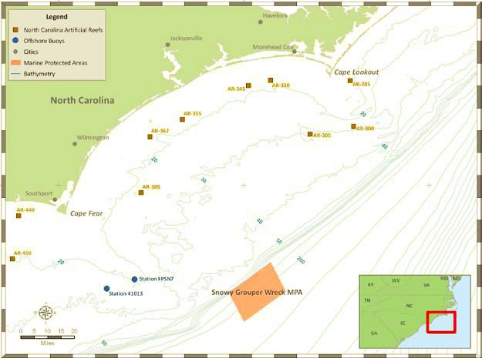
Figure 4.1.1. Snowy Grouper Wreck MPA, positioned southeast of Cape Fear, NC (SAFMC 2009).

Habitat and Managed Species Characterization
The Snowy-Grouper Wreck MPA is comprised of hard-bottom habitats, one primary wreck, and possible additional smaller wrecks, ranging in depth from 197 feet to 984 feet (Figure 4.1.2; SAFMC 2007).

Managed Species Resource Characterization
The prominent Snapper-Grouper species targeted at this site consist of include snowy grouper, speckled hind, gag grouper, and red porgy (SAFMC 2007). In the late 1990s, a population of spawning snowy grouper were targeted and fished down over the wreck area encompassed within this MPA (SAFMC 2007, 2009). SEFSC ROV Survey and Southeast Reef Fish Survey (SERFS) sampling has occurred within the Snowy-Grouper Wreck MPA. The SEFSC ROV survey has observed 58 different taxa within the MPA (Note: Some are listed at family or genus level) including speckled hind, a target species (Table 4.1.1). The SERFS data include information on rock hind, speckled hind, red grouper, snowy grouper, warsaw grouper, gag, scamp, greater amberjack, red porgy, silk snapper, lionfish, and blueline tilefish (Table 4.1.2). Red porgy was the only species analyzed by SERFS that was reported in spawning condition.

Table 4.1.1. Species observed during ROV dives within the Snowy Wreck MPA. Species in bold are target species.
Common Name | Scientific Name | Common Name | Scientific Name
Reticulate Moray | Muraena retifera | Porgy | Calamus sp.
Squirrelfish | Holocentridae sp. | Red Porgy | Pagrus pagrus
Blackbar Soldierfish | Myripristis jacobus | Jack-knife Fish | Equetus lanceolatus
Cardinal Soldierfish | Plectrypops retrospinis | Cubbyu | Pareques umbrosus
Scorpionfish | Scorpaenidae | Spotted Goatfish | Pseudupeneus maculatus
Lionfish | Pterois volitans | Longsnout Butterflyfish | Prognathodes aculeatus
Rock Hind | Epinephelus adscensionis | Spotfin Butterflyfish | Chaetodon ocellatus
Speckled Hind | Epinephelus drummondhayi | Reef Butterflyfish | Chaetodon sedentarius
Red Grouper | Epinephelus morio | Bank Butterflyfish | Prognathodes aya
Gag | Mycteroperca microlepis | French Butterflyfish | Prognathodes guyanensis
Scamp | Mycteroperca phenax | Cherubfish | Centropyge argi
Unidentified Anthiid | Anthiinae | Blue Angelfish | Holacanthus bermudensis
Creolefish | Paranthias furcifer | Rock Beauty | Holacanthus tricolor
Wrasse Bass | Liopropoma eukrines | Blue Chromis | Chromis cyaneus
Graysby | Cephalopholis cruentata | Yellowtail Reeffish | Chromis enchrysura
Orangeback Bass | Serranus annularis | Sunshinefish | Chromis insolata
Snow Bass | Serranus chionaraia | Purple Reeffish | Chromis scotti
Tattler | Serranus phoebe | Bicolor Damselfish | Stegastes partitus
Roughtongue Bass | Pronotogrammus martinicensis | Creole Wrasse | Clepticus parrae
Greater Soapfish | Rypticus saponaceus | Spotfin Hogfish | Bodianus pulchellus
Bigeye | Priacanthus arenatus | Red Hogfish | Decodon puellaris
Short Bigeye | Pristigenys alta | Yellowhead Wrasse | Halichoeres garnoti
Unidentified Jack | Carangidae | Wrasse | Halichoeres sp.
Greater Amberjack | Seriola dumerili | Hogfish | Lachnolaimus maximus
Almaco Jack | Seriola rivoliana | Greenblotch Parrotfish | Sparisoma atomarium
Blackfin Snapper | Lutjanus buccanella | Doctorfish | Acanthurus sp.
Vermilion Snapper | Rhomboplites aurorubens | Gray Triggerfish | Balistes capriscus
Tomtate | Haemulon aurolineatum | Sharpnose Puffer | Canthigaster rostrata
Striped Grunt | Haemulon striatum

Table 4.1.2. Target species number caught and average length of individuals collected through the SERFS within the Snowy Wreck MPA and size of maturity for reference. Other species were provided as additional information.
Target Species | Number Caught | Avg TL (cm) | Size of Maturity (cm)
Speckled Hind | 8 | 51 | 81
Snowy Grouper | 14 | 51 | 54
Warsaw Grouper | 3 | 104 | ~115
Blueline Tilefish | 3 | 66 | ~40

Other Species | Number Caught | Avg TL (cm)
Rock Hind | 1 | 44
Red Grouper | 14 | 74
Gag | 5 | 88
Scamp | 22 | 67
Greater Soapfish | 1 | 31
Greater Amberjack | 2 | 122
Red Porgy | 19 | 45
Silk Snapper | 7 | 50
Lionfish | 1 | 30

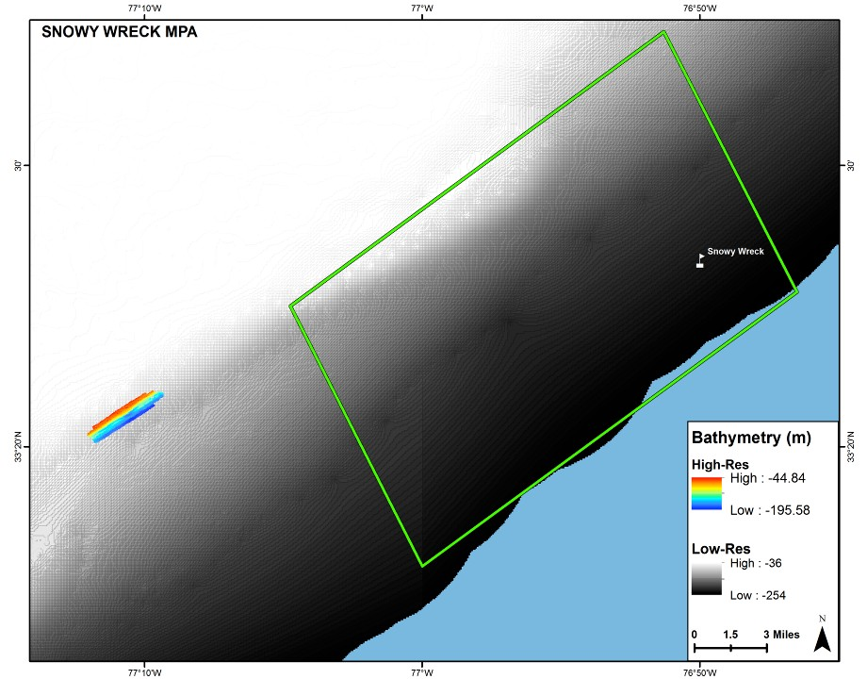

Figure 4.1.2. Bathymetry of the Snowy Grouper Wreck MPA (N. Farmer, 2014).

Northern South Carolina MPA
Location and Zoning
The Northern South Carolina MPA is located about 54 nautical miles southeast of Murrells Inlet, SC and spans approximately 50 square nautical miles (10 x 5 nautical miles) in size (Figure 4.2.1; SAFMC 2007, 2009).

Northwest corner at 32°53.5΄N, 78°16.75΄W Northeast corner at 32°53.5΄N, 78°4.75΄W Southwest corner at 32°48.5΄N, 78°16.75΄W Southeast corner at 32°48.5΄N, 78°4.75΄W (SAFMC 2007; 2009)
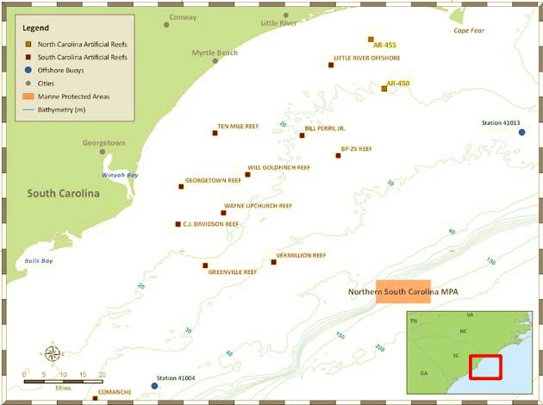

Figure 4.2.1. Northern South Carolina MPA, located southeast of Murrells Inlet, SC (SAFMC 2007).

Habitat and Managed Species Characterization
This MPA is comprised of “hard-bottom habitat consisting of eroded rock in shelf- edge” at depths from 164 to 561 feet (SAFMC 2007; Figure 4.2.2).

In reference to the Northern South Carolina MPA, “Fishermen refer to the area as “smurfville” because it holds many small vermilion snapper. Information received during the public input process indicated that this area is fished mostly in the winter and that it holds deepwater species like snowy grouper, yellowedge grouper, and speckled hind, as well as red porgy, triggerfish, and gag.” (SAFMC 2007). SEFSC ROV Survey and Southeast Reef Fish Survey (SERFS) sampling has occurred within the Northern South Carolina MPA. The SEFSC ROV Survey has observed 110 different taxa (Note: Some are listed at family or genus level due to difficulty identifying through video) including speckled hind, yellowedge grouper, snowy grouper, and blueline tilefish, which are target species. The SERFS data include information on red grouper, tomtate, white grunt, knobbed porgy, red porgy, and blueline tilefish (Table 4.2.2). Tomtate, white grunt, and red porgy have been collected in spawning condition within the MPA boundaries.

Table 4.2.1. Species observed during ROV dives within the Northern South Carolina MPA. Species in bold are target species. (Data provided by SEFSC)
Common Name | Scientific Name | Common Name | Scientific Name
Bignose Shark | Carcharhinus altimus | Blueline Tilefish | Caulolatilus microps
Spotted Moray | Gymnothorax moringa | Sand Tilefish | Malacanthus plumieri
Unidentified Moray | Muraenidae | Greater Amberjack | Seriola dumerili
Reticulate Moray | Muraena retifera | Almaco Jack | Seriola rivoliana
Stout Moray | Muraena robusta | Unidentified Jack | Decapterus sp.
Sharptail Eel | Myrichthys acuminatus | Unidentified Snapper | Lutjanus sp.
Goldspotted Eel | Myrichthys oculatus | Vermilion Snapper | Rhomboplites aurorubens
Unidentified Lizardfish | Synodus sp. | Tomtate | Haemulon aurolineatum
Sand Diver | Synodus intermedius | White Grunt | Haemulon plumierii
Goosefish | Lophius americanus | Striped Grunt | Haemulon striatum
Mora Cod | Laemonema sp. | Porgy | Calamus sp.
Carolina Hake | Urophycis earllii | Red Porgy | Pagrus pagrus
Big Roughy | Gephyroberyx darwinii | Jack-knife Fish | Equetus lanceolatus
Squirrelfish | Holocentridae sp. | Cubbyu | Pareques umbrosus
Blackbar Soldierfish | Myripristis jacobus | Blackbar Drum | Pareques iwamotoi
Bigeye Soldierfish | Ostichthys trachypoma | Spotted Goatfish | Pseudupeneus maculatus
Deepbody Boarfish | Antigonia capros | Longsnout Butterflyfish | Prognathodes aculeatus
Unidentified Cornetfish | Fistularia sp. | Spotfin Butterflyfish | Chaetodon ocellatus
Bluespotted Cornetfish | Fistularia tabacaria | Reef Butterflyfish | Chaetodon sedentarius
Trumpetfish | Aulostomus maculatus | Bank Butterflyfish | Prognathodes aya
Longspine Snipefish | Macrorhamphosus scolopax | French Butterflyfish | Prognathodes guyanensis
Scorpionfish | Scorpaenidae | Cherubfish | Centropyge argi
Lionfish | Pterois volitans | Blue Angelfish | Holacanthus bermudensis
Flying Gurnard | Dactylopterus volitans | Rock Beauty | Holacanthus tricolor
Bank Sea Bass | Centropristis ocyurus | Gray Angelfish | Pomacanthus arcuatus
Black Sea Bass | Centropristis striata | French Angelfish | Pomacanthus paru
Rock Hind | Epinephelus adscensionis | Blue Chromis | Chromis cyaneus
Speckled Hind | Epinephelus drummondhayi | Yellowtail Reeffish | Chromis enchrysura
Red Hind | Epinehphelus guttatus | Sunshinefish | Chromis insolata
Red Grouper | Epinephelus morio | Purple Reeffish | Chromis scotti
Yellowedge Grouper | Hyporthodus flavolimbatus | Bicolor Damselfish | Stegastes partitus
Snowy Grouper | Hyporthodus niveatus | Barracuda | Sphyraena barracuda
Gag | Mycteroperca microlepis | Spotfin Hogfish | Bodianus pulchellus
Scamp | Mycteroperca phenax | Red Hogfish | Decodon puellaris
Coney Grouper | Cephalopholis fulva | Spanish Hogfish | Bodianus rufus
Red Barbier | Hemanthias vivanus | Greenband Wrasse | Halichoeres bathyphilus
Unidentified Anthiid | Anthiinae | Yellowhead Wrasse | Halichoeres garnoti
Apricot Bass | Plectranthias garrupellus | Wrasse | Halichoeres sp.
Yellowfin Bass | Anthias nicholsi | Hogfish | Lachnolaimus maximus
Swallowtail Bass | Anthias woodsi | Greenblotch Parrotfish | Sparisoma atomarium
Bladefin Bass | Jeboehklia gladifer | Unidentified Parrotfish | Sparisoma sp.
Creolefish | Paranthias furcifer | Blue Goby | Ptereleotris calliura
Wrasse Bass | Liopropoma eukrines | Doctorfish | Acanthurus sp.
Graysby | Cephalopholis cruentata | Flounder | Bothidae
Orangeback Bass | Serranus annularis | Filefish | Aluterus sp.
Saddle Bass | Serranus notospilus | Gray Triggerfish | Balistes capriscus
Tattler | Serranus phoebe | Queen Triggerfish | Balistes vetula
Roughtongue Bass | Pronotogrammus martinicensis | Unidentified Trunkfish | Lactophrys sp.
Unidentified Soapfish | Rypticus sp. | Spotted Trunkfish | Lactophrys bicaudalis
Greater Soapfish | Rypticus saponaceus | Honeycomb Cowfish | Acanthostracion polygonius
Bigeye | Priacanthus arenatus | Scrawled Cowfish | Acanthostracion quadricornis
Short Bigeye | Pristigenys alta | Sharpnose Puffer | Canthigaster rostrata
Bulleye | Cookeolus boops | Bandtail Puffer | Sphoeroides spengleri
Unidentified Cardinalfish | Apogon sp. | Puffer | Diodon sp.
Twospot Cardinalfish | Apogon pseudomaculatus
Table 4.1.2. Target species number caught and average length of individuals collected through the SERFS within the Northern South Carolina MPA and size of maturity for reference. Other species were provided as additional information. (Data provided by SCDNR)
Target Species | Number Caught | Avg TL (cm) | Size of Maturity (cm)
Blueline Tilefish | 7 | 45 | ~40

Other Species | Number Caught | Avg TL (cm)
Red Grouper | 1 | 73
Tomtate | 2 | 18
White Grunt | 1 | 40
Knobbed Porgy | 2 | 34
Red Porgy | 37 | 31

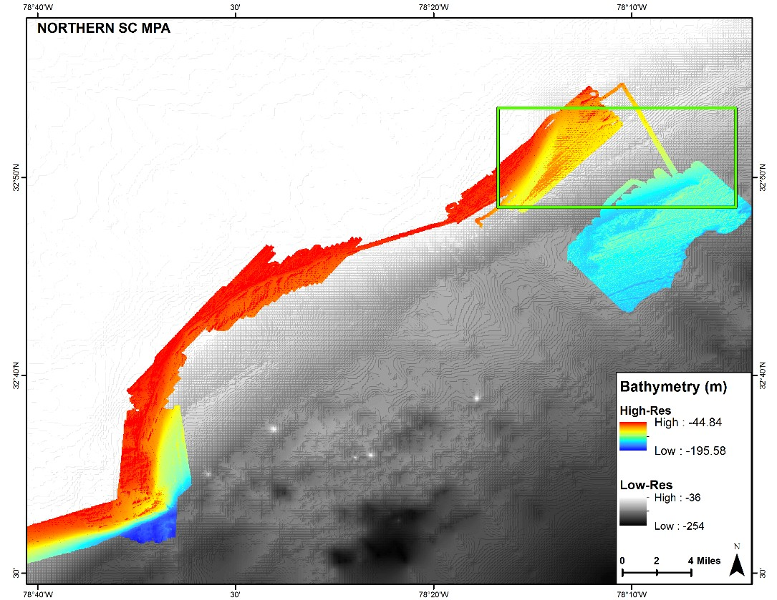
Figure 4.2.2. Low- and high-resolution bathymetry within and outside of the Northern South
Carolina MPA (Provided by N. Farmer).

Edisto MPA
Location and Zoning
The Edisto MPA is located about 45 nautical miles southeast of Charleston, SC and spans approximately 50 square nautical miles (10 x 5 nautical miles) in size (Figure 4.3.1; SAFMC 2007).

Northwest corner at 32°24΄N, 79°6΄W Northeast corner at 32°24΄N, 78°54΄W Southwest corner at 32°18.5΄N, 79°6΄W Southeast corner at 32°18.5΄N, 78°54΄W

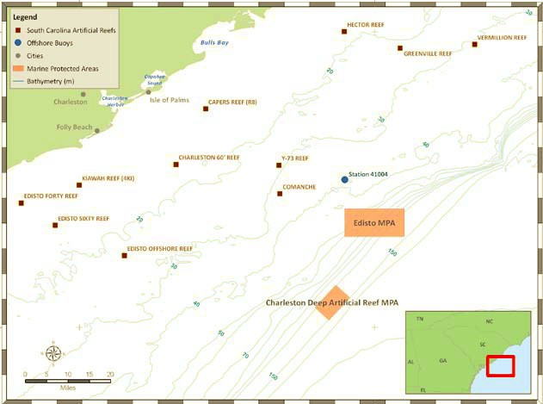

Figure 4.3.1. The Edisto and Charleston Deep Artificial Reef MPAs, located east of Charleston and
Charleston Harbor, SC (SAFMC 2007).

Habitat and Managed Species Characterization
“Oriented perpendicular to and southeast of the Charleston, SC, coastline, the area is heavily fished by both commercial and recreational fishermen. Water depths range from 262 ft. to 459 ft., with shallower areas from 148 ft. to 262 ft. The area includes shelf-edge habitat, home to species such as vermilion snapper, red porgy, gag, scamp, and black sea bass. Other deepwater species include: juvenile snowy grouper, speckled hind, and blueline tilefish. The large number of species found in this area may be related to regional circulation patterns: the MPA lies in an area where the Gulf Stream deflects, or bounces off, the “Charleston Bump,” a deepwater bank made up of a series of steep scarps with rocky cliffs, overhangs, and caves. This deflection creates a series of persistent clockwise swirls and upwelling currents referred to as the “Charleston Gyre,” resulting in nutrient rich water beneficial to early life stages of fishes. Furthermore, the Charleston Gyre may serve to retain larvae offshore, as well as transport the larvae of some species such as gag and snowy grouper toward nursery areas in estuarine waters. Thus, the area may serve both as a source of larvae for surrounding regions and a sink to retain young fish that need to remain offshore to complete their development.” (SAFMC 2007; Figure 4.3.2).

SEFSC ROV Survey and Southeast Reef Fish Survey (SERFS) sampling has occurred within the Edisto MPA. The SEFSC ROV Survey has observed 108 different taxa (Note: Some are listed at family or genus level due to difficulty identifying through video) including speckled hind and snowy grouper, which are target species (Table 4.3.1). The SERFS data include information on scamp, warsaw grouper, and red porgy (Table 4.3.2). Scamp have been collected in spawning condition within the MPA boundaries.

Table 4.3.1. Species observed during ROV dives within the Edisto MPA. Species in bold are target species. (Data provided by SEFSC)
Common Name | Scientific Name | Common Name | Scientific Name
Unidentified Shark | Carcharhinidae | Vermilion Snapper | Rhomboplites aurorubens
Moray Eel | Muraenidae | Tomtate | Haemulon aurolineatum
Spotted Moray | Gymnothorax moringa | White Grunt | Haemulon plumierii
Reticulate Moray | Muraena retifera | Striped Grunt | Haemulon striatum
Snake Eel | Ophichthidae | Spottail Pinfish | Diplodus holbrookii
Unidentified Lizardfish | Synodus sp. | Porgy | Calamus sp.
Sand Diver | Synodus intermedius | Red Porgy | Pagrus pagrus
Toadfish | Opsanus sp. | Jack-knife Fish | Equetus lanceolatus
Squirrelfish | Holocentridae sp. | Cubbyu | Pareques umbrosus
Blackbar Soldierfish | Myripristis jacobus | Yellow Goatfish | Mulloidichthys martinicus
Cardinal Soldierfish | Plectrypops retrospinis | Spotted Goatfish | Pseudupeneus maculatus
Unidentified Cornetfish | Fistularia sp. | Longsnout Butterflyfish | Prognathodes aculeatus
Bluespotted Cornetfish | Fistularia tabacaria | Spotfin Butterflyfish | Chaetodon ocellatus
Trumpetfish | Aulostomus maculatus | Reef Butterflyfish | Chaetodon sedentarius
Pipefish | Syngnathus sp. | Bank Butterflyfish | Prognathodes aya
Scorpionfish | Scorpaenidae | Banded Butterflyfish | Chaetodon striatus
Spotted Scorpionfish | Scorpaena plumieri | Cherubfish | Centropyge argi
Lionfish | Pterois volitans | Blue Angelfish | Holacanthus bermudensis
Flying Gurnard | Dactylopterus volitans | Rock Beauty | Holacanthus tricolor
Bank Sea Bass | Centropristis ocyurus | Gray Angelfish | Pomacanthus arcuatus
Rock Hind | Epinephelus adscensionis | French Angelfish | Pomacanthus paru
Speckled Hind | Epinephelus drummondhayi | Blue Chromis | Chromis cyaneus
Red Grouper | Epinephelus morio | Yellowtail Reeffish | Chromis enchrysura
Snowy Grouper | Hyporthodus niveatus | Sunshinefish | Chromis insolata
Gag | Mycteroperca microlepis | Purple Reeffish | Chromis scotti
Black Grouper | Mycteroperca bonaci | Bicolor Damselfish | Stegastes partitus
Scamp | Mycteroperca phenax | Barracuda | Sphyraena barracuda
Yellowmouth Grouper | Mycteroperca interstitialis | Creole Wrasse | Clepticus parrae
Coney Grouper | Cephalopholis fulva | Spotfin Hogfish | Bodianus pulchellus
Unidentified Anthiid | Anthiinae | Red Hogfish | Decodon puellaris
Creolefish | Paranthias furcifer | Spanish Hogfish | Bodianus rufus
Wrasse Bass | Liopropoma eukrines | Yellowhead Wrasse | Halichoeres garnoti
Graysby | Cephalopholis cruentata | Wrasse | Halichoeres sp.
Orangeback Bass | Serranus annularis | Hogfish | Lachnolaimus maximus
Lantern Bass | Serranus baldwini | Bluehead Wrasse | Thalassoma bifasciatum
Saddle Bass | Serranus notospilus | Greenblotch Parrotfish | Sparisoma atomarium
Tattler | Serranus phoebe | Unidentified Parrotfish | Sparisoma sp.
Whitespotted Soapfish | Rypticus maculatus | Doctorfish | Acanthurus sp.
Unidentified Soapfish | Rypticus sp. | Unicorn Filefish | Aluterus monoceros
Bigeye | Priacanthus arenatus | Scrawled Filefish | Aluterus scriptus
Short Bigeye | Pristigenys alta | Gray Triggerfish | Balistes capriscus
Unidentified Cardinalfish | Apogon sp. | Queen Triggerfish | Balistes vetula
Twospot Cardinalfish | Apogon pseudomaculatus | Planehead Filefish | Stephanolepis hispida
Sand Tilefish | Malacanthus plumieri | Unidentified Filefish | Monacanthidae
Cobia | Rachycentron canadum | Unidentified Trunkfish | Lactophrys sp.
Unidentified Jack | Carangidae | Honeycomb Cowfish | Acanthostracion polygonius
Black Jack | Caranx lugubris | Scrawled Cowfish | Acanthostracion quadricornis
Greater Amberjack | Seriola dumerili | Sharpnose Puffer | Canthigaster rostrata
Almaco Jack | Seriola rivoliana | Bandtail Puffer | Sphoeroides spengleri
Banded Rudderfish | Seriola zonata | Unidentified Burrfish | Chilomycterus sp.
Bluntnose Jack | Hemicaranx amblyrhynchus | Striped Burrfish | Chilomycterus schoepfi
Unidentified Snapper | Lutjanus sp. | Spot-fin Porcupinefish | Diodon hystrix
Gray Snapper | Lutjanus griseus | Long-spine Porcupinefish | Diodon holocanthus
Dog Snapper | Lutjanus jocu | Ocean Sunfish | Mola mola

Table 4.3.2. Target species number caught and average length of individuals collected through the SERFS within the Edisto MPA and size of maturity for reference. Other species were provided as additional information. (Data provided by SCDNR)
Target Species | Number Caught | Avg TL (cm) | Size of Maturity (cm)
Warsaw Grouper | 1 | 78 | ~115

Other Species | Number Caught | Avg TL (cm)
Scamp | 2 | 60
Red Porgy | 3 | 42

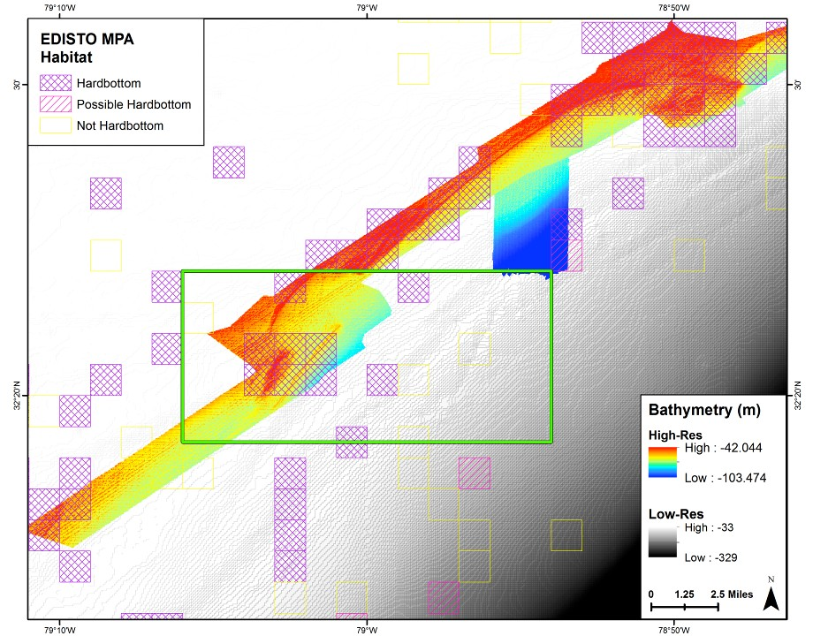
Figure 4.3.2. Low- and high-resolution bathymetry and habitat characterization within and outside of the Edisto MPA (Provided by N. Farmer).

Charleston Deep Artificial Reef MPA

Location and Zoning

The Charleston Deep Artificial Reef MPA is located about 50 nautical miles southeast of Charleston Harbor, SC and spans approximately 21 square nautical miles (3.5 x 6 nautical miles) in size (Figure 4.3.1; SAFMC 2007).

Northwest corner at 32°04΄ N, 79°12΄W Northeast corner at 32°8.5΄N, 79°7.5΄W Southwest corner at 32°1.5΄N, 79°9.3΄W Southeast corner at 32°6΄N, 79°5΄W

Habitat Characterization
“This area is proposed as an experimental artificial reef site as a result of public comment and support for creating artificial reefs. The area ranges in depth from 328 ft. to 492 ft. There is no hard bottom in the area. Any biological benefits to deepwater species would accrue after artificial reef material (such as sunken ships, tanks, or highway materials) is added to improve habitat and attract fish. Study of this site in the long-term may provide important biological information about deepwater snapper grouper species and the effectiveness of deepwater artificial reefs.” (SAFMC 2007; Figure 4.4.1)

The reef was sampled by SEFSC with ROVs in 2014 two months after the barges were sunk. Amberjack were present on both barges and one snowy grouper was observed on one barge. The artificial reef is not sampled by SERFS.

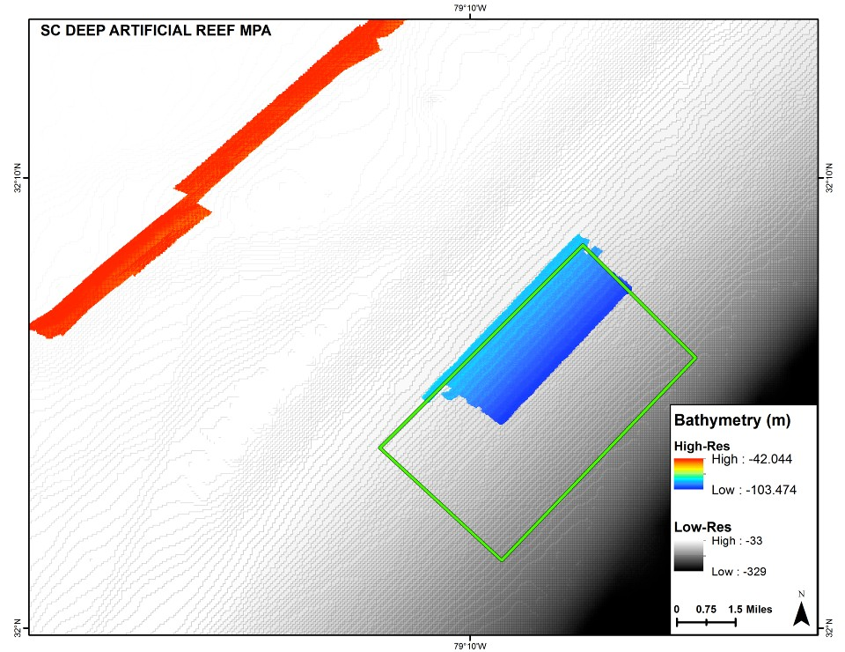

Figure 4.4.1. Low- and high-resolution bathymetry within and outside of the Charleston Deep
Artificial Reef MPA (Provided by N. Farmer).

Georgia MPA
Location and Zoning

The Georgia MPA is located about 69 nautical miles southeast of Wassaw Sound, GA and spans approximately 100 square nautical miles (10 x 10 nautical miles) in size (Figure 4.5.1; SAFMC 2007).

Northwest corner at 31°43΄N, 79°31΄W Northeast corner at 31°43΄N, 79°21΄W Southwest corner at 31°34΄N, 79°39΄W Southeast corner at 31°34΄N, 79°29΄W

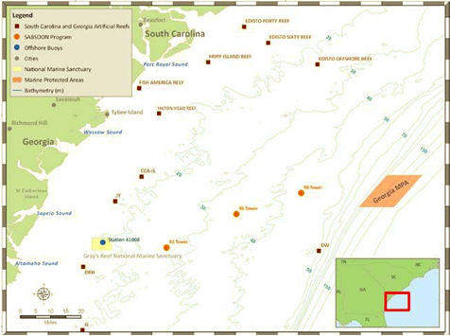

Figure 4.5.1. The Georgia MPA, located east of Wassaw Sound, GA (SAFMC 2009).

Habitat and Managed Species Characterization
“The area consists of a mud-bottom habitat in waters 295 ft. to 984 ft. deep. Species such as snowy grouper and golden tilefish are often caught within the area, although most fishing is for pelagic species such as tuna and dolphin. This area is occasionally fished commercially for snapper grouper species but lies east of an area called the “Triple Ledge” that is an important area for commercial fishermen. Oriented parallel to the coast and shelf break, the area encompasses additional deepwater habitat.” (SAFMC 2007; Figure 4.5.2)

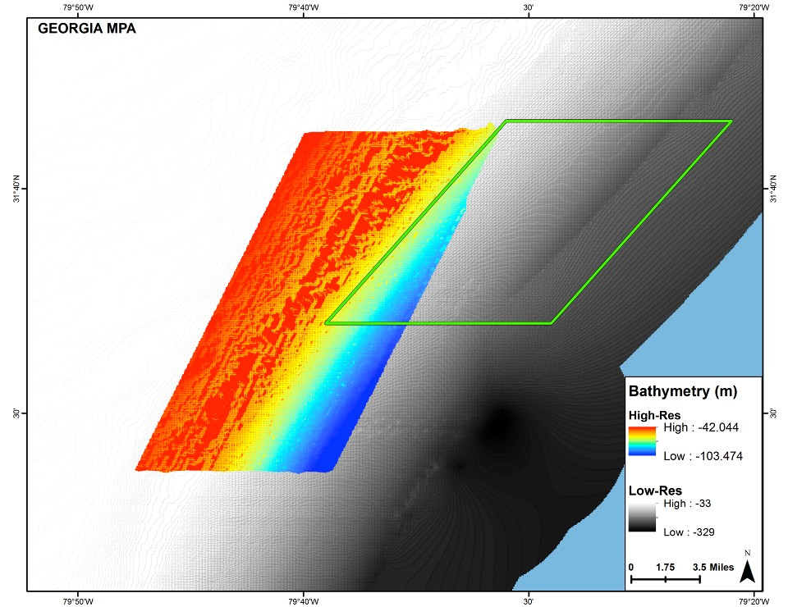

Figure 4.5.2. Low- and high-resolution bathymetry within and outside of the Georgia MPA (Provided by N. Farmer).

North Florida MPA
Location and Zoning
The North Florida MPA is located about 60 nautical miles off the St. John’s River in Jacksonville, FL and spans approximately 100 square nautical miles (10 x 10 nautical miles) in size (Fig. 4.6.1; SAFMC 2007).

Northwest corner at 30°29΄N, 80°14΄W Northeast corner at 30°29΄N, 80°2΄ W Southwest corner at 30°19΄N, 80°14΄W Southeast corner at 30°19΄N, 80°2΄W

Habitat and Managed Species Characterization
“The MPA consists of varying water depths ranging from 197 ft. to 656 ft., with
a deeper area up to 1,247 ft. The bottom habitat comprises some mud bottom habitat and shelf-edge reef of slab pavement, blocked boulders, and buried blocked boulders.” (SAFMC 2007; Figures 4.6.2 and 4.6.3)

“Snowy grouper and speckled hind have been caught in the area and the mud bottom may also be habitat for golden tilefish. Some mid-shelf species that are also likely to inhabit the area include vermilion snapper, hogfish, scamp, red porgy, and tomtate. The location of this MPA represents a compromise between fishermen and the Habitat Advisory Panel in order to balance biological benefits with social and economic impacts.” (SAFMC 2007)

SEFSC ROV Survey and Southeast Reef Fish Survey (SERFS) sampling has occurred within the North Florida MPA. The SEFSC ROV Survey has observed 82 different taxa (Note: Some are listed at family or genus level due to difficulty identifying through video) including speckled hind and snowy grouper, which are target species (Table 4.6.1). The SERFS data include information on speckled hind, red grouper, scamp, vermilion snapper, red porgy, and gray triggerfish (Table 4.6.2). Red porgy have been collected in spawning condition within the MPA boundaries.

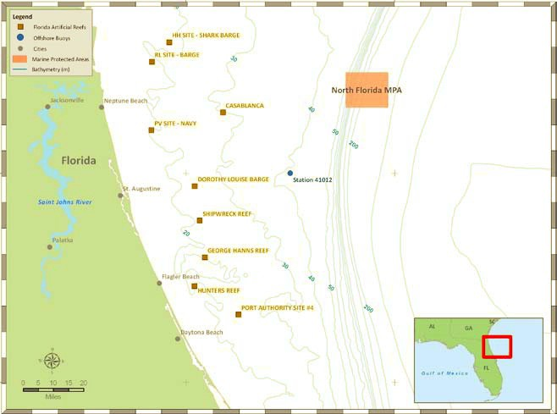
Figure 4.6.1. North Florida MPA located east of Neptune Beach, FL.

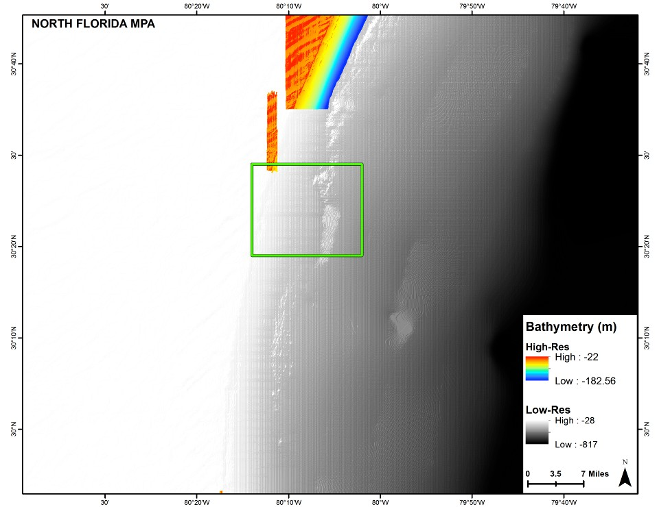
Figure 4.6.2. Low- and high-resolution bathymetry within and outside of the North Florida MPA (Provided by N. Farmer).

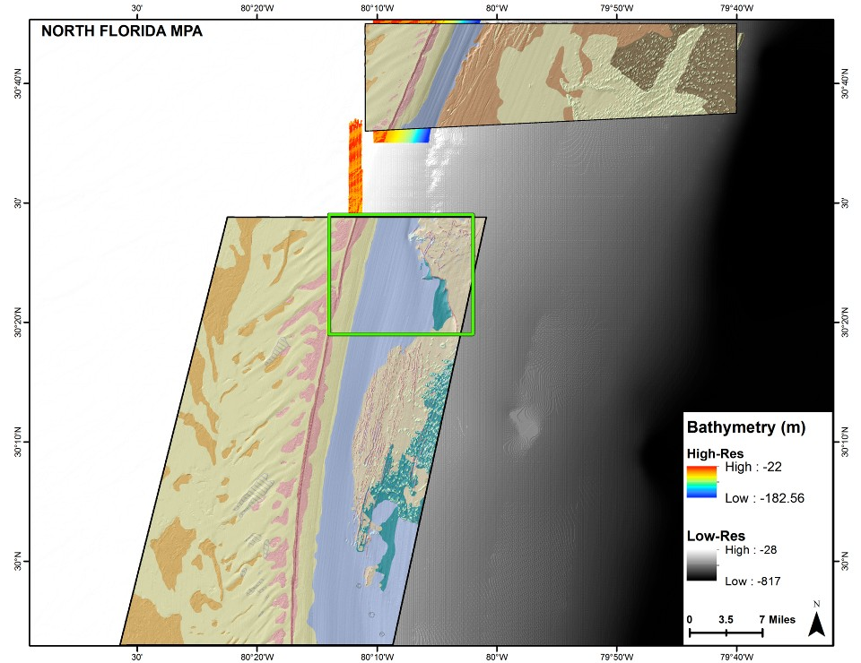
Figure 4.6.3. High-resolution habitat characterization within and outside of the North Florida MPA (Provided by N. Farmer).

Table 4.6.1. Species observed during ROV dives within the North Florida MPA. Species in bold are target species. (Data provided by SEFSC)
Common Name | Scientific Name | Common Name | Scientific Name
Moray Eel | Muraenidae | Yellowtail Snapper | Ocyurus chrysurus
Purplemouth Moray | Gymnothorax vicinus | Vermilion Snapper | Rhomboplites aurorubens
Spotted Moray | Gymnothorax moringa | Tomtate | Haemulon aurolineatum
Reticulate Moray | Muraena retifera | Striped Grunt | Haemulon striatum
Stout Moray | Muraena robusta | Porgy | Calamus sp.
Unidentified Lizardfish | Synodus sp. | Red Porgy | Pagrus pagrus
Toadfish | Opsanus sp. | Jack-knife Fish | Equetus lanceolatus
Squirrelfish | Holocentridae sp. | Cubbyu | Pareques umbrosus
Blackbar Soldierfish | Myripristis jacobus | Blackbar Drum | Pareques iwamotoi
Unidentified Cornetfish | Fistularia sp. | Spotted Goatfish | Pseudupeneus maculatus
Bluespotted Cornetfish | Fistularia tabacaria | Spotfin Butterflyfish | Chaetodon ocellatus
Scorpionfish | Scorpaenidae | Reef Butterflyfish | Chaetodon sedentarius
Lionfish | Pterois volitans | Bank Butterflyfish | Prognathodes aya
Flying Gurnard | Dactylopterus volitans | Blue Angelfish | Holacanthus bermudensis
Bank Sea Bass | Centropristis ocyurus | Gray Angelfish | Pomacanthus arcuatus
Speckled Hind | Epinephelus drummondhayi | French Angelfish | Pomacanthus paru
Goliath Grouper | Epinephelus itajara | Yellowtail Reeffish | Chromis enchrysura
Snowy Grouper | Hyporthodus niveatus | Sunshinefish | Chromis insolata
Gag | Mycteroperca microlepis | Purple Reeffish | Chromis scotti
Scamp | Mycteroperca phenax | Bicolor Damselfish | Stegastes partitus
Unidentified Anthiid | Anthiinae | Barracuda | Sphyraena barracuda
Creolefish | Paranthias furcifer | Spotfin Hogfish | Bodianus pulchellus
Wrasse Bass | Liopropoma eukrines | Greenband wrasse | Halichoeres bathyphilus
Graysby | Cephalopholis cruentata | Yellowhead Wrasse | Halichoeres garnoti
Orangeback Bass | Serranus annularis | Wrasse | Halichoeres sp.
Lantern Bass | Serranus baldwini | Hogfish | Lachnolaimus maximus
Snow Bass | Serranus chionaraia | Unidentified Parrotfish | Sparisoma sp.
Saddle Bass | Serranus notospilus | Doctorfish | Acanthurus sp.
Tattler | Serranus phoebe | Flounder | Bothidae
Unidentified Soapfish | Rypticus sp. | Gray Triggerfish | Balistes capriscus
Greater Soapfish | Rypticus saponaceus | Queen triggerfish | Balistes vetula
Bigeye | Priacanthus arenatus | Slender Filefish | Monacanthus tuckeri
Short Bigeye | Pristigenys alta | Unidentified Trunkfish | Lactophrys sp.
Sand Tilefish | Malacanthus plumieri | Honeycomb Cowfish | Acanthostracion polygonius
Greater Amberjack | Seriola dumerili | Scrawled Cowfish | Acanthostracion quadricornis
Almaco Jack | Seriola rivoliana | Unidentified Trunkfish | Acanthostracion quadricornis
Unidentified Jack | Decapterus sp. | Sharpnose Puffer | Canthigaster rostrata
Unidentified Snapper | Lutjanus sp. | Bandtail Puffer | Sphoeroides spengleri
Mutton Snapper | Lutjanus analis | Unidentified Burrfish | Chilomycterus sp.
Gray Snapper | Lutjanus griseus | Striped Burrfish | Chilomycterus schoepfi
Red Snapper | Lutjanus campechanus | Puffer | Diodon sp.

Table 4.6.2. Target species number caught and average length of individuals collected through the SERFS within the North Florida MPA and size of maturity for reference. Other species were provided as additional information. (Data provided by SCDNR)

Target Species | Number Caught | Avg TL (cm) | Size of Maturity (cm)
Speckled Hind | 1 | 54 | 81

Other Species | Number Caught | Avg TL (cm)
Red Grouper | 1 | 77
Scamp | 1 | 76
Vermilion Snapper | 11 | 36
Red Porgy | 64 | 40
Gray Triggerfish | 3 | 52

St. Lucie Hump MPA
Location and Zoning
The St. Lucie MPA is located about 9 nautical miles southeast of the St. Lucie Inlet, FL and spans approximately 8 square nautical miles (4 x 2 nautical miles) in size (Figure 4.7.1; SAFMC 2007).

Northwest corner at 27°8΄N, 80°W Northeast corner at 27°8΄N, 79°58΄W Southwest corner at 27°4΄N, 80°W Southeast corner at 27°4΄N, 79°58΄W
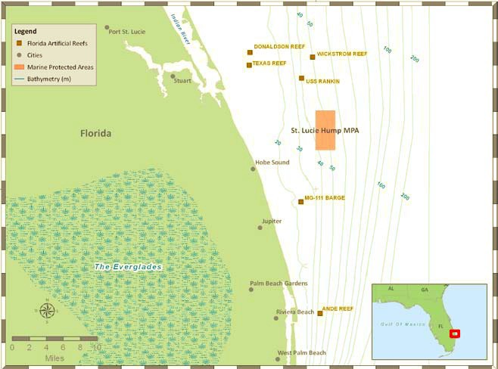
Figure 4.7.1. St. Lucie Hump MPA, located east of the St. Lucie Inlet, FL (SAFMC 2009).

Habitat and Managed Species Characterization
“This area, located east of Jupiter, FL, is habitat-rich and harbors speckled hind, juvenile snowy grouper, warsaw grouper, and mid-shelf species such as sea bass, red porgy, and red snapper. Water depths range from 216 ft. to 234 ft.” (SAFMC 2009; Figure 4.7.2)

“The area is heavily targeted by fishermen trolling for pelagic species and experiences a high level of vessel traffic. This MPA is located between fishing areas to the north and south that are more popular or just as popular; it is anticipated this will help reduce the potential socio-economic impacts to fishermen. The area has high potential for protecting deepwater snapper grouper species as well as some mid-shelf species.” (SAFMC 2007)

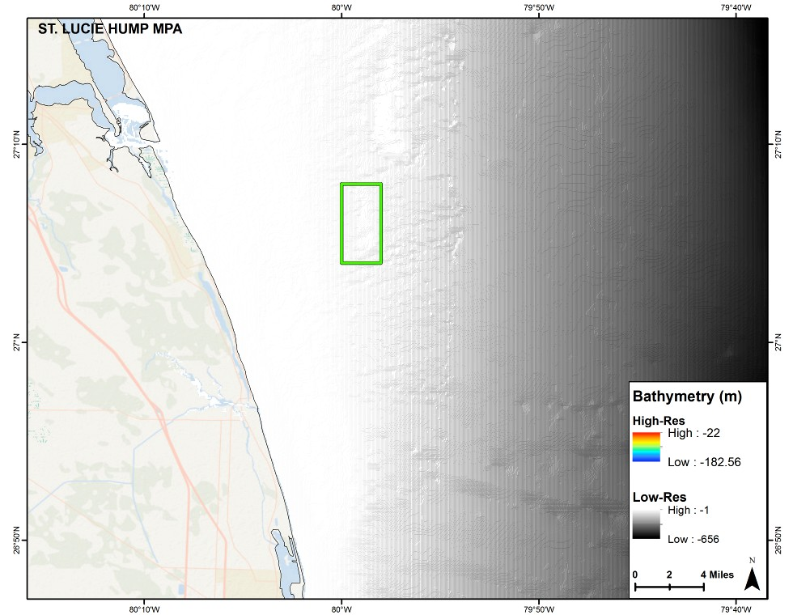
Figure 4.7.2. Low-resolution bathymetry of the St. Lucie Hump MPA (Provided by N. Farmer).

East Hump MPA
Location and Zoning
The East Hump MPA is located about 13 nautical miles southeast of Long Key, FL and spans approximately 50 square nautical miles (5 x 10 nautical miles) in size (Figure 4.8.1; SAFMC 2007, 2009).

Northwest corner at 24°36.5΄N, 80°45.5΄W Northeast corner at 24°32΄N, 80°36΄W Southwest corner at 24°32.5΄N, 80°48΄W Southeast corner at 24°27.5΄N, 80°38.5΄W

Habitat and Managed Species Characterization
“Located near the popular fishing spot called the “Islamorada Hump,” this site is
located in waters ranging from 636 ft. to 971 ft. deep, with the tops of the “humps” at 509 ft. to 541 ft. The humps are pinnacle-like formations that consist primarily of hardened layers of sandy carbonate sediments and support a diverse array of marine plants and animals, including deepwater corals. The area contains abundant habitat for snapper grouper species, such as snowy grouper, golden tilefish, and warsaw grouper.” (SAFMC 2007; Figure 4.8.2)

SEFSC ROV Survey sampling has occurred within the East Hump MPA. The SEFSC ROV Survey has observed 30 different taxa (Note: Some are listed at family or genus level due to difficulty identifying through video) including snowy grouper and blueline tilefish, which are target species (Table 4.8.1).

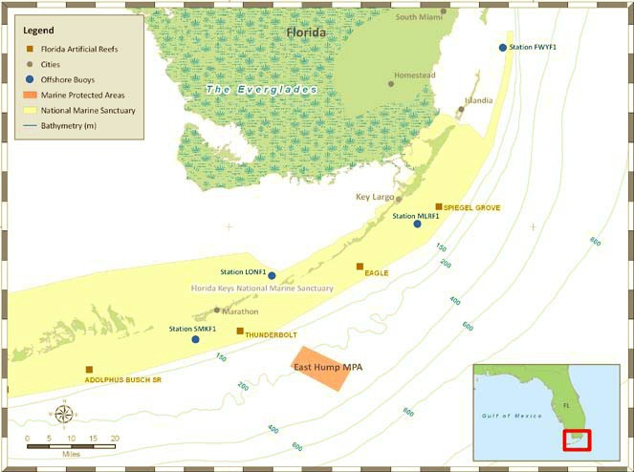
Figure 4.8.1. East Hump MPA, located southeast of Long Key, FL (SAFMC 2007).

Table 4.6.1. Species observed during ROV dives within the North Florida MPA. Species in bold are target species. (Data provided by SEFSC)
Common Name | Scientific Name | Common Name | Scientific Name
Moray Eel | Muraenidae | Yellowfin Bass | Anthias nicholsi
Green Moray | Gymnothorax funebris | Bladefin Bass | Jeboehklia gladifer
Shortnose Greeneye | Chloropthalmus agassiz | Roughtongue Bass | Pronotogrammus martinicensis
Shortbeard Codling | Laemonema barbatulum | Bigeye | Priacanthus arenatus
Mora Cod | Laemonema sp. | Blueline Tilefish | Caulolatilus microps
Big Roughy | Gephyroberyx darwinii | Greater Amberjack | Seriola dumerili
Deepbody Boarfish | Antigonia capros | Almaco Jack | Seriola rivoliana
Dragonet | Foetorepus sp. | Silk Snapper | Lutjanus vivanus
Longspine Snipefish | Macrorhamphosus scolopax | Queen Snapper | Etelis oculatus
Blackbelly Rosefish | Helicolenus dactylopterus | Reef Butterflyfish | Chaetodon sedentarius
Rover | Emmelichthyidae | Bank Butterflyfish | Prognathodes aya
Snowy Grouper | Hyporthodus niveatus | French Butterflyfish | Prognathodes guyanensis
Red Barbier | Hemanthias vivanus | Red Hogfish | Decodon puellaris
Unidentified Anthiid | Anthiinae | Barrelfish | Hyperoglyphe perciformis
Apricot Bass | Plectranthias garrupellus | Spiny Puffer | Didontidae

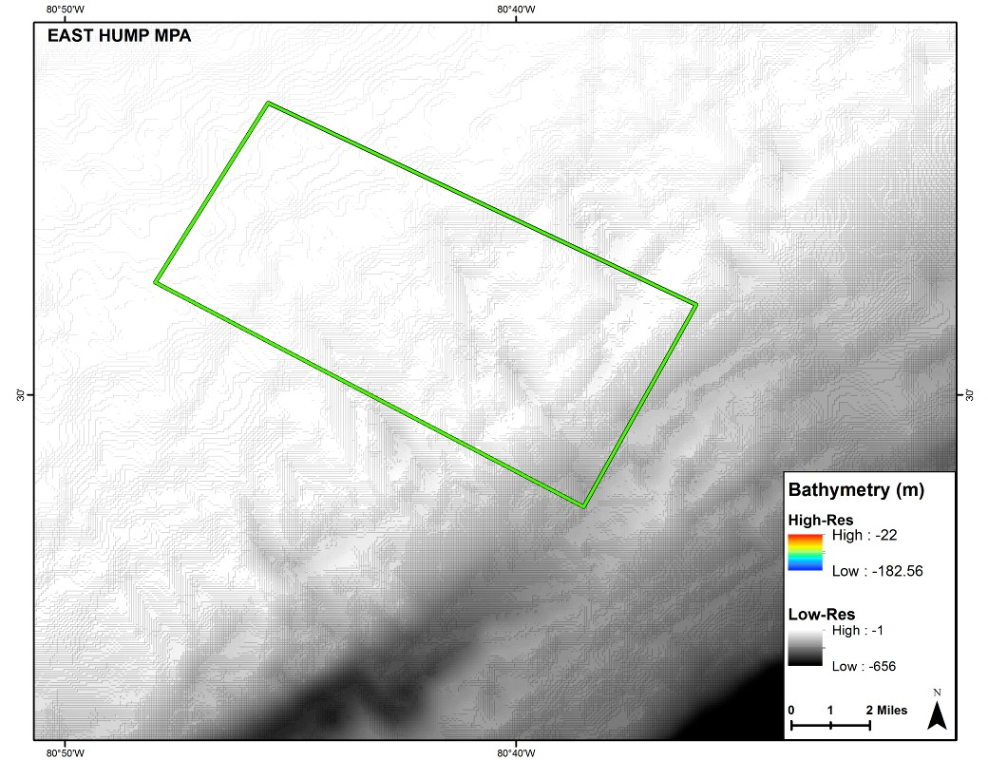

Figure 4.8.2. Low-resolution bathymetry of the East Hump MPA (Provided by N. Farmer).

Literature Cited & Resources Consulted

Ault, J.S., G.A. Meester, J. Luo, S.G. Smith, K.C. Lindeman. 2000. Natural resources affected environment: Dry Tortugas National Park draft environmental impact statement. In Dry Tortugas National Park General Management Plan. National Park Service. Denver, CO. 250 p.
Bachelor, N.M., C.M. Schobernd, Z.H. Schobernd, W.A. Mitchell, D.J. Berrane, G.T. Kellison, M.J.M. Reichert. 2013. Comparison of trap and underwater video gears for indexing reef fish presence and abundance in the southeast United States. Fisheries Research 143: 81- 88.
Burke, J.S., C.A. Currin, D.W. Field, M.S. Fonseca, J.A. Hare,W.J. Kenworthy, and A.V. Uhrin. 2003. Biogeographic analysis of the Tortugas Ecological Reserve: examining the refuge effect following reserve establishment. Marine Conservation Series MSD-04-1. U. S. Department of Commerce, NOAA, Marine Sanctuaries Division, Silver Spring, MD. 28pp.
California Department of Fish and Game. 2008. Master plan for marine protected areas. California Marine Life Protection Act.
Coastal Conservation and Education Foundation. 2011. MPA Meat: Marine Protected Area Management Effectiveness Assessment Tool. Cebu, Philippines. 15pp.
Commission for Environmental Cooperation. 2011. A Guide to Ecological Scorecards for Marine Protected Areas in North America. Montreal, Canada: Commission for Environmental Cooperation. 55pp.
Cowie-Haskell, B.D., and J.M. Delaney. 2003. Integrating science into the design of the Tortugas Ecological Reserve. MTS Journal. 37(1):68-79.
Dudley, N. (ed.). 2008. Guidelines for applying protected area management categories. Gland, Switzerland: IUCN. 86 p.
Ervin, J. 2003. WWF: Rapid Assessment and Prioritization of Protected Area Management (RAPPAM) Methodology. WWF, Gland Switzerland.
Fraser, S.B., and G.R. Sedberry. 2008. Reef morphology and invertebrate distribution at continental shelf edge reefs in the South Atlantic Bight. Southeastern Naturalist. 7(2):191-206.
Gleason, M., E. Fox, S. Ashcraft, J. Vasques, E. Whiteman, P. Serpa, E. Saarman, M. Caldwell, A. Frimodig, M. Miller0Henson, J. Kirlin, B. Ota, E. Pope, M. Weber, K. Wiseman. Designing a network of marine protected areas in California: Achievements, costs, lessons learned, and challenges ahead. Ocean and Coastal Management 74: 90-101.
Hare, J.A. and H.J. Walsh. 2007. Planktonic linkages among marine protected areas on the south Florida and southeast United States continental shelves. Can. J. Fish. Aquat. Sci. 64(9):1234-47.
Helies, F.C., J.L. Jamison, and A. Lasseter. 2011. Assessment of the Impacts of the Oculina Bank Marine Protected Area and In-Depth Ethnographic Profile of the Fort Pierce, Florida Fishing Community. Gulf and South Atlantic Fisheries Foundation. Saltonstall-Kennedy Grant #NA09NMF4270086 .
Hockings, M., S. Stolton, F. Leverington, N. Dudley, J. Courrau. 2006. Evaluating Effectiveness: A framework for assessing management effectiveness of protected areas. 2nd Edition. IUCN, Gland, Switzerland and Cambridge, UK. 105pp.
Huntsman, G.R., J. Potts, R. Mays, R.L. Dixon, P.W. Willis, M.L. Burton, B.W. Harvey. 1992. A stock assessment of the snapper-grouper complex in the U.S. South Atlantic based on fish caught in 1990. Report for the South Atlantic Fishery Management Council.
IUCN World Commission on Protected Areas (IUCN-WCPA). 2008. Establishing marine protected area networks—making it happen. Washington, D.C.: IUCN-WCPA, NOAA and TNC. 118 p.
Jeffrey, C.F.G., V.R. Leeworthy, M.E. Monaco, G. Piniak, and M. Fonseca (eds.). 2012. An integrated biogeographic assessment of reef fish populations and fisheries in Dry Tortugas: Effects of no-take reserves. NOAA Technical Memorandum NOS NCCOS 111. Prepared by the NCCOS Center for Coastal Monitoring and Assessment Biogeography Branch. Silver Spring, MD. 147 p.
Kelleher, G.1999. Guidelines for marine protected areas. IUCN, Gland, Switzerland and Cambridge, UK. 107 p.
Laffoley, D. (ed). 2008. Towards networks of marine protected areas. The MPA Plan of Action for IUCN’s World Commission on Protected Areas. IUCN WCPA, Gland, Switzerland. 28 p.
Lesher, A.T. 2008. An analysis of larval dispersal and retention within the South Atlantic Bight using satellite-tracked drifters released on reef fish spawning grounds. Master’s Thesis. The Graduate School of the College of Charleston. 64 p.
Leverington, F., K. Lemos Coast, J. Courrau, H. Pavese, C. Nolte, M. Marr, L. Coad, N. Burgess, B. Bomhard, M. Hockings. 2010. Management effectiveness evaluation in protected areas- a global study. 2nd Edition. University of Queensland. Brisbane, Australia. 101pp.
Lindeman, K.C., R. Pugliese, G.T. Waugh, and J.S. Ault. 2000. Developmental patterns within a multispecies reef fishery: management applications for essential fish habitats and protected areas. Bulletin of Marine Science. 66(3):929-56.
McGovern, J.C., G.R. Sedberry, H.S. Meister, T.M. Westendorff, D.M. Wyanski, P.J. Harris. 2005. A tag and recapture study of gag, Mycterperca microlepis, off the southeastern U.S. Bulletin of Marine Science. 76: 47-59.
National Research Council. 2001. Marine protected areas: tools for sustaining ocean ecosystems. National Research Council, Washington, D.C. 288 p.
NOAA. 2011. NOAA Coral Reef Conservation Program MPA Management Assessment Checklist. NOAA Coral Reef Conservation Program. 17pp.
Paris, C.B., R.K. Cowen, R. Claro, and K.C. Lindeman. 2005. Larval transport pathways from Cuban snapper (Lutjanidae) spawning aggregations based on biophysical modeling. Mar. Ecol. Prog. Ser. 296:93-106.
Pomeroy, R.S., J.E. Parks, and L.M. Watson. 2004. How is your MPA doing? A guidebook of natural and social indicators for evaluating marine protected area management effectiveness. IUCN, Protected Areas Program; WWF; United States, NOAA.
Potts, J. and K. Brennan. 2001. Trends in catch data and estimated static SPR values for fifteen species of reef fish landed along the southeastern United States. Report to the South Atlantic Fishery Management Council, One Southpark Circle, Suite 306, Charleston, SC 29407. 41 p.
Reed, J.K., S. Harter, S. Farrington, A. David. 2014. Characterization and interreleationships of deepwater coral/sponge habitats and fish communities off Florida. In: Interrelationships Between Corals and Fisheries. S.A. Bortone ed. CRC Press. Boca Raton, FL. 51-82.
Rizk, C., J. Semelin, C. Karibuhoye. 2011. Methodological guidebook for the development of management plans for marine protected areas in West Africa.
Rudershausen, P.J., W.A. Mitchell, J.A. Buckel, E.H. Williams, and E. Hazen. 2010. Developing a two-step fishery-independent design to estimate the relative abundance of deepwater reef fish: Application to a marine protected area off the southeastern United States coast. Fisheries Research. 105(3): 254–260.
SAFMC. 2005. Final Evaluation Plan for the Oculina Experimental Closed Area. South Atlantic Fishery Management Council, Charleston, South Carolina. 84 p.
SAFMC. 2009. Regulations for deepwater marine protected areas in the South Atlantic. South Carolina Seagrant Extension Program.
SAFMC. 2007. Snapper Grouper Amendment Number 14. South Atlantic Fishery Management Council, Charleston, South Carolina. 601 p.
SAFMC. 2015. Snapper Grouper Amendment Number 36 (Draft). South Atlantic Fishery Management Council, Charleston, South Carolina.
SAFMC. 2013. South Atlantic Fishery Management Council MPA Expert Workgroup Meeting II Overview. South Atlantic Fishery Management Council, Charleston, South Carolina.
SAFMC. 2012. South Atlantic Fishery Management Council MPA Expert Workgroup Meeting Overview. South Atlantic Fishery Management Council, Charleston, South Carolina.
Sale, P.F., H.V. Lavieren, M.C. Ablan Lagman, J. Atema, M. Butler, C. Fauvelot, J.D. Hogan,G.P. Jones, K.C. Lindeman, C.B. Paris, R. Steneck and H.L. Stewart. 2010. Preserving reef connectivity: A handbook for marine protected area managers. Connectivity Working Group, Coral Reef Targeted Research and Capacity Building for Management Program, UNU-INWEH.
Salm, R.V., and J.R. Clark. 2000. IUCN marine and coastal protected areas. IUCN, Washington, D.C. 370 p.
Sedberry, G.R., O. Pashuk, D.M. Wyanski, J.A. Stephen and P. Weinbach. 2006. Spawning locations for Atlantic reef fishes off the southeastern U.S. Proc. Gulf Carib. Fish. Inst. 57:463-514.
Sedberry, G.R., P. Weinbach, J.A. Stephen, D.J. Machowski, J.K. Loefer, D. dosReis, K. Draganov and S.B. Griffin. 2005. GIS analysis of fishery-independent data in relation to definition of essential fish habitat, habitat areas of particular concern, and marine protected areas in the South Atlantic Bight. Final Project Report, South Carolina Department of Natural Resources, MRRI. Charleston, South Carolina.
SEMARNAP. 2000. Programa de Manejo Parque Nacional Arrecife de Puerto Morelos. Comunidad de Puerto Morelos, Quintana Roo, Mexico.
Schobernd C.M., and G.R. Sedberry. 2009. Shelf-Edge and Upper-Slope Reef Fish Assemblages in the South Atlantic Bight: Habitat Characteristics, Spatial Variation, and Reproductive Behavior. Bulletin of Marine Science. 84(1):67-92.
Thomas, L. and J. Middleton. 2003. Guidelines for management planning of protected areas. IUCN Gland, Switzerland and Cambridge, UK. 79 p.
U.S. Department of Commerce. 2009. 50 CFR Part 622. Fisheries of the Caribbean, Gulf of Mexico, and South Atlantic; Snapper-Grouper Fishery off the Southern Atlantic States; Amendment 14: Final Rule. NOAA.
U.S. Department of Commerce. 2007. Florida Keys National Marine Sanctuary: Revised management plan. NOAA. 369 p.
U.S. Department of Commerce. 2006. Gray’s Reef National Marine Sanctuary: Final management plan / final environmental impact statement. NOAA. 260 p.
U.S. Department of Commerce. 2000. Tortugas Ecological Reserve: Final supplemental environmental impact statement / final supplemental management plan. NOAA. 310 p.
U.S. Public Law 109-479. 2007. Magnuson-Stevens Fishery Conservation and Management Reauthorization Act of 2006.
White, D.B. and S.M. Palmer. 2004. Age, growth, and reproduction of the red snapper, Lutjanus campechanus, from the Atlantic waters of the southeastern U.S. Bulletin of Marine Science. 75(3):335-360.

Appendices
Appendix I. List of Acronyms
Appendix II. Purpose and Need (Amendment 14 2009)
Appendix III. Goals and Objectives (Amendment 14 2009)
Appendix IV. Research, Outreach, and Enforcement Needs (Amendment 14 2009)
Appendix V. The IUCN Management Effectiveness Framework (Box 3 Pomeroy et.
al. 2004).
Appendix VI. Biophysical Goals and Objectives (Figure 2 Pomeroy et al. 2004)
Appendix VII. Socioeconomic Goals and Objectives (Figure 3 Pomeroy et al. 2004)
Appendix VIII. Governance Goals and Objectives (Figure 4 Pomeroy et al. 2004)
Appendix IX: List of Preparers

Appendix I. List of Acronyms
EFH Essential Fish Habitat
EFH-HAPC Essential Fish Habitat- Habitat Areas of Particular Concern
HAPC Habitat Areas of Particular Concern
MARMAP Marine Resources Monitoring, Assessment, and Prediction
MPA Marine Protected Area
NOAA National Oceanic and Atmospheric Administration
S-G Snapper-Grouper
SAFMC South Atlantic Fishery Management Council
SEFIS Southeast Fishery-Independent Survey
SEFSC Southeast Fisheries Science Center
SERO Southeast Regional Office
SMP System Management Plan

Appendix II. Purpose and Need (Amendment 14 2009)
The following are the goals and objectives from Amendment 14 for choosing the MPA sites (2009).

Purpose and Need
Recent stock assessments indicate snowy grouper, golden tilefish, vermilion snapper, and black sea bass are experiencing overfishing (NMFS 2005b). Snowy grouper, black sea bass, and red porgy are overfished (NMFS 2005b). While we do not know the status of all snapper grouper species, it is a safe presumption based on the data we do have that the size, age, and genetic structure of many snapper grouper species has been altered by fishing pressure. Amendment 13C included management measures that end overfishing of snowy grouper, golden tilefish, vermilion snapper, and black sea bass. Amendment 15 will specify rebuilding plans for snowy grouper, black sea bass, and red porgy. Many snapper grouper species are vulnerable to overfishing because they are long-lived (e.g., snowy grouper, golden tilefish, red snapper, gag, scamp, red grouper, and red porgy), protogynous, i.e., change sex usually from female to males as they grow older/larger (e.g., snowy grouper, speckled hind, Warsaw grouper, yellowedge grouper, gag, scamp, red porgy, and black sea bass), form spawning aggregations (e.g., snowy grouper, gag, scamp, and red snapper), and suffer high release mortality in deepwater. Deepwater species (snowy grouper, golden tilefish, speckled hind, Warsaw grouper, blueline tilefish, and misty grouper) are most vulnerable to overfishing because they live for longer than 50 years, do not survive the trauma of capture, and are protogynous (groupers) or exhibit sexual dimorphism, i.e., males and females grow at different rates (tilefishes). Data deficiencies make it difficult for fishery scientists and managers to develop management measures that can be trusted to sustain stocks over time, particularly for those species that are very vulnerable to overfishing while attempting to minimize, to the extent practicable, the adverse socioeconomic impacts of management measures on fishing communities.
The primary purpose of these actions is to employ a collaborative approach to identify MPA sites with the potential to protect a portion of the population (including spawning aggregations) and habitat of long-lived, slow growing, deepwater snapper grouper species
(speckled hind, snowy grouper, Warsaw grouper, yellowedge grouper, misty grouper, golden tilefish, and blueline tilefish) from directed fishing pressure to achieve a more natural sex ratio, age, and size structure within the proposed Type 2 MPAs, while minimizing adverse social and economic effects. The proposed Type 2 MPAs are the most effective fishery management tool that allows deepwater snapper grouper species to reach their natural size and age, protect spawning locations, and provide a refuge for early developmental stages of fish species. To determine alternatives for the location, size, and orientation of the MPAs, the Council considered the specific goals of: (1) Utilizing a collaborative process to select MPAs; (2) Maximizing the biological benefits; (3) Minimizing the adverse social and economic effects; (4) Maximizing MPA enforceability; and (5) Maximizing monitoring capabilities. The goals are statements of a desired outcome in terms of MPA location, size, and orientation from biological, social, economic, and enforcement perspectives. Objectives include criteria the Council considered when trying to achieve these goals. The goals and objectives were developed through discussions among various interest groups, Council committees, Advisory Panels (e.g., snapper grouper, law enforcement), scientific committees, and the public. The alternative comparison summaries in Section 2 of this amendment summarize the degree that each proposed site meets each goal.

Appendix III. Goals and Objectives (Amendment 14 2009)
The following are the goals and objectives from Amendment 14 for choosing the MPA sites (2009).

Goals and Objectives

Goal 1: Utilize a collaborative process to select MPAs
Objective A. Utilize input from scientists, fishermen, and the public to select proposed
MPAs. During the selection of the proposed Type 2 MPAs, a process was employed that involved scientists, fishermen, and the public. An Advisory Panel, consisting of scientists and fishermen, assembled known data to identify locations that would provide the greatest biological benefit to snapper grouper species. Experts on MPAs traveled throughout the southeast coast and discussed the benefits of MPAs with the public.
Public input during the scoping process and the informational public hearings revealed that closure of certain sites would generate intense public disapproval. The Council realized implementation of those sites would create a degree of controversy that could impede implementation of the MPAs and compliance. Following public input, the
Council employed a “bottom up” process where stakeholders proposed sites that could still achieve the biological objectives. As an example, the Council worked with fishermen in the Florida Keys following the Council’s proposed placement of an MPA on the popular location referred to as the “Islamorada Hump”. This proposal generated intense controversy due to the popularity of fishing for such fish as billfish, dolphin, wahoo, and mackerel at this site. The Council worked with the local fishing community to propose a nearby site that would achieve the biological objectives (of the MPA designation) but would not have the degree of impact and controversy as the original proposal.

Goal 2: Maximize biological benefits
Objective B. Protect some habitat known to support deepwater snapper and grouper species. Utilize hardbottom locations to provide locations suitable to satisfy the need for these MPAs. The Southeast Area Monitoring and Assessment Program (SEAMAP) has surveyed bottom habitat type and obtained additional data from numerous sources. This information, in part, was used to site the Type 2 MPAs to maximize the biological benefits. Submersible work and fishery-independent surveys have documented habitat in some proposed Type 2 MPAs that hold species such as vermilion snapper, red porgy, gag, scamp, and others. Therefore, additional
benefits include: protecting the size and age structure of species that suffer high release mortality at depths greater than 165 feet (50 meters) (e.g., vermilion snapper, red porgy, gag, scamp, red snapper, red grouper, gray triggerfish, black sea bass, and others) and protecting areas where commercially important reef fish species are known to spawn (e.g., red porgy, vermilion snapper, gray triggerfish, red snapper, scamp, gag, red grouper, gray triggerfish, and others).

Objective C. Protect some areas where spawning activity of snapper grouper has been recorded.
The Marine Resources Monitoring, Assessment, and Prediction Program
(MARMAP) has noted locations where fish (e.g., snowy grouper, golden tilefish, speckled hind, red porgy, vermilion snapper, gray triggerfish, red snapper, scamp, gag, red grouper, gray triggerfish, and others) were caught in spawning condition. This information, in part, was used to site the MPAs to maximize the biological benefits.

Objective D. Protect some areas known to be nursery areas for deepwater species. Submersible work has documented the presence of age-0 snowy grouper in shelf edge (170 to 220 feet) habitat in many of the proposed Type 2 MPAs. Fishery-independent data, fishery-dependent data, and submersible work have documented the presence of juvenile
speckled hind and Warsaw grouper in the same shelf edge habitat. The greatest abundance of speckled hind is currently in shelf edge habitat. This information, in part, was used to site the Type 2 MPAs to maximize the biological benefits to deepwater species.
Goal 3: Minimize adverse social and economic effects
Objective E. Minimize impact on fishermen in MPAs that do not target snapper grouper species. Many of the locations appropriate for protecting snapper grouper species are also popular fishing sites for pelagic species such as dolphin, wahoo, and mackerel. The Council felt it important to minimize the negative social and economic impacts MPAs could have on individuals fishing for non-snapper grouper species and promote stakeholder buy-in, while providing protection to the species most vulnerable to overfishing (deepwater snapper grouper species). Therefore, the alternatives proposed in this amendment are Type 2 MPAs where the harvest and possession of snapper species are prohibited within their borders (however, the prohibition on possession does not apply to a person aboard a vessel that is in transit with fishing gear appropriately stowed as defined in Appendix F).

Objective F. Orient the MPAs in a manner that provides consideration to the way that fishermen fish. Many commercial fishermen fish along the continental shelf break, which is parallel to the shoreline. Alternatives are provided that include closed areas parallel to the shelf break to minimize disruption to fishing activity when undergoing transit to different locations.

Objective G. Consider boater safety when designating proposed closed areas. The
Council avoided detailed consideration of sites that would significantly affect boater safety. Overly large sites and the placement of sites adjacent to major fishing ports were avoided, as both would hinder a vessel’s return to port during adverse weather.

Goal 4: Maximize MPA enforceability
Objective H. Consider the seven criteria from the Law Enforcement AP’s report when determining suitable MPA sites. The Council’s Law Enforcement Advisory Panel, in
1998, submitted a report (Appendix B) that outlined criteria that should be considering when determining attributes of MPA. These included: (1) a marine reserve should be configured in a square or rectangle; (2) the bigger the better; (3) the boundaries should be delineated in latitude and longitude; (4) must be in an acceptable format to be included and identified on NOAA charts; (5) allowable activities in the marine reserve should be limited; (6) locate marine reserves away from highly populated areas; and (7) provide for on-site enforcement capability. To maximize the efforts of law enforcement and fishermen compliance, the Council considered these criteria when developing the Type 2 MPAs.

Goal 5: Maximize research and monitoring capabilities
Objective I. Utilize available fishery-independent and fishery-dependent data to provide locations suitable to satisfy the need for MPAs. Closing areas to snapper grouper fishing is expected to result in changes in the community structure, species composition, sex ratio, reproductive potential, and size/age structure of species within the closed areas.
Some proposed Type 2 MPAs have been sampled annually by fishery-independent surveys. More recently, additional baseline data from within proposed Type 2 MPAs have been collected using ROVs, submersible, and from commercial fishermen through cooperative funding.
Documented information on the presence of snapper grouper species was considered when siting the Type 2 MPAs to maximize the biological benefits. It is anticipated that existing, long-term fishery independent surveys will continue in the proposed Type 2 MPAs to document any changes that occur.

Objective J. Utilize traditional knowledge, in part, to provide locations suitable to satisfy the need for MPAs. As fishery independent data are often scarce and fishery dependent information is collected on a large spatial scale, the Council frequently relied on local knowledge of fishermen and state agency personnel to propose suitable locations.
Information on spawning locations of deepwater snapper and grouper species is also limited and utilization of anecdotal knowledge is appropriate. While data has been collected in most of the proposed Type 2 MPAs, the extent of available habitat, particularly for deep-water species, is not known. It is anticipated that additional sampling will be conducted to better map available habitat and document species composition within the proposed Type 2 MPAs so that changes in community structure, sex ratio, and size/age structure can be documented. This effort would include commercial fishermen who may have knowledge of hard bottom locations. Through cooperative research, fishermen and scientists would work together to map available habitat within the proposed Type 2 MPAs and identify species composition. It is anticipated that additional funding would be provided to map the Type 2 MPAs with side scan sonar and visit potential hardbottom locations with ROV and submersible. Once additional hardbottom habitat is located, it would be monitored through fishery independent and fishery-dependent efforts.

Appendix IV. Research, Outreach, and Enforcement Needs (Amendment 14 2009)
The following are the Research, Outreach, and Enforcement needs from Sections 4.11-4.13 in Amendment 14 (2009).

Research Needs
Mapping needs
Map the proposed Type 2 MPAs.

Research and monitoring needs
Model coupled biological and physical properties as well as relevant chemical/nutrient and physiological characteristics.
Determine and monitor the effect of the Type 2 MPAs on deepwater snapper grouper species’ distribution and status.
Assess spawning aggregations of deepwater snapper grouper species.
Track fish movement.
Identify fish population demographics (e.g., size and age structure, sex ratio, etc.) within the Type 2 MPAs.
Determine pre-closure distribution of dominant harvested species in and outside the Type 2 MPAs, in order to provide historical context for subsequent assessments.
Determine age distribution, nursery grounds, migratory patterns, and mortality rates for dominant harvested fish stocks.
Identify stressors affecting the Deepwater Type 2 MPAs.
Identify natural and anthropogenic stressors (i.e., disease, gear impacts, poaching, enforcement, etc.)
Identify key trophodynamic functional groups.
Identify food web structure and dynamics.
Determine impact of lionfish invasion on recovery potential of deepwater snapper grouper species within the Type 2 MPAs.

Assessment needs
Determine the effect of management measures in the Type 2 MPAs on the status of deepwater snapper grouper fishery stocks:
Characterize deepwater snapper grouper species within the Type 2 MPAs compared to reference sites (including distribution and abundance patterns, size and age distribution, spawning aggregation presence, sex ratios, etc.).
Characterize fish communities, inside and out, including habitat utilization patterns, trophic interactions, ontogenetic changes, predator prey relationships, etc.
Connectivity to the broader seascape (larval sources and sinks, spill-over effects).
Determine how oceanographic conditions and episodic events affect fish stock condition, reproduction, and growth:
Quantify the extent, intensity, and frequency of episodic events (upwelling, storms, etc).
Assess the impact of episodic events (upwelling, storms, etc).

Outreach Needs
The list of outreach needs included in this section is modified from the outreach component of the Council’s 2005 Oculina Experimental Closed Area (OECA) Evaluation
Plan. For additional information about the OECA Evaluation Plan and efforts used to develop the outreach component of the plan, visit: http://www.safmc.net/HabitatManagement/DeepwaterCorals/Oculina/tabid/246/Default.a
spx.
The Council will solicit input from its Information and Education Advisory Panel and the Information and Education Committee in reviewing these needs and possibly developing further recommendations. As with the outreach component of the Oculina Experimental Closed Area Evaluation Plan, the Council acknowledges the need to work closely through partnerships to achieve these outreach needs. Possible partners in outreach efforts include, but are not limited to: Sea Grant, NOAA Fisheries, NOAA National Undersea Research Center at the University of North Carolina – Wilmington
(NURC/UNCW), NOAA Office for Law Enforcement, individual state marine resources and law enforcement agencies, NOAA National Marine Sanctuary Program, Harbor
Branch Oceanographic Institution, Centers for Ocean Sciences Education Excellence (COSEE) in South Carolina and Florida, Project Oceanica, and others.

GOAL: Increase awareness and understanding of the Deepwater Type 2 MPAs among fishermen, citizens, and visitors in the South Atlantic region and the U.S. public.
Project 1: Provide SAFMC regulation brochures to area fishermen.
Tasks: reprint updated federal regulation brochure to include the Type 2 MPAs and distribute to federal, state, and local law enforcement offices for distribution.
Justification: the regulations brochure will provide a summary of regulations and information for the Type 2 MPAs as well as an identification chart for snapper/grouper species found in the area.

Project 2: Work with fishing chart manufacturers (both printed and electronic) and/or vendors to improve available information for the Deepwater Type 2 MPAs
Tasks: identify manufacturers of more commonly used fishing charts in South Atlantic, contact manufacturers and coordinate methods to update products.
Justification: fishermen have expressed concerns that charts commonly used do not currently portray the coordinates and restrictions for new Type 2 MPAs.

Project 3: Develop and distribute news releases (coordinating with local contacts) to focus on law enforcement activities, research and monitoring projects, and the ecological importance of the Type 2 MPAs.
Tasks: work closely with law enforcement agencies (state and federal) to highlight law enforcement activities and cases; create science-based news releases relevant to ongoing research and monitoring activities with focus on habitat, snapper grouper species, and links to ecosystem- based management. Coordinate releases with ongoing activities and strive to provide high resolution photos and graphics to media.
Justification: increase awareness of all activities in the Type 2 MPAs.

Project 4: Develop Powerpoint presentations about Deepwater Type 2 MPAs; distribute on CD, post at Web site, and present to fishing clubs, environmental groups, local governments, etc.
Tasks: design and create a PowerPoint presentation using existing photos, video, maps, and other information to highlight Type 2 MPAs, history of management, research and monitoring activities, law enforcement, etc.
Justification: provides a quick method to distribute information for use by various audiences, can be readily updated.

Project 5: Develop and distribute posters and rack cards/informational brochures at area bait and tackle shops, marinas, fish houses, boating stores, fishing tournaments, boat shows, etc.
Tasks: contract design layout and printing for poster and complimentary rack cards and/or brochure, distribute to targeted businesses and fishing tournament directors.
Justification: effectively designed poster and brochures and/or rack cards would draw attention to the Type 2 MPAs and provide quick access to general information about habitat, fish species, maps, regulations, and law enforcement contacts.

Project 6: Expand the Council’s web site to provide comprehensive education and outreach products (e.g., regulations, publications, research and monitoring information, law enforcement activities, news releases, high resolution video and photographs, maps, etc.). Publicize availability of information by having links posted on other fishing/Non-Governmental Organizations/tourism related web sites.
Tasks: enhance the Council website and integrate materials, including links to other relevant sites. Publicize the availability of web-based information.
Justification: The Web site is the best media for maintaining comprehensive, dynamic content and imagery. The availability of this information can be publicized from other existing high- profile Web sites.

Project 7: Develop education products for teachers (K-12) and informal educators, post on SAFMC Web site, and develop packet for distribution to science teachers.
Tasks: Identify, develop, and produce education products
Justification: This was identified as a need at area constituent meetings held to address outreach needs for the OECA Evaluation Plan and determined a priority item by the Information
and Education Advisory Panel. Initial ground work will be needed to identify local education needs.

Project 8: Develop TV documentaries working with environmental TV outlets (e.g., Discovery Channel, Public TV, and independent media contractors).
Tasks: produce documentaries for television that feature the Type 2 MPAs; possibly tie in with interest in the proposed Deepwater Coral Habitat Areas of Particular
Concern and the Council’s approach to ecosystem-based management through the Fishery Ecosystem Plan and Comprehensive Amendment.
Justification: TV is number one way to reach the public.

Enforcement Needs
There are two very large obstacles facing enforcement of these proposed Type 2 MPAs.
The first is the great distance that the majority of these Type 2 MPAs are located from shore. The second is the fact that these are Type 2 areas which allow certain fishing activities to exist.
Consequently, occasional flyovers by enforcement aircraft would not be an effective tool; therefore, an on-site enforcement presence will be necessary in order to determine whether the fishing activity is lawful or not.
Law Enforcement Advisory Panel Members representing the member States have evaluated their assets and categorized their ability to effectively patrol each MPA as either HIGH, MODERATE, or LOW. This rating is based solely on the individual states assets and does not include the assets that their Federal partners may or may not have.

A “HIGH” rating means that the area is easily accessible with the assets and personnel already in place. Such an area may already be patrolled and would not require additional assets.
Additional funding may be required to maintain adequate enforcement patrols.

A “MODERATE” rating indicates that with some additional assets, or the relocation of existing assets, patrols could be conducted from time to time and during targeted details.

Additional funding will likely be required to increase the ability rating to “HIGH”.
A “LOW” rating means that patrols of the area would only occur during an organized enforcement detail with Federal partners such as NMFS or USCG. The States do not have the assets or personnel with the proper training to patrol the area. Additional funding will be essential to increase the ability rating.

Each proposed Type 2 MPA is listed below by State. Comments on location options are listed as well as the ability of patrol rating.

Florida
North Florida: No option preference. Enforceability: LOW
Sea Bass Rocks: No location option. Enforceability: MODERATE
East Hump: No location option. Enforceability: MODERATE

Georgia
Georgia MPA: No option preference. Enforceability: LOW

South Carolina
South Carolina A: Location option #3. Enforceability: LOW
South Carolina B: Location option #2. Enforceability: LOW
Deep Reef: No location option. Enforceability: LOW

North Carolina
Snowy Wreck: No location option Enforceability: LOW

Meeting even the LOW rating will only be accomplished at the expense of some other enforcement priority. To accomplish any increase in the enforcement rating/presence would require a substantial funding increase to include:
Hire, train, and equip additional law enforcement personnel
Administrative support
o Personnel o Equipment
Acquire several fully equipped large offshore patrol vessels
Recurring operational costs o Fuel
Maintenance o Dockage
Etc.
Aircraft surveillance support costs

Appendix V. The IUCN Management Effectiveness Framework
(Box 3 Pomeroy et al. 2004)

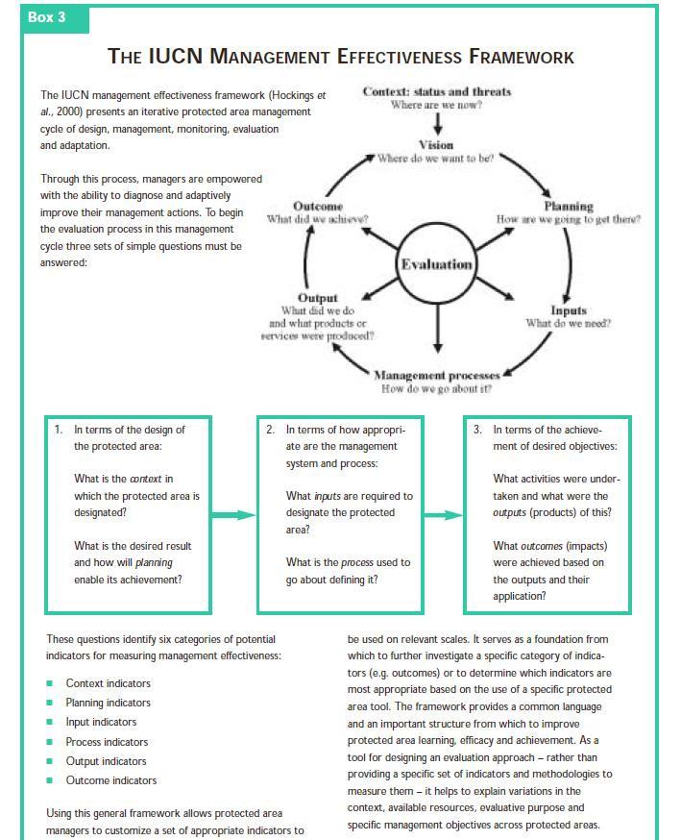

Appendix VI. Biophysical Goals and Objectives
(Figure 2 Pomeroy et al. 2004)

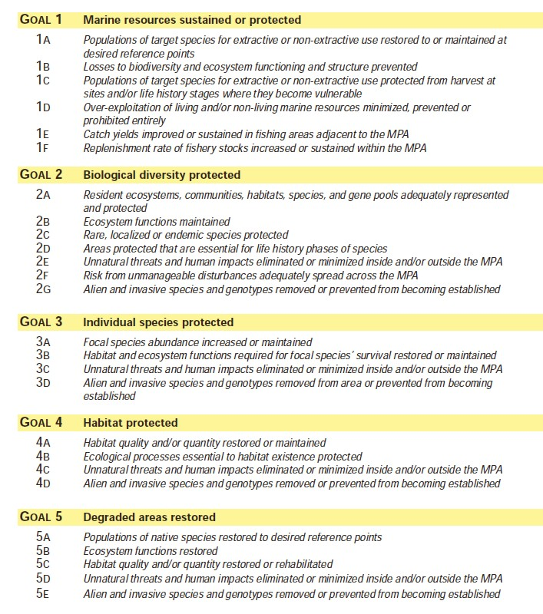

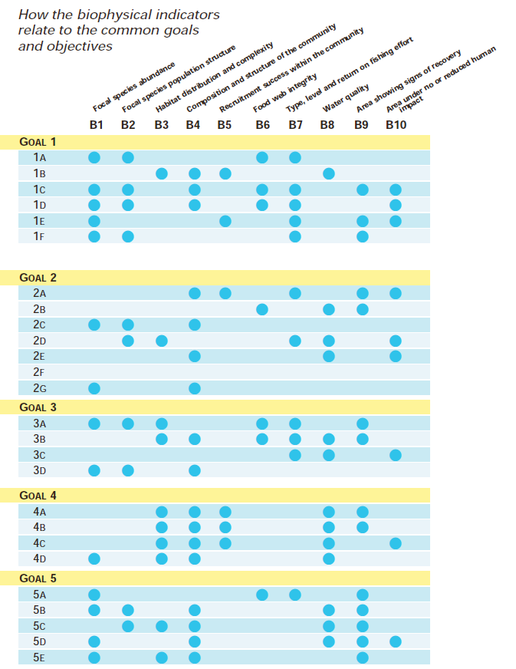

Appendix VII. Socioeconomic Goals and Objectives
(Figure 3 Pomeroy et al. 2004)

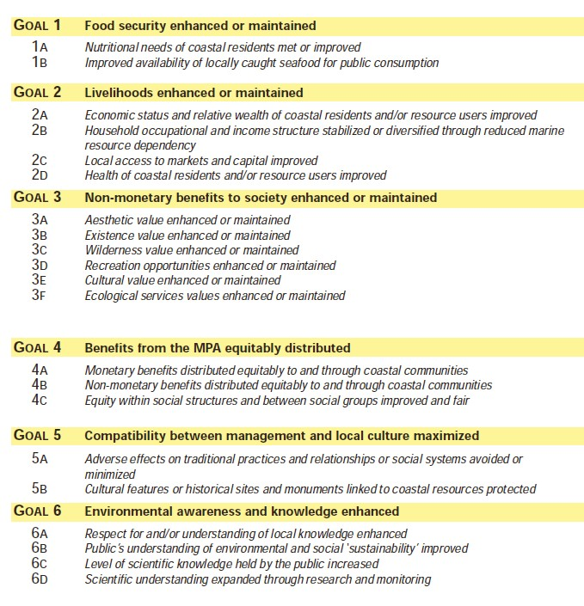

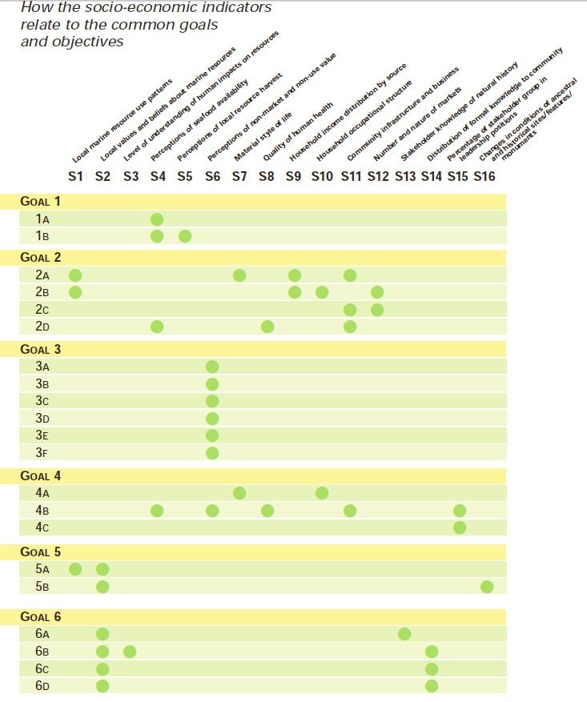

Appendix VIII. Governance Goals and Objectives
(Figure 4 Pomeroy et al. 2004)

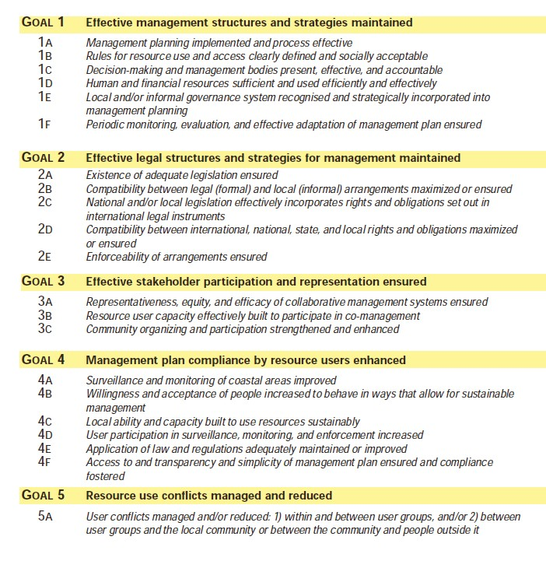

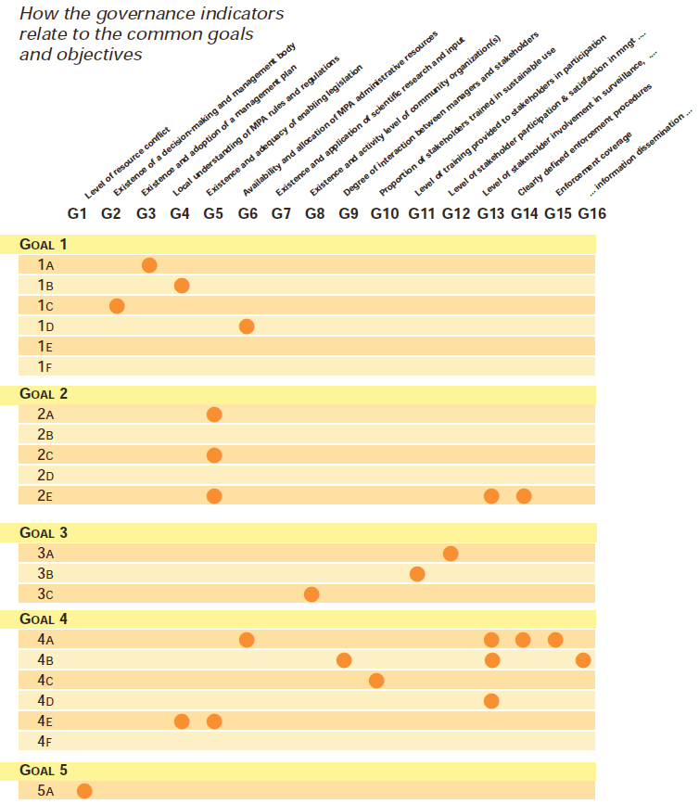

Appendix IX: Interdisciplinary Planning Team
John Carmichael, SEDAR
Brian Cheuvront, SAFMC
Chip Collier, SAFMC
David Dale, NMFS SERO
Andy David, NMFS SEFSC
Rick DeVictor, NMFS SERO
Mike Errigo, SAFMC
Nick Farmer, NMFS SERO
Stacey Harter, NMFS SEFSC
Andrew Herndon, NMFS SERO
Stephen Holiman, NMFS SERO
Michael Jepson, NMFS SERO
Todd Kellison, NMFS SEFSC
Jennifer Lee, NMFS SERO
Ken Lindeman, PhD, Florida Institute of Technology (Member, MPA Expert Working Group)
Kari MacLauchlin, SAFMC
John McGovern, NMFS SERO
Michelle Meadows, Meadows Ecological, LLC
Roger Pugliese, SAFMC
Jeff Radonski, NMFS OLE
Monica Smit-Brunello, NMFS SERO
Amber Von Harten, SAFMC
Gregg Waugh, SAFMC

