Decision Document

Coastal Migratory Pelagics
Framework Amendment 4

Management Measures for Atlantic Cobia
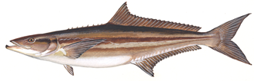

South Atlantic Mackerel Committee
March 2016

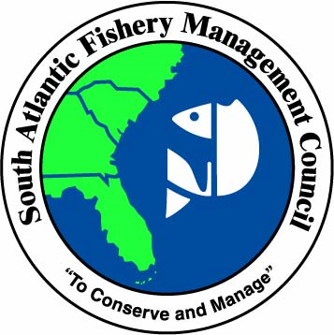

May 25, 2016

BACKGROUND
Recreational cobia landings for the Atlantic migratory group (Georgia to New York, Figure 1) in 2015 exceeded the recreational annual catch limit of 630,000 lbs. The current accountability measure (AM) for cobia states requires that if the sum of the recreational and commercial landings exceed the stock ACL (recreational ACL plus commercial ACL), the AM is triggered. In this case, the National Marine Fisheries Service (NMFS) must file a notice at or near the beginning of the following fishing year to reduce the length of the recreational season by the amount necessary to ensure recreational landings may achieve the recreational ACT, but do not exceed the recreational ACL.

To determine whether an ACL has been exceeded, CMP Amendment 18 (GMFMC/SAFMC 2011) required using 2011 landings in the first year, then the average of 2011/12 in the second year, and then a three-year average of landings in the third year onwards, unless an ACL changed. In this case, which the first single year of landings will be compared to the ACL. Because CMP Amendment 20B (GMFMC/SAFMC 2013) changed the ACL beginning in 2015 (based on the SEDAR 28 (2013) stock assessment), only the 2015 landings are used to determine whether the recreational or stock ACL was exceeded such that the AM is triggered. For 2015, both the recreational ACL and the stock ACL were exceeded, and thus, NMFS reduced the length of the 2016 fishing season.

On March 9, 2016, NMFS announced that the 2016 recreational season for Atlantic cobia would close on June 20, 2016. Because the closure would at the time of year when recreational fishing for cobia is highest, the early closure is expected to have negative social and economic impacts on recreational anglers, for-hire businesses, for-hire clients, and associated support businesses such as tackle shops. The negative effects of the closure will likely be most significant for recreational fishermen and businesses in North Carolina and Virginia (Table 1).

Table 1. Recreational landings of Atlantic cobia from 2005-2015. Data sources: MRIP and SEFSC
Year | VA Landings | NC Landings | SC Landings | GA Landings | TOTAL ATLANTIC
2005 | 577,284 | 322,272 | 5,793 | 3,358 | 908,707
2006 | 733,740 | 104,259 | 101,018 | 4,824 | 943,841
2007 | 322,887 | 90,197 | 268,677 | 64,708 | 746,469
2008 | 167,949 | 66,258 | 50,108 | 257,690 | 542,006
2009 | 552,995 | 123,061 | 76,229 | 3,997 | 756,282
2010 | 232,987 | 561,486 | 65,688 | 79,855 | 940,015
2011 | 136,859 | 121,689 | 3,565 | 90,375 | 352,488
2012 | 36,409 | 68,657 | 224,365 | 105,193 | 434,623
2013 | 354,463 | 492,969 | 19,130 | 29,224 | 895,786
2014 | 214,427 | 277,489 | 31,927 | 20,642 | 544,485
2015 | 718,647 | 630,373 | 123,952 | 67,804 | 1,540,776
* There are no MRIP-estimated recreational landings of Atlantic cobia in states north of Virginia.

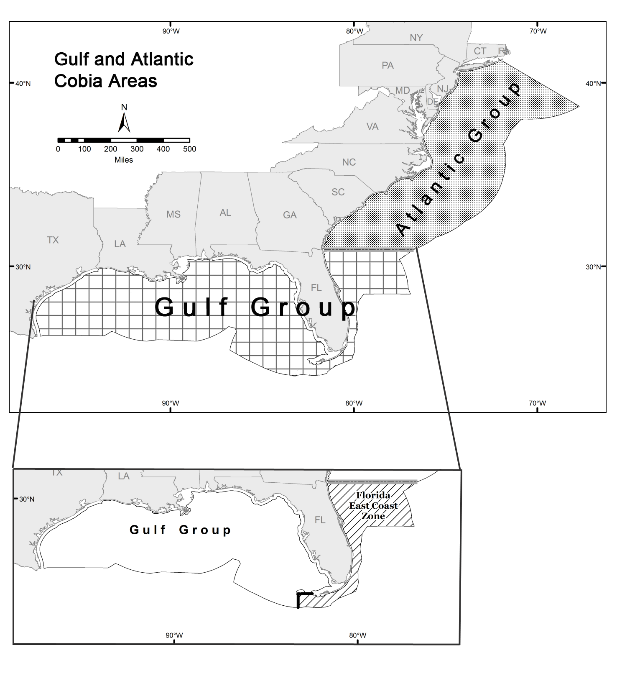
Figure 1. Boundary between Atlantic and Gulf group cobia

The South Atlantic Council is considering changes to management measures for Atlantic cobia harvest in the EEZ. The changes are expected to extend the recreational fishing season and to provide fair access to the Atlantic cobia resource for fishermen in all states. Additionally, the South Atlantic Council is also considering modifying the recreational AMs to be consistent with AMs for other species. Changes to the commercial management measures will contribute to minimizing the likelihood that the commercial ACL will be exceeded in the future.

DRAFT PURPOSE AND NEED

The purpose of this amendment is to revise the management measures for Atlantic migratory group cobia to ensure consistent, stable and equitable fishing opportunities for all participants in the Atlantic cobia fishery.

The need for this amendment is to respond to changing fishery characteristics for Atlantic migratory group cobia, while increasing social and economic benefits of the CMP fishery through sustainable fishing opportunities and harvest of Atlantic migratory group cobia.

COMMITTEE ACTION
1) Review, revise, and approve the Purpose and Need.

POTENTIAL ACTIONS FOR FRAMEWORK AMENDMENT 4
- Modify the recreational harvest limits (bag limit and vessel limit) and minimum size limit for Atlantic cobia
- Modify the fishing year for Atlantic cobia
- Modify the recreational accountability measures for Atlantic cobia
- Establish a commercial trip limit for Atlantic cobia

Draft Action 1: Modify the recreational management measures for Atlantic cobia
This action contains two sub-actions, which will be analyzed separately and in combination.

Draft Action 1-1: Modify the recreational harvest limits for Atlantic cobia

Alternative 1 (No Action). Do not modify the possession limit of 2 fish per person per day for Atlantic cobia that are not sold.

Alternative 2. Establish a recreational bag limit for Atlantic cobia.
Option 2a. 1 fish per person per day
Option 2b. 2 fish per person per day

Alternative 3. Establish a recreational vessel limit for Atlantic cobia.
Option 3a. 1 fish per vessel per day
Option 3b. 2 fish per vessel per day
Option 3c. 3 fish per vessel per day
Option 3d. 4 fish per vessel per day
Option 3e. 5 fish per vessel per day
Option 3f. 6 fish per vessel per day

The Council can select options under Alternatives 2 and 3 as the preferred alternatives/options, but will need to clarify how the bag limit and vessel limit will interact. For example, the Council may select a bag limit of 1 fish per person and vessel limit of 3 fish, whichever is lower.

Draft Action 1-2: Modify the minimum size limit for recreational harvest of Atlantic cobia

Alternative 1 (No Action). Do not modify the minimum size limit of 33 inches fork length (FL) for recreational and commercial harvest of Atlantic cobia.

Alternative 2. Modify the minimum size limit for Atlantic cobia for recreational and commercial harvest of Atlantic cobia.
Option 2a. 34 inches FL
Option 2b. 35 inches FL
Option 2c. 36 inches FL
Option 2d. 37 inches FL
Option 2e. 38 inches FL
Option 2f. 39 inches FL
Option 2g. 45 inches FL
Option 2h. 50 inches FL

NOTE: The Council directed staff to include Options 2a-2f. The IPT recommends including Options 2g and 2h.

Tables 2 and 3 show estimated percent decreases in recreational landings in state waters for combinations of vessel limits and minimum size limits. This analysis was provided by Mike Larkin, SERO staff, at an earlier date and will be expanded for the June 2016 meeting to include all vessel limits and minimum size limits in the potential alternatives. The analysis used preliminary trip intercept data provided by the Southeast Fisheries Science Center, and considered landings form 2013-2015 in the evaluation.

Table 2. Estimated percent decreases in cobia landings in North Carolina state waters for a combination of minimum size limits and vessel limits.
Vessel Limit | Minimum Size Limit (FL)
 | 33 | 34 | 35 | 36 | 37 | 38 | 39 (40)* | 45 | 50
1 | 28.3 | 31.1 | 33.5 | 35.5 | 36.8 |  | 44 | 67.4
2 | 27.3 | 30.1 | 32.5 | 34.5 | 35.8 |  | 43 | 66.4
3 | 12.1 | 14.9 | 17.3 | 19.3 | 20.6 |  | 27.8 | 51.2

Table 3. Estimated percent decreases in cobia landings in Virginia state waters for a combination of minimum size limits and vessel limits.
Vessel Limit | Minimum Size Limit (FL)
 | 33 | 34 | 35 | 36 | 37 | 38 | 39 (40)* | 45 | 50
1 | 48.3 | 48.3 | 48.3 | 54.3 | 55.5 |  | 66.2 | 87.4
2 | 22.5 | 22.5 | 22.5 | 28.5 | 29.7
3 | 17.9 | 17.9 | 17.9 | 23.9 | 25.1
4 | 7.9 | 7.9 | 7.9 | 13.9 | 15.1

Table 4 and 5 show the harvest limits and minimum size limits in the alternatives compared to state regulations (as of May 23, 2016).

Table 4. Bag limits and vessel limits in state waters of Virginia, North Carolina, South Carolina and Georgia, compared to limits in options in Action 1-1, Alternatives 2 and 3.
 | Bag limit | Vessel limit | Consistent Options
Virginia | 1 fish | 2 fish (effective 6/1/16) | Option 2a, 3b
North Carolina | 1 fish | For-hire: 4/ vessel, or 1/ person when less than 4 people on board  Private: 2 fish on vessels with more than 1 person on board | Options 2a, 3d (for-hire), 3b (private)
South Carolina – north of Jeremy Inlet, Edisto Island | 2 fish | None | Option 2b
South Carolina- south of Jeremy Inlet, Edisto Island | 1 fish June 1- Apr 30  Catch and release only May 1-May 31 | 3 fish per vessel or 1 fish per person, whichever is lower | June 1- Apr 30:  Options 2a and 3c
Georgia | 2 fish | None | Option 2b
Table 5. Minimum size limits in state waters of Virginia, North Carolina, South Carolina and Georgia, compared to limits in options under Action 1-2, Alternative 2.
 | Minimum size limit | Consistent Options
Virginia | 40 inches total length (effective 6/1/16) | None, but comparable to Option 2b or 2c.
North Carolina | 37 inches fork length | Option 2d
South Carolina | 33 inches fork length | Alt 1 No Action
Georgia | 33 inches fork length | Alt 1 No Action

Public input
- Implement a captain/crew exclusion on the cobia bag limit
- Vessel limit of 6 fish/ 3 fish/ 2 fish/ 1 fish (several comments addressed vessel limits)
- Vessel limits for charter and private recreational should be the same.
- 1 fish per day bag limit
- Increase the minimum size limit
- Increase the minimum size limit incrementally during the year
- Limit the number of cobia over a certain size that can be kept, per vessel.

Online form comments:
- 1/person and no vessel limit
- 1/person and 4/ vessel
- 1/person and 3/ vessel with only one over 50”
- 1/person and 2/ vessel
- 2/person and 6/ vessel, whichever less
- 36” FL
- 37” FL
- No change to minimum size limit
- Limits apply to both charter and private

COMMITTEE ACTIONS

1) Do you want to add Action 1-1 (recreational harvest limits)?
2) Do you want to add the draft alternatives and options?
- Revise, remove or add alternatives/options

3) Do you want to add Action 1-2 (recreational minimum size limit)?
4) Do you want to add the draft alternatives and options?
-Revise, remove or add alternatives/options

5) Do you want to select Preferred Alternatives/Options?

Draft Action 2: Modify the fishing year for recreational Atlantic cobia

Alternative 1 (No Action). Do not modify the current fishing year of January 1 through December 31.

Alternative 2. Modify the fishing year for Atlantic cobia to be May 1 through April 30.

Alternative 3. Modify the fishing year for Atlantic cobia to be June 1 through May 31.

Alternative 4. Modify the fishing year for Atlantic cobia to be April 1 through March 31.

Potential Alternative X. Establish a closed season for Atlantic cobia.
Option 4a. Closed May 1 – May 31
Option 4b. Closed May 1 – June 30

NOTE: The Council may decide for this action to apply to only one sector or to both sectors.

Figure 2. Atlantic recreational landings for January-October of 2013, 2014, 2015, average 2013-2015 landings, and average 2014-2015 landings by two-month wave. The landings for 2015 are preliminary. Source: SEFSC Recreational ACL Dataset

Public input
- Closure during the early spawning season.

Online form comments
- No spawning closure (Alternative 4)
- Do not change the fishing year.

COMMITTEE ACTIONS
1) Do you want to add Action 2?

2) Do you want the change in the fishing year for recreational, commercial, or both?

3) Do you want to add the draft alternatives and options?
- Revise, remove or add alternatives/options

4) Do you want to select Preferred Alternatives/Options?

Draft Action 3: Modify the recreational accountability measures for Atlantic cobia

Alternative 1 (No Action): Do not revise the recreational accountability measures (AMs) for Atlantic cobia as established in Amendment 18 (GMFMC/SAFMC 2011).

NOTE: Alternatives 2-4 were adapted from SG34/DW8/GC9 (Generic AM amendment, SAFMC 2015). The highlighted alternatives and sub-alternatives would align with the preferred alternatives from the Generic AM amendment.

Alternative 2. If recreational landings, as estimated by the Science and Research Director, exceed the recreational ACL, then during the following fishing year, recreational landings will be monitored for a persistence in increased landings. If necessary, the Regional Administrator shall publish a notice to reduce the length of the following fishing season to ensure that recreational landings meet the recreational ACT but do not exceed the recreational ACL, based on the recreational landings in the previous year. The length of the recreational season will not be reduced if the Regional Administrator determines, using the best scientific information available, that a reduction is unnecessary. The ACT for 2016 and subsequent fishing years is 500,000 lbs, as established in CMP Amendment 20B.
Sub-alternative 2a. The Regional Administrator will reduce the length of the following fishing year only if the species is overfished.
Sub-alternative 2b. The Regional Administrator will reduce the length of the following fishing year only if the total ACL (commercial ACL and recreational ACL) is exceeded.
Sub-alternative 2c. The Regional Administrator will reduce the length of the following fishing year only if the species is overfished and the total ACL (commercial ACL and recreational ACL) is exceeded.

Alternative 3. If recreational landings, as estimated by the Science and Research Director, exceed the recreational ACL, the Regional Administrator shall publish a notice to reduce the recreational ACL in the following fishing year by the amount of the recreational overage. The length of the recreational season will not be reduced if the Regional Administrator determines, using the best scientific information available, that a reduction is unnecessary. The ACT would also be adjusted according to the following formula: recreational sector ACT equals sector ACL[(1-PSE) or 0.5, whichever is greater].

Sub-alternative 3a. The Regional Administrator will reduce the recreational ACL and ACT of the following fishing year only if the species is overfished.
Sub-alternative 3b. The Regional Administrator will reduce the recreational ACL and ACT of the following fishing year only if the total ACL (commercial ACL and recreational ACL) is exceeded.
Sub-alternative 3c. The Regional Administrator will reduce the recreational ACL and ACT of the following fishing year only if the species is overfished and the total ACL (commercial ACL and recreational ACL) is exceeded.

Alternative 4. If recreational landings reach or are projected to reach the recreational ACL, the Regional Administator shall publish a notice to close the recreational sector for the remainder of the fishing year, unless, using the best scientific information available, the Regional Administrator determines that a closure is unnecessary.
Sub-alternative 4a. If the species is overfished.
Sub-alternative 4b. Regardless of the overfished status of the species.

Potential additional Alternative 5. If recreational landings reach or are projected to reach the recreational annual catch target (ACT), the Regional Administrator shall publish a notice to close the recreational sector for the remainder of the fishing year, unless, using the best scientific information available, the Regional Administrator determines that a closure is unnecessary.
Sub-alternative 5a. If the species is overfished.
Sub-alternative 5b. Regardless of the overfished status of the species.

Discussion:
The recreational AMs for the Atlantic migratory group of cobia were established in Amendment 18 (GMFMC/SAFMC 2011) as follows:

If the recreational sector quota (total ACL x recreational allocation) is exceeded, the Regional Administrator shall publish a notice to reduce the length of the following fishing year by the amount necessary to ensure landings do not exceed the recreational sector ACT for the following fishing year, but only if the Total ACL is exceeded. The season length will allow recreational landings to achieve the applicable recreational ACT but not exceed the applicable recreational ACL.

To calculate the recreational season length if this AM is triggered, the RA will use the following direction from Amendment 18:

Compare the recreational ACL with recreational landings over a range of years. For 2011, use only 2011 landings. For 2012, use the average landings of 2011 and 2012. For 2013 and beyond, use the most recent three-year (fishing years) running average. If in any year the ACL is changed, the sequence of future ACLs will begin again starting with a single year of landings compared to the ACL for that year, followed by two-year average landings compared to the ACL in the next year, followed by a three-year average of landings ACL for the third year and thereafter.

If the recreational ACL is exceeded, the Assistant Administrator for Fisheries shall file a notification with the Office of the Federal Register to reduce the recreational ACL in the following year by the amount of the overage, if the Total ACL is exceeded and the stock is overfished. The ACT would also be adjusted according to the following formula: recreational sector ACT equals sector ACL[(1-PSE) or 0.5, whichever is greater].

Table 6. Summary of Recreational AMs under the alternatives
 | In-season AM | Post-season AM
Alternative 1 (status quo) | No in-season closure | Reduced season length so ACT is met but ACL not exceeded ONLY if rec ACL and total ACL are exceeded. Use the rolling average of most recent 3 years.  Reduce the recreational ACL if rec ACL and total ACL are exceeded, AND Atlantic cobia is designated as overfished.
Alternative 2. Sub-alt 2a |  | Reduce season length based on last year’s landings if overfished  *Removes 3-year rolling average for evaluation
Alternative 2. Sub-alt 2b |  | Reduce season length based on last year’s landings if total ACL exceeded  *Removes 3-year rolling average for evaluation
Alternative 2. Sub-alt 2c |  | Reduce season length based on last year’s landings if total ACL exceeded and overfished  *Removes 3-year rolling average for evaluation
Alternative 3 Sub-alt 3a |  | Reduce rec ACL by amount of the overage if overfished
Alternative 3 Sub-alt 3b |  | Reduce rec ACL by amount of the overage if total ACL exceeded
Alternative 3 Sub-alt 3c |  | Reduce rec ACL by amount of the overage if total ACL exceeded and overfished
Alternative 4 Sub-alt 4a | In-season closure when rec ACL is met or projected to be met if overfished
Alternative 4 Sub-alt 4b | In-season closure when rec ACL is met or projected to be met regardless of stock status
Potential Alternative 5 Sub-alt 5a | In-season closure when rec ACT is met or projected to be met if overfished
Potential Alternative 5 Sub-alt 5b | In-season closure when rec ACT is met or projected to be met regardless of stock status

Public input
- ACL calculated based on landings from 2015-2018
- Use a minimum of a 3-year average in an annual average ACL overage should be utilized to initiate a shortened season/closure.
- The AM should be modified so that the reduced season length will not have more negative effects on one area/state than on the other states.
- Improve data collection for data used in evaluating an overage.

Online form comments:
- The current AM and 2016 closure is inconsistent with NS2 (best information available) and NS4 (cannot discriminate among states)
- The AM should not be triggered after only one year of overage.
- Improve monitoring and data collection
- Mandatory recreational reporting to improve monitoring.

COMMITTEE ACTIONS
1) Do you want to add Action 3?

2) Do you want to add the draft alternatives and sub-alternatives?
- Revise, remove or add alternatives/ sub-alternatives

3) Do you want to select Preferred Alternatives/ sub-alternatives?

Draft Action 4: Establish a commercial trip limit for Atlantic cobia

Alternative 1 (No Action). Do not modify the possession limit of 2 fish per person per day.

Alternative 2. Establish a commercial trip limit for Atlantic cobia of 2 fish per person per day. The trip limit will decrease to 1 fish per person per day when 75% of the commercial ACL has been met.

Alternative 3. Establish a commercial trip limit for Atlantic cobia of 6 fish per vessel per day.
The trip limit will decrease to 3 fish per vessel per day when 75% of the commercial ACL has been met.

Alternative 4. 2 fish/person/day and no more than 6/vessel. When 75%, decreases to 1/person and 3/vessel.

75% of the commercial ACL for 2016 and subsequent years is 37,500 lbs.

COMMITTEE ACTIONS
1) Do you want to add Action 4?

2) Do you want to add the draft alternatives?
- Revise, remove or add alternatives

3) Do you want to select a Preferred Alternative?

COMMITTEE ACTION- PUBLIC HEARINGS:
APPROVE FRAMEWORK AMENDMENT 4 FOR PUBLIC HEARINGS

TENTATIVE TIMELINE FOR FRAMEWORK AMENDMENT 4
- March 2016- South Atlantic Council directs staff to start development of the framework amendment
- June 2016- South Atlantic Council reviews public input, selects actions and alternatives, and approves for public hearings
- August 2016- Public hearings
- September 2016- Council reviews public hearing comments, selects preferred alternatives, and approves for formal review
- September 2016- Submit for Secretarial review
- Early spring 2017- Implementation

No landings were reported north of Virginia.

