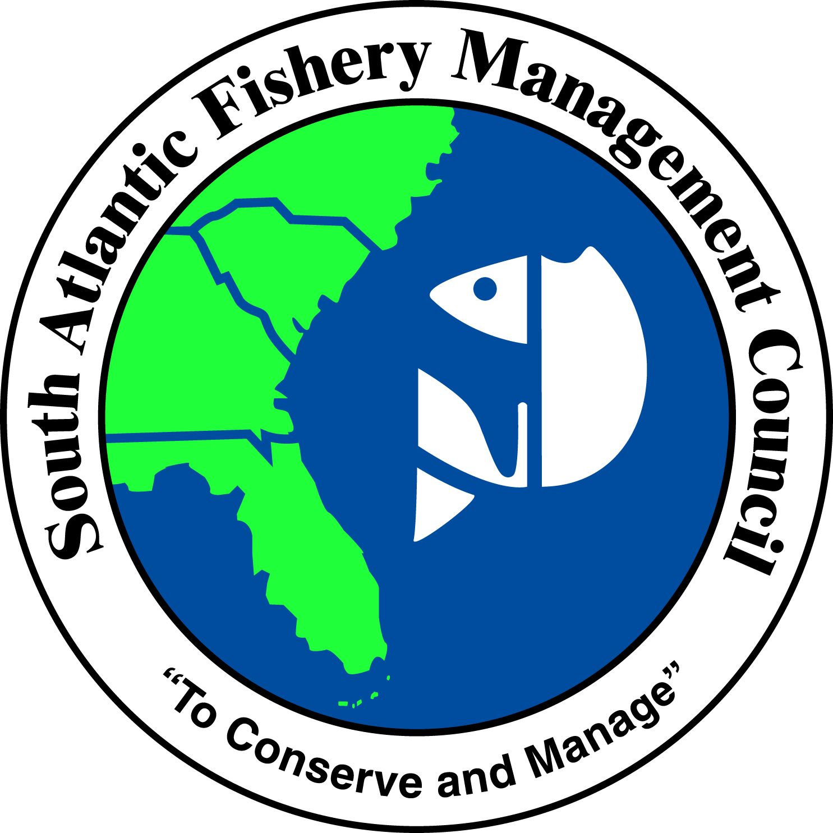 | SOUTH ATLANTIC FISHERY MANAGEMENT COUNCIL  4055 FABER PLACE DRIVE, SUITE 201  NORTH CHARLESTON, SOUTH CAROLINA 29405  TEL 843/571-4366 FAX 843/769-4520  Toll Free 1-866-SAFMC-10  email: safmc@safmc.net web page: www.safmc.net  David Cupka, Chairman Robert K. Mahood, Executive Director  Ben Hartig, Vice Chairman Gregg T. Waugh, Deputy Executive Director

SAFMC Policy for Protection and Enhancement of Marine Submerged Aquatic Vegetation (SAV) Habitat
(Re-Draft April 2013)

The South Atlantic Fishery Management Council (SAFMC) and the Habitat and Environmental Protection Advisory Panel has considered the issue of the decline of Marine Submerged Aquatic Vegetation SAV (or seagrass) habitat in Florida and North Carolina as it relates to Council habitat policy. Subsequently, the Council’s Habitat Committee requested that the Habitat Advisory Panel develop the following policy statement to support Council efforts to protect and enhance habitat for managed species.

Description and Function:
In the South Atlantic region, SAV is found primarily in the states of Florida and North Carolina where environmental conditions are ideal for the propagation of seagrasses. The distribution of SAV habitat is indicative of its importance to economically important fisheries: in North Carolina, total SAV coverage is estimated to be 200,000 acres; in Florida, the total SAV coverage is estimated to be 2.9 million acres. SAV serves several valuable ecological functions in the marine systems where it occurs. Food and shelter afforded by SAV result in a complex and dynamic system that provides a primary nursery habitat for various organisms that is important both to the overall system ecology as well as to commercial and recreationally important fisheries. SAV habitat is valuable both ecologically as well as economically; as feeding, breeding, and nursery ground for numerous estuarine species, SAV provides for rich ecosystem diversity. Further, a number of fish and shellfish species, around which is built several vigorous commercial and recreational fisheries, rely on SAV habitat for a least a portion of their life cycles. For more detailed discussion, please see Appendix 1.

Status:
SAV habitat is currently threatened by the cumulative effects of overpopulation and consequent commercial development and recreation in the coastal zone. The major anthropogenic threats to SAV habitat include:

(1) mechanical damage due to:
(a) propeller damage from boats,
(b) bottom-disturbing fish harvesting techniques,
(c) dredging and filling;

(2) biological degradation due to:
(a) water quality deterioration by modification of temperature, salinity, and light attenuation regimes;
(b) addition of organic and inorganic chemicals.
SAV habitat in both Florida and North Carolina has experienced declines from both natural and anthropogenic causes. However, conservation measures taken by state and federal agencies have produced positive results. The national Marine Fisheries Service has produced maps of SAV habitat in the Albemarle-Pamlico Sound region of North Carolina to help stem the loss of this critical habitat. The threats to this habitat and the potential for successful conservation measures highlight the need to address the decline of SAV. Therefore, the South Atlantic Council recommends immediate and direct action be taken to stem the loss of this essential habitat. For more detailed discussion, please see Appendix 2.

Management:
Conservation of existing SAV habitat is critical to the maintenance of the living resources that depend on these systems. A number of federal and state laws and regulations apply to modifications, either direct or indirect, to SAV habitat. However, to date the state and federal regulatory process has accomplished little to slow the decline of SAV habitat. Furthermore, mitigative measures to restore or enhance impacted SAV have met with little success. These habitats cannot be readily restored; the South Atlantic Council is not aware of any seagrass restoration project that has ever prevented a net loss of SAV habitat. It has been difficult to implement effective resource management initiatives to preserve existing seagrass habitat resources due to the lack of adequate documentation and specific cause/effect relationships. (for more detailed discussion, please see Appendix 3)
Because restoration/enhancement efforts have not met with success, the South Atlantic Council considers it imperative to take a directed and purposeful action to protect remaining SAV habitat. The South Atlantic Council strongly recommends that a comprehensive strategy to address the disturbing decline in SAV habitat in the South Atlantic region. Furthermore, as a stepping stone to such a long-term protection strategy, the South Atlantic Council recommends that a reliable status and trend survey be adopted to verify the scale of local declines of SAV.

The South Atlantic Council will address the decline of SAV, and consider establishing specific plans for revitalizing the SAV resources of the South Atlantic region. This may be achieved by the following integrated triad of efforts:

Planning:
• The Council promotes regional planning which treats SAV as a integral part of an ecological system.

• The Council supports comprehensive planning initiatives as well as interagency coordination and planning on SAV matters.

• The Council recommends that the Habitat Advisory Panel members actively seek to involve the Council in the review of projects which will impact, either directly or indirectly, SAV habitat resources.

Monitoring and Research:
• Periodic surveys of SAV in the region are required to determine the progress toward the goal of a net resource gain.

• The Council supports efforts to
(1) standardize mapping protocols,
(2) develop a Geographic Information System databases for essential habitat including seagrass, and
(3) research and document causes and effects of SAV decline including the cumulative impacts of shoreline development.

Education and Enforcement:
• The Council supports education programs designed to heighten the public’s awareness of the importance of SAV. An informed public will provide a firm foundation of support for protection and restoration efforts.

• Existing regulations and enforcement need to be reviewed for their effectiveness.

• Coordination with state resource and regulatory agencies should be supported to assure that existing regulations are being enforced.

SAFMC SAV Policy Statement- Appendix 1

DESCRIPTION AND FUNCTION
Worldwide, Submerged Aquatic Vegetation (SAV) constitutes one of the most conspicuous and common shallow-water habitat types. These angiosperms have successfully colonized standing and flowing fresh, brackish, and marine waters in all climatic zones, and most are rooted in the sediment. Marine SAV beds occur in the low intertidal and subtidal zones and may exhibit a wide range of habitat forms, from extensive collections of isolated patches to unbroken continuous beds. The bed is defined by the presence of either aboveground vegetation, its associated root and rhizome system (with living meristem), or the presence of a seed bank in the sediments, as well as the sediment upon which the plant grows or in which the seed back resides. In the case of patch beds, the unvegetated sediment among the patches is considered seagrass habitat as well.

There are seven species of seagrass in Florida’s shallow coastal areas: turtle grass (Thalassia testudium); manatee grass (Syringodium filiforme); shoal grass (Halodule wrightii); star grass (Halophila engelmanni); paddle grass (Halophila decipiens); and Johnson’s seagrass (Halophila johnsonii) (See distribution maps in Appendix 4). Recently, H. johnsonii has been proposed for listing by the National Marine Fisheries Service as an endangered plant species. Areas of seagrass concentration along Florida’s east coast are Mosquito Lagoon, Banana River, Indian River Lagoon, Lake Worth and Biscayne Bay. Florida Bay, located between the Florida Keys and the mainland, also has an abundance of seagrasses, but is currently experiencing an unprecedented decline in SAV distribution.

The three dominant species found in North Carolina are shoalgrass (Halodule wrightii), eelgrass (Zostera marina), and widgeongrass (Ruppia maritima). Shoalgrass, a subtropical species has its northernmost distribution at Oregon Inlet, North Carolina. Eelgrass, a temperate species, has its southernmost distribution in North Carolina. Areas of seagrass concentration in North Carolina are southern and eastern Pamlico Sound, Core Sound, Back Sound, Bogue Sound and the numerous small southern sounds located behind the beaches in Onslow, Pender, Brunswick, and New Hanover Counties (See distribution maps in Appendix 4).

Seagrasses serve several valuable ecological functions in the marine estuarine systems where they occur. Food and shelter afforded by the SAV result in a complex and dynamic system that provides a primary nursery habitat for various organisms that are important both ecologically and to commercial and recreational fisheries. Organic matter produced by these seagrasses is transferred to secondary consumers through three pathways: herbivores that consume living plant matter; detritivores that exploit dead matter; and microorganisms that use seagrass-derived particulate and dissolved organic compounds. The living leaves of these submerged plants also provide a substrate for the attachment of detritus and epiphytic organisms, including bacteria, fungi, meiofauna, micro- and marcroalgae, macroinvertebrates. Within the seagrass system, phytoplankton also are present in the water column, and macroalgae and microalgae are associated with the sediment. No less important is the protection afforded by the variety of living spaces in the tangled leaf canopy of the grass bed itself. In addition to biological benefits, the SAVs also cycle nutrients and heavy metals in the water and sediments, and dissipate wave energy (which reduces shoreline erosion and sediment resuspension).

There are several types of association fish may have with the SAVs. Resident species typically breed and carry out much of their life history within the meadow (e.g., gobiids and syngnathids). Seasonal residents typically breed elsewhere, but predictably utilize the SAV during a portion of their life cycle, most often as a juvenile nursery ground (e.g., sparids and lutjanids). Transient species can be categorized as those that feed or otherwise utilize the SAV only for a portion of their daily activity, but in a systematic or predictable manner (e.g., haemulids).

In Florida many economically important species utilize SAV beds as nursery and/or spawning habitat. Among these are spotted seatrout (Cynoscion nebulosus), grunts (Heaemulids), snook (Centropomus sp.), bonefish (Albulu vulpes), tarpon (Megalops atlanticus) and several species of snapper (Lutianids) and grouper (Serranids). Densities of invertebrate organisms are many times greater in seagrass beds than in bare sand habitat. Penaeid shrimp, spiny lobster (Panulirus argus), and bay scallops (Argopecten irradians) are also dependent on seagrass beds.

In North Carolina 40 species of fish and invertebrates have been captured on seagrass beds. Larval and juvenile fish and shellfish including gray trout (Cynoscion regalis), red drum (Sciaenops ocellatus), spotted seatrout (Cynoscion nebulosus), mullet (Mugil cephalus), spot (Leiostomus xanthurus), pinfish (Orthopristis chrysoptera), gag (Mycteroperca microlepis), white grunt (Haemulon plumieri), silver perch (Bairdiella chrysoura), summer flounder (Paralichthys dentatus), southern flounder (P. lethostigma), blue crabs (Callinectes sapidus), hard shell clams (Mercenaria mercenaria), and bay scallops (Argopecten irradains) utilize the SAV beds as nursery areas. They are the sole nursery grounds for bay scallops in North Carolina. SAV meadows are also frequented by adult spot, spotted seatrout, bluefish (Pomatomus saltatrix), menhaden (Brevortia tyrannus), summer and southern flounder, pink and brown shrimp, hard shell clams, and blue crabs. Offshore reef fishes including black sea bass (Centropristis striata), gag (Mycteroperca microlepis), gray snapper (Lutianus griseus), lane snapper (Lutjanus synagris), mutton snapper (Lutianus annalis), and spottail pinfish (Displodus holbrooki). Ospreys, egrets, herons, gulls and terns feed on fauna in SAV beds, while swans, geese, and ducks feed directly on the grass itself. Green sea turtles (Chelonia mydas) also utilize seagrass beds, and juveniles may feed directly on the seagrasses.

SAFMC SAV Policy Statement- Appendix 2

STATUS
The SAV habitat represents a valuable natural resource which is now threatened by overpopulation in coastal areas. The major anthropogenic activities that impact seagrass habitats are: 1) dredging and filling, 2) certain fish harvesting techniques and recreational vehicles, 3) degradation of water quality by modification of normal temperature, salinity, and light regimes, and 4) addition of organic and inorganic chemicals. Although not caused by man, disease (“wasting disease” of eelgrass) has historically been a factor. Direct causes such as dredging and filling, impacts of bottom disturbing fishing gear, and impacts of propellers and boat wakes are easily observed, and can be controlled by wise management of our seagrass resources (See Appendix 3). Indirect losses are more subtle and difficult to assess. These losses center around changes in light availability to the plants by changes in turbidity and water color. Other indirect causes of seagrass loss may be ascribed to changing hydrology which may in turn affect salinity levels and circulation. Reduction in flushing can cause an increase in salinity and the ambient temperature of a water body, stressing the plants. Increase in flushing can mean decreased salinity and increased turbidity and near-bottom mechanical stresses which damage or uproot plants.
Increased turbidity and decreasing water transparency are most often recognized as the cause of decreased seagrass growth and altered distribution of the habitats. Turbidity may result from upland runoff, either as suspended sediment or dissolved nutrients. Reduced transparency due to color is affected by freshwater discharge. The introduction of additional nutrients from terrigenous sources often leads to plankton blooms and increased epiphytization of the plants, further reducing light to the plants. Groundwater enriched by septic systems also may infiltrate the sediments, water column, and near-shore seagrass beds with the same effect. Lowered dissolved oxygen is detrimental to invertebrate and vertebrate grazers. Loss of these grazers results in overgrowth by epiphytes.
Large areas of Florida where seagrasses were abundant have now lost these beds from both natural and man-induced causes. (This is not well documented on a large scale except in the case of Tampa Bay). One of these depleted areas is Lake Worth in Palm Beach County. Here, dredge and fill activities, sewage disposal and stormwater runoff have almost eliminated this resource. North Biscayne Bay lost most of its seagrasses from urbanization. The Indian River Lagoon has lost many seagrass beds from stormwater runoff has caused a decrease in water transparency and reduced light penetration. Many seagrass beds in Florida have been scarred from boat propellers disrupting the physical integrity of the beds. Vessel registrations, both commercial and recreational, have tripled from 1970-71 (235, 293) to 1992-93 (715,516). More people engaged in marine activities having an effect on the limited resources of fisheries and benthic communities, Florida’s assessment of dredging/propeller scar damage indicates that Dade, Lee, Monroe, and Pinellas Counties have the most heavily damaged seagrass beds. Now Florida Bay, which is rather remote from human population concentrations, is experiencing a die-off of seagrasses, the cause of which has not yet been isolated. Cascading effects of die-offs cause a release of nutrients resulting in algal blooms which, in turn, adversely affect other seagrass areas, and appear to be preventing recolonization and natural succession in the bay. It appears that Monroe County’s commercial fish and shellfish resources, with a dockside landing value of $50 million per year, is in serious jeopardy.

In North Carolina total SAV coverage is estimated at 200,000 acres. Compared to the state’s brackish water SAV community, the marine SAVs appear relatively stable. The drought and increased water clarity during the summer of 1986 apparently caused an increase in SAV abundance in southeastern Pamlico Sound and a concomitant increase in bay scallop densities. Evidence is emerging, however, that characteristics of “wasting disease” are showing up in some of the eelgrass populations in southern Core Sound, Back Sound, and Bogue Sound. The number of permits requested for development activities that potentially impact SAV populations is increasing. The combined impacts of a number of small, seemingly isolated activities are cumulative and can lead to the collapse of large seagrass biosystems. Also increasing is evidence of the secondary removal of seagrasses. Clam-kicking (the harvest of hard clams utilizing powerful propeller wash to dislodge the clams from the sediment) is contentious issue within the state of North Carolina. The scientific community is convinced that mechanical harvesting of clams damages SAV communities. The scallop fishery also could be harmed by harvest-related damage to eelgrass meadows.

SAFMC SAV Policy Statement- Appendix 3

Management
Conservation of existing SAV habitat is critical to the maintenance of the living resources that depend on these systems. A number of federal and state laws require permits for modification and/or development in SAV. These include Section 10 of the Rivers and Harbors Act (1899), Section 404 of the Clean Water Act (1977), and the states’ coastal area management programs. Section 404 prohibits deposition of dredged or fill material in waters of the United States without a permit from the U.S. Army Corps of Engineers. The Fish and Wildlife Coordination Act gives federal and state resource agencies the authority to review and comment on permits, while the National Environmental Policy Act requires the development and review of Environmental Impact Statements. The Magnuson Fisheries Conservation and Management Act has been amended to require that each fishery management plan include a habitat section. The Council’s habitat subcommittee may comment on permit requests submitted to the Corps of Engineers when the proposed activity relates to habitat essential to managed species. State and federal regulatory processes have accomplished little to slow the decline of SAV habitat. Many of the impacts cannot be easily controlled by the regulations as enforced. For example, water quality standards are written so as to allow a specified deviation from background concentration, in this manner standards allow a certain amount of degradation. An example of this is Florida’s class III water transparency standard, which defines the compensation depth to be where 1% of the incident light remains. The compensation depth for seagrass is in excess of 10% and for some species is between 15 and 20%. The standard allows a deviation of 10% in the compensation depth which translates into 0.9% incident light or an order of magnitude less than what the plants require. Mitigative measures to restore or enhance impacted areas have met with little success. SAV habitats cannot be readily restored; in fact, the South Atlantic Council is not aware of any seagrass restoration project that has ever avoided a net loss of seagrass habitat. It has been difficult to implement effective resource management initiatives to preserve seagrass habitat due to the lack of documentation on specific cause/effect relationships. Even though studies have identified certain cause/effect relationships in the destruction of these areas, lack of long-term, ecosystem-scale studies precludes an accurate scientific evaluation of the long-term deterioration of seagrasses. Some of the approaches to controlling propeller scar damage to seagrass beds include: education, improved channel marking restricted access zones, (complete closure to combustion engines, pole or troll areas), and improved enforcement. The South Atlantic Council sees the need for monitoring of seagrass restoration and mitigation not only to determine success from plant standpoint but also for recovery of faunal populations and functional attributes of the essential habitat type. The South Atlantic Council also encourages long-term trend analysis monitoring of distribution and abundance using appropriate protocols and Geographic Information System approaches.

SAFMC SAV Policy Statement- Appendix 4
(SAV Distribution Maps in SAFMC 1995 and Revised in Appendix C of the Habitat Plan)

