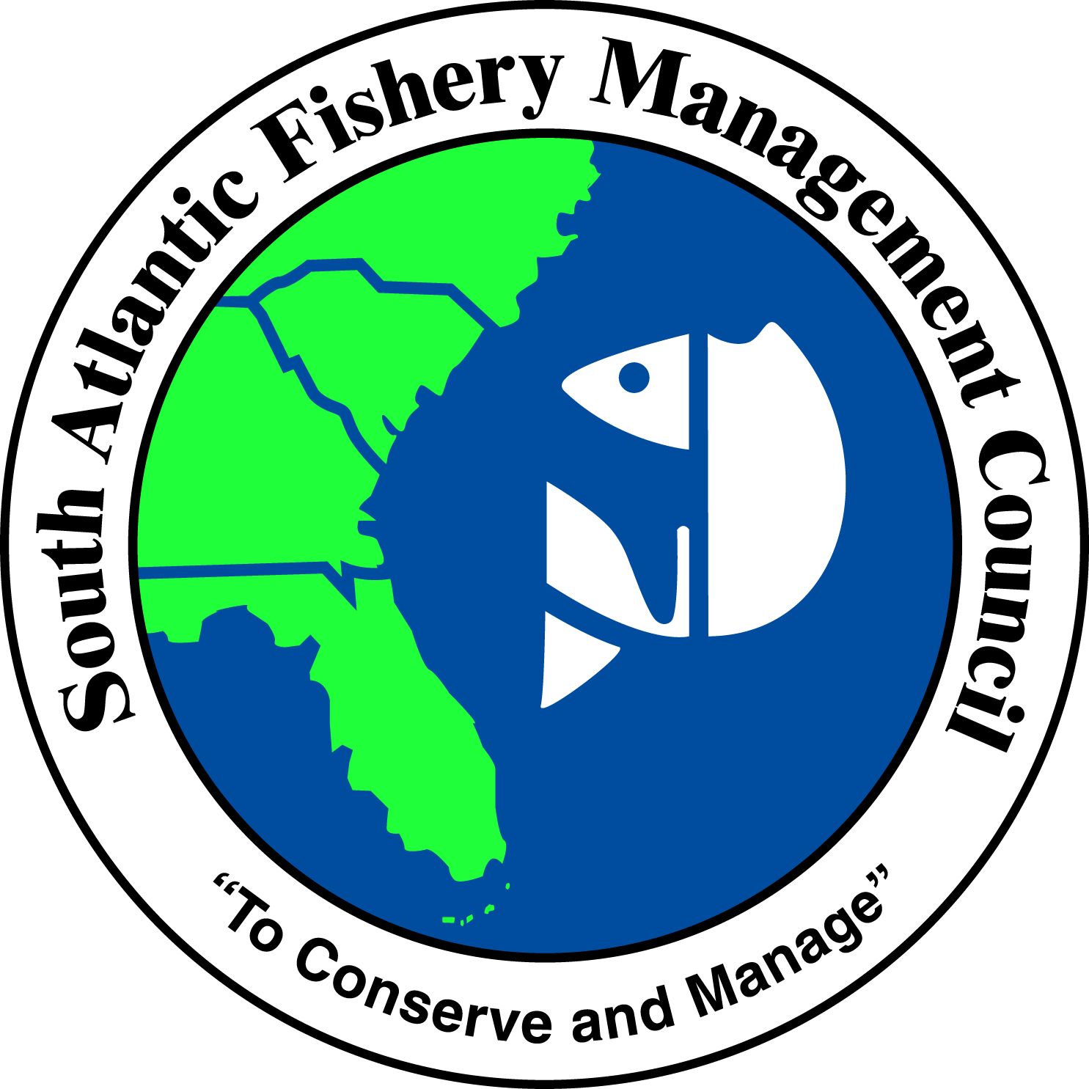 | SOUTH ATLANTIC FISHERY MANAGEMENT COUNCIL  4055 FABER PLACE DRIVE, SUITE 201  NORTH CHARLESTON, SOUTH CAROLINA 29405  TEL 843/571-4366 FAX 843/769-4520  Toll Free 1-866-SAFMC-10  email: safmc@safmc.net web page: www.safmc.net  David Cupka, Chairman Robert K. Mahood, Executive Director  Ben Hartig, Vice Chairman Gregg T. Waugh, Deputy Executive Director

POLICIES FOR THE PROTECTION OF SOUTH ATLANTIC
MARINE ECOSYSTEMS FROM NON-NATIVE AND INVASIVE SPECIES

(Re-Draft April 2013)

Policy Context
This document establishes the policies of the South Atlantic Fishery Management Council (SAFMC) regarding protection of South Atlantic marine ecosystems from potential impacts associated with invasive species. The policies are designed to be consistent with the overall habitat protection policies of the SAFMC as formulated in the Habitat Plan (SAFMC 1998a) and adopted in the Comprehensive EFH Amendment (SAFMC 1998b) and the various Fishery Management Plans (FMPs) of the Council.

The findings presented below assess potential impacts to the South Atlantic’s marine ecosystems posed by invasion of non-native species in offshore and coastal waters and the processes which could place those resources at risk. In adhering to a precautionary approach to management, the SAFMC establishes in this document policies and recommendations designed to avoid, minimize, and offset potential impacts to South Atlantic marine ecosystems.

According to Pimentel et al. (2000, 2005), the United States spends $137 billion annually on issues related to invasive species, including development of control strategies and removal as well as loss of revenue. Research indicates that non-native organisms may compete with native organisms, alter habitats (Mack et al. 2000; Kolar and Lodge 2001; Rahel 2002; Olden et al. 2004) and reduce biodiversity (Olden et al. 2004).

While the number of introduced non-native marine organisms is small compared to that of terrestrial and freshwater species, introductions have accelerated in recent decades mainly due to increase in coastal development and shipping (Morris & Whitfield 2009). According to the United States Geological Survey (2010), more than 72 marine species, including those that occupy marine waters for at least one life-history stage, have been introduced in North Carolina (27), South Carolina (48), Georgia (23) and the Atlantic coast of Florida to Key West (22). Of these, the majority comprises marine crustaceans (29%), with fishes and mollusks accounting for an additional 49%. Invasions by fishes and invertebrates is considered highly significant, with the potential to displace native species and impact community structure and biodiversity of
marine and estuarine ecosystems (e.g., Grozholz et al. 2000; Streftaris et al. 2005; Goren & Galil 2005; Dierking 2007; Albins & Hixon 2008; Rilov & Crooks 2009).

The SAFMC finds that:

1. Invasive marine organisms have the potential to cause adverse impacts to a variety of habitats across the shelf and to nearshore systems including:

a) exposed hard bottom (e.g. reefs and live bottom) in shallow and deep waters,
b) spawning and nursery areas.

2. Certain offshore and nearshore ecosystems are particularly important to the long-term viability of commercial and recreational fisheries under SAFMC management, and are potentially threatened by marine invasive species, including:

a) coral, coral reef and live/hard bottom habitat; and
b) marine waters.

3. Portions of the South Atlantic ecosystem potentially affected by invasive species, both individually and collectively, have been identified as EFH or EFH-HAPC by the SAFMC. Potentially affected species and their EFH under federal management include (SAFMC 1998b):

a) many snapper and grouper species (live hard bottom from shore to 600);
b) penaeid shrimp (offshore habitats used for spawning and growth to maturity, and waters connecting to inshore nursery areas);
c) coastal migratory pelagics (e.g., king mackerel, Spanish mackerel) (sandy shoals of capes and bars, barrier island ocean-side waters from the surf zone to the shelf break inshore of the Gulf Stream);
d) corals of various types and associated organisms (on hard substrates in shallow, midshelf, and deep water);
e) muddy, silt bottoms from the subtidal to the shelf break, deepwater corals and associated communities; and
f) areas identified as EFH for Highly Migratory Species managed by the Secretary of Commerce (e.g., sharks: inlets and nearshore waters, including pupping and nursery grounds).

4. Scientists have documented important habitat values for East coast Florida nearshore hard bottom used by over 500 species of fishes and invertebrates, including juveniles of many reef fishes. On the continental shelf off Georgia and South Carolina, 598 species of invertebrates have been collected in trawls and dredge tows over hard bottom habitats, and 845 unique invertebrate taxa were found in benthic suction and grab samples in the same area (Wenner et al. 1984).

5. Invasive marine species present an unacceptable risk to the biological integrity of South Atlantic ecosystems and must be addressed. Moreover, South Atlantic ecosystems have

been shown to be vulnerable to the establishment of non-indigenous species: 61% of the 104 marine or estuarine species reported as having been introduced into the SAFMC area of jurisdiction are considered to be established there (USGS 2010).

6. The addition of invasive lionfish (Pterois volitans and P. miles), the nonindigenous orange cup coral (Tubastraea coccinea), and the invasive, bloom-forming macroalga Caulerpa brachypus, and cyanobacteria of the genus Lyngbya (Kuffner et al. 2005; Paul et al., 2005) could cause negative changes in coral reef ecosystems of the South Atlantic region.

7. The risk of transmission of viral diseases from introduced Asian tiger shrimp (Penaeus monodon) to native species of penaeid shrimp remains unknown, as does the source of their introduction.

Threats from Invasive Marine Organisms

The SAFMC finds the following to constitute potential threats to South Atlantic ecosystems:

1. In addition to lionfish, 37 species of non-native marine fish have been documented along Florida’s Atlantic coast in the last decade. These species represent a “watch list” of potential future invaders. It is thought that most of these species are aquarium trade releases, similar to lionfish.

2. Potential impacts of the invasion of Indo-Pacific lionfish (Pterois volitans and P. miles) in South Atlantic waters include:
a) reduction of forage fish biomass;
b) increase in algal growth due to herbivore removal;
c) competition with native reef fish;
d) cascading trophic impacts on economically important species under SAFMC management;
e) competition with native species could hamper stock rebuilding efforts for the Snapper Grouper Complex;
f) impacts on commercial and recreational fisheries, the aquarium trade, and coastal tourism industry; and
g) increase in frequency of envenomations of recreational swimmers, fishermen, and divers

3. The orange cup coral, Tubastraea coccinea, is a stony coral not native to the South Atlantic region.
a) Artificial structures are their preferred habitat in the South Atlantic region and T. coccinea is prolific on some artificial structures in the Caribbean, Gulf of Mexico, and off Florida.
b) While there have been no reports of orange cup coral on natural substrate in Florida, it has been observed in the northern Bahamas reefs and it may eventually colonize natural reef/hard bottom in the region.

4. The invasive, bloom-forming macroalga Caulerpa brachypus and cyanobacteria of the genus Lyngbya directly overgrow reefs, are generally unpalatable to herbivores, and can also physically and chemically inhibit coral recruitment (Kuffner et al. 2006; Paul et al. 2005).

SAFMC Policies Addressing Invasive Species

The SAFMC establishes the following general policies related to invasive marine organisms:

1. In instances where an invasive species belongs to a group of organisms included in the Fishery Management Unit (FMU), e.g., stony corals, the species would need to be excluded from the FMU via a plan amendment (or an existing framework) before a control or eradication strategy could be implemented.

2. The Council encourages NOAA Fisheries Habitat Conservation Division (HCD) to consider recommending removal of invasive species as a compensatory mitigation measure. When removal of an invasive species is proposed in designated EFH, EFH-HAPCs or CHAPCs, the Council and HCD will work together to evaluate proposed removal techniques to ensure the method selected will avoid or minimize environmental damage.

3. The Council supports the availability of grant funding to promote research targeting invasive species -- including prevention of introductions, evaluation of impacts, expansion control and removal -- through existing partnerships (i.e., SARP) and in cooperation with state and federal agencies including NOAA’s Invasive Species Program, the National Invasive Species Council and the Gulf and South Atlantic Regional Panel of the National Aquatic Nuisance Species Task Force.

4. The Council supports the availability of grant funding to promote education and outreach efforts targeting invasive species.

5. The Council will recommend to the National Aquatic Nuisance Species Task Force, as appropriate, that management plans be developed for invasive species in South Atlantic waters (this does not imply plans developed by the Council).

6. The Council encourages the development of novel gears (other than those prohibited by the Council, such as fish traps) that effectively remove invasive species but do not compromise the integrity of South Atlantic habitats and ecosystems. The Council encourages consulting with appropriate law enforcement agencies to ensure compliance with existing regulations and to address possible enforceability challenges.

7. The Council strongly supports integrating monitoring of invasive species into existing fishery-independent and dependent programs.

8. The Council strongly suggests that permits for offshore placement of infrastructure for energy generation (e.g. oil platforms, windmills) include provisions for monitoring the settlement and dispersal of non-indigenous species on and among such structures and in potentially affected natural habitats.

9. The Council strongly suggests inspection and thorough cleaning of surfaces prior to placement of Fish Attracting Devices (FAD). The potential risk of inadvertently expanding the range of a non-native species through transport or establishment of new habitats should be carefully considered.

10. The Council supports programs to control invasive species’ populations (e.g. lionfish) in areas of high ecological/economic importance. The Council supports harvest, eradication, and/or removal strategies that do not impact populations of managed species or their habitats.

11. The Council strongly discourages the use of any non-indigenous species in aquaculture operations in the South Atlantic region.

12. The Council supports its regional partners in their endeavor to promulgate regulations for ballast water and their efforts toward research and development to advance treatment technology for ballast water.

References

Albins, M. A., M. A. Hixon. 2008. Invasive Indo-Pacific lionfish Pterois volitans reduce recruitment of Atlantic coral-reef fishes. Marine Ecology Progress Series 367: 233–238.

Dierking, J. 2007. Effects of the introduced predatory fish Cephalopholis argus on native reef fish populations in Hawaii. Ph.D. Dissertation. University of Hawaii at Manoa. 115 p.

Goren, M., and B. S. Galil. 2005. A review of changes in fish assemblages of Levantine inland and marine ecosystems following the introduction of non-native fishes. Journal of Applied Ichthyology 21: 364-370.

Grozholz, E. D., M. R. Gregory, C. A. Dean, K. A. Shirley, J. L. Maron, and P. G. Conners. 2000. The impacts of a nonindigenous marine predator in California Bay. Ecology 81:1206-1224.

Kolar,C. S. and D. M. Lodge. 2001. Progress in invasion biology: predicting invaders. Trends in Ecology and Evolution 16: 199-204.

Kuffner, I. B., L. J. Walters, M. A. Becerro, V. J. Paul, R. Ritson-Williams, and K. S. Beach. 2006. Inhibition of coral recruitment by macroalgae and cyanobacteria. Marine Ecology Progress Series 323:107-117.

Lapointe, B. E. and B. J. Bedford. 2010. Ecology and nutrition of invasive Caulerpa brachypus f. parvifolia blooms on coral reefs off southeast Florida, U.S.A. Harmful Algae 9:1-12.

Mack, R.N., D. Simberloff, W. M., Lonsdale, H. Evans, M. Clout, and F. A. Bazzaz. 2000. Biotic invasions: Causes, epidemiology, global consequences, and control. Ecological Applications 16:2035-2054.

Morris, J. A., Jr., J. L. Akins, A. Barse, D. Cerino, D. W. Freshwater, S. J. Green, R. C. Munoz, C. Paris and P. E. Whitfield. 2009. Biology and ecology of the invasive lionfishes, Pterois miles and P. volitans. Proceedings of the Gulf and Caribbean Fisheries Institute 29: 409-414.

Morris, J. A., Jr., and J. L. Akins. 2009. Feeding ecology of invasive lionfish (Pterois volitans) in the Bahamian archipelago. Environmental Biology of Fishes 86: 389-398.

Morris, J. A., Jr., and P. E. Whitfield. 2009. Biology, Ecology, Control and Management of the Invasive Indo-Pacific Lionfish: An Updated Integrated Assessment. NOAA Technical Memorandum NOS NCCOS 99. 57 pp.

Olden, J. D., N. L. Poff, M. R. Douglas, M. E. Douglas, and K. D. Fausch. 2004. Ecological and evolutionary consequences of biotic homogenization. Trends in Ecology and Evolution 19: 18-24.

Paul, V.J., R.W. Thacker, K. Banks and S. Golubic. 2005. Benthic cyanobacterial bloom impacts the reefs of South Florida (Broward County). Coral Reefs 24: 693-697.

Pimentel, D., L. Lach, R. Zuniga, and D. Morrison. 2000. Environmental and economic costs associated with nonindigenous species in the United States. Bioscience 50: 53-65.

Pimentel, D., R. Zuniga, and D. Morrison. 2005. Update on the environmental and economic costs associated with alien-invasive species in the United States. Ecological Economics 52: 273-288.

Rahel, F. J. 2002. Homogenization of freshwater faunas. Annual Reviews of Ecological Systems 33: 291-315.

Rilov, G., and J. A. Crooks. 2009. Biological Invasions in Marine Ecosystems – Ecological, Management, and Geographic Perspectives. Springer-Verlag, Berlin. 641 pp.

Schofield, P. J., J. A. Morris, Jr. and L. Akins. 2009. Field guide to nonindigenous marine fishes of Florida. NOAA Technical Memorandum NOS NCCOS 92. 210 pp.

South Atlantic Fishery Management Council (SAFMC). 1998a. Final Habitat Plan for the South Atlantic region: Essential Fish Habitat Requirements for Fishery Management Plans of the South Atlantic Fishery Management Council. South Atlantic Fishery Management Council, 1 Southpark Circle, Suite 306, Charleston, SC 29407-4699. 457 pp. plus appendices.

South Atlantic Fishery Management Council (SAFMC). 1998b. Final Comprehensive Amendment Addressing Essential Fish Habitat in Fishery Management Plans of the South Atlantic Region. Including a Final Environmental Impact Statement /Supplemental Environmental Impact Statement, Initial Regulatory Flexibility Analysis, Regulatory Impact Review, and Social Impact Assessment /Fishery Impact Statement. South Atlantic Fishery Management Council, 1 Southpark Circle, Suite 306, Charleston, SC 29407-4699. 136pp.

Streftaris, N., A. Zenetos, and E. Papathanassiou. 2005. Globalisation in marine ecosystems: the story of nonindigenous marine species across European seas. Oceanography and Marine Biology, An Annual Review 43: 319-453.

United States Geological Survey Nonindigenous Aquatic Invasive Species Database (USGS-NAS). 2010. Gainesville, FL. http://nas.er.usgs.gov

Wenner, E. L., P. Hinde, D. M. Knott, and R. F. Van Dolah. 1984. A temporal and spatial study of invertebrate communities associated with hard-bottom habitats in the South Atlantic Bight. NOAA Technical Report NMFS 18. 104 pp.

