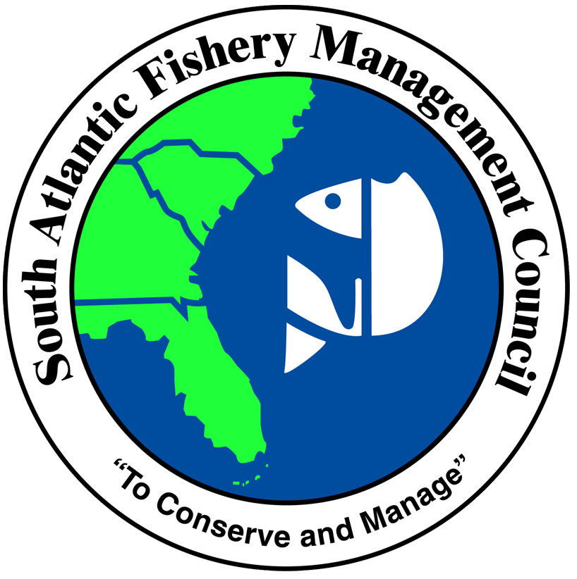

Status of Council Activities and Accomplishments During 2013

The Council has had a very active and productive year in 2013. It has been rewarding because we accomplished many of our goals relative to ending overfishing and rebuilding overfished stocks. We have also finally been able to give more fish back to our fishermen that have sacrificed so much over the past several years. It has required a tremendous amount of work by our Council members and staff, our SSC and AP members, as well as the NMFS folks at the SERO and the SEFSC.
We have worked on 21 major actions this year. Four amendments (all Snapper Grouper) have been completed and implemented by the Secretary of Commerce. Five other amendments have been completed and are currently undergoing Secretarial review (Snapper Grouper, Headboat Reporting, Dolphin Wahoo, Coral and Seafood Dealer Permitting and Reporting). Twelve other actions are under development (5 Snapper Grouper, Dolphin Wahoo, 3 Coastal Migratory Pelagics, Commercial Logbooks, Ecosystem-Based Bycatch, and Allocations and Accountability measures.)
It has been one of, if not the most, active year in the history of the South Atlantic Council.

Actions Completed and Implemented in 2013

Snapper Grouper Regulatory Amendment 15 (yellowtail snapper & grouper)
This amendment adjusts the yellowtail ABC, ACLs, and ACT based on the latest stock assessment, and modifies the accountability measure for gag grouper that prohibits harvest and possession of shallow-water groupers (red grouper, black grouper, scamp, yellowmouth grouper, yellowfin grouper, red hind, rock hind, graysby, and coney) when the gag commercial ACL is met or projected to be met.
The Council approved this amendment for submission to the Secretary of Commerce at the December 2012 meeting. Staff completed work on Regulatory Amendment 15 and submitted it to the Secretary of Commerce on March 1, 2013. The final rule published on August 13, 2013 and regulations became effective on September 12, 2013.

Snapper Grouper Regulatory Amendment 18 (vermilion snapper and red porgy)
Stock assessment updates for vermilion snapper and red porgy were conducted in 2012 and new ABCs have were recommended as a result. This amendment adjusted the ACL (and sector ACLs) for vermilion snapper and red porgy based on the recently completed stock assessment updates for those two species. In addition, the amendment removed the annual recreational closure for vermilion snapper and implemented a trip limit for the commercial sector. The trip limit is 1,000 pounds until 75% of the commercial ACL is landed, after which point the trip limit is reduced to 500 pounds.
The Council approved this amendment for submission to the Secretary of Commerce at their March 2013 meeting. Staff completed work on Regulatory Amendment 18 and submitted it to the Secretary of Commerce on March 4, 2013. The final rule published on August 6, 2013 and regulations became effective on September 5, 2013.

Snapper Grouper Amendment 28 (red snapper seasons)
Amendment 28 establishes (1) a process to determine if a fishing season will occur each year, which would include specification of the allowable harvest for both sectors and season length for the recreational sector; (2) an equation to determine the annual catch limit amount for each sector; and (3) management measures if fishing is allowed. The amendment was approved for submission to the Secretary of Commerce in December 2012. Staff completed work on Amendment 28 and submitted it to the Secretary of Commerce on January 24, 2013. The final rule for Amendment 28 published in the Federal Register on July 24, 2013.

Snapper Grouper Regulatory Amendment 19 (black sea bass)
The 2013 update to the black sea bass stock assessment indicated the stock was neither overfished nor undergoing overfishing and was rebuilt. Hence, at their March 2013 meeting, the Council requested development of Regulatory Amendment 19 to adjust the black sea bass harvest limits based on the results of the assessment. Because the increase to the ABC/ACL was substantial, there was concern that this could extend fishing with pots into the calving season for right whales and create a risk of entanglement for large migratory whales during the fall months. To minimize this risk, the amendment also proposed a closure to black sea bass pot gear from November 1 to April 30. The Council approved this amendment for submission to the Secretary of Commerce at the May 2013 webinar meeting. Staff completed work on Regulatory Amendment 19 and submitted it to the Secretary of Commerce on May 20, 2013. The final rule published rule was effective in two parts, September 23, 2013 and October 23, 2013.
Actions Approved by Council and Under Secretarial Review

Snapper Grouper Amendment 27 (Nassau grouper, blue runner, framework)
This amendment assumes management of Nassau grouper in the Gulf of Mexico; modifies the crew size restriction for dual-permitted vessels (those with a Snapper Grouper Unlimited or 225-Pound Permit and a Charter/Headboat Permit for Snapper Grouper); considers modifications to the bag limit retention restriction for captain and crew of for-hire vessels; proposes changes to the existing snapper grouper framework procedure to allow for more timely adjustments to ACLs; and modifies management measures for blue runner. The Council approved this amendment for submission to the Secretary of Commerce at their March 2013 meeting. Staff completed work on Amendment 27 and submitted it to the Secretary of Commerce on May 23, 2013. The proposed rule for this amendment published in the Federal Register on September 27, 2013. The comment period on the Proposed Rule ended on October 28.
Joint South Atlantic/Gulf of Mexico Generic Headboat Reporting Amendment (Snapper Grouper Amendment 31; Dolphin Wahoo Amendment 6; and Coastal Migratory Pelagic Amendment 22)
An action to address charter/headboat reporting was originally included in CE-BA 3. At the December 2012 meeting, the Council voted to develop that action in a separate generic amendment jointly with the Gulf of Mexico Council and so amend the Snapper Grouper, Dolphin Wahoo, and Coastal Migratory Pelagic Resources Fishery Management Plans to modify data reporting for charter/headboat vessels. The Councils’ currently preferred alternative would require that headboats submit fishing records to the Science and Research Director (SRD) weekly or at intervals shorter than a
week if notified. Weekly is defined as 7 days after the end of each week (Sunday). At the March 2013 SA Council meeting, staff reviewed the Gulf Council’s February 7, 2013 Data Collection Committee Report; indicated that the Gulf Council had approved the amendment for formal review, along with any
regulations deemed necessary and appropriate by the South Atlantic Council. Council staff also reviewed the compliance and catastrophic condition provisions that were added to the amendment to reflect the Councils’ intent. The amendment was approved for submission to the Secretary in March 2013 (SA Council). Staff completed work on the amendment and submitted it to the Secretary of Commerce on April 23, 2013. The Notice of Availability for the For-Hire Amendment published in the Federal Register on September 18, 2013 and the proposed rule published in the Federal Register on September 27, 2013).
Dolphin Wahoo Amendment 5 (ABCs/ACLs/ACTs/AMs, trip limits)
This amendment revises the ACLs for dolphin and wahoo based on updated information; considers changes in AMs to determine when ACL overages need to be paid back; updates the framework procedure; and considers a commercial trip limit for dolphin north and south of 31° N. Latitude. The Council approved the amendment for public hearings at their June 2013 meeting. Public hearings were held in August 2013 and the amendment approved by the Council during its September 2013 meeting. Staff completed work on Dolphin Wahoo Amendment 5 and submitted it to the Secretary of Commerce on November 25, 2013.

Coral Amendment 8 (modifications to coral HAPCs)
This amendment considers expansion of boundaries of the Oculina Bank Habitat Area of Particular Concern (HAPC); the boundaries of the Stetson-Miami Terrace CHAPC; and the boundaries of the Cape Lookout CHAPC. The Council approved the amendment for public hearings at their June 2013 meeting. Public hearings were held in August 2013 and the Council approved the amendment during its September 2013 meeting. Staff completed work on Coral Amendment 8 and submitted it to the Secretary of Commerce on November 26, 2013.

Generic Seafood Dealer Amendment
The amendment would modify the current permitting and reporting requirements for seafood dealers who first receive federally managed species. Currently, there are five federal dealer permits in the Gulf of Mexico and South Atlantic Regions, and the permits and reporting requirements are different depending on the species purchased. Federally permitted Gulf of Mexico reef fish and South Atlantic
snapper grouper (excluding wreckfish) dealers are required to submit dealer purchase forms once every two weeks via fax or online. South Atlantic golden crab, rock shrimp, and Atlantic dolphin wahoo dealers are required to submit purchase forms once a month via fax or online. The proposed action would require a federal dealer permit to first receive the following additional species: Gulf of Mexico and South Atlantic coastal migratory pelagic resources and spiny lobster, and Gulf of Mexico red drum.
The Gulf of Mexico and South Atlantic Councils approved the amendment for review by the Secretary of Commerce in August and September 2012, respectively. The amendment was submitted to NMFS in October 2012 to begin the formal review and approval process. However, in preparing the regulatory package a number of changes were made to clearly describe the current dealer reporting requirements, clarify the number of potential dealers affected and the number that may be subjected to duplicative reporting for a period of time, and elaborate on the impacts if a dealer does not currently own a computer. The South Atlantic Council approved the modification to the amendment and approved it for formal review again at their March 2013 meeting. At the June 2013 meeting, NOAA GC indicated the need for further clarification to the amendment. Hence, the SA Council approved making the necessary revisions to the amendment document and codified text; holding public hearings in the MAFMC and NEFMC areas; providing the amendment to the Gulf Council for approval for formal review at their August meeting; and bringing the amendment back to the South Atlantic Council for formal review at the September 2013 Council meeting. The South Atlantic Council took final action on the amendment for submission to the Secretary of Commerce at the September 2013 meeting. Staff completed work on the amendment and submitted it was for review on September 26, 2013.

Actions Under Council Development

Snapper Grouper Regulatory Amendment 14 (multiple snapper grouper species)
Regulatory Amendment 14 proposes actions to: (1) modify the commercial and recreational fishing years for greater amberjack, (2) modify the recreational fishing year for black sea bass; (3) modify the recreational accountability measure for black sera bass; (4) modify the commercial fishing year for black sea bass; (5) change the commercial fishing seasons for vermilion snapper; (6) modify the trip limit for gag; and (7) modify the recreational accountability measure for vermilion snapper.
The Council approved the amendment during its September 2013 meeting. Staff is currently working with NOAA GC to finalize the document for submission to the Secretary of Commerce.

Snapper Grouper Regulatory Amendment 16 (remove BSB pot prohibition)
The amendment includes one action to address the prohibition on the use of black sea bass pots that was implemented through Regulatory Amendment 19 and will became effective on October 23, 2013. The action includes alternatives to remove the closure, shorten the timeframe, confine spatially to apply only within designated critical right whale habitat, and confine it spatially based on a depth contour. The Council will review the document at the December 2013 meeting and approve for scoping. If approved, scoping will be held via webinar in February 2014.

Snapper Grouper Regulatory Amendment 17 (MPAs for speckled hind and warsaw grouper)
This amendment would consider alternatives for Marine Protected Areas (MPAs) that would help diminish bycatch of speckled hind and warsaw grouper. The Council initially convened a group of experts and held an MPA Expert Workgroup meeting in Pooler, GA in May 2012. The Workgroup comprised scientists with expertise in deepwater groupers and/or MPAs and commercial and recreational fishermen with extensive experience in the South Atlantic. The Workgroup produced a report that was presented to the Council in June 2012 and contained recommendations for both re-orientation of existing deepwater MPAs as well as options for new MPAs. The Council stated their intent to initially only consider re-orientation of some of the existing deepwater MPAs, however, they approved a motion at the December 2012 meeting to consider other areas. The MPA Expert Workgroup was convened again in February 4-6, 2013 in Charleston to provide further advice to the Council.
At the September 2013 meeting the Council revised the Purpose and Need for the amendment and will review the amendment at the December 2013 meeting to approve for scoping in January/February 2014.

Snapper Grouper Amendment 22 (recreational tag program)
Amendment 22 is being developed to closely control annual harvest levels of snapper grouper species with exceptionally low recreational annual catch limits (ACLs). In order to accomplish this, the Council requested that an amendment be developed to create a recreational tag program for these species. Recreational fishery participants would be issued tags through a pre-determined process. Tags issued to individuals or entities would allow the tag holder to harvest a set number of fish from federal waters in the South Atlantic Region. A Notice of Intent (NOI) to prepare a Draft EIS for Amendment 22 was published on January 3, 2011. The NOI listed several options the Council could consider when addressing long-term management for red snapper, including trip limits, bag limits, a catch share program, temporal and spatial closures including those to protect spawning stocks, a tag program, and gear prohibitions. Subsequent to the publication of the 2011 NOI, the amendment has been modified twice; once to apply a recreational harvest tag program to deep water snapper grouper species in addition to red snapper, and again to remove all species-specific options and create a harvest tag program that could be applied to any snapper grouper species with a very small recreational ACL. Based on these modifications, a supplemental NOI was published in the Federal Register to provide notice to the public of the broadened scope of Amendment 22.
The Council will review a draft of the amendment at their December 2013 meeting and consider approving for public hearings. If approved, public hearings will be held in January/February 2014.

Snapper Grouper Amendment 29 (ORCS and ABC Control Rule)
At the June 2013 Council meeting, the SSC presented to the Council their recommended changes to the ABC Control Rule. In addition, the SSC provided ABC recommendations for “Only Reliable Catch Stocks”. To implement these recommendations, the Council requested development of Amendment 29. A Decision Document/Options Paper was presented to the Council at their September 2013 meeting. At that time, the Council also added actions to implement management measures for gray triggerfish.
The Council will review a draft of the amendment at their December 2013 meeting and consider approving for public hearings. If approved, public hearings will be held in January/February 2014.

Dolphin Wahoo Amendment 7 (bringing dolphin and wahoo fillets from the Bahamas into the US EEZ)
This amendment considers allowing recreational fishermen to bring dolphin and wahoo fillets from the Bahamas into the US EEZ as is currently allowed with snapper grouper species. The Council directed this amendment be developed at the September 2013 meeting. Public hearings will be held
online in and at the December 2013 Council meeting. The amendment is scheduled for final approval at the December 2013.

Joint Mackerel (CMP) Amendment 20A (sales and permits)
This joint amendment with the Gulf Council would prohibit sale of recreationally caught king mackerel and Spanish mackerel, with an exception for sale of fish caught on for-hire trips on dually permitted vessels in the Gulf region, and an exception for sale of fish caught in state-permitted tournaments in both regions. The amendment also includes an action to reduce the number of latent king mackerel commercial permits but the Councils have selected No Action as the preferred alternative. The last action would eliminate income requirements for king mackerel and Spanish mackerel commercial permits. Public hearings were held in August 2013. The South Atlantic Council took final action in September 2013, and the Gulf Council took action in October 2013.

Joint Mackerel (CMP) Amendment 20B (zones and quotas)
This joint amendment with the Gulf Council would change the hook and line trip limits and fishing year for some of the Gulf group king mackerel zones/subzones, and establish a provision to allow transit through closed king mackerel areas. The amendment also includes an action to establish regional allocations of the Atlantic group king mackerel commercial ACL and the Atlantic group Spanish commercial ACL to a Northern Zone and Southern Zone (boundary at the NC/SC line). The amendment will also update language in the framework procedure. The last action will update the cobia ACLs based on the 2012 stock assessment, and will allocate part of the Gulf group cobia ACL to the Florida East Coast because of the designation of the biological boundary between the Gulf and Atlantic stocks at the GA/FL line. Public hearings were held in August 2013. The South Atlantic Council took final action in September 2013. In October 2013, the Gulf Council changed a preferred alternative under the action to change the Gulf group king mackerel trip limits and took final action. In December 2013 the South Atlantic Council will review the changes made by the Gulf Council and are scheduled to take final approval on the revised amendment.

South Atlantic Mackerel (CMP) Framework Action 2013 (transfer at sea provision and king mackerel trip limits)
This amendment would establish provisions to allow transfer at sea of Spanish mackerel caught in gillnet when one set exceeds the trip limit. The amendment also includes an action to modify the trip limit for the Florida East Coast subzone by moving the potential step-up to 75 fish/day in the last month of the season and if less than 70% of the subzone’s ACL has been met. The Council approved the amendment for public hearings at the June 2013 meeting. Public hearings were held in August 2013 and the amendment approved for formal review by the South Atlantic Council during its September 2013 meeting. The Gulf Council approved the amendment during its October 2013 meeting.

Joint Commercial Logbook Amendment (South Atlantic and Gulf)
During the December 2012 meeting, the South Atlantic Council approved a motion moving the commercial logbook reporting action out of CE-BA 3 and indicated their wish to work with the Gulf Council on a joint amendment to address commercial logbook issues in the South Atlantic and Gulf of Mexico.
The amendment includes an action to consider modifying the timing of reporting requirements for commercial logbooks in fisheries for snapper grouper, coastal migratory pelagic resources, dolphin/wahoo, and golden crab fisheries, and providing an option for logbooks to be submitted electronically. Currently, logbook reports from commercial fishermen targeting snapper grouper, coastal migratory pelagic, and dolphin/wahoo must be submitted to the Science and Research Director postmarked no later than 7 days after the end of each fishing trip. Logbook reporting forms for golden crab must be submitted to the Science and Research Director postmarked no later than 30 days after sale of the golden crab offloaded from a trip. The amendment also considers requiring that the components of the commercial logbooks (landings, economic, and bycatch) be submitted within 21 days after the end of each trip. This would increase the timeline for snapper grouper, coastal migratory pelagic, and
dolphin/wahoo fishermen to complete logbooks, and decrease the timeline for golden crab fishermen. Commercial electronic logbooks, as proposed in this amendment, would not be used to monitor annual catch limits; however, they could serve as a means to verify dealer reports and comply with the Atlantic Coastal Cooperative Statistics Program standards that require two sources for verification of quota-monitored species. It is the Council’s intent that NMFS use the commercial logbook landings, with the new timing and compliance requirements specified in this amendment, to compare with commercial trip ticket landings to help ensure the commercial ACLs are not exceeded.
At their June 2013 meeting, the Council approved scheduling a NMFS SEFSC presentation on the details of the commercial electronic logbook pilot study at the September 2013 meeting. SA Council staff will work with Gulf staff and NMFS staff to plan for completion of the amendment incorporating results from year 1 of the pilot study and target regulations being effective on January 1, 2016.

Comprehensive Ecosystem-Based Amendment 3 (bycatch)
The action in CE-BA 3 considers improvements in bycatch/discard data collection methods to better quantify all sources of fishing mortality in South Atlantic fisheries. Alternatives consider expanding aspects of the Atlantic Coastal Cooperative Statistics Program’s Release, Discard and Protected Species Module to coastal migratory pelagic (SA Council area only) and dolphin and wahoo fisheries; and also implementing a commercial observer program at 2-5% coverage levels for snapper grouper, coastal migratory pelagic (SA Council area only), dolphin and wahoo, and golden crab vessels.
At the March 2013 meeting, the Council delayed action on CE-BA 3 until a presentation by NOAA General Counsel staff was provided that assesses how the Council is meeting bycatch requirements under the Magnuson Act for SA fisheries. The NOAA General Counsel assessment was scheduled for the September 2013 meeting, then the December 2013 meeting, and is delayed until the March 2014 Council meeting. Accordingly, the Council will revisit discussions regarding CE-BA 3 in March 2014.

Comprehensive Allocations and Accountability Measures Amendment
An Options Paper will be presented to the Council at the December 2013 meeting including options to modify/establish allocations for snapper grouper species, dolphin, and wahoo. The amendment will also include options to modify accountability measures for snapper grouper species and golden crab. The intent is to make AMs consistent across FMPs. The Council will consider approving for scoping at the December 2013 meeting. If approved, scoping will be held via webinar in February 2014.

