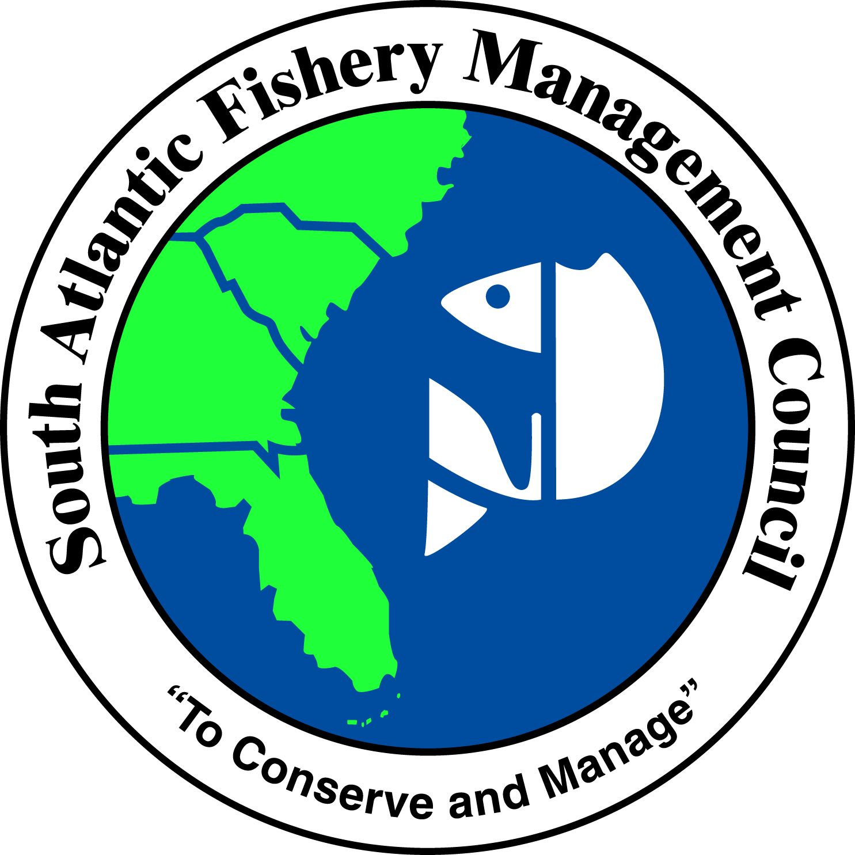 | SOUTH ATLANTIC FISHERY MANAGEMENT COUNCIL  4055 FABER PLACE DRIVE, SUITE 201  NORTH CHARLESTON, SOUTH CAROLINA 29405  TEL 843/571-4366 FAX 843/769-4520  Toll Free 1-866-SAFMC-10  email: safmc@safmc.net web page: www.safmc.net  Ben Hartig, Chairman Robert K. Mahood, Executive Director  Michelle Duval, Vice Chairman Gregg T. Waugh, Deputy Executive Director

POLICIES FOR THE PROTECTION OF SOUTH ATLANTIC
ESTUARINE ECOSYSTEMS FROM NON-NATIVE AND INVASIVE SPECIES

(Redraft February 2014)

Policy Context
This document establishes the policies of the South Atlantic Fishery Management Council (SAFMC) regarding protection of South Atlantic estuarine ecosystems from potential impacts associated with invasive species. The policies are designed to be consistent with the overall habitat protection policies of the SAFMC as formulated in the Habitat Plan (SAFMC 1998a) and adopted in the Comprehensive EFH Amendment (SAFMC 1998b) and the various Fishery Management Plans (FMPs) of the Council.

The findings presented below assess potential impacts to the South Atlantic’s estuarine ecosystems posed by invasion of non-native species and the processes which could place those resources at risk. In adhering to a precautionary approach to management, the SAFMC establishes in this document policies and recommendations designed to avoid, minimize, and offset potential impacts to South Atlantic estuarine ecosystems.

According to Pimentel et al. (2000, 2005), the United States spends $137 billion annually on issues related to invasive species, including development of control strategies and removal as well as loss of revenue. Research indicates that non-native organisms may compete with native organisms, alter habitats (Mack et al. 2000; Kolar and Lodge 2001; Rahel 2002; Olden et al. 2004) and reduce biodiversity (Olden et al. 2004).

While the number of introduced non-native marine organisms is small compared to that of terrestrial and freshwater species, introductions have accelerated in recent decades mainly due to increase in coastal development and shipping (Morris & Whitfield 2009). According to the United States Geological Survey (2010), more than 27 estuarine species, including those that occupy estuarine waters during at least one life-history stage, have been introduced in North Carolina (18), South Carolina (17), Georgia (16) and Florida (17). Of these, the majority comprises fishes (63%), with crustaceans and mollusks accounting for an additional 15%. Invasions by fishes and invertebrates is considered highly significant, with the potential to displace native species and impact community structure and biodiversity of marine and estuarine
ecosystems (e.g., Grozholz et al. 2000; Streftaris et al. 2005; Goren & Galil 2005; Dierking 2007; Albins & Hixon 2008; Rilov & Crooks 2009). Non-native plants also pose a threat to South Atlantic estuarine ecosystems. Recently, it has been found that two exotic mangrove species, introduced at a botanical garden, have spread and pose a threat to natural mangrove forests in south Florida (Fourqurean et al. 2010).

The SAFMC finds that:

1. Invasive estuarine organisms have the potential to cause adverse impacts to estuarine habitats including:
a) submerged aquatic vegetation
b) estuarine emergent vegetation, including mangroves;
c) shellfish beds, and
d) spawning and nursery areas.

2. Certain estuarine ecosystems are particularly important to the long-term viability of commercial and recreational fisheries under SAFMC management, and are potentially threatened by invasive species, including:
a) estuarine waters;
b) estuarine wetlands, including mangroves and marshes; and
c) submerged aquatic vegetation.

3. Portions of the South Atlantic ecosystem potentially affected by invasive species, both individually and collectively, have been identified as EFH or EFH-HAPC by the SAFMC. Potentially affected species and their EFH under federal management include (SAFMC 1998b):
a) for estuarine-dependent species (e.g., gag grouper and gray snapper) – unconsolidated bottoms and live hard bottoms to the 100 foot contour;
b) penaeid shrimp (waters connecting to inshore nursery areas);
c) muddy, silt bottoms from the subtidal to the shelf break,
d) areas identified as EFH for Highly Migratory Species managed by the Secretary of Commerce (e.g., sharks: inlets and nearshore waters, including pupping and nursery grounds).

4. Invasive species present an unacceptable risk to the biological integrity of South Atlantic ecosystems and must be addressed. Moreover, South Atlantic ecosystems have been shown to be vulnerable to the establishment of non-indigenous species: 61% of the 104 marine or estuarine species reported as having been introduced into the SAFMC area of jurisdiction are considered to be established there (USGS 2010).

5. Stakeholder opposition and uncertainty about potential ecological effects were major considerations in a decision by the USACOE and the states of Maryland and Virginia to reject the idea of using the Asian oyster Crassostrea ariakensis in aquaculture or in efforts to revive wild oyster populations in the Chesapeake Bay.

Threats from Invasive Estuarine Organisms

The SAFMC finds the following to constitute potential threats to South Atlantic estuarine ecosystems:

1. In general, non-native estuarine organisms have the potential to cause cascading trophic impacts on economically important species under SAFMC management.

2. The apparent increase in the incidence of infection of American eels by the introduced parasitic nematode Anguillicoloides crassus may present an increased threat to an already declining population of American eels in the southeastern US, where A. crassus has been documented to have significant negative impacts (ASMFC 2002, 2008). This non-native swim bladder parasite may decrease the American eel’s ability to swim and to reach its spawning grounds in the Sargasso Sea (ASMFC, 2011)

3. Studies describe high rates of survival and growth of Crassostrea ariakensis in subtidal habitats spanning a wide range of temperatures and salinities (see Kingsley-Smith et al., 2009). Most of its biological characteristics make C. ariakensis a strong candidate to become invasive, thus it is not advisable for use in aquaculture or in restoration activities in South Atlantic estuaries.

4. Invasive aquatic plants, such as hydrilla (Hydrilla verticillata) and non-native phragmites (Phragmites australis), can develop large, dense populations that displace desirable native vegetation.

5. The Eurasian watermilfoil (Myriophyllum spicatum) is known to out-compete Vallisneria americana beds (Hauxwell et al. 2004), which is EFH for white shrimp.

6. At least two species of Indo-Pacific mangroves (Bruguiera gymnorrhiza and Lumnitzera racemosa) have naturalized and spread in the mangrove forests of South Florida, showing that Atlantic mangrove forests are indeed susceptible to invasion. Given the importance of the mangroves of the tropical Atlantic to the functioning of the coastal seascape, the ecosystem functioning of the region’s mangrove forests may change as a consequence of invasive species (Fourqurean et al., 2010).

7. The large tropical Eastern Pacific barnacle, Megabalanus coccopoma, also known as the titan acorn barnacle, is a gregarious settler, and since it reaches a much larger size than native species of barnacles in the region, it may require greater maintenance efforts on surfaces exposed to coastal and high salinity estuarine areas if it becomes established.

8. The isopod Synidotea laevidorsalis, now successfully established on the US South Atlantic, is generally found fouling buoy and crab pot lines and floating docks in mesohaline to polyhaline reaches of coastal waters.

9. The green porcelain crab, Petrolisthes armatus, is well-established in the Indian River system, Florida, and on rocky rubble, oyster reefs, and other shallow subtidal and intertidal habitats throughout Georgia and South Carolina.

10. The spiny hands crab, Charybdis hellerii, has been collected occasionally from shallow coastal waters of the South Atlantic Bight between Crescent Beach, Florida, and Core Banks, North Carolina. The greatest number of specimens in that region has been found in the Winyah Bay estuary of South Carolina and in shallow waters off Core Banks, North Carolina.

11. The Asian green mussel, Perna viridis, is a nuisance even within its native range in the Indo-Pacific. Impacts from this species have the potential to be severe. In addition to hampering the effectiveness of cooling systems, it is also notorious for fouling navigation buoys, floating docks, piers, and pilings. Ecological studies in Florida have shown that P. viridis is also detrimental to intertidal oyster reefs, where it displaces adult oysters and reduces the density of juvenile oysters.

12. The Charrua mussel, Mytella charruana, belongs to the same family as the invasive green mussel and several native marine mussels. M. charruana poses the potential problem of fouling structures submerged in seawater. Potential impacts include economic hardship due to its fouling ability, and ecological alteration due to competition with native shellfish species.

13. Two visually identical species of lionfish (Pterois volitans and P. miles) were introduced into the northwest Atlantic Ocean, Caribbean Sea and the Gulf of Mexico, probably through the US aquarium trade, in the 1980’s. Lionfish have been established from Miami to North Carolina since 2002, and in the Florida Keys since 2009. On heavily invaded sites, lionfish have reduced fish prey densities
by up to 90% and continue to consume native coral-reef fishes and crustaceans at unsustainable rates. More recently, lionfish have been reported in increasing numbers from inshore and estuarine waters as far north as Narragansett Bay, RI (Schofield et al., 2013)

14. Introductions of the Asian tiger shrimp (Penaeus monodon) into the southeastern US may be due to escapement from aquaculture facilities following flooding by storms and hurricanes; larvae released from Caribbean shrimp farms and transported north via the Gulf Stream; and/or migration from areas where tiger shrimp had previously become established in the wild. Evidence suggests that there has been an increase in abundance along the southeastern US coast over the past five years, indicating the likely presence of a breeding population. (Knott et al., 2013). The extent to which tiger shrimp are transmitting viral diseases or displacing native shrimp species through predation or competition for prey remains unknown.

SAFMC Policies Addressing Estuarine Invasive Species

The SAFMC establishes the following general policies related to invasive estuarine organisms:

1. In instances where an invasive species belongs to a group of organisms included in the Fishery Management Unit, the species would need to be excluded from the FMU via a plan amendment (or an existing framework).

2. The Council encourages NOAA Fisheries Habitat Conservation Division (HCD) to consider recommending removal of invasive species as a compensatory mitigation measure. When removal of an invasive species is proposed in designated EFH, EFH-HAPCs or CHAPCs, the Council and HCD will work together to evaluate proposed removal techniques to ensure the method selected will avoid or minimize environmental damage.

3. Regarding compensatory mitigation projects or restoration activities that have a planting component, a requirement that plant materials be obtained through local nurseries within a certain radius around the estuary should be considered. Studies have shown different growth patterns of Spartina reared from nurseries located on the east coast of Florida versus the west coast of Florida.

4. The Council supports the availability of grant funding to promote research targeting invasive species -- including prevention of introductions, evaluation of impacts, expansion control and removal -- through existing partnerships (i.e., SARP) and in cooperation with state and federal agencies including NOAA’s Invasive Species Program, the National Invasive Species Council and the Gulf and South Atlantic Regional Panel of the National Aquatic Nuisance Species Task Force.

5. The Council supports the availability of grant funding to promote education and outreach efforts targeting invasive species.

6. The Council will recommend to the National Aquatic Nuisance Species Task Force, as appropriate, that management plans be developed for potentially invasive species in South Atlantic waters (this does not imply plans developed by the Council).

7. The Council encourages the development of novel gears (other than those prohibited by the Council, such as fish traps) that effectively remove invasive species but do not compromise the integrity of South Atlantic habitats and ecosystems. The Council encourages consulting with appropriate law enforcement agencies to ensure compliance with existing regulations and to address possible enforceability challenges.

8. The Council strongly supports integrating monitoring of invasive species into existing fishery-independent and dependent programs.

9. The Council supports programs to control invasive species’ populations in areas of high ecological/economic importance. The Council supports harvest, eradication, and/or removal strategies that do not impact populations of managed species or their habitats.

10. The Council strongly discourages the use of any non-indigenous species in aquaculture operations in the South Atlantic region.

11. The Council supports its regional partners in their endeavor to promulgate regulations for ballast water and their efforts toward research and development to advance treatment technology for ballast water.
References

Albins, M. A., M. A. Hixon. 2008. Invasive Indo-Pacific lionfish Pterois volitans reduce recruitment of Atlantic coral-reef fishes. Marine Ecology Progress Series 367: 233–238.

Atlantic States Marine Fisheries Commission. 2002. Interstate Fishery Management Plan for American Eel. Fishery Management Report No. 36 of the ASMFC. 79 pp.

Atlantic States Marine Fisheries Commission. 2008. Addendum II to the Fishery Management Plan for American Eel. 7 pp.

Atlantic States Marine Fisheries Commission. 2011. Integrated Peer Review Report of the American Eel Stock Assessment. ASMFC, Stock Assessment Report No. 11-01, Washington, D.C. 11 p.

Dierking, J. 2007. Effects of the introduced predatory fish Cephalopholis argus on native reef fish populations in Hawaii. Ph.D. Dissertation. University of Hawaii at Manoa. 115 p.

Fourqurean, J. W., T. J. Smith III, J. Possley, T. M. Collins, D. Lee, and S. Namoff. 2010. Are mangroves in tropical Atlantic ripe for invasion? Exotic mangrove trees in the forests of South Florida. Biological Invasions. DOI 10.1007/s10530-009-96608 http://www.springerlink.com/content/4x3j740724363778/fulltext.pdf

Goren, M., and B. S. Galil. 2005. A review of changes in fish assemblages of Levantine inland and marine ecosystems following the introduction of non-native fishes. Journal of Applied Ichthyology 21: 364-370.

Grozholz, E. D., M. R. Gregory, C. A. Dean, K. A. Shirley, J. L. Maron, and P. G. Conners. 2000. The impacts of a nonindigenous marine predator in California Bay. Ecology 81:1206-1224.

Hauxwell, J., C. W. Osenberg & T. K. Frazer. 2004. Conflicting management goals: manatees and invasive competitors inhibit restoration of a native macrophyte. Ecological Applications 14(2): 571-586.

Kingsley-Smith, P. R., H. D. Harwell, M. L. Kellogg, S. M. Allen, S. K. Allen Jr., D. W. Meritt, K. T. Paynter Jr. & M. W. Luckenbach. 2009. Survival and growth of triploid Crassostrea virginica (Gmelin, 1791) and C. ariakensis (Fujita, 1913) in bottom environments of Chesapeake Bay: Implications for an introduction. Journal of Shellfish Research 28(2): 169-184.

Knott, D.M., P.L. Fuller, A.J. Benson, and M.E. Neilson. 2013. Penaeus monodon. USGS Nonindigenous Aquatic Species Database, Gainesville, FL.
http://nas.er.usgs.gov/queries/factsheet.aspx?SpeciesID=1209 Revision Date: 6/5/2012

Kolar,C. S. and D. M. Lodge. 2001. Progress in invasion biology: predicting invaders. Trends in Ecology and Evolution 16: 199-204.

Mack, R.N., D. Simberloff, W. M., Lonsdale, H. Evans, M. Clout, and F. A. Bazzaz. 2000. Biotic invasions: Causes, epidemiology, global consequences, and control. Ecological Applications 16:2035-2054.

Morris, J. A., Jr., and P. E. Whitfield. 2009. Biology, Ecology, Control and Management of the Invasive Indo-Pacific Lionfish: An Updated Integrated Assessment. NOAA Technical Memorandum NOS NCCOS 99. 57 pp.

Olden, J. D., N. L. Poff, M. R. Douglas, M. E. Douglas, and K. D. Fausch. 2004. Ecological and evolutionary consequences of biotic homogenization. Trends in Ecology and Evolution 19: 18-24.

Pimentel, D., L. Lach, R. Zuniga, and D. Morrison. 2000. Environmental and economic costs associated with nonindigenous species in the United States. Bioscience 50: 53-65.

Pimentel, D., R. Zuniga, and D. Morrison. 2005. Update on the environmental and economic costs associated with alien-invasive species in the United States. Ecological Economics 52: 273-288.

Rahel, F. J. 2002. Homogenization of freshwater faunas. Annual Reviews of Ecological Systems 33: 291-315.

Rilov, G., and J. A. Crooks. 2009. Biological Invasions in Marine Ecosystems – Ecological, Management, and Geographic Perspectives. Springer-Verlag, Berlin. 641 pp.

Schofield, PJ, JA Morris, Jr, JN Langston, and PL Fuller. 2013. Pterois volitans/miles. USGS Nonindigenous Aquatic Species Database, Gainesville, FL.
http://nas.er.usgs.gov/queries/FactSheet.aspx?speciesID=963 Revision Date: 9/18/2012

South Atlantic Fishery Management Council (SAFMC). 1998a. Final Habitat Plan for the South Atlantic region: Essential Fish Habitat Requirements for Fishery Management Plans of the South Atlantic Fishery Management Council. South Atlantic Fishery Management Council, 1 Southpark Circle, Suite 306, Charleston, SC 29407-4699. 457 pp. plus appendices.

South Atlantic Fishery Management Council (SAFMC). 1998b. Final Comprehensive Amendment Addressing Essential Fish Habitat in Fishery Management Plans of the South Atlantic Region. Including a Final Environmental Impact Statement /Supplemental Environmental Impact Statement, Initial Regulatory Flexibility Analysis, Regulatory Impact Review, and Social Impact Assessment /Fishery Impact Statement. South Atlantic Fishery Management Council, 1 Southpark Circle, Suite 306, Charleston, SC 29407-4699. 136pp.

South Carolina Department of Natural Resources (SCDNR). 2008. South Carolina Aquatic Invasive Species Management Plan. South Carolina Department of Natural Resources in cooperation with the South Carolina Aquatic Invasive Species Task Force. Columbia, SC. 96 pp.

Streftaris, N., A. Zenetos, and E. Papathanassiou. 2005. Globalisation in marine ecosystems: the story of nonindigenous marine species across European seas. Oceanography and Marine Biology, An Annual Review 43: 319-453.

United States Geological Survey Nonindigenous Aquatic Invasive Species Database (USGS-NAS). 2010. Gainesville, FL. http://nas.er.usgs.gov

