Hogfish:
East Florida/Florida Keys Stock

Decision Document
(5/27/15)

JOINT SAFMC/GMFMC MEETING
JUNE 11, 2015
KEY WEST, FLORIDA

Why are the Councils Considering Action?

The Florida Fish and Wildlife Conservation Commission completed a stock assessment for hogfish in 2014. The South Atlantic Council’s SSC reviewed the assessment and provided fishing level recommendations in October 2014. The South Atlantic Council received their SSC’s recommendations at their December 2014 meeting. Based on genetic evidence, the SSC supported treating hogfish in the South Atlantic as two stocks: Georgia-North Carolina (GA-NC) and East Florida-Florida Keys. Each assessment was then evaluated with regard to fishing level recommendations. The South Atlantic SSC recommended that catch level recommendations for the GA-NC stock be developed using the Only Reliable Catch Stocks (ORCS) approach, as outlined in Level 4 of the South Atlantic Council’s ABC (Acceptable Biological Catch) control rule. The ABC for the GA-NC stock, as recommended by the South Atlantic Council’s SSC, is 28,161 pounds whole weight (lbs ww).

For the East Florida-Florida Keys stock, the South Atlantic Council’s SSC considered the benchmark assessment to represent the best available science and recommended it for use in management. The Southeast Fisheries Science Center (SEFSC) concurred with this determination. The assessment results indicated the East Florida-Florida Keys stock is undergoing overfishing and is overfished. The South Atlantic Council’s SSC then applied the South Atlantic Council’s ABC Control Rule and recommended a P* of 27.5%, and a P_{REBUILD} of 72.5% for that stock (Table 1). For rebuilding stocks, the South Atlantic Council’s SSC recommends ABC equal to the yield provided by the rebuilding plan chosen by the South Atlantic Council. Rebuilding provisions are specified by the Magnuson-Stevens Act (MSA), and since projections indicate the stock can rebuild in 10 years, the MSA allows the Council to specify a rebuilding period from 0 to 10 years. While the actual ABCs can be only determined once the South Atlantic Council specifies the rebuilding period and approach, the ABC values cannot exceed what is in Table 1. The South Atlantic Council’s SSC reviewed a range of alternatives based on various rebuilding times and success probabilities. The overfishing limit (OFL) is the yield at Fmsy. The Gulf Council’s SSC passed a motion at their May 2015 meeting concurring with this methodology and the values shown in Table 1.

Table 1. Overfishing limit (OFL) and acceptable biological catch (ABC) projections in pounds whole weight (lbs ww) for the East Florida/Florida Keys hogfish stock approved by both Councils’ SSCs.

Year | F | OFL (pounds ww) | ABC (pounds ww)
2016 | 0.089 | 127,490 | 81,610
2017 | 0.087 | 146,850 | 96,230
2018 | 0.086 | 166,560 | 111,800
2019 | 0.085 | 185,930 | 127,900
2020 | 0.084 | 204,610 | 144,210
2021 | 0.083 | 222,310 | 160,440
2022 | 0.083 | 238,830 | 176,310
2023 | 0.082 | 253,990 | 191,560
2024 | 0.082 | 267,700 | 206,010
2025 | 0.081 | 279,930 | 219,520
Source: South Atlantic Council Amendment 37.
Part of the modification to the management unit of hogfish is to identify the geographic range of the three hogfish stocks and establish management boundaries between the East Florida-Florida Keys stock, managed by the South Atlantic Council, and the Gulf of Mexico stock, managed by the Gulf Council. This demarcation is needed to aid in enforcing regulations and for proper tracking of the ACLs for each stock. An action is included in South Atlantic Council Snapper Grouper Amendment 37 that presents options for specifying a management boundary line. However, these proposals from the South Atlantic Council need the concurrence of the Gulf Council on how they would like to proceed.

This Decision Document is structured to provide the opportunity for the two Councils to reach agreement on how to proceed with management of the East Florida-Florida Keys hogfish stock.
The percentage of the East Florida-Florida Keys Stock that has been harvested from Gulf jurisdiction has ranged from 4.3%-13.3% based on landings from 2004-2012. This seems too high to ignore from a biological perspective, especially for a stock that needs a rebuilding plan.

Options for management authority:

- SAFMC true lead with SA Amendment – would only manage in SAFMC area and miss 4.3-13.3% of landings. In an overfished stock that requires a rebuilding plan this would be an unacceptable amount of landings that are not subject to the rebuilding plan and could result in the rebuilding plan not achieving its target.

- Gulf Council delegate management of hogfish in the Gulf Council’s area of Monroe County to the SAFMC – Gulf Council may have concerns and this would require a plan amendment on their part to do this. However, given the low level of landings, particularly as compared to the WFL stock, they may not object and they could do this when dealing with the West Florida stock fishing level recommendations.

- The SAFMC and GMFMC both delegate management of the East Florida-Florida Keys hogfish stock to State of Florida. Consider adding this hogfish stock to the Generic Joint South Florida Amendment – This hogfish stock occurs entirely off the Florida coast, so it could be delegated to Florida without affecting other states. In order for Florida to accept delegation, it would need to adopt regulations that are consistent with the applicable fishery management plans, which in this case mean adopting a rebuilding plan that is consistent with the requirements of the FMPs and Magnuson-Stevens Act.

- Manage the East Florida-Florida Keys Hogfish stock with a multijurisdictional ABC. The GMFMC would adopt the same recreational and commercial management measures for this hogfish stock in the following defined area specified below.

Option 4a. Monroe/Collier County line on the west coast of Florida to the Council boundary.

Option 4b. Shark Point 25 degrees 23 minutes north latitude on the west coast Florida to the Council boundary.

The SAFMC, GMFMC, and FWC all currently have identical recreational and commercial regulations. This option would allow the SAFMC to implement a rebuilding plan for the entire East Florida-Florida Keys hogfish stock without the need for delegation of management of the stock to SAFMC or the need for a joint rebuilding plan. The GMFMC would need to adopt potential changes in the annual catch limits (ACLs) and modifications to recreational and commercial management measures by a separate Framework Action.

- Establish a jurisdictional apportionment based on historical landings for the East Florida-Florida Keys Hogfish stock between the GMFMC and SAFMC. Use as similar methodology to what was done for yellowtail snapper, mutton snapper, and black grouper in the Generic Gulf of Mexico and Comprehensive South Atlantic ACL and AM Amendments (GMFMC 2011; SAFMC 2011). – This option may not be viable because this hogfish stock is relatively small and after the Council apportionments are applied and a rebuilding plan is established it may be very difficult to track landings and keep them within the ACL(s).

Possible Actions and Alternatives

Action 1. Modify the Gulf Reef Fish and South Atlantic Snapper Grouper Fishery Management Plans to Define the Geographic Range for Each Hogfish Stock

Alternative 1 (no action). The South Atlantic Council and Gulf Council jurisdiction for hogfish management is the jurisdictional boundary for the two Councils. The East Florida-Florida Keys hogfish stock defined in SEDAR 37 crosses the Council boundary and occurs in both jurisdictions. The west Florida shelf stock defined in SEDAR 37 occurs solely in the Gulf jurisdiction. The NC-GA hogfish stock defined in SEDAR 37 occurs solely in the South Atlantic Jurisdiction from the North Carolina/Virginia border to the Georgia/Florida border.

Alternative 2. Modify the FMU to specify an Atlantic Georgia through North Carolina (GA-NC) stock of hogfish to include Georgia through North Carolina. from the North Carolina/Virginia border to the Georgia/Florida border.

Alternative 3. Modify the FMU to specify a Florida an East Florida-Florida Keys stock of hogfish to include from the Florida/Georgia state line border south to:
Sub-alternative 3a. The South Atlantic/Gulf of Mexico Council boundary.
Sub-alternative 3b. The Monroe/Collier County line.
Sub-alternative 3c. Shark Point on Florida southwest coast.

Note: Shark Point is specified at 25 degrees 23 minutes north latitude on the west coast of Florida.

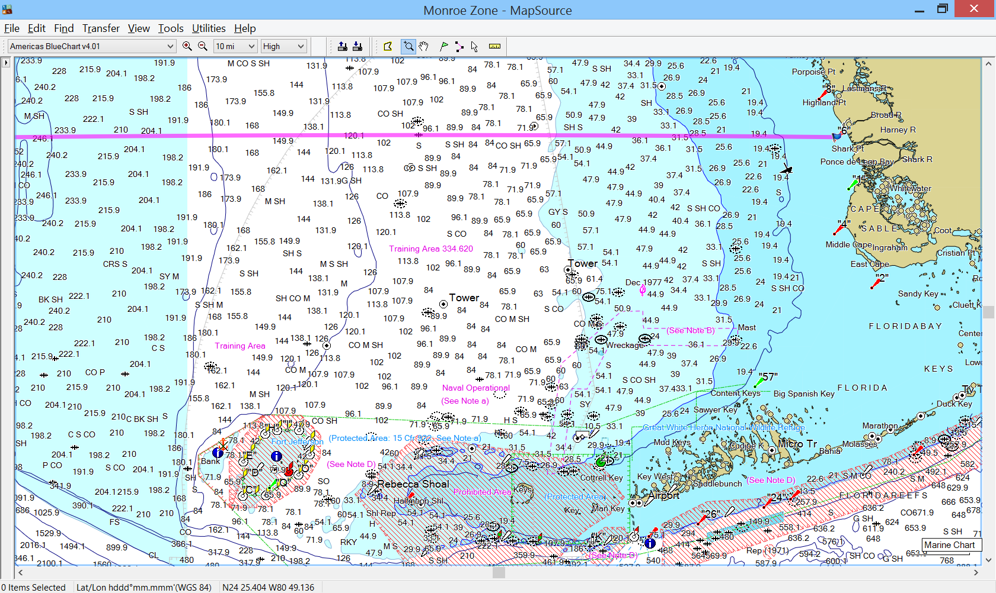

Discussion
Alternative 1 (No Action) would not modify the fishery management unit or plan to define the geographic range for each hogfish stock and therefore, fails to recognize the latest scientific information on the biological range of each of the hogfish stocks as provided in SEDAR 37.

Alternative 2 would specify the boundaries for the stock of hogfish that is distributed off Georgia and the Carolinas, as has been established via genetic evidence and taken into consideration in the SEDAR 37 stock assessment.

Alternative 3 and its sub-alternatives would define the boundaries of the East Florida-Florida Keys stock of hogfish. Sub-alternative 3a would use the jurisdictional boundary between the South Atlantic and Gulf Councils but would not fit the biological demarcation of the two stocks so that a portion of the East Florida-Florida Keys stock would remain within the Gulf Council’s jurisdiction. Sub-alternative 3b uses the Monroe/Collier County Line to differentiate the two stocks. This boundary would result in a better fit to the biological parameters, but law enforcement issues would prevail. Sub-alternative 3c considers Shark Point (25 degrees 23 minutes north latitude on the west coast of Florida) as a starting point for the boundary line to differentiate the two stocks. Shark Point is an area that occurs slightly north of the Monroe/Collier Line on the Florida southwest coast. According to local law enforcement officials, Shark Point constitutes a good demarcation point for fishing activity on the Florida west coast in that individuals that fish north of that line seldom come close to it and vice versa; hence, from a practical standpoint, it would be an accurate way to separate fishing activity on the Florida southwest coast. Moreover, the same boundary is being considered for a number of other species in the Joint South Florida Amendment. Hogfish landings (2004-2012) by area are shown in the table below.

