Alternatives and Council Conclusions in Amendment 17A
03.3.10

This document contains the alternatives and “Council Conclusions” in Amendment 17A in addition to proposed items for the Council’s consideration for inclusion in the “Council Conclusions” section.

Action 1. Proxy for Maximum Sustainable Yield (MSY) for red snapper

Table 2-1. MSY and MSY proxy alternatives for red snapper.

This shows the changes made to the December 2009 briefing book version.

Alternatives | Equation | F_{MSY} | MSY Values (lbs whole weight)
Alternative 1 (Status quo) | MSY equals the yield produced by F_{MSY.} F_{30%SPR} is used as the F_{MSY} proxy.. | F_{30%SPR}¹= 0.148² | 2,431,000³
Alternative 2  (preferred) | MSY equals the yield produced by F_{MSY} or the F_{MSY} proxy. MSY and F_{40%SPR} are recommended by the most recent SEDAR/SSC.⁴ | F_{40%SPR}= 0.104² | 2,304,000⁵
¹Prior to SEDAR 15 (2008), Potts et al. (2001) estimated F_{30%SPR}= 0.40.
²Source: Red Snapper Projections V dated March 19, 2009
³The value for MSY was not specified in Amendment 11. Based on SEDAR 15 (2008) F_{30%SPR} = 0.148; yield at F_{30%SPR} = 2,431,000 lbs whole weight (Table 4.1 from Red Snapper Projections V dated March 19, 2009).
⁴The Review Panel from SEDAR and the SSC recommended a proxy of F_{40%SPR} for F_{MSY.}
⁵The values for MSY and F_{40% SPR} are defined by Red Snapper Projections V dated March 19, 2009. The range is MSY from sensitivity runs is 559,000 lbs whole weight to 3,927,000 lbs whole weight.

Current Language in the Amendment for Council Conclusions:

The Council has chosen Alternative 2 as its preferred alternative. Alternative 2 (Preferred) is based on the SSC’s recommendation and would specify an MSY proxy equal the yield at F_{40%SPR} with a steepness of 0.95. F_{40%SPR} is a more conservative proxy for F_{MSY} than used previously. The choice of Alternative 2 (Preferred), which uses F_{40%SPR} as a proxy for F_{MSY} versus F_{30%SPR} (Alternative 1 (Status Quo)) as proxy for F_{MSY} depends on how much risk the Council is willing to take. The more conservative proxy chosen by the Council assumes less risk than that associated with the status quo F_{MSY} proxy. If the Council had chosen F_{30%SPR} and it was not a proper proxy for F_{MSY}, the Council could have to take corrective actions in the future to rebuild the stock to B_{MSY} within the allowable timeframe. Alternative 2 (Preferred), which uses F_{40%SPR} as a proxy for F_{MSY} is more conservative and provides greater assurance overfishing would be ended and the stock would rebuild within the specified time. Therefore, the biological benefits of Alternative 2 (Preferred) for the red snapper stock would be greater than Alternative 1 (Status Quo) because Alternative 2 (Preferred) would allow for less harvest and there would be a greater probability overfishing would end and the stock would be rebuilt to SSB_{MSY}.

Recommendations from APs and SSC:

Snapper Grouper AP Comments: No comments.

Law Enforcement AP Comments: No comments.

SSC Comments: The alternative to choose an Fmsy proxy is inappropriate and is inconsistent with the SEDAR review panel and SSC’s conclusions; the proxy for Fmsy is F40%.

Secondly, the review panel requested that F40% be used as a proxy for Fmsy. The review panel requested this change because the estimate of steepness in the base assessment was not estimated with confidence because it was hitting the upper bound. With this change, it was determined that the steepness associated with projections (h=0.68 when using F40%) differed from the base assessment leading to an abrupt change in recruitment between assessment years and projection years. Several alternatives to handle this inconsistency were provided to the SSC. These included changing all steepness in assessment and projections to 0.68, leaving them both at 0.95, and a hybrid where 0.95 was used for the assessment and 0.68 was used for projections. In accordance with previous decisions, the SSC chose to keep the estimate of steepness consistent between the model and the projections. Discussions then focused on two options for %SPR. One argued for following the suggestion from the CIE reviewers (using F40%) and cited literature and examples that showed that F40% is more appropriate and F30% is too high. The other group argued that F30% should be considered because it was approved by the council for other species (approved by the Council in the Comprehensive SFA Amendment) and that its corresponding h value is approximately 0.90 which was close to the estimated valued in the base estimation model. Although the CIE reviewers requested F40% be used as the Fmsy proxy, they did not ask that the corresponding steepness be used in projections; they pointed out that there was large uncertainty in projections and recommended that projections only be trusted for first few years because the stock-recruit relationship was not defined .

A motion was made to use F40% as the Fmsy proxy and retain the steepness of h=0.95 for short term projection. This motion was accepted by SSC. The assessment team provided the updated base model (h=0.95 in assessment and projections) with the new recreational landings to produce new projections.

Action 2. Red snapper rebuilding plan

Action 2A. Rebuilding schedule

There were no changes between the December 2009 briefing book version and the version that was filed with EPA/in the March 2010 briefing book in terms of the rebuilding schedule alternatives.

Alternative 1 (Status Quo). There currently is not a rebuilding plan for red snapper. Snapper Grouper Amendment 4 (regulations effective January 1992) implemented a 15-year rebuilding plan beginning in 1991 which expired in 2006.

Alternative 2. Define a rebuilding schedule as the shortest possible period to rebuild in the absence of fishing mortality (T_{MIN}). This would equal 15 years with the rebuilding time period ending in 2024, 2010 is Year 1.

Alternative 3. Define a rebuilding schedule as the mid-point between the shortest possible and maximum recommended period to rebuild. This would equal 25 years with the rebuilding time period ending in 2034, 2010 is Year 1.

Alternative 4 (Preferred). Define a rebuilding schedule as the maximum recommended period to rebuild if T_{MIN} > 10 years. The maximum recommended period equals T_{MIN} + one generation time. This would equal 35 years with the rebuilding time period ending in 2044 (SEDAR 15 2008 was the source of the generation time). 2010 is Year 1.

Current Language in the Amendment for Council Conclusions:

The Council chose Alternative 4 as their preferred rebuilding schedule alternative. Alternative 4 (Preferred) defines a rebuilding schedule as the maximum recommended period to rebuild if T_{MIN} > 10 years. The maximum recommended period equals T_{MIN} + one generation time. This would equal 35 years with the rebuilding time period ending in 2044 (SEDAR 15 2008 was the source of the generation time). 2010 is Year 1. By choosing the longest rebuilding schedule negative socioeconomic impacts would be mitigated to the greatest extent practicable. More restrictive harvest provision would be needed to rebuild the stock within a rebuilding schedule shorter than that of Alternative 4 (Preferred) and could possibly result in unnecessary socioeconomic impacts. Since the stock is still likely to rebuild within the longest rebuilding timeframe using less restrictive harvest prohibitions while incurring the least amount of negative economic impacts, the Council has concluded Alternative 4 (Preferred) is the best rebuilding schedule option for red snapper in the South Atlantic.

Recommendations from APs and SSC:

Snapper Grouper AP Comments: No comments.

Law Enforcement AP Comments: No comments.

SSC Comments: No comments.

Council Conclusions:

- The longest rebuilding timeframe would mitigate the effects from Amendment 17A, in addition to the cumulative effects of Amendment17A regulations and other circumstances (other fishery management regulations, rise in fuel costs, decrease in waterfront space for fishing activities, recession).
- Relatively long-lived fish will take longer to recover then a species with a short life span.
- Results of SEDAR 15 (2007) determined that in the absence of any fishing mortality, the fishery could rebuild to SSB_{MSY} in 15 years (T_{MIN}) (Alternative 2 – 15 years). The schedule specified in Alternative 2 (15 years) is not considered to be realistic since it would require a prohibition on all harvest of snapper grouper species to ensure there was no incidental catch, which would unnecessarily incur greater negative socioeconomic impacts compared to Alternative 3 (25 years) or Alternative 4 (Preferred) (35 years). Alternative 2 (15 years) would not be expected to rebuild the stock to B_{MSY} because it is not possible to eliminate incidental mortality on one species in a multi-species complex, without prohibiting fishermen from targeting all associated species wherever the prohibited species occurs.
- The probability that the stock could rebuild within the 25 year timeframe (Alternative 3 – 25 years) is less certain than longer timeframes due to uncertainties associated with assessment and effectiveness of proposed management measures.
- Alternative 4 (Preferred) would be accompanied by the least economic costs, among the alternatives, without necessarily sacrificing the long-term benefits from the fishery. This alternative offers fishery managers more flexibility in the type of management measures to implement over time. The associated costs of regulations with Alternative 4 (Preferred) would not be as high as in the other two alternatives.

Action 2B. Rebuilding strategy and OY

Note: Projections may be based upon various levels of recruitment in a fishery, ranging from very low to very high recruitment. All alternatives in this analysis are based upon a very high recruitment scenario referenced in the most recent SEFSC projections (January 2010, Appendix F) .

Table 2-4. Summary of the total kill required, reduction needed in total removals, and probability of rebuilding for Alternatives 1-9.

Alternative | Total Kill | % Reduction | Year Rebuilt (50% Prob) | Prob rebuilt 2044
Alternative 1 (Status Quo) (F_{45%SPR}) | 89,000 | 85% | 2035*; 2025** | 70%*; 99%**
Alternative 2 (85%F_{40%SPR}) | 89,000 | 85% | 2035 | 70%
Alternative 3 (75%F_{40%SPR}) | 79,000 | 87% | 2032 | 84%
Alternative 4 (65%F_{40%SPR}) | 68,000 | 91% | 2029 | 94%
Alternative 5 (Preferred) (97%F_{40%SPR}) | 101,000 | 83% | 2044 | 50%
Alternative 6 (85%F_{30%SPR}) | 125,000 | 79% | 2031 | 78%
Alternative 7 (75%F_{30%SPR}) | 111,000 | 82% | 2028 | 92%
Alternative 8 (65%F_{30%SPR}) | 97,000 | 84% | 2026 | 98%
Alternative 9 (98%F_{30%SPR}) | 144,000 | 76% | 2040 | 53%
*Compared to SSB_{MSY} = 17,863,000 lbs whole weight for F_{40%SPR} F_{MSY} proxy.
**Compared to SSB_{MSY} = 13,283 000 lbs whole weight for F_{30%SPR} F_{MSY} proxy.

Alternative 1 (Status Quo). Maintain a yield-based rebuilding strategy for red snapper where F_{OY} = F_{45%SPR} (equivalent to 85% F_{40%SPR} and 59%F_{30%SPR}). The value for OY at equilibrium is 2,196,000 lbs whole weight. Under this strategy, the fishery would have a 50% chance of rebuilding to SSB_{MSY} by 2035 and a 70% chance of rebuilding to SSB_{MSY} by 2044 based on a F_{40%SPR} proxy for F_{MSY}. ACL is not specified.

Alternative 2. Define a rebuilding strategy for red snapper that sets F_{OY} equal to 85% F_{MSY} (85%F_{40%}). There used to be a statement that read: “The ACL (total removals) for 2010 would be 89,000 lbs whole weight.” The ACL specified for 2010 would remain in effect beyond 2010 until modified. The Council will review ACL and management measures following the next scheduled assessment for red snapper. OY at equilibrium would be 2,199,000 lbs whole weight. Under this strategy, the fishery would have a 50% chance of rebuilding to SSB_{MSY} by 2035 and 70% chance of rebuilding to SSB_{MSY} by 2044 (Table 2-5a).

Alternative 3. Define a rebuilding strategy for red snapper that sets F_{OY} equal to 75% F_{MSY} (75%F_{40%}). There used to be a statement that read: “The ACL (total removals) for 2010 would be 79,000 lbs whole weight.” The ACL specified for 2010 would remain in effect beyond 2010 until modified. The Council will review ACL and management measures following the next scheduled assessment for red snapper. OY at equilibrium would be 2,104,000 lbs whole weight. Under this strategy, the fishery would have a 50% chance of rebuilding to SSB_{MSY} by 2032 and an 84% chance of rebuilding to SSB_{MSY} by 2044 (Table 2-5b).

Alternative 4. Define a rebuilding strategy for red snapper that sets F_{OY} equal to 65%F_{MSY} (65%F_{40%}). There used to be a statement that read: “The ACL (total removals) for 2010 would be 68,000 lbs whole weight.” The ACL specified for 2010 would remain in effect beyond 2010 until modified. The Council will review ACL and management measures following the next scheduled assessment for red snapper. OY at equilibrium would be 1,984,000 lbs whole weight. Under this strategy, the fishery would have a 50% chance of rebuilding to SSB_{MSY} by 2029, and a 94% chance of rebuilding to SSB_{MSY} by 2044 (Table 2-5c).

Alternative 5 (Preferred). Define a rebuilding strategy for red snapper that sets F_{OY} equal to 97% F_{MSY} (97%F_{40%}) and rebuilds in 35 years. The ACL (total removals) specified for 2010 would remain in effect beyond 2010 until modified. The Council will review ACL and management measures following the next scheduled assessment for red snapper. OY at equilibrium would be 2,291,000 lbs whole weight. Under this strategy, the fishery would have a 50% chance of rebuilding to SSB_{MSY} by 2044 (Table 2-5d).

Alternative 6. Define a rebuilding strategy for red snapper that sets F_{OY} equal to 85% F_{MSY} (85%F_{30%}). The ACL specified for 2010 would remain in effect beyond 2010 until modified. The Council will review ACL and management measures following the next scheduled assessment for red snapper. OY at equilibrium would be 2,392,000 lbs whole weight. Under this strategy, the fishery would have a 50% chance of rebuilding to SSB_{MSY} by 2031 and 78% chance of rebuilding to SSB_{MSY} by 2044 (Table 2-5e).

Alternative 7. Define a rebuilding strategy for red snapper that sets F_{OY} equal to 75% F_{MSY} (75%F_{30%}). The ACL specified for 2010 would remain in effect beyond 2010 until modified. The Council will review ACL and management measures following the next scheduled assessment for red snapper. OY at equilibrium would be 2,338,000 whole weight. Under this strategy, the fishery would have a 50% chance of rebuilding to SSB_{MSY} by 2028 and an 92% chance of rebuilding to SSB_{MSY} by 2044 (Table 2-5f).

Alternative 8. Define a rebuilding strategy for red snapper that sets F_{OY} equal to 65%F_{MSY} (65%F_{30%}). The ACL specified for 2010 would remain in effect beyond 2010 until modified. The Council will review ACL and management measures following the next scheduled assessment for red snapper. OY at equilibrium would be 2,257,000 whole weight. Under this strategy, the fishery would have a 50% chance of rebuilding to SSB_{MSY} by 2026, and a 98% chance of rebuilding to SSB_{MSY} by 2044 (Table 2-5g).

Alternative 9. Define a rebuilding strategy for red snapper that sets F_{OY} equal to 98% F_{MSY} (98%F_{30%}) and rebuilds in 35 years. The ACL (total removals) specified for 2010 would remain in effect beyond 2010 until modified. The Council will review ACL and management measures following the next scheduled assessment for red snapper. OY at equilibrium would be 2,464,000 lbs whole weight. Under this strategy, the fishery would have a 53% chance of rebuilding to SSB_{MSY} by 2044 (Table 2-5h).

These used to be under each alternative.

The following sub-alternatives would apply to Alternative 2 through Alternative 9.
Sub-alternative 2A-9A. Establish an ACL based on landings. The ACL in 2010 would equal 0.

Establish three AMs:

- Track CPUE of red snapper via a fishery-independent monitoring program (see Section 2.5) to track changes in biomass and take action to end overfishing if assessment indicates progress is not being made.
- Track the biomass and CPUE through fishery-dependent sampling as proposed in Section 2.5.
- CPUE would be evaluated every three years and adjustments would be made by the framework action being developed in Amendment 17B.

Sub-alternative 2B-9B. Establish an ACL based on total removals. The ACL in 2010 would equal the values for total kill specified in Table 2-3 of this section.

Establish three AMs:

- Track CPUE of red snapper via a fishery-independent monitoring program (see Section 2.5) to track changes in biomass and take action to end overfishing if assessment indicates progress is not being made.
- Track the biomass and CPUE through fishery-dependent sampling as proposed in Section 2.5.
- The Council would evaluate the size of the area closures when the dead discards are estimated to exceed the ACL. CPUE would be evaluated every three years and adjustments would be made by the framework action being developed in Amendment 17B.

Table 2-5. Reduction in total removals (landings plus dead discards) needed end overfishing. Determined by comparing expected landings in 2010 to average landings during 2006-2007. Non-shaded areas determined by comparing estimated landings in 2009 with allowable removals in 2010. Shaded areas are estimated by interpolation. Alternatives 2-5 use F_{40%SPR} as F_{MSY} proxy; Alternatives 6-9 use F_{30%SPR} as F_{MSY} proxy. Council’s preferred choice is to use very high recruitment with F_{40%SPR} proxy for F_{MSY}.
Fmsy proxy | F40% proxy |  |  |  | F30% proxy
Fmsy proxy | Base Estimated Recruitment | High Recruitment | Very High Recruitment | Extremely High Recruitment | Base Estimated Recruitment | High Recruitment | Very High Recruitment | Extremely High Recruitment
Alternative 2 and 6  (85% F_{MSY}) | 89% | 88% | 85% | 81% | 84% | 83% | 79% | 79%
Alternative 3 and 7  (75% F_{MSY}) | 90% | 89% | 87% | 85% | 86% | 85% | 82% | 81%
Alternative 4 and 8  (65% F_{MSY}) | 91% | 90% | 89% | 87% | 88% | 87% | 84% | 83%
Alternative 5 and 9  (97% F_{MSY}) | 87% | 86% | 83% | 81% | 82% | 81% | 76% | 73%

Table 2-5a. Red snapper projections under a fishing mortality rate of 85% F_{MSY} (85%F_{40%SPR}). F = fishing mortality rate (per year), LD = landings or new dead discards, DD = dead discards* (Alternative 2).
*LD represents either landed catch or red snapper > 20 inches TL that would be discarded if all red snapper harvest was prohibited. DD represents dead discards for red snapper < 20 inches TL. F_{MSY}=F_{40%}=0.104; MSST=7471mt; SSB_{MSY}=8103mt; Y@F_{MSY}=2,304,000 lb.

Table 2-5b. Red snapper projections under a fishing mortality rate of 75% F_{MSY} (75%F_{40%SPR}). F = fishing mortality rate (per year), LD = landings or new dead discards, DD = dead discards* (Alternative 3).
*LD represents either landed catch or red snapper > 20 inches TL that would be discarded if all red snapper harvest was prohibited. DD represents dead discards for red snapper < 20 inches TL. F_{MSY}=F40%=0.104; MSST=7471mt; SSB_{MSY}=8103mt; Y@F_{MSY}=2,304,000 lb.
Table 2-5c. Red snapper projections under a fishing mortality rate of 65% F_{MSY} (65%F_{40%SPR}). F = fishing mortality rate (per year), LD = landings or new dead discards, DD = dead discards* (Alternative 4).
*LD represents either landed catch or red snapper > 20 inches TL that would be discarded if all red snapper harvest was prohibited. DD represents dead discards for red snapper < 20 inches TL. F_{MSY}=F40%=0.104; MSST=7471mt; SSB_{MSY}=8103mt; Y@F_{MSY}=2,304,000 lb.
Table 2-5d. Red snapper projections under a fishing mortality rate of Frebuild = 97% F_{MSY} (97%F_{40%SPR}). F = fishing mortality rate (per year), LD = landings or new dead discards, DD = dead discards* (Alternative 5).
*LD represents either landed catch or red snapper > 20 inches TL that would be discarded if all red snapper harvest was prohibited. DD represents dead discards for red snapper < 20 inches TL. F_{MSY}=F40%=0.104; MSST=7471mt; SSB_{MSY}=8103mt; Y@F_{MSY}=2,304,000 lb.

Table 2-5e. Red snapper projections under a fishing mortality rate of 85% F_{MSY} (85%F_{30%SPR).} F = fishing mortality rate (per year), LD = landings or new dead discards, DD = dead discards* (Alternative 6).
*LD represents either landed catch or red snapper > 20 inches TL that would be discarded if all red snapper harvest was prohibited. DD represents dead discards for red snapper < 20 inches TL. F_{MSY}=F30%=0.148; MSST=5555mt; SSB_{MSY}=6205mt; Y@75%F_{MSY}=2,104,000 lb; Y@F_{MSY}=2,430,792 lb.

Table 2-5f. Red snapper projections under a fishing mortality rate of 75% F_{MSY} (75%F_{30%SPR}). F = fishing mortality rate (per year), LD = landings or new dead discards, DD = dead discards* (Alternative 7).
*LD represents either landed catch or red snapper > 20 inches TL that would be discarded if all red snapper harvest was prohibited. DD represents dead discards for red snapper < 20 inches TL. F_{MSY}=F30%=0.148; MSST=5555mt; SSB_{MSY}=6205mt; Y@75%F_{MSY}=2,104,000 lb; Y@F_{MSY}=2,430,792 lb.

Table 2-5g. Red snapper projections under a fishing mortality rate of 65% F_{MSY} (65%F_{30%SPR}). F = fishing mortality rate (per year), LD = landings or new dead discards, DD = dead discards* (Alternative 8).
*LD represents either landed catch or red snapper > 20 inches TL that would be discarded if all red snapper harvest was prohibited. DD represents dead discards for red snapper < 20 inches TL. F_{MSY}=F30%=0.148; MSST=5555mt; SSB_{MSY}=6205mt; Y@75%F_{MSY}=2,104,000 lb; Y@F_{MSY}=2,430,792 lb.

Table 2-5h. Red snapper projections under a fishing mortality rate of Frebuild = 98% F_{MSY} (98%F_{30%SPR}). F = fishing mortality rate (per year), LD = landings or new dead discards, DD = dead discards* (Alternative 9).
*LD represents either landed catch or red snapper > 20 inches TL that would be discarded if all red snapper harvest was prohibited. DD represents dead discards for red snapper < 20 inches TL. F_{MSY}=F30%=0.148; MSST=5555mt; SSB_{MSY}=6205mt; Y@75%F_{MSY}=2,104,000 lb; Y@F_{MSY}=2,430,792 lb.

Current Language in the Amendment for Council Conclusions:

The Council has chosen Alternative 5 as their preferred OY/rebuilding strategy alternative. Alternative 5 (Preferred) would define a rebuilding strategy for red snapper that sets F_{OY} equal to 97% F_{MSY} (97%F_{40%}) and rebuilds in 35 years. The ACL (total removals) specified for 2010 would remain in effect beyond 2010 until modified. The Council will review ACL and management measures following the next scheduled assessment for red snapper. OY at equilibrium would be 2,291,000 lbs whole weight. Environmental impacts under Alternative 5 (Preferred) may be considered to in the middle range of all impacts analyzed. In choosing Alternative 5 (Preferred), the Council acted on the SSC’s recommendation of using F_{40%SPR} as the F_{MSY} proxy, while choosing the highest level of OY within the parameters of the proposed new F_{MSY} proxy. In doing so, the Council mitigated, to the extent practicable, socioeconomic impacts that would be associated with proposed management measures intended to manage the stock to the new MSY and OY benchmark levels, while following the SSC’s F_{MSY} proxy recommendation. Though Alternative 5 (Preferred) is not likely to rebuild the stock in the fastest amount of time compared with other alternatives considered, it is expected to rebuild the stock within the specified timeframe, thus having the same overall long-term biological benefits as those alternatives that would have rebuilt the stock sooner.

(Add justification for very high recruitment.)

Recommendations from APs and SSC:

Council Conclusions: At their September 2009 meeting, the Council indicated that projections should consider very high recruitment, which likely occurred in 2006. Very high is reasonable as it is in the middle of those scenarios. It goes beyond anecdotal information. There is a report from the Science Center on all of the ages, and they clearly reflect high recruitment.

Snapper Grouper AP Comments: No comments.

Law Enforcement AP Comments: No comments.

SSC Comments: Assumptions are not always clearly stated, and in combination do not appear to paint a realistic picture, tending toward the optimistic end of possible assumptions. Some examples include, the projections assume the highest level of steepness of the stock-recruitment curve, which was deemed inappropriate by the SEDAR review panel. This highest level of steepness produces an overly optimistic prediction of the probability of rebuilding success. Some alternatives (including the preferred) are based on ‘very high’ recruitment in 2006, which is overly optimistic, not scientifically based, and produces high positive bias in the near-term predictions for ABC, ACL, etc.

Some rebuilding schedules are not consistent with the recently SSC approved ABC control rule, which would call for a 70% probability of success. The alternative to choose an Fmsy proxy is inappropriate and is inconsistent with the SEDAR review panel and SSC’s conclusions; the proxy for Fmsy is F40%. The assumption of “very high recruitment” in 2006 is not consistent with projections examined by the SSC in the past; at best, it probably was above average but not the biggest ever. Using the base run or "high recruitment" (e.g. 50% of the maximum estimated) was deemed to be more appropriate given the pattern of recruitment over the past 2 decades. The use of steepness of the stock-recruitment curve equal to 0.95 in all the projections is not consistent with the advice from the review workshop for long term projections.

Action 3. Red Snapper Management Measures

The alternative language below was included in the version that was filed with EPA/in the March 2010 briefing book. Changes made to the December 2009 version are highlighted.

Note: The prohibition of red snapper harvest in Alternatives 2-6 would remain in effect beyond 2009 until modified.

Alternative 1 (Status Quo). This would continue the 20-inch minimum size limit (commercial & recreational) and the recreational 2 fish bag limit (included in the 10 snapper per person limit).

Alternative 2. Prohibit all commercial and recreational fishing for (new statement), harvest, and possession, (removed “retention”) of red snapper year-round in the South Atlantic EEZ. Prohibition of red snapper applies in the South Atlantic on board a vessel for which a valid Federal charter vessel/headboat or commercial permit for South Atlantic snapper grouper has been issued, without regard to where such species were harvested, i.e., in state or Federal waters.

Alternative 3A. Prohibit all commercial and recreational fishing for (new statement), harvest, and possession, (removed “retention”) of red snapper year-round in the South Atlantic EEZ. Prohibition of red snapper applies in the South Atlantic on board a vessel for which a valid Federal charter vessel/headboat or commercial permit for South Atlantic snapper grouper has been issued, without regard to where such species were harvested, i.e., in state or Federal waters. Prohibit commercial and recreational fishing for (new statement) harvest, possession, (removed “retention”) of species in the snapper grouper FMU year-round in an area that includes commercial logbook grids 2880, 2980, 3080, and 3180, for a total of (replaced “or”) 14,496 mi² (37,544 km²) of the South Atlantic EEZ (Figure 2-1). Coordinates for the closure are shown in Table 2-7.
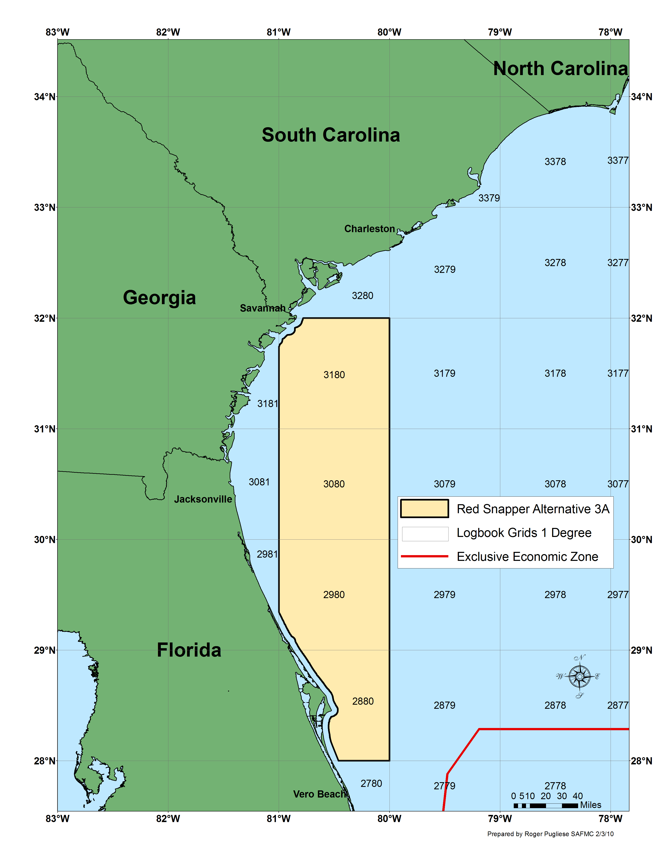
Figure 2-1. Map of proposed closed area under Alternative 3A.

Table 2-7 Waypoints used to delineate Alternative 3A.
ID | LAT_DMS | LON_DMS
1 | 28° 00' 00" | -80° 00' 00"
2 | 28° 00' 00" | -80° 27' 42"
3 | 29° 20' 33" | -81° 00' 00"
4 | 31° 44' 32" | -81° 00' 00"
5 | 32° 00' 00" | -80° 46' 56"
6 | 32° 00' 00" | -80° 00' 00"
Between point 2 and point 3, line follows inner boundary of U.S. EEZ.
Between point 4 and point 5, line follows inner boundary of U.S. EEZ.

Alternative 3B. Prohibit all commercial and recreational fishing for (new statement), harvest, and possession, (removed “retention”) of red snapper year-round in the South Atlantic EEZ. Prohibition of red snapper applies in the South Atlantic on board a vessel for which a valid Federal charter vessel/headboat or commercial permit for South Atlantic snapper grouper has been issued, without regard to where such species were harvested, i.e., in state or Federal waters. Prohibit commercial and recreational fishing for (new statement) harvest, possession, (removed “retention”) of species in the snapper grouper FMU year-round in an area that includes commercial logbook grids 2880, 2980, 3080, and 3180 between an approximate depth of 66 feet (11 fathoms; 20 m) to 240 feet (40 fathoms; 73 m), for a total of (replaced “or”) 10,567 mi² (27,368 km²) of the South Atlantic EEZ (Figure 2-2). Coordinates for the closure are shown in Table 2-8.

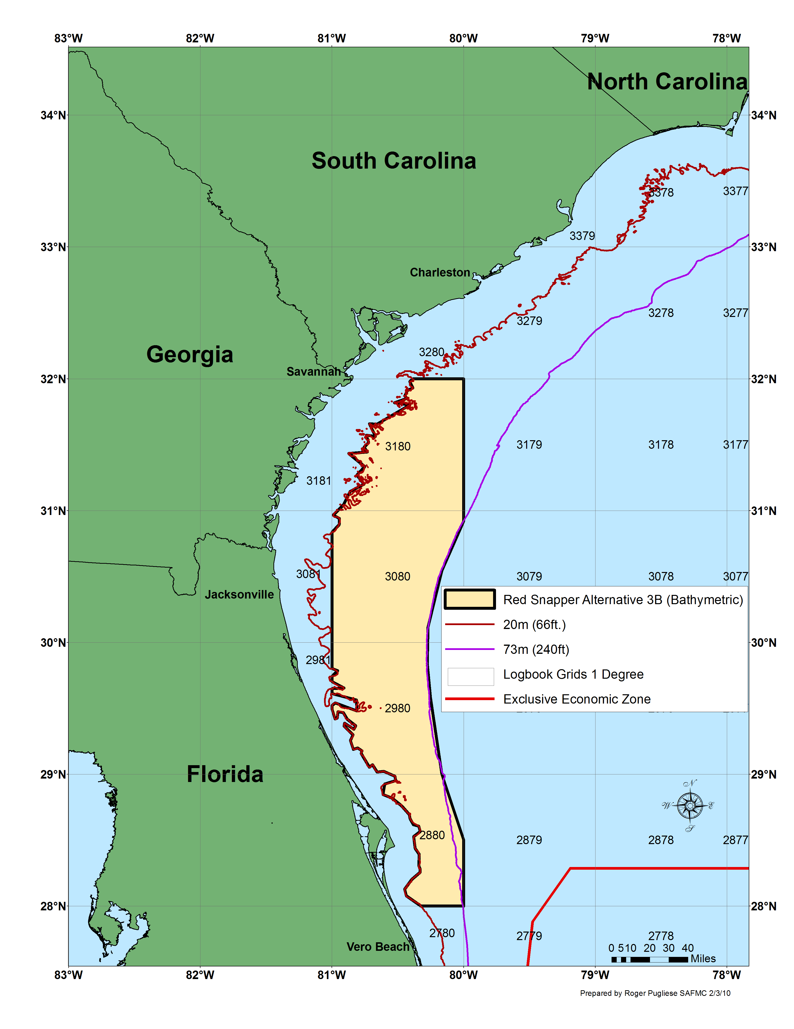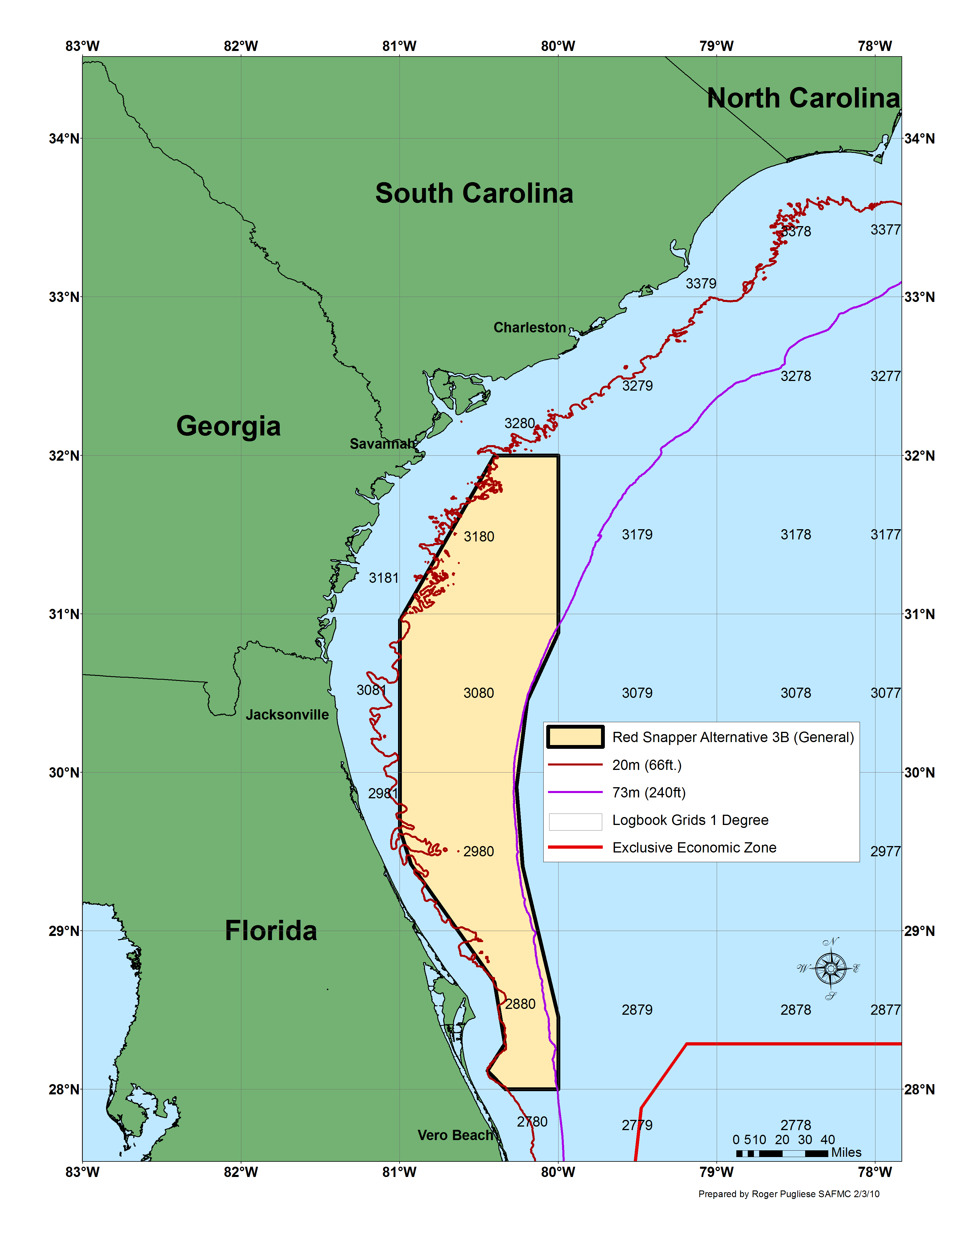
Figure 2-2. Map 1 of proposed closed area under Alternative 3B. Map 2 using generalized
boundary for proposed closed area under Alternative 3B

Table 2-8 Waypoints used to delineate Alternative 3B

Map 1 waypoints used to delineate Alternative 3B. |  |  | Map 2 waypoints used to delineate the generalized boundary under Alternative 3B.
ID | LAT_DMS | LON_DMS | ID | LAT_DMS | LON_DMS
1 | 28° 00' 00" | -80° 00' 00" | 1 | 28° 00' 00" | -80° 00' 00"
2 | 28° 00' 00" | -80° 19' 30" | 2 | 28° 00' 00" | -80° 20' 01"
3 | 28° 04' 39" | -80° 26' 11" | 3 | 28° 06' 58" | -80° 26' 49"
4 | 28° 07' 43" | -80° 26' 56" | 4 | 28° 17' 14" | -80° 20' 19"
5 | 28° 12' 08" | -80° 23' 46" | 5 | 28° 40' 32" | -80° 24' 09"
6 | 28° 15' 27" | -80° 19' 50" | 6 | 29° 25' 09" | -80° 55' 44"
7 | 28° 17' 09" | -80° 19' 58" | 7 | 29° 38' 20" | -81° 00' 00"
8 | 28° 18' 20" | -80° 20' 27" | 8 | 30° 57' 40" | -81° 00' 00"
9 | 28° 23' 33" | -80° 20' 17" | 9 | 32° 00' 00" | -80° 24' 12"
10 | 28° 26' 19" | -80° 22' 08" | 10 | 32° 00' 00" | -80° 00' 00"
11 | 28° 31' 34" | -80° 22' 48" | 11 | 30° 52' 54" | -80° 00' 00"
12 | 28° 34' 00" | -80° 19' 50" | 12 | 30° 27' 19" | -80° 11' 41"
13 | 28° 36' 20" | -80° 20' 28" | 13 | 29° 54' 31" | -80° 15' 51"
14 | 28° 37' 05" | -80° 22' 58" | 14 | 29° 24' 24" | -80° 13' 32"
15 | 28° 39' 49" | -80° 24' 28" | 15 | 28° 27' 20" | -80° 00' 00"
16 | 28° 41' 42" | -80° 24' 48"
17 | 28° 45' 40" | -80° 28' 22"
18 | 28° 49' 06" | -80° 32' 45"
19 | 28° 50' 45" | -80° 36' 51"
20 | 28° 55' 31" | -80° 36' 00"
21 | 28° 57' 07" | -80° 31' 04"
22 | 28° 59' 10" | -80° 31' 19"
23 | 29° 01' 21" | -80° 36' 26"
24 | 29° 01' 03" | -80° 39' 27"
25 | 29° 04' 17" | -80° 41' 32"
26 | 29° 03' 10" | -80° 43' 00"
27 | 29° 09' 34" | -80° 46' 48"
28 | 29° 10' 39" | -80° 46' 17"
29 | 29° 12' 00" | -80° 48' 18"
30 | 29° 11' 22" | -80° 50' 18"
31 | 29° 15' 26" | -80° 51' 39"
32 | 29° 17' 59" | -80° 50' 28"
33 | 29° 21' 59" | -80° 54' 32"
34 | 29° 23' 17" | -80° 54' 17"
35 | 29° 20' 34" | -80° 50' 08"
36 | 29° 22' 01" | -80° 49' 15"
37 | 29° 25' 07" | -80° 53' 04"
38 | 29° 28' 06" | -80° 54' 54"
39 | 29° 28' 31" | -80° 57' 20"
40 | 29° 25' 38" | -80° 57' 37"
41 | 29° 25' 10" | -80° 58' 37"
42 | 29° 29' 30" | -81° 00' 00"
43 | 29° 31' 26" | -81° 00' 00"
44 | 29° 32' 31" | -80° 58' 32"
45 | 29° 28' 48" | -80° 48' 41"
46 | 29° 33' 51" | -80° 48' 53"
47 | 29° 36' 44" | -81° 00' 00"
48 | 29° 39' 02" | -81° 00' 00"
49 | 29° 39' 18" | -80° 54' 32"
50 | 29° 42' 08" | -81° 00' 00"
51 | 29° 44' 44" | -81° 00' 00"
52 | 29° 47' 08" | -80° 57' 24"
53 | 29° 48' 05" | -81° 00' 00"
54 | 30° 50' 16" | -81° 00' 00"
55 | 30° 53' 39" | -80° 56' 45"
56 | 30° 56' 25" | -80° 56' 40"
57 | 30° 57' 56" | -80° 59' 30"
58 | 31° 02' 34" | -80° 54' 49"
59 | 31° 08' 43" | -80° 51' 49"
60 | 31° 12' 01" | -80° 45' 27"
61 | 31° 16' 09" | -80° 48' 40"
62 | 31° 20' 05" | -80° 45' 08"
63 | 31° 26' 03" | -80° 52' 29"
64 | 31° 26' 45" | -80° 43' 52"
65 | 31° 28' 48" | -80° 45' 24"
66 | 31° 31' 03" | -80° 43' 18"
67 | 31° 34' 23" | -80° 44' 20"
68 | 31° 33' 50" | -80° 40' 14"
69 | 31° 39' 37" | -80° 42' 58"
70 | 31° 39' 21" | -80° 39' 31"
71 | 31° 48' 09" | -80° 24' 39"
72 | 31° 49' 08" | -80° 31' 35"
73 | 31° 51' 08" | -80° 25' 59"
74 | 31° 52' 17" | -80° 26' 52"
75 | 31° 54' 38" | -80° 25' 43"
76 | 31° 55' 55" | -80° 23' 08"
77 | 31° 58' 44" | -80° 24' 37"
78 | 32° 00' 00" | -80° 23' 10"
79 | 32° 00' 00" | -80° 00' 00"
80 | 30° 55' 18" | -80° 00' 00"
81 | 30° 32' 40" | -80° 10' 00"
82 | 30° 07' 00" | -80° 16' 15"
83 | 29° 50' 25" | -80° 16' 38"
84 | 29° 35' 00" | -80° 15' 13"
85 | 29° 00' 00" | -80° 10' 00"
86 | 28° 30' 00" | -80° 00' 00"

Alternative 3C. Prohibit all commercial and recreational fishing for (new statement), harvest, and possession, (removed “retention”) of red snapper year-round in the South Atlantic EEZ. Prohibition of red snapper applies in the South Atlantic on board a vessel for which a valid Federal charter vessel/headboat or commercial permit for South Atlantic snapper grouper has been issued, without regard to where such species were harvested, i.e., in state or Federal waters. Prohibit commercial and recreational fishing for (new statement) harvest, possession, (removed “retention”) of species in the snapper grouper FMU year-round in an area that includes commercial logbook grids 2880, 2980, 3080, and 3180 between an approximate depth of 98 feet (16 fathoms; 30 m) to 240 feet (40 fathoms; 73 m), for a total of (replaced “or”) 6,375 mi² (16,511 km²),using bathymetric contours, of the South Atlantic EEZ (Figure 2-3). Coordinates for the closure are shown in Table 2-9.
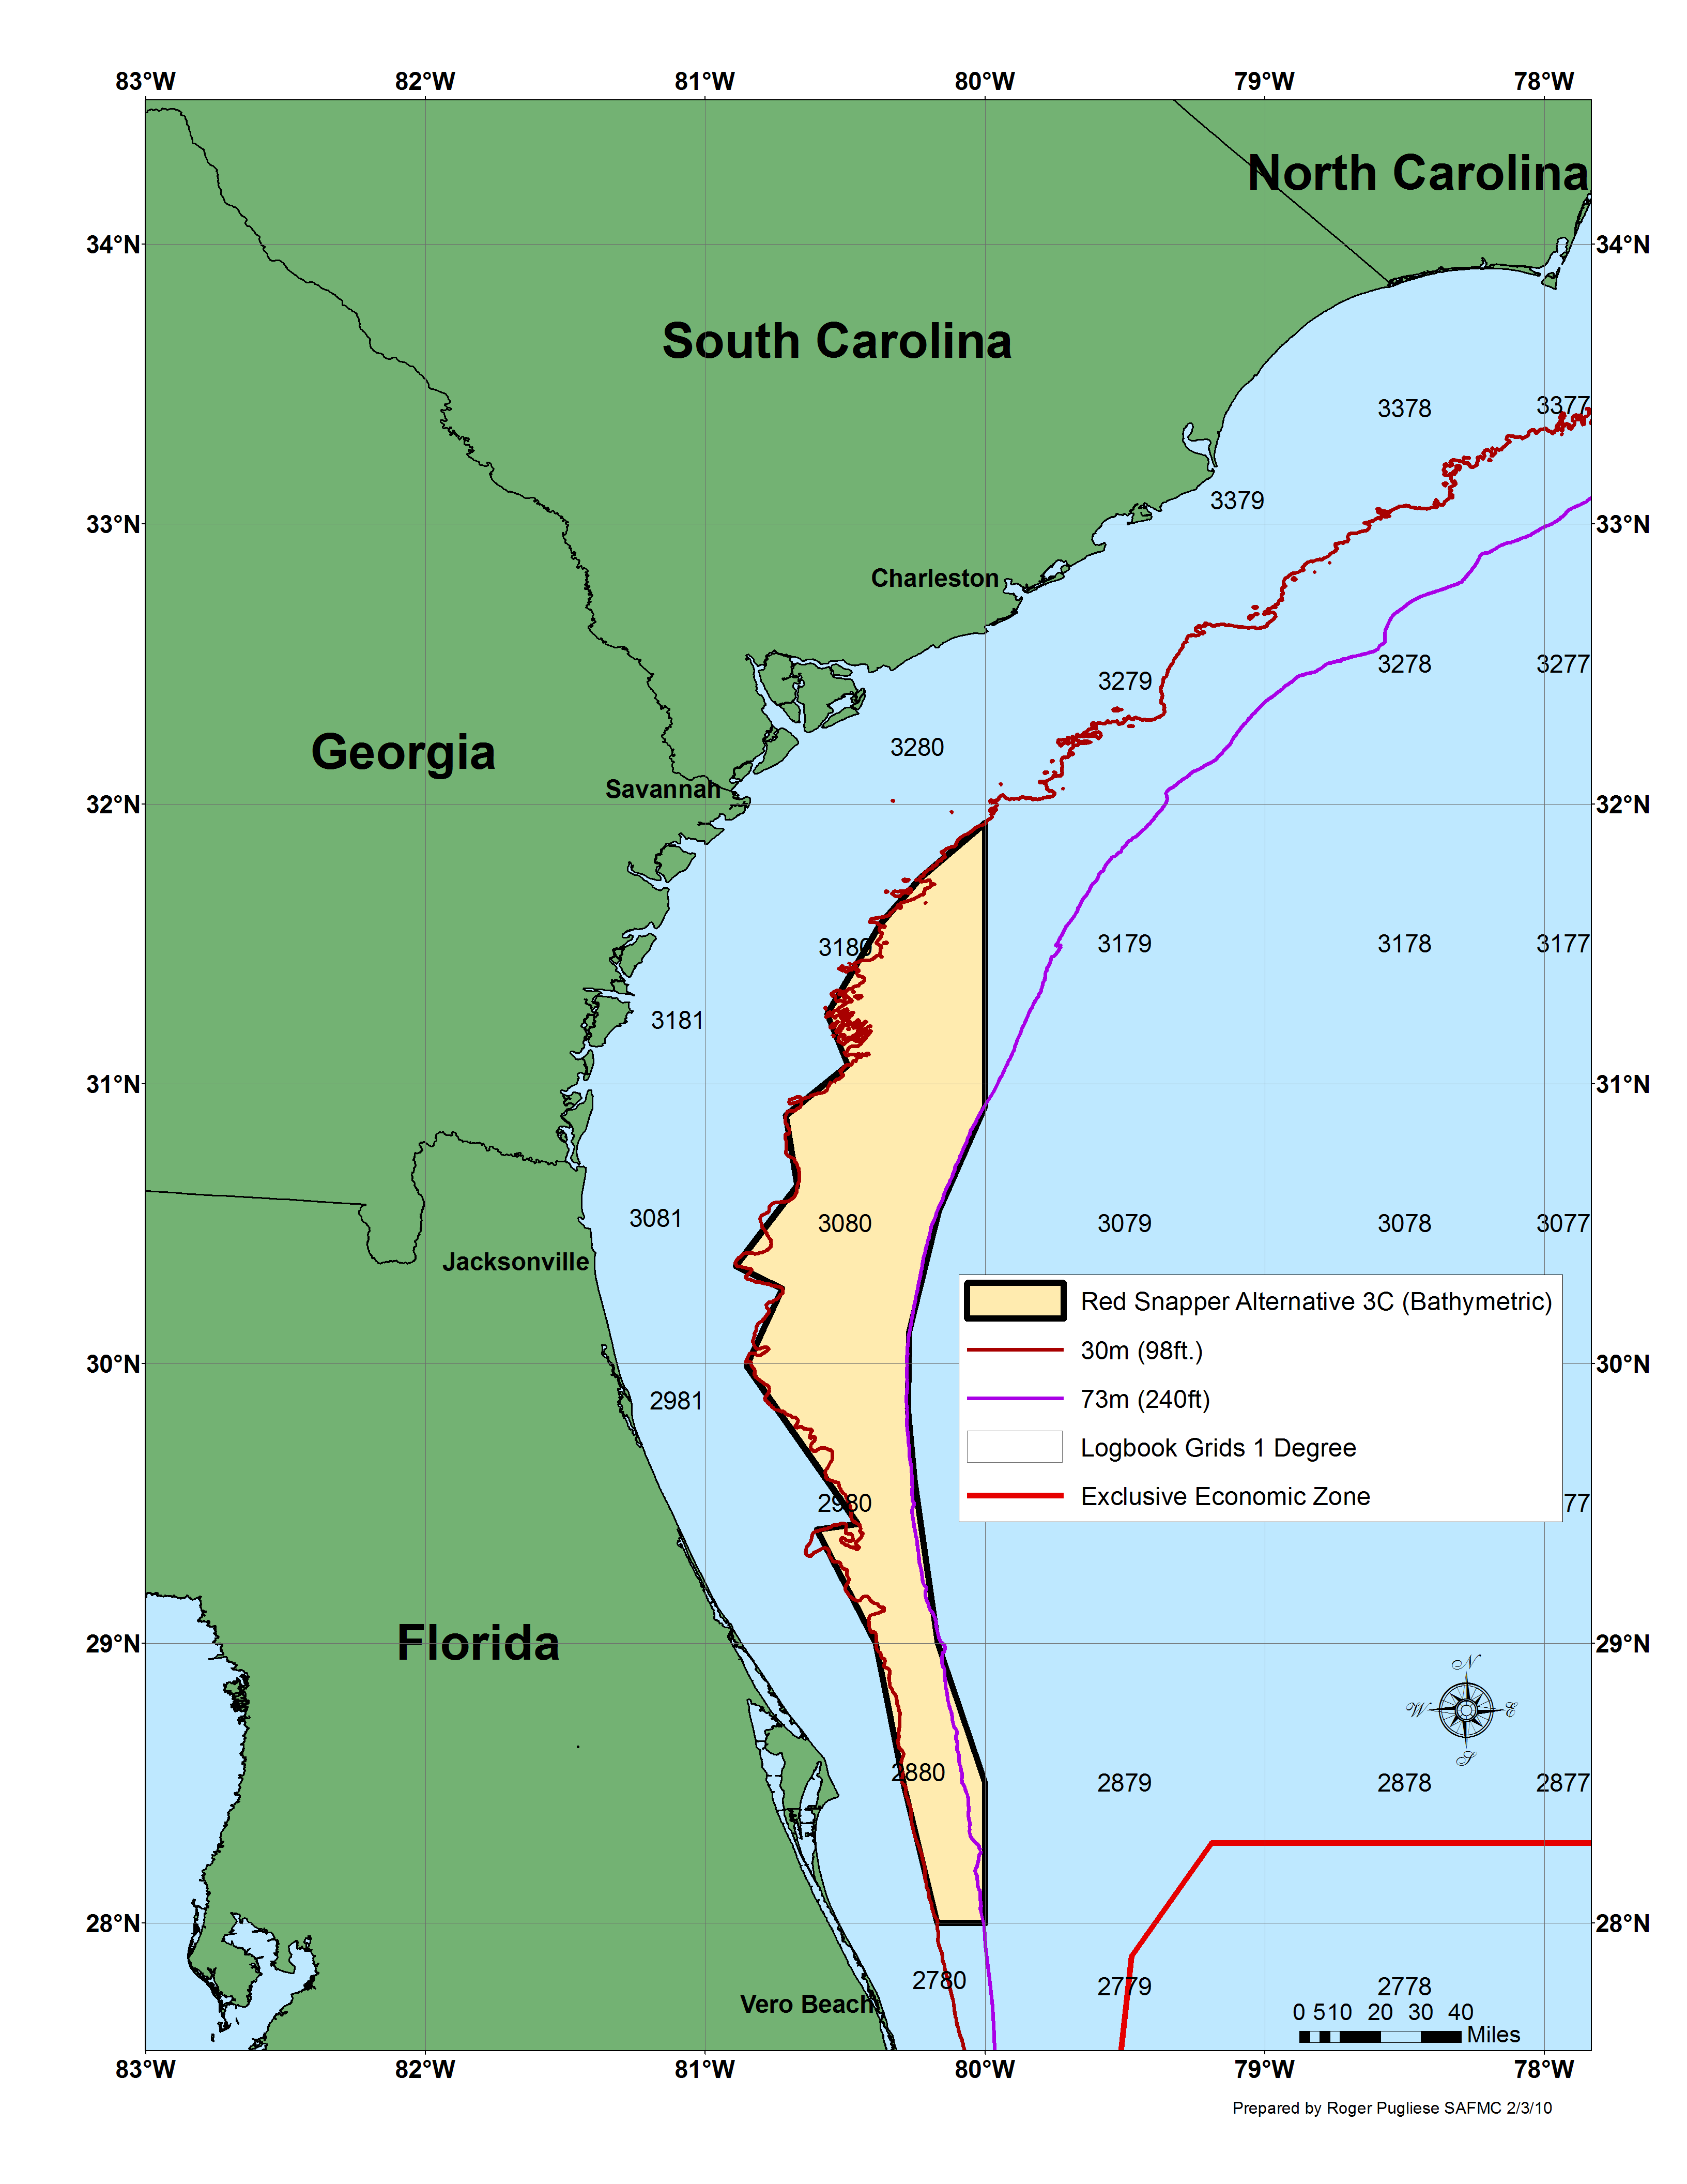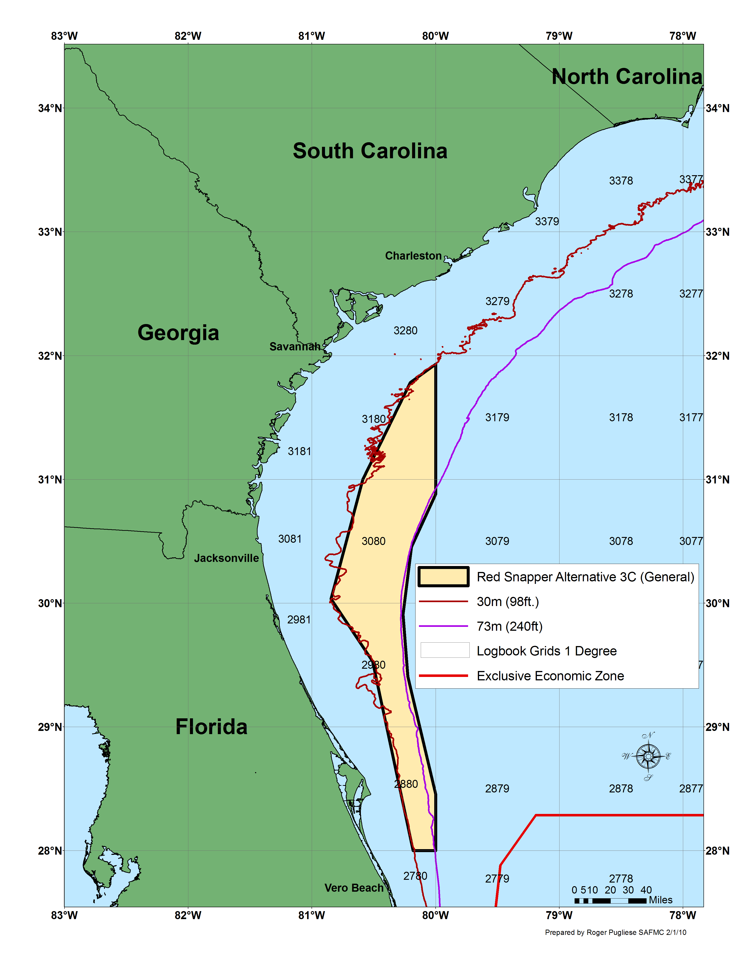

Figure 2-3 Map 1 of proposed closed area under Alternative 3C. Map 2 using generalized boundary for proposed closed area under Alternative 3C.

Table 2-9 Waypoints used to delineate Alternative 3C

Map 1 waypoints used to delineate Alternative 3C |  |  | Map 2 waypoints used to delineate the generalized boundary under Alternative 3C.
ID | LAT_DMS | LON_DMS | ID | LAT_DMS | LON_DMS
1 | 28° 00' 00" | -80° 00' 00" | 1 | 28° 00' 00" | -80° 00' 00"
2 | 28° 00' 00" | -80° 10' 15" | 2 | 28° 00' 00" | -80° 10' 57"
3 | 28° 29' 17" | -80° 17' 23" | 3 | 29° 31' 40" | -80° 30' 34"
4 | 29° 00' 00" | -80° 23' 30" | 4 | 30° 02' 03" | -80° 50' 45"
5 | 29° 24' 25" | -80° 36' 07" | 5 | 31° 00' 00" | -80° 35' 19"
6 | 29° 25' 39" | -80° 27' 21" | 6 | 31° 47' 00" | -80° 12' 15"
7 | 29° 59' 30" | -80° 51' 10" | 7 | 31° 55' 55" | -80° 00' 00"
8 | 30° 16' 02" | -80° 43' 36" | 8 | 30° 52' 54" | -80° 00' 00"
9 | 30° 20' 58" | -80° 53' 34" | 9 | 30° 27' 19" | -80° 11' 41"
10 | 30° 38' 08" | -80° 40' 18" | 10 | 29° 54' 31" | -80° 15' 51"
11 | 30° 53' 12" | -80° 42' 45" | 11 | 29° 24' 24" | -80° 13' 32"
12 | 31° 04' 00" | -80° 29' 29" | 12 | 28° 27' 20" | -80° 00' 00"
13 | 31° 14' 57" | -80° 33' 55"
14 | 31° 34' 11" | -80° 22' 34"
15 | 31° 44' 07" | -80° 14' 00"
16 | 31° 56' 00" | -80° 00' 00"
17 | 30° 55' 18" | -80° 00' 00"
18 | 30° 32' 40" | -80° 10' 00"
19 | 30° 07' 00" | -80° 16' 15"
20 | 29° 50' 25" | -80° 16' 38"
21 | 29° 35' 00" | -80° 15' 13"
22 | 29° 00' 00" | -80° 10' 10"
23 | 28° 30' 00" | -80° 00' 00"

Alternative 3D. Prohibit all commercial and recreational fishing for (new statement), harvest, and possession, (removed “retention”) of red snapper year-round in the South Atlantic EEZ. Prohibition of red snapper applies in the South Atlantic on board a vessel for which a valid Federal charter vessel/headboat or commercial permit for South Atlantic snapper grouper has been issued, without regard to where such species were harvested, i.e., in state or Federal waters. Prohibit commercial and recreational fishing for (new statement) harvest, possession, (removed “retention”) of species in the snapper grouper FMU year-round in an area that includes commercial logbook grids 2880, 2980, 3080, and 3180 between an approximate depth of 98 feet (16 fathoms; 30 m) to 300 feet (50 fathoms; 91 m), for a total of (replaced “or”) 6,567 mi² (17, 008 km²), using the bathymetric boundary, of the South Atlantic EEZ (Figure 2-4). Coordinates for the closure are shown in Table 2-10.

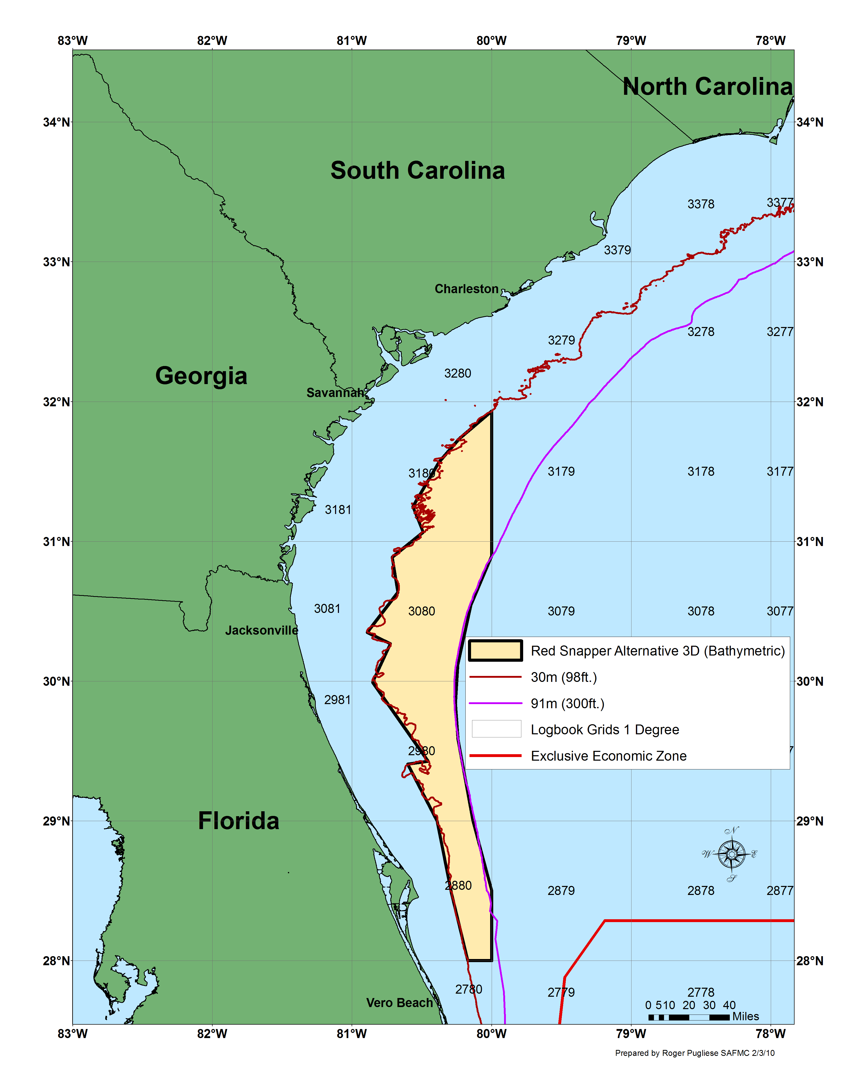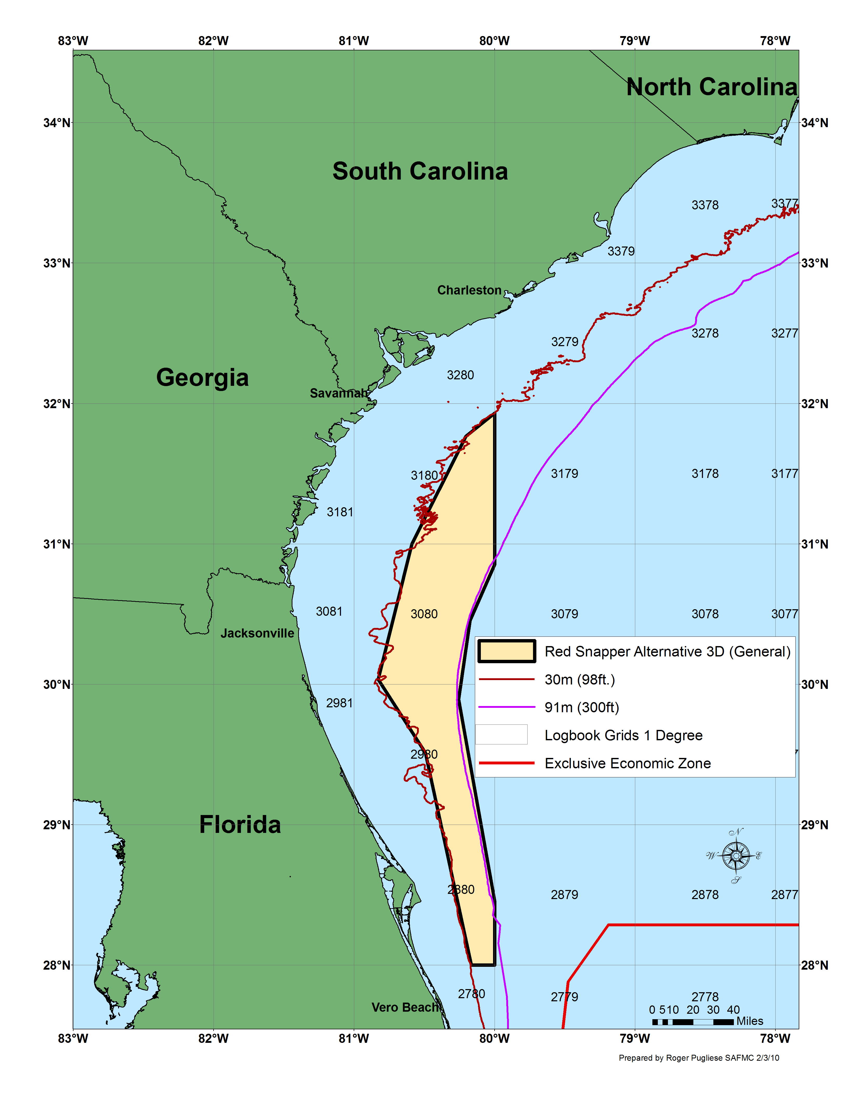
Figure 2-4. Map 1 of proposed closed area under Alternative 3D. Map 2 using generalized boundary for proposed closed area under Alternative 3D.
Table 2-10 Waypoints used to delineate Alternative 3D

Map 1 waypoints used to delineate Alternative 3D. |  |  | Map 2 waypoints used to delineate the generalized boundary under Alternative 3D.
ID | LAT_DMS | LON_DMS | ID | LAT_DMS | LON_DMS
1 | 28° 00' 00" | -80° 00' 00" | 1 | 28° 00' 00" | -80° 00' 00"
2 | 28° 00' 00" | -80° 10' 15" | 2 | 28° 00' 00" | -80° 09' 57"
3 | 28° 29' 17" | -80° 17' 23" | 3 | 29° 30' 40" | -80° 29' 34"
4 | 29° 00' 00" | -80° 23' 30" | 4 | 30° 02' 03" | -80° 49' 45"
5 | 29° 24' 25" | -80° 36' 07" | 5 | 31° 00′ 00" | -80° 35' 19"
6 | 29° 25' 39" | -80° 27' 21" | 6 | 31° 46' 00" | -80° 12' 15"
7 | 29° 59' 30" | -80° 51' 10" | 7 | 31° 55' 55" | -80° 00' 00"
8 | 30° 16' 02" | -80° 43' 36" | 8 | 30° 51' 13" | -80° 00' 00"
9 | 30° 20' 58" | -80° 53' 34" | 9 | 30° 27' 19" | -80° 10' 34"
10 | 30° 38' 08" | -80° 40' 18" | 10 | 29° 53' 31" | -80° 15' 25"
11 | 30° 53' 12" | -80° 42' 45" | 11 | 28° 27' 20" | -80° 00' 00"
12 | 31° 04' 00" | -80° 29' 29"
13 | 31° 14' 57" | -80° 33' 55"
14 | 31° 34' 11" | -80° 22' 34"
15 | 31° 44' 07" | -80° 14' 00"
16 | 31° 56' 00" | -80° 00' 00"
17 | 30° 53' 50" | -80° 00' 00"
18 | 30° 32' 40" | -80° 09' 00"
19 | 30° 07' 00" | -80° 14' 39"
20 | 29° 50' 25" | -80° 15' 39"
21 | 29° 35' 00" | -80° 14' 30"
22 | 29° 00' 00" | -80° 08' 04"
23 | 28° 30' 00" | -80° 00' 00"

Alternative 4A. Prohibit all commercial and recreational fishing for (new statement), harvest, and possession, (removed “retention”) of red snapper year-round in the South Atlantic EEZ. Prohibition of red snapper applies in the South Atlantic on board a vessel for which a valid Federal charter vessel/headboat or commercial permit for South Atlantic snapper grouper has been issued, without regard to where such species were harvested, i.e., in state or Federal waters. Prohibit commercial and recreational fishing for (new statement) harvest, possession, (removed “retention”) of species in the snapper grouper FMU year-round in an area that includes commercial logbook grids 2880, 2980, 3080, 3179, 3180, 3278, and 3279, for a total of (replaced “or”) of 26,001 mi² (68,893 km²) of the South Atlantic EEZ (Figure 2-5). Coordinates for the closure are shown in Table 2-11.

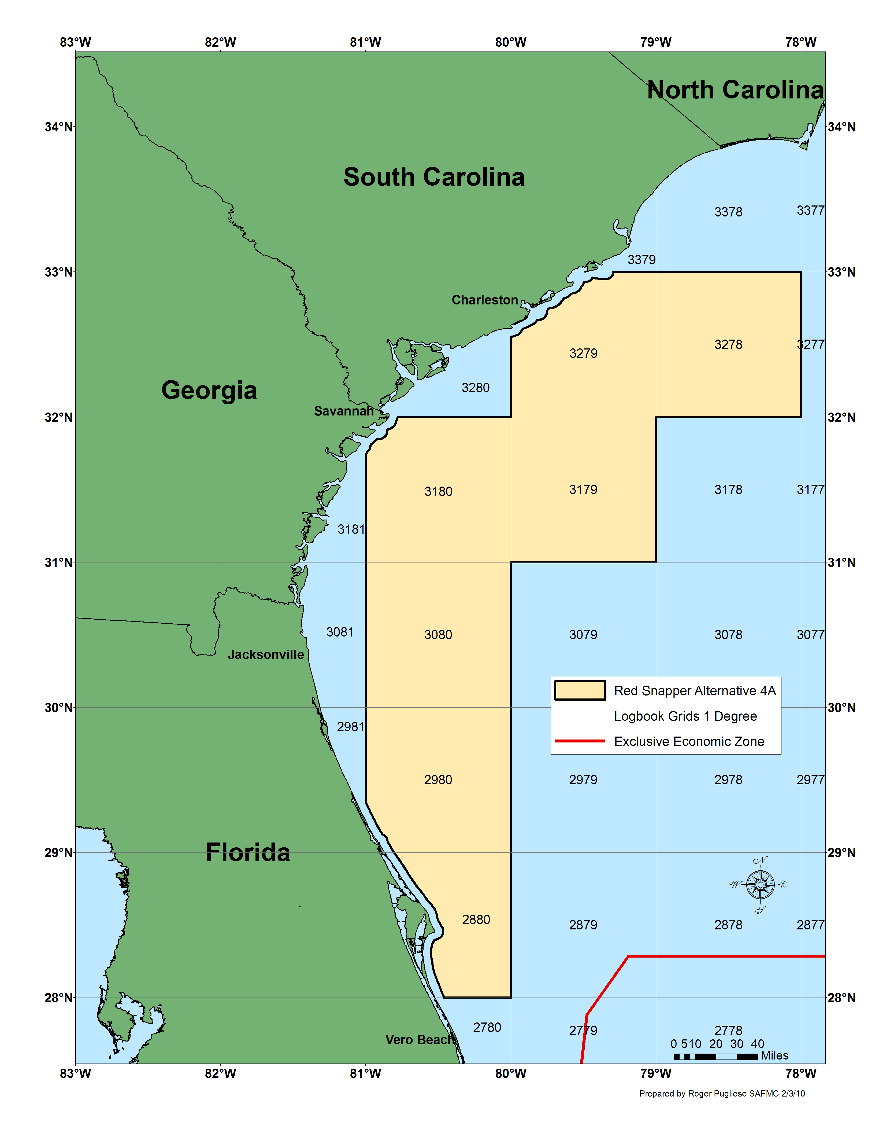
Figure 2-5. Map of proposed closed area under Alternative 4A.

Table 2-11 Waypoints used to delineate Alternative 4A.
ID | LAT_DMS | LON_DMS
1 | 28° 00' 00" | -80° 00' 00"
2 | 28° 00' 00" | -80° 27' 42"
3 | 29° 20' 33" | -81° 00' 00"
4 | 31° 44' 32" | -81° 00' 00"
5 | 32° 00' 00" | -80° 46' 56"
6 | 32° 00' 00" | -80° 00' 00"
7 | 32° 33' 08" | -80° 00' 00"
8 | 33° 00' 00" | -79° 17' 45"
9 | 33° 00' 00" | -78° 00' 00"
10 | 32° 00' 00" | -78° 00' 00"
11 | 32° 00' 00" | -79° 00' 00"
12 | 31° 00' 00" | -79° 00' 00"
13 | 31° 00' 00" | -80° 00' 00"
Between point 2 and point 3, line follows inner boundary of U.S. EEZ.
Between point 4 and point 5, line follows inner boundary of U.S. EEZ.
Between point 7 and point 8, line follows inner boundary of U.S. EEZ.

Alternative 4B. Prohibit all commercial and recreational fishing for (new statement), harvest, and possession, (removed “retention”) of red snapper year-round in the South Atlantic EEZ. Prohibition of red snapper applies in the South Atlantic on board a vessel for which a valid Federal charter vessel/headboat or commercial permit for South Atlantic snapper grouper has been issued, without regard to where such species were harvested, i.e., in state or Federal waters. Prohibit commercial and recreational fishing for (new statement) harvest, possession, (removed “retention”) of species in the snapper grouper FMU year-round in an area that includes commercial logbook grids 2880, 2980, 3080, 3179, 3180, 3278, and 3279 between an approximate depth of 66 feet (11 fathoms; 20 m) to 240 feet (40 fathoms; 73 m), for a total of (replaced “or”) of 15,269 mi² (39, 547 km²), using the bathymetric boundary, of the South Atlantic EEZ (Figure 2-6). Coordinates for the closure are shown in Table 2-12.
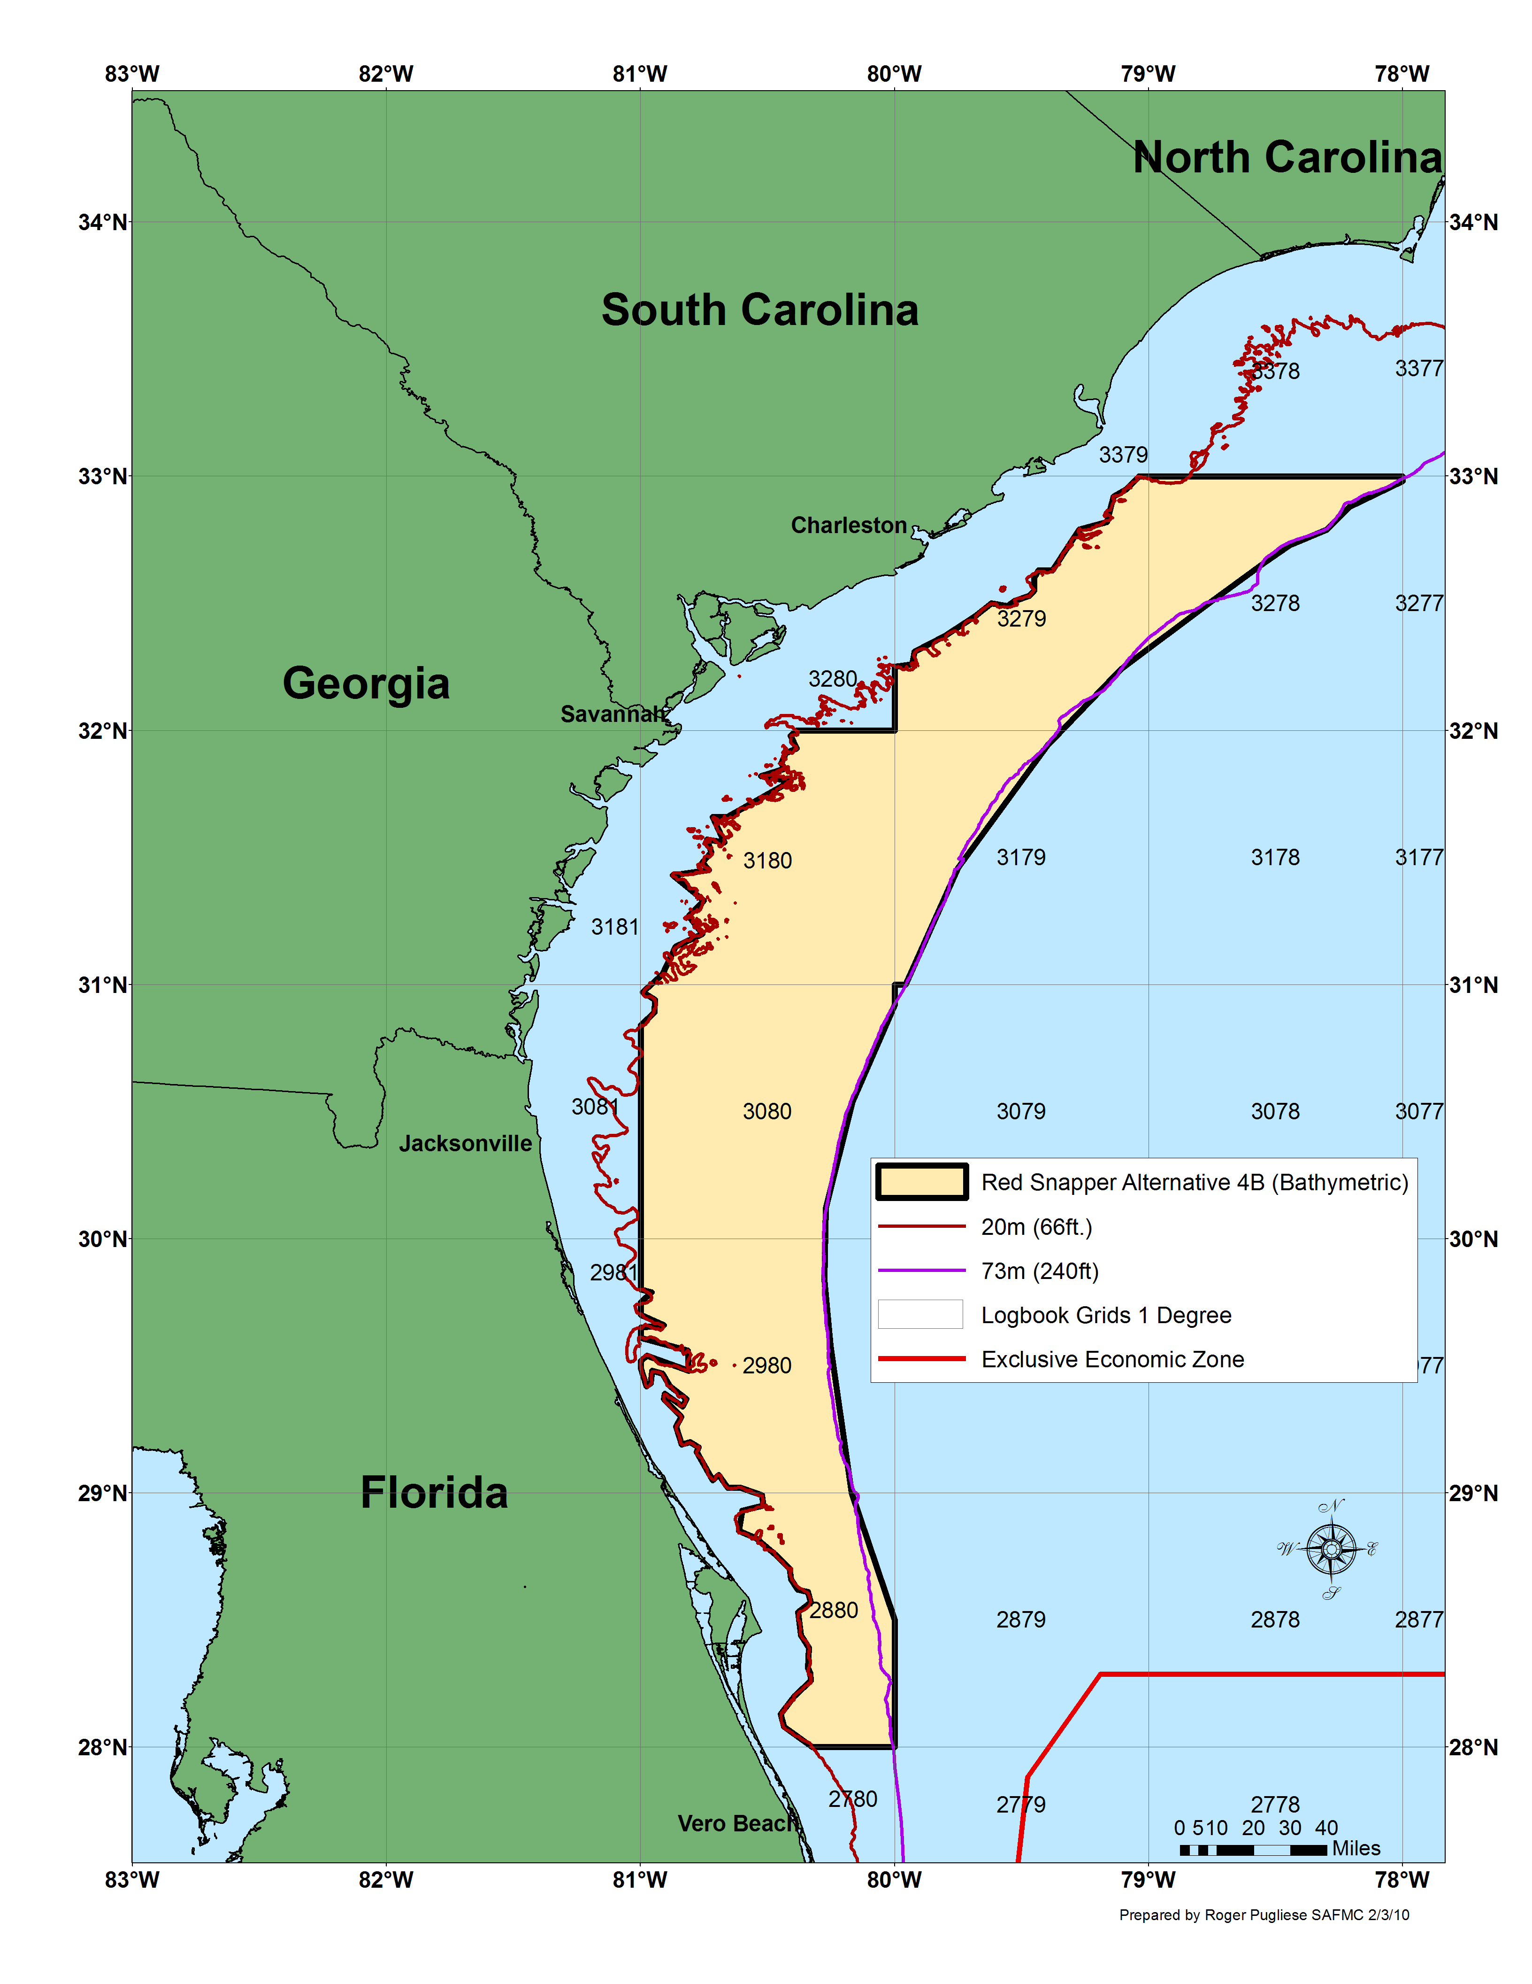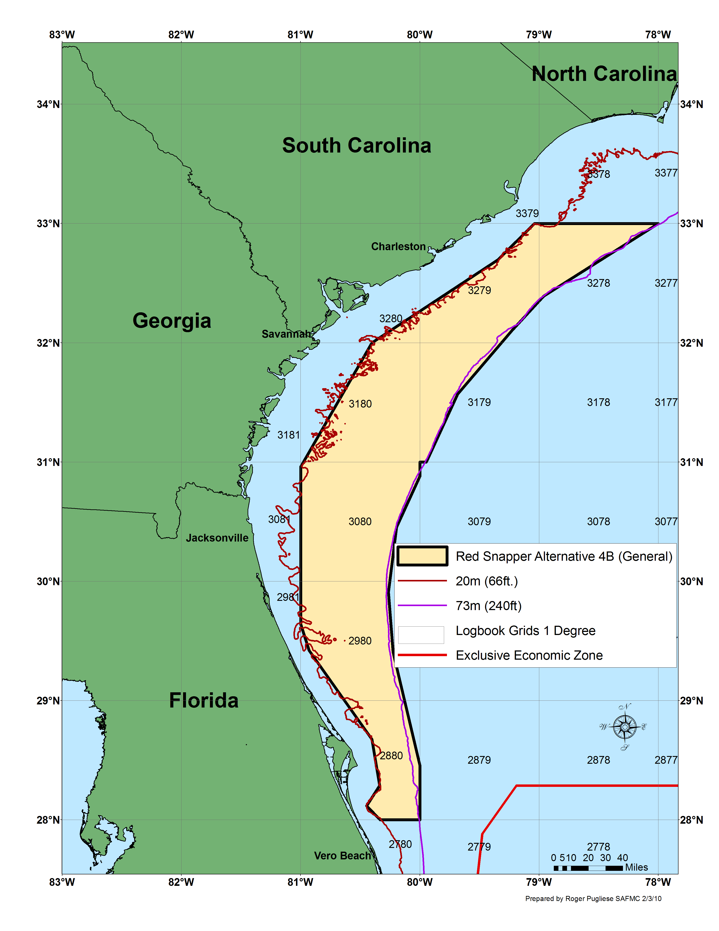
Figure 2-6. Map 1 of proposed closed area under Alternative 4B. Map 2 using generalized boundary for proposed closed area under Alternative 4B.

Table 2-12 Waypoints used to delineate Alternative 4B.

Map 1 waypoints used to delineate Alternative 4B. |  |  | Map 2 waypoints used to delineate the generalized boundary under Alternative 4B.
ID | LAT_DMS | LON_DMS | ID | LAT_DMS | LON_DMS
1 | 28° 00' 00" | -80° 00' 00" | 1 | 28° 00' 00" | -80° 00' 00"
2 | 28° 00' 00" | -80° 19' 30" | 2 | 28° 00' 00" | -80° 20' 01"
3 | 28° 04' 39" | -80° 26' 11" | 3 | 28° 06' 58" | -80° 26' 49"
4 | 28° 07' 43" | -80° 26' 56" | 4 | 28° 17' 14" | -80° 20' 19"
5 | 28° 12' 08" | -80° 23' 46" | 5 | 28° 40' 32" | -80° 24' 09"
6 | 28° 15' 27" | -80° 19' 50" | 6 | 29° 25' 09" | -80° 55' 44"
7 | 28° 17' 09" | -80° 19' 58" | 7 | 29° 38' 20" | -81° 00' 00"
8 | 28° 18' 20" | -80° 20' 27" | 8 | 30° 57' 40" | -81° 00' 00"
9 | 28° 23' 33" | -80° 20' 17" | 9 | 32° 00' 00" | -80° 24' 12"
10 | 28° 26' 19" | -80° 22' 08" | 10 | 32° 41' 38" | -79° 20' 50"
11 | 28° 31' 34" | -80° 22' 48" | 11 | 33° 00' 00" | -79° 02' 22"
12 | 28° 34' 00" | -80° 19' 50" | 12 | 33° 00' 00" | -78° 00' 00"
13 | 28° 36' 20" | -80° 20' 28" | 13 | 32° 23' 28" | -78° 57' 38"
14 | 28° 37' 05" | -80° 22' 58" | 14 | 32° 06' 03" | -79° 13' 46"
15 | 28° 39' 49" | -80° 24' 28" | 15 | 31° 34' 08" | -79° 41' 03"
16 | 28° 41' 42" | -80° 24' 48" | 16 | 31° 00' 00" | -79° 56' 43"
17 | 28° 45' 40" | -80° 28' 22" | 17 | 31° 00' 00" | -80° 00' 00"
18 | 28° 49' 06" | -80° 32' 45" | 18 | 30° 52' 54" | -80° 00' 00"
19 | 28° 50' 45" | -80° 36' 51" | 19 | 30° 27' 19" | -80° 11' 41"
20 | 28° 55' 31" | -80° 36' 00" | 20 | 29° 54' 31" | -80° 15' 51"
21 | 28° 57' 07" | -80° 31' 04" | 21 | 29° 24' 24" | -80° 13' 32"
22 | 28° 59' 10" | -80° 31' 19" | 22 | 28° 27' 20" | -80° 00' 00"
23 | 29° 01' 21" | -80° 36' 26"
24 | 29° 01' 03" | -80° 39' 27"
25 | 29° 04' 17" | -80° 41' 32"
26 | 29° 03' 10" | -80° 43' 00"
27 | 29° 09' 34" | -80° 46' 48"
28 | 29° 10' 39" | -80° 46' 17"
29 | 29° 12' 00" | -80° 48' 18"
30 | 29° 11' 22" | -80° 50' 18"
31 | 29° 15' 26" | -80° 51' 39"
32 | 29° 17' 59" | -80° 50' 28"
33 | 29° 21' 59" | -80° 54' 32"
34 | 29° 23' 17" | -80° 54' 17"
35 | 29° 20' 34" | -80° 50' 08"
36 | 29° 22' 01" | -80° 49' 15"
37 | 29° 25' 07" | -80° 53' 04"
38 | 29° 28' 06" | -80° 54' 54"
39 | 29° 28' 31" | -80° 57' 20"
40 | 29° 25' 38" | -80° 57' 37"
41 | 29° 25' 10" | -80° 58' 37"
42 | 29° 29' 30" | -81° 00' 00"
43 | 29° 31' 26" | -81° 00' 00"
44 | 29° 32' 31" | -80° 58' 32"
45 | 29° 28' 48" | -80° 48' 41"
46 | 29° 33' 51" | -80° 48' 53"
47 | 29° 36' 44" | -81° 00' 00"
48 | 29° 39' 02" | -81° 00' 00"
49 | 29° 39' 18" | -80° 54' 32"
50 | 29° 42' 08" | -81° 00' 00"
51 | 29° 44' 44" | -81° 00' 00"
52 | 29° 47' 08" | -80° 57' 24"
53 | 29° 48' 05" | -81° 00' 00"
54 | 30° 50' 16" | -81° 00' 00"
55 | 30° 53' 39" | -80° 56' 45"
56 | 30° 56' 25" | -80° 56' 40"
57 | 30° 57' 56" | -80° 59' 30"
58 | 31° 02' 34" | -80° 54' 49"
59 | 31° 08' 43" | -80° 51' 49"
60 | 31° 12' 01" | -80° 45' 27"
61 | 31° 16' 09" | -80° 48' 40"
62 | 31° 20' 05" | -80° 45' 08"
63 | 31° 26' 03" | -80° 52' 29"
64 | 31° 26' 45" | -80° 43' 52"
65 | 31° 28' 48" | -80° 45' 24"
66 | 31° 31' 03" | -80° 43' 18"
67 | 31° 34' 23" | -80° 44' 20"
68 | 31° 33' 50" | -80° 40' 14"
69 | 31° 39' 37" | -80° 42' 58"
70 | 31° 39' 21" | -80° 39' 31"
71 | 31° 48' 09" | -80° 24' 39"
72 | 31° 49' 08" | -80° 31' 35"
73 | 31° 51' 08" | -80° 25' 59"
74 | 31° 52' 17" | -80° 26' 52"
75 | 31° 54' 38" | -80° 25' 43"
76 | 31° 55' 55" | -80° 23' 08"
77 | 31° 58' 44" | -80° 24' 37"
78 | 32° 00' 00" | -80° 23' 10"
79 | 32° 00' 00" | -80° 00' 00"
80 | 32° 15' 03" | -80° 00' 01"
81 | 32° 15' 53" | -79° 55' 54"
82 | 32° 18' 27" | -79° 55' 19"
83 | 32° 21' 54" | -79° 48' 17"
84 | 32° 26' 49" | -79° 40' 58"
85 | 32° 29' 56" | -79° 37' 06"
86 | 32° 29' 10" | -79° 33' 22"
87 | 32° 30' 48" | -79° 31' 41"
88 | 32° 31' 41" | -79° 28' 11"
89 | 32° 33' 14" | -79° 27' 05"
90 | 32° 35' 47" | -79° 27' 04"
91 | 32° 37' 33" | -79° 26' 02"
92 | 32° 37' 31" | -79° 22' 41"
93 | 32° 47' 39" | -79° 16' 27"
94 | 32° 49' 27" | -79° 09' 53"
95 | 32° 55' 16" | -79° 08' 22"
96 | 32° 57' 12" | -79° 05' 14"
97 | 33° 00' 00" | -79° 02' 23"
98 | 33° 00' 00" | -78° 00' 00"
99 | 32° 58' 50" | -78° 00' 00"
100 | 32° 53' 02" | -78° 12' 38"
101 | 32° 47' 21" | -78° 17' 49"
102 | 32° 43' 47" | -78° 26' 40"
103 | 32° 39' 37" | -78° 32' 45"
104 | 32° 30' 36" | -78° 45' 00"
105 | 32° 14' 24" | -79° 06' 36"
106 | 31° 56' 24" | -79° 24' 00"
107 | 31° 27' 36" | -79° 45' 00"
108 | 31° 00' 00" | -79° 57' 28"
109 | 31° 00' 00" | -80° 00' 00"
110 | 30° 55' 18" | -80° 00' 00"
111 | 30° 32' 40" | -80° 10' 00"
112 | 30° 07' 00" | -80° 16' 15"
113 | 29° 50' 25" | -80° 16' 38"
114 | 29° 35' 00" | -80° 15' 13"
115 | 29° 00' 00" | -80° 10' 10"
116 | 28° 30' 00" | -80° 00' 00"

Alternative 4C. Prohibit all commercial and recreational fishing for (new statement), harvest, and possession, (removed “retention”) of red snapper year-round in the South Atlantic EEZ. Prohibition of red snapper applies in the South Atlantic on board a vessel for which a valid Federal charter vessel/headboat or commercial permit for South Atlantic snapper grouper has been issued, without regard to where such species were harvested, i.e., in state or Federal waters. Prohibit commercial and recreational fishing for (new statement) harvest, possession, (removed “retention”) of species in the snapper grouper FMU year-round in an area that includes commercial logbook grids 2880, 2980, 3080, 3179, 3180, 3278, and 3279 between an approximate depth of 98 feet (16 fathoms; 30 m) to 240 feet (40 fathoms; 73 m), for a total of (replaced “or”) 9,823 mi² (25,441 km²), using the bathymetric boundary, of the South Atlantic EEZ (Figure 2-7). Coordinates for the closure are shown in Table 2-13.
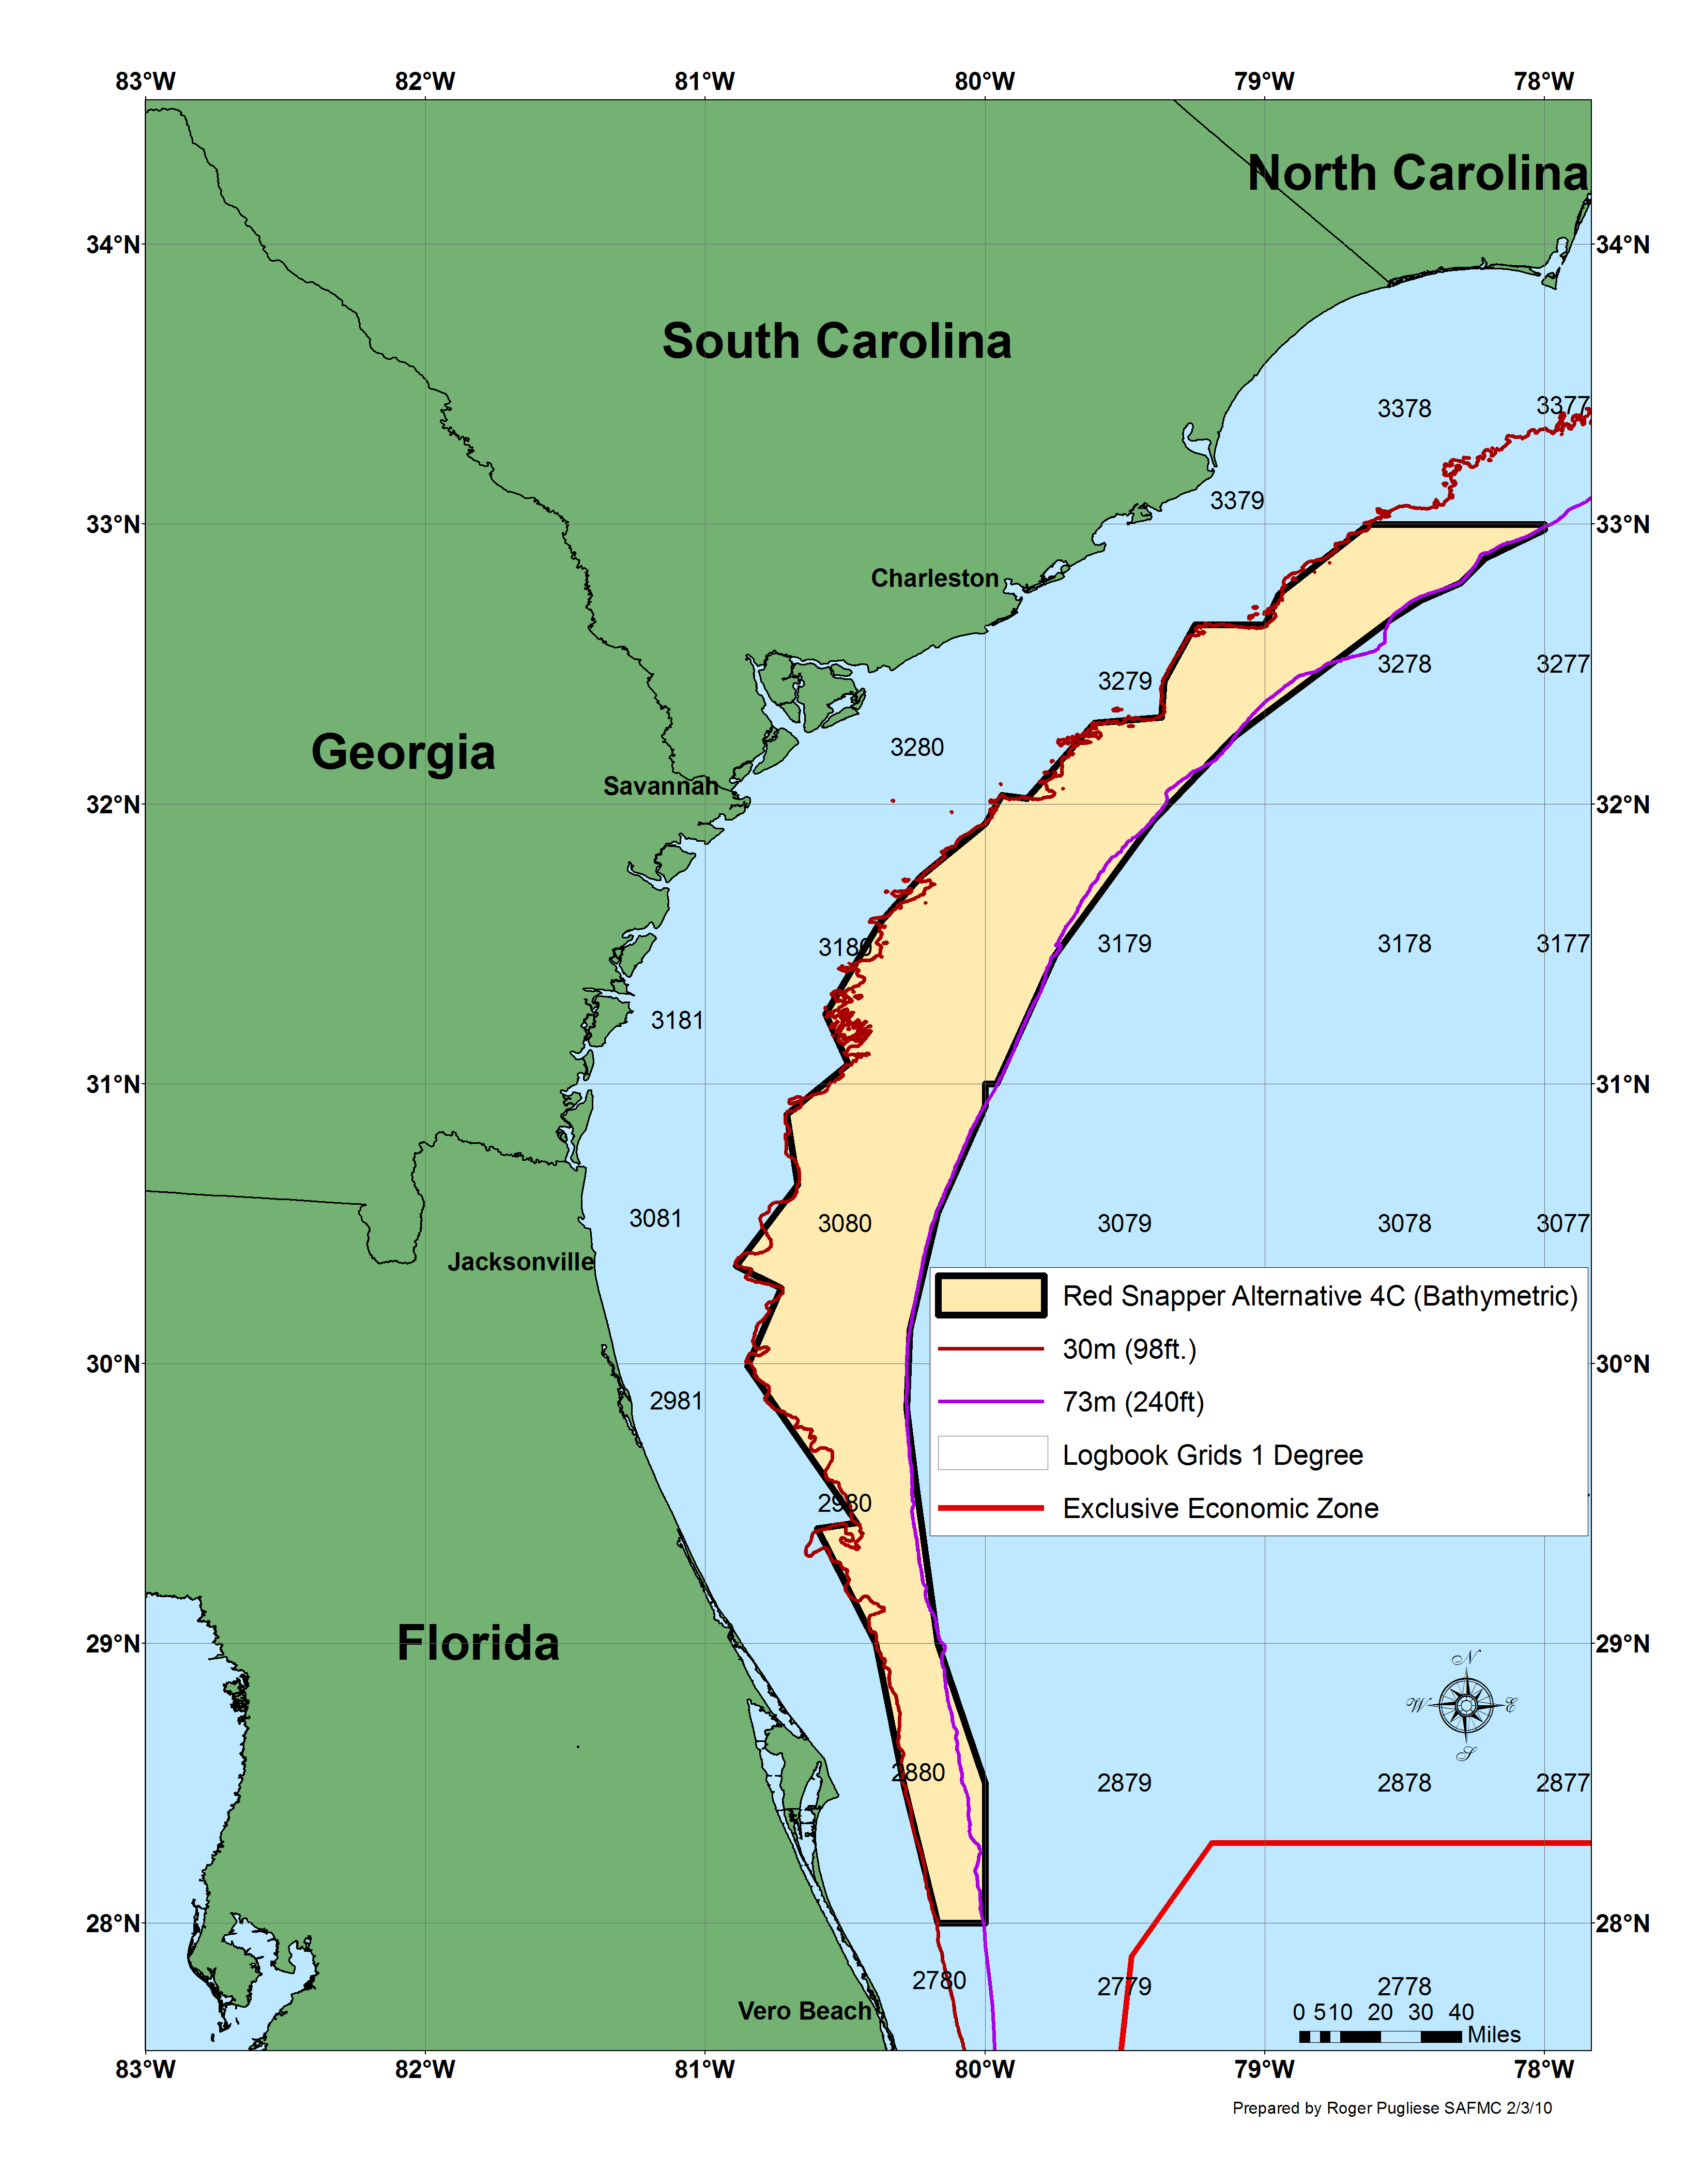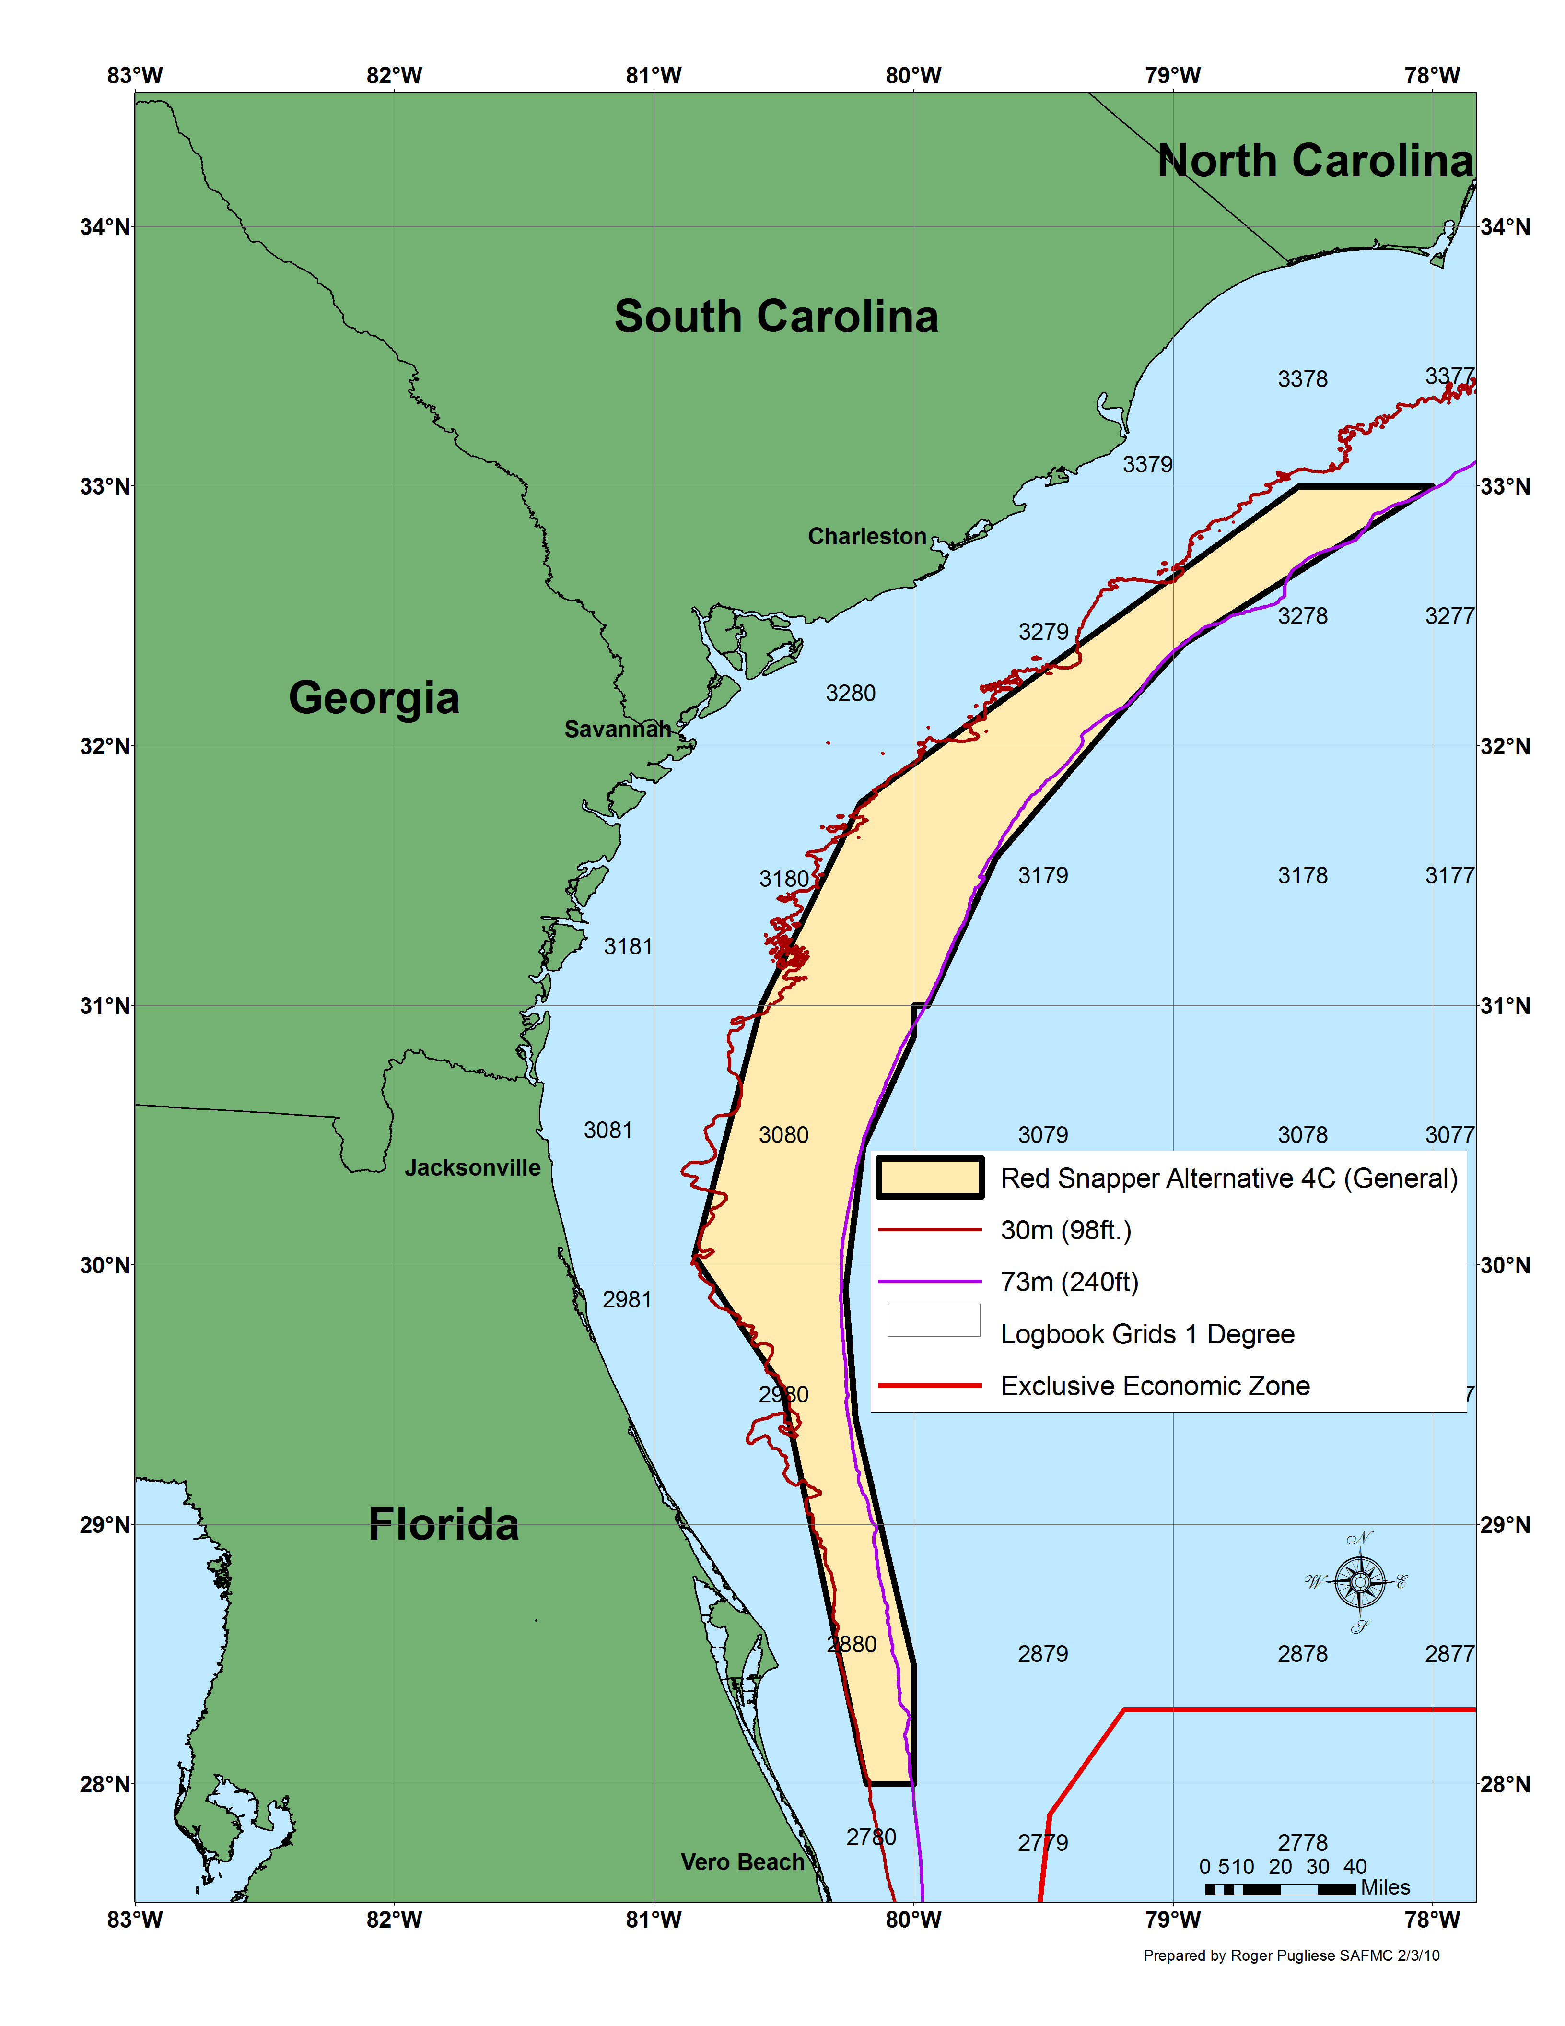

Figure 2-7. Map 1 of proposed closed area under Alternative 4C. Map 2 using generalized boundary for proposed closed area under Alternative 4C.

Table 2-13 Waypoints used to delineate Alternative 4C.

Map 1 waypoints used to delineate Alternative 4C. |  |  | Map 2 waypoints used to delineate the generalized boundary under Alternative 4C.
ID | LAT_DMS | LON_DMS | ID | LAT_DMS | LON_DMS
1 | 28° 00' 00" | -80° 00' 00" | 1 | 28° 00' 00" | -80° 00' 00"
2 | 28° 00' 00" | -80° 10' 15" | 2 | 28° 00' 00" | -80° 10' 57"
3 | 28° 29' 17" | -80° 17' 23" | 3 | 29° 31' 40" | -80° 30' 34"
4 | 29° 00' 00" | -80° 23' 30" | 4 | 30° 02' 03" | -80° 50' 45"
5 | 29° 24' 25" | -80° 36' 07" | 5 | 31° 00' 00" | -80° 35' 19"
6 | 29° 25' 39" | -80° 27' 21" | 6 | 31° 47' 00" | -80° 12' 15"
7 | 29° 59' 30" | -80° 51' 10" | 7 | 33° 00' 00" | -78° 31' 05"
8 | 30° 16' 02" | -80° 43' 36" | 8 | 33° 00' 00" | -78° 00' 00"
9 | 30° 20' 58" | -80° 53' 34" | 9 | 32° 23' 28" | -78° 57' 38"
10 | 30° 38' 08" | -80° 40' 18" | 10 | 32° 06' 03" | -79° 13' 46"
11 | 30° 53' 12" | -80° 42' 45" | 11 | 31° 34' 08" | -79° 41' 03"
12 | 31° 04' 00" | -80° 29' 29" | 12 | 31° 00' 00" | -79° 56' 43"
13 | 31° 14' 57" | -80° 33' 55" | 13 | 31° 00' 00" | -80° 00' 00"
14 | 31° 34' 11" | -80° 22' 34" | 14 | 30° 52' 54" | -80° 00' 00"
15 | 31° 44' 07" | -80° 14' 00" | 15 | 30° 27' 19" | -80° 11' 41"
16 | 31° 56' 00" | -80° 00' 00" | 16 | 29° 54' 31" | -80° 15' 51"
17 | 32° 02' 00" | -79° 56' 31" | 17 | 29° 24' 24" | -80° 13' 32"
18 | 32° 01' 12" | -79° 50' 43" | 18 | 28° 27' 20" | -80° 00' 00"
19 | 32° 17' 21" | -79° 36' 42"
20 | 32° 18' 38" | -79° 22' 01"
21 | 32° 26' 25" | -79° 21' 53"
22 | 32° 38' 13" | -79° 14' 52"
23 | 32° 38' 24" | -79° 00' 00"
24 | 32° 45' 05" | -78° 57' 05"
25 | 33° 00' 00" | -78° 37' 53"
26 | 33° 00' 00" | -78° 00' 00"
27 | 32° 58' 50" | -78° 00' 00"
28 | 32° 53' 02" | -78° 12' 38"
29 | 32° 47' 21" | -78° 17' 49"
30 | 32° 43' 47" | -78° 26' 40"
31 | 32° 39' 37" | -78° 32' 45"
32 | 32° 30' 36" | -78° 45' 00"
33 | 32° 14' 24" | -79° 06' 36"
34 | 31° 56' 24" | -79° 24' 00"
35 | 31° 27' 36" | -79° 45' 00"
36 | 31° 00' 00" | -79° 57' 28"
37 | 31° 00' 00" | -80° 00' 00"
38 | 30° 55' 18" | -80° 00' 00"
39 | 30° 32' 40" | -80° 10' 00"
40 | 30° 07' 00" | -80° 16' 15"
41 | 29° 50' 25" | -80° 16' 38"
42 | 29° 35' 00" | -80° 15' 13"
43 | 29° 00' 00" | -80° 10' 10"
44 | 28° 30' 00" | -80° 00' 00"

Alternative 4D (Preferred) Prohibit all commercial and recreational fishing for (new statement), harvest, and possession, (removed “retention”) of red snapper year-round in the South Atlantic EEZ. Prohibition of red snapper applies in the South Atlantic on board a vessel for which a valid Federal charter vessel/headboat or commercial permit for South Atlantic snapper grouper has been issued, without regard to where such species were harvested, i.e., in state or Federal waters. Prohibit commercial and recreational fishing for (new statement) harvest, possession, (removed “retention”) of species in the snapper grouper FMU year-round in an area that includes commercial logbook grids 2880, 2980, 3080, 3179, 3180, 3278, and 3279 between an approximate depth of 98 feet (16 fathoms; 30 m) to 300 feet (50 fathoms; 91 m), for a total of (replaced “or”) 10,293 sq miles (26 659 km²), using the bathymetric boundary, or 9588 mi² (24832 km²), using the general boundary, of the South Atlantic EEZ (Figure 2-8). Coordinates for the closure are shown in Table 2-14.

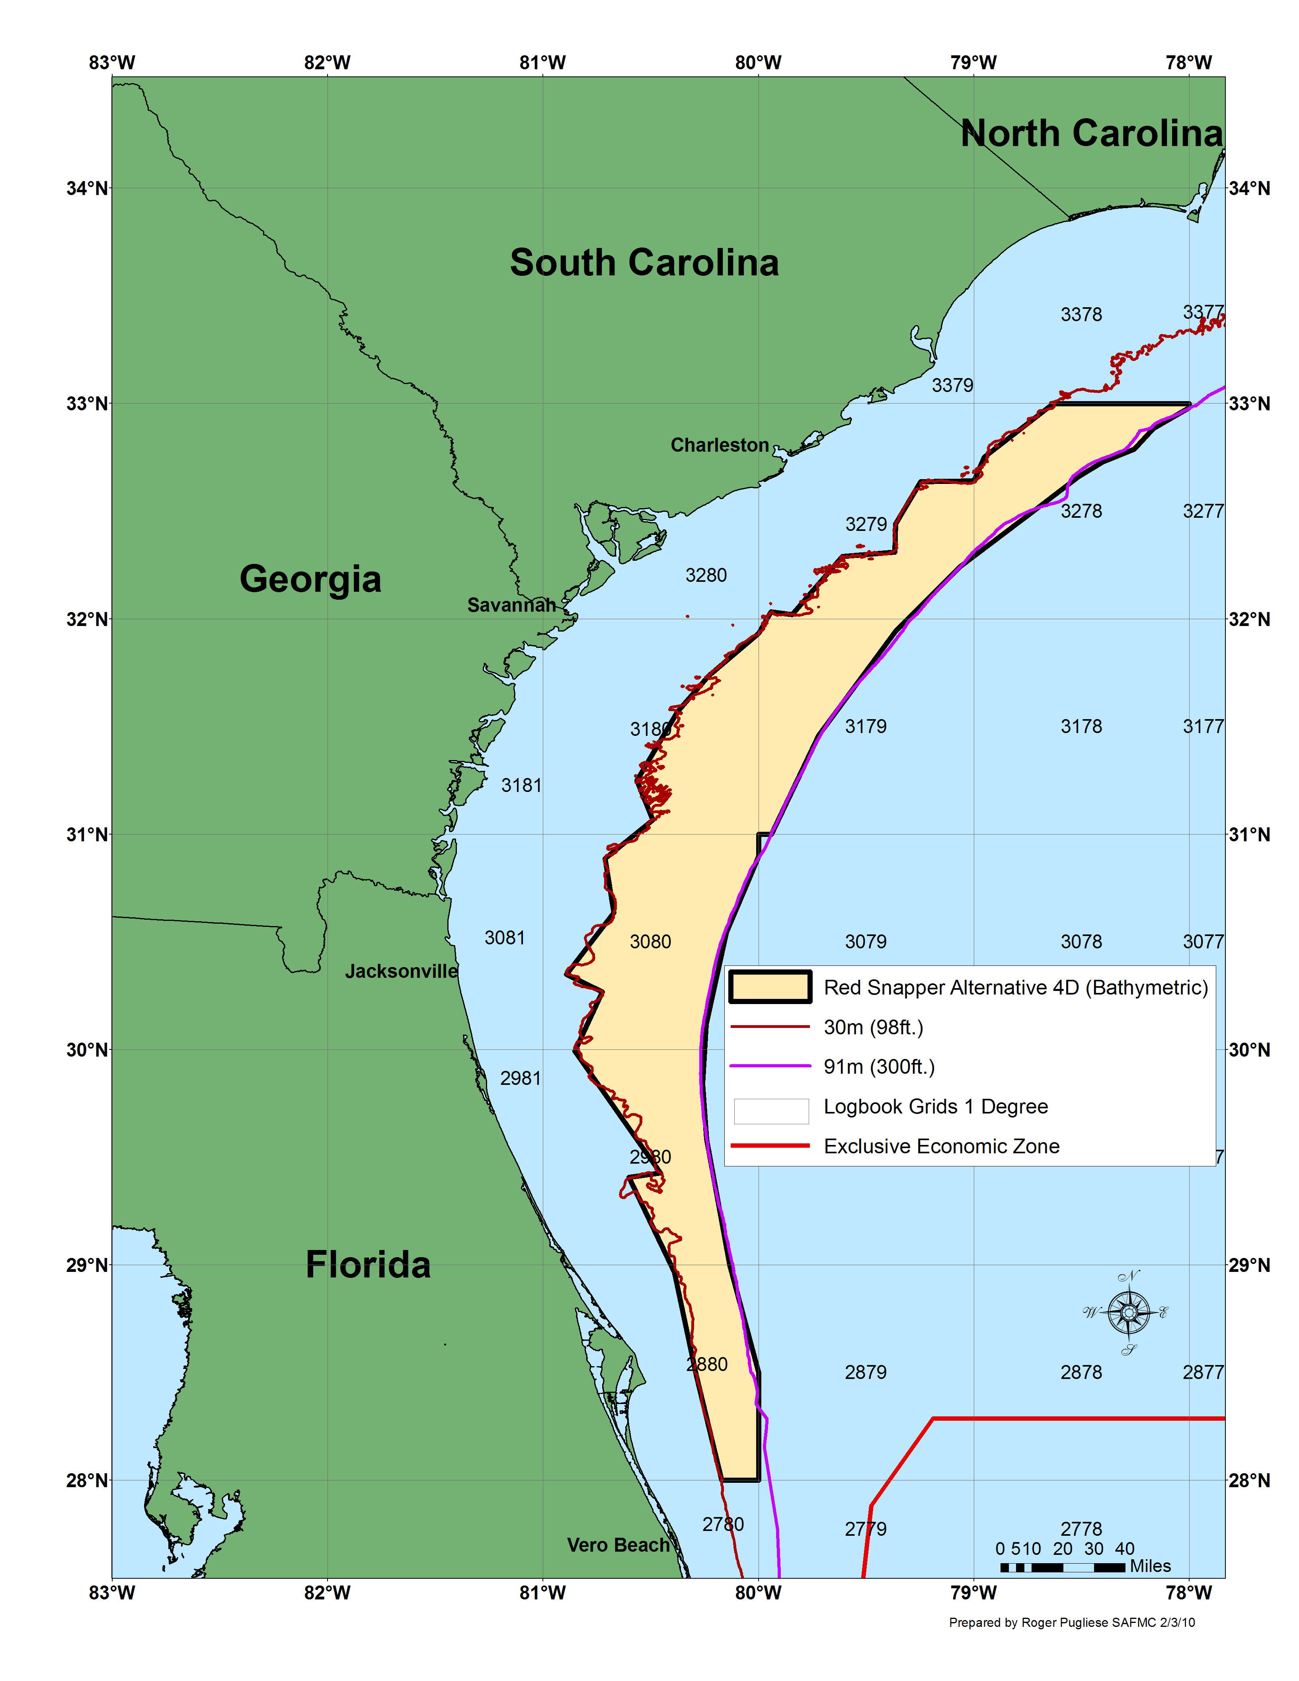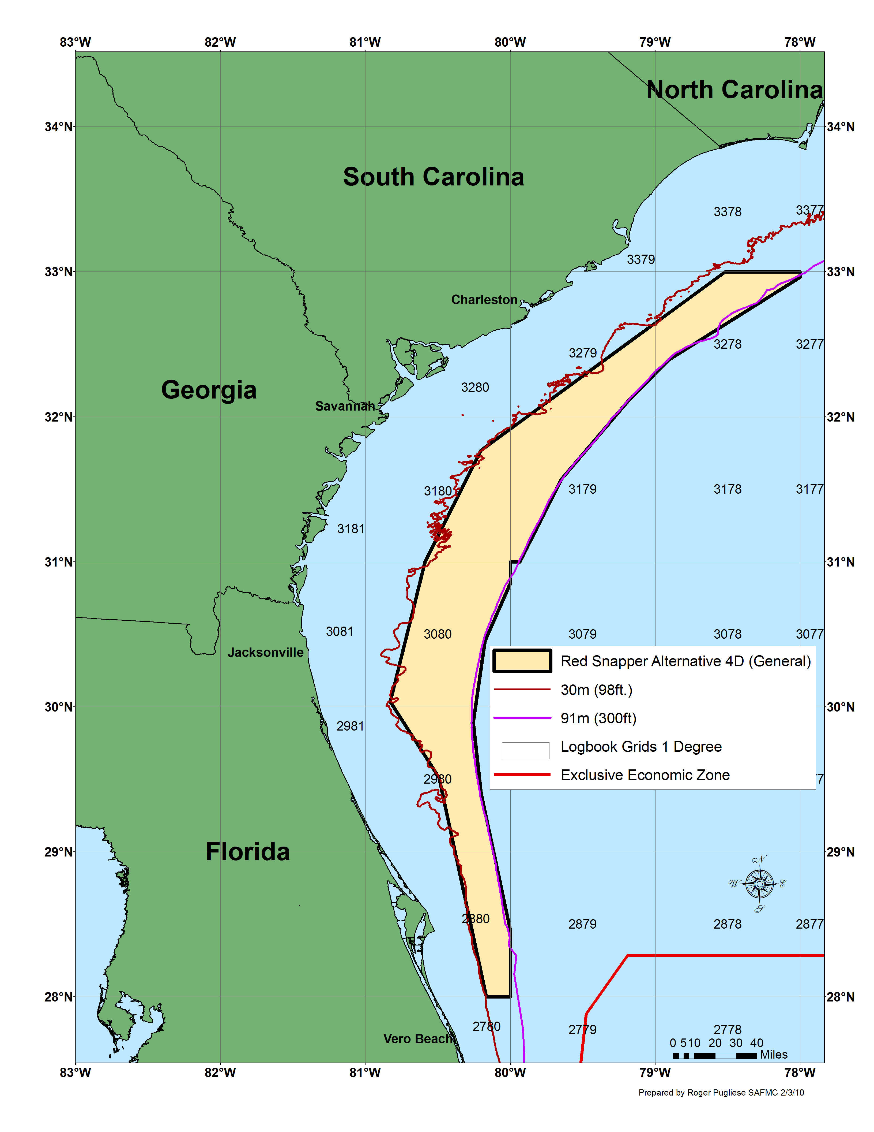
Figure 2-8. Map 1 of proposed closed area under Alternative 4D. Map 2 using generalized boundary for proposed closed area under Alternative 4D.
Table 2-14 Waypoints used to delineate Alternative 4D.
Map 1 waypoints used to delineate Alternative 4D.
ID | LAT_DMS | LON_DMS
1 | 28° 00' 00" | -80° 00' 00"
2 | 28° 00' 00" | -80° 10' 15"
3 | 28° 29' 17" | -80° 17' 23"
4 | 29° 00' 00" | -80° 23' 30"
5 | 29° 24' 25" | -80° 36' 07"
6 | 29° 25' 39" | -80° 27' 21"
7 | 29° 59' 30" | -80° 51' 10"
8 | 30° 16' 02" | -80° 43' 36"
9 | 30° 20' 58" | -80° 53' 34"
10 | 30° 38' 08" | -80° 40' 18"
11 | 30° 53' 12" | -80° 42' 45"
12 | 31° 04' 00" | -80° 29' 29"
13 | 31° 14' 57" | -80° 33' 55"
14 | 31° 34' 11" | -80° 22' 34"
15 | 31° 44' 07" | -80° 14' 00"
16 | 31° 56' 00" | -80° 00' 00"
17 | 32° 02' 00" | -79° 56' 31"
18 | 32° 01' 12" | -79° 50' 43"
19 | 32° 17' 21" | -79° 36' 42"
20 | 32° 18' 38" | -79° 22' 01"
21 | 32° 26' 25" | -79° 21' 53"
22 | 32° 38' 13" | -79° 14' 52"
23 | 32° 38' 24" | -79° 00' 00"
24 | 32° 45' 05" | -78° 57' 05"
25 | 33° 00' 00" | -78° 37' 53"
26 | 33° 00' 00" | -78° 00' 00"
27 | 32° 58' 50" | -78° 00' 00"
28 | 32° 53' 02" | -78° 10' 01"
29 | 32° 47' 21" | -78° 15' 20"
30 | 32° 43' 47" | -78° 24' 06"
31 | 32° 39' 37" | -78° 30' 52"
32 | 32° 30' 36" | -78° 42' 43"
33 | 32° 14' 24" | -79° 04' 07"
34 | 31° 56' 24" | -79° 22' 00"
35 | 31° 27' 36" | -79° 43' 17"
36 | 31° 00' 00" | -79° 56' 27"
37 | 31° 00' 00" | -80° 00' 00"
38 | 30° 53' 50" | -80° 00' 00"
39 | 30° 32' 40" | -80° 09' 00"
40 | 30° 07' 00" | -80° 14' 39"
41 | 29° 50' 25" | -80° 15' 39"
42 | 29° 35' 00" | -80° 14' 30"
43 | 29° 00' 00" | -80° 08' 04"
44 | 28° 30' 00" | -80° 00' 00"
Map 2 waypoints used to delineate the generalized boundary under Alternative 4D
ID | LAT_DMS | LON_DMS
1 | 28° 00' 00" | -80° 00' 00"
2 | 28° 00' 00" | -80° 09' 57"
3 | 29° 30' 40" | -80° 29' 34"
4 | 30° 02' 03" | -80° 49' 45"
5 | 31° 00' 00" | -80° 35' 19"
6 | 31° 46' 00" | -80° 12' 15"
7 | 33° 00' 00" | -78° 31' 05"
8 | 33° 00' 00" | -78° 00' 00"
9 | 32° 57' 44" | -78° 00' 00"
10 | 32° 23' 28" | -78° 54' 32"
11 | 32° 06' 03" | -79° 11' 41"
12 | 31° 34' 08" | -79° 38' 57"
13 | 31° 00' 00" | -79° 56' 05"
14 | 31° 00' 00" | -80° 00' 00"
15 | 30° 51' 13" | -80° 00' 00"
16 | 30° 27' 19" | -80° 10' 34"
17 | 29° 53' 31" | -80° 15' 25"
18 | 29° 24' 24" | -80° 12' 13"
19 | 28° 27' 20" | -80° 00' 00"

Alternative 5 (Preferred). Allow fishing for, harvest and possession of snapper grouper species (with exception of red snapper) in the closed area if fish were harvested with black sea bass pots with endorsements.

Alternative 6. Allow fishing for, harvest and possession of snapper grouper species (with exception of red snapper) with bottom longline gear in the closed area deeper than 50 fathoms as specified in CFR §622.35.

Alternative 7 (Preferred). Allow fishing for, harvest and possession of snapper grouper species (with the exception of red snapper) in the closed area if fish were harvested with spearfishing gear.

Alternative 8. Allow transit through areas closed to snapper grouper harvest.

Sub-alternative 8a (Preferred). The prohibition on possession does not apply to a person aboard a vessel that is in transit with snapper grouper species on board and with fishing gear appropriately stowed.

Vessels (both commercial and recreational) may transit through any snapper grouper closed area in the South Atlantic EEZ with snapper grouper species on board if prohibited fishing gear is appropriately stowed and not available for immediate use. The Council is considering alternatives that could allow fishing for snapper grouper species with spearfishing gear, black sea bass pots, and/or bottom longline within the proposed closed areas.

The term “transit” means: Direct, non-stop progression through any snapper grouper closed area in the South Atlantic EEZ on a constant heading, along a continuous straight line course, while making way by means of a source of power at all times.

The term “Gear appropriately stowed” includes but is not limited to: Terminal gear (i.e., hook, leader, sinker, flasher, or bait) used with an automatic reel, bandit gear, buoy gear, trolling gear, hand-line, or rod and reel must be disconnected and stowed separately from such fishing gear. Rod and reel must be removed from the rod holder and stowed securely on or below deck; longline gear may be left on the drum if all gangions and hooks are disconnected and stowed below deck, hooks cannot be baited, all buoys must be disconnected from the gear; however, buoys may remain on deck; trawl and try net gear may remain on deck, but trawl doors must be disconnected from such net and must be secured; gill nets, stab nets, or trammel nets must be left on the drum, any additional such nets not attached to the drum must be stowed below deck; and crustacean traps, or golden crab trap, cannot be baited, all buoys must be disconnected from the gear; however, buoys may remain on deck. Other methods of stowage authorized in writing by the Regional Administrator, and subsequently published in the Federal Register may also be utilized under this definition.

The term “Not available for immediate use” means: Gear that is shown to not have been in recent use and that is stowed in conformance with the definitions included under “gear appropriately stowed”.

Sub-alternative 8b. The prohibition on possession does not apply to a person aboard a vessel that has snapper grouper species onboard if the vessel is in transit.

Vessels (both commercial and recreational) may transit through any snapper grouper closed area in the South Atlantic EEZ with snapper grouper species.

The term “transit” means: Direct, non-stop progression through any snapper grouper closed area in the South Atlantic EEZ on a constant heading, along a continuous straight line course, while making way by means of a source of power at all times.

Sub-alternative 8c. The prohibition on possession does not apply to a person aboard a vessel that has wreckfish onboard if the vessel is in transit.

Vessels (both commercial and recreational) may transit through any snapper grouper closed area in the South Atlantic EEZ with snapper grouper species and/or wreckfish on board.

The term “transit” means: Direct, non-stop progression through any snapper grouper closed area in the South Atlantic EEZ on a constant heading, along a continuous straight line course, while making way by means of a source of power at all times.

Current Language in the Amendment for Council Conclusions:

The Council has concluded the closed area under Alternative 4D (Preferred), along with exemptions for fishing within the closed area using black sea bass pots, and spearfishing gear are likely to end overfishing of red snapper within the rebuilding period, and minimize to the extent practicable socioeconomic impacts. The Council and the SSC supported the selection of a closed area smaller than the total logbook grids under Alternatives 3A, and 4A, and they felt the closure under Alternative 4D (Preferred) would be adequate to end overfishing of red snapper while incurring the lowest possible level of economic impact. Because black sea bass pot gear is not likely to capture a significant number of red snapper the Council concluded the use of this gear type within the closed area could be permitted without negatively affecting the rebuilding process for red snapper. The Council reached the same conclusion regarding the use of spearfishing gear within the proposed closed area. Spearfishing gear is a highly selective gear type, and those using spearguns within the proposed closed area could easily targets species other than red snapper. Therefore, Alternatives 5 and 7 were also chosen as preferred alternatives.

Because the closed area extends over a large portion of the South Atlantic EEZ, the Council felt it was important to allow transit through the area with snapper grouper species onboard that were caught legally outside of the closed area. Allowing transit under very specific provisions included in Alternative 8A (Preferred) would mitigate any safety at sea issues that could arise in poor weather conditions without impacting the rebuilding efforts for red snapper.

Recommendations from APs and SSC:

Snapper Grouper AP Comments: Comments at end of document.

Law Enforcement Comments:

Motion 1: LE AP preference is for alternative 3 with straightened lines along the eastern and western edges and close gap between the Oculina HAPC and closure. Recommend the council consider the other closures in relation to these closures.

Substitute motion 2: adopt alternative 7c as the preferred transit alternative [deviate from 7c in that golden tilefish, black sea bass (caught with pots), and wreckfish are the only snapper grouper species allowed onboard during transit in the closed area]. Add language to the amendment concerning transit with snapper grouper fishing from Bahamian waters.

Motion 3: align the closure in 17b to match the eastern line in 17a according to the previous motion.

Motion 4: redefine transit provisions in the current deepwater MPAs to match the transit regulations in amendments 17a and 17b. Leap recommends no transit except with wreckfish.

Motion 5: specify an allowable golden tilefish fishing area.

Motion 6: in regard to amendment 17a, do not allow spearfishing for snapper grouper complex species in closed areas.

SSC Comments: The percent reductions are based on an area analysis which has not been thoroughly reviewed and assumes values for inputs that seem overly optimistic, unrealistic, or questionable. For example, the area analyses assume no effort shifting will occur with the effort currently occurring in the proposed closed areas. Another example includes the assumption that compliance will be 100% with the closed areas. An SSC subgroup worked with SERO staff and determined that when more realistic assumptions (e.g. 10% effort shift, 90% compliance and 40% release mortality for all sectors) are used, no area-based alternatives achieved the required decrease in catch in 2010, suggesting larger closed areas may be required.

The sum of all the optimistic assumptions being made suggest a high probability that none of the options in 17A will end overfishing, as defined in the SEDAR 15 stock with an Fmsy proxy of F40%. Additionally, the options only address ending overfishing in 2010, not out years.

Additional SSC comments concerning the economic and social analyses is at the end of the document.

Action 4. Require the use of circle hooks

There were no changes between the December 2009 briefing book version and the version that was filed with EPA/in the March 2010 briefing book in terms of the circle hook alternatives.

Alternative 1 (Status Quo). Do not require the use of circle hooks when using hook and line gear for snapper grouper species within any particular area of the South Atlantic EEZ when fishing for snapper grouper species.

Alternative 2 (Preferred). Require the use of non-off set, non-stainless steel circle hooks when fishing for snapper grouper species with hook and line gear north of 28 degrees. It is unlawful to possess snapper grouper species without possessing non-off set, non-stainless steel circle hooks. Apply to the use of natural baits only.

Alternative 3. Require the use of non-off set, non-stainless steel circle hooks when fishing for snapper grouper species with hook and line gear within the South Atlantic EEZ. It is unlawful to possess snapper grouper species without possessing non-off set, non-stainless steel circle hooks. Apply to the use of natural baits only.

Current Language in the Amendment for Council Conclusions:

The Council has chosen Alternative 2 as their preferred circle hook alternative. Alternative 2 (Preferred) would require the use of non-off set, non-stainless steel circle hooks when fishing for snapper grouper species with hook and line gear north of 28 degrees. It would also make it unlawful to possess snapper grouper species without possessing non-off set, non-stainless steel circle hooks. Few studies on the effects of using circle hooks with snapper grouper species have been completed, though some do support the use of circle hooks as means of decreasing bycatch mortality. One study found circle hooks significantly reduced gut hooking in all grouper species (gag, red grouper, and scamp) as well as smaller grunt and porgy species. Overall, circle hooks could reduce regulatory discards, thereby providing additional benefits to snapper grouper species including red snapper. Based on the little data that does exist, the Council felt taking advantage of any method to reduce red snapper bycatch mortality is warranted considering its overfished condition. The Council is also aware that use of circle hooks could substantially reduce harvest of some species, which would have positive biological benefits but have negative social and economic impacts on fishermen dependent upon the species. Most of the species that fishermen are concerned about not being able to catch with circle hooks occur south of 28 degrees latitude. Therefore, the Council felt it was important to limit the circle hook requirement to South Atlantic areas north of 28 degrees, and felt it could do so with little impact to red snapper rebuilding efforts.

(add fisheries that it could impact: yellowtail fishery, the mangrove fishery, the gray triggerfish fishery.)

Recommendations from APs and SSC:

Snapper Grouper AP: No comments.

Law Enforcement AP Comments: No comments.

SSC Comments: At their June 2008 meeting when discussing the circle hook action in Amendment 16, the SSC felt that there needed to be a better documentation of the effects. More specifically, the SSC wanted a discussion in the document concerning the exact percent reduction in mortality that might occur due to the implementation of the circle hooks.

PAGE 91: Move a substitute motion to move despite appreciate of the effort extended to address
bycatch reduction in Amendment 16, the committee determines that the justification for
measures as applied to the species addressed in Amendment 16 intended to reduce bycatch are
deficient and strongly urges that language be included to clearly document the effects of such
measures. Substitute motion carried on Page 91. The substitute motion carried as the main
motion on Page 91.

Action 5. Establish a Red Snapper Monitoring Program

The alternative language below was included in the version that was filed with EPA/in the March 2010 briefing book. Changes made to the December 2009 version are highlighted.

Alternative 1. (Status Quo) Utilize existing data collection programs to monitor the rebuilding progress of red snapper. Existing programs include the fishery dependent Marine Recreational Fisheries Statistical Survey (MRFSS) (replaced “Marine Recreational Information Program (MRIP))”, logbook, discard logbook, headboat logbook, Trip Interview Program (TIP), and dealer reported landings. Fishery independent methods include Marine Resources Monitoring Assessment and Prediction Program (MARMAP), and the Southeast Area Monitoring and Assessment Program (SEAMAP). Over the course of the next three years MARMAP will be looking for red snapper sampling sites along the north FL, and South GA coast.

Alternative 2 (Preferred). Establish fishery-independent monitoring program to track progress
of red snapper. Sampling would include deployment of chevron traps, cameras, and hook and
line at randomly selected stations.

Alternative 3. Establish a red snapper fishery-dependent monitoring program involving for-hire
vessels (charter boat and headboats). Participating vessels may be authorized to harvest and land
fish in excess of Federal possession limits and/or during fishery closures. Retention limits for
red snapper would be based upon research objectives. The trip limits and number of trips per
month will depend on the number of selected vessels, available quota, and objectives of the
research fishery (Table 4-22).

This table was in the December 2009 version but not the March 2010 one.

Table 2-12. Sub-Alternatives under consideration for the red snapper research fishery. Note, this table cannot be completed until the Council selects a preferred management alternative and the size of the proposed closed area is known.

 | Number of vessels to participate |  | Trip Limit (lbs whole weight) | Trips/month | Fishing Season
 | CB | HB
Alternative 3a
Alternative 3b
Alternative 3c

Current Language in the Amendment for Council Conclusions:

The Council has chosen Alternative 2 as their preferred red snapper monitoring alternative. Alternative 2 (Preferred) would establish an enhanced fishery-independent monitoring program to track progress of red snapper and other snapper grouper species. Sampling would likely include deployment of chevron traps, cameras, and hook and line at randomly selected stations but specifics of such a program are currently being developed by the SEFSC. This option would build upon the existing MARMAP sampling program, which already exists. The program would be expanded and sampling made more specific for monitoring red snapper and better monitoring of other snapper grouper species. The improved sampling plan would likely increase the (1) spatial footprint (central FL to Cape Hatteras, NC), (2) sample size, and (3) number of gear utilized over current survey levels, thereby considerably improving program effectiveness. The core aspects of the current sampling program (survey design, chevron trap, short bottom long-line and rod and reel sampling) would remain the core of the improved program, enabling comparisons of data collected in the improved program with those collected during previous years by MARMAP. The disadvantage to using a fishery-independent monitoring program alone is that there is a potential for fishermen to feel like they are being excluded from participating in data collection efforts. However, this amendment does not preclude the use of fishery-dependent data for monitoring red snapper in the future, as NOAA Fisheries Service and SEFSC are constantly working toward improved data gathering and methods of analysis. Additional fishery dependent data could be obtained by means of grant-funded research through the Cooperative Research Program. Fishermen, working with researchers, could obtain funding from NOAA Fisheries Service to obtain information on red snapper for studies on life history, release mortality, mapping locations of high abundance, etc.

Recommendations from APs and SSC:

Snapper Grouper AP Comments:

Include guideboats with charter and headboats for consideration in a research set-aside program.

MOTION 9: MOVE SAFMC DEVELOP A RESEARCH SET-ASIDE PROGRAM FOR MANAGEMENT AND DATA NEEDS OF THE SOUTH ATLANTIC SNAPPER GROUPER COMPLEX. THE PROGRAM SHOULD UTILIZE TO THE MAXIMUM EXTENT POSSIBLE THE VESSELS AND EXPERTISE OF INDIVIDUALS IN SOUTH ATLANTIC SNAPPER GROUPER COMPLEX FISHERY.
10 FOR
2 OPPOSED
1 ABSTAIN

MOTION 10: MOVE SAFMC AND NMFS AGGRESIVELY SUPPORT THE DATA RESEARCH NEEDS IDENTIFIED IN THE SEDAR REPORT FOR RED SNAPPER.
15 FOR
0 OPPOSED
0 ABSTAIN

MOTION 11: REQUEST NMFS HMS TO INVESTIGATE THE INTERACTION WITH SNAPPER GROUPER SPECIES WITHIN THE PROPOSED MANAGEMENT AREAS IN AMENDMENT 17A
7 FOR
1 OPPOSED
5 ABSTAIN

MOTION 12: MOVE SAFMC URGE NMFS TO DEVELOP CENSUS REPORTING DATA SYSTEMS FOR ALL COMMERCIAL AND FOR-HIRE PARTICIPANTS.
15 FOR
0 OPPOSED
0 ABSTAIN

MOTION 13: MOVE SAFMC URGE NMFS AND STATES TO IMPLEMENT REAL-TIME REPORTING SYSTEMS FOR ALL SECTORS TO TRACK LANDINGS AND DISCARDS FOR DAILY MONITORING AND QUOTA MANAGEMENT.
11 FOR
2 OPPOSED
1 ABSTAIN

MOTION 14: MOVE SAFMC REVIEW THE APPROPRIATENESS OF ALL SIZE LIMITS IN SNAPPER GROUPER COMPLEX.
15 FOR
0 OPPOSED
0 ABSTAIN

MOTION 17: IMPLEMENT A SALTWATER VESSEL PERMIT WITH A MONITORING SYSTEM
9 FOR
2 OPPOSED
2 ABSTAIN

Law Enforcement AP Comments: No comments.

SSC Comments:

Given the proposed regulations, there will be a lack of red snapper catch data for upcoming assessments. Thus, a monitoring program is necessary in order to assess red snapper in the future. The two options were (1) an expansion of the fishery-independent program (a combination of MARMAP and new sampling by the NOAA Beaufort lab) and (2) a headboat sampling program. Given issues with the headboat sampling program (mortality too high, change in behavior of fishers; see Attachment 25), Williams recommended the expanded fishery-independent sampling program. The SSC agreed with this conclusion.

AP Recommendations on closures.

MOTION 1: IN AMENDMENT 17A, RECOMMEND THAT THE COUNCIL ANALYZE THE FOLLOWING RECREATIONAL MANAGEMENT MEASURES OFF THE COAST OF GEORGIA:
--6 MONTH CLOSURE STARTING OCT 1
--BAG LIMIT TO 1, EXCLUDING CAPT AND CREW (KEEP 1ST FISH CAUGHT)
--NO MIN SIZE LIMIT
--MAX SIZE LIMIT 28”
--CLOSE 50% OF LIVE BOTTOM TO ALL SNAPPER GROUPER HARVEST WHERE RED SNAPPER ARE YEAR-ROUND (RECONSIDER CLOSURE FOLLOWING NEXT STOCK ASSESSMENT)
--ONE HOOK PER ROD AND REELS, MANUAL ROD AND REEL ONLY
12 FOR
0 OPPOSED
2 ABSTAIN

MOTION 2: 31 20 LATITUDE LINE TO BE THE NORTHERN END OF THE GA CLOSURE (NORTHERN SECTION OPEN TO FISHING).
9 FOR
0 OPPOSED
4 ABSTAIN

MOTION 3: COUNCIL EXPLORE METHODS TO PROTECT SPAWNING REEF FISH.
15 FOR
0 OPPOSED
0 ABSTAIN

MOTION 4: COUNCIL TO INVESTIGATE CLOSING AREAS WHERE FISH ARE KNOWN TO SPAWN
7 FOR
2 OPPOSED
5 ABSTAIN

MOTION 5: RECOMMEND THE COUNCIL INVESTIGATE METHODS TO REDUCE RECREATIONAL LIMITS THROUGH VESSEL LIMITS (1/PERSON OR 4/VESSELS WHICHEVER IS MORE RESTRICTIVE) WITH ADJUSTMENTS TO VESSEL LIMITS FOLLOWING THE NEXT ASSESSMENT. ALSO INVESTIGATE A REDUCTION IN RED SNAPPER MINIMUM SIZE TO 16”
8 FOR
4 OPPOSED
3 ABSTAIN

MOTION 6: PROHIBIT RED SNAPPER COMMERCIAL HARVEST UNTIL THE NEXT STOCK ASSESSMENT ALLOWS A HIGHER QUOTA.
15 FOR
0 OPPOSED
1 ABSTAIN

MOTION 8: MOVE SAFMC INVESTIGATE ALTERNATIVE EFFORT CONTROLS TO ACHIEVE MULTI-SPECIES MANAGEMENT OBJECTIVES. THE DAYS-AT-SEA CONCEPT INVOLVES CONTROLLING MULTISPECIES HARVEST PRESSURE (HOOKS IN THE WATER) BY TIME RATHER THAN CLOSURE OF AREAS.
11 FOR
2 OPPOSED
1 ABSTAIN

MOTION 15: FOR COMMERCIAL ONLY:
NO NEW CLOSED AREAS. COMMERCIAL ANNUAL CATCH TARGET = 40%(ANNUAL CATCH LIMIT)=40%(61,000 LBS WHOLE WEIGHT)=24,400 LBS WHOLE WEIGHT. IMPLEMENT THE FOLLOWING MONITORING DEVICES: VMS, REAL-TIME ELECTRONIC BYCATCH REPORTING, AND OBSERVERS. IF DISCARDS ARE GREATER THAN 24,400 LBS, PROHIBIT THE USE OF HOOK AND LINE GEAR FOR FISHING FOR MID-SHELF SPECIES. SPEARFISHING AND BLACK SEA BASS POTS WOULD BE ALLOWED. IF BYCATCH REPORTING IS VIOLATED, LOSE PERMIT. ALSO PLACE A SMALLER CLOSURE IF RED SNAPPER ACL IS MET BUT INCLUDE A QUOTA BUFFER FROM THE 24,400 LBS TO ACCOUNT FOR THE RED SNAPPER MORTALITY (I.E SOUTHERN FL AND 32 NORTH 80 WEST).
11 FOR
1 OPPOSED
2 ABSTAIN

MOTION 16: AFTER THE RED SNAPPER COMMERCIAL ACL IS MET, ALLOW HARVEST WITH SPEARFISHING GEAR IN SOUTH ATLANTIC EEZ EXCLUDING ANY CLOSED AREAS
7 FOR
5 OPPOSED
1 ABSTAIN

RECOMMENDATIONS (The following items are recommendations to the Council.)

Ideas to limit mortality of red snapper
(a) VMS (all vessels that harvest snapper grouper species in the EEZ)
(b) Consider recommendations from LAPP Workgroup
(c) Smaller closures closed to all fishing and target closures to spawning locations
(d) Closures that change throughout the year and location changes

(e)
- Close 50% of live bottom off GA coast
- 6 month closure (Nov 1 through March 31) for for-hire and pr. rec
- Bag limit to 1/person excluding captain and crew
- Eliminate 20” size limit
- Maximum of 28” size limit for red snapper
- Restrict to 1 hook per angler for hook and line fishing
- Prohibit use of electric reel for recreational fishermen
- Create mid-shelf spawning area with no fishing allowed
- Artificial reef placement

(f) Implement days-at-sea restrictions, close spawning locations

(g) No sale of red snapper (partial support of Snapper Grouper Advisory Panel)

(h) No size limit option

(i) Recommendation: The AP requests that the Council consider roll-overs of underages and paybacks of overages for non-overfished species.

(j) Include guideboats with charter and headboats for consideration in a research set-aside program.

(k) Establish an ad-hoc group to discuss recreational monitoring, data collection

(l) For Florida red snapper regulations:
1/person
4/vessel
excluding capt/crew
keep size limit
closure areas to protect spawning areas
one hook per rod and reels, manual rod and reel only

2. Comments on Economic Analysis

Commercial Sector

•
The economic effects of the alternatives are based on changes in net operating revenue at the trip level for the commercial sector and are an average for one year based on data from 2005-8. This methodology is consistent with what has been presented in the past for previous amendments.

•
The net operating revenue was calculated as the sum of gross revenues of all species, of which red snapper is a minor component overall, less variable operating costs (including the opportunity cost of labor). Any differences between alternatives regarding changes in targeting behavior or employment alternatives (e.g., due to regional differences) would affect the relative estimates of economic effects, which are not captured. These assumptions were adequately summarized in the ‘area closure’ document with respect to the ‘Economic Trip Reduction Model’ for the commercial sector.

•
The estimates will be too high to the extent that net operating revenue at the trip level can be maintained by changing fishing targeting behavior, however, any substitution will not fully compensate – if at all – for losses given the alternatives are sub-optimal and regulations on some of the other species have become more restrictive. This discussion was also addressed in the ‘area closure’ document but bears repeating.

•
Changes in net operating revenue at the trip level are not reflective of the sustainability of the fishery at the vessel or fleet level. Most notable are the need to cover fixed costs. This caveat was mentioned in the ‘area closure’ document. In addition, the uncertainty of the industry would also justify the need to cover a higher rate of return. Inclusion of these additional costs would cause the number of trips considered to be ‘taken’ to fall. The implication of this on the estimates should be addressed to the extent that they would differ across alternatives.

•
Since the estimates are for a single year only, they are most reflective of immediate (short run) impacts. The analysis does not support generic statements about long-run impacts. Any differences between alternatives regarding the rebuilding rate or time horizon would affect the relative estimates of economic effects. The simulation of net benefits over time would be warranted to the extent that long-run economic benefits can affect the choice between alternatives (despite the need to use the short run estimates). Examples of general discussions that relate to the long run implications but are not based on the analysis include:

A riskier biological alternative is considered to have higher negative long-run economic impacts because future regulatory measures may be “more drastic” (p. 8). This would likely only be true under very restrictive assumptions, including a zero percent discount rate.

The statements that shorter rebuilding horizons produce greater positive long-term economic effects (p. 16) should be referenced and counterbalanced with studies that show the opposite. The former are based on the annual net operating revenues associated with the TACs/quotas assuming harvesting costs (i.e., industry structure) are unchanged, the latter are based on a suite of factors including bioeconomic models that incorporate fleet dynamics, market effects, community effects and the benefits of “sentinel fisheries” for providing data needed for assessments. The result is an empirical issue, not generic.

Non-use values (e.g., existence) are mentioned with respect to providing higher values from faster rebuilding horizons. The literature that supports positive non-use values for these species and, in particular, higher values from faster rebuilding, need to be included to justify these statements.

While there are differences in the literature with respect to how the rate and duration of rebuilding affect net benefits of the fishery, the literature is consistent on the need for management to address any issues of overcapacity – at the beginning of a rebuilding plan - that will undermine any attempts to increase stock size overtime. Maintaining the same regulatory environment can compromise the rebuilding plan and undermine the potential economic benefits of having a larger stock size.

Recreational Sector
The economic analysis likely overestimates the effects (i.e., costs) of Amendment 17A as a result of two assumptions. First, the analysis uses an economic value per target trip that is actually the value of a one fish harvest per trip. The implicit assumption is that each target trip results in the harvest of one fish. If each target trip results in less than a one fish harvest then the economic effects are overestimated. Less likely, if each target trip results in more than a one fish harvest then the economic effects are underestimated.
Second, the analysis assumes that anglers cancel trips if the target species is unavailable. Since anglers may target other species on a trip instead of cancelling the trip then this assumption increases estimates of economic effects.
There are three alternative analyses that could be pursued.

1.
The analysis could value the loss of recreational harvest by attaching the economic value of one fish harvest to proposed reductions in harvest. The value of a one fish harvest should be obtained from a behavioral model that incorporates species-substitution opportunities.

2.
The analysis could value the loss of target trips by attaching economic values of lost trip taking opportunities to the lost trips. The value of lost trip taking opportunities should be obtained from a behavioral model that incorporates substitution opportunities.

3.
The analysis could conduct sensitivity analysis around the assumptions that likely result in overestimates of economic effects. For example, considering the second point above, an analysis that cancels 75%, 50% and 25%, in addition to 100% of target trips would highlight the sensitivity of results to the assumption.

We recommend pursuing alternative 3 above.
More accurate estimates and/or sensitivity analyses should appear in tables, rather than being solely mentioned in the text.

