Decision Document

Coastal Migratory Pelagics
Joint Amendment 30
(Atlantic Cobia Recreational Fishing Year)

South Atlantic Mackerel Cobia Committee
December 2016

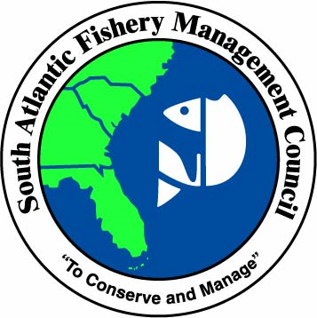

November 14, 2016

ACTION FOR AMENDMENT 30
- Change the recreational fishing year for Atlantic cobia

BACKGROUND
In 2015, recreational landings for Atlantic migratory group (Georgia to New York) cobia (Atlantic cobia) exceeded the 2015 recreational ACL of 630,000 pounds whole weight (ww), and the 2015 stock ACL (commercial and recreational ACLs combined) of 690,000 lbs ww. The current AM for Atlantic cobia requires that if total landings exceed the stock ACL, NMFS must file a notice to reduce the length of the following recreational season by the amount necessary to ensure recreational landings may achieve the recreational annual catch target, but do not exceed the recreational ACL.

On March 10, 2016, NMFS announced that the 2016 recreational season for Atlantic cobia in federal waters would close on June 20, 2016 (81 FR 12601). Because the closure occurred at the time of year when recreational fishing for cobia is typically the highest, the early closure is expected to have had negative social and economic impacts on recreational anglers, for-hire businesses, for-hire clients, and associated support businesses, such as tackle shops. Public comment indicates that the June 20 closure negatively affected many recreational fishermen and businesses in North Carolina and Virginia, even though preliminary 2016 MRIP estimates indicate that landings continued to be high in these states after the federal closure. (see Table 1) Although Virginia and North Carolina did not adopt compatible regulations after the federal closure was announced, and harvest in Virginia and North Carolina state waters remained open after June 20, 2016, the more restrictive management measures implemented for Virginia and North Carolina state waters also affected recreational fishermen and businesses in those areas, as described in further detail in Chapter 4. The negative effects of the federal closure would likely be greatest for recreational fishermen and businesses in North Carolina and Virginia as landings are highest in these states (Table 1) and recreational landings are generally higher in the later months of the summer in North Carolina and Virginia (Figure 1).

Table 1. Recreational landings (lbs ww) of Atlantic cobia from 2005-2015, and 2016 preliminary landings. Data sources: MRIP and SEFSC
Year | VA Landings | NC Landings | SC Landings | GA Landings | TOTAL ATLANTIC
2005 | 577,284 | 322,272 | 5,793 | 3,358 | 908,707
2006 | 733,740 | 104,259 | 101,018 | 4,824 | 943,841
2007 | 322,887 | 90,197 | 268,677 | 64,708 | 746,469
2008 | 167,949 | 66,258 | 50,108 | 257,690 | 542,006
2009 | 552,995 | 123,061 | 76,229 | 3,997 | 756,282
2010 | 232,987 | 561,486 | 65,688 | 79,855 | 940,015
2011 | 136,859 | 121,689 | 3,565 | 90,375 | 352,488
2012 | 36,409 | 68,657 | 224,365 | 105,193 | 434,623
2013 | 354,463 | 492,969 | 19,130 | 29,224 | 895,786
2014 | 214,427 | 277,489 | 31,927 | 20,642 | 544,485
2015 | 718,647 | 630,373 | 123,952 | 67,804 | 1,565,186
2016* | 919,992 | 285,352 | 77,744 | 0 | 1,283,088
*2016 data shown in the table include Waves 1-4 and were retrieved from the MRIP Database. The 2016 data are preliminary.

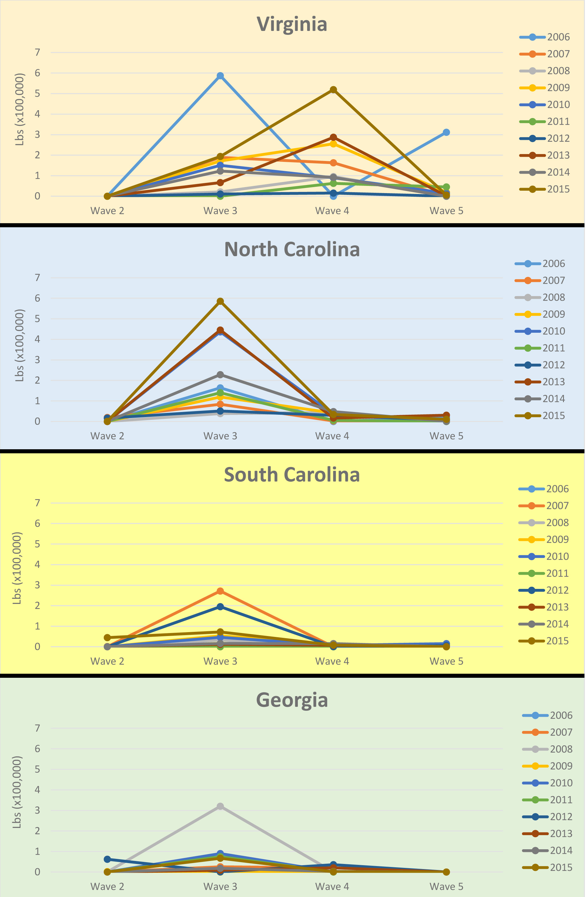
Figure 1. Recreational catch of Atlantic cobia (lbs ww) by wave from 2006-2015 for Waves 2-5. Data sources: SERO and MRIP database. The MRIP-estimated recreational landings of Atlantic cobia in states north of Virginia from 2006-2015 are minimal. MRIP estimates for 2016 (preliminary) show landings from Maryland.

In combination with the proposed changes to slow the rate of recreational harvest in Framework Amendment 4, the objective of the proposed measure is to ensure that in the event of a future ACL overage and implementation of associated AM(s), the recreational fishing season would be open long into the fishing year and at the time of year when cobia fishing is most popular (May through September) to allow for recreational fishermen in all states to have the opportunity to catch cobia.

EXPECTED TIMELINE FOR AMENDMENT 30
- August 2016- public hearings (as part of Framework Amendment 4)
- September 2016- South Atlantic Council moves the action to Amendment 30 and selects a preferred alternative
- October 2016- public comment period and webinar hearing
- October 2016- Gulf Council reviews amendment, selects preferred alternative and approves for formal review
- December 2016 - South Atlantic Council reviews public input and approves for formal review
- December 2016 - Finalize amendment and submit for Secretarial review

DRAFT PURPOSE AND NEED
Purpose for Action
The purpose of this amendment is to modify the recreational and commercial fishing year for Atlantic migratory group cobia to ensure consistent, stable, and equitable fishing opportunities for recreational participants in the Atlantic cobia component of the coastal migratory pelagics fishery.

Need for Action
The need for this amendment is to respond to changing fishery characteristics for Atlantic cobia, while increasing social and economic benefits of the coastal migratory pelagics fishery through sustainable recreational fishing opportunities and harvest of Atlantic cobia.

COMMITTEE ACTION
1) Review, edit and approve the purpose and need.
Add commercial?

Action: Modify the recreational fishing year for Atlantic cobia

Alternative 1 (No Action). Do not modify the current recreational fishing year of January 1 through December 31.

Preferred Alternative 2. Modify the recreational fishing year for Atlantic cobia to be May 1 through April 30.

Alternative 3. Modify the recreational fishing year for Atlantic cobia to be June 1 through May 31.

Alternative 4. Modify the recreational fishing year for Atlantic cobia to be April 1 through March 31.

----
The proposed harvest limits in Framework Amendment 4 and the change in the fishing year in Amendment 30 are expected to affect the rate of harvest and when recreational landings reach the recreational ACL, and increase the likelihood that recreational harvest will be open during the time of year when cobia fishing is most popular (May through September, see Figure 2). The alternatives in this action are analyzed with the Framework Amendment 4 proposed harvest limits (Tables 2 and 3). These estimated dates that the recreational ACL would be met assume that regulations are consistent in state and federal waters. The estimates would likely vary each year depending on a number of factors that could affect the level of recreational effort and catch. Additional information about the analyses is included in Appendix H of CMP Amendment 20 (Attachment 4a).

Figure 2. Atlantic recreational landings for January-October of 2013, 2014, 2015, average 2013-2015 landings, and average 2014-2015 landings by two-month wave. Source: SEFSC Recreational ACL Dataset

These estimates assume that the accountability measures (AM) were not triggered in the previous year and that the fishing season has not been shortened due to the AM for a reduced season length. Specifically, the estimated dates in Tables 2 and 3 are provided to show how the fishing years in Alternatives 1-4 would each interact with the proposed harvest limits, and how the alternatives compare to each other. Because there is no in-season AM to close harvest when the recreational ACL is met or projected to be met, any specification of the length of a fishing season would depend on the previous year’s landings and if the AM to reduce the season length was applied.

Table 2 includes estimated dates when the recreational landings would reach the recreational ACL under each alternative using landings data from 2013-2015. This period of time includes the 2015 landings, which were much higher than any other year from 2005-2015. The results of the analysis in Table 2 indicate how the proposed harvest limits would interact with the fishing years under the alternatives during years with high recreational effort and landings of Atlantic cobia.
Table 2. Estimated dates when Atlantic cobia recreational landings would meet the recreational ACL under the proposed bag limit, vessel limit and minimum size limit in Framework Amendment 4, for each alternative. This analysis includes landings data from 2013-2015.
Fishing Year | 1/person and  36” FL minimum size | 6/vessel and  36” FL minimum size
Alternative 1 (No Action)  Jan 1 – Dec 31 | July 15 | July 17
Preferred Alternative 2  May 1 - Apr 30 | July 18 | July 19
Alternative 3  June 1 - May 31 | May 5 | May 25
Alternative 4  Apr 1 – Mar 31 | July 16 | July 18

Table 3 includes estimated dates when the recreational landings would reach the recreational ACL under each alternative using landings data from 2005-2014. Landings in this period varied from 352,488 pounds (lbs) to 943,841 lbs, with an average of 706,470 lbs (see Table 1). Even the highest landings between 2005 through 2014 (941,841 lbs) are much lower than the recreational landings in 2015 (1,540,776 lbs). Input during the public hearings for Framework Amendment 4 suggested that the 2015 landings were so much higher than landings in 2005 through 2014, that the 2015 landings should be considered an outlier and that the 2005-2014 period more adequately captured the dynamics of the cobia portion of the coastal migratory pelagics (CMP) fishery. In response to this input, the Council requested that analysis using data from 2005-2014 be incorporated into the amendment. Table 3 provides estimates on how the fishing year in each action would interact with the proposed harvest limits from Framework Amendment 4 in years with landings closer to the average landings of 2005-2014.

Table 3. Estimated range of dates when Atlantic cobia recreational landings would meet the recreational ACL under the proposed bag limit, vessel limit and minimum size limit in Framework Amendment 4, for each alternative. This analysis includes landings data from 2005-2014.
Fishing Year | 1/person and  36” FL minimum size | 6/vessel and  36” FL minimum size
Alternative 1 (No Action)  Jan 1 – Dec 31 | Oct 23 | Oct 11
Preferred Alternative 2  May 1 - Apr 30 | March 21 | Oct 31
Alternative 3  June 1 - May 31 | May 31 | May 29
Alternative 4  Apr 1 – Mar 31 | Feb 12 | Oct 25

PUBLIC INPUT
Comment summary from August 2016 hearings on the recreational fishing year
There were only a few people who commented on this action. One individual supported No action, and one person supported Alternative 3 (June 1- May 31). Several commenters did state that it is important that the recreational fishery for Atlantic cobia is open for the month of May, for a season of May through September or October.

Comment summary from October 2016 webinar hearing and comment period
- One commenter supported a season from May 1 through September 15, with the fishery closed the rest of the year.
- One commenter supported a closure in June and July for all state and federal waters.
- Three commenters supported Preferred Alternative 2 (May 1 opening), although one commenter felt that the effects analysis indicated that Alternative 3 (June 1 opening) would be the better choice because landings would reach the ACL further into the fishing year.
- One commenter supported Alternative 3 (June 1) as the best alternative for Virginia fishermen, but felt that state quotas would reduce negative impacts on other states.

COMMITTEE ACTION
1) Do you want to change the preferred alternative?

NOTE: The Committee needs to discuss how application of the recreational AM will apply with implementation of a new start date for the recreational fishing year.
- How would a closure date (if needed) be calculated if the new fishing year is implemented mid-2017?
- Retroactive to the start of that fishing year (e.g., SA yellowtail).

Draft motion to approve for formal review:
Approve Coastal Migratory Pelagics Amendment 30 as modified for Secretarial review, and deem the codified text as necessary and appropriate. Give staff editorial license to make any necessary editorial changes to the document/codified text and give the Council Chair authority to approve the revisions and re-deem the codified text.

NOTE: Including staff edits to address comments from SEFSC, GC and IPT.

