Decision Document

Coastal Migratory Pelagics
Joint Amendment 29
(Allocation Sharing and Accountability Measures for Gulf King Mackerel)

South Atlantic Mackerel Cobia Committee
December 2016

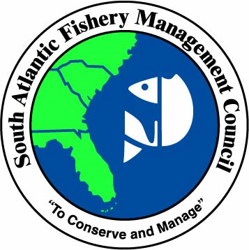

November 14, 2016

ACTIONS FOR AMENDMENT 29
- Gulf Migratory Group King Mackerel Allocation Sharing
- includes options for each sector’s access to the Gulf king mackerel ACL
- Adjust the Recreational Accountability Measure (AM) for Gulf Migratory Group King Mackerel
- post-season accountability measures

BACKGROUND
The Councils are considering a quota sharing system for Gulf king mackerel to allow recreational and commercial allocations to be adjusted each year, if specified conditions are met. Over the past decade, the commercial sector has regularly met or exceeded the commercial ACL while the recreational sector has landed low proportions of the recreational ACL. The Councils did not make any changes to the sector allocations for Gulf king mackerel in CMP Amendment 26; however, they did direct staff to begin an amendment to examine how to utilize underages of Gulf king mackerel ACL, along with any necessary changes to recreational accountability measures (AMs).

TENTATIVE TIMELINE FOR AMENDMENT 29
- Jan/April 2015- scoping (as a part of Amendment 26)
- August 2016- Gulf Council reviews options paper and provide direction to staff
- September 2016- South Atlantic Council reviews the amendment
- October 2016- Gulf Council reviews public input, selects preferred alternatives, and approves for public hearings
- November/December 2016- Gulf public hearings
- December 2016 - South Atlantic Council reviews public input, selects preferred alternatives, and approves for formal review
- January/February 2017- Gulf Council reviews public input, selects preferred alternatives, and approves for formal review
- February 2017- Finalize amendment and submit for Secretarial review
- March 2017 - South Atlantic Council reviews public input, selects preferred alternatives, and approves for formal review
- April 2017- Finalize amendment and submit for Secretarial review

Current king mackerel zones
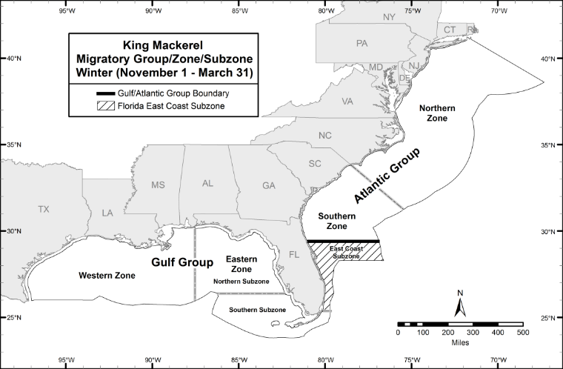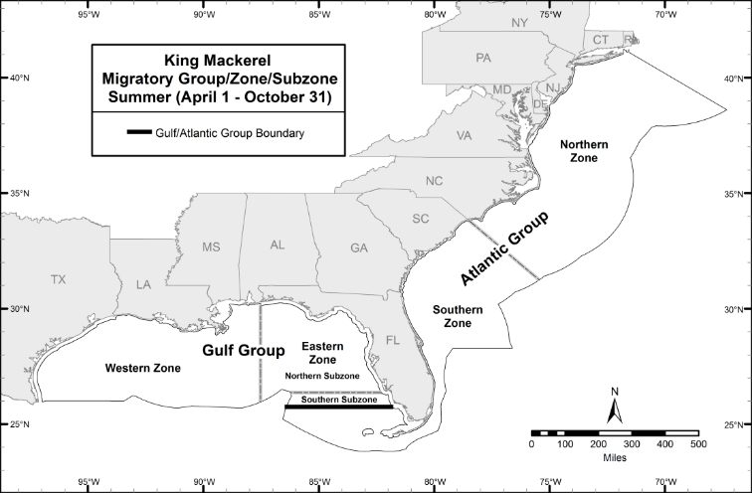
B
A
A
Figure 1. Gulf and Atlantic king mackerel zones for A) November 1 – March 31, and B) April 1 – October 31.

Proposed king mackerel zones
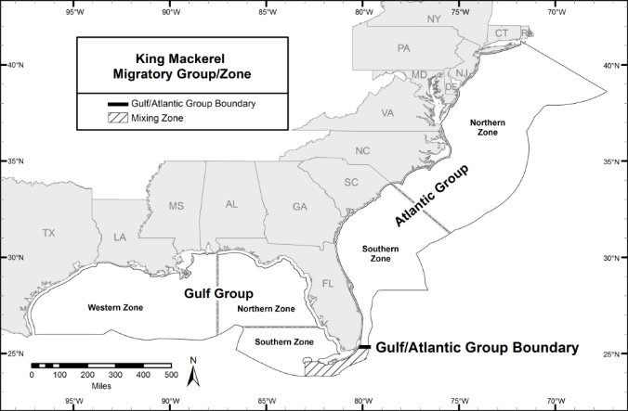
Figure 2. Boundary between Atlantic and Gulf migratory groups of king mackerel, as proposed by SEDAR 38 (2014) and Amendment 26 to the CMP FMP (GMFMC and SAFMC 2016).

PURPOSE AND NEED
(Approved by the South Atlantic in September 2016)
Purpose for Action
The purpose of this amendment is to consider changes to the recreational and commercial allocations for Gulf migratory group king mackerel and the recreational accountability measure.

Need for Action
The need for this amendment is to achieve optimum yield while ensuring overfishing does not occur in the coastal migratory pelagics (CMP) fishery, thereby increasing social and economic benefits of the CMP fishery through sustainable and valuable harvest of king mackerel.

Most recent Gulf Purpose statement, to be approved by South Atlantic:
The purpose of this amendment is to consider temporary modifications to the recreational and commercial allocations for Gulf migratory group king mackerel and changes to the recreational accountability measure.

COMMITTEE ACTION
1) Review, edit and approve the purpose statement.

Action 1 – Gulf Migratory Group King Mackerel Quota Sharing

Alternative 1: No Action – Do not establish a quota sharing system. Maintain the current recreational and commercial allocations for Gulf of Mexico migratory group king mackerel (68% recreational, 32% commercial).

Gulf Preferred Alternative 2: Conditionally transfer a certain percentage (Options 2a-2d) of the allocation to the commercial sector in the next fishing year, if the minimum recreational landings threshold is not met (Options 2e-2g). If the commercial sector does not land at least 90% of its annual catch limit (ACL), this transfer will not occur. Landings data from two years prior will be used to determine allocation transfers.
Conditional Quota Transfer (MUST CHOOSE ONE):
Option 2a: Conditionally transfer 5% from the stock allocation to the commercial allocation.
Gulf Preferred Option 2b: Conditionally transfer 10% from the stock allocation to the commercial allocation.
Option 2c: Conditionally transfer 15% from the stock allocation to the commercial allocation.
Option 2d: Conditionally transfer 20% from the stock allocation to the commercial allocation.

Recreational ACL Minimum Threshold (MUST CHOOSE ONE), if the recreational sector landings are:
Option 2e: less than 50% of the recreational ACL.
Option 2f: less than 65% of the recreational ACL.
Gulf Preferred Option 2g: less than 75% of the recreational ACL.

[Highlighted text shows changes made by the Gulf, which need to be approved by the South Atlantic.]
Alternative 3: If the stock ACL is not harvested in a fishing year, the [Gulf Council’s] Scientific and Statistical Committee (SSC) will be convened to consider increasing the acceptable biological catch (ABC) for the following fishing year only. If the SSC recommends increasing the ABC, the amount of the increase (in pounds) would be added to the ACL of the sector which harvested its ACL (within 10%) in the previous fishing year would be added to the ACL of the sector which landed at least 90% of its ACL in the previous fishing year. Consideration of an ABC adjustment by the SSC would only be requested if a minimum percentage of the stock ACL was not harvested in a given fishing season The SSC would convene to consider an adjustment in the ABC only if a minimum percentage of the stock ACL was not harvested in a given fishing season (Options 3a-3c). If one of Options 3a, 3b, or 3c is not chosen as preferred, and the stock ACL has not been landed, then the SSC will consider raising the ABC in any year when the stock ACL is not harvested:
Remaining Stock ACL Threshold (CHOOSE ONE):
Option 3a: At least 15% of the stock ACL remains unharvested.
Option 3b: At least 20% of the stock ACL remains unharvested.
Option 3c: At least 25% of the stock ACL remains unharvested.

Note: The recreational fishing year is January – December and the commercial fishing year for most zone quotas is July – June, with the exception of the Gulf Northern Zone. Any quota transfer will be based on recreational landings through December of the previous year, and applied to the commercial allocation for that year’s fishing season. This will allow time to receive MRIP and other recreational landings before the start of the commercial season.

COMMITTEE ACTION
1) Review and approve the Gulf edits to Alternative 3.

2) Do you want to select preferred alternative(s) and option(s)?

Gulf AP recommendation (November 2016): Alternative 1 (No Action)

Public comments: Some support for Preferred alternatives, but some support for no action from recreational groups.

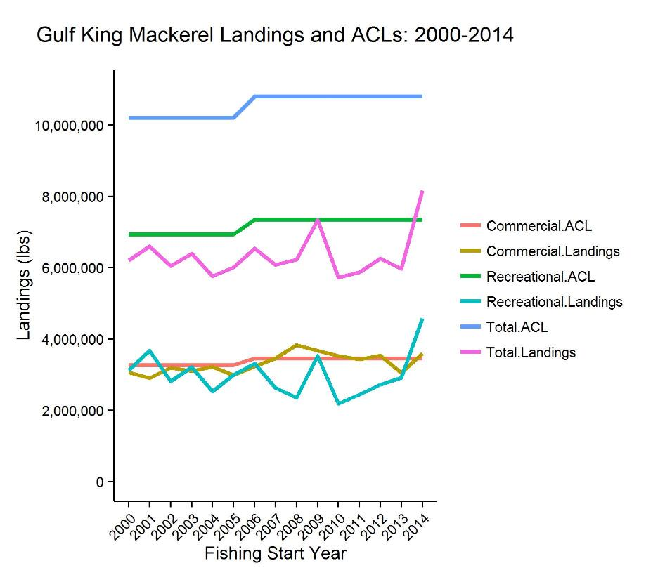
Figure 2. Trends in Gulf king mackerel landings by sector for the 2000/01 through the 2014/15 fishing seasons. Landings are in pounds.

Table 1. Resultant allocations based on options presented in Gulf Preferred Alternative 2 of Action 1.
Gulf Preferred Alternative 2 | Commercial Allocation | Recreational Allocation
Option 2a | 37% | 63%
Gulf Preferred Option 2b | 42% | 58%
Option 2c | 47% | 53%
Option 2d | 52% | 48%

An example for Gulf Preferred Alternative 2:
- Assume Gulf Preferred Options 2b (10% will be transferred) and 2g (rec landings have to be <75% of the rec ACL)
- Example: in the 2018/19 fishing year, stock ACL= 10 mp (3.2 mp commercial (32%) and 6.8 mp rec (68%)).
- Commercial sector landed full commercial ACL
- Rec sector landed 3mp, or 44.1% of the rec ACL
- In the 2019/20 fishing year, the rec landings are projected to be <75% of the rec ACL.
- In the 2020/21 fishing year, 10% of the stock ACL would be transferred to the commercial ACL for 2020/21 only.
- The 2020/21 allocations would be 42% commercial and 58% recreational.
- In 2021/22, the commercial allocation would return to 32% unless the allocation sharing was triggered again.

Note: Because of the delay between a year with a recreational underage and the year when the quota transfer could occur, recreational landings in the intervening year (2019/2020 in the example above) could rapidly increase. If the recreation landings increased to where the sector was exceeding its minimum landings threshold (Options 2e – 2g), it would be inappropriate to shift quota away from that sector in the following year. For that reason, if recreational landings are projected to meet or exceed the recreational ACL threshold in the intervening fishing year, the next quota transfer would be cancelled.

An example for Alternative 3:
- Assume that 2018/19 fishing year, stock ACL = 10 mp (3.2 mp comm and 6.8 mp rec)
- In 2018/19, commercial sector lands the full commercial ACL but recreational does not.
- Assume the unharvested stock ACL is 2 mp (20% underage).
- Under Option 3a (≤15% unharvested) or 3b (≤20% unharvested), the Gulf SSC would consider increasing the ABC for 2019/20 only. Option 3c requires at least 25% unharvested.
- Assume the SSC recommends an increase in the ABC of 500,000 lbs.
- The 2019/20 ABC would be 10.5 mp (commercial 3.7 mp and recreational 6.8 mp)
- In 2020/21, the ABC, stock ACL, and sector allocations would return to 10 mp (3.2 comm and 6.8 mp rec), unless the 2019/20 fishing year triggered another review by SSC.

Note: The post-season AM for the Gulf king mackerel gillnet sector includes a payback of any overage in the following fishing year. If there was an increase in the commercial ACL, an increase to that year’s gillnet quota would only be applied after any necessary payback was applied.

Action 2 – Adjust the Recreational Accountability Measure for Gulf Migratory Group King Mackerel

Alternative 1: No Action – Retain the in-season recreational accountability measure (AM). If recreational landings reach or are projected to reach the recreational ACL, the bag limit will be reduced to zero for the remainder of the fishing year.

Alternative 2: Replace the current in-season AM with a post-season AM. If the recreational ACL is exceeded in any fishing year, the length of the following fishing season will be reduced by the amount necessary to ensure the landings do not exceed the ACL.

Gulf Preferred Alternative 3: Replace the current in-season AM with a post-season AM. If both the recreational ACL and the stock ACL are exceeded in a fishing year, the length of the following recreational fishing season will be reduced by the amount necessary to ensure the landings do not exceed the recreational ACL.

Gulf AP recommendation (November 2016): Alternative 3

Public comments:

COMMITTEE ACTION
1) 2) Do you want to select a preferred alternative?

Action 2 is designed to work in tandem with Action 1, such that the recreational sector is not penalized for sharing allocation with the commercial sector. A functional example of how these two actions work together is presented in Figure 3 below.

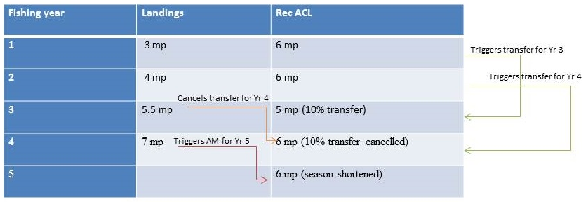
Figure 3. Functional example of the relationship between Actions 1 and 2, using the current preferred alternatives.

Draft motion to approve for formal review:
Approve Coastal Migratory Pelagics Amendment 29 as modified for Secretarial review, and deem the codified text as necessary and appropriate. Give staff editorial license to make any necessary editorial changes to the document/codified text and give the Council Chair authority to approve the revisions and re-deem the codified text.

