https://thehill.com/opinion/energy-environment/3538198-reopening-florida-corals-to-fishing-defies-science-and-economics/

[Opinion](https://thehill.com/opinion/)>[Energy and Environment](https://thehill.com/opinion/energy-environment/)

**Reopening Florida corals to fishing defies science and economics**

by Jennifer Browning, opinion contributor - 06/27/22 3:30 PM ET  
The views expressed by contributors are their own and not the view of The Hill

[Share](https://www.facebook.com/sharer/sharer.php?u=https%3A%2F%2Fthehill.com%2Fopinion%2Fenergy-environment%2F3538198-reopening-florida-corals-to-fishing-defies-science-and-economics%2F&picture=https%3A%2F%2Fthehill.com%2Fwp-content%2Fuploads%2Fsites%2F2%2F2022%2F06%2Fcoral_white_oculina_head_NOAA_.jpg%3Fw%3D900&title=Reopening%20Florida%20corals%20to%20fishing%20defies%20science%20and%20economics&description=Removing%20protections%20for%20deep-sea%20Oculina%20corals%20would%20also%20be%20out%20of%20step%20with%20the%20Biden-Harris%20administration%E2%80%99s%20vision.)

[Tweet](https://twitter.com/intent/tweet?text=Reopening%20Florida%20corals%20to%20fishing%20defies%20science%20and%20economics&url=https%3A%2F%2Fthehill.com%2Fopinion%2Fenergy-environment%2F3538198-reopening-florida-corals-to-fishing-defies-science-and-economics%2F)

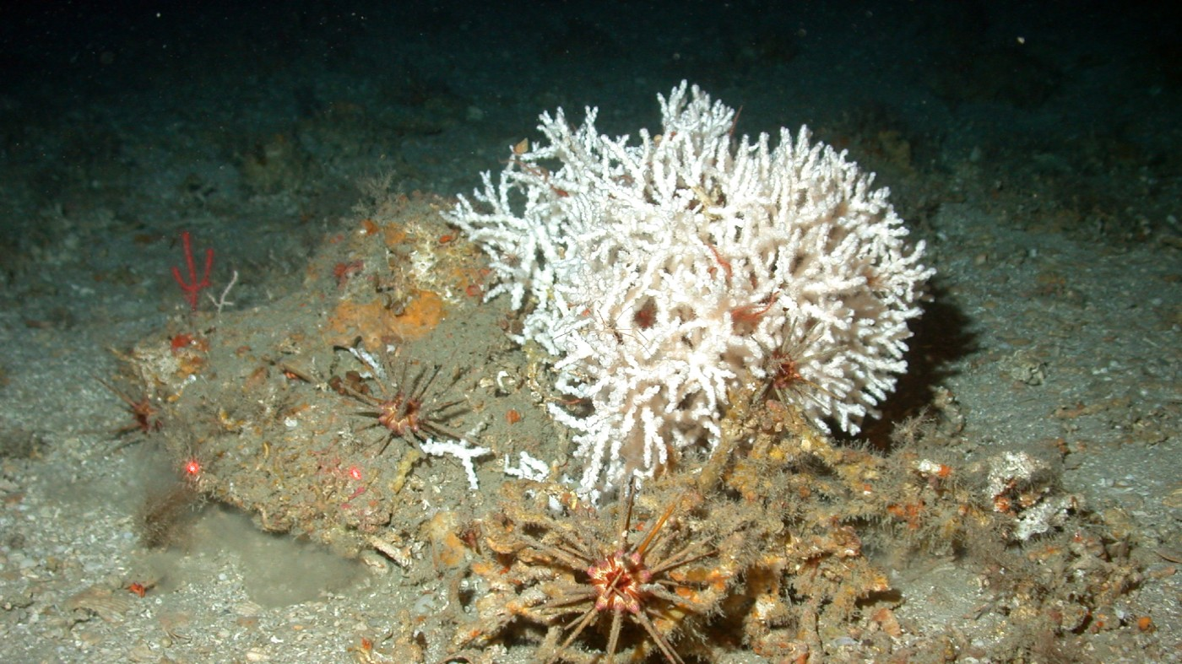Credit: National Oceanic and Atmospheric Administration

This May 2003 image provided by the National Oceanic and Atmospheric Administration shows a deep-sea oculina coral head. Deep-sea Oculina corals like this one are found off the east coast of Florida and form unique thickets.

In the waters off Florida’s Atlantic coast stands a wonder of nature that few people would expect to find: an old-growth forest. Some 50 miles east of Daytona and in 230 to 325 feet of water, the ivory tree coral Oculina varicosagrows in dense thickets — the [only place this coral species is found on Earth.](https://www.fisheries.noaa.gov/southeast/oculina-habitat-area-particular-concern) [Scientific core sampling](https://safmc.net/documents/2022/04/coral-amendment-10.pdf/) from some mounds of Oculina has dated them at 1,000 to 1,500 years old, and [the tallest among them reaches 115 feet in height](https://oceanexplorer.noaa.gov/explorations/02sab/background/corals/corals.html#:~:text=The%20deep%2Dwater%20Oculina%20coral,to%2035%20m%20in%20height). Similar to other deeper-water corals, Oculina grows slowly, only [1.6 centimeters a year](https://hero.epa.gov/hero/index.cfm/reference/details/reference_id/8608410).

And like a forest on land, the Oculina reef is teeming with other life, [including black sea bass, speckled hind, Warsaw grouper and deep-sea sponges](https://www.fisheries.noaa.gov/southeast/oculina-habitat-area-particular-concern) — one reason why the National Oceanic and Atmospheric Administration’s Fisheries Service (NOAA Fisheries), the agency responsible for the stewardship of marine resources, [identified this underwater forest as a Habitat Area of Particular Concern in 1984](https://www.fisheries.noaa.gov/southeast/oculina-habitat-area-particular-concern) and made it off-limits to fishing gear that could damage these fragile corals. In 2014, [the agency expanded the area](https://safmc.net/documents/2022/04/coral-amendment-8.pdf/) to encompass newly discovered mounds of coral.

So, it is bewildering that [NOAA Fisheries is now considering](https://www.federalregister.gov/documents/2022/04/29/2022-09211/fisheries-of-the-caribbean-gulf-of-mexico-and-south-atlantic-coral-coral-reefs-and-livehard-bottom#open-comment) a request from the South Atlantic Fishery Management Council — which proposes fisheries regulations in the region — to open the area for the rock shrimp fishery to bottom trawl. Such a move would threaten the existence of these ancient corals.

Extensive and well-documented damage from rock shrimp trawling was [the primary reason](https://www.researchgate.net/publication/233671566_Impacts_of_bottom_trawling_on_a_deep_-_water_Oculina_coral_ecosystem_off_Florida) NOAA Fisheries protected the area in the first place. While fishermen claim they won’t trawl on the corals — only nearby — the strong and unpredictable currents here make it difficult for fishermen to control exactly where their gear goes and impossible for them to guarantee they won’t damage or destroy corals. Even if they managed to avoid the corals, the trawling would still kick up sediment plumes that could [travel significant distances](https://peerj.com/articles/2711/) on currents and blanket the corals, [blocking their feeding mechanism](https://www.researchgate.net/publication/250219532_Sediment_tolerance_of_two_different_morphotypes_of_the_deep-sea_coral_Lophelia_pertusa_from_the_Gulf_of_Mexico) [and suffocating them](https://www.sciencedirect.com/science/article/pii/S0025326X12001981#:~:text=In%20many%20cases%2C%20dredging%20operations,by%20elevated%20turbidity%20and%20sedimentation.).

The council’s request is not supported by science. Both the council’s coral advisory panel and its habitat protection and ecosystem-based management advisory panel [recommended keeping protections](https://safmc.net/wp-content/uploads/2022/05/HabEco_A1a_Coral_Amendment10_-Decision-Doc_Aug_21.pdf) in place and presented evidence that rolling back restrictions would cause long-term damage to the coral ecosystem there.

And other regions in the country have made steady gains in protecting deep-sea coral — including [Alaska](https://www.pewtrusts.org/en/about/news-room/opinion/2005/03/05/a-great-step-for-fishermen-and-the-sea), along the [Pacific Coast](https://www.pewtrusts.org/en/research-and-analysis/articles/2018/05/14/in-landmark-vote-pacific-council-protects-critical-ocean-habitat), [the Gulf of Mexico](https://www.pewtrusts.org/en/research-and-analysis/articles/2020/10/16/gulf-of-mexico-deep-sea-corals-win-protection), the [Mid-Atlantic](https://www.pewtrusts.org/en/research-and-analysis/articles/2017/01/13/a-bright-day-for-deep-sea-corals) and [New England](https://www.pewtrusts.org/en/research-and-analysis/articles/2018/01/30/new-england-fishery-council-votes-to-protect-deep-sea-corals) — which makes the South Atlantic Council’s latest proposal even more puzzling.

The council claims it is following direction from a [May 2020 executive order](https://www.federalregister.gov/documents/2020/05/12/2020-10315/promoting-american-seafood-competitiveness-and-economic-growth), issued by then-President Donald Trump, to expand commercial fishing opportunities for the purpose of economic growth and global competitiveness. Yet [the most profitable year for the rock shrimp fishery since 2009 was 2017](https://safmc.net/wp-content/uploads/2022/05/Coral-10-Public-Hearing-Presentation_May_2021.pdf) — three years after the closure went into effect. That could be because protecting the places fish feed, reproduce and shelter actually helps fish populations thrive.

Destroying the very habitat that supports fish populations to catch more fish is not only shortsighted and counterproductive, it also runs counter to the objectives of the country’s primary fisheries conservation and management law, [the Magnuson-Stevens Act](https://www.congress.gov/bill/109th-congress/house-bill/5946). One of the core tenets of the Magnuson-Stevens Act is that fishery managers should prevent overfishing and rebuild depleted fish populations so that our country can enjoy the optimum yield from these renewable natural resources. Removing protections for Oculinacorals would degrade the essential habitat for a number of fish [NOAA Fisheries lists as overfished](https://media.fisheries.noaa.gov/2021-05/2020%20Status%20of%20Stocks%20RtC_5-18-21_FINAL.pdf?null) — among them red snapper, gage and snowy groupers, and red porgy — which would hamstring efforts to recover these vulnerable populations.

Losing these rare corals could also mean the extinction of yet undiscovered species. [Scientists found this Oculinaforest in 1975,](https://oceanexplorer.noaa.gov/explorations/17sedci/background/oculina/oculina.html) and it remains, like much of the deep ocean, largely unexplored. Discoveries in other deep-sea coral communities around the world have included compounds to [treat cancer](https://www.ncbi.nlm.nih.gov/pmc/articles/PMC3801121/) and other [medical conditions](https://www.ncbi.nlm.nih.gov/pmc/articles/PMC3783861/).

Removing protections for deep-sea Oculina corals would also be out of step with the Biden-Harris administration’s vision. Based on policy initiatives to date, the administration understands the increasing threats to marine ecosystems due to climate change, the value of science, and the importance of conservation — to nature, the economy, and Americans’ well-being. Management changes that could result in the destruction of these Oculinacorals would directly undermine directions from the Biden-Harris administration, including the [America the Beautiful initiative,](https://www.noaa.gov/america-the-beautiful) which aims to increase resilience and maintain biodiversity by conserving 30 percent of America’s lands and waters by 2030.

[No miracle tech needed: How to switch to renewables now and lower costs doing it](https://thehill.com/opinion/energy-environment/3539703-no-miracle-tech-needed-how-to-switch-to-renewables-now-and-lower-costs-doing-it/) [America’s newest national security threat: Obesity](https://thehill.com/opinion/national-security/3538705-americas-newest-national-security-threat-obesity/)

Fortunately, members of this administration — NOAA Fisheries Assistant Administrator Janet Coit, NOAA Administrator Richard Spinrad, and Commerce Secretary Gina Raimondo — have a chance to correct this misguided proposal. NOAA Fisheries is [accepting comments](https://www.federalregister.gov/documents/2022/04/29/2022-09211/fisheries-of-the-caribbean-gulf-of-mexico-and-south-atlantic-coral-coral-reefs-and-livehard-bottom#open-comment) on the South Atlantic Fishery Management Council’s proposal through June 28.

The Pew Charitable Trusts will be officially opposing this measure and invites others to do the same. Preserving this remarkable Oculina forest and habitat would benefit the ecosystem and the future of fishing and wildlife for generations to come.

*Jennifer Browning leads The Pew Charitable Trusts’ Conserving Marine Life in the U.S. project.*

Tags [Coral reefs](https://thehill.com/social-tags/coral-reefs/) [Environmental impact of fishing](https://thehill.com/social-tags/environmental-impact-of-fishing/) [Fishing industry in the United States](https://thehill.com/social-tags/fishing-industry-in-the-united-states/) [NOAA](https://thehill.com/social-tags/noaa/) [Politics of the United States](https://thehill.com/social-tags/politics-of-the-united-states/)