Oculina Bank
Habitat Area of Particular Concern

Quarterly Enforcement Report

3rd Quarter FY 09
April to June 2009

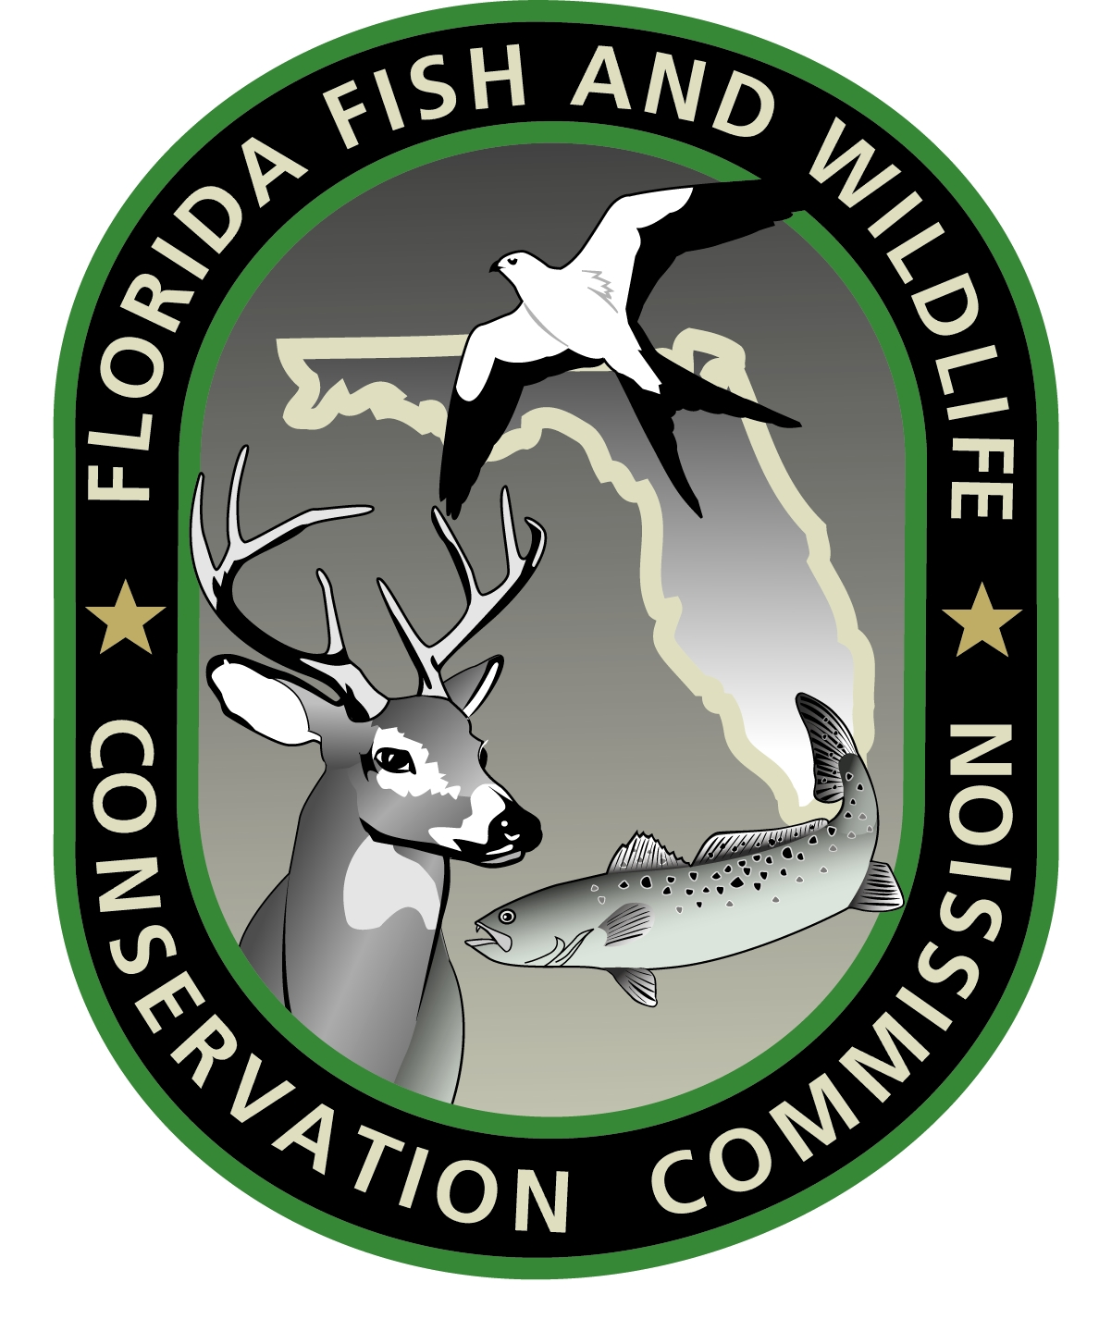




Prepared by:
Richard Chesler
Special Agent, NOAA OLE

September 2009
CONTENTS:

Case Dispositions

Enforcement media stories

Enforcement outreach activities

Enforcement training

Patrol Activity Highlights

Patrol Reports

CASE DISPOSITIONS:

SE0800778 - A settlement agreement was reached with Robert Preston/Chances R. Fisheries Inc., owner of the F/V THREE OF A KIND, for unlawfully retaining golden tilefish in the Oculina Bank HAPC Experimental Closed Area. The owner/operator agreed to pay $3,000 over time.

MEDIA:

No Oculina specific media this quarter.

OUTREACH:

No Oculina specific outreach conducted this quarter.

TRAINING:

No Oculina specific training conducted this quarter.

PATROL ACTIVITY HIGHLIGHTS:

- The FL FWCC Patrol Vessel C.T. Randall suffered an engine room fire in mid-May and was taken out of the water for repairs. FWCC stepped up patrols with mid-range patrol vessels to compensate.

- The USCG and FL FWCC conducted patrols during the Blue Water Tournament out of Sebastian Inlet. No violations noted.

PATROL REPORTS:

Attachment A: USCG and FL FWCC Oculina Bank patrol effort report, Apr - Jun, 2009 (Spreadsheet)

Attachment B: Oculina patrols by agency, Apr - Jun, 2009 (Graph)

Attachment C: Oculina detections and boardings, Apr - Jun, 2009
(Graph)

NOTES:

This report is comprised of data submitted by LT Brian Sullivan USCG, Lt. Jeff Sidor FL FWCC.

Secondary hours for the USCG indicates hours an asset (aircraft, cutter, boat) was in the Oculina Bank but on a non-fisheries mission.

Secondary hours for the FL FWCC indicate hours an asset (aircraft, patrol vessel, boat) was transiting to the Oculina Bank or patrolling near the area and available to respond.

