Oculina Bank
Habitat Area of Particular Concern

Quarterly Enforcement Report

2nd Quarter FY 09
January to March 2009

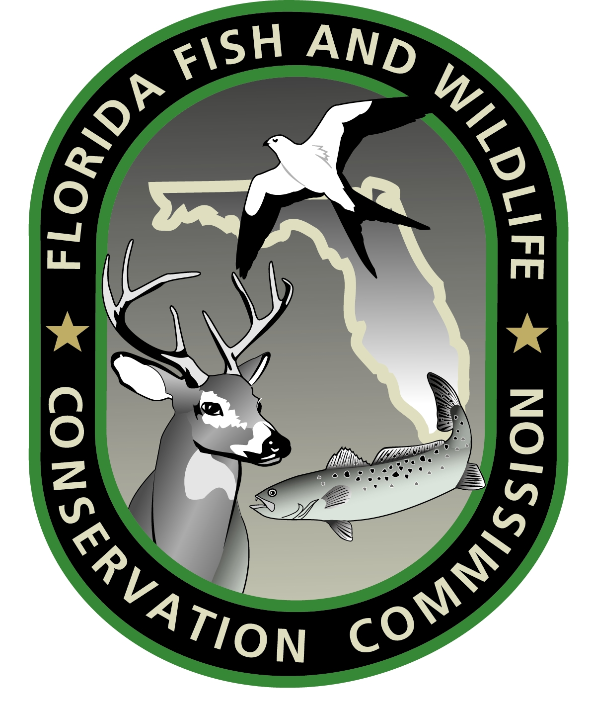
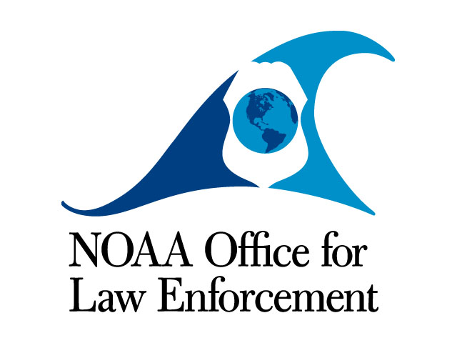

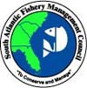

Prepared by:
Richard Chesler
Special Agent, NOAA OLE

September 2009
CONTENTS:

Case Dispositions

Enforcement media stories

Enforcement outreach activities

Enforcement training

Patrol Activity Highlights

Patrol Reports

CASE DISPOSITIONS:

No Oculina specific case dispositions this quarter.

MEDIA:

A Daytona Beach News-Journal column mentioned the Oculina Bank documentary, “Fragile Forests of the Deep” which featured interviews of enforcement personnel and footage of enforcement patrols and VMS monitoring.

OUTREACH:

No Oculina specific outreach conducted this quarter.

TRAINING:

No Oculina specific training conducted this quarter.

PATROL ACTIVITY HIGHLIGHTS:

- The FL FWCC Patrol Vessel C.T. Randall responded to a medical emergency onboard a commercial fishing vessel adjacent to the Oculina HAPC satellite areas. The Randall conducted a medical evacuation of a crewman back to Port Canaveral for further treatment.

- The USCG conducted combined air and sea patrols during January and March. No violations noted.

- SA Chesler and SA Fields responded to Port Canaveral to investigate possible bottom longlining activity within the Oculina HAPC as indicated by VMS. The agents and a boarding team from USCG Station Port Canaveral boarded the bottom longliner, interviewed the operator, and examined the vessel’s GPS plotter. The investigation revealed that no fishing activity took place within the OHAPC.

PATROL REPORTS:

Attachment A: USCG and FL FWCC Oculina Bank patrol effort report, Jan-Mar, 2009 (Spreadsheet)

Attachment B: Oculina patrols by agency, Jan – Mar, 2009 (Graph)

Attachment C: Oculina detections and boardings, Jan – Mar, 2009
(Graph)

NOTES:

This report is comprised of data submitted by LT Brian Sullivan USCG, Lt. Jeff Sidor FL FWCC.

Secondary hours for the USCG indicates hours an asset (aircraft, cutter, boat) was in the Oculina Bank but on a non-fisheries mission.

Secondary hours for the FL FWCC and NOAA indicate hours an asset (aircraft, patrol vessel, boat) was transiting to the Oculina Bank or patrolling near the area and available to respond.

