Oculina Bank
Habitat Area of Particular Concern

Quarterly Enforcement Report

4th Quarter FY 09
Jul - Sep 2009

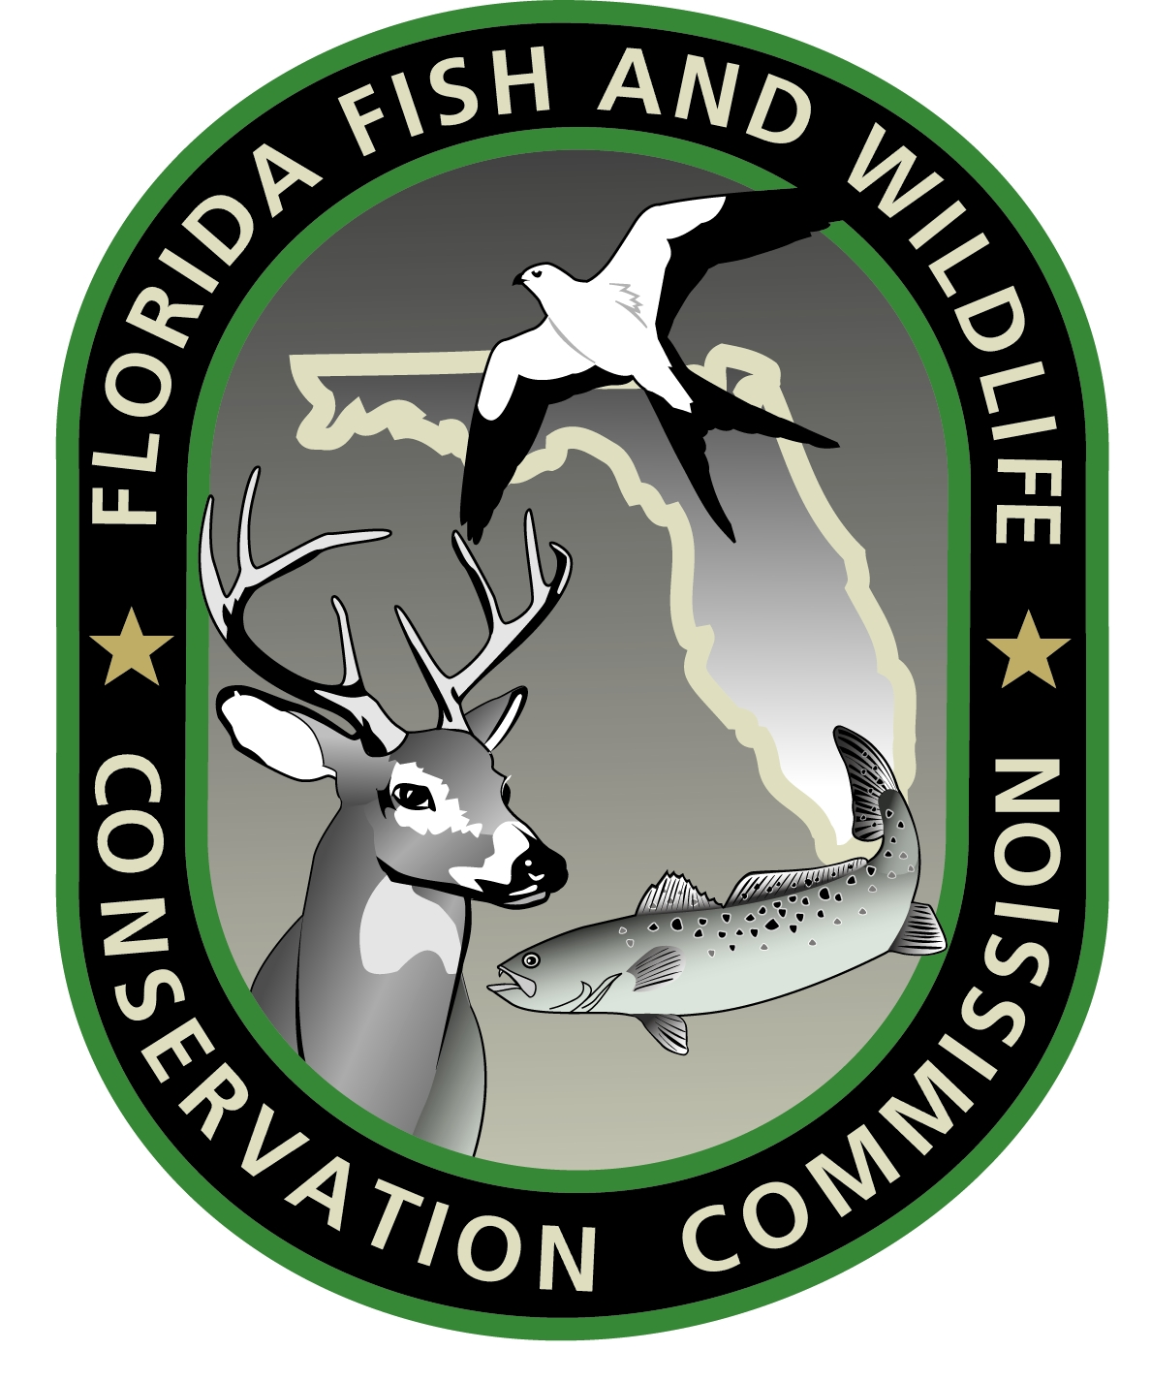




Prepared by:
Richard Chesler
Special Agent, NOAA OLE

February 2010

CONTENTS:

Case Dispositions

Enforcement media stories

Enforcement outreach activities

Enforcement training

Patrol Activity Highlights

Patrol Reports

CASE DISPOSITIONS:

SE0700293FM – A settlement agreement was reached with Robert Pritchard and Cieutat Trawlers Inc., captain and owner, respectively of the F/V THE SHOOTIST for using a grapple and chain in the Oculina Bank HAPC. $1,000 was paid. The owner and vessel will not be allowed to fish for or deal in any federally regulated species of fish for which South Atlantic Rock Shrimp or Penaeid Shrimp are required or to fish in the South Atlantic - including state and federal waters - from 10/1/09 through 1/31/11. The captain will not be allowed to fish for or deal in any federally regulated species of fish for which South Atlantic Rock Shrimp or Penaeid Shrimp permits/endorsements or an Operator's permits/endorsements are required or to fish in the South Atlantic - including state and federal waters - from 7/15/09 through 7/14/12. Both are under probation for 36 months (3 years).

MEDIA:

No Oculina enforcement specific media during this quarter.

OUTREACH:

SA Chesler gave a presentation on Oculina Bank regulations and enforcement efforts at the Barrier Island Sanctuary in Melbourne Beach, FL. The presentation followed a lecture on the Oculina Bank given by sanctuary staff. SA Chesler also distributed Oculina Bank regulations brochures.

SA Chesler contacted Florida Today fishing writer Capt. Ted Lund regarding a fishing forecast that mentioned bottom fishing offshore of Sebastian Inlet. SA Chesler provided Lund Oculina Bank regulations and boundaries. Capt. Lund subsequently published a reminder of these regulations in an October fishing forecast.

TRAINING:

No Oculina specific training conducted this quarter.

PATROL ACTIVITY HIGHLIGHTS:

- The FL FWCC Patrol Vessel C.T. Randall remained out of service during this quarter due to an engine room fire.

- The USCG utilized medium endurance cutters to patrol the Oculina Bank en route to their southern patrol areas.

- The USCG spent approximately 8 days on scene during September.

PATROL REPORTS:

Attachment A: USCG and FL FWCC Oculina Bank patrol effort report, Jul - Sep, 2009 (Spreadsheet)

Attachment B: Oculina patrols by agency, Jul - Sep, 2009 (Graph)

Attachment C: Oculina detections and boardings, Jul - Sep, 2009
(Graph)

NOTES:

This report is comprised of data submitted by LT Brian Sullivan USCG, Lt. Jeff Sidor and Lt. Jason Marlow FL FWCC.

Secondary hours for the USCG indicates hours an asset (aircraft, cutter, boat) was in the Oculina Bank but on a non-fisheries mission.

Secondary hours for the FL FWCC indicate hours an asset (aircraft, patrol vessel, boat) was transiting to the Oculina Bank or patrolling near the area and available to respond.

