Oculina Bank
Habitat Area of Particular Concern

Quarterly Enforcement Report

1st Quarter FY 10
October to December 2009

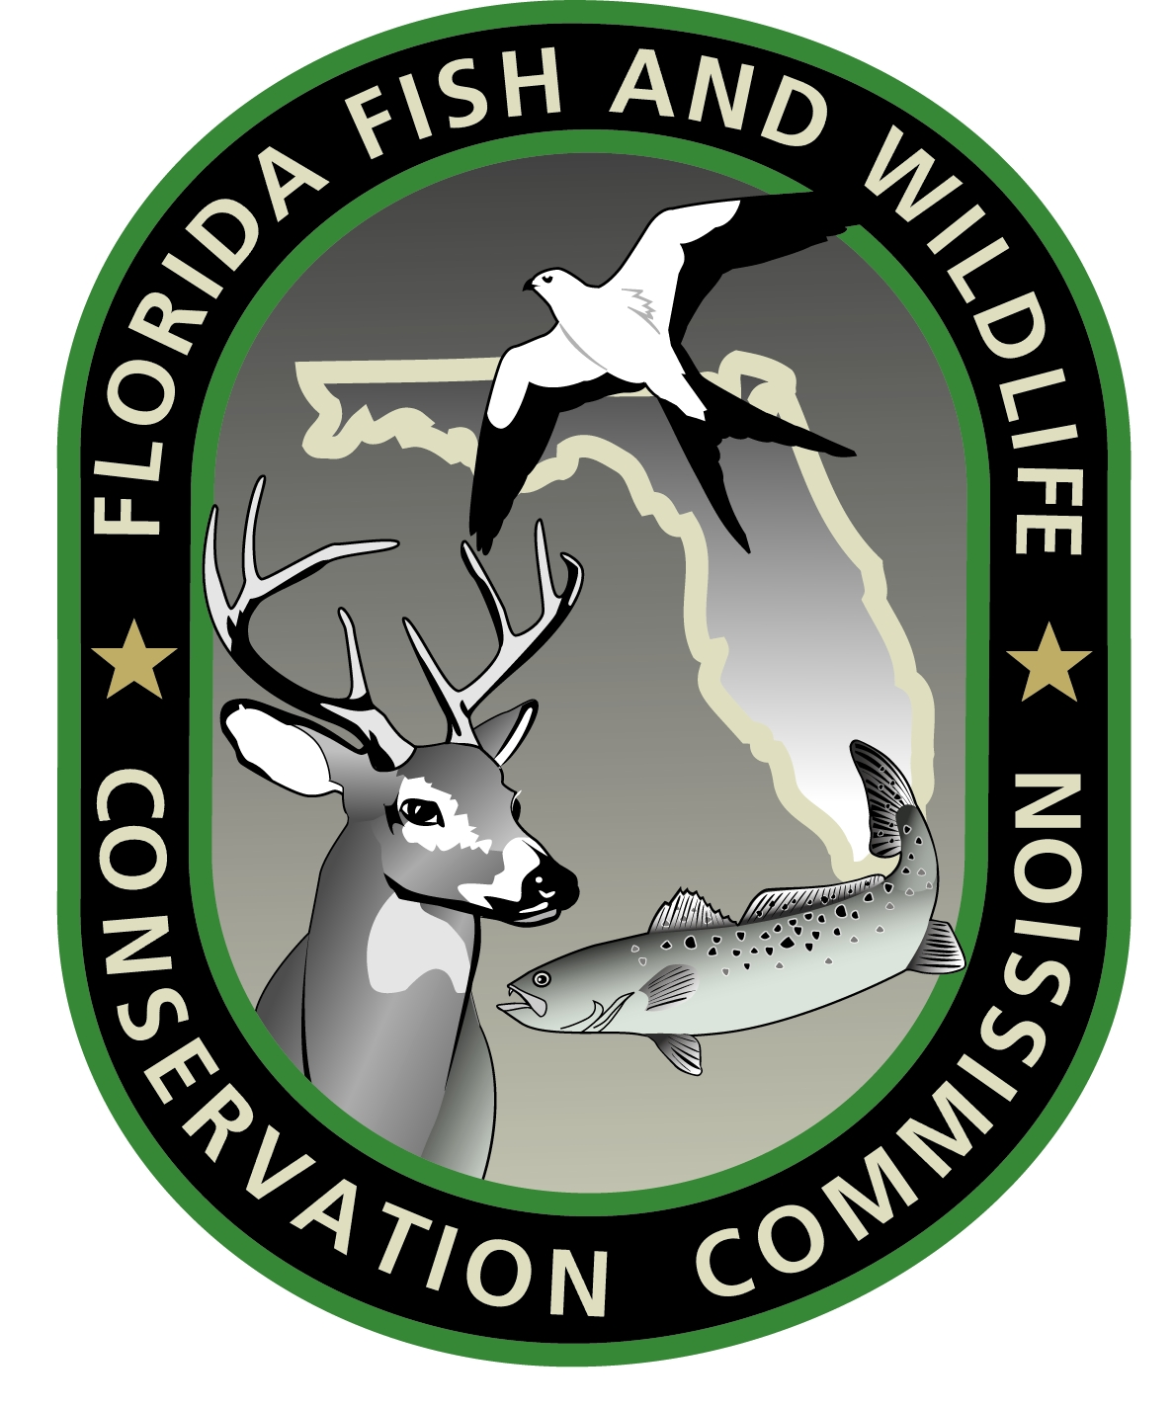
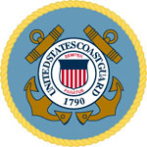
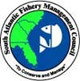


Prepared by:
Richard Chesler
Special Agent, NOAA OLE

February 2010

CONTENTS:

Case Dispositions

Enforcement media stories

Enforcement outreach activities

Enforcement training

Patrol Activity Highlights

Patrol Reports

CASE DISPOSITIONS:

No Oculina specific case dispositions this quarter.

MEDIA:

Florida Today fishing writer Capt. Ted Lund reminded fishermen of Oculina Bank regulations in his October 2 fishing forecast:

“Remember, when fishing out of Sebastian, the area approximately 20 miles east of the inlet (the Oculina Bank Experimental Closed Area) is off-limits to bottom fishing and anglers could receive stiff fines for retaining bottom fish in those areas.”

OUTREACH:

SA Chesler provided Oculina Bank regulations to a Port Canaveral charter operator.

TRAINING:

SA Chesler and SA Messa provided Oculina Bank refresher training to two duty sections at USCG Station Fort Pierce. Several FL FWCC officers, including the South Region A commander, were also present. The training covered Oculina regulations, boundaries, and documenting violations.

PATROL ACTIVITY HIGHLIGHTS:

- The FL FWCC Patrol Vessel C.T. Randall remained out of service this quarter due to a previous engine room fire.
- The USCGC TAMPA detected a recreational vessel inside the Oculina ECA. A subsequent boarding outside of the area revealed a greater amberjack onboard. NOAA OLE is conducting a follow-up investigation.

- SA Chesler conducted joint patrols with USCG Station Fort Pierce. No violations were noted.

- NOAA OLE VMS monitoring detected an incursion into the Oculina ECA by a rock shrimp trawler. The vessel was boarded dockside by NOAA agents and a FL FWCC officer. Investigation is pending.

PATROL REPORTS:

Attachment A: USCG and FL FWCC Oculina Bank patrol effort report, Oct – Dec, 2009 (Spreadsheet)

Attachment B: Oculina patrols by agency, Oct - Dec, 2009 (Graph)

Attachment C: Oculina detections and boardings, Oct - Dec, 2009
(Graph)

NOTES:

This report is comprised of data submitted by LT Brian Sullivan USCG, Lt. Jeff Sidor, and Lt. Jason Marlow, FL FWCC.

Secondary hours for the USCG indicates hours an asset (aircraft, cutter, boat) was in the Oculina Bank but on a non-fisheries mission.

Secondary hours for the FL FWCC and NOAA indicate hours an asset (aircraft, patrol vessel, boat) was transiting to the Oculina Bank or patrolling near the area and available to respond.

