.
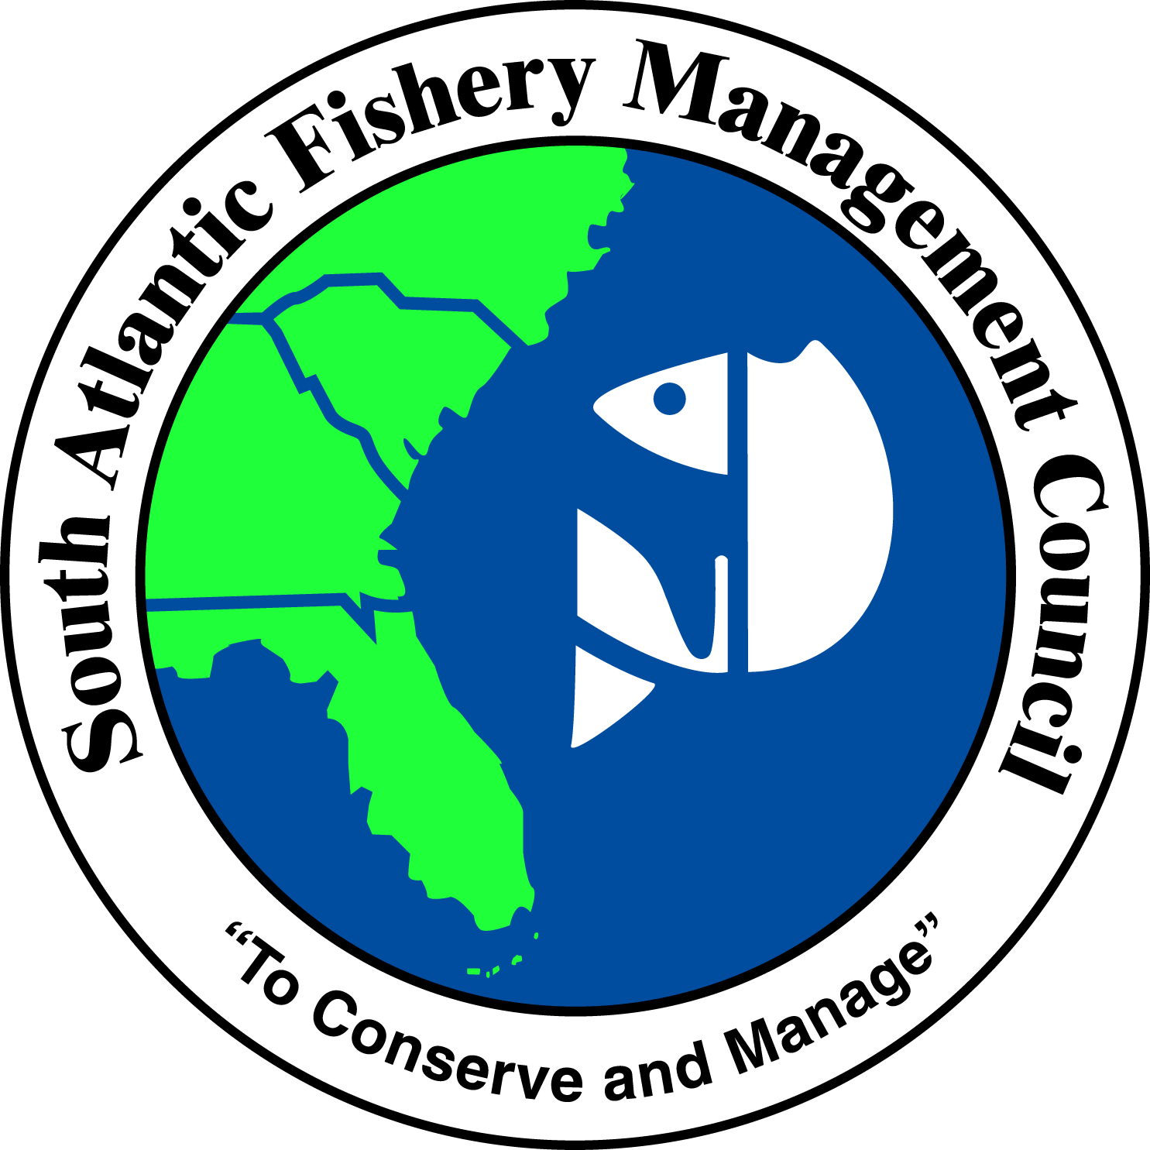 | SOUTH ATLANTIC FISHERY MANAGEMENT COUNCIL  4055 FABER PLACE DRIVE, SUITE 201  NORTH CHARLESTON, SOUTH CAROLINA 29405  TEL 843/571-4366 FAX 843/769-4520  Toll Free: 1-866-SAFMC-10  E-mail: safmc@safmc.net Web site: www.safmc.net  David Cupka, Chairman Robert K. Mahood, Executive Director  Ben Hartig, Vice-Chairman Gregg Waugh, Deputy Executive Director

December 8, 2011

Draft
John Thomas
Raleigh Regulatory Field Office
3331 Heritage Trade Drive, Suite 105
Wake Forest, NC 27587

Dear Mr. Thomas:

The South Atlantic Fishery Management Council (SAFMC) offers the following comments on the proposed Milburnie Dam Removal project (SAW-2010-00020). These comments are based on Council habitat conservation policies and draw on comments and recommendations developed by regional partners with the USFWS and NCDMF. We concur that the proposed project should improve water quality, reestablish an appropriate aquatic community, facilitate habitat restoration for threatened or endangered aquatic species and restore access of historic spawning and nursery habitat within the Neuse River ecosystem. The project also reconnects miles of fragmented sections of the Neuse River facilitating movement and migration of resident aquatic fauna and the reestablishment of interchange necessary for maintaining river flows and species genetic diversity.

The Council adopted a policy statement regarding protection of the essential fish habitats associated with alterations of riverine, estuarine and nearshore flows to address hydrologic alterations which have or could modify the normative hydrograph of these systems. The policy (http://www.safmc.net/Portals/0/HabitatPolicies/FlowsPolicy.pdf) is designed to be consistent with the overall habitat protection policies of the SAFMC as formulated and adopted in the Habitat Plan (October 1998) and the Comprehensive EFH Amendment (October1998) and Fishery Ecosystem Plan (2009).

Thank you for the opportunity to provide comment. If you have any additional questions please feel free to contact Roger Pugliese (roger.pugliese@safmc.net) at the Council office.

Sincerely,
David Cupka

Chairman
cc: Council Members and Staff

