SouthEast Fishery-Independent Survey (SEFIS)
Update - SAFMC Meeting December, 2010

Objectives of SEFIS in 2010:
- Increase spatial footprint and sample sizes of fishery-independent sampling in US South Atlantic waters.
- Deploy video cameras on previously used chevron traps to address trap selectivity issues and develop robust indices of abundance for reef fish species.
- Map hardbottom habitats using multibeam sonar to increase reef fish sampling universe and improve survey design.
- Use ROVs to assess habitat and red snapper densities in deep waters.
- Compare red snapper age distribution in shelf-break waters versus those in continental shelf waters.

2010 Results of SEFIS:
Chevron trapping
- 63 days at-sea (34 on Nancy Foster, 29 on R/V Savannah)
- 480 traps deployed
- 142 red snapper collected in addition to many other species; data entry occurring
- Significant enhancement of MARMAP sampling (days at-sea have been increased over previous years)

Trap videos
- 468 traps outfitted with video cameras (> 97% of all traps deployed)
- More than 700 hours of video collected; developing viewing protocols
- Videos will be used to index red snapper and many other species

ROV work
- 32 ROV dives completed on Nancy Foster
- More than 50 hours of video collected and is currently being analyzed

Multibeam sonar habitat mapping
- 37 new areas mapped between SC and central FL, totaling 377 km²
- Habitat maps used to identify new hardbottom sites to expand sampling universe (see Figure 1 for example of multibeam sonar map)

Commercial longlining project
- 4 of 8 latitudinal bands (most northerly) have been completed
- 67 red snapper collected, 65 of which were aged
- Ages ranged from 3 to 15 (mean = 6.9; see Figure 2)
- Lengths ranged from 46 to 93 cm (mean = 73 cm; see Figure 3)

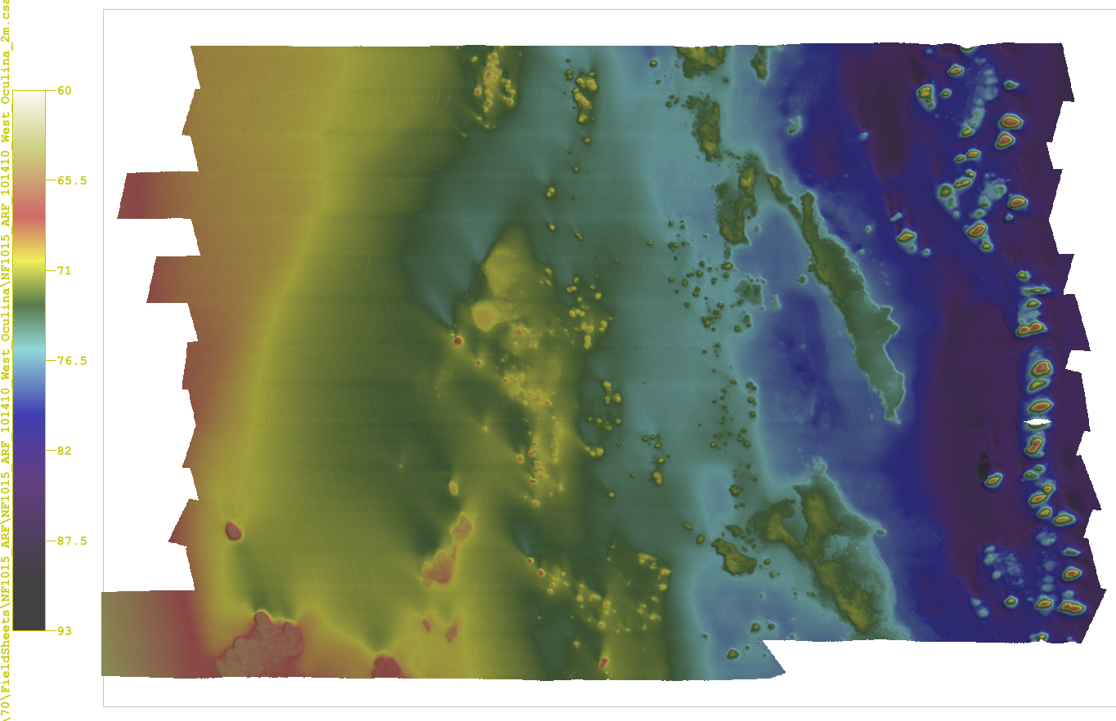

Figure 1. Example of a multibeam sonar habitat map from 25 miles east of Cape Canaveral, Florida. Colors correspond to bathymetric depths provided in legend on left. Mapped on 10/14/2010 from the NOAA ship Nancy Foster.
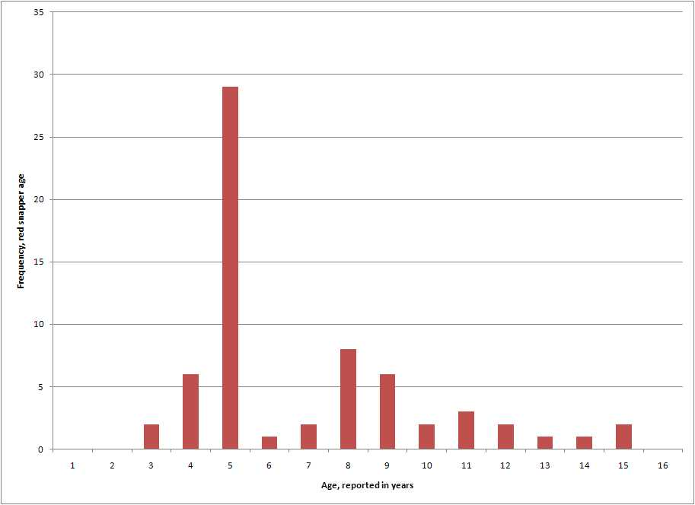
Figure 2. Age-frequency distribution of red snapper caught in the commercial longline project, 2010. Note that only 4 of 8 latitudinal bands have been fished thus far (the most northerly bands).
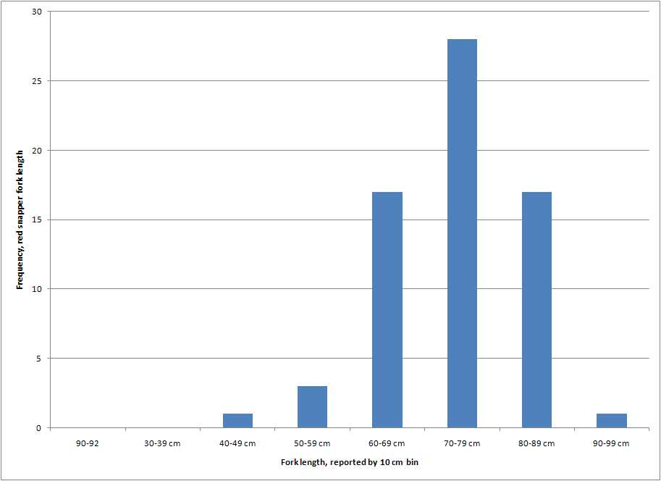

Figure 3. Length-frequency distribution of red snapper caught in the commercial longline project, 2010. Note that only 4 of 8 latitudinal bands have been fished thus far (the most northerly bands).

