Final Summary Report

Snapper Grouper Committee
Doubletree by Hilton Atlantic Beach Oceanfront
2717 W. Fort Macon Road
Atlantic Beach, NC

December 2015

The Snapper Grouper Committee met on December 8 & 9, 2015, in Atlantic Beach, NC.

Status of landings for quota-managed snapper grouper species

Dr. Jack McGovern, SERO, presented an overview of commercial landings of snapper grouper species through December 3, 2015. Dr. McGovern also presented an overview of recreational landings through Wave 4 of 2015 (July-August) including headboat landings.

Status of amendments approved for Secretarial Review
- Amendment 33 (fillets) – Included with Dolphin Wahoo Amendment 7 to allow transport of fillets of dolphin, wahoo, and snapper grouper species harvested in the Bahamas into the U.S. EEZ. Submitted to NMFS on 5/1. Final Rule package is under review at the SERO.
- Amendment 34 (AMs) – Included with Dolphin Wahoo Amendment 8. Submitted to NMFS on 2/27. The Final Rule package is under review at NMFS HQ.
- Amendment 35 (removal of species and golden tilefish endorsement) – submitted to NMFS on 9/10. Proposed Rule package under review at the SERO.
- Amendment 32 ER Request – NMFS sent a letter to Dr. Duval (dated October 23, 2015) with rationale for why the agency was denying the request for emergency action. Rationale included:
  - On March 10, the Mid-Atlantic Council submitted a request for emergency action to implement temporary management measures for blueline tilefish in the Greater Atlantic Region.
  - The Mid-Atlantic Council is working on a plan amendment to manage blueline tilefish in the mid-Atlantic region with the intent to establish ABC and ACL for blueline tilefish in the mid-Atlantic region and to implement management measures to constrain harvest to the ACL.
  - There was disagreement between the South Atlantic SSC and a sub-panel of the Mid-Atlantic SSC regarding whether SEDAR 32 was considered Best Scientific Information Available.
  - The South Atlantic SSC increased their recommendation for the blueline tilefish ABC
  - The South Atlantic Council is moving forward with an amendment to implement less restrictive management measures and catch levels for blueline tilefish in the South Atlantic.

Red Snapper Management (Amendment 43)

Gregg Waugh led the Committee in discussing options for management of red snapper. A stock assessment is underway and completion is expected in spring 2016. The SSC will review results of the assessment at their May 2016 meeting and provide fishing level recommendations to the Council. The Council will hold discussions at their June 2016 meeting and provide guidance to staff. The Committee discussed general management options such as:
- Desire is for a longer season rather than higher bag limit
- Fishing season should be structured so as not to straddle an MRIP wave.
- Possible bag limit of 1 fish per person per day
- A mechanism for possible increase to the ACL should be built in the amendment
- Recreational harvest should be allowed later in the year so as not to overlap with peak spawning (Note: Council chose to allow harvest during spawning season to increase collection of samples for reproductive research and so harvest would coincide with that of black sea bass and reduce regulatory discards)
- Possible 20-inch minimum size limit for both sectors (smaller fish experience lower release mortality than larger individuals)
- Per boat limit should also be considered
- Possible commercial trip limit (50-100 lbs could be considered)

SSC Report

Dr. Luiz Barbieri, SSC Chair, presented an overview the SSC’s deliberations during their October 2015 meeting. Items presented in the report included:
- SSC requests that the annual briefing that the agency provides to them include total removals (landings + discards) as opposed to only landings on order for the SSC to better evaluate their ABC recommendations and the status of a stock relative to the OFL.
- Specifying the recreational ACL in numbers of fish (instead of pounds) may be appropriate in some situations but not all. It is very important to continue focusing on adequate sampling and monitoring for the fishery.
- A 5-year sunset for the Spawning SMZs (Amendment 36) may not provide enough time to evaluate spawning activity for long-lived species.
- Concern that the size of the proposed Spawning SMZs is too small to provide the spawning benefits the Council envisions.
- The revised projections for hogfish (Amendment 37) represent BSIA and are adequate to use in management. However, some of the F values are very low so that differences among f projected rebuilding scenarios may not be statistically detectable. Therefore, it is difficult for the SSC to recommend one scenario over the other from a technical merit perspective.
- Only Reliable Catch Stocks (ORCS) methodology is applicable to the GA-NC stock of hogfish. The SSC recommends no revisions to the level of overexploitation scalar for that stock.
- Alternative methods to estimate recreational landings for rare-event species show higher precision than the current methodology and are reasonable and promising but still require testing and refinement.
- SSC recommends a benchmark assessment for blueline tilefish and reiterated that their current ABC recommendation is interim in nature. The South Atlantic SSC will coordinate with the Mid-Atlantic SSC regarding fishing level recommendations for blueline tilefish.

Snapper Grouper Advisory Panel Report

Mr. Jim Atack, Chair of the Snapper Grouper AP, discussed AP recommendations pertaining to management of the snapper grouper fishery. The AP met in Charleston on November 3-4, 2015. It was noted that there was poor attendance at the meeting (8 members did not attend) and some of the APs recommendations may have been affected by this.

Regulatory Amendment 16 (black sea bass pot closure)

Brian Cheuvront, Council staff, led presented an overview of items for which guidance was still needed to complete the amendment and approve it for submission to the Secretary of Commerce. The Committee made the following motions:

MOTION: ACCEPT MODIFICATIONS TO WORDING FOR PREFERRED ALTERNATIVE 11 AND ALTERNATIVE 12.

APPROVED BY COMMITTEE

APPROVED BY COUNCIL

New Wording for Preferred Alternative 11 and Alternative 12:

Preferred Alternative 11. From November 1 through 30 and from April 1 through 30 each year, the black sea bass pot closure applies to waters inshore of points 1-35 listed in Table 2.1.10; approximately Daytona Beach, Florida, to Cape Hatteras, North Carolina (Figure 2.1.11). From December 1 through March 31, the black sea bass pot closure applies to waters inshore of points 1-28 listed below Table 2.1.11; approximately Cape Canaveral, Florida, to Cape Hatteras, North Carolina (Figure 2.1.12).

From November 1 through 30 and from April 1 through 30 each year, the boundaries off Florida and Georgia are nearly identical to the boundaries in Alternative 5. Off North Carolina and South Carolina, the black sea bass pot closure applies in the exclusive economic zone in waters shallower than 25 meters, corresponding with Alternative 8.

From December 1 through March 31, this area generally represents waters 25 m or shallower from 28° 21’ N (approximately Cape Canaveral, Florida) to Savannah, Georgia; from the Georgia/South Carolina border to Cape Hatteras, North Carolina, the closure applies to waters under Council management that are 30 meters or shallower and corresponds with Alternative 4. This bathymetric area is based on right whale sightings (all demographic segments) and sightings per unit of effort (proxy of density) by depth and captures 97% and 96% of right whale sightings off the North Carolina/South Carolina area, and Florida/Georgia area, respectively.

Note: Federal regulations would only apply to that portion of the area within the South Atlantic EEZ. The states will be asked to implement compatible regulations within state waters.

Table 2.1.10. Eastern boundary coordinates for the proposed black sea bass pot closure in Preferred Alternative 11 from November 1 through November 30 and April 1 through April 30.
Point | N Latitude | W Longitude | Point | N Latitude | W Longitude
1 | 35° 15’ | State/EEZ Boundary | 19 | 33° 06’ | 78° 31’
2 | 35° 15’ | 75° 09’ | 20 | 33° 05’ | 78° 40’
3 | 35° 06’ | 75° 22’ | 21 | 33° 01’ | 78° 43’
4 | 35° 06’ | 75° 39’ | 22 | 32° 56’ | 78° 57’
5 | 35° 01’ | 75° 47’ | 23 | 32° 44’ | 79° 04’
6 | 34° 54’ | 75° 46’ | 24 | 32° 42’ | 79° 13’
7 | 34° 52’ | 76° 04’ | 25 | 32° 34’ | 79° 23’
8 | 34° 33’ | 76° 22’ | 26 | 32° 25’ | 79° 25’
9 | 34° 23’ | 76° 18’ | 27 | 32° 23’ | 79° 37
10 | 34° 21’ | 76° 27’ | 28 | 31° 53’ | 80° 09’
11 | 34° 25’ | 76° 51’ | 29 | 31º 31’ | 80º 33’
12 | 34° 09’ | 77° 19’ | 30 | 30º 43’ | 80º 49’
13 | 33° 44’ | 77° 38’ | 31 | 30º 30’ | 81º 01’
14 | 33° 25’ | 77° 27’ | 32 | 29º 45’ | 81º 01’
15 | 33° 22’ | 77° 40’ | 33 | 29º 31’ | 80º 58’
16 | 33° 28’ | 77° 41’ | 34 | 29º 13’ | 80º 52’
17 | 33° 32’ | 77° 53’ | 35 | 29º 13’ | State/EEZ Boundary
18 | 33° 22’ | 78° 26’
Source: Amanda Frick, NMFS SERO

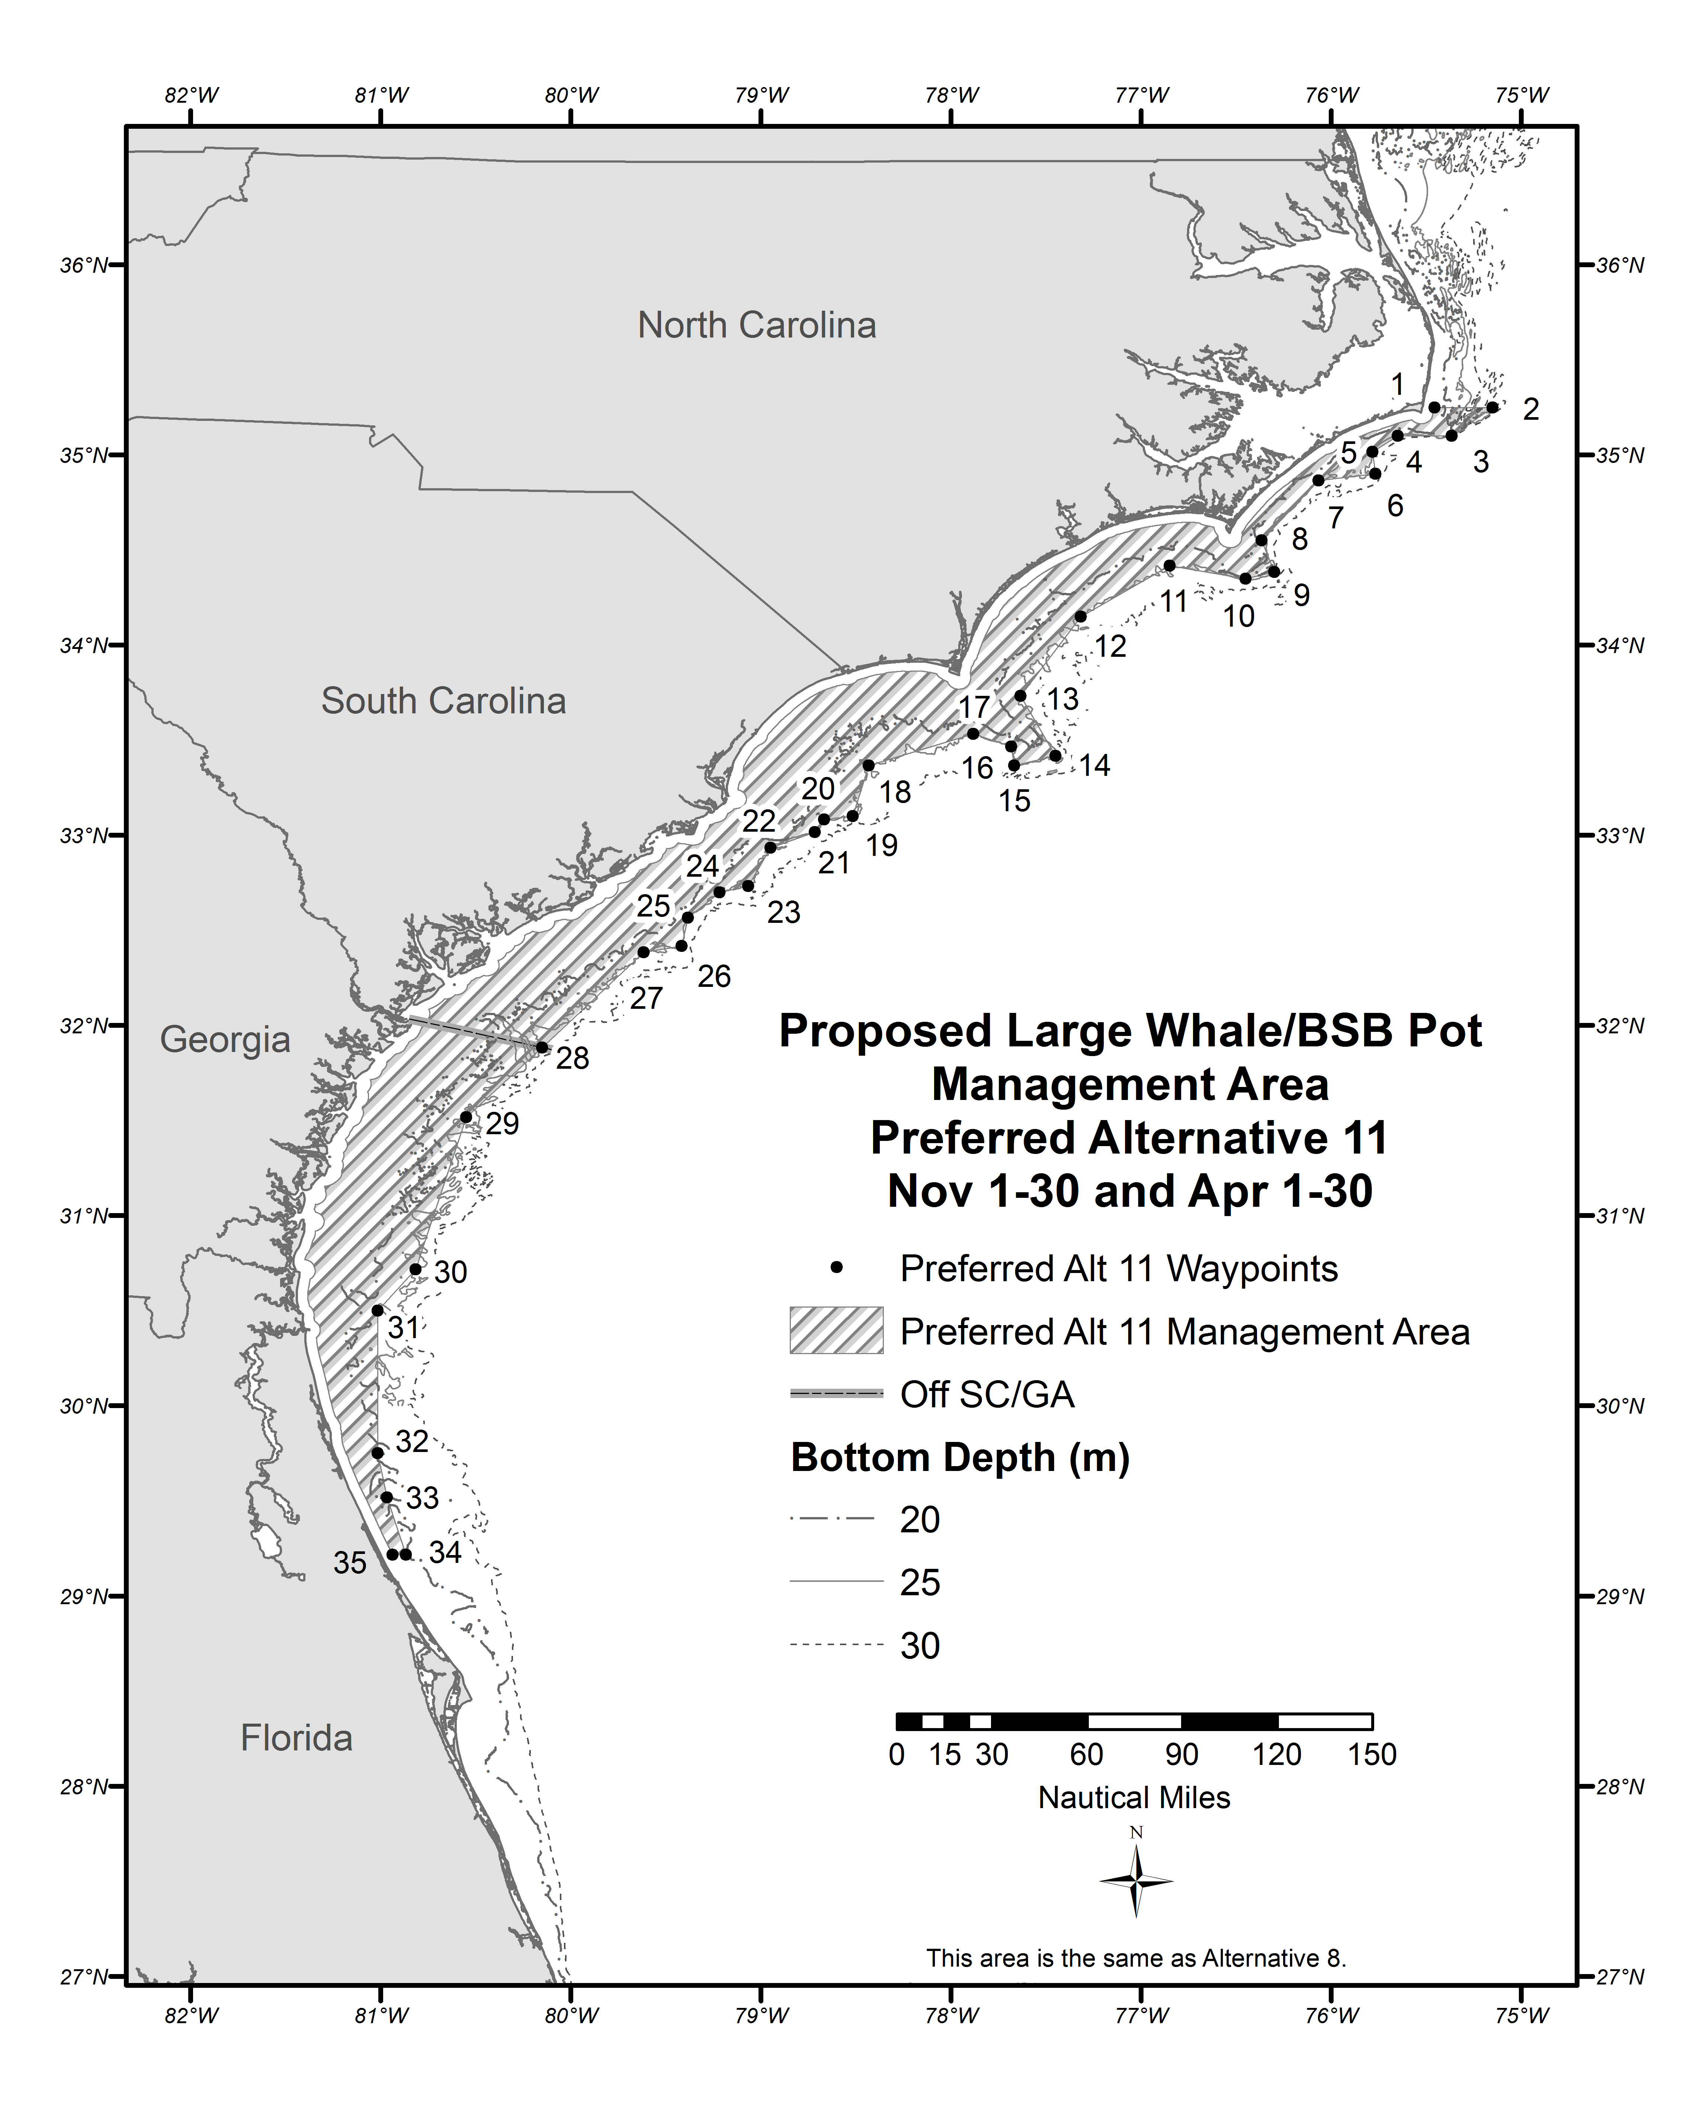
Figure 2.1.11. Area for the proposed black sea bass pot closure in Preferred Alternative 11 from November 1 through November 30 and April 1 through April 30.
Source: Amanda Frick, NMFS SERO
Table 2.1.11. Eastern boundary coordinates for the proposed black sea bass pot closure in Preferred Alternative 11 for December 1 through March 31.
Point | N Latitude |  | W Longitude | Point | N Latitude | W Longitude
1 | 35° | 15’ | State/EEZ boundary | 15 | 33° 01’ | 78° 38’
2 | 35° | 15’ | 75° 08’ | 16 | 32° 40’ | 79° 01’
3 | 34° | 58’ | 75° 41’ | 17 | 32° 36’ | 79° 18’
4 | 34° | 49’ | 75° 50’ | 18 | 32° 19’ | 79° 22’
5 | 34° | 47’ | 76° 05’ | 19 | 32° 16’ | 79° 37’
6 | 34° | 31’ | 76° 18’ | 20 | 32° 03’ | 79° 48’
7 | 34° | 20’ | 76° 13 | 21 | 31° 39’ | 80° 27’
8 | 34° | 12’ | 77° 00’ | 22 | 30° 58’ | 80° 47’
9 | 33° | 43’ | 77° 30’ | 23 | 30° 13’ | 81° 01’
10 | 33° | 21’ | 77° 21’ | 24 | 29° 32’ | 80° 39’
11 | 33° | 18’ | 77° 41’ | 25 | 29° 22’ | 80° 44’
12 | 33° | 22’ | 77° 56’ | 26 | 28° 50’ | 80° 22’
13 | 33° | 12’ | 78° 20’ | 27 | 28° 21’ | 80° 18’
14 | 33° | 05’ | 78° 22’ | 28 | 28° 21’ | State/EEZ boundary
Source: Amanda Frick, NMFS SERO

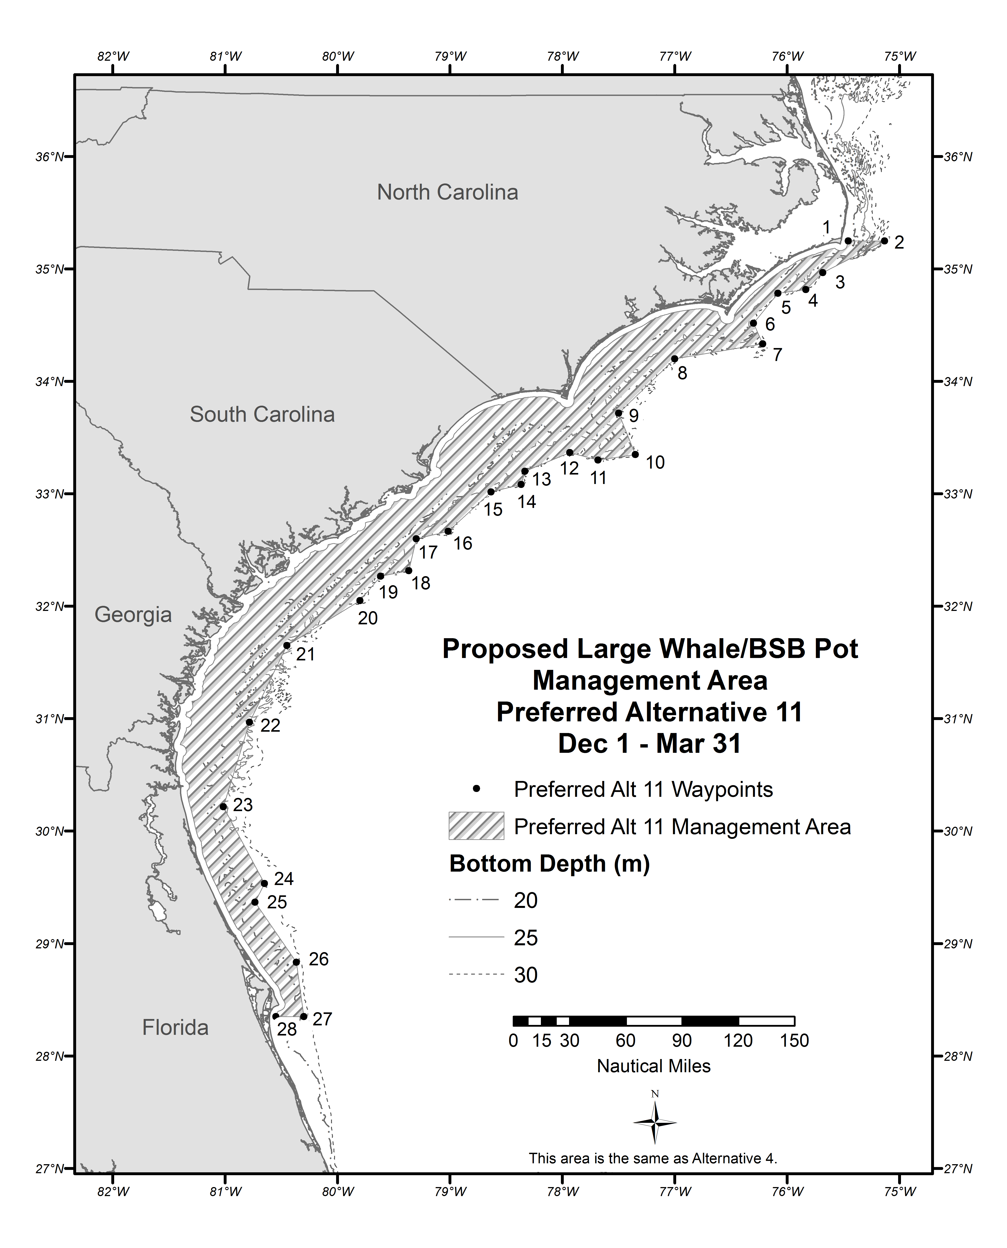
Figure 2.1.12. Area for the proposed black sea bass pot closure in Preferred Alternative 11 from November 1 through November 30 and April 1 through April 30.

Source: Amanda Frick, NMFS SERO

Alternative 12. From November 1 through April 30, the black sea bass pot closure applies to waters inshore of points 1-31 listed below (Table 2.1.12); approximately Cape Canaveral, Florida, to Cape Hatteras, North Carolina (Figure 2.1.13).

This closure approximates the midpoints between proposed closure Alternative 4 and Sub-Alternative 8a.

Note: Federal regulations would only apply to that portion of the area within the South Atlantic EEZ. The states will be asked to implement compatible regulations within state waters.

Table 2.1.12. Eastern boundary coordinates for the proposed black sea bass pot closure in Alternative 12 for November 1 through April 30.
Point | N Latitude | W Longitude | Point | N Latitude | W Longitude
1 | 35° 15' | State/EEZ Boundary | 17 | 33° 05' | 78° 26'
2 | 35° 15' | 75° 09' | 18 | 33° 03' | 78° 39'
3 | 35° 06' | 75° 22' | 19 | 32° 42' | 79° 03'
4 | 35° 04' | 75° 38' | 20 | 32° 37' | 79° 18'
5 | 35° 00' | 75° 44' | 21 | 32° 22' | 79° 23'
6 | 34° 54' | 75° 46' | 22 | 32° 20' | 79° 36'
7 | 34° 51' | 75° 50' | 23 | 31° 31' | 80° 32'
8 | 34° 50' | 76° 04' | 24 | 30° 43' | 80° 49'
9 | 34° 32' | 76° 20' | 25 | 30° 30' | 80° 58'
10 | 34° 21' | 76° 15' | 26 | 30° 13' | 81° 01'
11 | 34° 15' | 77° 04' | 27 | 29° 32' | 80° 49'
12 | 33° 43' | 77° 34' | 28 | 29° 13' | 80° 46'
13 | 33° 23' | 77° 24' | 29 | 28° 37' | 80° 20'
14 | 33° 20' | 77° 41' | 30 | 28° 21' | 80° 18'
15 | 33° 27' | 77° 54' | 31 | 28° 21' | State/EEZ Boundary
16 | 33° 17' | 78° 22'

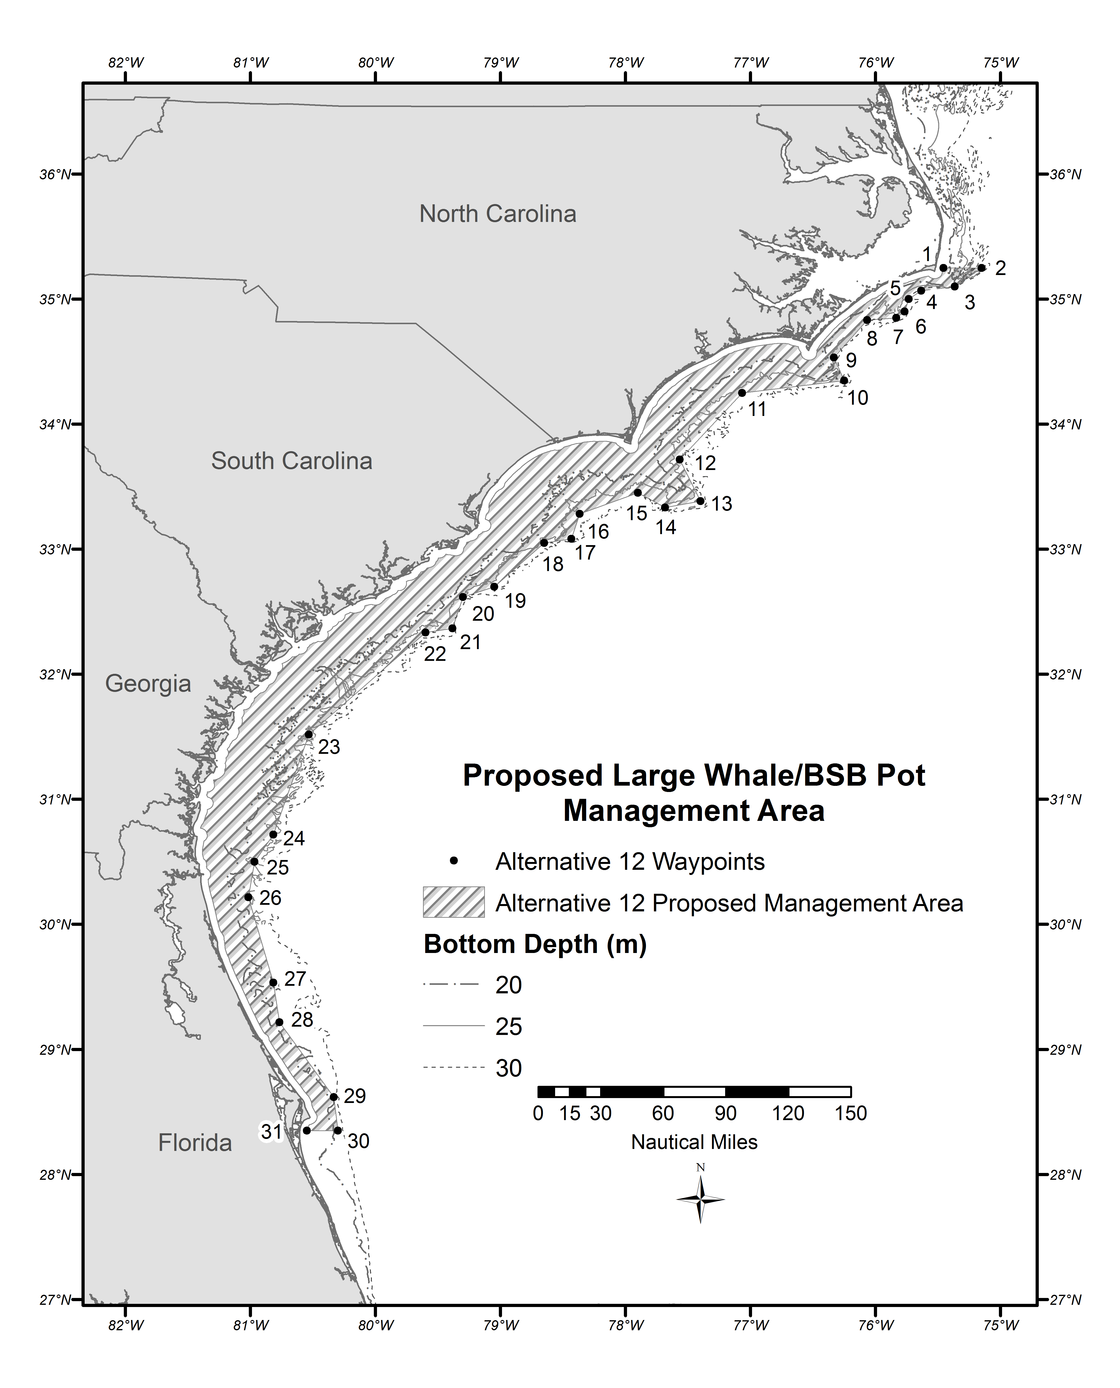
Figure 2.1.13. Area for the proposed black sea bass pot closure in Alternative 12 from November 1 through April 30.
Source: Amanda Frick, NMFS SERO

The Committee discussed transit provisions for black sea bass pots through closed areas. The Committee made revisions to the transit provision.

MOTION: ACCEPT THE REVISED TRANSIT PROVISIONS FOR ACTION 1.

Sea bass pots must be removed from the water in the applicable closed area within the South Atlantic EEZ before the applicable time period, and may not be onboard a vessel in the closed area within the South Atlantic EEZ during the applicable closure, except for such sea bass pot gear appropriately stowed onboard a vessel in transit through the closed area. Transit means non-stop progression through the area; fishing gear appropriately stowed means all black sea bass pot gear must be out of the water and on board the deck of the vessel. All buoys must either be disconnected from the gear or stowed within the sea bass pot. Disconnected buoys may remain on deck.”

APPROVED BY COMMITTEE

APPROVED BY COUNCIL

By consensus, the Committee decided not to review preliminary Biological Opinion (BiOp) for the snapper grouper fishery based on the interest of getting Regulatory Amendment 16 in effect by November of 2016. There was discussion that the Council could discuss the decisions made in the BiOp once it was in place and the BiOp could be modified, if needed at a later date.

The Committee recommended the Council vote to sent Regulatory Amendment 16 to the U.S. Secretary of Commerce for formal review.

MOTION: APPROVE SNAPPER GROUPER REGULATORY AMENDMENT 16 FOR FORMAL SECRETARIAL REVIEW AND DEEM THE CODIFIED TEXT AS NECESSARY AND APPROPRIATE. GIVE STAFF EDITORIAL LICENSE TO MAKE ANY NECESSARY EDITORIAL CHANGES TO THE DOCUMENT/CODIFIED TEXT AND GIVE THE COUNCIL CHAIR AUTHORITY TO APPROVE THE REVISIONS AND RE-DEEM THE CODIFIED TEXT.

APPROVED BY COMMITTEE

APPROVED BY COUNCIL

Amendment 37 (hogfish)

Myra Brouwer, Council staff, gave an overview of the amendment. The Committee did not make any motions or recommendations pertaining to Actions 1-3 of the draft amendment. The Committee made the following motions pertaining to the other actions:

MOTION: ACCEPT IPT’S SUGGESTED EDITS FOR ACTION 4

Action 4. Establish Annual Catch Limits (ACLs) for the GA-NC stock of hogfish

Alternative 2. Establish an ACL for the GA-NC stock. Specify commercial and recreational ACLs using re-calculated sector allocations based on proposed modifications to the management unit (81.91% 69.1% commercial and 18.09% 30.9% recreational). The ABC for the GA-NC stock = 28,161 35,716 pounds whole weight (lbs ww).

Sub-alternative 2a. ACL = OY = ABC

Sub-alternative 2b. ACL = OY = 95% ABC

Sub-alternative 2c. ACL = OY = 90% ABC

APPROVED BY COMMITTEE

APPROVED BY COUNCIL

MOTION: SELECT SUB-ALTERNATIVE 2A AS PREFERRED:

Sub-alternative 2a. ACL = OY = ABC

SUBSTITUTE MOTION: SELECT SUB-ALTERNATIVE 2B AS PREFERRED:

Sub-alternative 2b. ACL = OY = 95%ABC

SUBSTITUTE MOTION BECOMES MAIN MOTION

MAIN MOTION APPROVED BY COMMITTEE

APPROVED BY COUNCIL

MOTION: ACCEPT THE IPT’S SUGGESTED EDITS FOR ACTION 5

Action 5. Establish a rebuilding plan for the Florida Keys/East Florida (FLK/EFL) stock of hogfish

(see draft amendment for edits to alternatives)

APPROVED BY COMMITTEE

APPROVED BY COUNCIL

MOTION: ACCEPT THE IPTS’ SUGGESTED EDITS FOR ACTION 6.

Action 6. Establish Annual Catch Limits (ACLs) for the Florida Keys/East Florida (FLK/EFL) stock of hogfish

Preferred Alternative 2. Establish annual catch limits (ACLs) for the Florida Keys/East Florida (FLK/EFL) stock of hogfish. Specify commercial and recreational ACLs for 2017-2025. ACLs will not increase automatically in a subsequent year if present year projected catch has exceeded the total ACL. Specify commercial and recreational ACLs using re-calculated sector allocations based on proposed modifications to the management unit (24.29% 9.6% commercial and 75.71% 90.4% recreational).

APPROVED BY COMMITTEE

APPROVED BY COUNCIL

MOTION: CHANGE PREFERRED FOR ACTION 6 TO SUB-ALTERNATIVE 2B

Sub-alternative 2b. ACL = OY = 95% ABC

APPROVED BY COMMITTEE

APPROVED BY COUNCIL

MOTION: CHANGE PREFERRED FOR ACTION 8 TO SUB-ALTERNATIVE 2B

Action 8. Increase the commercial and recreational minimum size limit for the GA-NC and the Florida Keys/East Florida (FLK/EFL) stocks of hogfish

Preferred Alternative 2. Increase the commercial and recreational minimum size limit for the GA-NC stock of hogfish in the South Atlantic Region.

Sub-alternative 2b. 17 inches FL

(NOTE: Previous preferred was Sub-alternative 2e: 20 inches FL)

APPROVED BY COMMITTEE

APPROVED BY COUNCIL

MOTION: SELECT ALTERNATIVE 3, SUB-ALTERNATIVE 3B AS PREFERRED UNDER ACTION 9

Action 9. Establish a commercial trip limit for the GA-NC and the Florida Keys/East Florida (FLK/EFL) stocks of hogfish

Sub-alternative 3b. 50 lbs per trip.

SUBSTITUTE MOTION: SELECT SUB-ALTERNATIVE 3A AS PREFERRED UNDER ACTION 9

Sub-alternative 3a. 25 lbs per trip.

SUBSTITUTE BECOMES MAIN MOTION

MAIN MOTION APPROVED BY COMMITTEE

APPROVED BY COUNCIL

MOTION: ADD SUB-ALTERNATIVES 2E AND 3F TO ALTERNATIVES 2 AND 3 UNDER ACTION 9 FOR NO COMMERCIAL TRIP LIMIT

APPROVED BY COMMITTEE

APPROVED BY COUNCIL

MOTION: SELECT SUB-ALTERNATIVE 2E UNDER ACTION 9 AS PREFERRED

SUBSTITUTE MOTION: SELECT SUB-ALTERNATIVE 2C UNDER ACTION 9

Sub-alternative 2c. 500 lbs per trip.

SUBSTITUTE BECOMES MAIN MOTION

MAIN MOTION APPROVED BY COMMITTEE

APPROVED BY COUNCIL

MOTION: REMOVE ALTERNATIVES 4 AND 5 FROM ACTION 10 AND ADD TO NEW ACTION 11

Action 10. Modify and/or establish recreational bag limits for the GA-NC and the Florida Keys/East Florida (FLK/EFL) stocks of hogfish

Action 11. Establish a recreational fishing season for the GA-NC and Florida Keys/East Florida (FLK/EFL) stocks of hogfish

Alternative 2. Establish a recreational fishing season for the GA-NC stock of hogfish in the South Atlantic region.

Sub-alternative 2a. May-August

Sub-alternative 2b. July-August

Sub-alternative 2c. May-June

Alternative 3. Establish a recreational fishing season for the Florida Keys/East Florida (FLK/EFL) stock of hogfish in the South Atlantic region.

Sub-alternative 3a. May-June

Sub-alternative 3b. July-August

APPROVED BY COMMITTEE

APPROVED BY COUNCIL

MOTION: SELECT SUB-ALTERNATIVES 2A AND 3B UNDER ACTION 10 AS PREFERREDS

SUBSTITUTE MOTION: SELECT SUB-ALTERNATIVES 2A AND 3C UNDER ACTION 10 AS PREFERREDS

Action 10. Modify and/or establish recreational bag limits for the GA-NC and the Florida Keys/East Florida (FLK/EFL) stocks of hogfish

Alternative 2. Establish a recreational bag limit for the GA-NC stock of hogfish in the South Atlantic Region.

Sub-alternative 2a. 2 fish per person per day.

Alternative 3. Modify the recreational bag limit for the Florida Keys/East Florida (FLK/EFL) stock of hogfish in the South Atlantic Region.

Sub-alternative 3c. 1 fish per person per day.

SUBSTITUTE BECOMES MAIN MOTION

MAIN MOTION APPROVED BY COMMITTEE

APPROVED BY COUNCIL

MOTION: MOVE ALTERNATIVE 2 UNDER ACTION 11 TO THE CONSIDERED BUT REJECTED APPENDIX

Action 11. Establish a recreational fishing season for the GA-NC and Florida Keys/East Florida (FLK/EFL) stocks of hogfish

Alternative 2. Establish a recreational fishing CLOSED season for the GA-NC stock of hogfish in the South Atlantic region.

Sub-alternative 2a. May-August

Sub-alternative 2b. July-August

Sub-alternative 2c. May-June

APPROVED BY COMMITTEE

APPROVED BY COUNCIL

MOTION: ADD SUB-ALTERNATIVE 3C (JULY THROUGH SEPTEMBER) UNDER ACTION 11

Alternative 3. Establish a recreational fishing season for the Florida Keys/East Florida (FLK/EFL) stock of hogfish in the South Atlantic region.

Sub-alternative 3c. July-September

APPROVED BY COMMITTEE

APPROVED BY COUNCIL

MOTION: SELECT SUB-ALTERNATIVE 3C UNDER ACTION 11 AS PREFERRED

APPROVED BY COMMITTEE

APPROVED BY COUNCIL

MOTION: ADD ALTERNATIVE 5 TO ACTION 12

Action 12. Establish commercial and recreational accountability measures (AMs) for the GA-NC and the Florida Keys/East Florida (FLK/EFL) stocks of hogfish

Alternative 5. If recreational landings exceed the recreational annual catch limit (ACL) for two consecutive fishing years, then during the following (i.e., third) fishing year, recreational landings will be monitored for a persistence in increased landings. If necessary, NMFS would reduce the length of fishing season and the recreational ACL after two consecutive years of exceeding the recreational ACL in the following fishing year by the amount of the average annual recreational overage, only if the species is overfished and the total ACL (commercial ACL and recreational ACL) of the respective stock is exceeded. The length of the recreational season and recreational ACL will not be reduced if NMFS determines, using the best scientific information available, that a reduction is unnecessary.

Sub-alternative 5a. For the GA-NC stock of hogfish.

Sub-alternative 5b. For the Florida Keys/East Florida (FLK/EFL) stock of hogfish.

APPROVED BY COMMITTEE

APPROVED BY COUNCIL

MOTION: APPROVE AMENDMENT 37 FOR PUBLIC HEARINGS

APPROVED BY COMMITEE

APPROVED BY COUNCIL

Presentation on the genetic structure of the blueline tilefish population

Dr. Tanya Darden, South Carolina Department of Natural Resources, presented results of her research on the genetic population structure of blueline tilefish. The study used samples from off Virginia (northern area) and off the Carolinas, Georgia, and Florida (southern area) to explore genetic differences that would suggest the existence of distinct population segments. However, the study did not support this hypothesis. Moreover, the study indicated that the population of blueline tilefish seems to have experienced a genetic bottleneck in recent times. This finding is consistent with the stock status of that stock (undergoing overfishing).

Regulatory Amendment 25 (blueline tilefish, black sea bass, yellowtail snapper)

Myra Brouwer, Council staff, presented a summary of public comments received on the amendment. Public hearings and a Question & Answer webinar were held in November 2015. The public hearing presentation was delivered via webinar and comment stations were in Manteo, NC; Charleston, SC; Brunswick, GA; and St. Augustine, FL. The Committee made the following motions:

MOTION: ACCEPT IPT’S SUGGESTED EDITS TO ACTION 1 AND ALTERNATIVES.
Action 1. Adjust the Acceptable Biological Catch (ABC), Annual Catch Limit (ACL) and Optimum Yield (OY) for the South Atlantic Blueline Tilefish Stock
Alternative 1 (No Action). ACL = OY = 98%(ABC).
Alternative 2. ACL=OY=98%(stock ABC)
NOTE: This alternative uses the current ABC equation implemented through Amendment 32 but applied to the new ABC recommendation
Alternative 3. ACL = OY = 96%(stock ABC) (The ratio of landings between the South Atlantic and Greater Atlantic Regions from 2005-2010 is 96%.).
Alternative 4. ACL = OY = 93%(stock ABC) (The ratio of landings between the South Atlantic and Greater Atlantic Regions from 2005-2013 is 93%).
Alternative 5. ACL = OY = 89%(stock ABC) (The ratio of landings between the South Atlantic and Greater Atlantic Regions from 2011-2013 is 89%.).
Alternative 6. ACL = OY = 88%(stock ABC) (The ratio of landings between the South Atlantic and Greater Atlantic Regions from 2005-2014 is 88%).
Alternative 7. ACL = OY = 78%(stock ABC) (The ratio of landings between the South Atlantic and Greater Atlantic Regions from 2011-2014 is 78%).

APPROVED BY COMMITTEE

APPROVED BY COUNCIL

MOTION: SELECT ALTERNATIVE 7 UNDER ACTION 1 AS PREFERRED

Alternative 7. ACL = OY = 78%(stock ABC) (The ratio of landings between the South Atlantic and Greater Atlantic Regions from 2011-2014 is 78%).

APPROVED BY COMMITTEE

APPROVED BY COUNCIL

SUBSTITUTE MOTION: SELECT ALTERNATIVE 5 UNDER ACTION 1 AS PREFERRED

Alternative 5. ACL = OY = 89%(stock ABC) (The ratio of landings between the South Atlantic and Greater Atlantic Regions from 2011-2013 is 89%.).

SUBSTITUTE MOTION FAILS

MOTION: ACCEPT THE IPT’S RECOMMENDED EDITS TO ALTERNATIVES 1-3 UNDER ACTION 2

Action 2. Revise the Commercial Trip Limit for Blueline Tilefish

Alternative 1 (No Action). The commercial trip limit for blueline tilefish of is 100 pounds gutted weight (lbs gw).

Alternative 2. Increase the commercial trip limit for blueline tilefish to 200 lbs gw.

Alternative 3. Increase the commercial trip limit for blueline tilefish to 300 lbs gw.

APPROVED BY COMMITTEE

APPROVED BY COUNCIL

MOTION: ADD AN ALTERNATIVE FOR 400 POUND TRIP LIMTI TO ACTION 2

MOTION FAILS FOR LACK OF A SECOND

MOTION: ADD ALTERNATIVE UNDER ACTION 2 TO CONSIDER A 100 POUND TRIP LIMIT FROM JANUARY 1 TO MAY 31 AND 400 POUNDS FOR THE REMAINDER OF THE SEASON

MOTION FAILS

MOTION: SELECT ALTERNATIVE 3 AS PREFERRED UNDER ACTION 2

Alternative 3. Increase the commercial trip limit for blueline tilefish to 300 lbs gw.

APPROVED BY COMMITTEE

APPROVED BY COUNCIL

MOTION: ACCEPT THE IPT’S SUGGESTED EDITS TO ACTION 3 ALTERNATIVES
Action 3. Adjust the Bag Limit for Blueline Tilefish for the Recreational Sector
Alternative 1 (No Action). The recreational harvest of blueline tilefish is limited to vessel limit of 1 fish/vessel/day May through August (closed rest of year) within the aggregate grouper bag limit. The aggregate group contains the following species: gag, black grouper, snowy grouper, misty grouper, red grouper, scamp, yellowedge grouper, yellowfin grouper, yellowmouth grouper, blueline tilefish, golden tilefish, sand tilefish, coney, graysby, red hind, and rock hind.
Alternative 2. Establish a blueline tilefish bag limit of 1 fish/person/day year-round within the aggregate grouper bag limit.
Alternative 3. Establish a blueline tilefish vessel limit of 1 fish/vessel/day year-round within the aggregate grouper bag limit.
Alternative 4. Establish a blueline tilefish bag limit of 1fish/person/day May through August within the aggregate grouper bag limit. Prohibit retention of blueline tilefish for the remainder of the year.
Alternative 5. Establish a blueline tilefish bag limit of 3 fish/person/day year-round within the aggregate bag limit.
Alternative 6. Establish a blueline tilefish bag limit of 3 fish/person/day May through August within the aggregate bag limit.

APPROVED BY COMMITTEE

APPROVED BY COUNCIL

MOTION: SELECT ALTERNATIVE 6 UNDER ACTION 3 AS PREFERRED

Alternative 6. Establish a blueline tilefish bag limit of 3 fish/person/day May through August within the aggregate bag limit.

APPROVED BY COMMITTEE

APPROVED BY COUNCIL

MOTION: ACCEPT THE IPT’S SUGGESTED EDITS TO ACTION 4 AND ALTERNATIVES
Action 4. Increase the Recreational Bag Limit of Black Sea Bass
Alternative 1 (No action). The recreational bag limit of black sea bass is 5 fish per person per day.
APPROVED BY COMMITTEE
APPROVED BY COUNCIL

MOTION: SELECT ALTERNATIVE 3 UNDER ACTION 4 AS PREFERRED
Alternative 3. Increase the recreational bag limit of black sea bass to 7 fish per person per day.
APPROVED BY COMMITTEE
APPROVED BY COUNCIL

SUBSTITUTE MOTION: SELECT ALTERNATIVE 6 AS PREFERRED
Alternative 6. Increase the recreational bag limit of black sea bass to 10 fish per person per day.
SUBSTITUTE MOTION FAILS

MOTION: ACCEPT THE IPT’S SUGGESTED EDITS TO ACTION 5 ALTERNATIVES AND INCLUSION OF SUB-ALTERNATIVES 2D AND 3D
Action 5. Modify the Fishing Year for Yellowtail Snapper
Alternative 1 (No Action). The fishing year for yellowtail snapper (commercial and recreational) is the calendar year, January 1 through December 31.
Alternative 2. Modify the fishing year for the commercial sector for yellowtail snapper.
Sub-alternative 2a. June 1 through May 31
Sub-alternative 2b. July 1 through June 30
Sub-alternative 2c. August 1 through July 31
Sub-alternative 2d. September 1 to August 31
Alternative 3. Modify fishing year for the recreational sector for yellowtail snapper.
Sub-alternative 3a. June 1 through May 31
Sub-alternative 3b. July 1 through June 30
Sub-alternative 3c. August 1 through July 31
Sub-alternative 3d. September 1 to August 31
APPROVED BY COMMITTEE
APPROVED BY COUNCIL

MOTION: SELECT SUB-ALTERNATIVES 2C AND 3C UNDER ACTION 5 AS PREFERREDS
Alternative 2. Modify the fishing year for the commercial sector for yellowtail snapper.
Sub-alternative 2c. August 1 through July 31
Alternative 3. Modify fishing year for the recreational sector for yellowtail snapper.
Sub-alternative 3c. August 1 through July 31
APPROVED BY COMMITTEE
APPROVED BY COUNCIL

MOTION: REMOVE ACTION 6 FROM REGULATORY AMENDMENT 25 AND MODIFY THE PURPOSE STATEMENT ACCORDINGLY
Action 6. Revise Commercial Closure Accountability Measures for Yellowtail Snapper

Purpose for Action
Adjust annual catch limits, optimum yield, and management measures for the blueline tilefish stock in the South Atlantic region in response to a re-evaluation of the stock assessment (SEDAR 32 2013) projections and the development of a new acceptable biological catch recommendation; increase the recreational bag limit for black sea bass; and change the fishing year for yellowtail snapper.
APPROVED BY COMMITTEE
APPROVED BY COUNCIL

MOTION: APPROVE SENDING REGULATORY AMENDMENT 25 FOR FORMAL REVIEW AND GIVE THE COUNCIL CHAIR AND STAFF EDITORIAL LICENSE TO MAKE MODIFICATIONS TO THE AMENDMENT AS NECESSARY. DEEM THE CODIFIED TEXT AS NECESSARY AND APPROPRIATE AND GIVE THE COUNCIL CHAIR AND STAFF EDITORIAL LICENSE TO MAKE MODIFICTIONS AND RE-DEEM AS NECESSARY.
APPROVED BY COMMITTEE
APPROVED BY COUNCIL

Amendment 41 (mutton snapper)
Jessica McCawley, Council member (Florida Fish and Wildlife Commission), gave a presentation regarding management options for mutton snapper in Florida state waters. The FWC intends to gather public input on proposed management measures during a series of workshops in early 2016. The workshops will be held in conjunction with SAFMC public meetings. The intent is to implement consistent regulations for mutton snapper in state and federal waters.

Myra Brouwer, Council staff, gave an overview of the scoping document for Amendment 41. The Committee made the following motions:

MOTION: APPROVE INCLUSION OF ACTION 1 IN AMENDMENT 41 AND APPROVE THE RANGE OF ALTERNATIVES UNDER ACTION 1 FOR DETAILED ANALYSIS.
Action 1. Specify Maximum Sustainable Yield (MSY) for mutton snapper
Alternative 1 (No Action). Do not modify the current definition of maximum sustainable yield (MSY) for mutton snapper. Currently, MSY equals the yield produced by F_{MSY}. F_{30%SPR} is used as the F_{MSY} proxy.
Alternative 2. Maximum sustainable yield (MSY) equals the yield produced by F_{MSY} or the F_{MSY} proxy. MSY and F_{MSY} are recommended by the most recent SEDAR/SSC.
APPROVED BY COMMITTEE
APPROVED BY COUNCIL

****DIRECTION TO STAFF – GIVE IPT EDITORIAL LICENSE TO MODIFY THE WORDING OF NO ACTION ALTERNATIVES THROUGHOUT THE DOCUMENT AS NEEDED****

MOTION: APPROVE INCLUSION OF ACTION 2 IN AMENDMENT 41 AND APPROVE THE RANGE OF ALTERNATIVES UNDER ACTION 2 FOR DETAILED ANALYSIS.
Action 2. Specify Minimum Stock Size Threshold (MSST) for mutton snapper
Alternative 1 (No Action). Do not modify the current definition of minimum stock size threshold (MSST) for mutton snapper. MSST = SSB_{MSY} ((1-M) or 0.5, whichever is greater).
Alternative 2. Minimum stock size threshold (MSST) = 50% of SSB_{MSY}
Alternative 3. Minimum stock size threshold (MSST) = 75% of SSB_{MSY}
APPROVED BY COMMITTEE
APPROVED BY COUNCIL

MOTION: APPROVE INCLUSION OF ACTION 3 IN AMENDMENT 41 AND APPROVE THE RANGE OF ALTERNATIVES UNDER ACTION 3 FOR DETAILED ANALYSIS.
Action 3. Revise Annual Catch Limits (ACLs) and Optimum Yield (OY) for mutton snapper in the South Atlantic region
Alternative 1 (No action). Do not adjust annual catch limits (ACLs) and optimum yield (OY) for mutton snapper in the South Atlantic. The current ABC and OY for mutton snapper is 926,600 lbs ww. The current commercial ACL is 157,743 lbs ww and the recreational ACL is 768,857 lbs ww. (NOTE: The commercial allocation in the Comp ACL was 17.02% and the recreational allocation was 82.98%. However the ACLs that were implemented were calculated using this allocation to 6 decimal places instead of 2).
Alternative 2. The jurisdictional allocation for the South Atlantic is 82% of the acceptable biological catch (ABC). Specify annual catch limits (ACLs) and optimum yield (OY) for the South Atlantic using the existing sector allocations (17.02% commercial and 82.98% recreational) and specify the recreational ACL in numbers of fish:
Sub-alternative 2a. ACL = OY = ABC.
Sub-alternative 2b. ACL = OY = 95% ABC.
Sub-alternative 2c. ACL = OY = 90% ABC.
APPROVED BY COMMITTEE
APPROVED BY COUNCIL

MOTION: APPROVE INCLUSION OF ACTION 4 IN AMENDMENT 41 AND APPROVE THE RANGE OF ALTERNATIVES UNDER ACTION 4 FOR DETAILED ANALYSIS.
Action 4. Revise Recreational Annual Catch Target (ACT) for mutton snapper in the South Atlantic region
Alternative 1 (No Action). Do not modify the annual catch target (ACT) for mutton snapper for the recreational sector. The current ACT is 668,906 lbs ww and applies to mutton snapper throughout the South Atlantic Council’s jurisdiction. The ACT = recreational ACL*(1-PSE) or ACL*0.5, whichever is greater, and where Percent Standard Error (PSE) = 13% = average PSE 2005-2009 (for South Atlantic only).
Alternative 2. Revise the annual catch target (ACT) for mutton snapper for the recreational sector and specify the recreational ACT in numbers of fish.
Sub-alternative 2a. ACT = recreational ACL*(1-PSE) or ACL*0.5, whichever is greater.
Sub-alternative 2b. ACT =85% recreational ACL.
Sub-alternative 2c. ACT = 75% recreational ACL.
APPROVED BY COMMITTEE
APPROVED BY COUNCIL

MOTION: APPROVE INCLUSION OF ACTION 5, AS MODIFIED, IN AMENDMENT 41 AND APPROVE THE RANGE OF ALTERNATIVES UNDER ACTION 5 FOR DETAILED ANALYSIS. COUNCIL STAFF TO COORDINATE WITH FWC STAFF REGARDING SPAWNING SEASON OPTIONS (ADDITIONAL ACTION).
Action 5. Modify Mutton Snapper Recreational Bag Limit in the South Atlantic

Alternative 1 (No Action). Mutton snapper is part of the aggregate 10 snapper bag limit in the South Atlantic. In the South Atlantic, the 10 snapper-per-person aggregate includes all snapper species in the snapper grouper management unit except red snapper and vermilion snapper. Cubera snapper less than 30 inches total length (TL) are included in the 10 fish bag limit. The aggregate 10 snapper bag limit includes a maximum of 2 cubera snapper per person (not to exceed 2 per/vessel) for fish 30 inches TL or larger off Florida. Note: The Gulf of Mexico Fishery Management Council and the State of Florida regulations include mutton snapper in the 10 snapper bag limit.

Alternative 2. Retain mutton snapper within the recreational 10 snapper aggregate bag limit in the South Atlantic, but specify a bag limit for mutton snapper during (months)
Sub-alternative 2a. 10 fis.h/person/day
Sub-alternative 2b. 5 fish/person/day
Sub-alternative 2c. 4 fish/person/day

Alternative 3. Retain mutton snapper within the recreational 10 snapper aggregate bag limit in the South Atlantic, but specify bag/vessel limits for mutton snapper during (months)
Sub-alternative 3a. 2 fish/person/day
Sub-alternative 3b. 2 fish/vessel/day
Sub-alternative 3c. 5 fish/vessel/day
Sub-alternative 3d. 10 fish/vessel/day
Sub-alternative 3e. 12 fish/vessel/day

Alternative 4. Retain mutton snapper within the recreational 10 snapper aggregate bag limit in the South Atlantic, but specify bag limits for mutton snapper within the aggregate bag limit year round.
Sub-alternative 4a. 2 fish/person/day.
Sub-alternative 4b. 3 fish/person/day.
Sub-alternative 4c. 5 fish/person/day.
APPROVED BY COMMITEE
APPROVED BY COUNCIL

MOTION: APPROVE INCLUSION OF ACTION 6, AS MODIFIED, IN AMENDMENT 41 AND APPROVE THE RANGE OF ALTERNATIVES UNDER ACTION 6 FOR DETAILED ANALYSIS.
Action 6. Modify Mutton Snapper Commercial Trip Limit in the South Atlantic
Alternative 1 (No action). During the spawning season the commercial sector in the South Atlantic is restricted to 10 mutton snapper per day or 10 mutton snapper per trip, whichever is more restrictive, and sale is allowed. There is no bag or trip limit for the commercial sector in the Gulf or South Atlantic from July through April.
Alternative 2. Establish a commercial trip limit for mutton snapper during the regular season in the South Atlantic.
Sub-alternative 2a. 300 pounds
Sub-alternative 2b. 400 pounds
Sub-alternative 2c. 500 pounds
Alternative 3. Specify a commercial trip limit for mutton snapper during the spawning season in the South Atlantic.
Sub-alternative 3a. 2 fish/person/day
Sub-alternative 3b. 5 fish/person/day
Sub-alternative 3c. 2 fish/vessel/day
Sub-alternative 3d. 5 fish/vessel/day
Sub-alternative 3e. 10 fish/vessel/day
Sub-alternative 3f. 12 fish/vessel/day
Alternative 4. Specify a commercial trip limit for mutton snapper that is identical to the recreational bag limit during the spawning season in the South Atlantic.
APPROVED BY COMMITTEE
APPROVED BY COUNCIL

***GUIDANCE TO EDIT LANGUAGE OF ACTION 6 TO BE CONSISTENT WITH LANGUAGE OF ACTION 5***

MOTION: APPROVE AMENDMENT 41 AS MODIFIED FOR SCOPING.
APPROVED BY COMMITTEE
APPROVED BY COUNCIL

Amendment 36 (Spawning SMZs)

Dr. Nick Farmer, SERO, gave a presentation that included detailed information on the bottom topography of the proposed Spawning SMZs as well as instances of species collected within the proposed SMZs that were in spawning condition. Gregg Waugh, Council staff, gave an overview of the draft amendment. The language below for the Purpose and Need of Amendment 36 was approved in September 2015:

MOTION: APPROVE THE PURPOSE AND NEED BELOW:

Purpose: Protect important spawning habitat for snapper grouper species that can be designated for protection to enhance spawning. Reduce bycatch and bycatch mortality of snapper grouper species, including speckled hind and warsaw grouper.

Need: Prevent overfishing and achieve optimum yield (National Standard 1); reduce bycatch and bycatch mortality of economically and ecologically important snapper grouper species, including speckled hind and warsaw grouper, to the extent practicable (NS 9); and achieve conservation goals while minimizing to the extent practicable negative social and economic effects to snapper grouper fishermen and fishing communities (NS 8).

APPROVED BY COUNCIL

COUNCIL’S INTENT: MODIFYING SPAWNING SMZS INCLUDES REMOVING THE SUNSET PROVISION.

Action 2. Modify the framework procedure to allow modifications of and/or additional Spawning Special Management Zones (Spawning SMZs) to be added and/or modified through framework action

Preferred Alternative 2. Modify the framework for the Snapper Grouper FMP to include modifying or establishing new Spawning SMZs.

AGREED BY CONSENSUS

MOTION: CHANGE THE PREFERRED ALTERNATIVE FOR ACTION 6, ALTERNATIVE 2 TO SUB-ALTERNATIVE 2C. WARSAW HOLE (4 SQUARE MILES)

Action 6. Establish Spawning Special Management Zones (Spawning SMZs) off Florida

Preferred Alternative 2. Establish a Spawning SMZ in the Warsaw Hole area that prohibits fishing for, harvest, and/or possession of species in the snapper grouper fishery management unit year-round.

Sub-alternative 2a. Warsaw Hole (2 square miles)

Preferred Sub-alternative 2b. Warsaw Hole (1 square mile)

Sub-alternative 2c. Warsaw Hole (4 square mile)

APPROVED BY COMMITTEE
APPROVED BY COUNCIL

SUBSTITUTE MOTION: CHANGE THE PREFERRED ALTERNATIVE FOR ACTION 6, ALTERNATIVE 2 TO SUB-ALTERANTIVE 2A

SUBSTITUTE MOTION DISAPPROVED

MOTION: SELECT PREFERRED ALTERNATIVE 3, SUB-ALTERNATIVE 3B AS PREFERRED FOR ACTION 8

Action 8. Establish Transit and Anchoring Provisions

Preferred Alternative 3. Prohibit anchoring by fishing vessels in the proposed spawning SMZs.

Sub-alternative 3b. Prohibit anchoring by fishing vessels in all Spawning SMZs except Area 51 and Area 53.

APPROVED BY COMMITTEE
APPROVED BY COUNCIL

MOTION: ACCEPT THE PROCEDURE OUTLINED AND SELECT ALTERNATIVE 2, SUB-ALTERNATIVE 2B AS PREFERRED FOR ACTION 9.

Action 9. Establish a Sunset Provision for the Spawning SMZs

Alternative 2. The Spawning SMZs will sunset 10 years after implementation if not reauthorized.

Sub-alternative 2b. Apply the sunset provision to all Spawning SMZs except Area 51 and Area 53.

APPROVED BY COMMITTEE

APPROVED BY COUNCIL

SUBSTITUTE MOTION: ACCEPT THE PROCEDURE OUTLINED AND SELECT ALTERNATIVE 4, SUB-ALTERANTIVE 4B AS PREFERRED FOR ACTION 9.

SUBSTITUTE MOTION DISAPPROVED

SUBSTITUTE MOTION: CHANGE THE 10-YEAR SUNSET TO 7 YEARS (SUB-ALTERNATIVE 3B)

SUBSTITUTE MOTION DISAPPROVED

The following steps will be used to evaluate each Spawning SMZ with regards to the sunset provision:
- Council specifies 10, 7, or 5 year sunset period calculated from the effective date of the final rule for Amendment 36.
- Council receives annual status reports outlining accomplishments to date for items in the System Management Plan.
- If 5 years is chosen, one TWO yearS prior to the sunset date, the Council will receive a detailed evaluation report for all of the sites.
- If 7 years is chosen, the Council will receive a detailed evaluation report for all of the sites at the end of year 3 4 and TWO one yearS prior to the sunset date.
- If 10 years is chosen, the Council will receive a detailed evaluation report for all of the sites at the end of year 3 4, at the end of year 5 7, and one TWO yearS prior to the sunset date.
- After each annual status report and detailed evaluation report, the Council will make an informed decision whether a sufficient level of spawning has been documented in a site to warrant removing the sunset provision for that site.
- To remove the sunset provision for a site(s), the Council will develop a Regulatory Amendment to extend the site(s) the Council concludes have a sufficient level of documented spawning. The public will have an opportunity to comment during development of the regulatory amendment and at Council meetings.

THE COMMITTEE AGREED BY CONSENSUS TO MODIFY THE TARGET SPECIES AS SHOWN BELOW:

Table S-19. Spawning SMZs target species.

Groupers

Goliath grouper (Epinephelus itajara), Nassau grouper (E. striatus), red grouper (E. morio), red hind (E. guttatus) (due to documented aggregations in other areas), speckled hind (E. drummondhayi), snowy grouper (Hyporthodus niveatus formerly E. niveatus), Warsaw grouper (H. nigritus formerly E. nigritus), black grouper (Mycteroperca bonaci), gag (M. microlepis), scamp (M. phenax)

Snappers

Yellowtail snapper (Ocyurus chrysurus), cubera snapper (Lutjanus cyanopterus), dog snapper (L. jocu), gray snapper (L. griseus), lane snapper (L. synagris), mutton snapper (L. analis), red snapper (L. campechanus), silk snapper (L. vivanus)

Tilefish

Golden tilefish (Lopholatilus chamaeleonticeps), blueline tilefish (Caulolatilus microps)

ADD ROCK HIND, GRASBY, CONEY & BLACKFIN SNAPPER AND GREATER AMBERJACK

****Direction to Staff*****
- Add discussion about what needs to be done; also refer to Appendix N.
- Add wording to alternatives that discusses what specifically allows a site to sunset.
- Add Sub-alternatives under the sunset provision to allow Areas 51/53 to remain in place permanently.
Sub-alternative a. Apply the sunset provision to all Spawning SMZs.
Sub-alternative b. Apply the sunset provision to all Spawning SMZs except Area 51 and Area 53
- Use the following list of species to document spawning activity within Spawning SMZs:

Table xx. Spawning SMZs target species.
Groupers
Goliath grouper (Epinephelus itajara), Nassau grouper (E. striatus), red grouper (E. morio), red hind (E. guttatus) (due to documented aggregations in other areas), speckled hind (E. drummondhayi), snowy grouper (Hyporthodus niveatus formerly E. niveatus), Warsaw grouper (H. nigritus formerly E. nigritus), black grouper (Mycteroperca bonaci), gag (M. microlepis), scamp (M. phenax), YELLOWEDGE GROUPER

Snappers
Yellowtail snapper (Ocyurus chrysurus), cubera snapper (Lutjanus cyanopterus), dog snapper (L. jocu), gray snapper (L. griseus), lane snapper (L. synagris), mutton snapper (L. analis), red snapper (L. campechanus), silk snapper (L. vivanus)

Tilefish
Golden tilefish (Lopholatilus chamaeleonticeps), blueline tilefish (Caulolatilus microps)

System Management Plan for Deepwater MPAs

Chip Collier, Council staff, provided a brief overview of the draft plan during Full Council. A request was made to clarify the ranking of objectives. Since the Council did not have time to review the draft plan in detail, the System Management Plan for Deepwater MPAs will be approved at the March 2016 meeting.

Approaches to monitor recreational harvest of deepwater species

Work has continued on this topic, and John Carmichael, Council staff, updated the Full Council on progress to date. An item was added to the Timing and Task motion below regarding this topic.

Timing & Tasks

MOTION: APPROVE THE FOLLOWING TASK AND TIMING ITEMS:
- Conduct public hearings on Amendment 37 in January/February 2016
- Conduct scoping on Amendment 41 in January/February 2016 in conjunction with FWC workshops
- Prepare Regulatory Amendment 25 for formal review
- Prepare Regulatory Amendment 16 for formal review
- Revise Amendment 36 and file the DEIS (comment period to end prior to the March 2016 meeting)
- Prepare Amendment 36 for final approval at the March 2016 meeting
- Coordinate with fisheries agencies in SE to conduct a workshop in 2016 to evaluate application of approaches to improve recreational estimates for rare-event species

APPROVED BY COUNCIL

