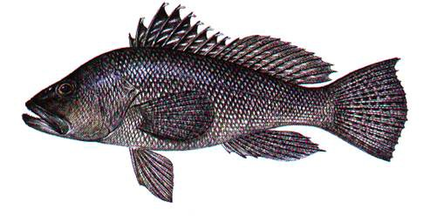
Regulatory Amendment 16
to the Fishery Management Plan
for the Snapper Grouper Fishery
of the South Atlantic Region

DECISON DOCUMENT

DECEMBER 2015

Background

In 2013, a stock assessment concluded that the black sea bass stock in the South Atlantic is not undergoing overfishing, is not overfished, and is rebuilt. In response to the stock assessment, the South Atlantic Fishery Management Council’s (Council) Scientific and Statistical Committee (SSC), at their April 2013 meeting, recommended an increase to the acceptable biological catch (ABC) for black sea bass. The increase in the ABC allowed the commercial and recreational annual catch limits (ACL) to increase. The Council and NMFS, through Regulatory Amendment 19 to the Fishery Management Plan (FMP) for the Snapper Grouper Fishery of the South Atlantic Region (Snapper Grouper FMP) (SAFMC 2013), modified the ABC, ACLs, recreational annual catch target (ACT), and optimum yield (OY) for the black sea bass stock.

The increase to the commercial ACL could have extended fishing activity with black sea bass pot gear past November 1, the onset of right whale calving season in the South Atlantic and migration of large Endangered Species Act (ESA)-listed whales. Since black sea bass pot gear could potentially be used past November 1, the only way the ACL increase could be implemented quickly was for the Council and NMFS to implement a prohibition on the use of black sea bass pot gear from November 1 through April 30 each year, beginning in 2013. Further, with the change in the start of the commercial black sea bass fishing year to January 1 each year proposed in Regulatory Amendment 14, there would likely be pots in the water during the first part of the year when whales would be present in the South Atlantic.

Without the prohibition on the use of black sea bass pots during the large whale migration and right whale calving season, a re-initiation of formal consultation for the snapper grouper fishery would have been triggered under the ESA. The consultation would have required development of a biological opinion to perform the additional analyses to evaluate the effects of black sea bass pot gear on ESA listed species. Those analyses would not have been completed in time to allow the ACL increases to be implemented for the 2013-2014 fishing season, which began on June 1. The black sea bass pot prohibition was a precautionary step taken by the Council and NMFS to allow the black sea bass ACL to increase in the 2013-2014 fishing year, while preventing potential entanglements with ESA-listed whales until a comprehensive biological impact analysis could be completed.

Through Regulatory Amendment 16, the Council and NMFS are reconsidering the annual November 1 through April 30 prohibition on the use of black sea bass pot gear. Fishery managers are considering adjustments to both the geographical and temporal boundaries of the closure in order to improve socio-economic benefits to black sea bass pot endorsement holders while maintaining protection for ESA-listed whales in the South Atlantic region. During the scoping process for Regulatory Amendment 16, fishermen reported that fishing for black sea bass during winter months is important to them and claim that the fish migrate southward and are generally found closer to shore making them easier to harvest. Fishermen have also reported this time period is important due to the coloration of the fish. Fish tend to be a lot darker during winter months, which commands a higher price on the market.

History of Management of the Black Sea Bass Pot Fishery

The black sea bass fishery has been managed under the Snapper Grouper FMP since the plan was first published in 1983. Table 1 shows the actions implemented from 1983 through 2013 that have affected the black sea bass pot fishery.

Table 1. History of SAFMC management of the black sea bass pot fishery.
Date | Document | Action
8/31/83 | Original FMP | 8" size limit
1/1/92 | Amendment 1 | Prohibit black sea bass pots south of Cape Canaveral
8/31/92 | Emergency Rule | Modified definition of black sea bass pots
 |  | Allowed multigear trips for black sea bass
 |  | Retention of bycatch in the black sea bass fishery
2/24/99 | Amendment 9 | 10" total length size limit
 |  | Require escape vents and degradable fasteners
12/2/99 | Amendment 11 | Set overfished level at 3.72 mp
10/23/06 | Amendment 13c | Commercial step-down in ACL from 477,000 lbs gw in 2006 to 309,000 lbs gw in 2008
 |  | Require 2" mesh on pots
 |  | Change fishing year to June through May
7/1/12 | Amendment 18a | Reduced participation to 32 endorsements
 |  | 1,000 lbs gw (1,180 ww) commercial trip limit
 |  | Maximum of 35 pots per vessel
 |  | Increased size limit to 11" total length
 |  | Pots must be brought to shore at the conclusion of a trip
9/23/13 | Reg Amend 19 | Increase commercial ACL from 309,000 to 780,020 lbs ww
10/23/13 | Reg Amend 19 | Pot closure from 11/1 through 4/30
12/8/14 | Reg Amend 14 | Commercial fishing year changed to January - December
 |  | Hook and line trip limit is 300 lbs gw November 1 - April 30

Snapper Grouper Amendment 13c in 2006 greatly stepped down the commercial ACL for black sea bass, the majority of which is taken in the pot fishery. Two additional amendments, 18a and Regulatory Amendment 19 further affected commercial fishing for black sea bass, but in very different ways.

Amendment 18a saw the implementation of required endorsements to participate in the fishery. Thirty-two endorsements were issued. For the first time, there was a commercial trip limit of 1,000 lbs gw (1,180 lbs ww) for the pot fishery. Participants in the fishery were limited to no more than 35 pots per vessel, whereas some were fishing as many as 150 pots. Leaving black sea bass pots to soak unattended was prohibited, as pots were required to be brought back at the end of each trip. The size limit for commercial black sea bass was also increased from 10 to 11 inches total length.

While Amendment 18a generally limited participation and reduced gear presence in the water, Regulatory Amendment 19 increased the commercial ACL from 309,000 to 780,020 lbs ww. Because of the limitations put into place in Amendment 18a, the commercial black sea bass pot fishery is expected to last much longer than it has in recent years.

All of these changes taken together create a management scenario that makes it difficult to predict how fishery participants will modify their behavior, and in turn, the economic effects in response to the alternatives proposed in this action. Because of the uncertainty, multiple scenarios must be considered where appropriate when estimating economic effects of potential management changes.

The Black Sea Bass Pot Sector Since the 2006 Biological Opinion

This amendment, which considers alternatives allowing pot fishing during all or part of the closed season, at least in some areas, is expected to result in NMFS SERO Protected Resources beginning development of a Biological Opinion (BiOp) should the SAFMC choose any alternative other than Alternative 1 (No Action) for Action 1. Until a new BiOp is in place, the previous BiOp from 2006 is considered current in the fishery. However, it should be noted that any new BiOp that would be developed for this fishery would also take into account decisions made by the Atlantic Large Whale Take Reduction Plan.

As discussed, Amendment 18a and Regulatory Amendment 19, as well as other factors such as the general downturn in the economy, greatly changed the black sea bass pot fishery since the 2006 Biological Opinion was published following the Council’s development of Snapper Grouper Amendment 13c. The 2006 BiOp assessed potential impacts from the snowy grouper, golden tilefish, vermilion snapper, red porgy, and black sea bass fisheries.

Table 2 shows a few of the characteristics of the black sea bass pot fishery. As the 2006 BiOp went into effect on June 7th of that year, the characteristics for 2006 are split for pre and post 2006 BiOp. While trips and pounds landed are additive for 2006, the number of vessels participating in the fishery are not because many of the vessels that participated in the fishery in the first part of the year also participated in the second part of the fishing year. Also, note that the effects of Amendment 18a and Regulatory Amendment 19 are not reflected in these landings, as they were too recent in time to be reflected in the overall characteristics.

Since the 2006 BiOp, the average annual number of vessels participating in the black sea bass pot fishery has been reduced from 43 to 35 (19%) and the average number of trips has been reduced from 675 to 393 (42%). The changes were due largely to Amendment 13c that reduced the overall ACL for black sea bass.

Table 2. Black sea bass pot fishery characteristics, 2002 through 2012.
 | Fishing Year | Vessels | Trips | Landings (lb gw)
Pre-2006 BiOp | 1996-1997 | 86 | 1276 | 609,424
 | 1997-1998 | 77 | 1258 | 525,920
 | 1998-1999 | 70 | 1277 | 633,987
 | 1999-2000 | 64 | 808 | 344,906
 | 2000-2001 | 61 | 903 | 430,008
 | 2001-2002 | 58 | 1082 | 423,902
 | 2002-2003 | 48 | 693 | 308,005
 | 2003-2004 | 52 | 878 | 591,403
 | 2004-2005 | 47 | 732 | 458,264
 | 2005-2006 | 47 | 658 | 298,782
 | 2006-2007 | 55 | 739 | 409,162
Post-2006 BiOp | 2007-2008 | 49 | 556 | 279,888
 | 2008-2009 | 56 | 562 | 346,765
 | 2009-2010 | 41 | 434 | 288,059
 | 2010-2011 | 52 | 406 | 345,118
 | 2011-2012 | 40 | 235 | 260,464
 | 2012-2013 | 26 | 322 | 213,509
 | 2013-2014 | 27 | 366 | 223,633
Averages | 1999-2006 | 54 | 822 | 407,896
 | 2007-2014 | 42 | 412 | 279,634

Source: SEFSC Logbook data

Note: Landings from 2006 are excluded from Averages calculated for both Pre and Post 2006 Biological Opinion.

DEIS Comments Review: DEIS comment period ended 12/7/2015.

MOTION:

REQUIRED COMMITTEE ACTION:
Purpose for Action

The purpose of Regulatory Amendment 16 is to reevaluate the annual November 1 through April 30 prohibition on the use of black sea bass pot gear and enhance buoy line/weak link gear requirements and buoy line rope marking for black sea bass pots required by the Atlantic Large Whale Take Reduction Plan.

Need for Action

The need for the amendment is to reduce the adverse socioeconomic impacts resulting from the annual November 1 through April 30 prohibition on the use of black sea bass pot gear and increase the flexibility of black sea bass pot endorsement holders to fish with this gear while continuing to protect ESA-listed whales in the South Atlantic region; and reduce the adverse effects on whales if entangled and help identify black sea bass pot lines used in the South Atlantic.

Option 1: Modify the Purpose and Need
Option 2: Approve the Purpose and Need as shown above
Option 3: Others??

MOTION:

Proposed Actions

Action 1. Modify the annual November 1 through April 30 prohibition on the use of black sea bass pot gear

Note: There are many alternatives and sub-alternatives under Action 1. The Council’s intent with this action is to find the maximal combination of management measures that will allow the entire commercial black sea bass fishery (all gears) to open beginning January 1 each year and have it last as long as possible before reaching the ACL and forcing a closure of the fishery prior to December 31st. The Council is also factoring in the need to protect critically endangered North Atlantic Right Whales (NARW) that migrate through South Atlantic waters and calve in the South Atlantic Bight roughly during the November through April time frame. To meet these two objectives, the Council is considering various time frames, water depths, and locations for allowing or not allowing black sea bass pot gear to be in the waters managed by the South Atlantic Council, so as to reduce as much as possible, the potential for interactions between NARWs and black sea bass pot gear. Each of the alternatives and sub-alternatives of Action 1 manipulate timing and location/depth of prohibited fishing areas to maximize fishing opportunity and protection for whales.

Alternative 1 (No Action). Retention, possession, and fishing for black sea bass is prohibited using black sea bass pot gear, annually, from November 1 through April 30 where black sea bass is managed in the South Atlantic EEZ (south of Cape Hatteras, NC).
The following provisions currently exist that may reduce entanglements of whales listed under the Endangered Species Act. The South Atlantic Fishery Management Council does not intend to change these provisions through this amendment.

Amendment 18A to the Snapper Grouper Fishery Management Plan of the South Atlantic Region (SAFMC 2012a):

- Established an endorsement program that capped the number of vessels utilizing pot gear at 32;
- Limited the number of pots per vessel to 35;
- Required that pots be brought back to shore after each trip; and
- Established a commercial trip limit of 1,000 lbs gw.
See Table 1.6.1 in Regulatory Amendment 16 for measures mandated through the Atlantic Large Whale Take Reduction Plan.

Alternative 2. The black sea bass pot closure applies to the area currently designated as North Atlantic right whale critical habitat (Figure 2.1.1). North Atlantic right whale critical habitat encompasses waters between 31° 15’N, (approximately the mouth of the Altamaha River, Georgia) and 30° 15’N (approximately Jacksonville, Florida) from the shoreline out to 15 nautical miles offshore; and the waters between 30° 15’N and 28 °00’N, (approximately Sebastian Inlet, Florida) from the shoreline out to 5 nautical miles. The closure applies to the area annually from November 15 through April 15.

This area represents North Atlantic right whale critical habitat in the South Atlantic region designated on June 3, 1994. The map below provides location of the critical habitat boundary. The critical habitat designation did not provide waypoints for the boundary. The boundary would not automatically change if the boundary for the right whale critical habitat were to change. North Atlantic right whale critical habitat is currently undergoing a revision based on more current data. Proposed changes are published at: 80 FR 9314.

The following is language describing the North Atlantic right whale critical habitat area from 50 CFR 226:
Southeastern United States: The area designated as critical habitat in these waters encompasses waters between 31 deg.15’N (approximately located at the mouth of the Altamaha River, GA) and 30 deg.15’N (approximately Jacksonville, FL) from the shoreline out to 15 nautical miles offshore; and the waters between 30 deg.15’N and 28 deg.00’N (approximately Sebastian Inlet, FL) from the shoreline out to 5 nautical miles.

Note: Federal regulations would only apply to that portion of the area within the South Atlantic EEZ. The states will be asked to implement compatible regulations within state waters.

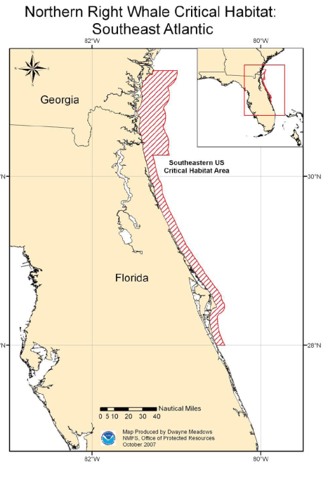

Figure 2.1.1. Area for the proposed black sea bass pot closure in Alternative 2.
Source: http://www.fisheries.noaa.gov/pr/pdfs/criticalhabitat/northatlanticrightwhale.pdf

Alternative 3. The black sea bass pot closure applies to waters inshore of points 1-15 listed below (Table 2.1.1); approximately Ponce Inlet, Florida, to Cape Hatteras, North Carolina (Figure 2.1.2). The closure applies to the area annually from November 1 through April 30.

This area likely represents North Atlantic right whale calving habitat. The area identified from Cape Fear, North Carolina, southward to 29°N (approximately Ponce Inlet, Florida) is based on model outputs (i.e., Garrison 2007, Keller et al. 2012, Good 2008). The area from Cape Fear, North Carolina, to Cape Hatteras, North Carolina, is an extrapolation of those model outputs and based on sea surface temperatures and bathymetry.

Note: Federal regulations would only apply to that portion of the area within the South Atlantic EEZ. The states will be asked to implement compatible regulations within state waters.

Table 2.1.1. Eastern boundary coordinates for the proposed black sea bass pot closure in Alternative 3.
Point | N Latitude | W Longitude
1 | 35°15′ N | State/EEZ boundary
2 | 35°15’ | 75°12’
3 | 34°51’ | 75°45’
4 | 34°21’ | 76°18’
5 | 34°21’ | 76°45’
6 | 34°12’ | 77°21’
7 | 33°37’ | 77°47
8 | 33°28’ | 78°33
9 | 32°59’ | 78°50’
10 | 32°17’ | 79°53’
11 | 31°31’ | 80°33’
12 | 30°43’ | 80°49’
13 | 30°30’ | 81°01’
14 | 29°45’ | 81°01’
15 | 29°00’ | State/EEZ boundary
Source: Amanda Frick, NMFS SERO

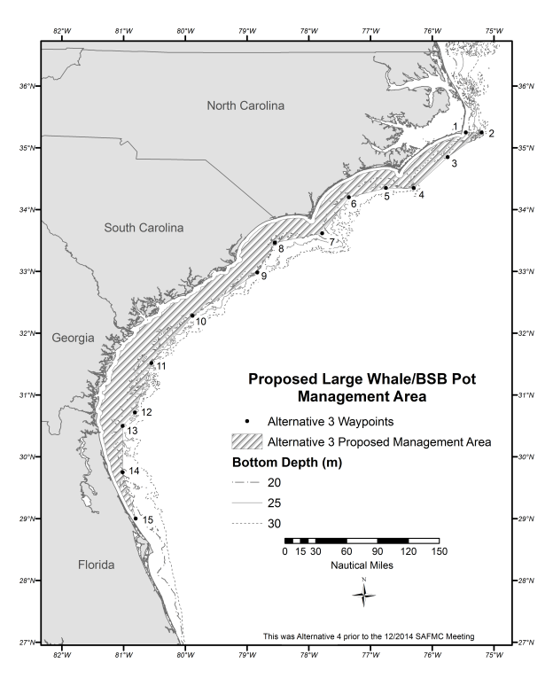
Figure 2.1.2. Area for the proposed black sea bass pot closure in Alternative 3.
Source: Amanda Frick, NMFS SERO
Alternative 4. The black sea bass pot closure applies to waters inshore of points 1-28 listed below (Table 2.1.2); approximately Cape Canaveral, Florida, to Cape Hatteras, North Carolina (Figure 2.1.3). The closure applies to the area annually from November 1 through April 30.

This area generally represents waters 25 meters or shallower from 28° 21’N (approximately Cape Canaveral, Florida) to Savannah, Georgia; from the Georgia/South Carolina border to Cape Hatteras, North Carolina, the closure applies to waters under Council management that are 30 meters or shallower. This bathymetric area is based on right whale sightings (all demographic segments) and sightings per unit of effort (proxy of density) by depth and captures 97% and 96% of right whale sightings off the North Carolina/South Carolina area, and Florida/Georgia area, respectively. The map below provides an approximate location of the proposed boundary.

Note: Federal regulations would only apply to that portion of the area within the South Atlantic EEZ. The states will be asked to implement compatible regulations within state waters.

Table 2.1.2. Eastern boundary coordinates for the proposed black sea bass pot closure in Alternative 4.
Point | N Latitude |  | W Longitude | Point | N Latitude | W Longitude
1 | 35° | 15’ | State/EEZ boundary | 15 | 33° 01’ | 78° 38’
2 | 35° | 15’ | 75° 08’ | 16 | 32° 40’ | 79° 01’
3 | 34° | 58’ | 75° 41’ | 17 | 32° 36’ | 79° 18’
4 | 34° | 49’ | 75° 50’ | 18 | 32° 19’ | 79° 22’
5 | 34° | 47’ | 76° 05’ | 19 | 32° 16’ | 79° 37’
6 | 34° | 31’ | 76° 18’ | 20 | 32° 03’ | 79° 48’
7 | 34° | 20’ | 76° 13 | 21 | 31° 39’ | 80° 27’
8 | 34° | 12’ | 77° 00’ | 22 | 30° 58’ | 80° 47’
9 | 33° | 43’ | 77° 30’ | 23 | 30° 13’ | 81° 01’
10 | 33° | 21’ | 77° 21’ | 24 | 29° 32’ | 80° 39’
11 | 33° | 18’ | 77° 41’ | 25 | 29° 22’ | 80° 44’
12 | 33° | 22’ | 77° 56’ | 26 | 28° 50’ | 80° 22’
13 | 33° | 12’ | 78° 20’ | 27 | 28° 21’ | 80° 18’
14 | 33° | 05’ | 78° 22’ | 28 | 28° 21’ | State/EEZ boundary
Source: Amanda Frick, NMFS SERO

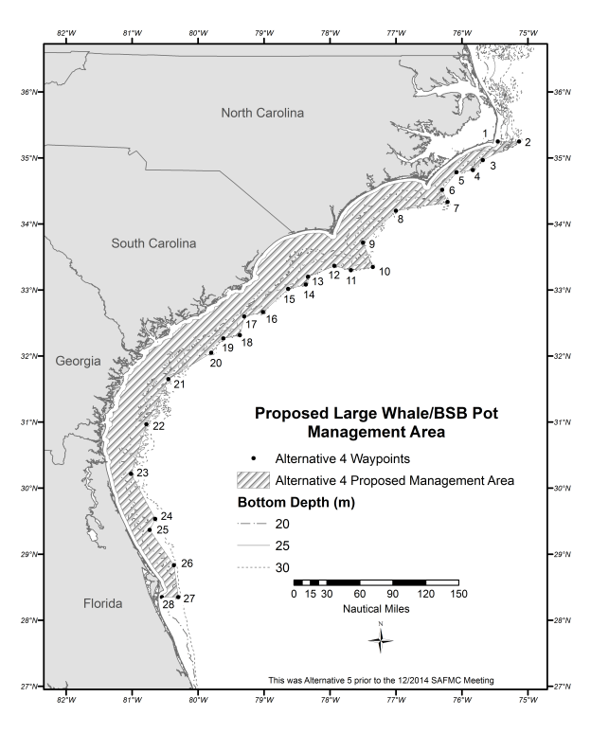
Figure 2.1.3. Area for the proposed black sea bass pot closure in Alternative 4.
Source: Amanda Frick, NMFS SERO
Alternative 5. The black sea bass pot closure applies to waters inshore of points 1-28 listed below (Table 2.1.3); approximately Daytona Beach, Florida, to Cape Hatteras, North Carolina (Figure 2.1.4). The closure applies to the area annually from November 1 through April 30.

This area is based on joint comments received from non-government organizations (dated January 3, 2014) in response to NMFS’ December 4, 2013, Federal Register Notice of Intent to Prepare this Draft Environmental Impact Statement (DEIS) (78 FR 72868). The non-government organizations proposed the area as a reasonable alternative for consideration. The area, also included in a Center for Biological Diversity et al. petition in 2009 for right whale critical habitat, is off the coasts of Georgia and Florida and based on calving right whale habitat modeling work of Garrison (2007) and Keller et al. (2012). This area represents the 75th percentile of sightings (91% of historical sightings included in their study) off Florida and Georgia (Garrison 2007 and Keller et al. 2012). Off the coasts of North Carolina and South Carolina, the closure extends from the start of the EEZ to 30 nautical miles offshore. The map below provides approximate location of proposed boundary.

Note: Federal regulations would only apply to that portion of the area within the South Atlantic EEZ. The states will be asked to implement compatible regulations within state waters.

Table 2.1.3. Eastern boundary coordinates for the proposed black sea Bass pot closure in Alternative 5.
Point | N Latitude | W Longitude | Point | N Latitude | W Longitude
1 | 35°15’ | State/EEZ Boundary | 15 | 33°21’ | 77°45’
2 | 35°15’ | 74°54’ | 16 | 33°19’ | 78°02’
3 | 35°03’ | 74°57’ | 17 | 33°24’ | 78°17’
4 | 34°51’ | 75°06’ | 18 | 33°14’ | 78°33’
5 | 34°45’ | 75°18’ | 19 | 32°55’ | 78°39’
6 | 34°43’ | 75°33’ | 20 | 32°39’ | 78°56’
7 | 34°26’ | 75°57’ | 21 | 31°42’ | 80°24’
8 | 34°12’ | 76°07’ | 22 | 31°31’ | 80°33’
9 | 34°04’ | 76°26’ | 23 | 30°43’ | 80°49’
10 | 34°05’ | 76°41’ | 24 | 30°30’ | 81°01’
11 | 34°10’ | 76°55’ | 25 | 29°45’ | 81°01’
12 | 33°58’ | 77°16’ | 26 | 29°31’ | 80°58’
13 | 33°41’ | 77°23’ | 27 | 29°13’ | 80°52’
14 | 33°28’ | 77°32’ | 28 | 29°13’ | State/EEZ boundary
Source: Amanda Frick, NMFS SERO

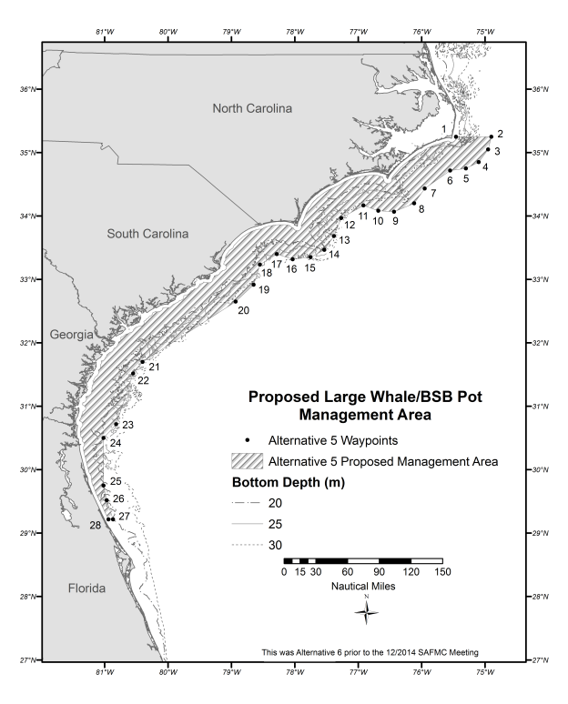
Figure 2.1.4. Area for the proposed black sea bass pot closure in Alternative 5.
Source: Amanda Frick, NMFS SERO

Alternative 6. The black sea bass pot closure applies to waters inshore of points 1-20 listed below (Table 2.1.4); approximately Sebastian, Florida, to Cape Hatteras, North Carolina (Figure 2.1.5). The closure applies to the area annually from November 1 through April 30.

This area is also based on joint comments received from a number of environmental groups (dated January 3, 2014) in response to NMFS’ December 4, 2013, Federal Register Notice of Intent to Prepare this DEIS (78 FR 72868). The environmental groups proposed the area as a reasonable alternative for consideration. This area represents an existing management area, the Southeast Seasonal Gillnet Restricted Area, under the Atlantic Large Whale Take Reduction Plan; and an additional area off North Carolina. The area off North Carolina includes waters shallower than 30 meters and is northward of the designated ALWTRP Southeast Restricted Area.

Note: Federal regulations would only apply to that portion of the area within the South Atlantic EEZ. The states will be asked to implement compatible regulations within state waters.

Table 2.1.4. Eastern boundary coordinates for the proposed black sea bass pot closure in Alternative 6.
Point | N Latitude |  | W Longitude
1 | 35º | 15’ | State/EEZ Boundary
2 | 35º | 15’ | 75º 08’
3 | 34º | 58’ | 75º 41’
4 | 34º | 49’ | 75º 50’
5 | 34º | 47’ | 76º 05’
6 | 34º | 31’ | 76º 18’
7 | 34º | 20’ | 76º 13’
8 | 34º | 12’ | 77º 00’
9 | 33º | 43’ | 77º 30’
10 | 33º | 21’ | 77º 21’
11 | 33º | 18’ | 77º 41’
12 | 33º | 22’ | 77º 56’
13 | 33º | 19’ | 78º 06’
14 | 32º | 58’ | 78º 39’
15 | 32º | 39’ | 78º 59’
16 | 32º | 37’ | 79º 14’
17 | 32º | 22’ | 79º 22’
18 | 32º | 00’ | 80º 00’
19 | 27º | 51’ | 80º 00’
20 | 27º | 51’ | State/EEZ Boundary
Source: Amanda Frick, NMFS SERO

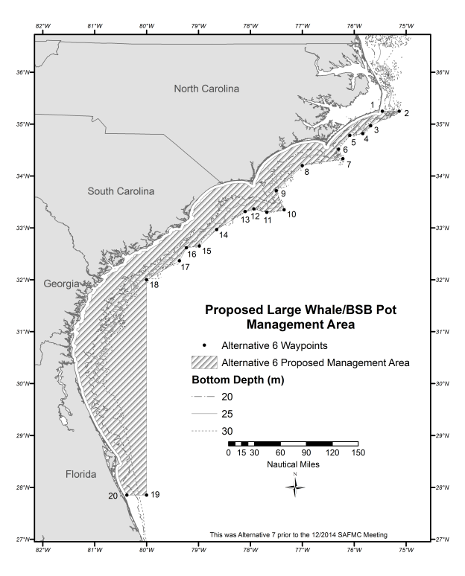
Figure 2.1.5. Area for the proposed black sea bass pot closure in Alternative 6.
Source: Amanda Frick, NMFS SERO
Alternative 7. The black sea bass pot closure applies to the area currently designated as North Atlantic right whale critical habitat, in addition to waters inshore of points 1-29 listed below (Table 2.1.5); approximately North of the Altamaha River, Georgia, to Cape Hatteras, North Carolina (Figure 2.1.6).

Sub-alternative 7a. The black sea bass pot closure applies to the area annually from November 1 through December 15 and March 15 through April 30.

Sub-alternative 7b. For the area off North Carolina and South Carolina, the black sea bass pot closure applies annually from November 1 through December 15 and March 15 through April 30. For the area off Georgia and Florida, the black sea bass pot closure applies annually from November 15 through April 15.

Sub-alternative 7c. For the area off North Carolina and South Carolina, the black sea bass pot closure applies annually from February 15 through April 30. For the area off Georgia and Florida, the black sea bass pot closure applies annually from November 15 through April 15.

This area represents existing North Atlantic right whale critical habitat in the South Atlantic region designated on June 3, 1994. The boundary would not automatically change if the boundary for the right whale critical habitat were to change. North Atlantic right whale critical habitat is currently undergoing a revision based on more current data. Proposed changes are published at: 80 FR 9314. Off North Carolina and South Carolina, the black sea bass pot closure applies in the exclusive economic zone in waters shallower than 25 meters. The eastern boundary of the closure between these two areas was formed by drawing a straight line from the southeastern corner waypoint of the northern portion (NC/SC) to the northeastern corner waypoint of the southern section (FL/GA).

The following is language describing the North Atlantic right whale critical habitat area from 50 CFR 226:
Southeastern United States: The area designated as critical habitat in these waters encompasses waters between 31 deg.15’N (approximately located at the mouth of the Altamaha River, GA) and 30 deg.15’N (approximately Jacksonville, FL) from the shoreline out to 15 nautical miles offshore; and the waters between 30 deg.15’N and 28 deg.00’N (approximately Sebastian Inlet, FL) from the shoreline out to 5 nautical miles.

Note: Federal regulations would only apply to that portion of the area within the South Atlantic EEZ. The states will be asked to implement compatible regulations for the portion of the area within state waters.

Table 2.1.5. Eastern boundary coordinates for the proposed black sea bass pot closure in Alternative 7.
Point | N Latitude | W Longitude | Point | N Latitude | W Longitude
1 | 35° 15’ | State/EEZ boundary | 22 | 32° 56’ | 78° 57’
2 | 35° 15’ | 75° 09’ | 23 | 32° 44’ | 79° 04’
3 | 35° 06’ | 75° 22’ | 24 | 32° 42’ | 79° 13’
4 | 35° 06’ | 75° 39’ | 25 | 32° 34’ | 79° 23’
5 | 35° 01’ | 75° 47’ | 26 | 32° 25’ | 79° 25’
6 | 34° 54’ | 75° 46’ | 27 | 32° 23’ | 79° 37’
7 | 34° 52’ | 76° 04’ | 28 | 31° 53’ | 80° 09’
8 | 34° 33’ | 76° 22’ | 29 | 31° 15’ | 80° 59’
9 | 34° 23’ | 76° 18’ | 30 | 30° 56’ | 81° 05’
10 | 34° 21’ | 76° 27’ | 31 | 30° 42’ | 81° 07’
11 | 34° 25’ | 76° 51’ | 32 | 30° 15’ | 81° 05’
12 | 34° 09’ | 77° 19’ | 33 | 30° 15’ | 81° 17’
13 | 33° 44’ | 77° 38’ | 34 | 29° 40’ | 81° 07’
14 | 33° 25’ | 77° 27’ | 35 | 29° 08’ | 80° 51’
15 | 33° 22’ | 77° 40’ | 36 | 28° 36’ | 80° 28’
16 | 33° 28’ | 77° 41’ | 37 | 28° 26’ | 80° 25’
17 | 33° 32’ | 77° 53’ | 38 | 28° 20’ | 80° 31’
18 | 33° 22’ | 78° 26’ | 39 | 28° 11’ | 80° 30’
19 | 33° 06’ | 78° 31’ | 40 | 28° 00’ | 80° 25’
20 | 33° 05’ | 78° 40’ | 41 | 28° 00’ | State/EEZ Boundary
21 | 33° 01’ | 78° 43’
Source: Amanda Frick, NMFS SERO
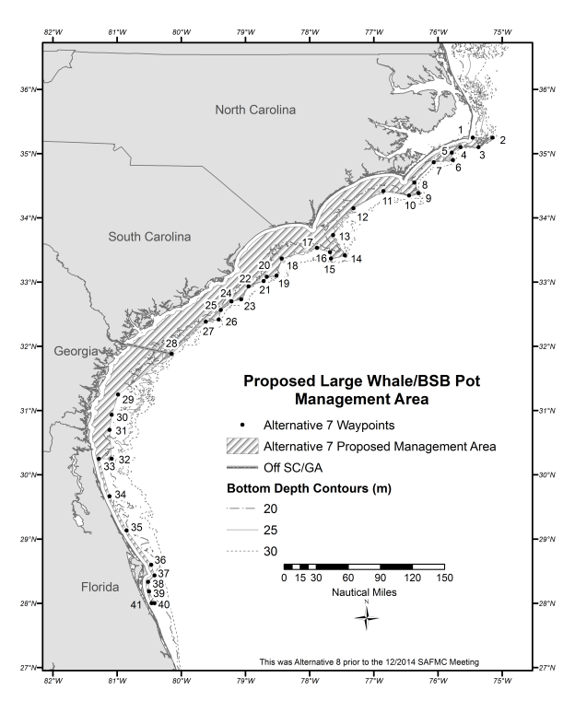
Figure 2.1.6. Area for the proposed black sea bass pot closure in Alternative 7.
Source: Amanda Frick, NMFS SERO
Alternative 8 . The black sea bass pot closure applies to waters inshore of points 1-35 listed below (Table 2.1.6); approximately Daytona Beach, Florida, to Cape Hatteras, North Carolina (Figure 2.1.7).

Sub-alternative 8a. The black sea bass pot closure applies to the area annually from November 1 through April 15.

Sub-alternative 8b. For the area off North Carolina and South Carolina, the black sea bass pot closure applies annually from November 1 through December 15 and February 15 through April 30. For the area off Georgia and Florida, the black sea bass pot closure applies annually from November 15 through April 15.

In Alternative 8, the boundaries off Florida and Georgia are identical to the boundaries in Alternative 5. Off North Carolina and South Carolina, the black sea bass pot closure applies in the exclusive economic zone in waters shallower than 25 meters.

Note: Federal regulations would only apply to that portion of the area within the South Atlantic EEZ. The states will be asked to implement compatible regulations for the portion of the area within state waters.

Table 2.1.6. Eastern boundary coordinates for the proposed black sea bass pot closure in Alternative 8.
Point | N Latitude | W Longitude | Point | N Latitude | W Longitude
1 | 35° 15’ | State/EEZ Boundary | 19 | 33° 06’ | 78° 31’
2 | 35° 15’ | 75° 09’ | 20 | 33° 05’ | 78° 40’
3 | 35° 06’ | 75° 22’ | 21 | 33° 01’ | 78° 43’
4 | 35° 06’ | 75° 39’ | 22 | 32° 56’ | 78° 57’
5 | 35° 01’ | 75° 47’ | 23 | 32° 44’ | 79° 04’
6 | 34° 54’ | 75° 46’ | 24 | 32° 42’ | 79° 13’
7 | 34° 52’ | 76° 04’ | 25 | 32° 34’ | 79° 23’
8 | 34° 33’ | 76° 22’ | 26 | 32° 25’ | 79° 25’
9 | 34° 23’ | 76° 18’ | 27 | 32° 23’ | 79° 37
10 | 34° 21’ | 76° 27’ | 28 | 31° 53’ | 80° 09’
11 | 34° 25’ | 76° 51’ | 29 | 31º 31’ | 80º 33’
12 | 34° 09’ | 77° 19’ | 30 | 30º 43’ | 80º 49’
13 | 33° 44’ | 77° 38’ | 31 | 30º 30’ | 81º 01’
14 | 33° 25’ | 77° 27’ | 32 | 29º 45’ | 81º 01’
15 | 33° 22’ | 77° 40’ | 33 | 29º 31’ | 80º 58’
16 | 33° 28’ | 77° 41’ | 34 | 29º 13’ | 80º 52’
17 | 33° 32’ | 77° 53’ | 35 | 29º 13’ | State/EEZ Boundary
18 | 33° 22’ | 78° 26’
Source: Amanda Frick, NMFS SERO
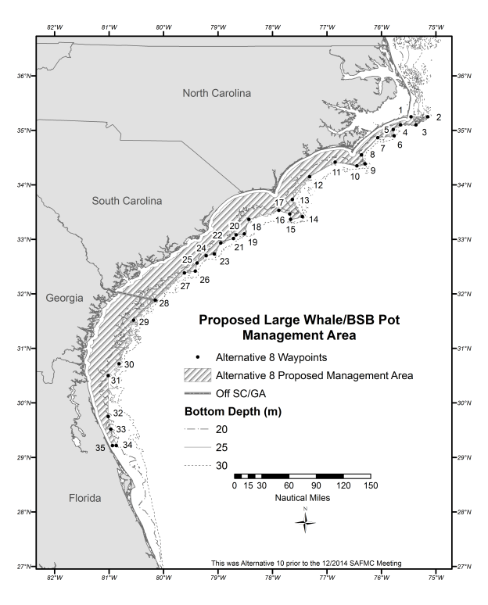
Figure 2.1.7. Area for the proposed black sea bass pot closure in Alternative 8.
Source: Amanda Frick, NMFS SERO
Alternative 9. The black sea bass pot closure applies to waters inshore of points 1-28 listed below (Table 2.1.7); approximately Daytona Beach, Florida, to Cape Hatteras, North Carolina (Figure 2.1.8).

Sub-alternative 9a. The black sea bass pot closure applies to the area annually from November 1 through April 15.

Sub-alternative 9b. For the area off North Carolina and South Carolina, the black sea bass pot closure applies annually from November 1 through December 15 and February 15 through April 30. For the area off Georgia and Florida, the black sea bass pot closure applies annually from November 15 through April 15.

In Alternative 9, the boundaries off Florida and Georgia are identical to the boundaries in Alternative 5. Off North Carolina and South Carolina, the black sea bass pot closure applies in the exclusive economic zone in waters shallower than 20 meters.

Note: Federal regulations would only apply to that portion of the area within the South Atlantic EEZ. The states will be asked to implement compatible regulations for the portion of the area within state waters.

Table 2.1.7. Eastern boundary coordinates for the proposed black sea bass pot closure in Alternative 9.
Point | N Latitude | W Longitude
1 | 35° 15′ | State/EEZ Boundary
2 | 35° 15’ | 75° 20’
3 | 35° 05’ | 75° 24’
4 | 35° 08’ | 75° 38’
5 | 35° 04’ | 75° 52’
6 | 34° 51’ | 76° 11’
7 | 34° 36’ | 76° 24’
8 | 34° 24’ | 76° 19’
9 | 34° 21’ | 76° 27’
10 | 34° 33’ | 76° 48’
11 | 34° 16’ | 77° 25’
12 | 33° 44’ | 77° 46’
13 | 33° 30’ | 77° 31’
14 | 33° 28’ | 77° 35’
15 | 33° 36’ | 77° 55’
16 | 33° 34’ | 78° 28’
17 | 32° 59’ | 78° 52’
18 | 32° 59’ | 79° 02’
19 | 32° 31’ | 79° 30’
20 | 31° 57’ | 80° 27’
21 | 31° 42’ | 80° 24’
22 | 31º 31’ | 80º 33’
23 | 30º 43’ | 80º 49’
24 | 30º 30’ | 81º 01’
25 | 29º 45’ | 81º 01’
26 | 29º 31’ | 80º 58’
27 | 29º 13’ | 80º 52’
28 | 29º 13’ | State/EEZ Boundary
Source: Amanda Frick, NMFS SERO
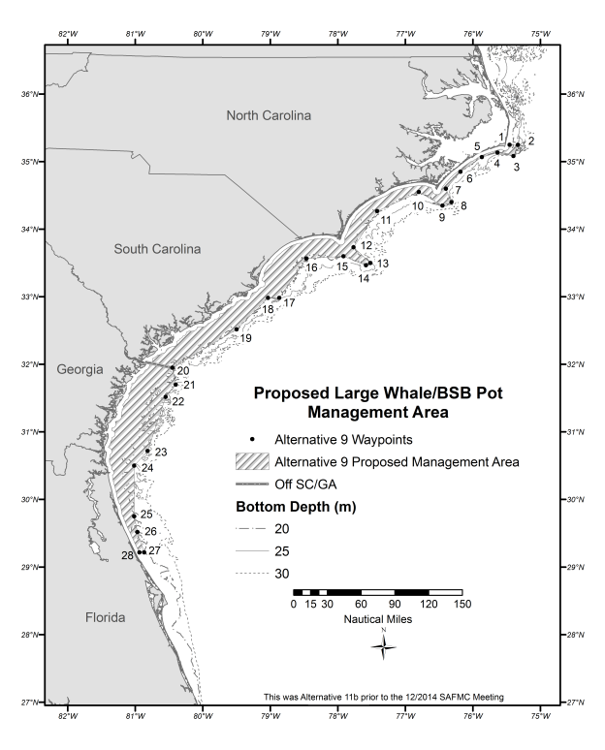
Figure 2.1.8. Area for the proposed black sea bass pot closure in Alternative 9.
Source: Amanda Frick, NMFS SERO
Alternative 10. From November 1 through December 15, the black sea bass pot closure applies to waters inshore of points 1-20 listed below (Table 2.1.8), approximately Georgia/South Carolina State Line, to Cape Hatteras, North Carolina (Figure 2.1.9).

From February 15 through April 30, the black sea bass pot closure applies to waters inshore of points 1-28 listed below (Table 2.1.9), approximately Georgia/South Carolina State Line, to Cape Hatteras, North Carolina (Figure 2.1.10).

From December 16 through February 14, there would be no closure off of the Carolinas.

From November 15 through April 15, the black sea bass pot closure applies to waters inshore of points 20-28 listed below (Table 2.1.8), approximately Georgia/South Carolina State Line, to approximately Daytona Beach, Florida (Figure 2.1.9).

In Alternative 10, the boundaries off Florida and Georgia are identical to the boundaries in Alternative 5. Off North Carolina and South Carolina, the black sea bass pot closure applies in the exclusive economic zone in waters shallower than 20 meters from November 1 through December 15 and 25 meters from February 15 through April 30.

Note: Federal regulations would only apply to that portion of the area within the South Atlantic EEZ. The states will be asked to implement compatible regulations within state waters.

Table 2.1.8. Eastern boundary coordinates for the proposed black sea bass pot closure in Alternative 10 for November 1 through December 15 and November 15 through April 15.
Point | N Latitude | W Longitude | Point | N Latitude |  | W Longitude
1 | 35° 15′ | State/EEZ Boundary | 15 | 33° 36’ | 77° 55’
2 | 35° 15’ | 75° 20’ | 16 | 33° 34’ | 78° 28’
3 | 35° 05’ | 75° 24’ | 17 | 32° 59’ | 78° 52’
4 | 35° 08’ | 75° 38’ | 18 | 32° 59’ | 79° 02’
5 | 35° 04’ | 75° 52’ | 19 | 32° 31’ | 79° 30’
6 | 34° 51’ | 76° 11’ | 20 | 31° 57’ | 80° 27’
7 | 34° 36’ | 76° 24’ | 21 | 31° 42’ | 80° 24’
8 | 34° 24’ | 76° 19’ | 22 | 31º 31’ | 80º 33’
9 | 34° 21’ | 76° 27’ | 23 | 30º 43’ | 80º 49’
10 | 34° 33’ | 76° 48’ | 24 | 30º 30’ | 81º 01’
11 | 34° 16’ | 77° 25’ | 25 | 29º 45’ | 81º 01’
12 | 33° 44’ | 77° 46’ | 26 | 29º 31’ | 80º 58’
13 | 33° 30’ | 77° 31’ | 27 | 29º 13’ | 80º 52’
14 | 33° 28’ | 77° 35’ | 28 | 29º 13’ | State/EEZ Boundary
Source: Amanda Frick, NMFS SERO

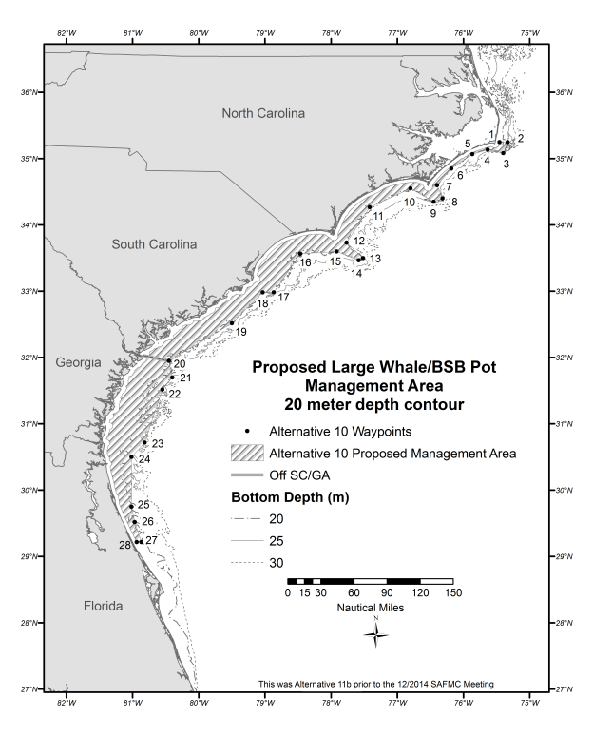
Figure 2.1.9. Area for the proposed black sea bass pot closure in Alternative 10 from November 1 through December 15 and November 15 through April 15.
Source: Amanda Frick, NMFS SERO
Table 2.1.9. Eastern boundary coordinates for the proposed black sea bass pot closure in Alternative 10 for February 15 through April 30.
Point | N Latitude | W Longitude | Point | N Latitude | W Longitude
1 | 35° 15’ | State/EEZ Boundary | 19 | 33° 06’ | 78° 31’
2 | 35° 15’ | 75° 09’ | 20 | 33° 05’ | 78° 40’
3 | 35° 06’ | 75° 22’ | 21 | 33° 01’ | 78° 43’
4 | 35° 06’ | 75° 39’ | 22 | 32° 56’ | 78° 57’
5 | 35° 01’ | 75° 47’ | 23 | 32° 44’ | 79° 04’
6 | 34° 54’ | 75° 46’ | 24 | 32° 42’ | 79° 13’
7 | 34° 52’ | 76° 04’ | 25 | 32° 34’ | 79° 23’
8 | 34° 33’ | 76° 22’ | 26 | 32° 25’ | 79° 25’
9 | 34° 23’ | 76° 18’ | 27 | 32° 23’ | 79° 37
10 | 34° 21’ | 76° 27’ | 28 | 31° 53’ | 80° 09’
11 | 34° 25’ | 76° 51’ | 29 | 31º 31’ | 80º 33’
12 | 34° 09’ | 77° 19’ | 30 | 30º 43’ | 80º 49’
13 | 33° 44’ | 77° 38’ | 31 | 30º 30’ | 81º 01’
14 | 33° 25’ | 77° 27’ | 32 | 29º 45’ | 81º 01’
15 | 33° 22’ | 77° 40’ | 33 | 29º 31’ | 80º 58’
16 | 33° 28’ | 77° 41’ | 34 | 29º 13’ | 80º 52’
17 | 33° 32’ | 77° 53’ | 35 | 29º 13’ | State/EEZ Boundary
18 | 33° 22’ | 78° 26’
Source: Amanda Frick, NMFS SERO
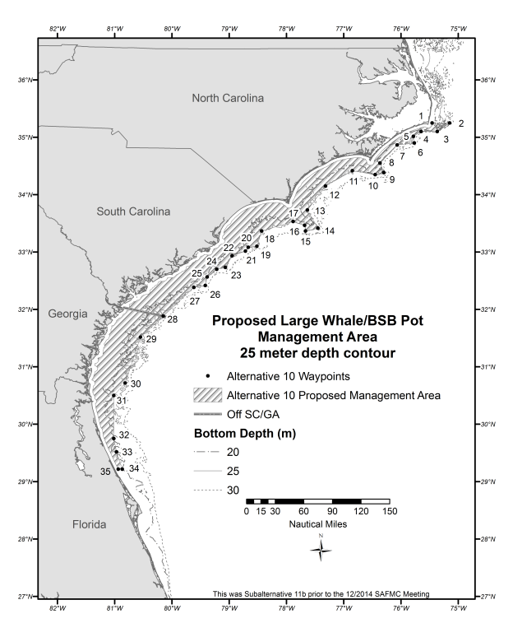
Figure 2.1.10. Area for the proposed black sea bass pot closure in Alternative 10 from February 15 through April 30.
Source: Amanda Frick, NMFS SERO
Preferred Alternative 11. From November 1 through 30 and from April 1 through 30 each year, the black sea bass pot closure applies to waters inshore of points 1-35 listed in Table 2.1.10; approximately Daytona Beach, Florida, to Cape Hatteras, North Carolina (Figure 2.1.11). From December 1 through March 31, the black sea bass pot closure applies to waters inshore of points 1-28 listed below Table 2.1.11; approximately Cape Canaveral, Florida, to Cape Hatteras, North Carolina (Figure 2.1.12).

From November 1 through 30 and from April 1 through 30 each year, the boundaries off Florida and Georgia are nearly identical to the boundaries in Alternative 5. Off North Carolina and South Carolina, the black sea bass pot closure applies in the exclusive economic zone in waters shallower than 25 meters, corresponding with Alternative 8.

From December 1 through March 31, this area generally represents waters 25 m or shallower from 28° 21’ N (approximately Cape Canaveral, Florida) to Savannah, Georgia; from the Georgia/South Carolina border to Cape Hatteras, North Carolina, the closure applies to waters under Council management that are 30 meters or shallower and corresponds with Alternative 4. This bathymetric area is based on right whale sightings (all demographic segments) and sightings per unit of effort (proxy of density) by depth and captures 97% and 96% of right whale sightings off the North Carolina/South Carolina area, and Florida/Georgia area, respectively.

Note: Federal regulations would only apply to that portion of the area within the South Atlantic EEZ. The states will be asked to implement compatible regulations within state waters.

Table 2.1.10. Eastern boundary coordinates for the proposed black sea bass pot closure in Preferred Alternative 11 from November 1 through November 30 and April 1 through April 30.
Point | N Latitude | W Longitude | Point | N Latitude | W Longitude
1 | 35° 15’ | State/EEZ Boundary | 19 | 33° 06’ | 78° 31’
2 | 35° 15’ | 75° 09’ | 20 | 33° 05’ | 78° 40’
3 | 35° 06’ | 75° 22’ | 21 | 33° 01’ | 78° 43’
4 | 35° 06’ | 75° 39’ | 22 | 32° 56’ | 78° 57’
5 | 35° 01’ | 75° 47’ | 23 | 32° 44’ | 79° 04’
6 | 34° 54’ | 75° 46’ | 24 | 32° 42’ | 79° 13’
7 | 34° 52’ | 76° 04’ | 25 | 32° 34’ | 79° 23’
8 | 34° 33’ | 76° 22’ | 26 | 32° 25’ | 79° 25’
9 | 34° 23’ | 76° 18’ | 27 | 32° 23’ | 79° 37
10 | 34° 21’ | 76° 27’ | 28 | 31° 53’ | 80° 09’
11 | 34° 25’ | 76° 51’ | 29 | 31º 31’ | 80º 33’
12 | 34° 09’ | 77° 19’ | 30 | 30º 43’ | 80º 49’
13 | 33° 44’ | 77° 38’ | 31 | 30º 30’ | 81º 01’
14 | 33° 25’ | 77° 27’ | 32 | 29º 45’ | 81º 01’
15 | 33° 22’ | 77° 40’ | 33 | 29º 31’ | 80º 58’
16 | 33° 28’ | 77° 41’ | 34 | 29º 13’ | 80º 52’
17 | 33° 32’ | 77° 53’ | 35 | 29º 13’ | State/EEZ Boundary
18 | 33° 22’ | 78° 26’
Source: Amanda Frick, NMFS SERO

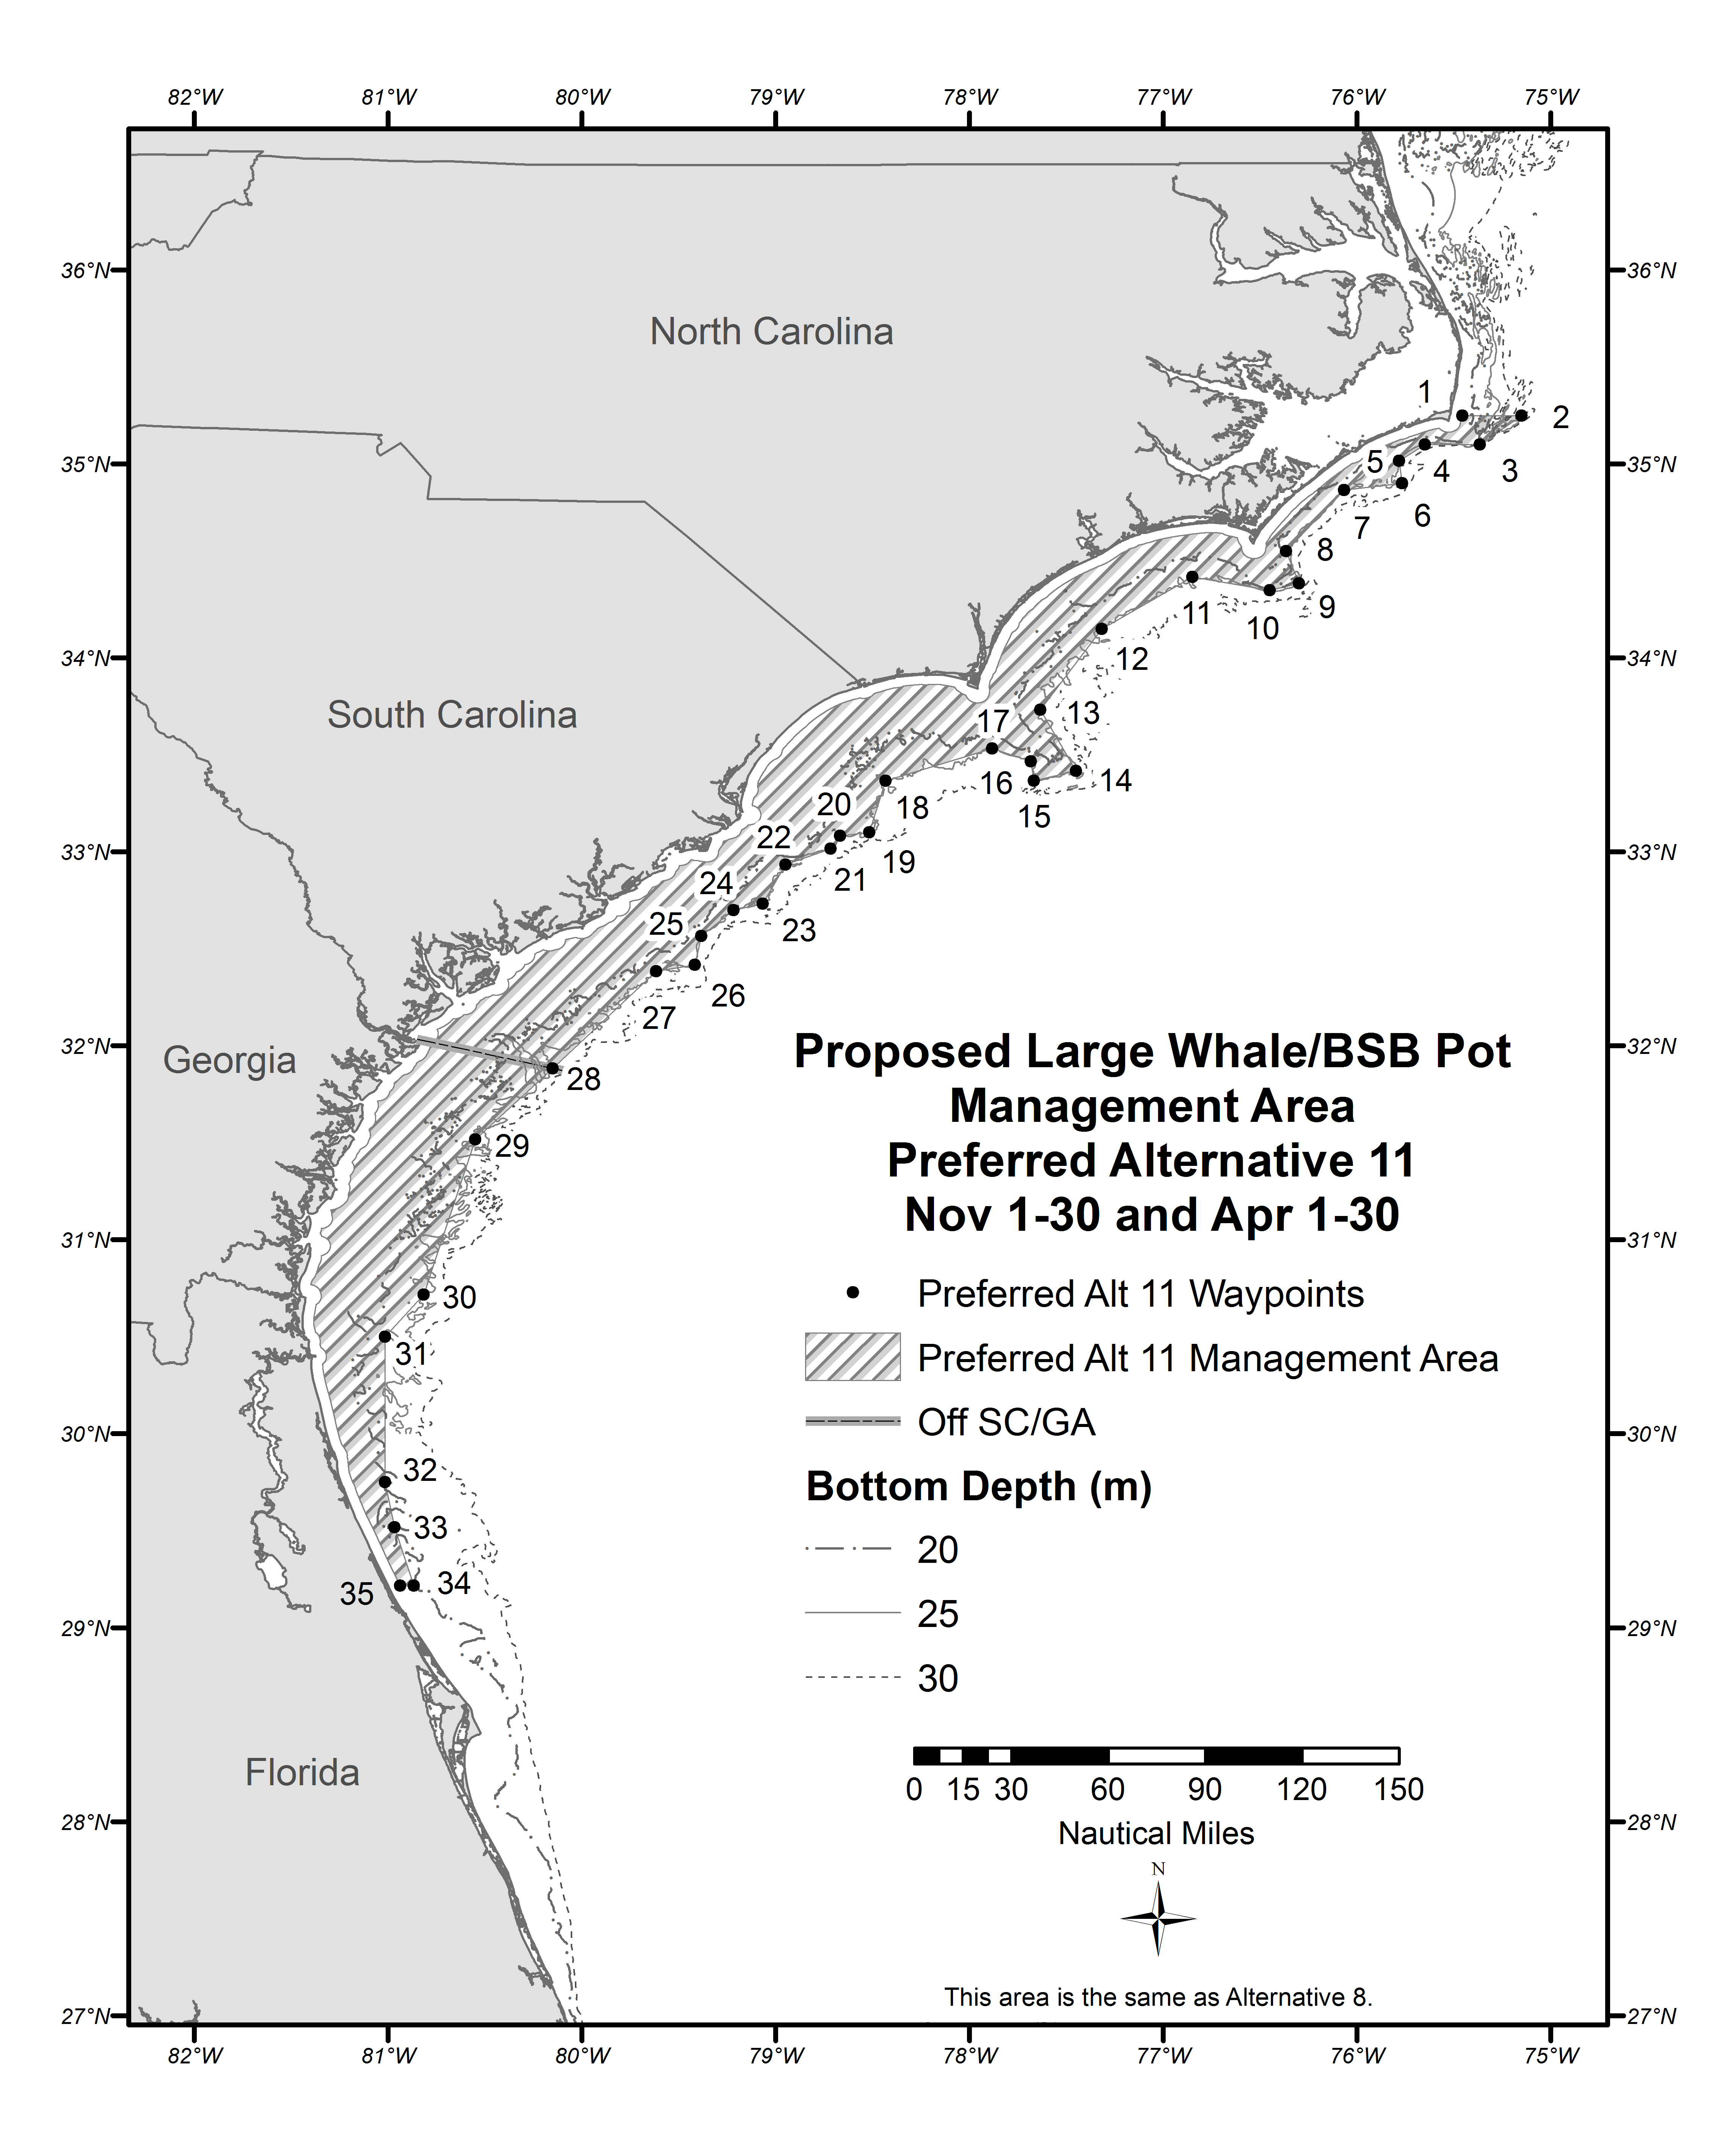
Figure 2.1.11. Area for the proposed black sea bass pot closure in Preferred Alternative 11 from November 1 through November 30 and April 1 through April 30.
Source: Amanda Frick, NMFS SERO
Table 2.1.11. Eastern boundary coordinates for the proposed black sea bass pot closure in Preferred Alternative 11 for December 1 through March 31.
Point | N Latitude |  | W Longitude | Point | N Latitude | W Longitude
1 | 35° | 15’ | State/EEZ boundary | 15 | 33° 01’ | 78° 38’
2 | 35° | 15’ | 75° 08’ | 16 | 32° 40’ | 79° 01’
3 | 34° | 58’ | 75° 41’ | 17 | 32° 36’ | 79° 18’
4 | 34° | 49’ | 75° 50’ | 18 | 32° 19’ | 79° 22’
5 | 34° | 47’ | 76° 05’ | 19 | 32° 16’ | 79° 37’
6 | 34° | 31’ | 76° 18’ | 20 | 32° 03’ | 79° 48’
7 | 34° | 20’ | 76° 13 | 21 | 31° 39’ | 80° 27’
8 | 34° | 12’ | 77° 00’ | 22 | 30° 58’ | 80° 47’
9 | 33° | 43’ | 77° 30’ | 23 | 30° 13’ | 81° 01’
10 | 33° | 21’ | 77° 21’ | 24 | 29° 32’ | 80° 39’
11 | 33° | 18’ | 77° 41’ | 25 | 29° 22’ | 80° 44’
12 | 33° | 22’ | 77° 56’ | 26 | 28° 50’ | 80° 22’
13 | 33° | 12’ | 78° 20’ | 27 | 28° 21’ | 80° 18’
14 | 33° | 05’ | 78° 22’ | 28 | 28° 21’ | State/EEZ boundary
Source: Amanda Frick, NMFS SERO
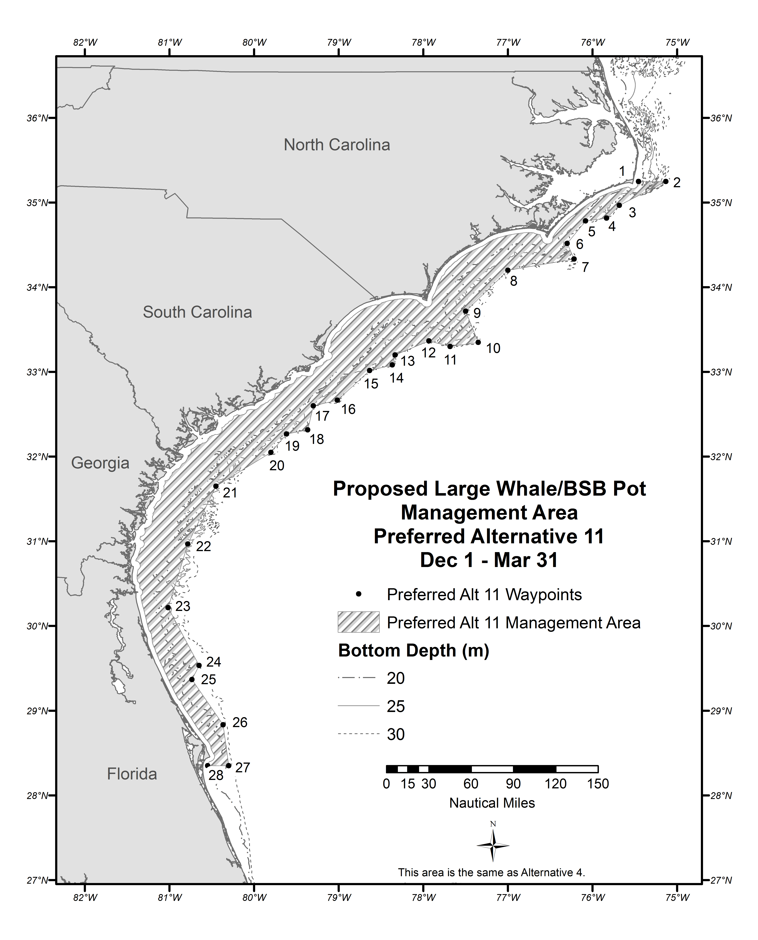
Figure 2.1.12. Area for the proposed black sea bass pot closure in Preferred Alternative 11 from November 1 through November 30 and April 1 through April 30.
Source: Amanda Frick, NMFS SERO

Alternative 12. From November 1 through April 30, the black sea bass pot closure applies to waters inshore of points 1-31 listed below (Table 2.1.12); approximately Cape Canaveral, Florida, to Cape Hatteras, North Carolina (Figure 2.1.13).

This closure approximates the midpoints between proposed closure Alternative 4 and Sub-Alternative 8a.

Note: Federal regulations would only apply to that portion of the area within the South Atlantic EEZ. The states will be asked to implement compatible regulations within state waters.

Table 2.1.12. Eastern boundary coordinates for the proposed black sea bass pot closure in Alternative 12 for November 1 through April 30.
Point | N Latitude | W Longitude | Point | N Latitude | W Longitude
1 | 35° 15' | State/EEZ Boundary | 17 | 33° 05' | 78° 26'
2 | 35° 15' | 75° 09' | 18 | 33° 03' | 78° 39'
3 | 35° 06' | 75° 22' | 19 | 32° 42' | 79° 03'
4 | 35° 04' | 75° 38' | 20 | 32° 37' | 79° 18'
5 | 35° 00' | 75° 44' | 21 | 32° 22' | 79° 23'
6 | 34° 54' | 75° 46' | 22 | 32° 20' | 79° 36'
7 | 34° 51' | 75° 50' | 23 | 31° 31' | 80° 32'
8 | 34° 50' | 76° 04' | 24 | 30° 43' | 80° 49'
9 | 34° 32' | 76° 20' | 25 | 30° 30' | 80° 58'
10 | 34° 21' | 76° 15' | 26 | 30° 13' | 81° 01'
11 | 34° 15' | 77° 04' | 27 | 29° 32' | 80° 49'
12 | 33° 43' | 77° 34' | 28 | 29° 13' | 80° 46'
13 | 33° 23' | 77° 24' | 29 | 28° 37' | 80° 20'
14 | 33° 20' | 77° 41' | 30 | 28° 21' | 80° 18'
15 | 33° 27' | 77° 54' | 31 | 28° 21' | State/EEZ Boundary
16 | 33° 17' | 78° 22'

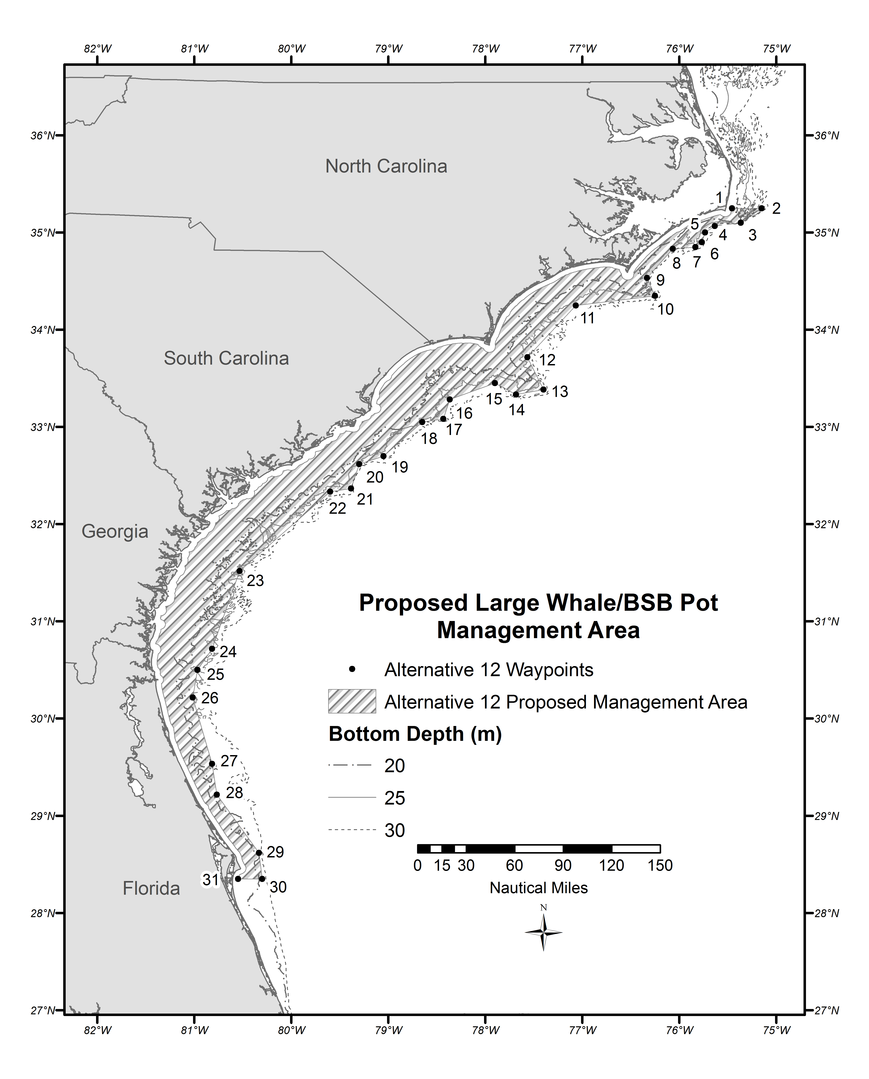
Figure 2.1.13. Area for the proposed black sea bass pot closure in Alternative 12 from November 1 through April 30.
Source: Amanda Frick, NMFS SERO

Biological Effects:

Black Sea Bass
Regardless of which alternative the South Atlantic Council chooses, no biological impacts to the black sea bass stock are expected. Adverse effects are prevented because overall harvest in the commercial sector is limited to the commercial annual catch limit (ACL); commercial accountability measures are also in place. The ACL is reduced from the overfishing level as required to address assessment uncertainty. In addition, there is no evidence to suggest that changing the timing of harvest within the periods covered by the alternatives would have adverse biological impacts. These alternatives are predicted to harvest 97-100% of the ACL and would not provide additional protection to the black sea bass stock in terms of reduced harvest (Table 3). Therefore, there is no difference in the biological effects on black sea bass from the alternatives.

Table 3. Expected closure dates for the commercial black sea bass fishery with a January 1 fishing year start date.
 | Scenario 1 | Scenario 2 | Scenario 3 | Scenario 4
Alternative 1 | No Closure | No Closure | No Closure | No Closure
Alternative 2 | 10/2 | 8/4 | 10/26 - 11/4 | 11/19 - 12/3
Alternative 3 | 11/26 - 12/5 | 10/4 - 10/17 | 10/26 - 11/4 | 11/19 - 12/3
Alternative 4 | 12/20 - 12/30 | 12/7 - 12/22 | 12/11 - 12/18 | 12/19 - 12/30
Alternative 5 | 12/16 - 12/24 | 12/1 - 12/11 | 12/6 - 12/11 | 12/15 - 12/23
Alternative 6 | 12/20 - NC* | 12/7 - 12/25 | 12/10 - 12/20 | 12/19 - NC
Sub-Alternative 7a | 10/11 - 10/12 | 8/18 - 8/20 | 10/6 - 10/9 | 10/7 - -10/9
Sub-Alternative 7b | 12/28 - NC | 12/18 - 12/30 | 12/17 - 12/21 | 12/28 - NC
Sub-Alternative 7c | 12/22 - 12/28 | 12/9 - 12/17 | 12/11 - 12/14 | 12/23 - 12/29
Sub-Alternative 8a | 12/6 - 12/11 | 10/14 - 10/25 | 10/29 - 11/5 | 12/5 - 12/9
Sub-Alternative 8b | 12/29 - NC | 12/20 - 12/30 | 12/18 - 12/21 | 12/29 - NC
Sub-Alternative 9a | 10/28 - 11/9 | 9/15 - 9/27 | 10/13 - 10/19 | 10/24 - 11/3
Sub-Alternative 9b | 12/26 - NC | 12/15 - 12/28 | 12/14 - 12/20 | 12/26 - NC
Alternative 10 | 12/27 - NC | 12/17 - 12/29 | 12/16 - 12/20 | 12/28 - NC
Preferred Alternative 11 | 12/18 – 12/28 | 12/3 -12/18 | 12/6 – 12/13 | 12/17 – 12/27
Alternative 12 | 12/15 – 12/23 | 11/21 – 12/10 | 12/5 – 12/11 | 12/14 – 12/22

Protected Resources
Entanglement in fixed fishing gear is a leading cause of right whale mortality (Knowlton et al. 2012). Rope from trap/pot gear was more frequently found on entangled right whales than rope associated with gillnets when gear from entangled whales could be identified (Johnson et al. 2005). Knowlton et al. (2012) report that approximately 83% of all right whales have been entangled at least once, and 60% of those animals had been entangled multiple times. The authors further clarify that this is a minimum estimate (Knowlton et al. 2012). Based on the current known information about North Atlantic right and humpback whales in the southeastern United States, Alternative 1 (No Action) removes temporal and spatial overlap between the black sea bass pot fishery and these species; essentially eliminating entanglement risk. Maintaining status quo ensures that no black sea bass trap lines will be in the water when ESA-listed large whales are likely to be in or transiting through waters under the SAFMC’s jurisdiction.

Alternative 2 introduces the greatest amount of entanglement risk relative to all the other alternatives. The SERO-LAPP-2014-09 analysis indicates a very high increase in entanglement risk for right whales off North Carolina and from South Carolina to Florida for Alternative 2, relative to Alternative 1 (No Action). The very high relative risk associated with Alternative 2 is because predicted North Atlantic right whale presence is high outside of the spatial boundaries of Alternative 2. Alternative 2 is based on the currently designated North Atlantic right whale critical habitat, designated in the 1994. This area was originally based on 303 sightings from 1950-1989. In the 20+ years since designation, the understanding of where North Atlantic right whales occur, or are most likely to occur, in southeastern United States has grown significantly. North Atlantic right whale critical habitat is currently undergoing a revision based on more current data. A Notice of Proposed Rulemaking to modify North Atlantic right whale critical habitat was published in the Federal Register on February 20, 2015(80 FR 9314).

Alternative 3 would likely introduce less entanglement risk that most alternatives (i.e., Alternative 2 and 10 and Sub-Alternatives 7a, 7b, 7c, 8a, 8b, 9a, and 9b), but introduce more entanglement risk than others (i.e., Alternative 1 (No Action), 4, 5, and 6). The SERO-LAPP-2014-09 analysis indicates a low to moderate increased entanglement risk in right whales off North Carolina, for this alternative, relative to Alternative 1 (No Action). However, that analysis indicates a low to high increased risk of entanglement from South Carolina to Florida for this alternative, relative to Alternative 1 (No Action). Alternative 3 considers the entire period when ESA-listed large whales may be in the southeastern United States (i.e., November 1 through April 30). However, the increase in relative risk is likely because the area proposed in Alternative 3 is based on habitat features preferred by pregnant right whales and mother/calf pairs only (Good 2008, Keller et al. 2012). It does not consider juveniles, non-reproducing adults, or account for the north/south migratory behavior of right whales (i.e., whales that may occur outside of predicted areas due to behavioral reasons). Juvenile right whales are the age class most prone to entanglement and entangle at a higher rate (Knowlton et al. 2012).

Alternative 4 likely introduces relatively little entanglement risk relative to almost all of the alternatives. Only Alternative 1 (No Action) and Alternative 6 would introduce less entanglement risk than Alternative 4. The SERO-LAPP-2014-09 analysis indicates a low increased risk of entanglement both off North Carolina and from South Carolina to Florida, for this alternative, relative to Alternative 1 (No Action). The area proposed under this alternative is based on bathymetry; 2005/06-2012/13 right whale Early Warning System data; South Carolina/Georgia aerial survey data; and 2001/02, 2005/06, and 2006/07 surveys by the University of North Carolina-Wilmington (Garrison 2014). These data sources are more expansive and recent than those used to develop the area proposed in Alternative 3. These newer data sources are particularly more robust off the state of South Carolina, and include all right whale demographic segments (i.e., mother/calf pairs, pregnant females, non-reproducing females, adult males, and juveniles). This alternative considers the entire period when ESA-listed large whales may be in the southeastern United States (i.e., November 1 through April 30) and captures approximately 97% and 96% of right whale sightings in the North Carolina/South Carolina region and the Florida/Georgia region, respectively.

Alternative 5 introduces less entanglement risk relative to most of the alternatives (i.e., Alternatives 2, 3, and 10 and Sub-Alternatives 7a, 7b, 7c, 8a, 8b, 9a, and 9b) but more than others (i.e., Alternatives 1 (No Action), 4, and 6). The SERO-LAPP-2014-09 analysis indicates a low increased entanglement risk in right whales off North Carolina, for this alternative, relative to Alternative 1 (No Action). However, that analysis indicates a low to high increased risk of entanglement from South Carolina to Florida for this alternative, relative to Alternative 1 (No Action). The area proposed off Florida/Georgia under this alternative is based on the right whale calving habitat model that is also the basis for Alternative 3. Off the coasts of North Carolina/South Carolina, the closure extends offshore 30 nautical miles. This alternative considers the entire period when ESA-listed large whales may be in the southeastern United States (i.e., November 1 through April 30). However, the increase in relative risk from South Carolina to Florida is the result of estimated commercial black sea bass pot gear effort south and east of the proposed area closure from St. Augustine to Cape Canaveral, Florida. This alternative provides less protection in the core calving area because the protected area likely does not extend far enough into South Florida waters to capture the full extent of right whale occurrence based on updated information.

Alternative 6 would likely introduce very little entanglement risk; only Alternative 1 (No Action) is expected to have lower entanglement risks. The SERO-LAPP-2014-09 analysis indicates a low increased entanglement risk in right whales off North Carolina, and no increased risk from South Carolina to Florida for this alternative, relative to Alternative 1 (No Action). This area represents an existing federal management area, the Southeast Restricted Area for gillnets, under the Atlantic Large Whale Take Reduction Plan (ALWTRP); and an additional area off North Carolina. The area off North Carolina includes waters shallower than 30 meters. This alternative considers the entire period when ESA-listed large whales may be in the southeastern United States (i.e., November 1 through April 30). This area extends substantially further offshore of Florida and Georgia than areas included in other alternatives. Thus, no increase in relative risk to right whales is anticipated off Florida and Georgia and a negligible increase in relative risk is projected off South Carolina.

Sub-Alternative 7a is likely to introduce less entanglement risk than Sub-Alternative 7b or 7c, as well as Alternatives 2 and 10 and Sub-Alternative 8b and 9b, but would likely introduce more entanglement risk than the remaining alternatives. The SERO-LAPP-2014-09 analysis indicates a high increased entanglement risk for right whales off North Carolina, and a very high increased risk of entanglement for right whales off from South Carolina to Florida for Sub-Alternative 7a, relative to Alternative 1 (No Action). The SERO-LAPP-2014-09 analysis indicates a high to very high increased risk of entanglement under Sub-Alternatives 7b and 7c in right whales off North Carolina and from South Carolina to Florida. Each sub-alternative establishes a “book end” closure period for the area off North Carolina/South Carolina and for the area off Florida/Georgia. As noted previously, North Atlantic right whales may be found in the southeastern United States from November 1 through April 30, and do not mass migrate only at the beginning and end of the calving season but rather there is a steady stream of animals traveling between the northeastern and southeastern United States habitats in fall, winter, and spring. As a result, the closure periods proposed under these sub-alternatives do not cover the entire period when these animals occur in the region. Sub-Alternative 7c covers more of the period when North Atlantic right whales occur in the southeastern United States; however, the fishery is anticipated to reach its ACL soonest under Sub-Alternative 7a (somewhere between early August and early October), followed by Sub-Alterative 7c and Sub-Alterative 7b. Thus, the SERO-LAPP-2014-09 analysis indicates Sub-Alternative 7a will introduce less entanglement risk than Sub-Alternatives 7c and 7b, respectively.

Sub-Alternative 8a is likely to introduce less entanglement risk than a number of others (i.e., Alternatives 2 and 10 and Sub-Alternatives 7a, 7b, 7c, 9a, and 9b) including Sub-Alternative 8b, but will likely introduce more than others (i.e., Alternative 1, 3, 4, 5, and 6). The SERO-LAPP-2014-09 analysis indicates a low to moderate increase in entanglement risk for right whales off North Carolina, and a low to high increased risk of entanglement from South Carolina to Florida for Sub-Alternative 8a, relative to Alternative 1 (No Action). Conversely, the SERO-LAPP-2014-09 analysis indicates a high increased risk of entanglement under Sub-Alternatives 8b off North Carolina and a high to very high increase in entanglement risk from South Carolina to Florida. Sub-Alternative 8a is likely to introduce less entanglement risk relative to Sub-Alternative 8b for two primary reasons. As noted previously, North Atlantic right whales may be found in the southeastern United States from November 1 through April 30, and do not mass migrate only at the beginning and end of the calving season but rather there is a steady stream of animals traveling between the northeastern and southeastern United States habitats in fall, winter, and spring. The closure under Sub-Alternative 8a spans almost the entire period North Atlantic right whales will occur in the southeastern United States, whereas Sub-Alternative 8b establishes a “book-end” closure that does not. The ACL is also projected to be met sooner (between mid-October and mid-December) under Sub-Alternative 8a than under Sub-Alternative 8b (mid-December or not met at all). The sooner the ACL is met, the less likely trap pots will be in the water when right whales may be in the region.

Sub-Alternative 9a is likely to introduce less entanglement risk than Alternatives 2 and 10 and Sub-Alternatives 7a, 7b, 7c, 8b, and 9b, but will likely introduce more entanglement risk than Alternative 1, 3, 4, 5, 6, and Sub-Alternative 8a). The SERO-LAPP-2014-09 analysis indicates a moderate to high increase in entanglement risk for right whales off North Carolina, and from South Carolina to Florida for Sub-Alternative 9a, relative to Alternative 1 (No Action). Conversely, the SERO-LAPP-2014-09 analysis indicates a high to very high increased risk of entanglement under Sub-Alternatives 9b off North Carolina and from South Carolina to Florida. Sub-Alternative 9a is likely to introduce less entanglement risk relative to Sub-Alternative 9b for two primary reasons. As noted previously, North Atlantic right whales may be found in the southeastern United States from November 1 through April 30, and do not mass migrate only at the beginning and end of the calving season but rather there is a steady stream of animals traveling between the northeastern and southeastern United States habitats in fall, winter and spring. The closure under Sub-Alternative 9a spans almost the entire period North Atlantic right whales will occur in the southeastern United States, whereas Sub-Alternative 9b establishes a “book-end” closure that does not. The ACL is projected to be met sooner under Sub-Alternative 9a (between mid-September and early November) than under Sub-Alternative 9b (mid-December or not met at all). The sooner the ACL is met, the less likely trap pots will be in the water when right whales may be in the region.

Alternative 10 is likely introduce more entanglement risk than the majority of alternatives and sub-alternatives (i.e., Alternatives 1, 3, 4, 5, 6, and Sub-Alternatives 7a and 8b), though is likely to introduce less risk than a few (i.e., Alternative 2 and Sub-Alternatives 7b, 7c, and 9b). The SERO-LAPP-2014-09 analysis indicates a high to very high increase in entanglement risk for right whales off North Carolina and from South Carolina to Florida for Alternative 10, relative to Alternative 1 (No Action). As with other alternative and sub-alternatives, Alternative 10 establishes “book-end” closure periods for areas off North Carolina and South Carolina, while establishing a year-round closure off Florida and Georgia. As noted previously, North Atlantic right whales may be found in the southeastern United States from November 1 through April 30, and do not mass migrate only at the beginning and end of the calving season but rather there is a steady stream of animals traveling between the northeastern and southeastern United States habitats in fall, winter and spring. As a result, the “book-end” closure of November 1 through December 15 and February 15 through April 20 off North Carolina and South Carolina is likely to have limited biological benefits. The closure period off Florida and Georgia is likely to be more biologically beneficial, but does not encompass the entire period when North Atlantic right whales will occur in the southeastern United States.

Preferred Alternative 11 is likely to introduce relatively little entanglement risk compare to most alternatives (i.e., Alternatives 2, 3, 5, 10, and 12, and Sub-Alternatives 7a, 7b, 7c, 8a, 8b, 9a, and 9b) but will likely introduce more entanglement risk than Alternatives 1 (No Action), 4, and 6. The SERO-LAPP-2014-09 analysis (Appendix N) indicates a low increased entanglement risk in right whales off North Carolina and from South Carolina to Florida, for this alternative, relative to Alternative 1 (No Action). This alternative is a hybrid of Alternative 4 and 8a. Preferred Alternative 11 would implement a “book-end” closure, closing fishing only from November 1-30 and April 1-30 in the area proposed for closure under Alternative 8a. However, it would also implement a much longer closure from December 1-March 31 in the area currently proposed for closure under Alternative 4. This alternative provides protection to whales during the primary “shoulder season” when whales are migrating to and from the calving grounds. As noted previously, North Atlantic right whales do not mass migrate only at the beginning and end of the calving season but rather there is a steady stream of animals traveling between the northeastern and southeastern United States habitats in fall, winter, and spring. As a result, the “book-end” closure may expose some late/early migrating animals to entanglement risk. However, the alternative does provide a high level of protection to the core calving area, including young calves that are likely to persist off Florida throughout the primary calving season.

Alternative 12 is likely to introduce less entanglement risk than all alternatives other than Alternatives 1 (No Action), 4, 6, and 11. The SERO-LAPP-2014-09 analysis indicates a low increased entanglement risk in right whales off North Carolina and from South Carolina to Florida, for this alternative, relative to Alternative 1 (No Action). Alternative 12 essentially “splits the difference” between the western boundaries of Alternative 4 and 8a. This closure would implement a year round closure for the proposed area from November 1 through April 30. This alternative considers the entire period when ESA-listed large whales may be in the southeastern United States (i.e., November 1 through April 30).

Economic Effects:

The commercial black sea bass sector was closed prior to the end of the fishing year in 2008/2009, on May 15, 2009, when the commercial annual catch limit (ACL) was met. Prior to that season, the sector operated without closures. Figure S-1 shows the average percent of total annual commercial black sea bass landings by month from June 2000 through May 2009, the most recent seasons prior to years when there were ACL-related closures. When operating without closures, the months of June through September saw the fewest commercial landings of black sea bass, ranging from 2-4% each month, while landings tended to increase in November with an average of 11% of the landings. However, fall through spring months saw the highest percentage of annual landings. Highest average annual percentage of total landings occurred in December and January at approximately 18% in each month.

Figure S-1. Percent of average annual commercial black sea bass landings by month from June 2000 through May 2009.
Source: SEFSC/SSRG Economic Panel Data

Expected dockside revenue of the commercial black sea bass portion of the snapper grouper fishery

This analysis of the expected ex-vessel revenue of the alternatives and applied scenarios assumes that consumer demand for black sea bass would at least remain constant regardless of when the fish would be landed. At the very least, demand for black sea bass is assumed to be at the same level as in those years when no closures were in effect.

An expected closure date alone does not give the best estimate of expected value because the price per pound changes from month to month and is influenced also by which gear is being used at the time. The highest expected ex-vessel value will come when the expected landings are highest in months with the highest price per pound. Various estimates of average monthly price per pound, daily expected catch rates, and anticipated closure dates were used to calculate estimated annual dockside values for black sea bass. Estimates are shown for the four catch rate scenarios used in the SERO-LAPP-2014-09 (Appendix N) analysis and are based on the assumption that spatial location of gear in future years would mirror the average of the 2006/2007 through 2008/2009 fishing seasons where there was no closure in the commercial black sea bass season. Table S-5 shows the differences in expected dockside values for Alternative 1 (No Action) subtracted from each of the Alternatives 2 – 12 for all four catch rate scenarios based on monthly price per pound calculations for two different time series, 2000 – 2013 landings and 2011 – 2013 landings.

Table S-5. Expected difference in dockside value of commercial black sea bass under the alternatives of Action 1 compared to Alternative 1 (No Action) using two price per pound estimates, the four different catch rate scenarios (Appendix N), and estimations of spatial locations of gear based on the 2006/2007 through 2008/2009 fishing seasons (Scenario C; Appendix N).
 | Price/lb years | Scenario 1 | Scenario 2 | Scenario 3 | Scenario 4
Alternative 2 | 2000-2013 | $55,579 | $41,654 | $54,865 | $59,233
 | 2011-2013 | $56,344 | $43,028 | $55,362 | $59,967
Alternative 3 | 2000-2013 | $48,666 | $57,925 | $53,395 | $50,417
 | 2011-2013 | $49,040 | $58,597 | $53,638 | $50,776
Alternative 4 | 2000-2013 | $43,849 | $44,929 | $46,574 | $43,207
 | 2011-2013 | $44,042 | $45,276 | $46,699 | $43,393
Alternative 5 | 2000-2013 | $44,747 | $48,036 | $45,777 | $45,404
 | 2011-2013 | $44,967 | $48,431 | $45,920 | $45,616
Alternative 6 | 2000-2013 | $44,488 | $45,844 | $41,955 | $43,936
 | 2011-2013 | $44,682 | $46,194 | $42,082 | $44,123
Sub-Alternative 7a | 2000-2013 | $54,285 | $45,784 | $56,192 | $57,759
 | 2011-2013 | $55,050 | $47,158 | $56,690 | $58,494
Sub-Alternative 7b | 2000-2013 | $53,721 | $44,771 | $55,776 | $57,106
 | 2011-2013 | $54,486 | $46,144 | $56,273 | $57,840
Sub-Alternative 7c | 2000-2013 | $50,866 | $48,204 | $50,690 | $50,188
 | 2011-2013 | $51,631 | $49,578 | $51,188 | $50,923
Sub-Alternative 8a | 2000-2013 | $43,933 | $52,528 | $50,096 | $46,268
 | 2011-2013 | $44,230 | $53,061 | $50,288 | $46,553
Sub-Alternative 8b | 2000-2013 | $50,933 | $48,325 | $50,797 | $50,256
 | 2011-2013 | $51,698 | $49,698 | $51,295 | $50,990
Sub-Alternative 9a | 2000-2013 | $51,312 | $55,582 | $56,634 | $52,214
 | 2011-2013 | $51,812 | $56,480 | $56,960 | $52,694
Sub-Alternative 9b | 2000-2013 | $54,038 | $47,112 | $53,751 | $55,192
 | 2011-2013 | $54,803 | $48,485 | $54,248 | $55,926
Alternative 10 | 2000-2013 | $50,933 | $48,325 | $50,797 | $50,256
 | 2011-2013 | $51,698 | $49,698 | $51,295 | $50,990
Preferred Alternative 11 | 2000-2013 | $45,640 | $43,541 | $45,570 | $46,367
 | 2011-2013 | $45,834 | $43,889 | $45,696 | $46,553
Alternative 12 | 2000-2013 | $45,723 | $48,492 | $44,941 | $46,941
 | 2011-2013 | $45,956 | $48,911 | $45,093 | $47,165

The various alternatives and sub-alternatives of Action 1 shift the balance among the gear that can harvest black sea bass. While Table S-5 showed total expected differences in values for all the alternatives/sub-alternatives for each of the four catch rates estimated compared to Alternative 1 (No Action), Table S-6 shows the expected dockside values based on monthly price per pound calculations based two different time series, 2000 – 2013 landings and 2011 – 2013 landings, but just for pot landings. Table S-7 is similar to Table S-6, but includes only the value of landings for all non-pot gear landings. And by way of comparison, Table S-8 shows the estimated percent of total landings by pot gear for the alternatives/sub-alternatives and for each of the four catch rate scenarios.

Table S-6. Expected dockside value of commercial black sea bass using pot gear only under the alternatives of Action 1 using two price per pound estimates, the four different catch rate scenarios (Appendix N), and estimations of spatial locations of gear based on the 2006/2007 through 2008/2009 fishing seasons (Scenario C; Appendix N).
 | Price/lb years | Scenario 1 | Scenario 2 | Scenario 3 | Scenario 4
Alternative 1 | 2000-2013 | $462,689 | $462,689 | $462,689 | $462,689
 | 2011-2013 | $488,456 | $488,456 | $488,456 | $488,456
Alternative 2 | 2000-2013 | $724,469 | $831,939 | $745,783 | $737,062
 | 2011-2013 | $832,095 | $996,907 | $887,610 | $850,222
Alternative 3 | 2000-2013 | $664,496 | $723,896 | $687,255 | $668,844
 | 2011-2013 | $760,533 | $837,248 | $803,188 | $761,967
Alternative 4 | 2000-2013 | $565,101 | $629,624 | $611,748 | $569,339
 | 2011-2013 | $634,498 | $721,730 | $711,203 | $640,319
Alternative 5 | 2000-2013 | $585,520 | $662,012 | $635,352 | $591,058
 | 2011-2013 | $660,970 | $761,957 | $741,575 | $668,001
Alternative 6 | 2000-2013 | $565,739 | $630,539 | $612,009 | $570,068
 | 2011-2013 | $635,344 | $722,853 | $711,270 | $641,314
Sub-Alternative 7a | 2000-2013 | $710,039 | $804,150 | $719,244 | $719,351
 | 2011-2013 | $812,133 | $956,191 | $846,533 | $824,560
Sub-Alternative 7b | 2000-2013 | $709,475 | $803,136 | $718,827 | $718,698
 | 2011-2013 | $811,393 | $954,861 | $845,993 | $823,700
Sub-Alternative 7c | 2000-2013 | $689,105 | $765,302 | $699,146 | $692,806
 | 2011-2013 | $781,711 | $896,229 | $818,255 | $786,332
Sub-Alternative 8a | 2000-2013 | $628,628 | $695,146 | $672,231 | $635,843
 | 2011-2013 | $715,341 | $797,732 | $784,537 | $723,297
Sub-Alternative 8b | 2000-2013 | $689,172 | $765,422 | $699,253 | $692,874
 | 2011-2013 | $781,793 | $896,375 | $818,385 | $786,414
Sub-Alternative 9a | 2000-2013 | $682,253 | $755,850 | $709,469 | $688,993
 | 2011-2013 | $774,717 | $884,926 | $834,595 | $783,398
Sub-Alternative 9b | 2000-2013 | $703,954 | $791,798 | $716,802 | $710,946
 | 2011-2013 | $802,711 | $936,438 | $843,331 | $811,997
Alternative 10 | 2000-2013 | $689,172 | $765,422 | $699,253 | $692,874
 | 2011-2013 | $781,793 | $896,375 | $818,385 | $786,414
Preferred Alternative 11 | 2000-2013 | $576,653 | $647,757 | $635,145 | $582,260
 | 2011-2013 | $652,062 | $748,810 | $743,778 | $659,166
Alternative 12 | 2000-2013 | $591,376 | $666,177 | $639,396 | $597,474
 | 2011-2013 | $668,430 | $764,288 | $746,439 | $676,231
Table S-7. Expected dockside value of commercial black sea bass using non-pot gear under the alternatives of Action 1 using two price per pound estimates, the four different catch rate scenarios (Appendix N), and estimations of spatial locations of gear based on the 2006/2007 through 2008/2009 fishing seasons (Scenario C; Appendix N).
 | Price/lb years | Scenario 1 | Scenario 2 | Scenario 3 | Scenario 4
Alternative 1 | 2000-2013 | $866,496 | $866,496 | $866,496 | $866,496
 | 2011-2013 | $1,110,579 | $1,110,579 | $1,110,579 | $1,110,579
Alternative 2 | 2000-2013 | $660,295 | $538,900 | $638,267 | $651,356
 | 2011-2013 | $780,282 | $643,937 | $755,643 | $770,207
Alternative 3 | 2000-2013 | $713,354 | $663,214 | $695,325 | $710,758
 | 2011-2013 | $849,048 | $783,787 | $822,353 | $844,518
Alternative 4 | 2000-2013 | $807,933 | $744,490 | $764,011 | $803,053
 | 2011-2013 | $1,010,593 | $902,276 | $935,604 | $1,002,261
Alternative 5 | 2000-2013 | $788,412 | $715,209 | $739,610 | $783,532
 | 2011-2013 | $977,265 | $852,283 | $893,944 | $968,933
Alternative 6 | 2000-2013 | $807,933 | $744,490 | $759,131 | $803,053
 | 2011-2013 | $1,010,593 | $902,276 | $927,272 | $1,002,261
Sub-Alternative 7a | 2000-2013 | $673,431 | $570,819 | $666,134 | $667,593
 | 2011-2013 | $796,058 | $680,026 | $787,293 | $789,046
Sub-Alternative 7b | 2000-2013 | $673,431 | $570,819 | $666,134 | $667,593
 | 2011-2013 | $796,058 | $680,026 | $787,293 | $789,046
Sub-Alternative 7c | 2000-2013 | $690,946 | $612,088 | $680,729 | $686,568
 | 2011-2013 | $817,094 | $726,517 | $804,823 | $811,835
Sub-Alternative 8a | 2000-2013 | $744,490 | $686,568 | $707,050 | $739,610
 | 2011-2013 | $902,276 | $811,835 | $838,047 | $893,944
Sub-Alternative 8b | 2000-2013 | $690,946 | $612,088 | $680,729 | $686,568
 | 2011-2013 | $817,094 | $726,517 | $804,823 | $811,835
Sub-Alternative 9a | 2000-2013 | $698,244 | $628,917 | $676,351 | $692,406
 | 2011-2013 | $825,859 | $745,241 | $799,564 | $818,847
Sub-Alternative 9b | 2000-2013 | $679,270 | $584,499 | $666,134 | $673,431
 | 2011-2013 | $803,070 | $695,492 | $787,293 | $796,058
Alternative 10 | 2000-2013 | $690,946 | $612,088 | $680,729 | $686,568
 | 2011-2013 | $817,094 | $726,517 | $804,823 | $811,835
Preferred Alternative 11 | 2000-2013 | $798,173 | $724,969 | $739,610 | $793,293
 | 2011-2013 | $993,929 | $868,947 | $893,944 | $985,597
Alternative 12 | 2000-2013 | $783,532 | $711,500 | $734,730 | $778,652
 | 2011-2013 | $968,933 | $845,812 | $885,612 | $960,601

The alternatives and sub-alternatives of Action 1 based on when the pot sector is open or closed redistribute the commercial ACL between gear types. Table S-8 shows the percentage of the total ACL expected to be caught by pot gear by alternative.

Table S-8. Expected dockside value of commercial black sea bass using pot gear only expressed as percent of expected total landings for all gear types under the alternatives of Action 1 using two price per pound estimates, the four different catch rate scenarios (Appendix N), and estimations of spatial locations of gear based on the 2006/2007 through 2008/2009 fishing seasons (Scenario C; Appendix N).
 | Price/lb years | Scenario 1 | Scenario 2 | Scenario 3 | Scenario 4
Alternative 1 | 2000-2013 | 35% | 35% | 35% | 35%
 | 2011-2013 | 31% | 31% | 31% | 31%
Alternative 2 | 2000-2013 | 52% | 61% | 54% | 53%
 | 2011-2013 | 52% | 61% | 54% | 52%
Alternative 3 | 2000-2013 | 48% | 52% | 50% | 48%
 | 2011-2013 | 47% | 52% | 49% | 47%
Alternative 4 | 2000-2013 | 41% | 46% | 44% | 41%
 | 2011-2013 | 39% | 44% | 43% | 39%
Alternative 5 | 2000-2013 | 43% | 48% | 46% | 43%
 | 2011-2013 | 40% | 47% | 45% | 41%
Alternative 6 | 2000-2013 | 41% | 46% | 45% | 42%
 | 2011-2013 | 39% | 44% | 43% | 39%
Sub-Alternative 7a | 2000-2013 | 51% | 58% | 52% | 52%
 | 2011-2013 | 50% | 58% | 52% | 51%
Sub-Alternative 7b | 2000-2013 | 51% | 58% | 52% | 52%
 | 2011-2013 | 50% | 58% | 52% | 51%
Sub-Alternative 7c | 2000-2013 | 50% | 56% | 51% | 50%
 | 2011-2013 | 49% | 55% | 50% | 49%
Sub-Alternative 8a | 2000-2013 | 46% | 50% | 49% | 46%
 | 2011-2013 | 44% | 50% | 48% | 45%
Sub-Alternative 8b | 2000-2013 | 50% | 56% | 51% | 50%
 | 2011-2013 | 49% | 55% | 50% | 49%
Sub-Alternative 9a | 2000-2013 | 49% | 55% | 51% | 50%
 | 2011-2013 | 48% | 54% | 51% | 49%
Sub-Alternative 9b | 2000-2013 | 51% | 58% | 52% | 51%
 | 2011-2013 | 50% | 57% | 52% | 50%
Alternative 10 | 2000-2013 | 50% | 56% | 51% | 50%
 | 2011-2013 | 49% | 55% | 50% | 49%
Preferred  Alternative 11 | 2000-2013 | 42% | 47% | 46% | 42%
 | 2011-2013 | 40% | 46% | 45% | 40%
Alternative 12 | 2000-2013 | 43% | 48% | 47% | 43%
 | 2011-2013 | 41% | 47% | 46% | 41%

Given the uncertainty of how fishery participants would change their behavior in the future, each of the four catch rate scenarios are plausible estimates of future fishing behavior. One way to simplify comparisons between alternatives is to use mean values across the four scenarios for each alternative or sub-alternative. Table S-9 shows the percent of expected ex-vessel value landed by pot gear averaged across the four landings scenarios as a percent of expected black sea bass ex-vessel values for all gear types combined. Regardless of whether 2000–2013 or 2011–2013 price per pound values were used, Alternative 1 (No Action) had a lower percentage of the expected ex-vessel value landed by pot gear than all of the other alternatives/sub-alternatives considered. When using the 2000–2013 price per pound values, Alternative 2, Sub-Alternative 7a, and Sub-Alternative 9a had the highest expected percentage of overall ex-vessel values for black sea bass landed by pot gear. When using the 2011–2013 price per pound values, Alternative 2, Sub-Alternative 8b, and Sub-Alternative 8a had the highest expected percentage of overall ex-vessel values for black sea bass landed by pot gear.

Table S-9. Mean percentage and ranking of expected ex-vessel value of black sea bass landed by pot gear as a percent of expected ex-vessel value of black sea bass landed by all gear types averaged across the four landings scenarios.
 | 2000-2013 |  | 2011 -2013
 | Mean | Rank | Mean | Rank
Alternative 1 | 35% | 16 | 31% | 16
Alternative 2 | 55% | 1 | 55% | 1
Alternative 3 | 50% | 9 | 49% | 9
Alternative 4 | 43% | 15 | 41% | 15
Alternative 5 | 45% | 12 | 43% | 12
Alternative 6 | 43% | 14 | 41% | 14
Sub-Alternative 7a | 53% | 2 | 53% | 2
Sub-Alternative 7b | 53% | 3 | 53% | 3
Sub-Alternative 7c | 52% | 7 | 51% | 7
Sub-Alternative 8a | 48% | 10 | 47% | 10
Sub-Alternative 8b | 52% | 5 | 51% | 5
Sub-Alternative 9a | 51% | 8 | 51% | 8
Sub-Alternative 9b | 53% | 4 | 52% | 4
Alternative 10 | 52% | 5 | 51% | 5
Preferred Alternative 11 | 44% | 13 | 43% | 13
Alternative 12 | 45% | 11 | 44% | 11

Economic effects of risk to North Atlantic Right Whales (NARWs) and the black sea bass pot sector

Throughout the range of the NARWs, the NMFS budgeted $8.7 million in FY 2013 and $8.4 million in FY 2014 in whale recovery budgets. As an example, NMFS (NMFS SERO PRD 2015) estimates that it cost $87,900 for a multi-agency attempt to rescue a NARW in trap/pot gear in 2010/2011. Between FY 2003 and FY 2005, the costs of actions to reduce fishery bycatch of NARWs were between $4.9 million and $7.7 million across several federal and NGO organizations (Reeves et al. 2007). During the fiscal years 2003-2005, the multi-agency costs to promote NARW recovery ranged from $13.1 million to $16.7 million throughout the NARW range.

Potential economic outcomes must be weighed against the chance that a NARW would become entangled in black sea bass pot gear. SERO-LAPP-2014-09 (Appendix N) analyzed the potential co-occurrence of black sea bass trap pot gear and NARW in space and time across the Action 1 alternatives for a wide variety of potential scenarios (i.e., different assumptions regarding the distribution of trap gear, catch rates, and NARW responses to environmental conditions). In this analysis, co-occurrence was treated as a proxy for relative entanglement risk, an assumption used in other whale risk assessment models (NMFS 2014; Redfern et al. 2013). The analysis was robust with regards to the differences between alternatives, although the absolute risk of a given alternative cannot be quantified because the entanglement rate of whales in black sea bass pots is unknown.

The Action 1 alternatives/sub-alternatives can be compared in terms of relative risk as it is operationally defined here. However, the magnitude of the potential relative risk between the alternatives/sub-alternatives in this action cannot be estimated without knowing what the total risk would be if there were no restrictions on using black sea bass pot gear. In this analysis, greater relative risk means the likelihood of entanglements increases when there is more black sea bass pot gear in the water at the same time there is an increase in the presence of whales. In this sense, the alternatives/sub-alternatives can be ranked (e.g., most relative risk to least relative risk); however, the absolute additional amount of risk posed by one alternative/sub-alternative cannot be compared to the absolute amount of risk posed by another alternative/sub-alternative.

Given these caveats for understanding the relative risk, Figure 1 shows the two separate price per pound time series, the two models used to estimate NARW relative risk from black sea bass pot gear, and the difference between each of the alternatives/sub-alternatives for Action 1 compared to Alternative 1 (No Action). For Florida through South Carolina, Alternatives 4 and 6 provide the least relative risk to the NARW while Alternative 2 provides the greatest relative risk to the NARW. For North Carolina, Alternatives 4 - 6 provide the least relative risk to the NARW while Alternative 2 provides the greatest relative risk to the NARW. Using 2011-2013 price per pound estimates, Sub-Alternative 8b has the potential to provide the highest level of ex-vessel value for all the South Atlantic States. Using 2000-2013 price per pound estimates, Alternative 2 has the potential to provide the highest level of ex-vessel value for all the South Atlantic States.

Figure 1. Estimated change in value of commercial black sea bass fishery versus relative right whale risk off FL-SC (top) and NC (bottom for spatial closure alternatives proposed in Regulatory Amendment 16.

Social Effects:

The social effects of removal or modifications to the seasonal closure for black sea bass pots include direct effects on participants in the black sea bass pot fishery and direct effects on participants in the hook-and-line (and other gear types) portion of the black sea bass fishery. For pot fishermen, the potential effects are primarily associated with foregone economic benefits due to restricted or no access to the black sea bass resource during the winter. For hook-and-line fishermen, the potential effects of removal or modifications to the seasonal closure for black sea bass pots are associated with greater competition with pot fishermen, less access to the increased black sea bass ACL, and a likely shorter fishing season because the ACL would be more available to the pot fishermen, who make up most of the landings. Minimal indirect effects are expected for recreational anglers and for-hire businesses.

REQUIRED COMMITTEE ACTION:
Option 1: Accept modifications to Preferred Alternative 11 and Alternative 12 in Action 1.
Option 2: Do not accept modifications to Preferred Alternative 11 and Alternative 12 in Action 1.
Option 3: Others??

MOTION: ACCEPT MODIFICATIONS TO WORDING FOR Preferred ALTERNATIVE 11 AND ALTERNATIVE 12.
MOTION APPROVED BY COMMITTEE

Transit Provision
A transit provision needs to be added to the amendment to be consistent with Snapper Grouper Amendments like Amendment 36. Wording needs to be added to the amendment (probably in chapter 2) as follows to be consistent between the amendments and the codified text:
“Sea bass pots must be removed from the water in the applicable closed area within the South Atlantic EEZ before the applicable time period, and may not be onboard a vessel in the closed area within the South Atlantic EEZ during the applicable closure, except for such sea bass pot gear appropriately stowed onboard a vessel in transit through the closed area. Transit means non-stop progression through the area; fishing gear appropriately stowed means all black sea bass pot gear must be out of the water and on board the deck of the vessel. All buoys must either be disconnected from the gear or stowed within the sea bass pot. Disconnected buoys may remain on deck.”
REQUIRED COMMITTEE ACTION:
Option 1: Accept transit provision language for Action 1.
Option 2: Do not accept transit provision language for Action 1.
Option 3: Others??

MOTION: ACCEPT THE REVISED TRANSIT PROVISIONS FOR ACTION 1.
MOTION APPROVED BY COMMITTEE

Action 2. Enhance the existing Atlantic Large Whale Take Reduction Plan (ALWTRP) buoy line/weak link gear requirements and buoy line rope marking for black sea bass pots

One or more actions in addition to the requirements under Alternative 1 (No Action) may be chosen.

Alternative 1 (No Action). Commercial black sea bass fishermen are required to abide by the pot configuration restrictions, pot escape mechanism requirements, and pot construction and escape mechanism requirements contained in 50 CFR § 622.189 (see discussion below). Additionally, commercial fishermen will continue to fish in compliance with existing buoy line and weak link gear requirements for black sea bass pots as required by the ALWTRP (50 CFR § 229.32).

Alternative 2. In addition to the requirements in 50 CFR § 622.189, enhance the current ALWTRP buoy line requirements from November 1 through April 30 in federal waters in the South Atlantic EEZ.
Sub-alternative 2a: The breaking strength must not exceed 2,200 lbs.
Sub-alternative 2b: The breaking line strength must not exceed 1,200 lbs.

Note: Fishermen could decide whether they would want to use the same buoy line from May 1 through October 31.

Alternative 3. In addition to the requirements in 50 CFR § 622.189, enhance the current ALWTRP weak link requirements. From November 1 to April 30, the breaking strength of the weak links must not exceed 400 pounds for black sea bass pots in the South Atlantic EEZ.
Note: Fishermen could decide whether they would want to use the same weak link strength from May 1 through October 31.

Preferred Alternative 4. In addition to the requirements in 50 CFR § 622.189, enhance the current ALWTRP gear marking requirements. In addition to the ALWTRP’s rope marking requirements, include a feature to specifically distinguishing the commercial South Atlantic black sea bass pot component of the snapper grouper fishery. Currently the ALWTRP requires three 12-inch color marks at the top, midway, and bottom sections of the buoy line specified for the individual management area in which the gear are deployed. This alternative will require an additional 12-inch wide purple band be added at the end of each required 12-inch colored mark. Each of the three marks would be a total of 24 inches in length. The additional gear marking requirements of this action are required in federal waters from November 15 through April 15 (Southeast Restricted Area North), September 1 through May 31 (Offshore Trap/Pot Area), and September 1 through May 31 (Southern Nearshore Trap/Pot Waters Area).

Action 2 Discussion
50 CFR § 622.189 Restrictions and requirements for sea bass pots.

(a) Tending restriction. A sea bass pot in the South Atlantic EEZ may be pulled or tended only by a person (other than an authorized officer) aboard the vessel permitted to fish such pot or aboard another vessel if such vessel has on board written consent of the owner or operator of the vessel so permitted.
(b) Configuration restriction. In the South Atlantic EEZ, sea bass pots may not be used or possessed in multiple configurations, that is, two or more pots may not be attached one to another so that their overall dimensions exceed those allowed for an individual sea bass pot. This does not preclude connecting individual pots to a line, such as a "trawl" or trot line.
(c) Requirement for escape mechanisms. (1) A sea bass pot that is used or possessed in the South Atlantic EEZ between 35°15.19' N. lat. (due east of Cape Hatteras Light, NC) and 28°35.1' N. lat. (due east of the NASA Vehicle Assembly Building, Cape Canaveral, FL) is required to have--
(i) On at least one side, excluding top and bottom, a panel or door with an opening equal to or larger than the interior end of the trap's throat (funnel). The hinges and fasteners of each panel or door must be made of one of the following degradable materials:
(A) Ungalvanized or uncoated iron wire with a diameter not exceeding 0.041 inches (1.0 mm), that is, 19 gauge wire.
(B) Galvanic timed-release mechanisms with a letter grade designation (degradability index) no higher than J.
(ii) An unobstructed escape vent opening on at least two opposite vertical sides, excluding top and bottom. The minimum dimensions of an escape vent opening (based on inside measurement) are:
(A) 1 1/8 by 5 3/4 inches (2.9 by 14.6 cm) for a rectangular vent.
(B) 1.75 by 1.75 inches (4.5 by 4.5 cm) for a square vent.
(C) 2.0-inch (5.1-cm) diameter for a round vent.
(2) [Reserved]
(d) Construction requirements and mesh sizes. (1) A sea bass pot used or possessed in the South Atlantic EEZ must have mesh sizes as follows (based on centerline measurements between opposite, parallel wires or netting strands):
(i) For sides of the pot other than the back panel:
(A) Hexagonal mesh (chicken wire)--at least 1.5 inches (3.8 cm) between the wrapped sides;
(B) Square mesh--at least 1.5 inches (3.8 cm) between sides; or
(C) Rectangular mesh--at least 1 inch (2.5 cm) between the longer sides and 2 inches (5.1 cm) between the shorter sides.
(ii) For the entire back panel, i.e., the side of the pot opposite the side that contains the pot entrance, mesh that is at least 2 inches (5.1 cm) between sides.
(2) [Reserved]
(e) Requirements for pot removal. (1) A sea bass pot must be removed from the water in the South Atlantic EEZ and the vessel must be returned to a dock, berth, beach, seawall, or ramp at the conclusion of each trip. Sea bass pots may remain on the vessel at the conclusion of each trip.
(2) A sea bass pot must be removed from the water in the South Atlantic EEZ when the applicable quota specified in § 622.190(a)(5) is reached. After a closure is in effect, a black sea bass may not be retained by a vessel that has a sea bass pot on board.
(f) Restriction on number of pots. A vessel that has on board a valid Federal commercial permit for South Atlantic snapper-grouper and a South Atlantic black sea bass pot endorsement that fishes in the South Atlantic EEZ on a trip with black sea bass pots, may possess only 35 black sea bass pots per vessel per permit year. Each black sea bass pot in the water or onboard a vessel in the South Atlantic EEZ, must have a valid identification tag attached. Endorsement holders must apply for new tags each permit year through NMFS to replace tags from the previous year.

Biological Effects:
Black Sea Bass
The alternatives range from maintaining the current pot gear requirements to specifying buoy line strength and decreasing weak link breaking weight to adding an extra marking on the buoy line. Regardless of which alternative the South Atlantic Council chooses, no biological impacts to the black sea bass stock are expected. Adverse effects are prevented because overall harvest in the commercial sector is limited to the commercial ACL; commercial accountability measures are also in place. The ACL is reduced from the overfishing level as required to address assessment uncertainty. In addition, there is no evidence to suggest that changing the gear requirements for the black sea bass pot fishery would have adverse biological impacts. These alternatives are not predicted to reduce harvest and would not provide additional protection to the black sea bass stock. Therefore, there is no difference in the biological effects on black sea bass from the alternatives.

Protected Resources
Alternative 2 is likely to maintain or slightly reduce the overall breaking strength of line used in the commercial black sea bass pot fishery throughout the South Atlantic Council’s jurisdiction. Reduced line breaking strength can be less life threatening to large whales than lines with higher breaking strength if line breaking strength is below the threshold at which whales can safely break free from the lines. Knowlton et al. (in press) suggest that if buoy line breaking strength was 1,700 pounds or less, the number of life-threatening entanglements to large whales would be reduced substantially. Sub-Alternative 2a (maximum line strength of 2,200 lb) would likely maintain the breaking strength of lines currently being used and would have limited, if any, benefits for listed whale species. Sub-Alternative 2b (maximum line strength of 1,200 lb) would likely result in substantially fewer life-threatening entanglements for humpback whales and juvenile and adult right whales. The breaking strength in both Sub-Alternative 2a and Sub-Alternative 2b is greater than what minke whales are able to escape from. Given that very young right whale calves are smaller and weaker than minke whales, the breaking strength of both sub-alternatives is also likely greater than what young calves could shed. Consequently, Sub-Alternative 2b would not provide less risk from entanglement to very young right whale calves.

The biological impacts from Alternative 3 on ESA-listed whales in unclear, but are likely beneficial. Weak links break apart when enough opposing pressure is applied to the either side of the link. On trap/pot gear, weak links are installed where the surface buoy attaches to the buoy (vertical) line. When the weak link breaks, it releases the buoy from the vertical buoy line and attached pot. A benefit of releasing the buoy is that the remaining entangling line will then be free to slide through baleen or over/around flippers and be shed by a free swimming whale. Weak link provisions are likely to reduce entanglement risk relative to lines without weak links because the buoys can break away allowing the remaining gear to be potentially shed by the whale. A breaking strength of 400 lbs may be low enough to be broken by very young right whale calves. However, since adequate opposing pressure must be applied to the weak link to break the link, it is unclear how effective this measure will be on a case by case basis.

Preferred Alternative 4 provides a mechanism to identify the black sea bass pot fishery if a line entangles a whale. There are no direct biological benefits from Preferred Alternative 4, however, any information gained from entangled whales on fishery type, entanglement location, and entanglement date is important to assess the impacts of a fishery and better understand and possibly work towards reducing future entanglements. However, not all gear remains on the individual after an interaction occurs. Furthermore, many entangled right whales are never seen nor is gear recovered. For line markings to be effective, the gear must be recovered, and the recovered gear must retain the marks. Line markings do improve the chances of identifying recovered gear, particularly as the number and size of marks increases. This alternative provides a mechanism to identify the black sea bass pot fishery if an interaction occurs and if the gear remains entangled on the whale. This gear marking would be in addition to the gear marking required in the Large Whale Take Reduction Plan (http://www.greateratlantic.fisheries.noaa.gov/protected/whaletrp/docs/2015-12869.pdf).

None of these alternatives would reduce the potential of interaction between a black sea bass pot and ESA-listed whales. The alternatives could reduce the potential of serious injury or mortality (Alternatives 2 and 3) and potentially identify or eliminate the black sea bass pot fishery as a gear with an entanglement (Preferred Alternative 4).

Economic Effects:
Alternative 2, Sub-Alternative 2a would require minimum line breaking strength of 2,200 pounds for North Carolina, which the ALWTRP already requires for South Carolina, Georgia, and Florida (Alternative 1 – No Action). A typical black sea bass pot buoy line is 100 to 130 feet in length (Jack Cox, pers. comm.) Assuming all 17 North Carolina fishermen with black sea bass pot endorsements have 35 pots and need to replace all the buoy lines, at 125 feet per pot, the cost to buy four bundles of line would be $716 (4 bundles x $179/bundle = $716, with each bundle having 1,000’ of line and with 32 traps x 125 feet = 4,000’ buoy line would be needed). The total expected maximum cost associated with Alternative 2, Sub-Alternative 2a is $12,172 (17 x $716). It is not known how many black sea bass pot fishermen currently use buoy line with a breaking strength less than 1,200 pounds as proscribed by Sub-Alternative 2b. The worst case scenario is that all 32 endorsement holders would have to buy new buoy line at $149 per 1,000 foot bundle, or $596, assuming fishermen would attach 125 feet of buoy line to each pot (32 traps x 125’ = 4,000’ buoy line). The total expected maximum cost associated with Sub-Alternative 2b is $19,072.

Alternative 3 would require a step-down from 600 to 400-pound in weak link strength. All 32 endorsement holders in all four states could be required to buy new weak links as the current required links have a 600-pound breaking strength. The cost for new weak links for each fisherman is estimated to be $65 (35 traps x $1.85 per weak-link). The total cost for Alternative 3 for all endorsement holders would therefore be expected to be $2,080 (32 x $65) if specifically-made weak links are added to each pot. Some fishermen choose to set up their gear using hog rings to act as the weak link. To reduce to a 400-pound weak link, the fishermen would simply need to remove the number of hog rings necessary to reduce the breaking strength down to a 400-pound maximum. A potential side effect of this step-down in weak-link strength could be an increased probability of the links breaking and resulting in gear loss.

While it is unknown what the rate of lost gear might be should the Council choose any alternative/sub-alternative of Action 2 as preferred alternatives/sub-alternatives, the cost to replace lost gear can be estimated. Two active black sea bass pot fishermen estimated their replacement costs for an entire pot assembly (Jack Cox pers. comm., May 7, 2015; Tom Burgess, pers. comm., May 10, 2015). The following are the estimated costs for replacement:

Trap: $38.50 - $50
Buoys: $4 - $20
Iron weights: $5 - $7
Line: $10 - $40
Weak links: $0 - $1.85 ($0 assumes the fisherman will remove hog rings)
Floy tags: $1.50 – $1.85
Shipping cost for equipment: $10
One hour of labor to assemble a single pot: $23.

Based on these estimates, the range of cost to replace a single lost black sea bass pot runs from approximately $92 to $154.

Preferred Alternative 4 would require fishermen to mark three 12 inch bands on each buoy line. If using paint, it is assumed that one quart of marine buoy paint would be sufficient to paint the bands on 35 traps. The cost for a quart of marine buoy paint is $47.35. The total maximum cost associated with Preferred Alternative 4 if all endorsement holders marked their lines with paint is $1,515 (32 x $47.35). Some fishermen have reported that they mark their lines by weaving in surveyor’s tape. Checking various sources online (www.amazon.com, www.uline.com/BL_6423/Flagging-Tape, and www.tigersupplies.com) show that rolls of 300’ of surveyor’s tape costs $3 - $11 per roll. This analysis assumes that three 12 inch strips per trap would come out to 105 feet (12 inches per strip x 3 strips per line x 35 pots) to initially equip each pot line. Therefore, if an endorsement holder decided to use surveyor’s tape to mark lines, one roll would be sufficient. If all endorsement holders used surveyor’s tape, the total cost would be between $96 (32 x $3) and $352 (32 x $11).

Social Effects:
In general, the social effects of additional gear specifications would be associated with the economic effects and burden on black sea bass fishermen, and with broad social benefits that could occur with improved protection for right whales. There could be some economic costs for fishermen if gear specifications require purchase of additional line and marking supplies. This could affect business cost decisions, which may have some negative effects on crew and associated shoreside support. Under Alternative 1 (No Action), these effects would not be expected because the black sea bass pot fishermen are already required to meet the ALWTRP gear specifications. Changing the specified breaking strength and markings under Alternative 2 – Preferred Alternative 4 would likely increase business costs by requiring new gear to meet the requirements.

REQUIRED COMMITTEE ACTION:
Option 1: Modify action and alternatives for Action 2.
Option 2: Do not modify action and alternatives for Action2.
Option 3: Others??

Biological Opinion: The Committee ought to discuss and make a recommendation on the record as to whether or not they want to see a draft Biological Opinion for the snapper grouper fishery before the final opinion is drafted. It has been suggested that if the Council wishes to see a draft opinion, it may not be possible for NMFS/U.S. Secretary of Commerce to implement Snapper Grouper Regulatory Amendment 16 prior to the beginning of November 2016. As per the Integration agreement, the PR Committee ought to recommend that the Council requests an update to the BiOp (under Option 1 of the agreement).

REQUIRED COMMITTEE ACTION:
Option 1. Approve SG Regulatory Amendment 16 for formal secretarial review and deem the codified text as necessary and appropriate.
Option 2. Do not approve SG Regulatory Amendment 16 for formal secretarial review and do not deem the codified text as necessary and appropriate.
Option 3. Others??

MOTION: APPROVE SNAPPER GROUPER REGULATORY AMENDMENT 16 FOR FORMAL SECRETARIAL REVIEW AND DEEM THE CODIFIED TEXT AS NECESSARY AND APPROPRIATE. GIVE STAFF EDITORIAL LICENSE TO MAKE ANY NECESSARY EDITORIAL CHANGES TO THE DOCUMENT/CODIFIED TEXT AND GIVE THE COUNCIL CHAIR AUTHORITY TO APPROVE THE REVISIONS AND RE-DEEM THE CODIFIED TEXT.
MOTION APPROVED BY COMMITTEE

Timing for SG Regulatory Amendment 16
• South Atlantic Council reviews the final document, makes any modifications as necessary, and approves for formal review in December 2015.
• Send SG Regulatory Amendment 16 for formal review by January 15, 2016.
• Target date for regulations to be in place is by Summer 2016.

