
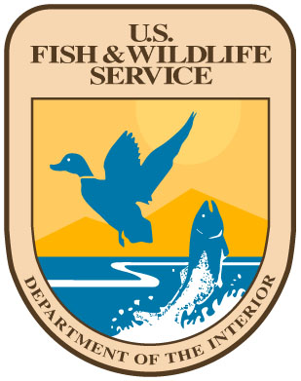
United States Department of the Interior

U.S. FISH AND WILDLIFE SERVICE
South Atlantic Fish and Wildlife Conservation Office
P.O. Box 33683
Raleigh, North Carolina 27636-3683
Phone: 919-515-5019 FaxForm: 919-515-4454
July 30, 2026

Reply: South Atlantic Fisheries Coordinator, USFWS, Raleigh, NC

Subject: Update on U.S. Fish and Wildlife Service and Partner Activities

To: South Atlantic Fishery Management Council Members and Staff

Colleagues:

The following are items and/or updates of interest undertaken by the U.S. Fish and Wildlife Service (Service or FWS) and partners during the first quarter of 2012 which may be of interest. If you have questions, please contact the noted individual(s). Thanks to all of the FWS field and Regional Office staff, and partners, who contributed information for this report.

U.S. Fish and Wildlife Service: Staff Update

Leopoldo Miranda-Castro was named as the new Assistant Regional Director-Ecological Services, for the Southeast Region.

Albemarle Pamlico National Estuary Program Status and Trends Report Released

The Albemarle Pamlico National Estuary Program (APNEP) has completed a draft of the new Status and Trends Report. The report has undergone review by the APNEP Science and Technical Advisory Committee (STAC). It was prepared by APNEP staff, STAC members, and contributing partners. It is available for review, along with other APNEP documents, on the APNEP web site.
Contact(s): Director, Albemarle Pamlico National Estuary Program, NC Department of Environment and Natural Resources, Raleigh, NC: Bill Crowell: Bill.Crowell@ncdenr.gov: telephone: 919-715-1327; Program Scientist, APNEP, NCDENR, Raleigh, NC: Dr. Dean Carpenter: Dean.Carpenter@ncdenr.gov: telephone: 919-715-7735. Also see the web site:
http://portal.ncdenr.org/web/apnep/home

Alligator River National Wildlife Refuge Sea Level Rise Adaptation Project

The FWS and The Nature Conservancy (TNC) continue experiments to test some ways to help sensitive ecosystems and the wildlife that depend on them adapt to this changing world (http://www.fws.gov/alligatorriver/news/2010%20News/news-SeaLevelRise.html). Projections predicting that a vast majority of the acreage comprising Alligator River National Wildlife Refuge may be under water in the next 100-150 years made this refuge a prime candidate for study. TNC and the Refuge jointly planned a project to move forward and actually try several management actions in an effort to “buy some time” for wildlife and their habitats to adapt to the rapidly changing environments. The first phase of the project involved experimental plantings of native tree species that show some resistance to salt water compared to pocosin vegetation. Bald cypress, black gum, and pond pine were planted over about 40 acres adjacent to Point Peter Road Oyster reefs will be constructed near shore to dissipate wave energy on the shoreline. These oyster reefs are expected to slow erosion of the shoreline, improve estuarine water quality, provide near-shore aquatic habitat for numerous fishes, and sequester carbon. Another phase of the project is to place water control structures in strategic locations to prevent the jetting of salt water up the canals and into these freshwater systems. For more information: http://www.nature.org/wherewework/northamerica/states/northcarolina/

Contact(s): Refuge Biologist, Alligator River National Wildlife Refuge, Manteo, NC: Dennis Stewart: Dennis_Stewart@fws.gov: telephone: 252-4473-1131; Refuge Manager, ARNWR, Manteo, NC: Mike Bryant: Mike_Bryant@fws.gov: telephone: 252-473-1131, ext. 22; The Nature Conservancy: Brian Boutin: BBoutin@tnc.org: telephone: 252-441-2525.

American Eel Status Review

The Service received a petition dated April 30, 2010, to list the American eel. The petitioner is the Council for Endangered Species Act Reliability (CESAR). We received a Notice of Intent to Sue, dated September 7, 2010, from CESAR for failure to issue a 90-day finding on the petition. The Service has allocated funding for preparation of a 90-day funding on the eel petition. On February 2, 2007, the Service issued a negative 12-month finding on a previous petition to list the eel. The 2010 petition was found warranted, and the Service will be conducting a Status Review. Staff has not yet been assigned to conduct the review, but the Service’s Northeast Region has the lead responsibility.

Contact: Chief, Division of Endangered Species, U.S. Fish and Wildlife Service, 300 Westgate Center Dr., Hadley, MA 01035: Martin Miller: Martin_Miller@fws.gov: telephone: 413-253-8615.

Atlantic Sturgeon Survey, Roanoke River and Albemarle Sound, NC

On September 28, 2010, biologists from Commonwealth Environmental (consultant to Dominion Generation), the NC Department of Environment and Natural Resources-Division of Marine Fisheries, NC Wildlife Resources Commission-Division of Inland Fisheries, North Carolina State University-Department of Biology, U.S. Fish and Wildlife Service-South Atlantic Fisheries Coordination Office, and U.S. Geological Survey-North Carolina Cooperative Fish and Wildlife Research Unit, successfully captured and acoustically tagged three mature Atlantic sturgeon at Weldon, NC. Two of the fish were running ripe males. The fish have since departed the river, based on detections at receivers strategically placed in the river. One of the fish was subsequently been detected in the Atlantic Ocean, southeast of Cape Hatteras, in an acoustic receiver array deployed and maintained by East Carolina University (Dr. Roger Rulifson, Principal Investigator). All three of the fish have been detected at various locations along the coast, and an additional fish was tagged in the fall of 2011. The NMFS Section 6 project funding the work has been significantly cut.

Contacts: North Carolina Cooperative Fish and Wildlife Research Unit, U.S. Geological Survey, Assistant Unit Leader-Fisheries, Dr. Joseph Hightower, Raleigh, NC: JHightower@ncsu.edu, telephone: 919-515-8836; North Carolina Department of Environment and Natural Resources-Division of Marine Fisheries, Atlantic Sturgeon Lead Biologist, Michael Loeffler, Elizabeth City, NC: Michael.Loeffler@ncdenr.gov: telephone: 252-264-3911; North Carolina Wildlife Resources Commission, Division of Inland Fisheries, Diadromous Fish Coordinator, Kinston, NC: Bennett Wynne: Bennett.Wynne@ncwildlife.org: telephone: 252-522-9736.

Cape Hatteras Acoustic Listening Array

In 2008, East Carolina University established a 12-kilometer acoustic listening array (VR2W receivers) southeast of Cape Hatteras, North Carolina, in the Atlantic Ocean perpendicular to the shoreline. The array was designed to detect spiny dogfish which had been implanted with acoustic tags. In addition to detecting those fish, the array has also detected multiple individuals of many other species, including American shad, Atlantic sturgeon, cownose ray, hickory shad, sandbar shark, sand tiger shark, and spiny butterfly rays. Given the success of the array in detecting not only spiny dogfish but numerous additional species, the South Atlantic Fish and Wildlife Conservation Office, and North Carolina Sea Grant Program, are collaborating to fund the refurbishment and redeployment of the array, into the winter and spring of 2012. The array has been redeployed and is currently being operated to continue detections.

Table 1. Summary of species recorded by the ECU Acoustic Array in Hatteras Bight, NC 2008-2011.

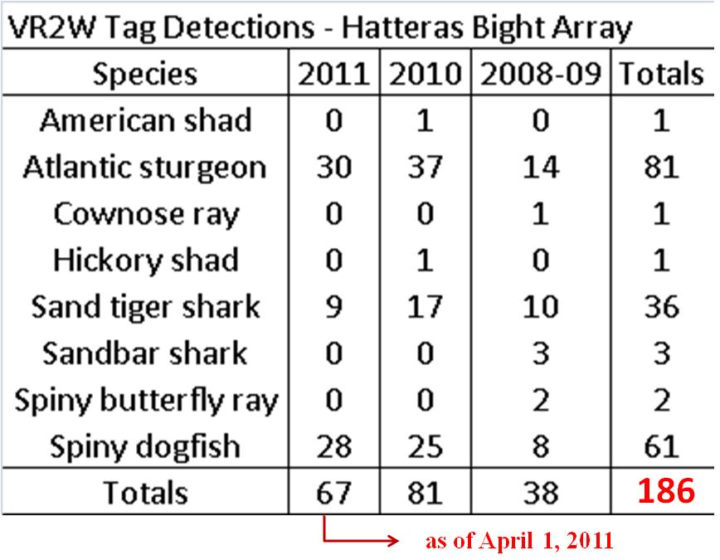

Contacts: Dr. Roger Rulifson, Department of Biology, East Carolina University, Greenville, NC: RulifsonR@ecu.edu, telephone: 252-238-9400.

Center for Biological Diversity Listing Petition

The Center and six other organizations filed a petition with the Service on April 20, 2010, asking for Endangered Species Act protection for 404 aquatic species. The 1,145-page petition seeks listing for 48 fish, 92 freshwater mussels and snails, 92 crustaceans, 82 plants, 13 reptiles, 4 mammals, 15 amphibians, 55 insects and 3 birds. Noah Greenwald, Endangered Species Program Director for the Center, said that “Dams, pollution, growing demand for water, and uncertainty about future water availability with global climate change mean these 404 species need Endangered Species Act protection to have any chance at survival. The Service has completed review of the petition and determined that 374 of the species warranted further review. Additional reviews are underway to determine if species are eligible for consideration for the development of Candidate Conservation Agreements (CCAs), or Candidate Conservation Agreements with Assurances (CCAAs). For more information, see:
http://www.biologicaldiversity.org/news/press_releases/2010/southeast_petition-04-20-2010.html

Contact: Ecological Services Division, U.S. Fish and Wildlife Service, Southeast Regional Office, Atlanta, GA: Janet Mitzi: Janet_Mizzi@fws.gov: telephone: 404 679-7169.

Cooperative Winter Tagging Cruise

The Cooperative Winter Tagging Cruise (Cruise) is an outstanding example of a highly successful state-federal science partnership which has persisted for 25 years (1988-2012, inclusive). The Cruise began in 1988 as a component of the Atlantic States Marine Fisheries Commission’s migratory striped bass management plan, as part of the coastwide migratory striped bass tagging program ( for more information on the striped bass tagging program see: http://www.fws.gov/northeast/marylandfisheries/projects/Striped%20Bass.html). While the Cruise was designed to tag striped bass on their wintering grounds off NC and VA, from the beginning Atlantic sturgeon were also tagged. During the first 23 years, the Cruise has tagged 44,125 striped bass and 252Atlantic sturgeon. Other species (horseshoe crabs, red drum, spiny dogfish, summer flounder and thresher shark) have been tagged, as well as documented and sampled for aging structures (skates, alosines, scianids). The tag return rate for migratory striped bass (those over 28 inches total length) has been 19 percent, with an overall rate of return (all fish tagged regardless of size) of 17 percent. The data provided by the Cruise are used in the management of Atlantic sturgeon, striped bass, spiny dogfish, and other species by the National Marine Fisheries Service, by Fishery Management Councils, by the U.S. Fish and Wildlife Service, and by state co-managers. The Cruises have also supported a number of graduate student theses at partnering institutions (Acadia University, Delaware State University, East Carolina University, North Carolina State University, and University of Massachusetts-Amherst)..

Cooperative Winter Tagging Cruise 2011 Results Update

No cruise was conducted in the traditional manner during 2011. Due to the Continuing Resolution (CR), no funding was received from NMFS headquarters this year. The North Carolina Division of Marine Fisheries was able to contract with charter fishing vessels for day trips offshore to tag striped bass. A total of 108 fish were tagged during one day. The remaining trip scheduled was cancelled due to adverse weather. Cruise partners are working on several grant applications in an effort to secure funding to conduct the Cruise in 2012, which will be the 25th annual one.

Cooperative Winter Tagging Cruise 2012 Results Update

No cruise was conducted in the traditional manner during 2012. No funding was received from NMFS headquarters this year. The North Carolina Division of Marine Fisheries was able to contract with charter fishing vessels for day trips offshore to tag striped bass. A total of 6 fish were tagged during one day. The remaining trip scheduled was cancelled due to adverse weather. Cruise partners have secured a grant from the NC Coastal Recreational Fishng Licence Program to conduct the traditional Cruise, as well as hook-and-line tagging, in 2013, which will be the 26th year the program has been conducted.

Contact: U.S. Fish and Wildlife Service, South Atlantic Fisheries Coordinator, Raleigh, NC: Dr. Wilson Laney: Wilson_Laney@fws.gov, telephone: 919-515-5019.

Mississippi Canyon 252 Oil Discharge Response Update

Service employees in the Southeast Region, as well as volunteers from other Regions, continue involvement in the response to the disaster in the Gulf of Mexico. The Service web site (http://www.fws.gov) has posted five fact sheets which include among others, The Effects of Oil on Wildlife and Habitat. For more information see: http://www.fws.gov/home/dhoilspill/index.html

Contact: US Fish and Wildlife Service, Southeast Region, Regional Director, Atlanta, GA: Cynthia Dohner: Cynthia_Dohner@fws.gov: telephone 404-679-4000.

Roanoke Rapids Dam, Roanoke River, NC, Eelways Update

Eelways were constructed on the Roanoke Rapids Dam during 2009, and became operational on March 1, 2010 (South Eelway) and April 5, 2010 (North Eelway). The numbers of eels captured in the facilities far exceeded the design capacity of the eelway and required design changes to increase the size of the holding tank, and increase water flow through the tank. All viable eels (89% of the estimated total, through 2010) have been transported to Roanoke Rapids Lake or its Deep Creek tributary for release. Eel catches remained substantial during 2011. To date, nearly 700,000 eels have been captured and transported into Roanoke Rapids Reservoir. FWS ARD-Ecological Services, Leo Miranda-Castro, will visit the facility with NMFS Habitat Conservation personnel during the week of March 12, to tour the eelways and discuss design, construction and operations with Dominion Generation staff.

Contact: Bob Graham, Environmental Biology, Richmond, VA: bob.graham@dom.com
Telephone: (O) 804 271-5377; (C) 804 350-7047.

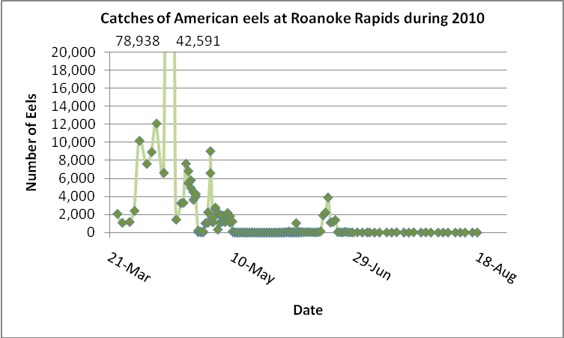

Shortnose Sturgeon Status Review Update

The FWS South Atlantic Fisheries Coordinator continues to serve on the Shortnose Sturgeon Status Review Team. The draft of the Status Review and Biological Opinion is being finalized by the National Marine Fisheries Service, Northeast and Southeast Regions, after having undergone legal review.

Contacts: Dr. Stephania Bolden, Protected Resources, National Marine Fisheries Service, Southeast Regional Office, St. Petersburg, FL: Stephania.Bolden@noaa.gov, telephone: 727-824-5312; or Jessica Pruden, Protected Resources, National Marine Fisheries Service, Northeast Regional Office, Gloucester, MA: Jessica.Pruden@noaa.gov, telephone: 978-282-8482.

South Atlantic Landscape Conservation Cooperative (SALCC) Update

Members of the Council were previously briefed on the FWS Strategic Habitat Conservation (SHC) approach for landscape and fish and wildlife population conservation (see http://training.fws.gov/EC/resources/SHC/shc_finalrpt.pdf). As a component of the FWS climate change strategy, the Service further developed a proposal to establish Landscape Conservation Cooperatives (LCCs) across the nation to provide scientific and technical support for conservation at landscape scales, defined in this case as the entire range of a species, or group of species (e.g., the south Atlantic snapper-grouper complex). The LCC concept was subsequently adopted by the U.S. Department of the Interior as a departmental program. For more information, see http://www.fws.gov/science/shc/lcc.html The SALCC covers portions of the Piedmont and Coastal Plain, from southeastern Virginia through northern Florida, extending to the Gulf of Mexico via the Suwannee and Apalachicola-Chattahoochee-Flint river basins. Kenneth McDermond is serving as the SALCC Coordinator and is based in Raleigh, NC.
(see: http://www.fws.gov/southeast/LCC/SouthAtlantic/). He is co-located with the North Carolina Wildlife Resources Commission on Centennial Campus at North Carolina State University. Dr. Rua Mordecai serves as the SALCC Science Coordinator and is also stationed in the NCWRC building on Centennial Campus. The SALCC has a new website:
http://southatlanticlcc.ning.com The SALCC has solicited proposals for funding additional science projects in the SALCC geography. See the web site for details.

Contacts: US Fish and Wildlife Service, South Atlantic Landscape Conservation Cooperative Coordinator, Raleigh, NC: Ken McDermond: Kenneth_McDermond@fws.gov: telephone: 919-707-0121; U.S. Fish and Wildlife Service, South Atlantic Landscape Conservation Cooperative Science Coordinator, Dr. Rua Mordecai, Rua_Mordecai@fws.gov.
.

