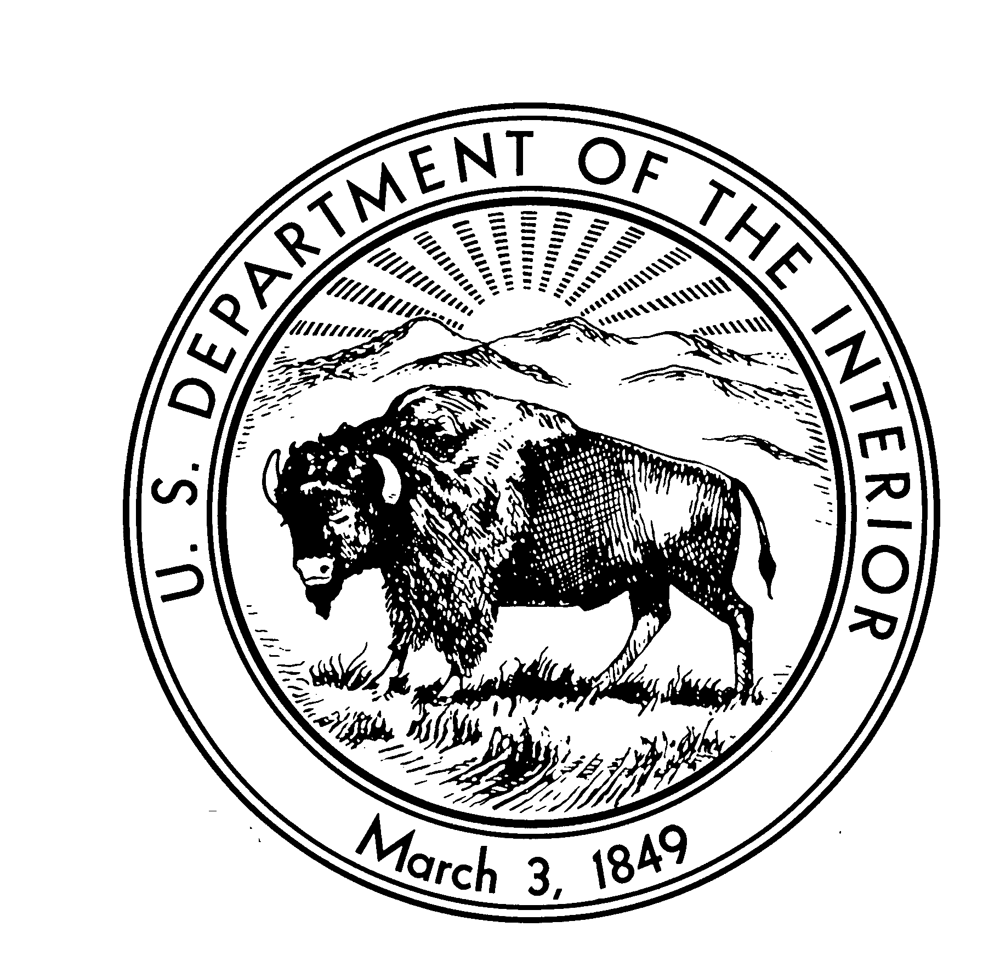
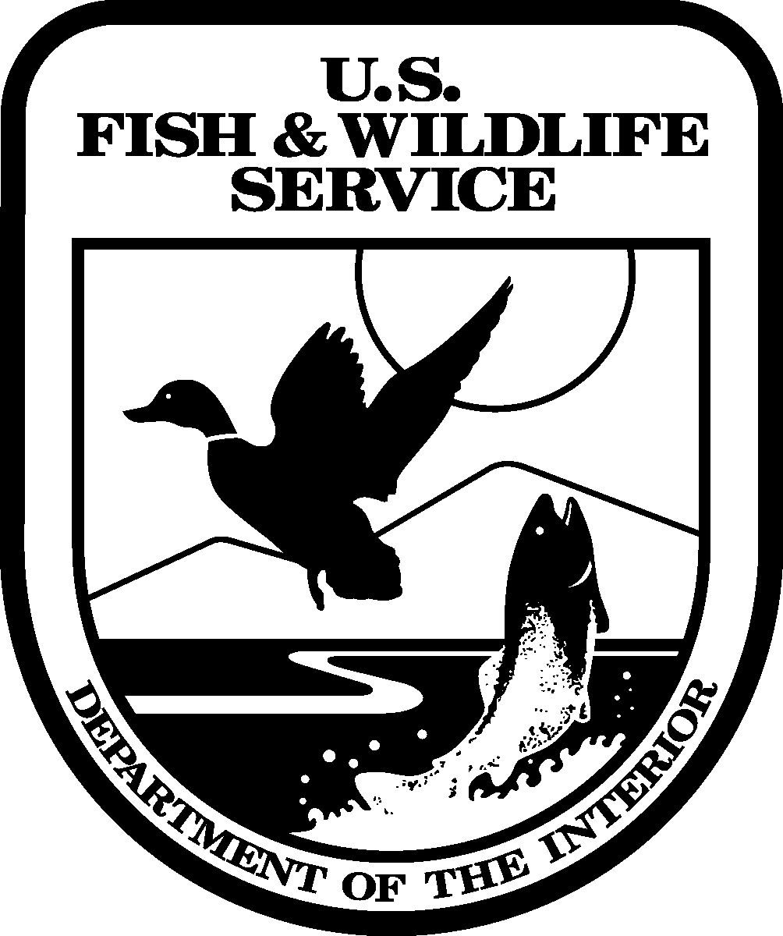
United States Department of the Interior
South Atlantic Fisheries Coordination Office
UNITED STATES FISH AND WILDLIFE SERVICE
Post Office Box 33683
Raleigh, NC 27636-3683
Phone: (919) 515-5019 FAX: (919)515-4454

U.S. Fish and Wildlife Service Report to
South Atlantic Fishery Management Council

Renaissance Hotel Orlando Airport, Orlando, Florida
June 13, 2008

American Shad Spawning on Savannah River, GA and SC: Due to operational issues at New Savannah Bluff Lock and Dam, the U.S. Fish and Wildlife Service (USFWS or Service), National Marine Fisheries Service, South Carolina DNR and Georgia DNR and other partners collaborated this spring to collect American shad and move them above the dam to enable them to complete their spawning run. The efforts were highly publicized and should bring more public focus on efforts to develop a long-term solution to fish passage on the Savannah River. Contacts: regarding the electrofishing operations, Tripp Boltin, USFWS, Wadmalaw Island Fisheries and Wildlife Coordination Office (FWCO), 843-819-1229; regarding New Savannah Bluff Lock and Dam, Amanda Hill, USFWS, Ecological Services, Charleston, SC, 843-727-4707.

American Shad Status on Edisto River, SC: In partnership with South Carolina DNR, the Bears Bluff National Fish Hatchery (NFH) and Wadmalaw Island FWCO conducted two electrofishing operations on the South Edisto River to evaluate American shad brood collection locations. Commercial and recreational fishermen have expressed concerns about the status of the shad fishery on the river. The current American shad stock assessment conducted by SCDNR and the Atlantic States Marine Fisheries Commission (ASMFC, see Limburg et al. 2007, available on the ASMFC web site, www.ASMFC.org) shows the stock as “declining.” Several funding proposals have been submitted to begin a more elaborate evaluation of the American shad within the Edisto River to include investigation of spawning sites, juvenile outmigration and population estimates. Juvenile sampling will begin this fall and the two agencies will be working on a river specific management/study plan this summer. Contact: Tripp Boltin, USFWS, Wadmalaw Island Fisheries and Wildlife Coordination Office, 843-819-1229.

American Shad Stocking, Roanoke River, VA and NC: The North Carolina Wildlife Resources Commission, Division of Inland Fisheries, Watha State Fish Hatchery, and the USFWS Edenton National Fish Hatchery collaborated this year to produce 8,502,099 OTC-marked fry for stocking into the Roanoke River. Fry were stocked above the U.S. Army Corps of Engineers Kerr Reservoir, near Altavista, Virginia, and also at Weldon, North Carolina, below Roanoke Rapids Dam. Marked outmigrating juveniles resulting from the Altavista stockings have been recovered downstream of the Roanoke River dams, and marked adult shad have also been recovered, demonstrating the success of the project in contributing to the restoration of American shad stocks on the Roanoke. Contact: Stephen Jackson, USFWS, Edenton National Fish Hatchery, Edenton, NC, 252-482-4118.

Asian Swamp Eel Control, FL: Dr. John Galvez of the Service’s South Florida Fisheries Resources Office is leading efforts to contain and control the Asian Swamp Eel. Removal through electrofishing has resulted in elimination of large numbers of adult eels and a reduced number and smaller size of eels remaining. Control efforts will continue. Contacts: Dr. John Galvez, USFWS, South Florida Fisheries Resources Office, Vero Beach, FL, 772-562-3909; Jay Troxel, Southeast Region ANS Coordinator, USFWS, Atlanta, GA, 404-679-4151.

ASMFC Habitat Committee: Under the leadership of Commission Chair George LaPointe, the Habitat Committee membership has been filled, with representatives from all states as well as key federal agencies, including for the first time the U.S. Army Corps of Engineers and U.S. Geological Survey. The Committee has revised its strategic plan and is seeking to improve the process for ASMFC to comment on projects which could have a significant impact on ASMFC-managed resources. Other projects include preparation of a handbook for review and comment of proposed energy projects with regard to their potential impacts on fisheries resources. Dr. Laney now serves as Vice Chair of the Committee. Contact: Jessie Thomas, Habitat Coordinator, ASMFC, Washington, D.C., 202-289-6400.

ASMFC Significant Actions on Anadromous Species: Shad and River Herring Amendment 2 is in preparation and will detail the ASMFC response to the recent American shad stock assessment (see Limburg et al. 2007, available on the ASMFC web site as noted above). The stock assessment for river herring is in preparation with data being assembled in advance of the planned data workshop. Contacts: Erika Robbins, ASMFC, or Patrick Campfield, ASMFC, Washington, D.C., 202-289-6400.

Atlantic Coast Fish Habitat Partnership, U.S. east coast drainages: The partnership has a new Coordinator, Emily Greene, who is based at ASMFC. The Interim Steering Committee will be meeting in Manchester, NH, on June 27, following the ASMFC Habitat Committee meeting, to continue preparing its strategy. Contact: Emily Greene, ASMFC, 202-289-6400.

Atlantic Sturgeon Restoration, St. Mary’s River, GA: Warm Springs Fish Tech Center has requested authorization to remove four Atlantic sturgeon from the Altamaha River population during 2008 and place them in the hatchery (at the Bears Bluff NFH, Wadmalaw Island, SC, location) to begin developing husbandry methods appropriate for southeastern U.S., Atlantic coast drainages. The ASMFC Sturgeon Technical Committee endorsed the request, with qualifications. Technical advice is being provided to ASMFC and USFWS Southeastern Region personnel by staff of the Lamar, PA, Fish Tech Center in the Service’s Northeast Region, which literally wrote the book on Atlantic sturgeon culture and husbandry. Contacts: Vincent Mudrak, Director, USFWS, Warm Springs Fish Tech Center, Warm Springs, GA, 706-655-3382; or Erika Robbins, ASMFC, Washington, D.C., 202-289-6400.

Channeled Apple Snail Infestation, SC: A new infestation of the introduced channeled apple snail was recently documented in South Carolina near Waccamaw National Wildlife Refuge and the Service is working with state partners to eradicate or control that population. Contacts: Craig Sasser, USFWS, Waccamaw National Wildlife Refuge, Georgetown, SC, 843-527-8069; Jay Troxel, Regional Aquatic Nuisance Species Coordinator, USFWS, Atlanta, GA, 404-679-4151.

Cooperative Winter Tagging Cruise, Atlantic Ocean, VA and NC: The Cruise completed it’s 21st voyage the last two weeks of January. Successes included the capture and tagging of 73 Atlantic sturgeon, the highest number in the time series, including four recaptures. About half the average number of migratory Atlantic striped bass were tagged, due in part to problems with the NOAA Research Vessel Oregon II’s trawl winch, which necessitated towing only one trawl, instead of the usual two, for most of the Cruise. Staff and collaborators are working on a summary report, to be published by the Atlantic States Marine Fisheries Commission, that will detail the data collected, results generated and management implications of the 21-year time series. Data and analysis will be included for Atlantic sturgeon, alosine species, horseshoe crabs, kingfishes, red drum, skates, smooth and spiny dogfish, spotted sea trout, striped bass, summer flounder and thresher sharks. The goal is to have a draft report by the ASMFC fall meeting in October. At present, there is no NOAA vessel available for January, 2009. We are working with ASMFC and NOAA headquaters staff to secure one. Contact: Dr. Wilson Laney.

Eastern Oyster Reef and Red Drum habitat, Edisto River, SC: In partnership with South Carolina DNR's SCORE program, the Bears Bluff NFH and Wadmalaw Island FWCO recently completing building a .25 acre footprint oyster reef in the North Edisto River. Additionally, "expired" crab traps were used to create an additional .25 acre footprint oyster reef. The crab trap approach is being investigated for use in soft substrate areas which may be applied in other river systems such as the Ashley River. The NFH produces red drum in partnership with SC. The oyster reef footprint establishment is aimed at improving oyster reefs along the SC shore as well as providing habitat for juvenile drum and other aquatic species. The NFH is gearing up to serve as an oyster recycling location, equipped with a dump trailer for oyster roasts, to expand the effort already initiated. Contacts: Tripp Boltin, USFWS, Wadmalaw Island FWCO, 843-819-1229; or Kent Ware, Bears Bluff NFH, Wadmalaw Island, SC, 843-559-2315.

Evans Road Fire, NC: A major fire begun by a lightening strike on June 1 continues to burn in eastern North Carolina, largely in Pocosin Lakes National Wildlife Refuge. As of June 18, the fire had burned over 42,000 acres and the smoke plume has covered large portions of NC and VA. Four helicopters and over 250 personnel are working to contain the blaze and eliminate hotspots. The fire is being managed by the Service and the North Carolina Forest Service. Contact: Bonnie Strawser, Alligator River NWR, Manteo, NC, 252-473-1131.

FERC Flows and Fish Passage Implementation: Service field teams continue to work with the NMFS, our state fishery management agency partners, and power company representatives to design and implement provisions for improving flow regimes and providing fish passage within south Atlantic drainage basins. On the Roanoke River in North Carolina and Virginia, we are scheduled to begin moving American eels above Roanoke Rapids Dam this year. They will be implanted with coded wire tags. Design work has begun on an eelway for the dam. Sampling for the past three years has documented the migration pattern and distribution of elvers arriving at the dam annually by the thousands. The plan for restoration was reviewed and endorsed by the ASMFC American Eel Technical Committee. Relicensing is ongoing on the Pee Dee River in North Carolina, where the Service, American Rivers and the City of Rockingham continue to press for higher flow releases from Progress Energy’s Tillery Dam. Service staff are also participating in ongoing discussions regarding the South Carolina Public Service Authority and Duke Power dams on the Santee-Cooper and Catawba-Wateree river systems in North and South Carolina. Target species for restoration efforts focusing on flows and passage include American shad, American eel, river herring and robust redhorse. Contacts: For the Roanoke River, Dr. Wilson Laney, USFWS, South Atlantic Fisheries Coordination Office, Raleigh, NC, 919-515-5019; for the Pee Dee River, Mark Bowers, USFWS, Ecological Services, Raleigh, NC, 919-856-4520; for the Santee River Basin, Amanda Hill, Ecological Services, Charleston, SC, 843-727-4707; and for the Catawba-Wateree, Amanda Hill, or: Mark Cantrell, Ecological Services, Asheville, NC, 828-258-3939.

Fish Passage Projects, NC-FL: Fish Passage Projects, NC-FL: The Service's Southeast Fisheries Program has funded 3 fish passage projects for FY 2008. The projects include the breaching of Henry River Dam (NC), removal of the Valley Falls Dam (SC), restoring fish passage to artificially impounded wetlands (FL), and installing culverts along Research Road in Everglades NP (FL). Work has been initiated for the wetland project in FL, while the other three projects are in the early stages of contracting the removal. These projects reconnect areas that have been fragmented by dam or dike construction. Breaching the Henry River Dam opens 112 miles of river to resident fishes; removing Valley Falls Dam opens nearly 15.4 miles and sets a precedent for removal of barriers down stream and opening whitewater opportunities; breaching of man-made dikes at Merritt Island NWR will open approx 444 acres of wetlands to estuarine dependent avian and aquatic species; and fish passage along Research Road will restore fish passage and water flow to over 8,300 acres in the Everglades NP. Contacts: Regarding Southeast Region's Fish Passage Program, Tripp Boltin, Wadmalaw Island Fisheries and Wildlife Coordination Office, 843-819-1229; Henry River Dam project, Mark Cantrell, Asheville ES, 828-258-3939; Valley Falls Dam, Amanda Hill, Charleston ES Office, 843-727-4707 and Mark Cantrell, Asheville ES Office, 828-258-3939; Artificially Impounded Wetland, Allan Brown, Welaka NFH, 386-467-2374; Everglades NP, John Galvez, South Florida Fisheries Resources Office, 772-562-3909.

Shortnose Sturgeon Status Review, U.S. east coast: The South Atlantic Fisheries Coordinator is serving on the Shortnose Sturgeon Status Review Team, which is co-chaired by staff from the Northeast and Southeast Regions of NMFS. The draft Status Review is currently in preparation, and FWS staff is writing the North Carolina rivers section. The team will be meeting in August to continue work on the extinction risk analysis and is developing an improved methodology. Anticipated completion date is late 2008 or early 2009. Contacts: Dana Hartley, Protected Resources Division, Northeast Region, NMFS, Gloucester, MA, 978-281-9300; or Dr. Stephania Bolden, Protected Resources, Southeast Region, St. Petersburg, FL, 727-824-5312.

USFWS Strategic Habitat Conservation Planning: The Service continues to plan for changing the way it does business, moving to a more strategic approach. Most USFWS Regions have established teams which are working to assess existing resources, and conduct planning for future implementation of a Strategic Habitat Conservation approach to doing business. The Southeast Region’s SHC Advisory Team is currently building a draft road map for consideration by the Regional Directorate and as part of that process is compiling a complete list of federal trust species for which USFWS has primary management responsibility in the Southeast Region. The initial list will include Council and Commission-managed species. The Service had already begun significant SHC-based projects in northeastern NC (Southeastern Virginia and Northeaster North Carolina SHC Initiative), SC (Santee River Basin Accord) south FL (Everglades Restoration) and the Lower Mississippi Valley (Lower Mississippi Joint Venture) and will continue these efforts and initiate others as resources permit. The USFWS hopes to collaborate with the Council on habitat-based restoration of fish stocks in the south Atlantic. Contact: Dr. Laura Brandt, Joint Ecosystem Team Leader, USFWS and USGS, Fort Lauderdale Research and Education Center, Davie, FL, 954-477-6343.

