5/20/2015
Modifications to Gulf Reef Fish and South Atlantic Snapper Grouper Fishery Management Plans

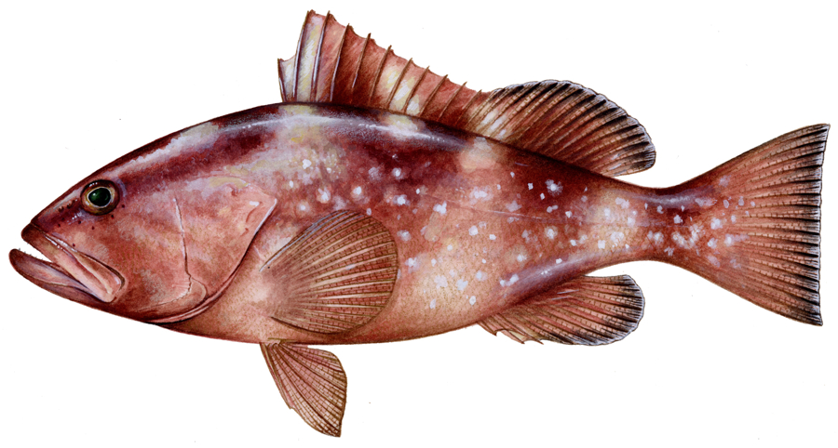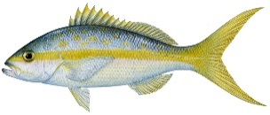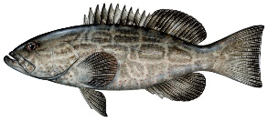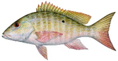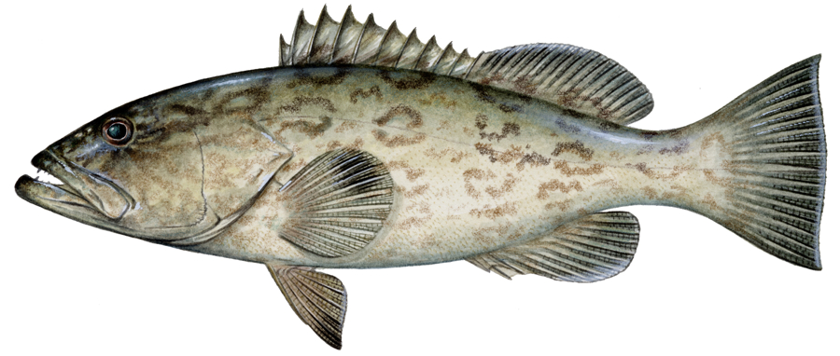

Draft Joint Generic Amendment
on South Florida Management Issues

June 2015

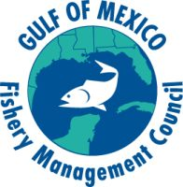

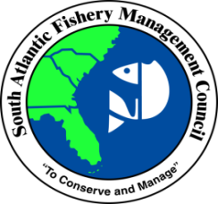

This is a publication of the Gulf of Mexico Fishery Management Council Pursuant to National Oceanic and Atmospheric Administration Award No. NA15NMF4410011.

Chapter 2. Draft Management Alternatives

Action 2: Establish and Consolidate ABCs and ACLs for Yellowtail Snapper

Alternative 1. No action. Maintain the current commercial and recreational ACLs for yellowtail snapper based on the South Atlantic Council’s Snapper Grouper Fishery Management Plan and maintain the current total ACL for yellowtail snapper in the Gulf based on the Reef Fish FMP. (SAFMC SG AP)

Alternative 2: Manage yellowtail snapper as a single unit with an overall combined multijurisdictional acceptable biological catch (ABC) and annual catch limit (ACL).

Alternative 3. Use both Councils’ agreed upon ABC for yellowtail snapper and allocate the commercial and recreational ACLs for the Gulf and South Atlantic:
Option 3a: Use the following sector allocation formula: divide the sector allocations based on the ratio of landings with 50% of the weighting given to the mean of the landings from 1993-2008, and 50% on the mean of the landings from 2009-2013.
Option 3b: Base sector allocations on average landings from 2009-2013
Option 3c: Base sector allocations on average landings from 2004-2013

IPT Note: Staff needs clarification if this action pertain to waters adjacent to State of Florida or throughout the Gulf and South Atlantic Council jurisdictions

Discussion

This action considers establishing and combining Gulf and South Atlantic annual catch limits (ACLs) for yellowtail snapper into one Southeastern U.S. acceptable biological catch (ABC) and ACL. The NMFS would continue to monitor the landings and notify the Councils when the ACL is met or projected to be met. The respective Scientific and Statistical Committees (SSC) for each Council would meet jointly to review stock assessment information, and would collectively determine appropriate values for the overfishing limit (OFL) and ABC for yellowtail snapper. Although yellowtail snapper has been managed as two separate stocks for regulatory purposes, the stock assessment considered yellowtail snapper from the Gulf and South Atlantic to be a single biological stock (SEDAR 27 2013). For the purposes of management of yellowtail snapper, the ACL could be set equal to the ABC since the stock is not currently overfished or undergoing overfishing (SEDAR 27 2013). Currently, only landings data are being used to determine allocations for this amendment. The Councils are considering other criteria in addition to landings data, such as social and economic considerations, for determining allocations in the future.

Currently, each Council’s SSC agrees to an ABC for yellowtail snapper based on yield projections from the most recent stock assessment (SEDAR 27 2013). The current jurisdictional apportionment is based on the Florida Keys (Monroe County) jurisdictional boundary between the Gulf and South Atlantic Councils for yellowtail snapper ABC. The jurisdictional split of the ABC was established by using 50% of catch history from 1993-2008 + 50% of catch history from 2006-2008 resulting in 75% of the ABC going to the South Atlantic, 25% of the ABC going to the Gulf. This methodology was established in the Generic Gulf of Mexico and Comprehensive South Atlantic ACL and AM Amendments (GMFMC 2011; SAFMC 2011) (Alternative 1).

Alternative 2 would use both Councils’ agreed upon ABC for management of yellowtail snapper as a single unit with an overall combined ACL. Currently each Council’s SSC agrees to an ABC for yellowtail snapper from the most recent stock assessment. A similar method would be used for this alternative and for Alternative 3. The method of management in Alternative 2 could still have within it recreational and commercial fishing allocations. However, neither sector would close in a fishing year so long as the overall ACL had not been met, if that accountability measure (AM) was selected as preferred.

Alternative 3 would use both Councils’ agreed upon ABC for yellowtail snapper and allocate the commercial and recreational ACLs for the Gulf and South Atlantic using one of the time period options. When determining the resultant sector allocations for Options 3a – 3c, sector landings will be capped at their respective sector ACLs (where appropriate), to ensure that overfishing in some years does not result in biased allocation ratios. Option 3a would divide the sector allocations based on the ratio of landings with 50% of the weighting given to the mean of the landings from 1993-2008, and 50% on the mean of the landings from 2009-2013. Option 3b would base sector allocations for waters off the State of Florida on average landings from 2009-2013. Option 3c would base sector allocations for waters off the State of Florida on average landings from 2004-2013. Table 5 outlines the resultant allocations for Options 3a – 3c of Alternative 3, based on the recreational and commercial landings in Table 6. Sector allocation options were determined with landings constrained to be no higher than the ACL for each respective sector in each Council’s jurisdiction. For yellowtail snapper, the respective ACLs were not exceeded; however, in 2012 the commercial sector landed 90% of their ACL. Subsequently a new stock assessment showed that the ABC could be increased permitting an increase in ACLs for both Councils.

Table 5. Sector allocation options for yellowtail snapper for Alternative 3 of Action 2. Percentages were derived from landings in whole weight.

Yellowtail Snapper Sector ACL Options
Option | Commercial | Recreational
Option 3a | 76% | 24%
Option 3b | 80% | 20%
Option 3c | 73% | 27%

Landings Data Description

The following methods were used to partition landings of yellowtail snapper, mutton snapper, and black grouper between the Gulf and South Atlantic Councils by sector. Commercial landings are assigned to sub-region (Gulf of Mexico or South Atlantic) based on fisher-reported catch area. For example, landings reported north of U.S. 1 are considered to be within the Gulf of Mexico jurisdiction and south of U.S. 1 landings are considered to be within the South Atlantic jurisdiction. Headboats based from Texas to Gulf-based in Monroe County are within the Gulf of Mexico jurisdiction, and headboats from North Carolina to the Florida Keys are within the South Atlantic jurisdiction. Marine Recreational Fisheries Statistics Survey (MRFSS) data was post-stratified to break the Florida Keys out from the Gulf of Mexico landings. The MRFSS landings from the Florida Keys were re-assigned to the South Atlantic Council, because most legal sized yellowtail snapper, black grouper, and mutton snapper are likely caught in South Atlantic waters (GMFMC CL/AM Amendment 2011).

Landings indicate that the yellowtail snapper fishery has historically been dominated by the commercial fishery. It is important to note that during the time periods considered in Alternative 3, neither the commercial nor the recreational sector exceeded their respective ACLs in the South Atlantic waters and the Stock ACL in the Gulf waters.

Table 6. Commercial and recreational landings of yellowtail snapper in the Gulf of Mexico and South Atlantic for 1993-2013. Landings are reported in pounds whole weight. Gulf commercial landings data for 1993 are confidential.

Year | Commercial |  | Recreational
 | Gulf | South Atlantic | Gulf | South Atlantic
1993 | Confidential | 1311367 | 51015 | 1189637
1994 | 1344942 | 860543 | 11762 | 880763
1995 | 591074 | 1265856 | 3434 | 660358
1996 | 485120 | 973815 | 2854 | 554130
1997 | 218384 | 1455496 | 2008 | 702997
1998 | 341479 | 1183074 | 4965 | 487063
1999 | 601027 | 1245345 | 39260 | 288951
2000 | 388984 | 1203154 | 4781 | 395845
2001 | 246849 | 1174008 | 7045 | 328458
2002 | 341823 | 1069057 | 7782 | 407848
2003 | 463743 | 948886 | 11472 | 510314
2004 | 478221 | 1002309 | 17937 | 698058
2005 | 510437 | 814899 | 31176 | 576247
2006 | 542237 | 694958 | 21477 | 560320
2007 | 350079 | 628608 | 19726 | 786399
2008 | 460569 | 910323 | 6056 | 746313
2009 | 891925 | 1085281 | 19250 | 348536
2010 | 569275 | 1126231 | 8783 | 434259
2011 | 769730 | 1125220 | 25560 | 390998
2012 | 630984 | 1439586 | 5087 | 493409
2013 | 728387 | 1305002 | 6991 | 666026
Source: SERO ALS Database (commercial landings) and MRIP (recreational landings)

